Supplementary materials

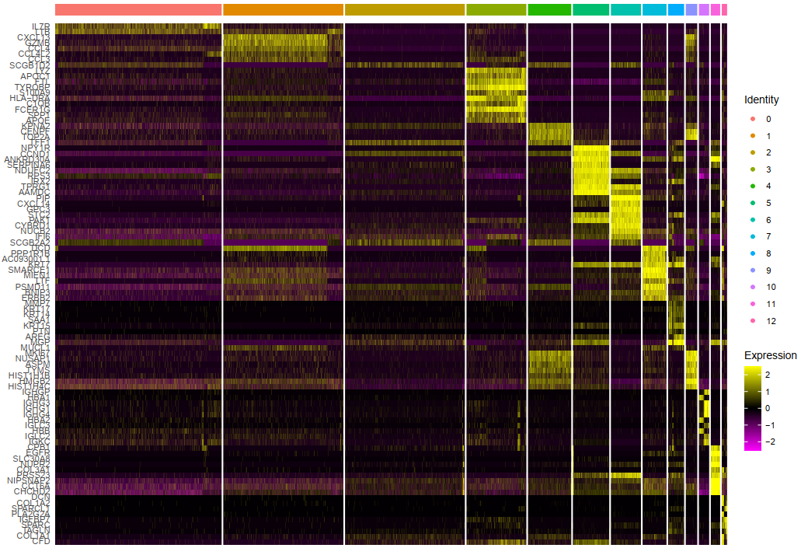
Figure S1. Single-cell RNA analysis identified γδT cells and relative markers. Heatmap of the top marker genes in cell clusters.
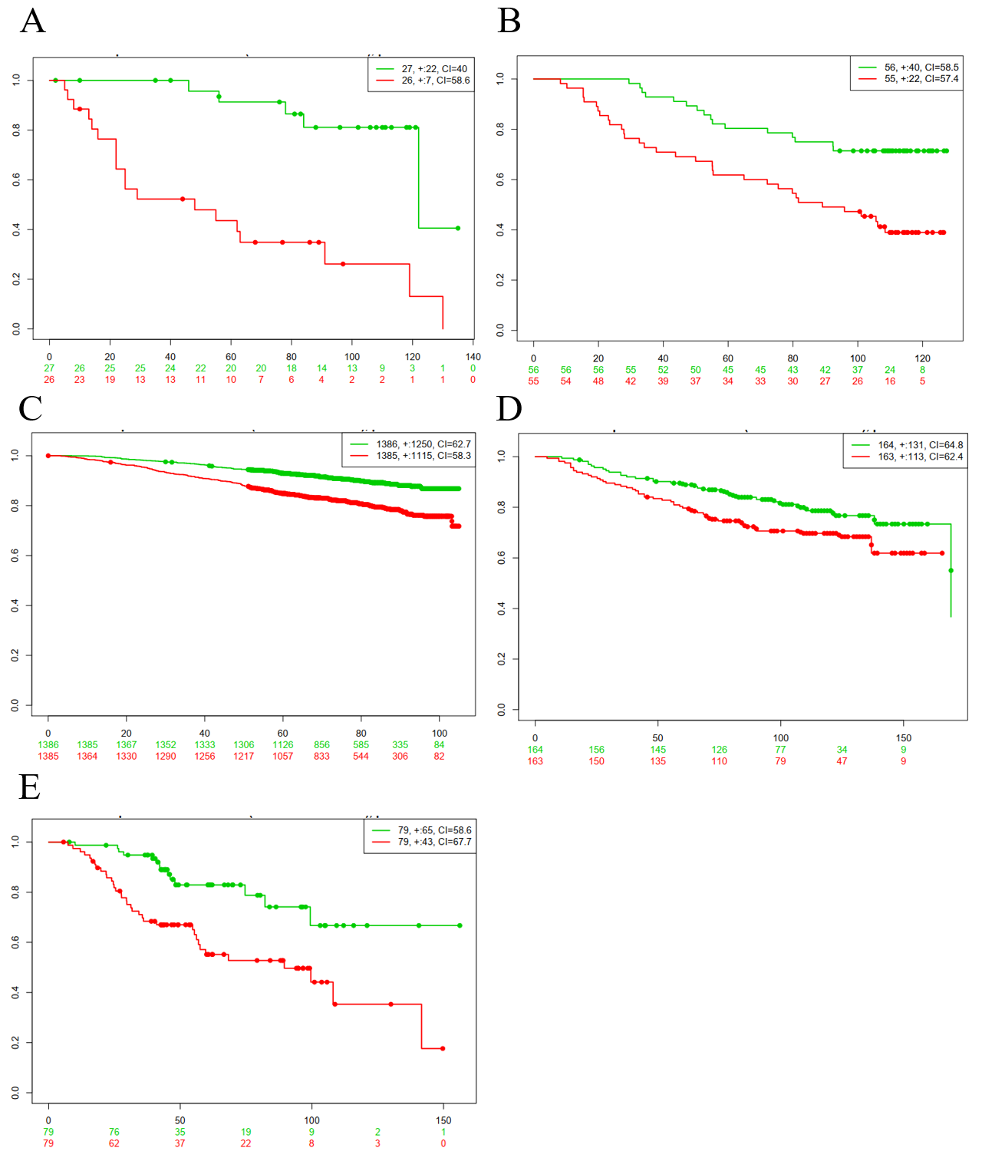
Figure S2. Validation in five independent GEO datasets. Survival analysis of (A) GSE35629 (n = 55). (B) GSE19536 (n = 110). (C) GSE 202203 (n = 2915). (D) GSE20685 (n = 327). (E) GSE3143 (n = 158).

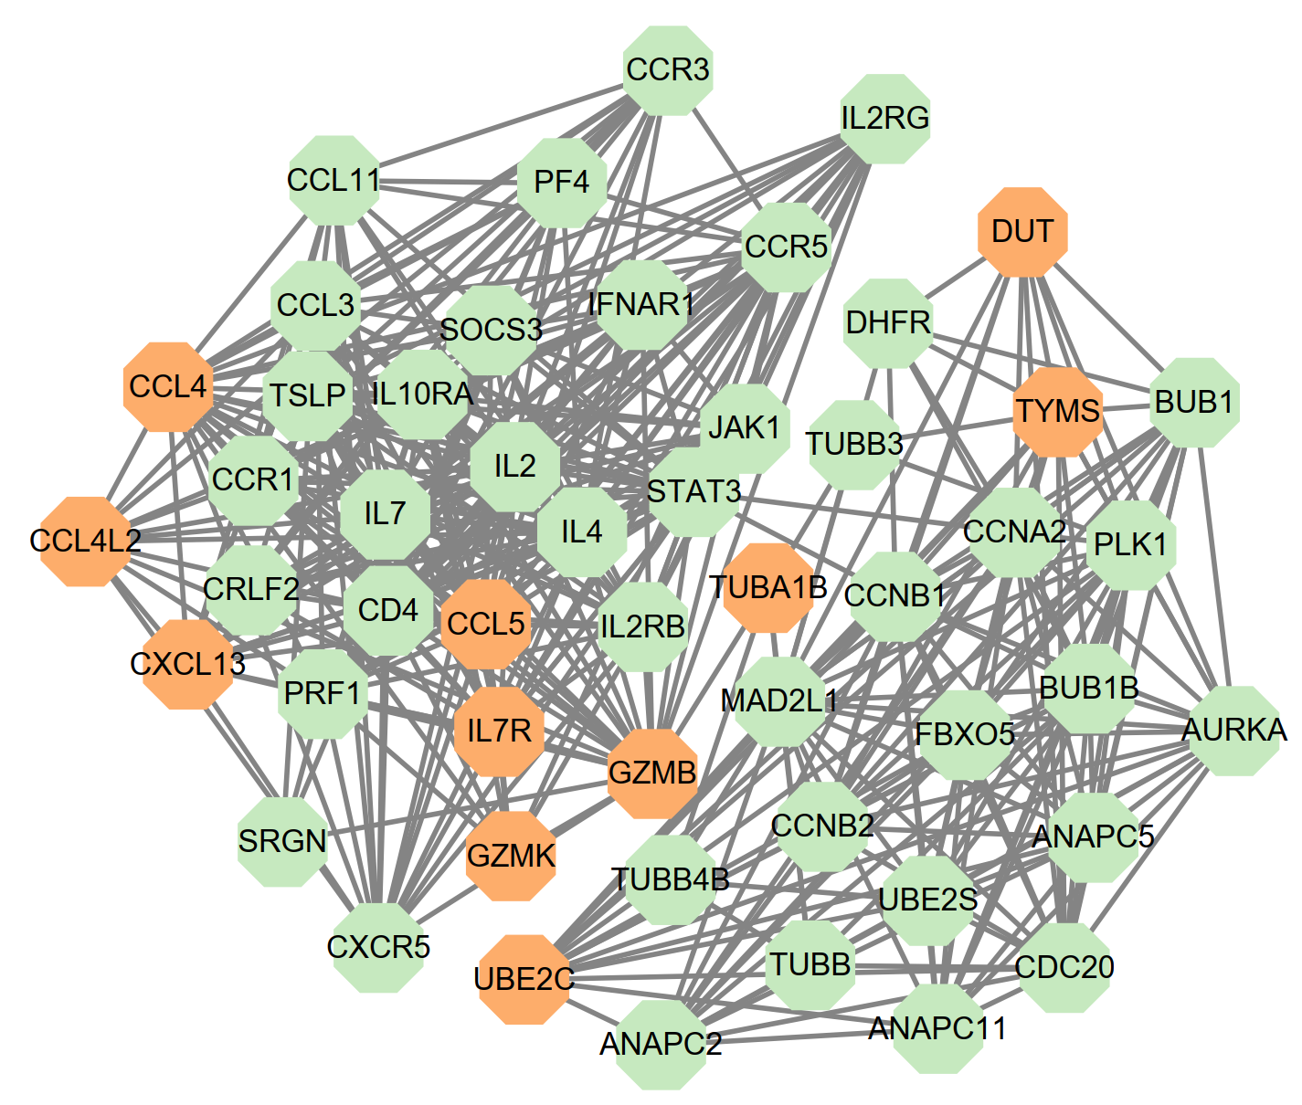
Figure S3. Functional analysis of the signature. PPI network generated from the 12 genes (colored by orange).

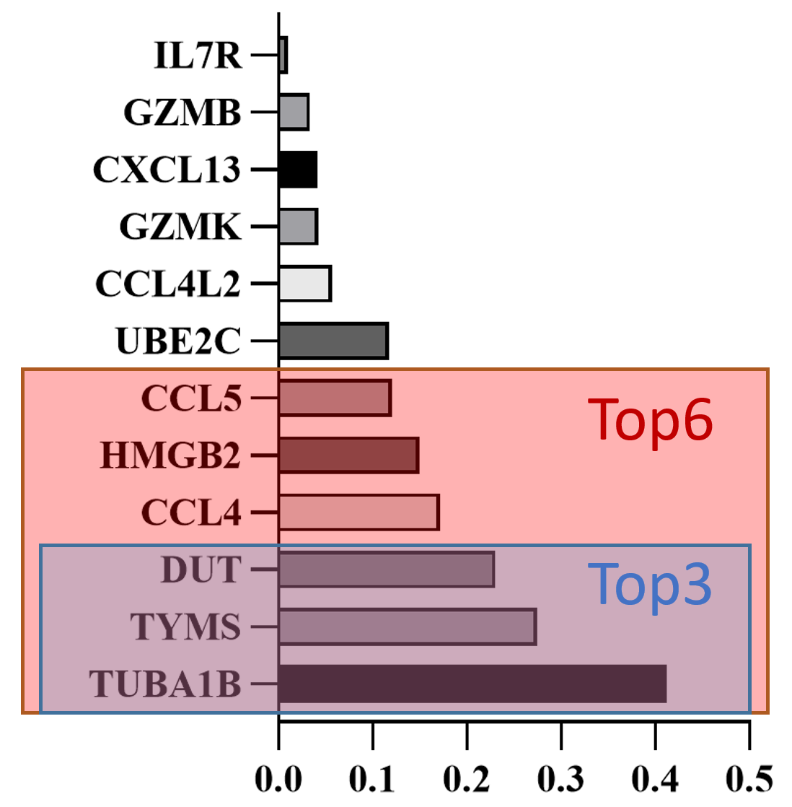
Figure S4. Validation in the cohort from our hospital. Different strategies of variable reduction.

