Supporting information

Exposure and risk assessment for agricultural workers during chlorothalonil and flubendiamide treatments in pepper fields

Deuk-Yeong Lee¹, Jong-Wook Song¹, Ji-Young An¹, Yeong-Jin Kim¹, Jong-Su Seo¹, and Jong-Hwan Kim^{1,*}
¹Environmental Chemistry Research Group, Korea Institute of Toxicology, Jinju, 52834, Republic of Korea

Table S1. Field, application and climate conditions in pepper field trials
Condition | Region (pesticide)
Condition | Uiseong-gun  (chlorothalonil) | Yeongyang-gun  (flubendiamide)
Field
Plant height (cm) | 70-120 (95) | 60-120 (85)
Plantation distance (cm) | 30-40 (33.8) | 30-50 (38.4)
Row distance (cm) | 70-130 (99.5) | 100-140 (121)
Field area (m²) | 2,000-4,700 | 3,300-10,000
Climate
Temperature (℃) | 25.3-33.1 (28.3) | 20.5-31.5 (25.4)
Relative humidity (%) | 59-91.4 (77.8) | 55.3-89.5 (74.1)
Wind speed (m/sec) | 0.0-1.8 (0.61) | 0.0-2.5 (1.3)
Application
Applicator | Power sprayer | Power sprayer
Nozzle pressure (MPa) | 2.5-3.4 | 2.0-5.0
Spraying volume (L) | 600-1,000 | 820-1,800

Table S2. The instrumental condition of GC-MS/MS for quantitative analysis of chlorothalonil
Instrument | Bruker SCION triple quadrupole (TQ) GC-MS (Bruker, Billerica, MA, USA)
Injection | 2 μL (250℃)
Column | DB-5MS UI (30m × 0.25 mm, 0.25 µm)
Flow | 1.0 mL min⁻¹ (He)
Oven condition | Temperature (℃) | Rate (℃ min⁻¹) | Hold (min)
Oven condition | 150 | 0 | 2
Oven condition | 300 | 25 | 4
Ionization source | Electron ionization (EI)
Polarity | Positive
Source temperature | 220℃
Transferline temperature | 260℃
MRM | Precursor ion (m/z) | Product ion  (m/z) | Collision energy (V)
MRM | 266 | 231 | 20
MRM | 266 | 168 | 20

Table S3. The instrumental condition of LC-MS/MS for quantitative analysis of flubendiamide
Instrument | Agilent Technologies 6420 Triple Quad LC/MS (Agilent, Santa Clara, CA, USA)
Column | Poroshell 120 EC-C18 (2.1 × 100 mm, 2.7 µm)
Flow | 0.3 mL min⁻¹
Mobile phase | A : 0.1% Formic acid with 5mM ammonium formate in water  B : 0.1% Formic acid with 5mM ammonium formate in methanol
Mobile phase | Time (min) |  | %A |  | %B
Mobile phase | 5 |  | 20 |  | 80
Injection volume | 4 μL
Ionization source | Electrospray ionization (ESI)
Polarity | Negative
Source temperature | 150℃
Capillary voltage | 4000 V
Gas temperature | 325℃ (N₂, 360 L hr⁻¹)
MRM | Precursor ion (m/z) | Product ion (m/z) |  | Fragment voltage (V) |  | Collision energy (V)
MRM | 681 | 273.9 |  | 200 |  | 8
MRM | 681 | 254.2 |  | 200 |  | 18

Table S4. Recoveies, CVs and MLOQ of the chlorothalonil in exposure matrices
Matrix | Fortification level | Recovery (%) | CV (%) | MLOQ (mg kg⁻¹)
Outer clothing | MLOQ | 104 | 2.6 | 0.005
Outer clothing | 10MLOQ | 94.5 | 1.3 | 0.005
Outer clothing | 100MLOQ | 96.2 | 0.5 | 0.005
Outer clothing | 100MLOQª | 103 | 5.1 | 0.005
Inner clothing | MLOQ | 101 | 1.2 | 0.005
Inner clothing | 10MLOQ | 107 | 1.3 | 0.005
Inner clothing | 100MLOQ | 103 | 0.6 | 0.005
Inner clothing | 100MLOQª | 101 | 6.2 | 0.005
Gauze | MLOQ | 102 | 1.7 | 0.005
Gauze | 10MLOQ | 93.7 | 2.5 | 0.005
Gauze | 100MLOQ | 87.6 | 1.5 | 0.005
Gauze | 100MLOQª | 85.6 | 3.4 | 0.005
Glove  (washing solution) | MLOQ | 73.6 | 12 | 0.005
Glove  (washing solution) | 10MLOQ | 92.3 | 17 | 0.005
Glove  (washing solution) | 100MLOQ | 113 | 10 | 0.005
Glove  (washing solution) | 100MLOQª | 110 | 4.0 | 0.005
Hand  (washing solution) | MLOQ | 112 | 6.1 | 0.005
Hand  (washing solution) | 10MLOQ | 97.0 | 13 | 0.005
Hand  (washing solution) | 100MLOQ | 107 | 16 | 0.005
Hand  (washing solution) | 100MLOQª | 110 | 7.0 | 0.005
Glass fiber filter | MLOQ | 110 | 2.2 | 0.005
Glass fiber filter | 10MLOQ | 97.4 | 1.5 | 0.005
Glass fiber filter | 100MLOQ | 87.6 | 1.8 | 0.005
Glass fiber filter | 100MLOQª | 86.4 | 4.4 | 0.005
ª Field recovery test

Table S5. Recoveies, CVs and MLOQ of the flubendiamide in exposure matrices
Matrix | Fortification level | Recovery (%) | CV (%) | MLOQ (mg kg⁻¹)
Outer clothing | MLOQ | 84.7 | 3.6 | 0.005
Outer clothing | 10MLOQ | 111 | 8.5 | 0.005
Outer clothing | 100MLOQ | 109 | 3.9 | 0.005
Outer clothing | 100MLOQª | 103 | 9.6 | 0.005
Inner clothing | MLOQ | 86.7 | 4.8 | 0.005
Inner clothing | 10MLOQ | 112 | 1.8 | 0.005
Inner clothing | 100MLOQ | 110 | 0.8 | 0.005
Inner clothing | 100MLOQª | 97.1 | 4.9 | 0.005
Gauze | MLOQ | 81.3 | 3.8 | 0.005
Gauze | 10MLOQ | 107 | 3.3 | 0.005
Gauze | 100MLOQ | 93.0 | 1.0 | 0.005
Gauze | 100MLOQª | 105 | 2.9 | 0.005
Glove  (washing solution) | MLOQ | 86.7 | 3.5 | 0.005
Glove  (washing solution) | 10MLOQ | 102 | 3.9 | 0.005
Glove  (washing solution) | 100MLOQ | 103 | 1.1 | 0.005
Glove  (washing solution) | 100MLOQª | 93.7 | 6.7 | 0.005
Hand  (washing solution) | MLOQ | 86.0 | 6.2 | 0.005
Hand  (washing solution) | 10MLOQ | 101 | 4.1 | 0.005
Hand  (washing solution) | 100MLOQ | 97.3 | 5.5 | 0.005
Hand  (washing solution) | 100MLOQª | 101 | 3.7 | 0.005
Glass fiber filter | MLOQ | 90.6 | 2.1 | 0.005
Glass fiber filter | 10MLOQ | 102 | 3.3 | 0.005
Glass fiber filter | 100MLOQ | 98.6 | 1.7 | 0.005
Glass fiber filter | 100MLOQª | 97.9 | 3.9 | 0.005
ª Field recovery test

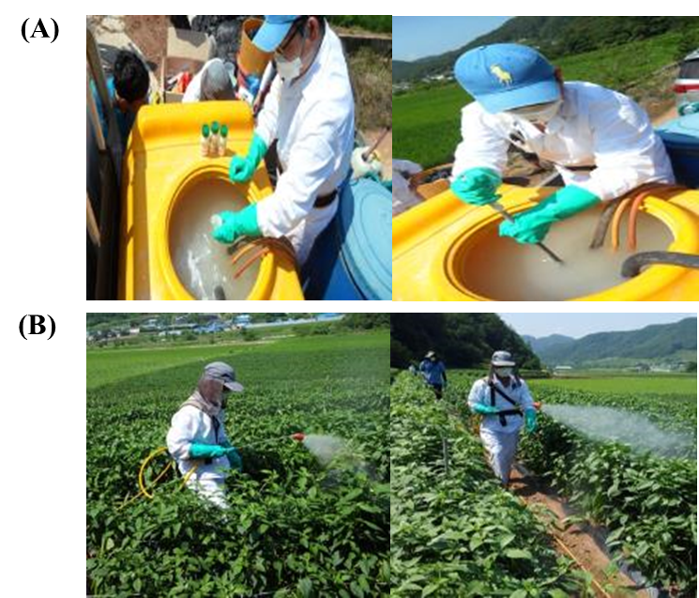
Fig. S1. Exposure scenarios of mix/load (A) and application (B).

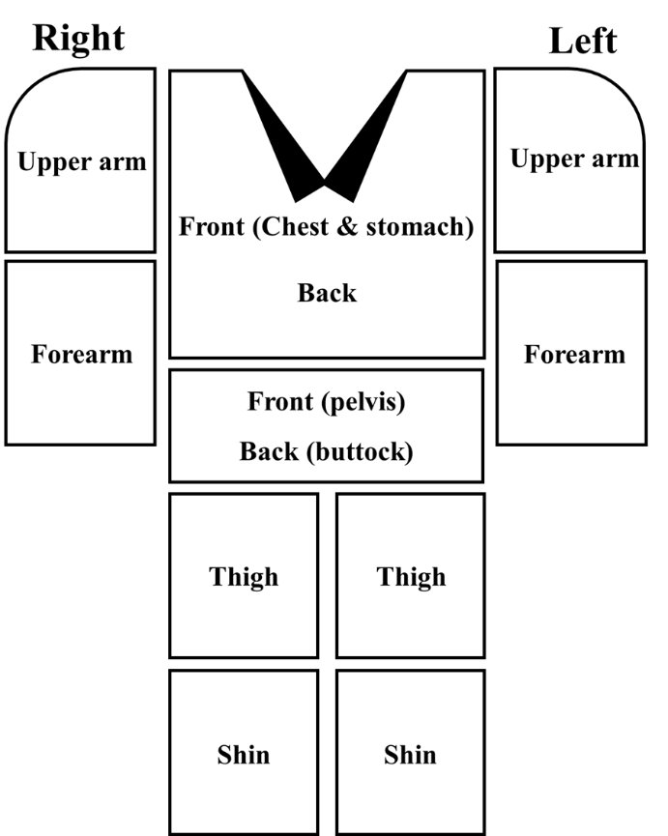
Fig S2. Sampling of agricultural workers clothing (outer and inner) for the calculated exposure amount by part of the body.

