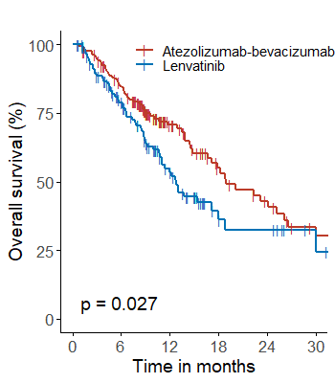
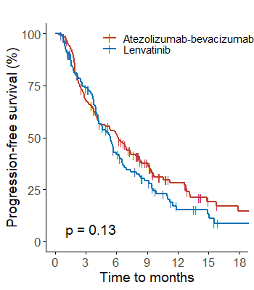
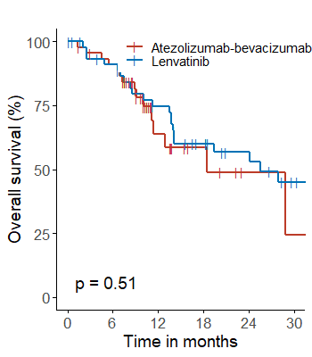
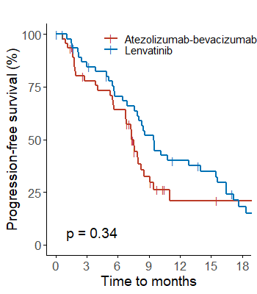
Viral etiology

a
Non-viral etiology

b

Supplementary Fig. 1. Kaplan–Meier curves of progression-free survival and overall survival for patients treated with atezolizumab-bevacizumab and lenvatinib according to the etiology of hepatocellular carcinoma. (a) Viral etiology and (b) non-viral etiology.

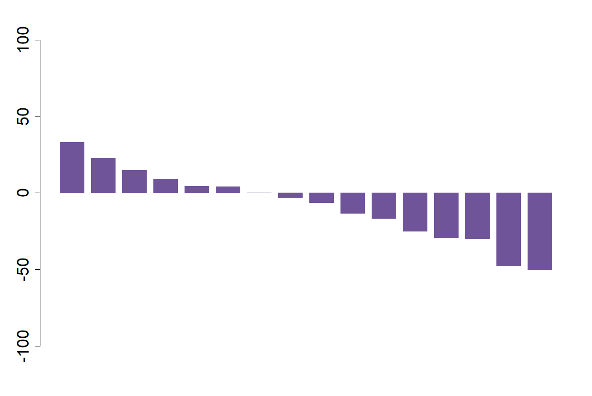
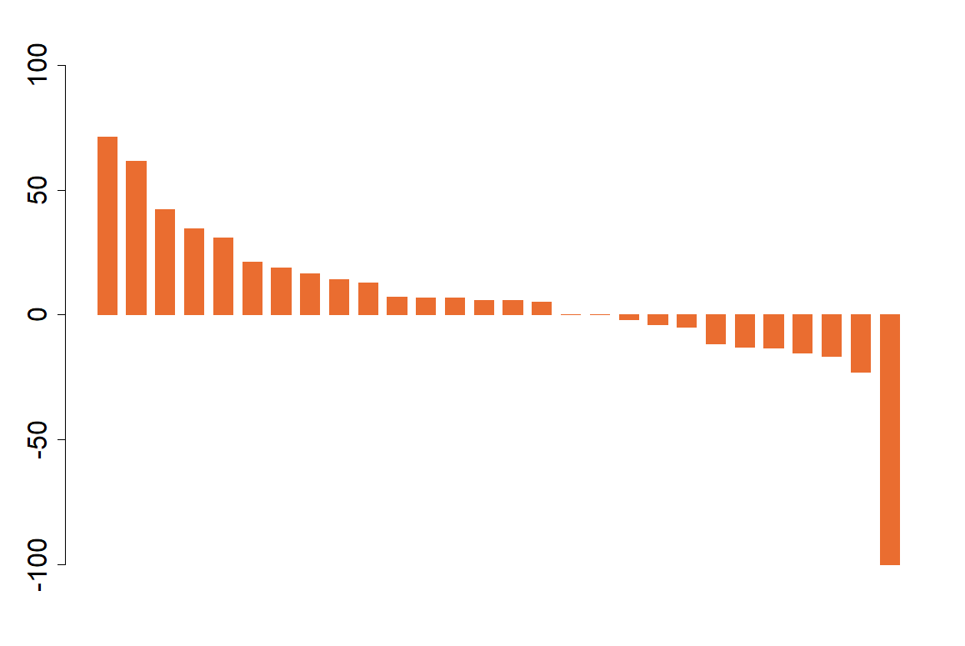
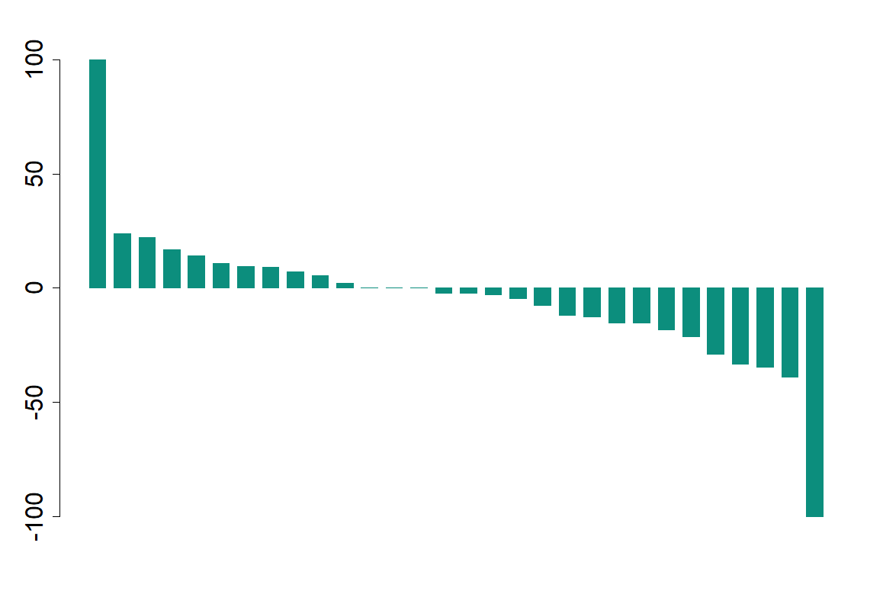
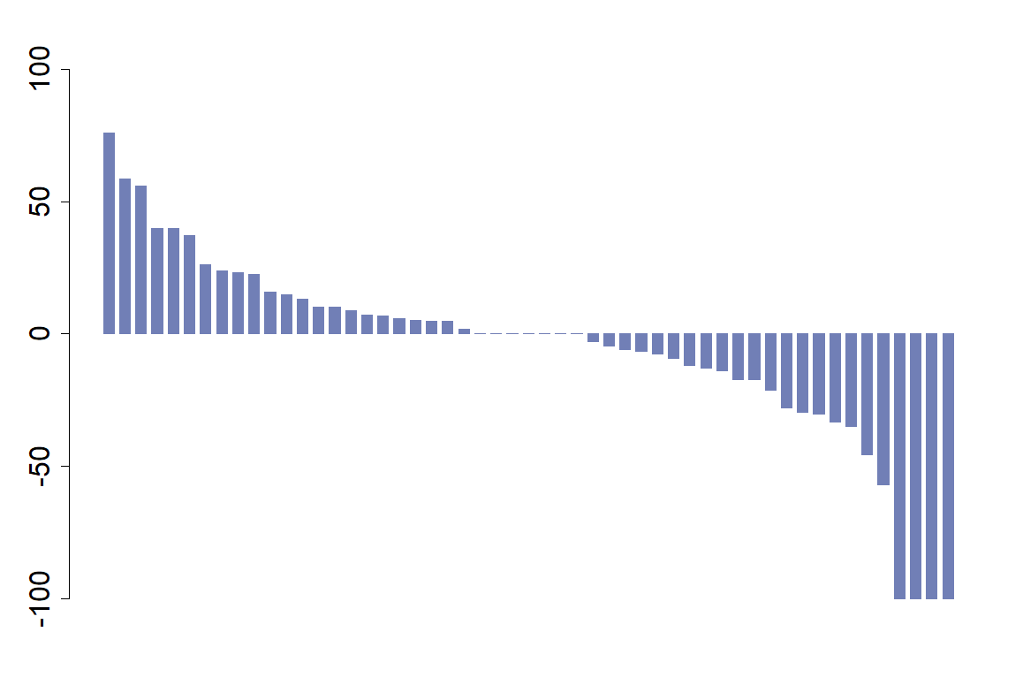
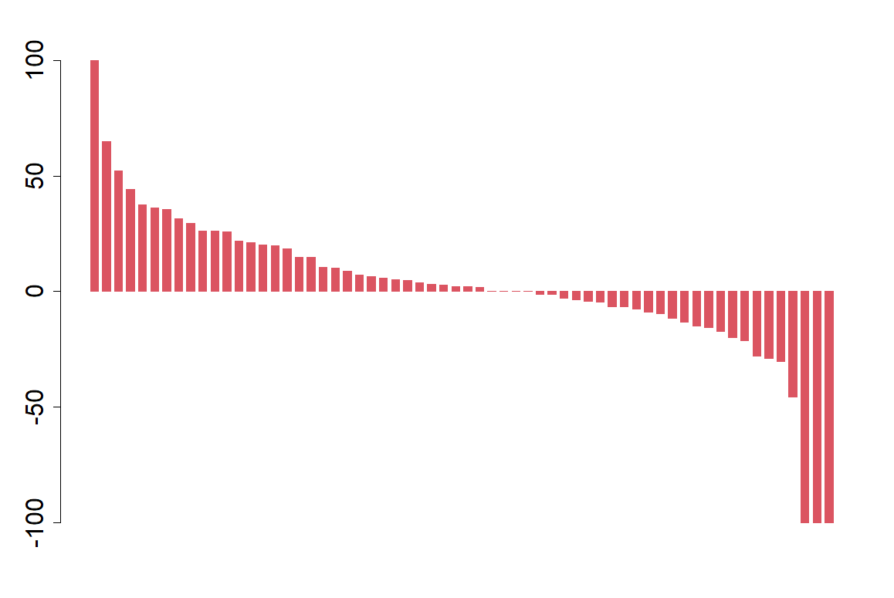
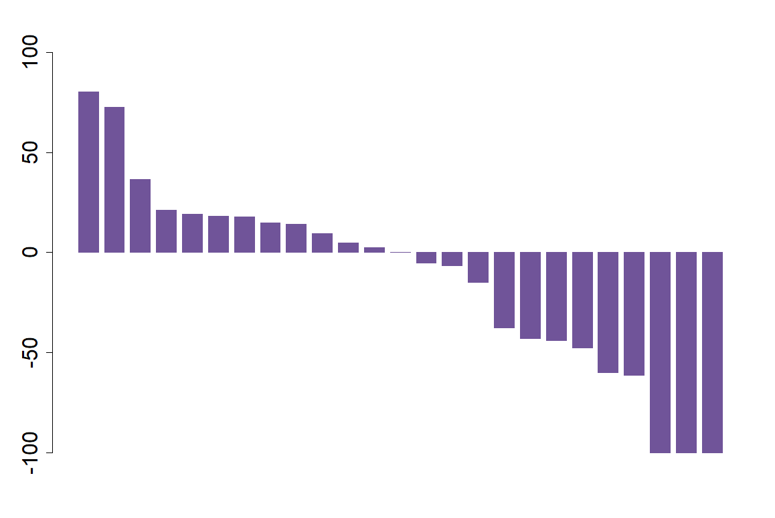
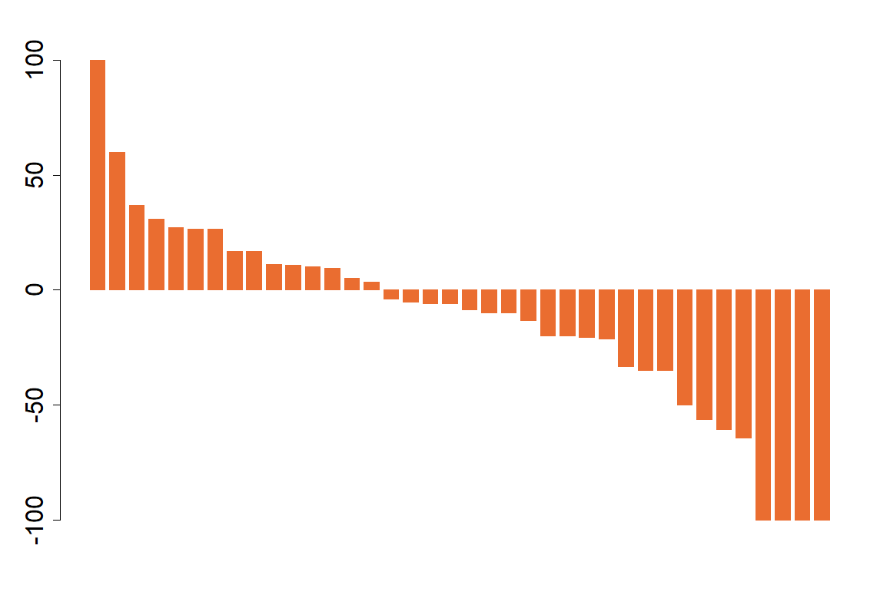
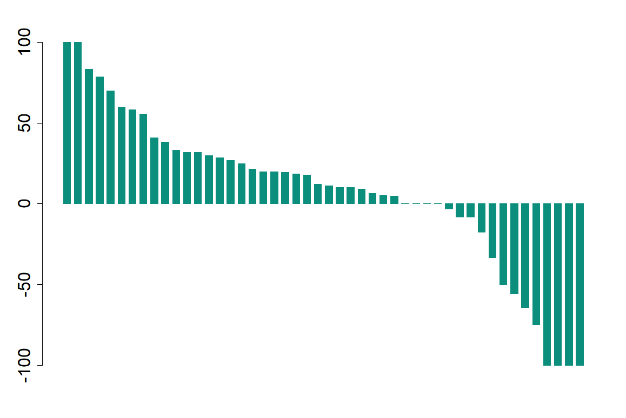
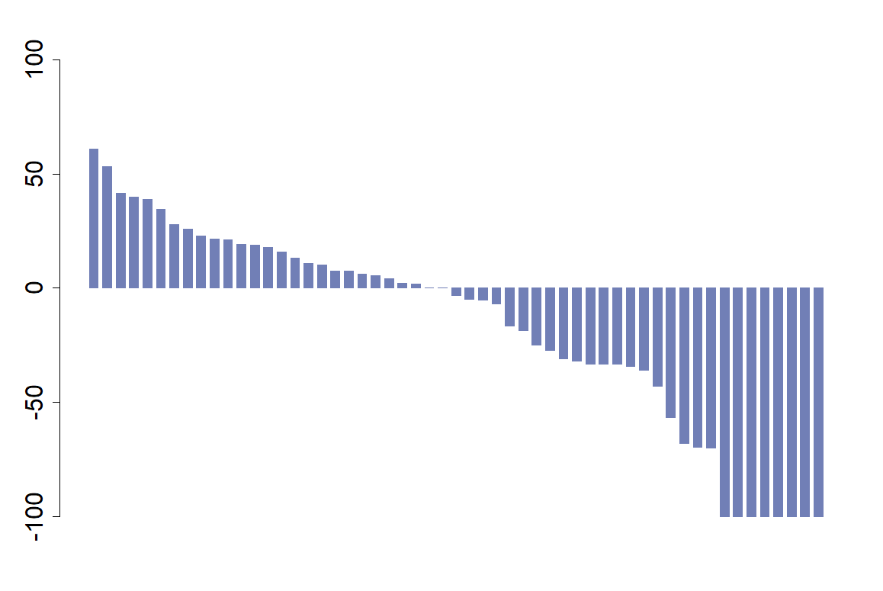
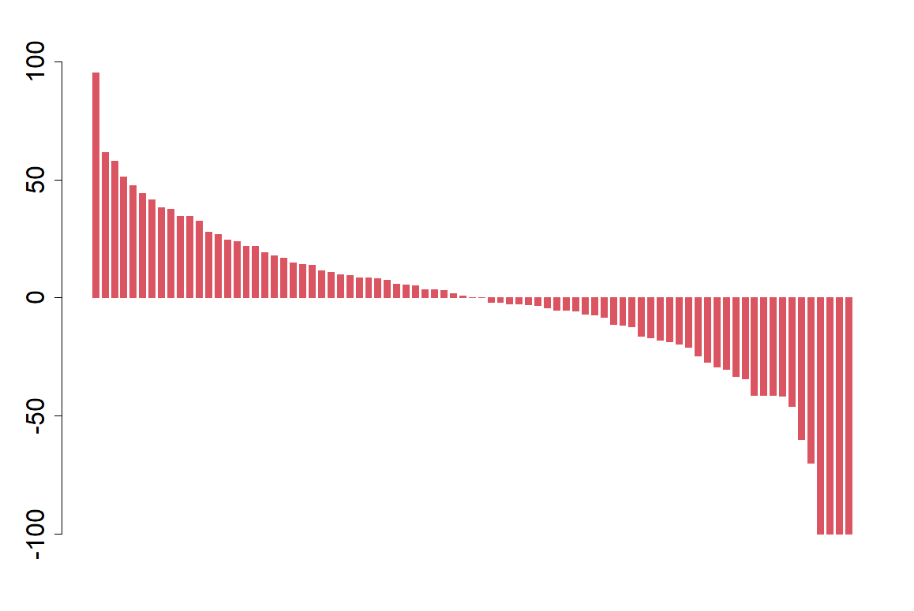
Lenvatinib
Changes in target lesions from baseline, %
Changes in target lesions from baseline, %
Changes in target lesions from baseline, %
Changes in target lesions from baseline, %
Changes in target lesions from baseline, %
Lung
Intra-abdomen
Liver (size method)
Liver (enhancement method)
Lymph node
Atezolizumab-bevacizumab
Changes in target lesions from baseline, %
Changes in target lesions from baseline, %
Changes in target lesions from baseline, %
Changes in target lesions from baseline, %
Changes in target lesions from baseline, %
Liver (size method)
Liver (enhancement method)
Lung
Lymph node
Intra-abdomen

b
a
Supplementary Fig. 2. Comparison of organ-specific response evaluation of patients with a viral etiology. (a) Atezolizumab-bevacizumab and (b) lenvatinib.


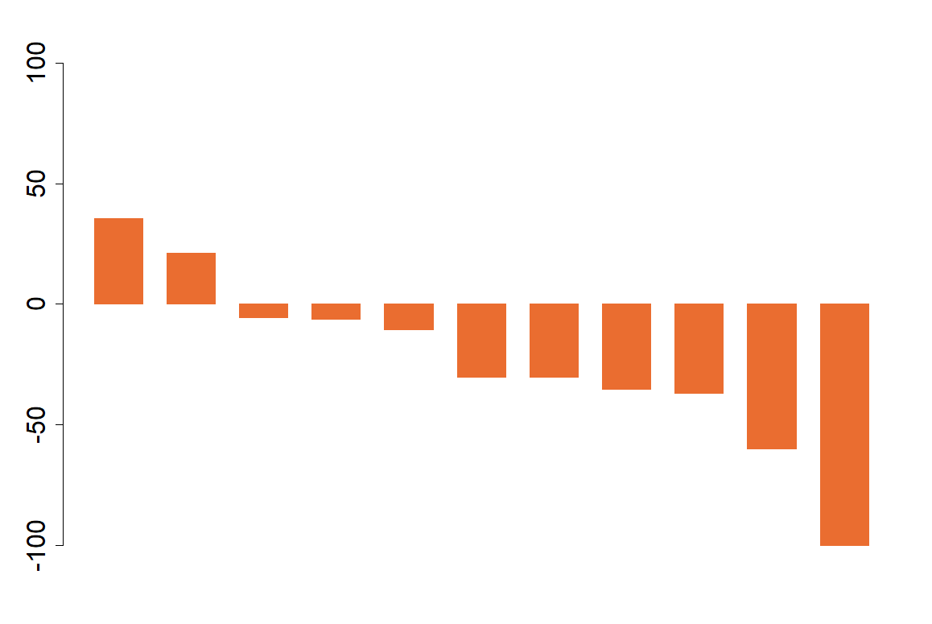
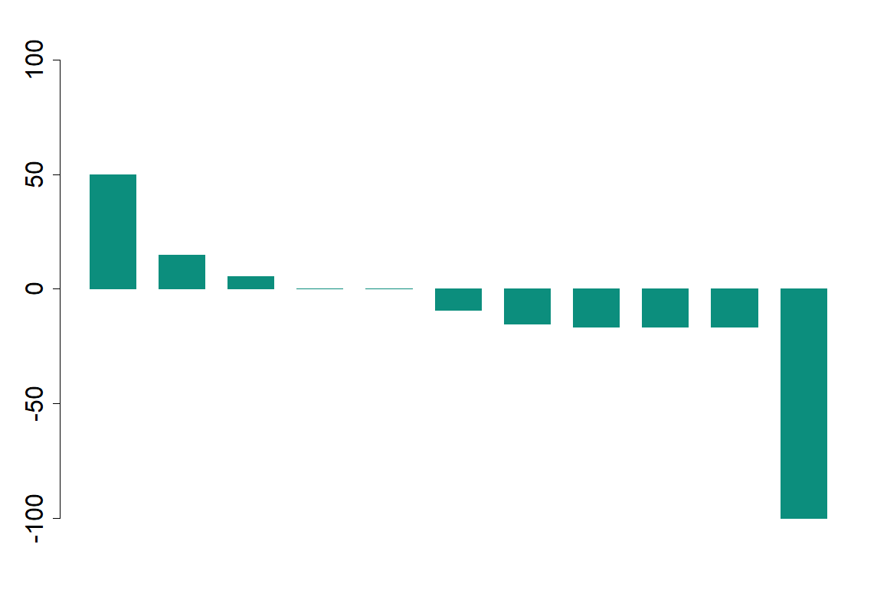
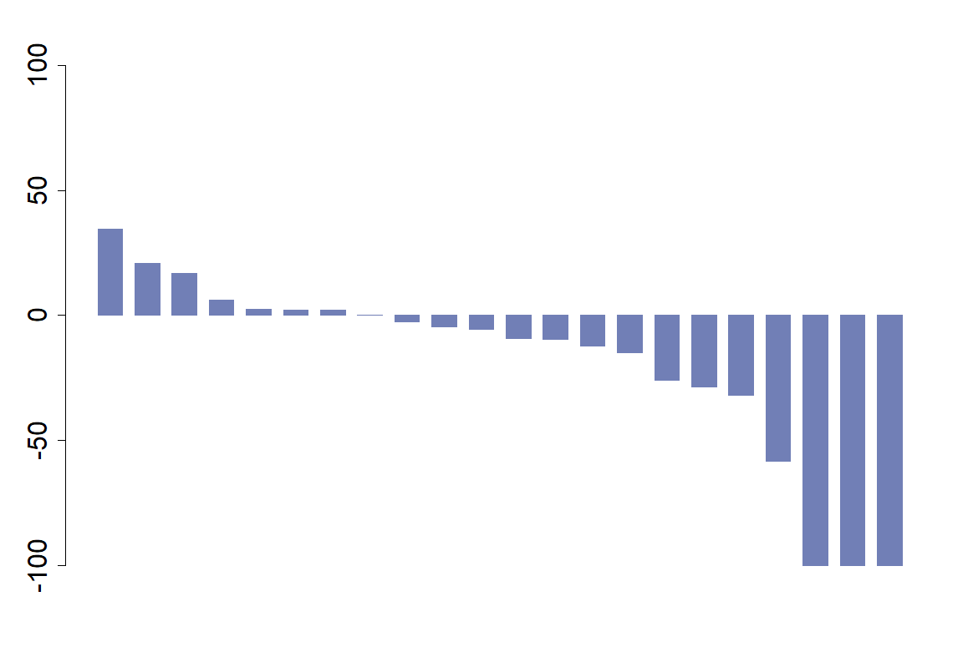
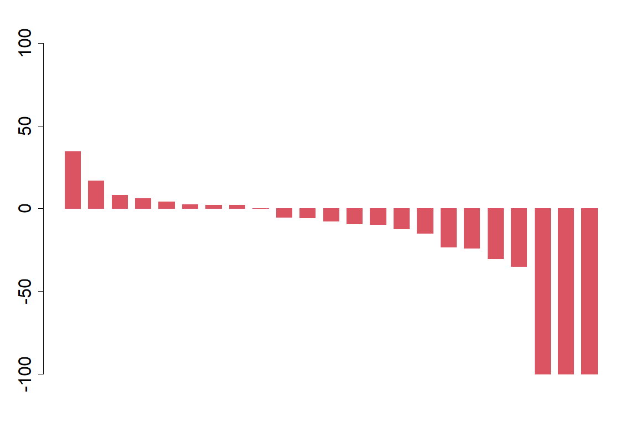
Lenvatinib
Changes in target lesions from baseline, %
Changes in target lesions from baseline, %
Changes in target lesions from baseline, %
Changes in target lesions from baseline, %
Changes in target lesions from baseline, %
Lung
Intra-abdomen
Liver (size method)
Liver (enhancement method)
Lymph node
Atezolizumab-bevacizumab
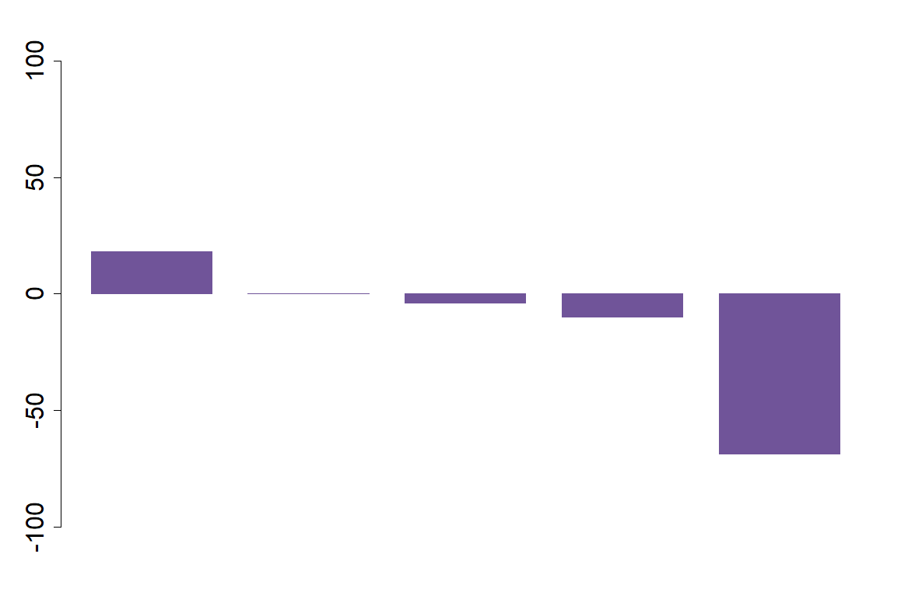
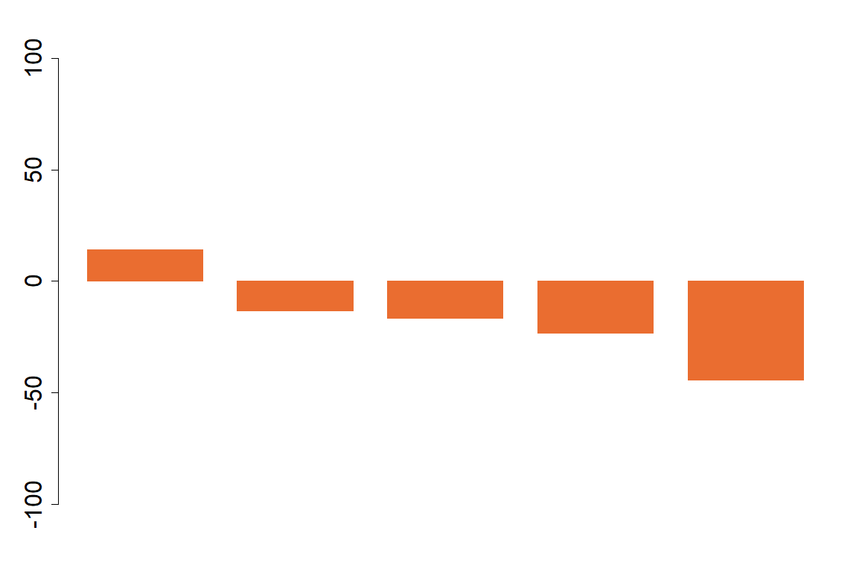
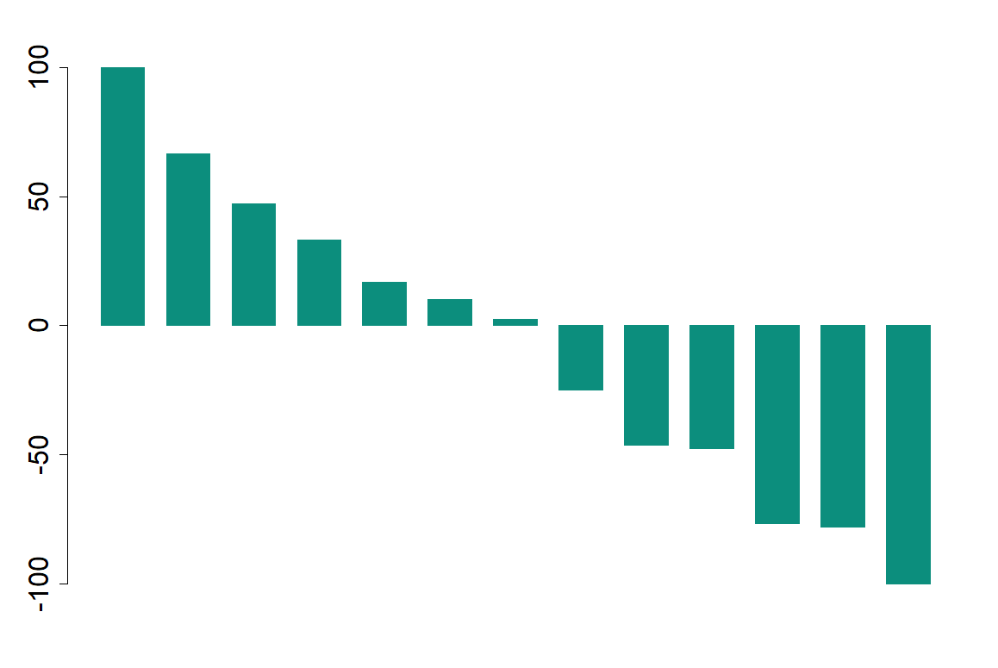
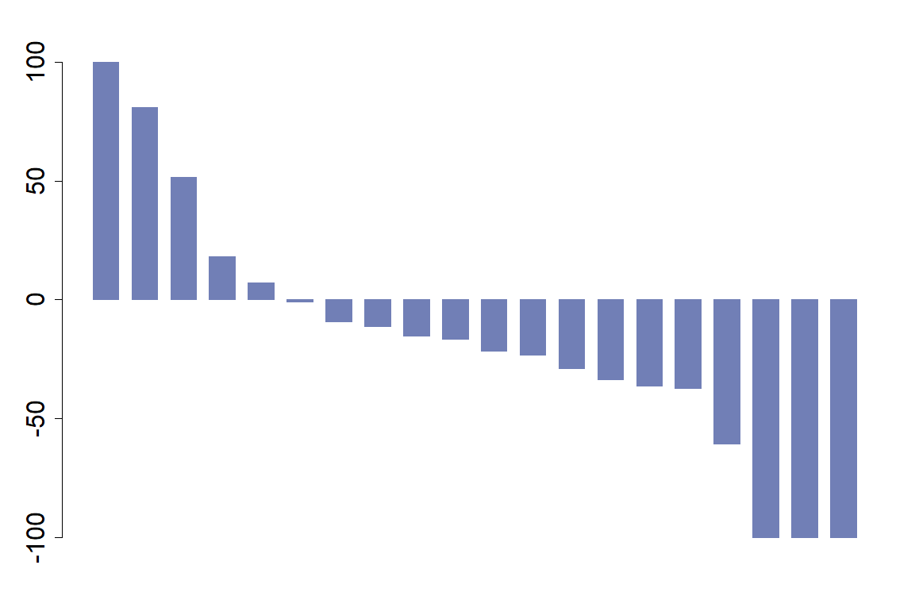
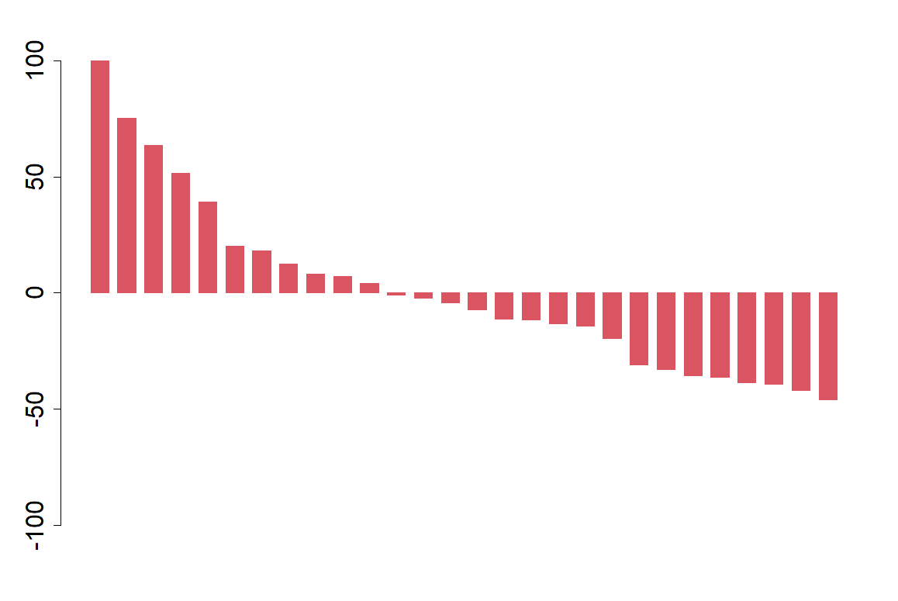
Changes in target lesions from baseline, %
Changes in target lesions from baseline, %
Changes in target lesions from baseline, %
Changes in target lesions from baseline, %
Changes in target lesions from baseline, %
Liver (size method)
Liver (enhancement method)
Lung
Lymph node
Intra-abdomen

a
b

Supplementary Fig. 3. Comparison of organ-specific response evaluation of patients with a non-viral etiology. (a) Atezolizumab-bevacizumab and (b) lenvatinib.

