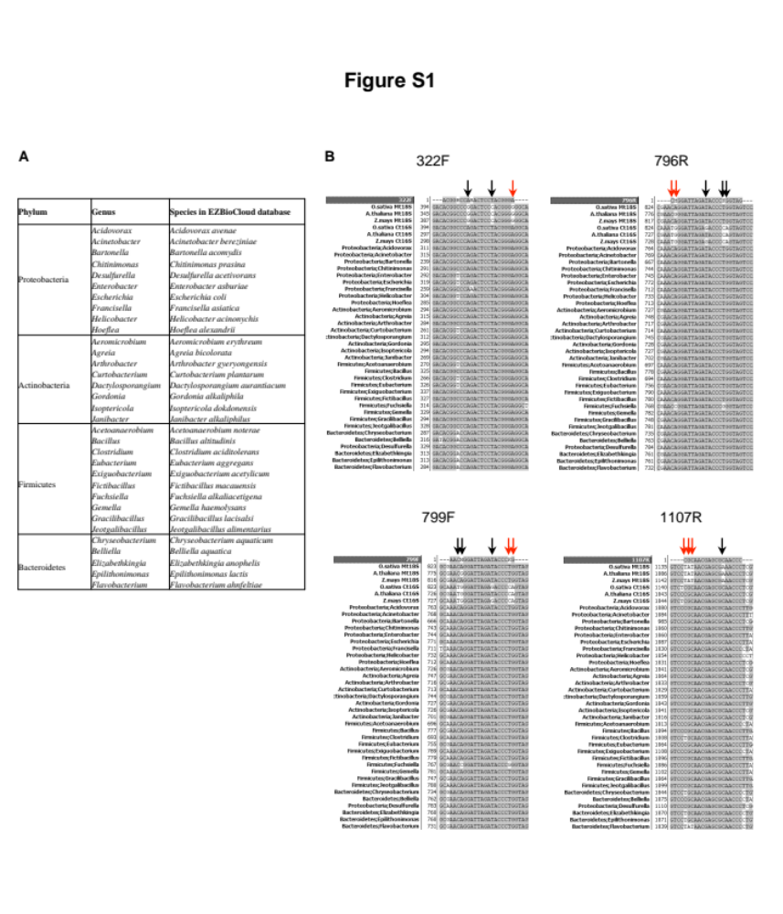
Figure S1. Primer design for plant DNA-free amplification of bacterial 16S. A. Bacterial species whose 16S regions were aligned to design sequencing primers. B. Alignment of designed primers and bacterial 16S, plant Mt18S, and Ct16S sequences. Arrows indicate bases that mismatch to plant Mt18S or Ct16S. Red arrow(s) indicate mismatched base or adjacent mismatches located at 3′ end. H=A/T/C, V=G/A/C, W=A/T, R=A/G, M=A/C, K=G/T, Y=C/T.
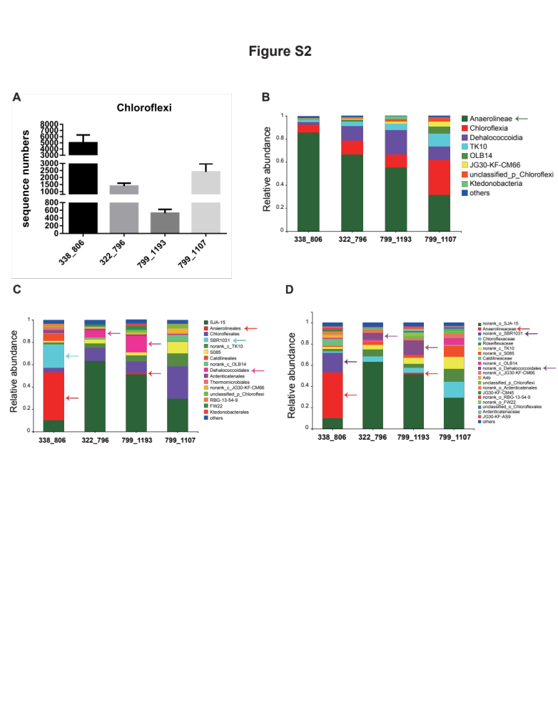
Figure S2. Differences in detection of phylum Chloroflexi among four primer pairs. A. Number of Chloroflexi sequences amplified by four primer pairs. B–D. Community composition of Chloroflexi deciphered by four primer pairs at class (B), order (C) and family (D) levels. Taxa with relative abundance >1% are shown. Arrows indicate taxa that were differentially amplified by the four primer sets.
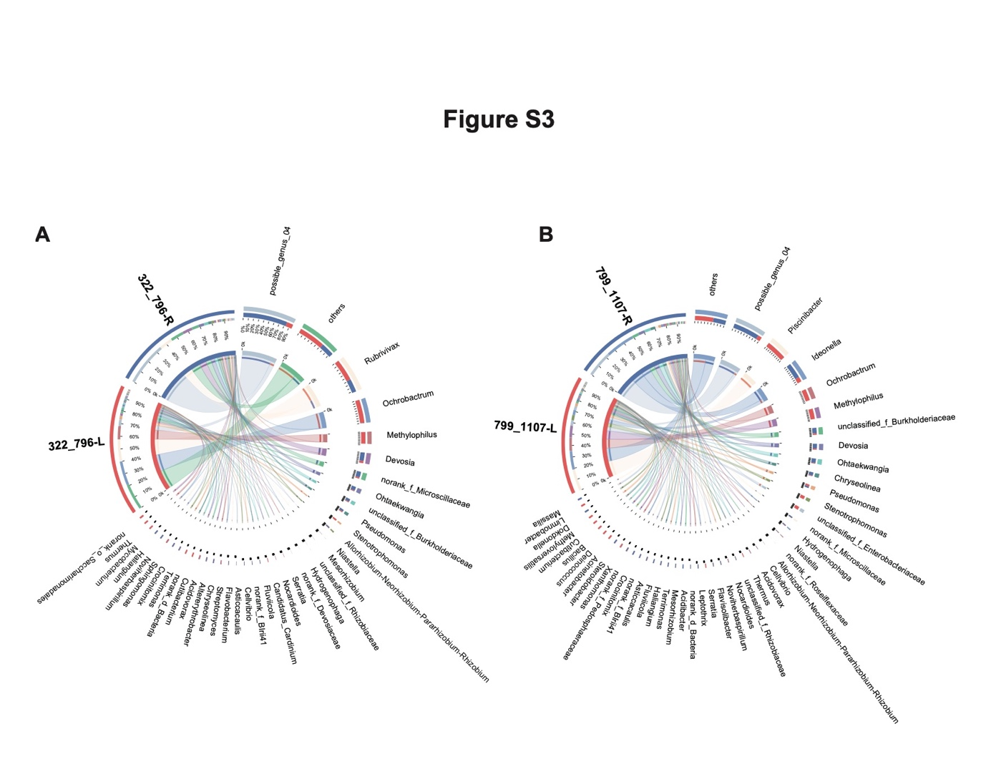
Figure S3. Composition of rice root and leaf endo-bacteriomes at the genus level. Composition of endo-bacteriomes at genus level as determined using 322F-796R (A) and 799F-1107R (B). Genera with relative abundance >0.5% are shown.
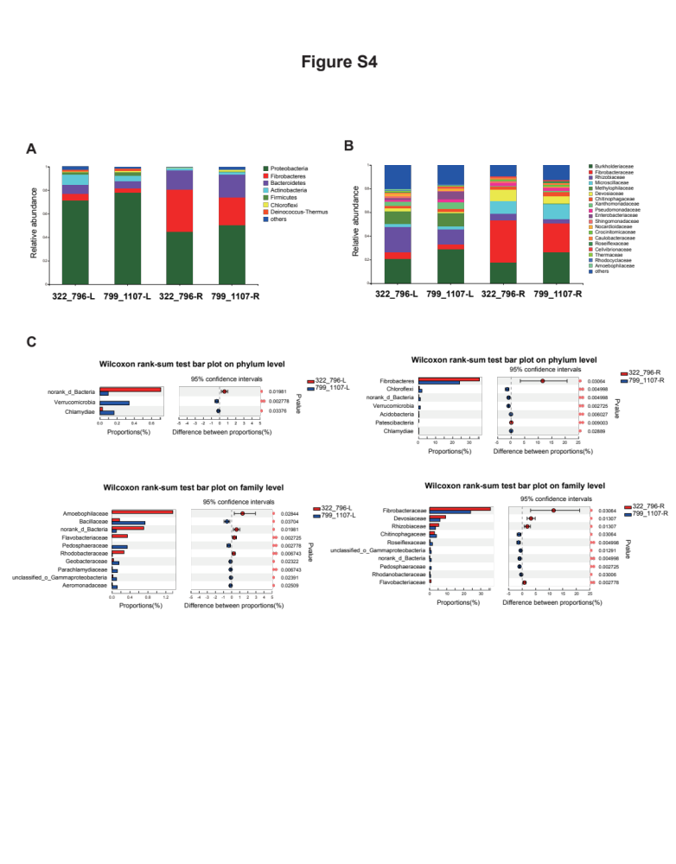
Figure S4. Endophytic leaf and root bacteriomes as determined using 322F/796R and 799F/1107R. A&B. Relative abundances (Mt18S removed) determined using two different primer sets. A. Results at phylum level. B. Results at family level. Taxa with relative abundance >0.5% are shown. C. Wilcoxon rank-sum test bar plot at phylum or family levels. *, p<0.05, **, p<0.01. R and L, root and leaf endo-bacteriome, respectively.
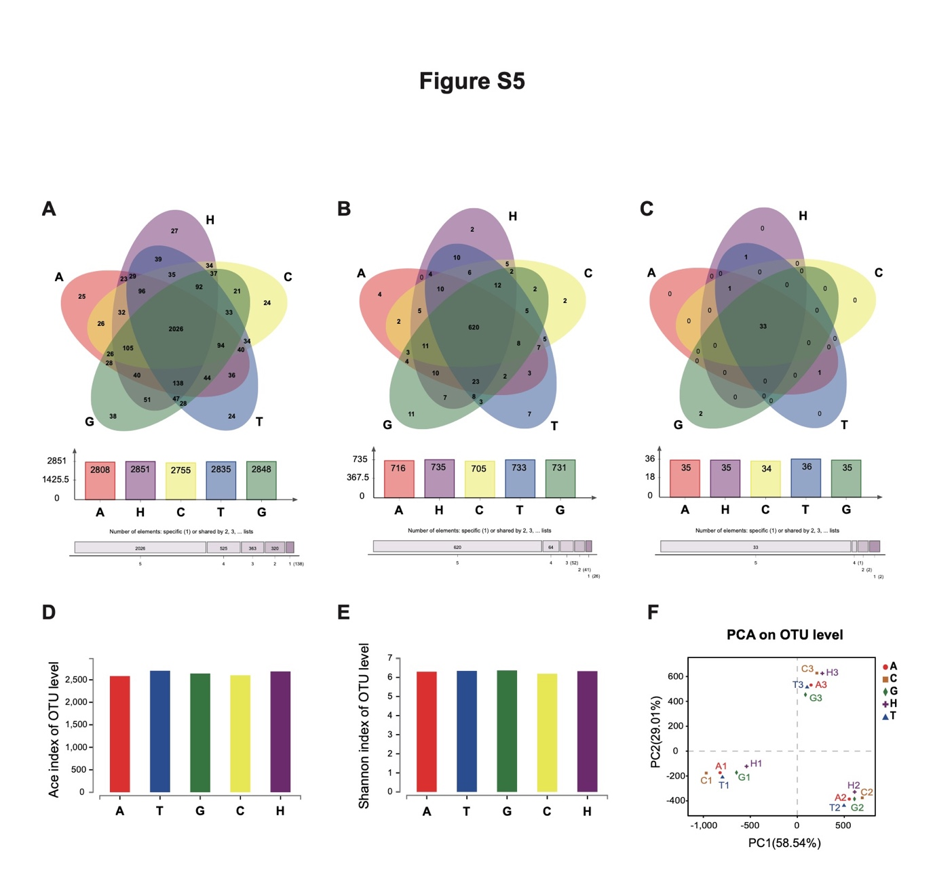
Figure S5. Experimental comparison of 322F/796R and 322F-Dr/796Rs using planting soil microbiota. A–-C. Venn diagrams at OTU (A), genus (B), and phylum (C) levels. Different colors represent different primer set groups. Overlaps represent common taxa between groups; non-overlapping portions represent unique taxa in each group. D–E. Alpha diversity indices of different groups (322F-796R and 322F-Dr/796Rs) at OTU level. Each set of sample-type data was calculated from three repeats. F. PCA showing that all five different primer sets, when applied to the same planting soil sample (three samples were sequenced), generated similar results for microbial community structure. G, 322F/796R; A, 322F-A/796R; T, 322F-T/796R; C, 322F-C/796R; H, 322F-H/796R.

