Supplement
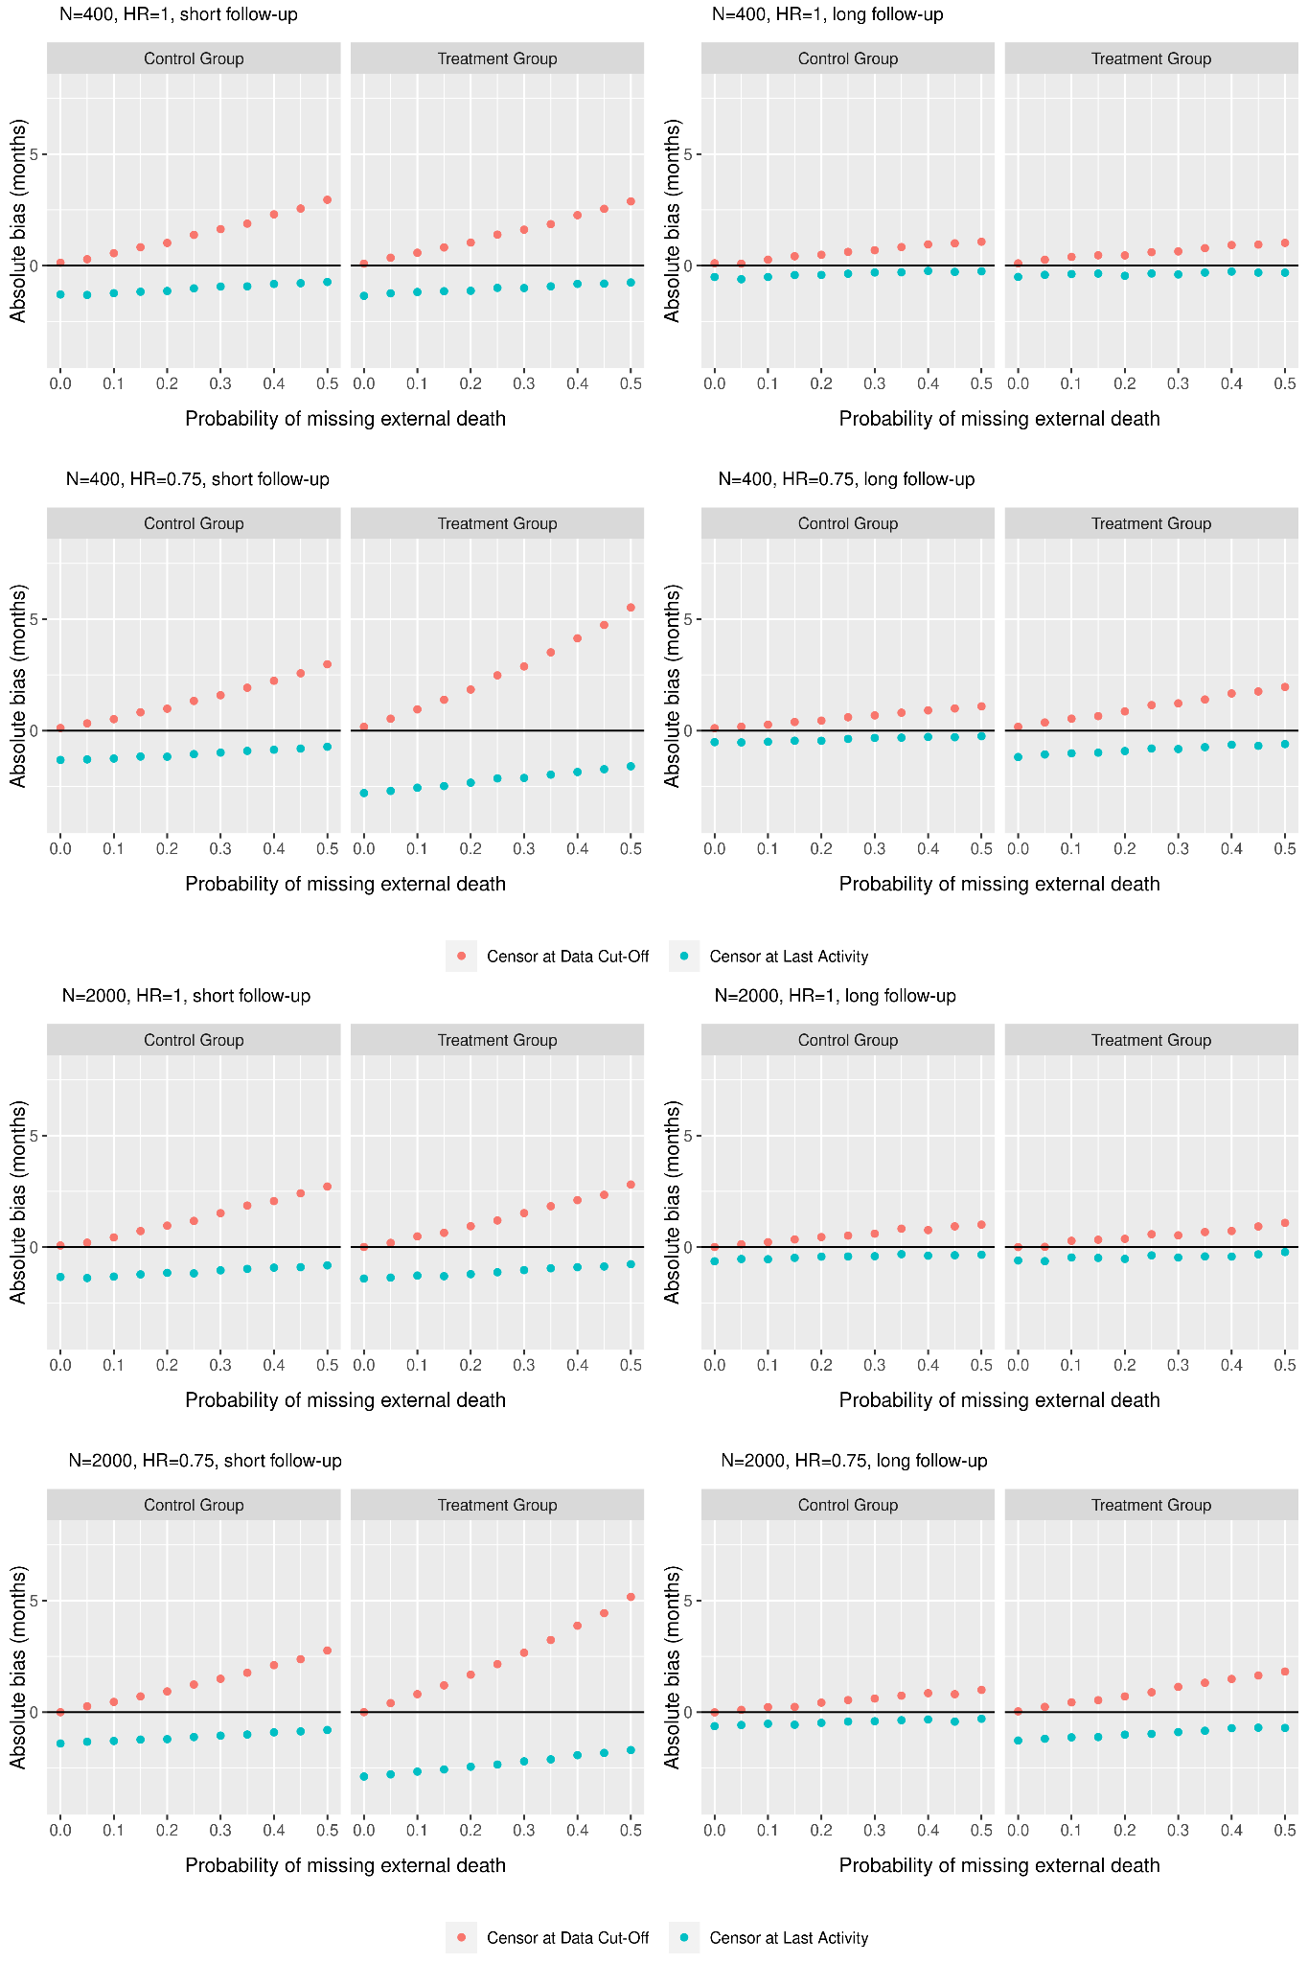
Appendix Figure 1a. Bias of median OS comparing the primary and sensitivity analyses
Appendix Figure 1b. Coverage of median OS comparing the primary and sensitivity analyses
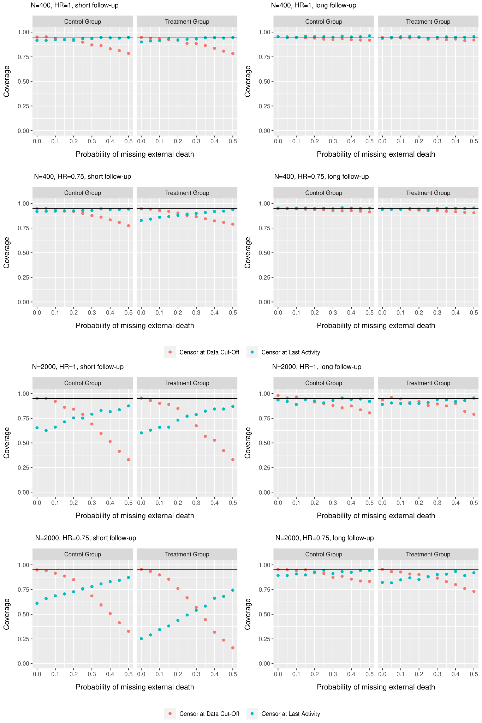
Appendix Figure 1c. Variance of median OS comparing the primary and sensitivity analyses
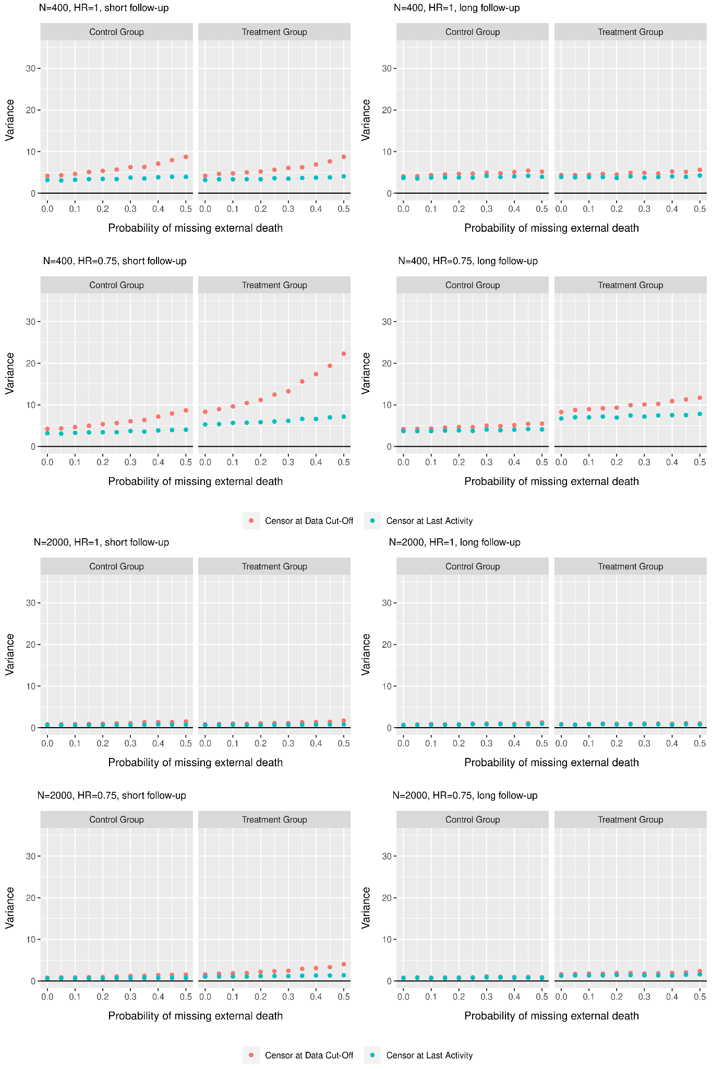

Appendix 2a. Bias of HR comparing the primary and sensitivity analyses
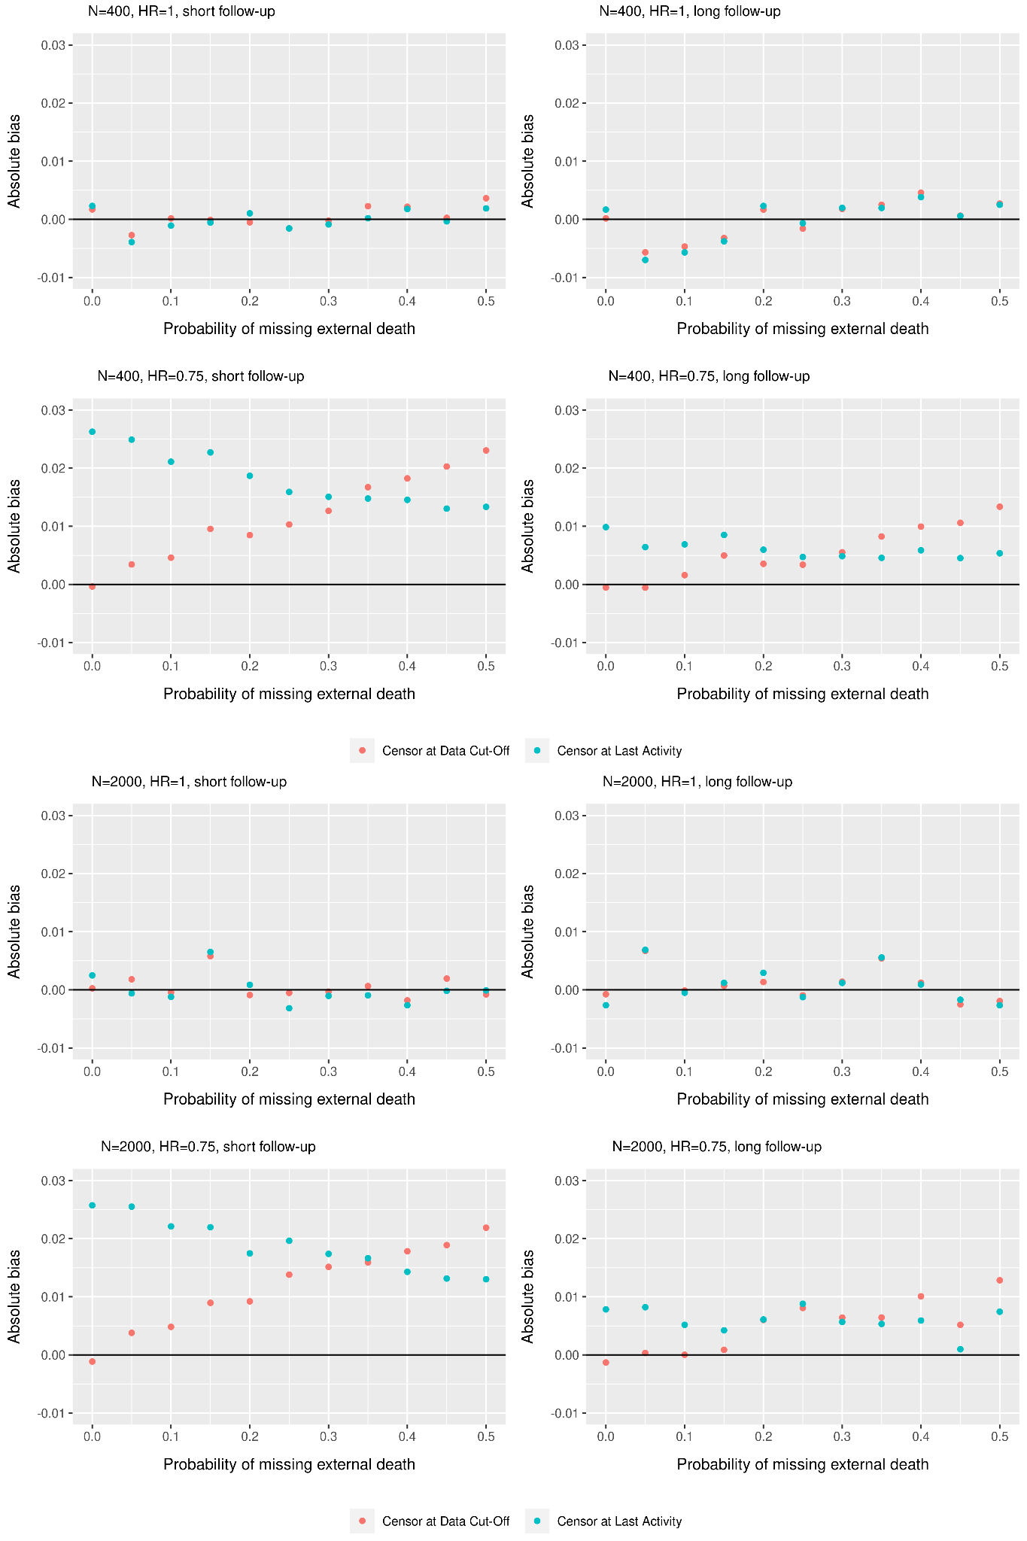
Appendix 2b. Rejection rate of HR comparing the primary and sensitivity analyses
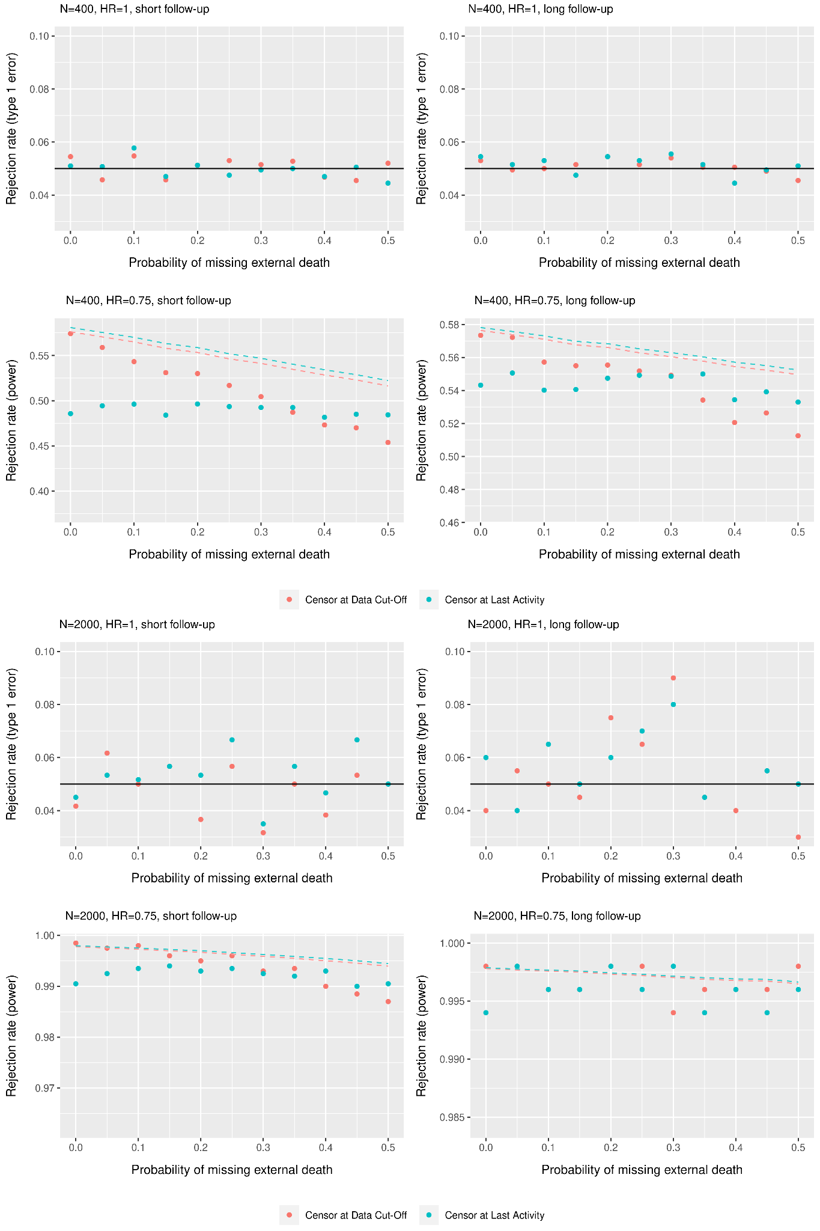
Appendix Figure 2c. Coverage of HR comparing the primary and sensitivity analyses
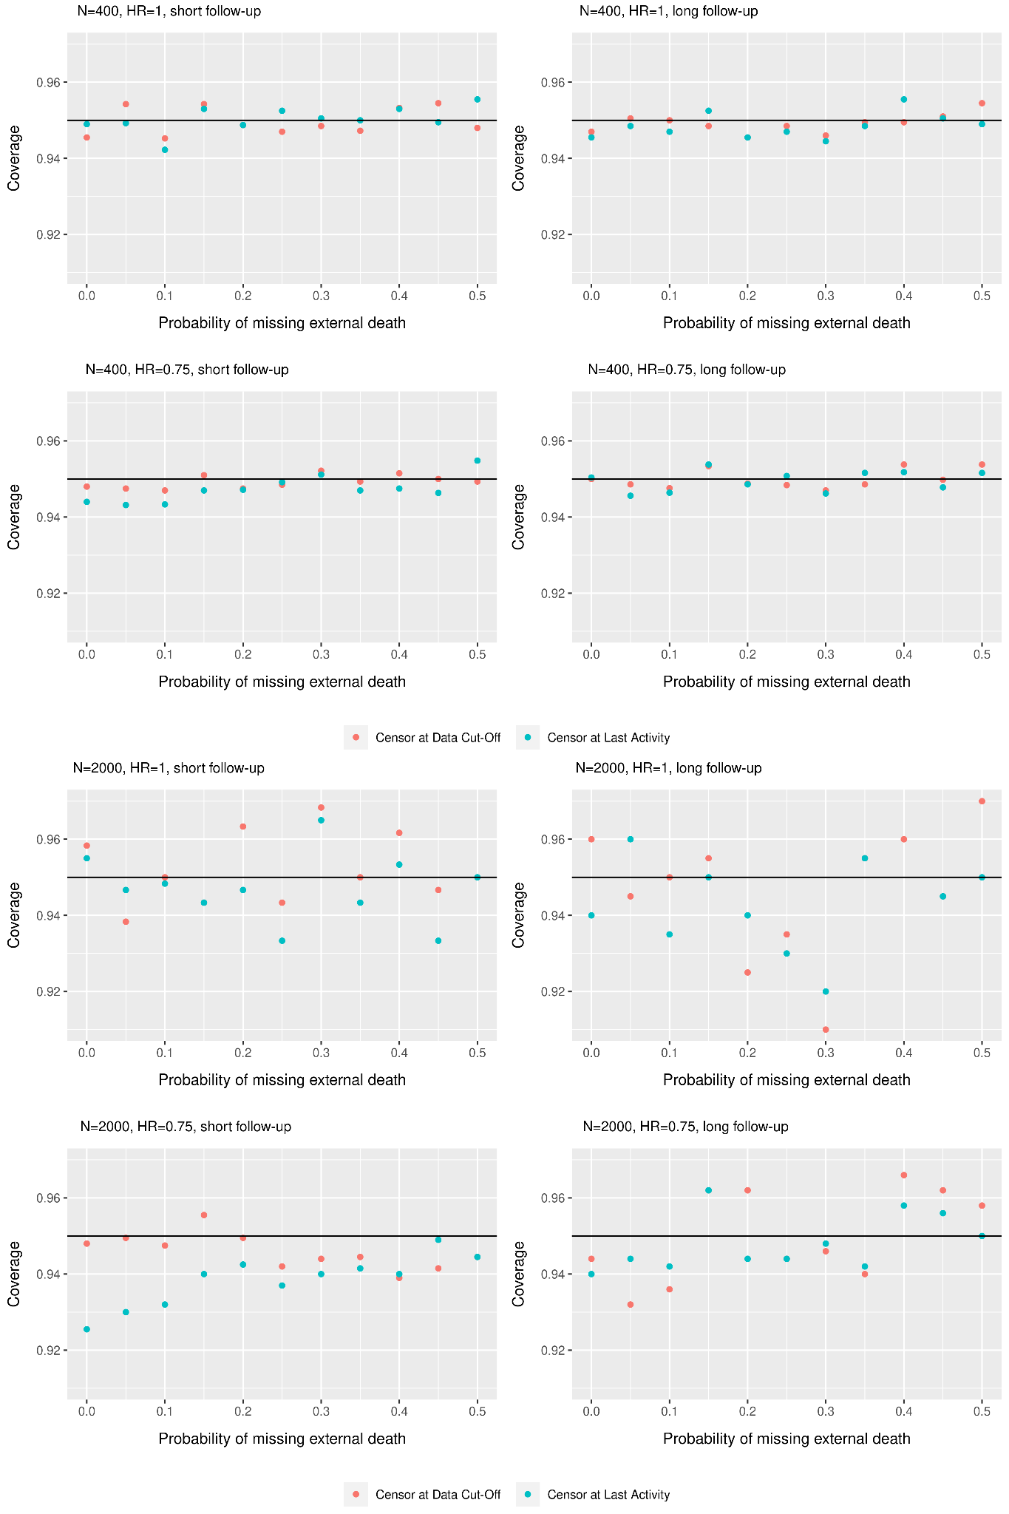
Figure 2d. Variance of HR comparing the primary and sensitivity analyses
