SUPPLEMENTARY INFORMATION

Supplementary Table 1: Demographic features and COVID-19 vaccination details of healthy adult controls

Supplementary Table 2: Clinical, demographic and laboratory features of children included in the Transcriptomic Cohort.

Supplementary Tables 3: Clinical characteristics of patients included in the mass cytometry experiments.

Supplementary Tables 4: Variance in data in Immunophenotyping of peripheral blood by MOFA Factor, and contribution to the variance by the immune cell proportion data and the cell status/activity data.

Supplementary Table 5: Summary of supernatant cytokine analysis following cell stimulation experiments.

Supplementary Table 6. Clinical characteristics of patients and controls included in the cell stimulation mass cytometry experiment.

Supplementary Table 7. Strobe Checklist

Supplementary Figure 1: Upset plot visualizing counts of patients/controls across different assays.

Supplementary Figure 2. Mass cytometry methods

Supplementary Figure 3. MOFA of immune features from immunophenotyping shows differences between disease groups and key factors of protein expression and cell proportion features in acute (T1) disease and over the trajectory of illness.

Supplementary Figure 4: K-means clustering analysis: effects of immunomodulatory treatment on supernatant cytokines.

Supplementary Figure 5: Supernatant cytokine analysis 1: interferons

Supplementary Figure 6: Supernatant cytokine analysis 2: remaining cytokines

Supplementary Figure 7. Supernatant cytokine sub-analysis of MIS-C T1 by clusters identified on mass cytometry.

Supplementary Figure 8. Heatmap summarising mass cytometry results of stimulated samples

Supplementary Table 1: Demographic features and COVID-19 vaccination details of healthy adult controls

Participant ID | Sex | Age (years) | Self-reported ethnicity | Date of sample | COVID-19 vaccine received | Date of vaccination | Dose of last vaccine prior to sampling
Healthy adult control 1 | Male | > 21 | North/Mid/East European | 06/07/2021 | mRNA Vaccine BNT162b2 | 10/03/2021 | Second
Healthy adult control 2 | Female | > 21 | North/Mid/East European | 06/07/2021 | mRNA Vaccine BNT162b3 | 21/04/2021 | Second
Healthy adult control 3 | Female | > 21 | North/Mid/East European | 06/07/2021 | mRNA Vaccine BNT162b4 | 04/03/2021 | Second
Healthy adult control 4 | Female | > 21 | South Asian | 06/07/2021 | mRNA Vaccine BNT162b5 | 07/04/2021 | Second
Healthy adult control 5 | Female | > 21 | North/Mid/East European | 13/07/2021 | mRNA Vaccine BNT162b6 | 13/04/2021 | Second
Healthy adult control 6 | Male | > 21 | North/Mid/East European | 13/07/2021 | mRNA Vaccine BNT162b7 | 16/03/2021 | Second
Healthy adult control 7 | Male | > 21 | North/Mid/East European | 13/07/2021 | Non-replicating viral vector vaccine AZD1222 (ChAdOx1) | 20/05/2021 | Second
Healthy adult control 8 | Male | > 21 | African - other | 13/07/2021 | mRNA Vaccine BNT162b4 | 31/03/2021 | Second
Healthy adult control 9 | Female | > 21 | North/Mid/East European | 13/07/2021 | mRNA Vaccine BNT162b4 | 01/07/2021 | Second
Healthy adult control 10 | Female | > 21 | North/Mid/East European | 14/07/2021 | mRNA Vaccine BNT162b4 | 20/03/2021 | Second
Healthy adult control 11 | Male | > 21 | South American - other | 14/07/2021 | mRNA Vaccine BNT162b4 | 12/05/2021 | Second
Healthy adult control 12 | Male | > 21 | North/Mid/East European | 15/07/2021 | mRNA Vaccine BNT162b4
Healthy adult control 13 | Male | > 21 | North/Mid/East European | 22/07/2021 | mRNA Vaccine BNT162b4 | 10/03/2021 | Second
Healthy adult control 14 | Male | > 21 | North/Mid/East European | 22/07/2021 | Non-replicating viral vector vaccine AZD1222 (ChAdOx1) | 24/06/2021 | Second
Healthy adult control 15 | Female | > 21 | North/Mid/East European | 03/02/2021 | mRNA Vaccine BNT162b4 | 04/01/2021 | First
Healthy adult control 16 | Female | > 21 | North/Mid/East European | 05/02/2021 | mRNA Vaccine BNT162b4 | 01/01/2021 | First
Healthy adult control 17 | Female | > 21 | East Asian | 06/10/2021 | mRNA Vaccine BNT162b4 | 19/03/2021 | Second
Healthy adult control 18 | Female | > 21 | North/Mid/East European | 06/10/2021 | mRNA Vaccine BNT162b4 | 22/03/2021 | Second
Healthy adult control 19 | Male | > 21 | South American - other | 06/10/2021 | mRNA Vaccine BNT162b4 | 26/08/2021 | Second
Healthy adult control 20 | Female | > 21 | North/Mid/East European | 06/10/2021 | mRNA Vaccine BNT162b4 | 10/04/2021 | Second
Healthy adult control 21 | Female | > 21 | North/Mid/East European | 26/11/2021 | mRNA Vaccine BNT162b4 | 07/10/2021 | Booster
Healthy adult control 22 | Male | > 21 | North/Mid/East European | 26/11/2021 | mRNA Vaccine BNT162b4 | 02/10/2021 | Booster
Healthy adult control 23 | Male | > 21 | South Asian | 26/11/2021 | mRNA Vaccine BNT162b4 | 04/05/2021 | Second
Healthy adult control 24 | Female | > 21 | East Asian | 01/12/2021 | mRNA Vaccine BNT162b4 | 17/11/2021 | Booster
Healthy adult control 25 | Male | > 21 | North/Mid/East European | 01/12/2021 | mRNA Vaccine BNT162b4 | 03/04/2021 | First
Healthy adult control 26 | Male | > 21 | Middle Eastern - Arab | 01/12/2021 | mRNA Vaccine BNT162b4 | 11/07/2021 | Second
Healthy adult control 27 | Male | > 21 | North/Mid/East European | 01/12/2021 | mRNA Vaccine BNT162b4 | > 14 days prior to sampling | Second
Supplementary Table 2: Clinical, demographic and laboratory features of children included in the Transcriptomic Cohort. Healthy controls were used for normalisation of the data but not for differential expression analysis or feature selection.

 | ^{MIS-C (n=38)} | ^{KD (n=136)} | ^{Viral (n=138)} | ^{Bacterial (n=188)} | ^{Healthy controls (n=134)}
^{Age in months} | ¹²⁶ ⁽⁶⁵⁻¹⁵¹⁾ | ³⁰ ⁽¹⁶⁻⁵²⁾ | ⁷ ⁽²⁻²⁰⁾ | ³⁸ ⁽¹¹⁻⁹⁶⁾ | ^{92 (29 – 154)}
^{Sex at birth (female, %)} | ^{13 (39%)} | ^{59 (43%)} | ^{45 (33%)} | ^{85 (45%)} | ^{63 (47%)}
^{Days since symptom onset} | ⁶ ⁽⁵⁻⁷⁾ | ⁶ ⁽⁵⁻⁸⁾ | ⁵ ⁽²⁻⁶⁾ | ² ⁽¹⁻⁴⁾ | ⁻
Required inotropic support (n, %) | ^{20 (52.6%)} | ^{2 (1.4%)} | ^{3 (2%)} | ^{50 (26.6%)} | ⁻
Required non-invasive ventilation (n, %) | ^{5 (13.2%)} | ^{2 (1.4%)} | ^{6 (4.3%)} | ^{46 (24%)} | ⁻
Required invasive ventilation (n, %) | ^{4 (10.5%)} | ⁰ | ^{7 (5.1%)} | ^{16 (8.5%)} | ⁻
^{Admitted to PICU (n, %)} | ^{23 (60.6%)} | ^{1 (0.7%)} | ^{25 (18%)} | ^{84 (44.7%)} | ⁻
^{White blood cells (109/L)} | ^{9.7 (8.1-11.5)} | ^{13.2 (10.4-18)} | ^{9.9 (6-14)} | ^{13.2 (8.1-20.6)} | ⁻
^{Neutrophils (109/L)} | ^{8.1 (4.5-11.0)} | ^{9.2 (6.3-11.5)} | ^{3.6 (1.8-6.5)} | ^{14.1 (6-47)} | ⁻
^{Lymphocytes (109/L)} | ^{1.2 (0.8-1.8)} | ^{2.8 (1.7-4.9)} | ^{4.7 (2.8-6.7)} | ^{2.8 (1.5-8.6)} | ⁻
^{Monocytes (109/L)} | ^{0.3 (0.2-0.4)} | ^{0.7 (0.5-1.1)} | ^{0.8 (0.5-1.4)} | ^{1.6 (0.7-4.8)} | ⁻
^{Platelets (109/L)} | ^{209 (144-300.5)} | ³⁴³ ⁽²⁵⁷⁻⁴²⁶⁾ | ³⁶⁵ ⁽²⁴⁵⁻⁵⁰⁹⁾ | ²⁴³ ⁽¹⁵⁷⁻³²⁹⁾ | ⁻
^{CRP (mg/L)} | ¹⁷³ ⁽⁹⁹⁻²⁵⁰⁾ | ⁷³ ⁽⁴³⁻¹⁶²⁾ | ^{13.2 (4.1-38)} | ^{116.8 (40.3-212)} | ⁻

Supplementary Table 3: Clinical characteristics of patients included in the mass cytometry experiment.

Characteristics | MIS-C | SBI | SVI | KD | HPC
n | 35 | 17 | 10 | 4 | 10
Age (years) (median, IQR) | 8.0 (2.6–13.3) | 6.4 (2.6–13.9) | 2.6 (1.4–10.1) | 0.8 (0.6–2.1) | 6.6 (5.1–10)
Female (n, %) | 14 (40%) | 5 (31%) | 7 (70%) | 1 (25%) | 4 (40%)
Self-reported ethnicity
Asian (n, %) | 5 (15%) | 1 (5.9%) | 1 (10%) | 1 (25%) | 0
Black (n, %) | 8 (24%) | 1 (5.9%) | 2 (20%) | 0 | 2 (20%)
Other (n, %) | 9 (26%) | 1 (5.9%) | 0 | 1 (25%) | 1 (10%)
White (n, %) | 12 (35%) | 14 (82%) | 7 (70%) | 2 (50%) | 7 (70%)
Comorbidity¹ | 4 (11%) | 7 (41%) | 1 (10%) | 1 (25%) | 0
Presenting clinical features
Gastrointestinal symptoms | 27 (77%) | 12 (71%) | 3 (30%) | 3 (75%) | –
Oral mucositis | 4 (11%) | 0 | 0 | 2 (50%) | –
Rash | 23 (66%) | 5 (29%) | 2 (20%) | 4 (100%) | –
Respiratory symptoms | 8 (23%) | 12 (71%) | 7 (70%) | 0 | –
Additional findings during admission
Maximum CRP concn (mg/l) (median, IQR) | 200 (143–270) | 197 (168–299) | 129 (67–150) | 111 (89–147) | –
Maximum neutrophil count (x10⁹/l) (median, IQR) | 13 (9.8–18) | 15 (9.0–20) | 8.8 (7.2–13) | 14 (11–16) | –
Minimum lymphocyte count (x10⁹/l) (median, IQR) | 0.6 (0.4–1.2) | 1.3 (0.6–2.9) | 1.0 (0.7–2.0) | 2.4 (1.7–3.2) | –
Coronary artery aneurysm (n, %) | 5 (14%) | 0 | 0 | 1 (25%) | –
Treatments during admission
Mechanical ventilation (n, %) | 3 (8.8%) | 8 (47%) | 8 (80%) | 0 | –
Vasoactive infusion (n, %) | 32 (94%) | 9 (56%) | 3 (3.3%) | 0 | –
Intravenous immunoglobulin | 12 (34%) | 2 (12%) | 0 | 4 (100%) | –
High dose corticosteroids | 33 (94%) | 1 (5.8%) | 0 | 3 (75%) | –
Monoclonal antibody therapy² | 8 (23%) | 0 | 0 | 0 | –
Outcome
PICU admission (n, %) | 34 (97%) | 16 (94%) | 9 (90%) | 0 | –
Hospital length of stay (days) (median, IQR) | 6.7 (5.5–8.2) | 8.7 (7.8–17) | 14 (7.4–28) | 6.7 (4.9–8.6) | –
In-hospital mortality (n, %) | 1 (2.9%) | 1 (5.9%) | 1 (10%) | 0 | –
Infections identified
SARS-CoV-2 PCR/antigen positive (n, %) | 1 (2.9%) | 0 | 3 (30%) | 0 | –
SARS-CoV-2 IgG antibody positive (n, %) | 33 (94%) | 0 | 3 (30%) | 0 | –
¹MIS-C: Minor neurological co-morbidities 2, respiratory 1, endocrinological 1; SBI: respiratory 2, cardiac 1, endocrinological 1, minor neurological 2, other genetic syndrome 1; SVI: other genetic syndrome 1; KD: renal 1 child. ²MIS-C: tocilizumab in 8 children.

Supplementary Table 4. Clinical characteristics of children within Cluster 1 and Cluster 2 as defined my immunophenotyping using mass cytometry data.

 | Cluster 1 | Cluster 2 | p
n | 29 (44%) | 37 (56%)
Disease group
MIS-C | 22 (76%) | 13 (35%) | 0.001
SBI | 4 (14%) | 13 (35%) | 0.087
SVI | 3 (10%) | 7 (19%) | 0.493
KD | 0 | 4 (11%) | 0.125
Age (years) (median, IQR) | 9.3 (4.9–14) | 5.4 (1.6–8.9) | <0.001
Female (n, %) | 12 (41%) | 15 (41%) | 1
Self-reported ethnicity
Asian (n, %) | 1 (3%) | 2 (5%) | 1
Black (n, %) | 5 (17%) | 5 (14%) | 0.738
Other (n, %) | 10 (34%) | 9 (24%) | 0.419
White (n, %) | 13 (45%) | 21 (57%) | 0.457
Additional findings during admission
Maximum CRP concn (mg/l) (median, IQR) | 209 (134–288) | 179 (124–220) | 0.392
Treatments during admission
Mechanical ventilation (n, %) | 7 (24%) | 9 (24%) | 1
Vasoactive infusion (n, %) | 19 (66%) | 15 (41%) | 0.051
Intravenous immunoglobulin (pre-T1 sampling) | 5 (17%) | 5 (14%) | 0.738
High dose corticosteroids (pre-T1 sampling) | 12 (41%) | 8 (22%) | 0.108
Monoclonal antibody therapy² (pre-T1 sampling) | 0 | 1 (3%) | 1
Outcome
PICU admission (n, %) | 23 (79%) | 25 (68%) | 0.405
Hospital length of stay (days) (median, IQR) | 6.8 (6.2–7.9) | 8.1 (5.5–10) | 0.413
p values between Cluster 1 and Cluster 2 calculated using Wilcoxon Rank Sum test for continuous variables and χ² test with Fisher's correction for proportions.

Supplementary Table 5: Summary of supernatant cytokine analysis following cell stimulation experiments. Median values by cohort and timepoint for baseline results and percentage change from baseline following stimulation with SARS-CoV-2 antigen and mitogen (phytohemagglutinin) are shown. Patients with Multisystem Inflammatory Syndrome in Children (MIS-C), Severe bacterial illness (SBI), Kawasaki disease (KD), Severe viral illness (SVI) and other inflammatory conditions at acute (TP1) and convalescence (TP3), as well as healthy paediatric controls and healthy COVID-19 vaccinated adults were included. The number of samples are indicated in the table for each result.

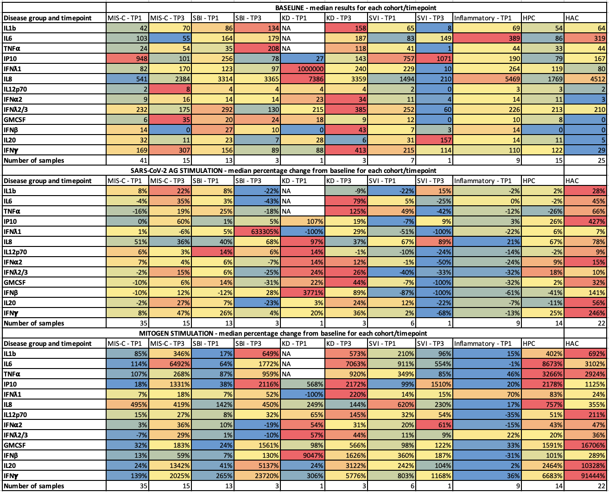

Supplementary Table 6: Clinical characteristics of patients and controls included in the cell stimulation mass cytometry experiment. Abbreviations: HPC, healthy pediatric controls.

 | MIS-C  (N = 12) | HPCs  (N = 3)
Age (years), median [IQR] | 6.0 [4.0 - 11] | 9.5 [6.0-12]
Male sex, n (%) | 8 (66.7%) | 2(66.7%)
Ethnicity
African/Caribbean | 6 (50.0%) | 0 (0%)
Asian | 2 (16.7%) | 0 (0%)
Caucasian | 3 (25.0%) | 3 (100%)
Mixed | 0 (0%) | 0 (0%)
Other/Not known | 1 (8.3%) | 0 (0%)
Maximum CRP (mg/L), median [IQR] | 220 [160 - 300] | -
Maximum Neutrophil count (x10⁹/L), median [IQR] | 14 [11 - 18] | -
Maximum Lymphocyte count (x10⁹/L), median [IQR] | 7.5 [5.0 - 12] | -
IVIG pre-mass cytometry sample, n(%) | 5 (41.7%) | -
Steroids pre-mass cytometry sample, n(%) | 10 (83.3%) | -
Monoclonal antibodies pre-mass cytometry sample, n(%) | 3 (25.0%) | -
ITU, n (%) | 10 (83.3%) | -
Shock, n (%) | 9 (75.0%) | -
Inotropes, n (%) | 9 (75.0%) | -
Invasive ventilation, n (%) | 1 (8.3%) | -
Death, n (%) | 0 (0%) | -
Length of hospital admission (days), median [IQR] | 6.5 [5.0 - 8.0] | -
SARS-CoV-2 PCR positive, n (%) | 0 (0%) | -
SARS-CoV-2 Serology positive, n (%) | 10 (83%) | -

Supplementary Table 7. Strobe Checklist

STROBE Statement—checklist of items that should be included in reports of observational studies

 | Item No. | Recommendation | Page  No. | Relevant text from manuscript
Title and abstract | 1 | (a) Indicate the study’s design with a commonly used term in the title or the abstract
Title and abstract | 1 | (b) Provide in the abstract an informative and balanced summary of what was done and what was found
Introduction
Background/rationale | 2 | Explain the scientific background and rationale for the investigation being reported
Objectives | 3 | State specific objectives, including any prespecified hypotheses
Methods
Study design | 4 | Present key elements of study design early in the paper
Setting | 5 | Describe the setting, locations, and relevant dates, including periods of recruitment, exposure, follow-up, and data collection
Participants | 6 | (a) Cohort study—Give the eligibility criteria, and the sources and methods of selection of participants. Describe methods of follow-up  Case-control study—Give the eligibility criteria, and the sources and methods of case ascertainment and control selection. Give the rationale for the choice of cases and controls  Cross-sectional study—Give the eligibility criteria, and the sources and methods of selection of participants
Participants | 6 | (b) Cohort study—For matched studies, give matching criteria and number of exposed and unexposed  Case-control study—For matched studies, give matching criteria and the number of controls per case
Variables | 7 | Clearly define all outcomes, exposures, predictors, potential confounders, and effect modifiers. Give diagnostic criteria, if applicable
Data sources/ measurement | 8* | For each variable of interest, give sources of data and details of methods of assessment (measurement). Describe comparability of assessment methods if there is more than one group
Bias | 9 | Describe any efforts to address potential sources of bias
Study size | 10 | Explain how the study size was arrived at

Quantitative variables | 11 | Explain how quantitative variables were handled in the analyses. If applicable, describe which groupings were chosen and why
Statistical methods | 12 | (a) Describe all statistical methods, including those used to control for confounding
Statistical methods | 12 | (b) Describe any methods used to examine subgroups and interactions
Statistical methods | 12 | (c) Explain how missing data were addressed
Statistical methods | 12 | (d) Cohort study—If applicable, explain how loss to follow-up was addressed  Case-control study—If applicable, explain how matching of cases and controls was addressed  Cross-sectional study—If applicable, describe analytical methods taking account of sampling strategy
Statistical methods | 12 | (e) Describe any sensitivity analyses
Results
Participants | 13* | (a) Report numbers of individuals at each stage of study—eg numbers potentially eligible, examined for eligibility, confirmed eligible, included in the study, completing follow-up, and analysed
Participants | 13* | (b) Give reasons for non-participation at each stage
Participants | 13* | (c) Consider use of a flow diagram
Descriptive data | 14* | (a) Give characteristics of study participants (eg demographic, clinical, social) and information on exposures and potential confounders
Descriptive data | 14* | (b) Indicate number of participants with missing data for each variable of interest
Descriptive data | 14* | (c) Cohort study—Summarise follow-up time (eg, average and total amount)
Outcome data | 15* | Cohort study—Report numbers of outcome events or summary measures over time
Outcome data | 15* | Case-control study—Report numbers in each exposure category, or summary measures of exposure
Outcome data | 15* | Cross-sectional study—Report numbers of outcome events or summary measures
Main results | 16 | (a) Give unadjusted estimates and, if applicable, confounder-adjusted estimates and their precision (eg, 95% confidence interval). Make clear which confounders were adjusted for and why they were included
Main results | 16 | (b) Report category boundaries when continuous variables were categorized
Main results | 16 | (c) If relevant, consider translating estimates of relative risk into absolute risk for a meaningful time period

Other analyses | 17 | Report other analyses done—eg analyses of subgroups and interactions, and sensitivity analyses
Discussion
Key results | 18 | Summarise key results with reference to study objectives
Limitations | 19 | Discuss limitations of the study, taking into account sources of potential bias or imprecision. Discuss both direction and magnitude of any potential bias
Interpretation | 20 | Give a cautious overall interpretation of results considering objectives, limitations, multiplicity of analyses, results from similar studies, and other relevant evidence
Generalisability | 21 | Discuss the generalisability (external validity) of the study results
Other information
Funding | 22 | Give the source of funding and the role of the funders for the present study and, if applicable, for the original study on which the present article is based

*Give information separately for cases and controls in case-control studies and, if applicable, for exposed and unexposed groups in cohort and cross-sectional studies. Note: An Explanation and Elaboration article discusses each checklist item and gives methodological background and published examples of transparent reporting. The STROBE checklist is best used in conjunction with this article (freely available on the Web sites of PLoS Medicine at http://www.plosmedicine.org/, Annals of Internal Medicine at http://www.annals.org/, and Epidemiology at http://www.epidem.com/). Information on the STROBE Initiative is available at www.strobe-statement.org.

Supplementary Figure 1. Upset plot visualizing counts of patients/controls across different assays.

The number of patients and controls analyzed by various combination of assays is shown by vertical bars on the top of the diagrams. The total number of patients analyzed with each assay is indicated by horizontal bars on the right of each panel.

Supplementary Figure 2. Mass cytometry methods. a–d, Antibodies used for the mass cytometry methods. Antibodies were from Fluidigm (CA, USA) unless specified. Biolegend (CA, USA) antibodies were custom conjugated to metal tags at the at Guy’s and St Thomas’ NHS Foundation Trust. Antibodies used for analysis of cell proportions are denoted with an asterix (also see gating strategy that details this analysis). Note CD8a and CD64 were chelated to the same metal tag but manually gated separately using CD3 as a marker for T cells. d, Manual gating strategy, and e, implementation of this strategy on a single representative patient (drawn from FlowJo, Beckmann-Coulter based directly on gating in Cytobank, Beckmann-Coulter). e, Expression of markers on cell populations from patients with acute MIS-C (other time points and severe febrile illnesses were examined in the same manner).
Supplementary Figure 3. MOFA of immune features from immunophenotyping shows differences between disease groups and key factors of protein expression and cell proportion features in acute (T1) disease and over the trajectory of illness. a, Variance in data by MOFA Factor, and contribution to the variance by the immune cell proportion data and the cell population expression data. b, Relative contribution of features to the top four factors derived from MOFA. c, Correlation of Factors to disease group and time point. d, Correlation of Factors to Cluster 1 and 2 (from Figure 2c) *p<0.05, **p<0.01, ***p<0.001, ****p<0.0001. Data shown are normalized to the median value for HPCs.

Supplementary Figure 3. Factors 1-3 by disease groups and timepoints. a, Factor 1 by illness group; b, Factor 1 for MIS-C patients over trajectory of illness; c, Factor 1 for SBI over trajectory of illness. d, Factor 2 by disease group; e, Factor 2 for MIS-C patients over trajectory of illness; f, Factor 2 for SBI over trajectory of illness. g, Factor 3 by disease group; h, Factor 3 for MIS-C patients over trajectory of illness; i, Factor 3 for SBI over trajectory of illness. j, GLM for association of inflammation severity (C-reactive protein concentration) with Factors 1–4 by illness group.
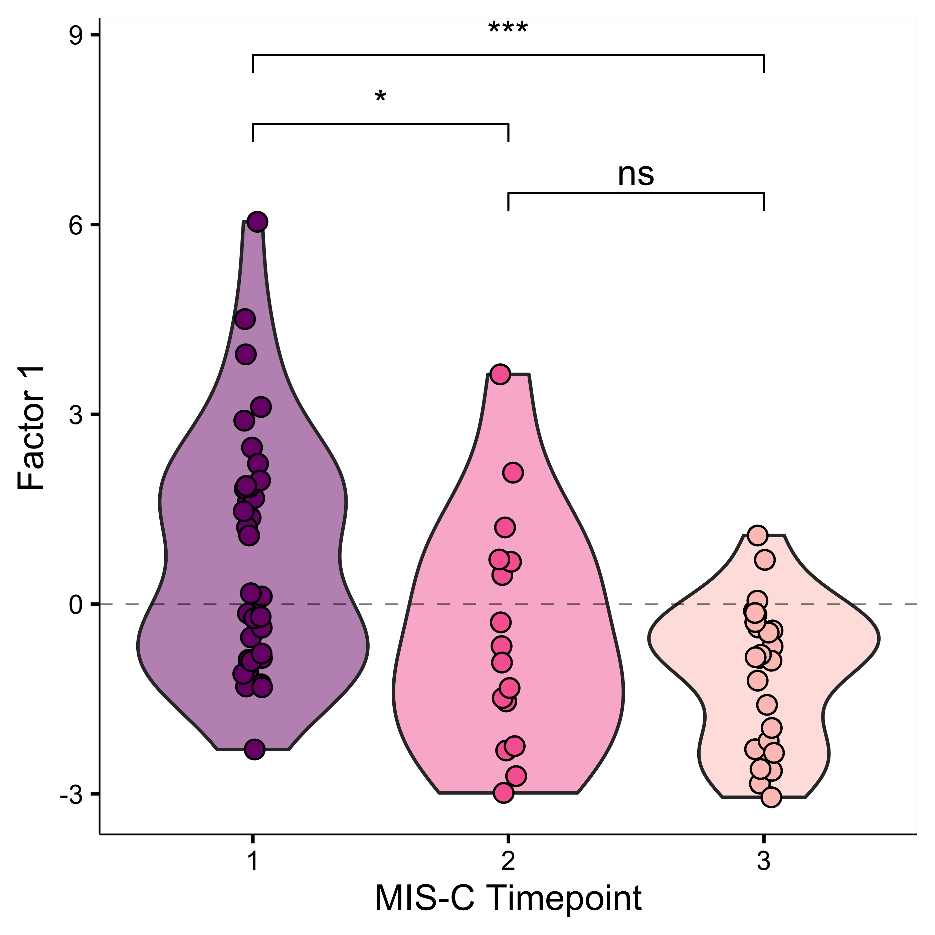
a
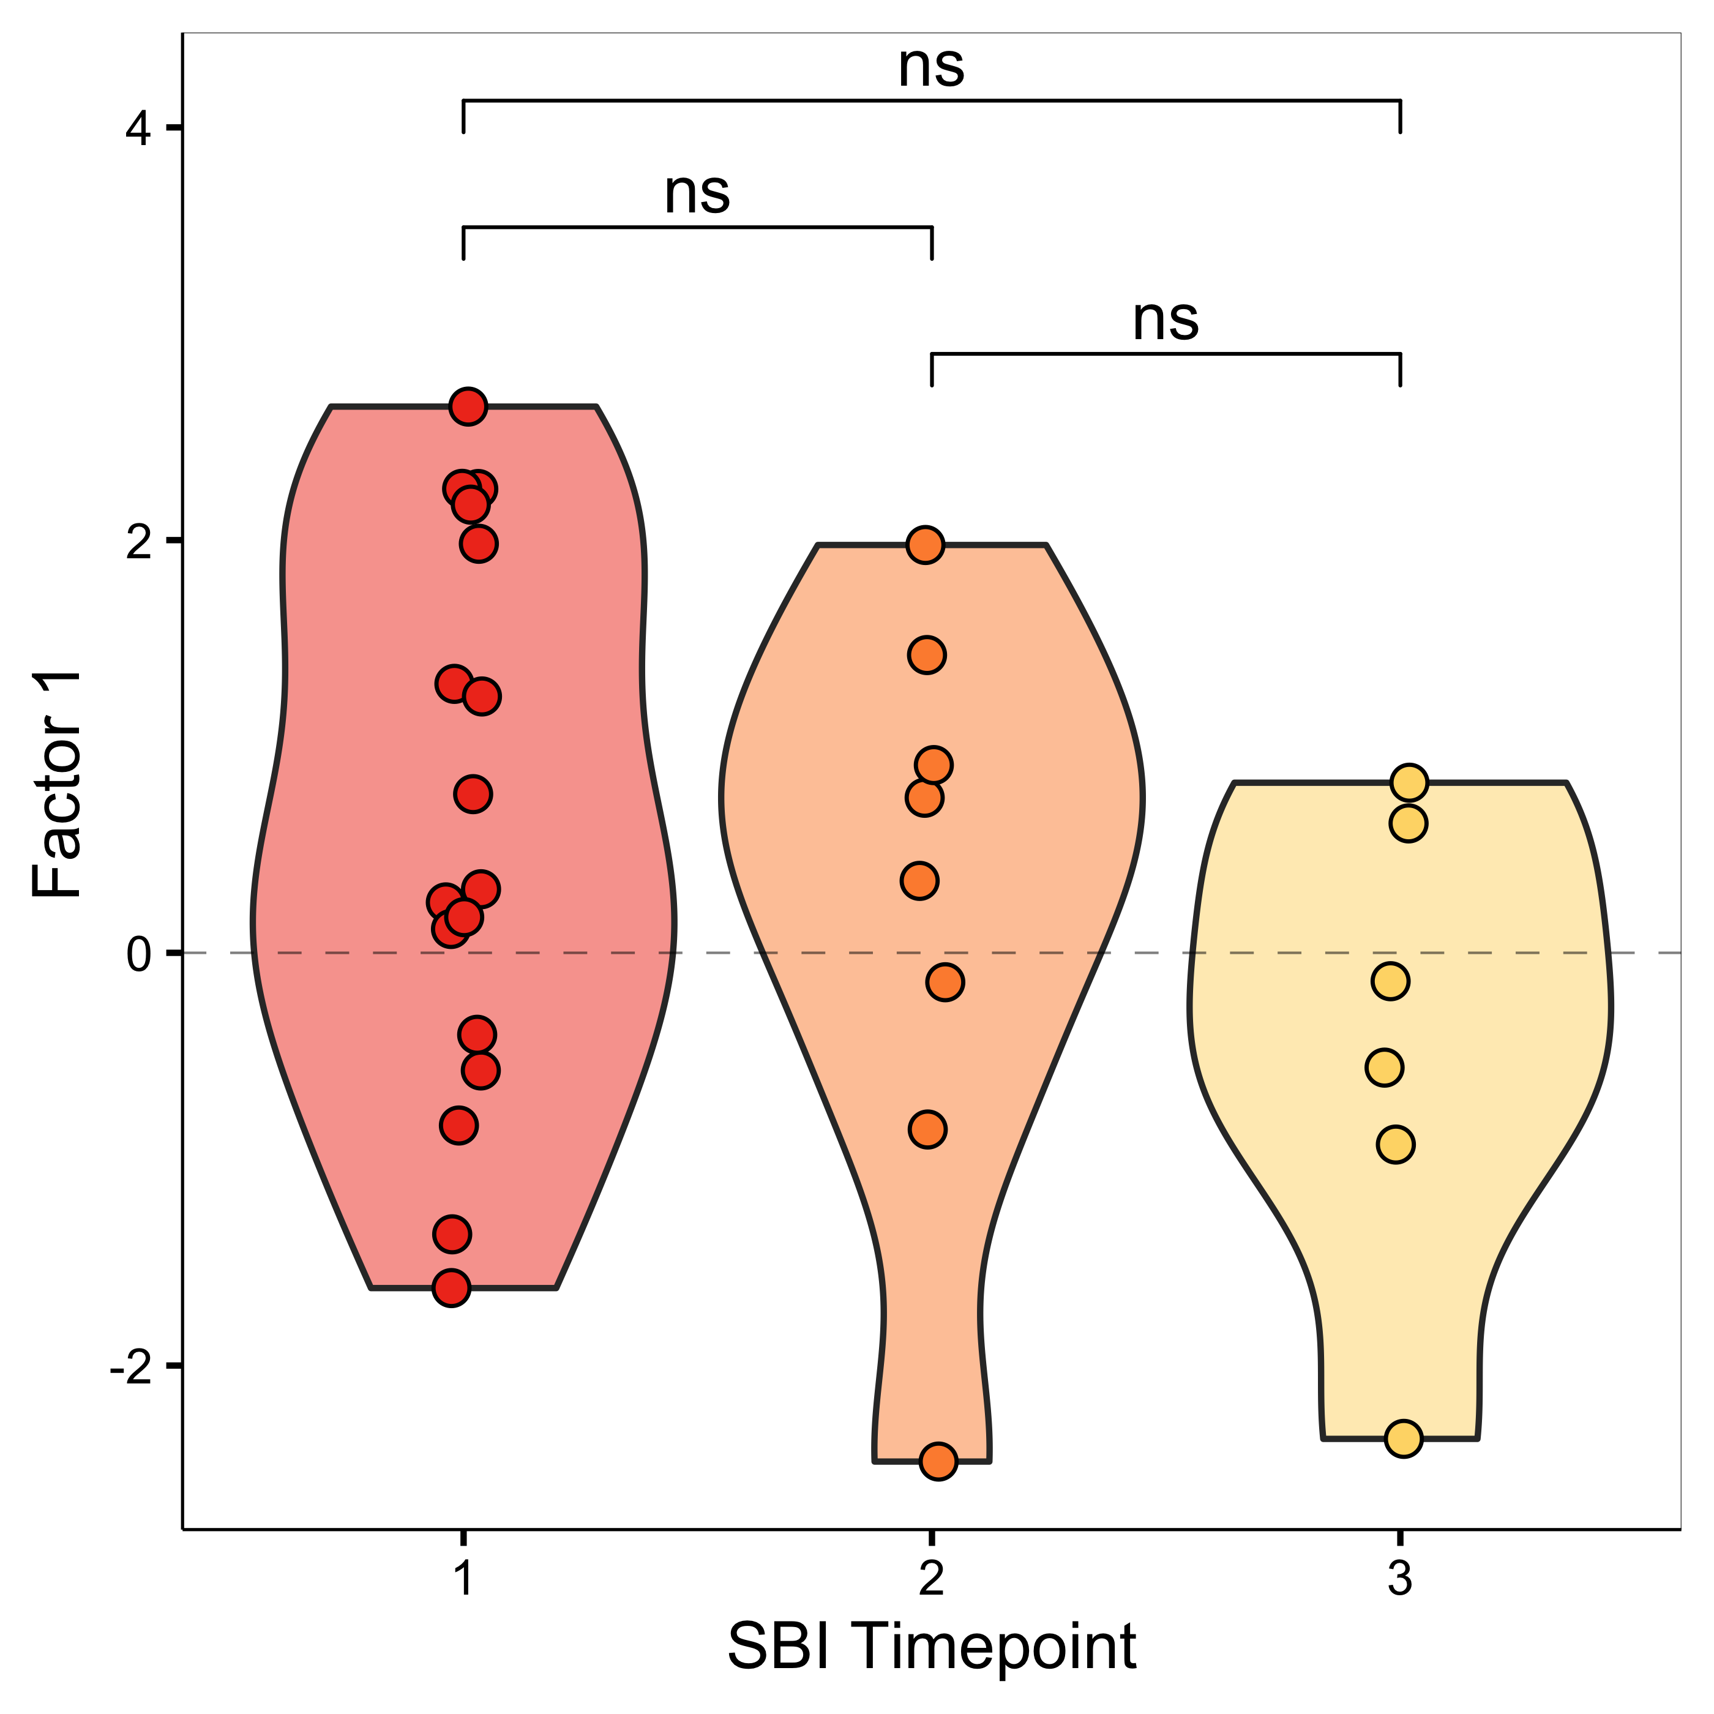
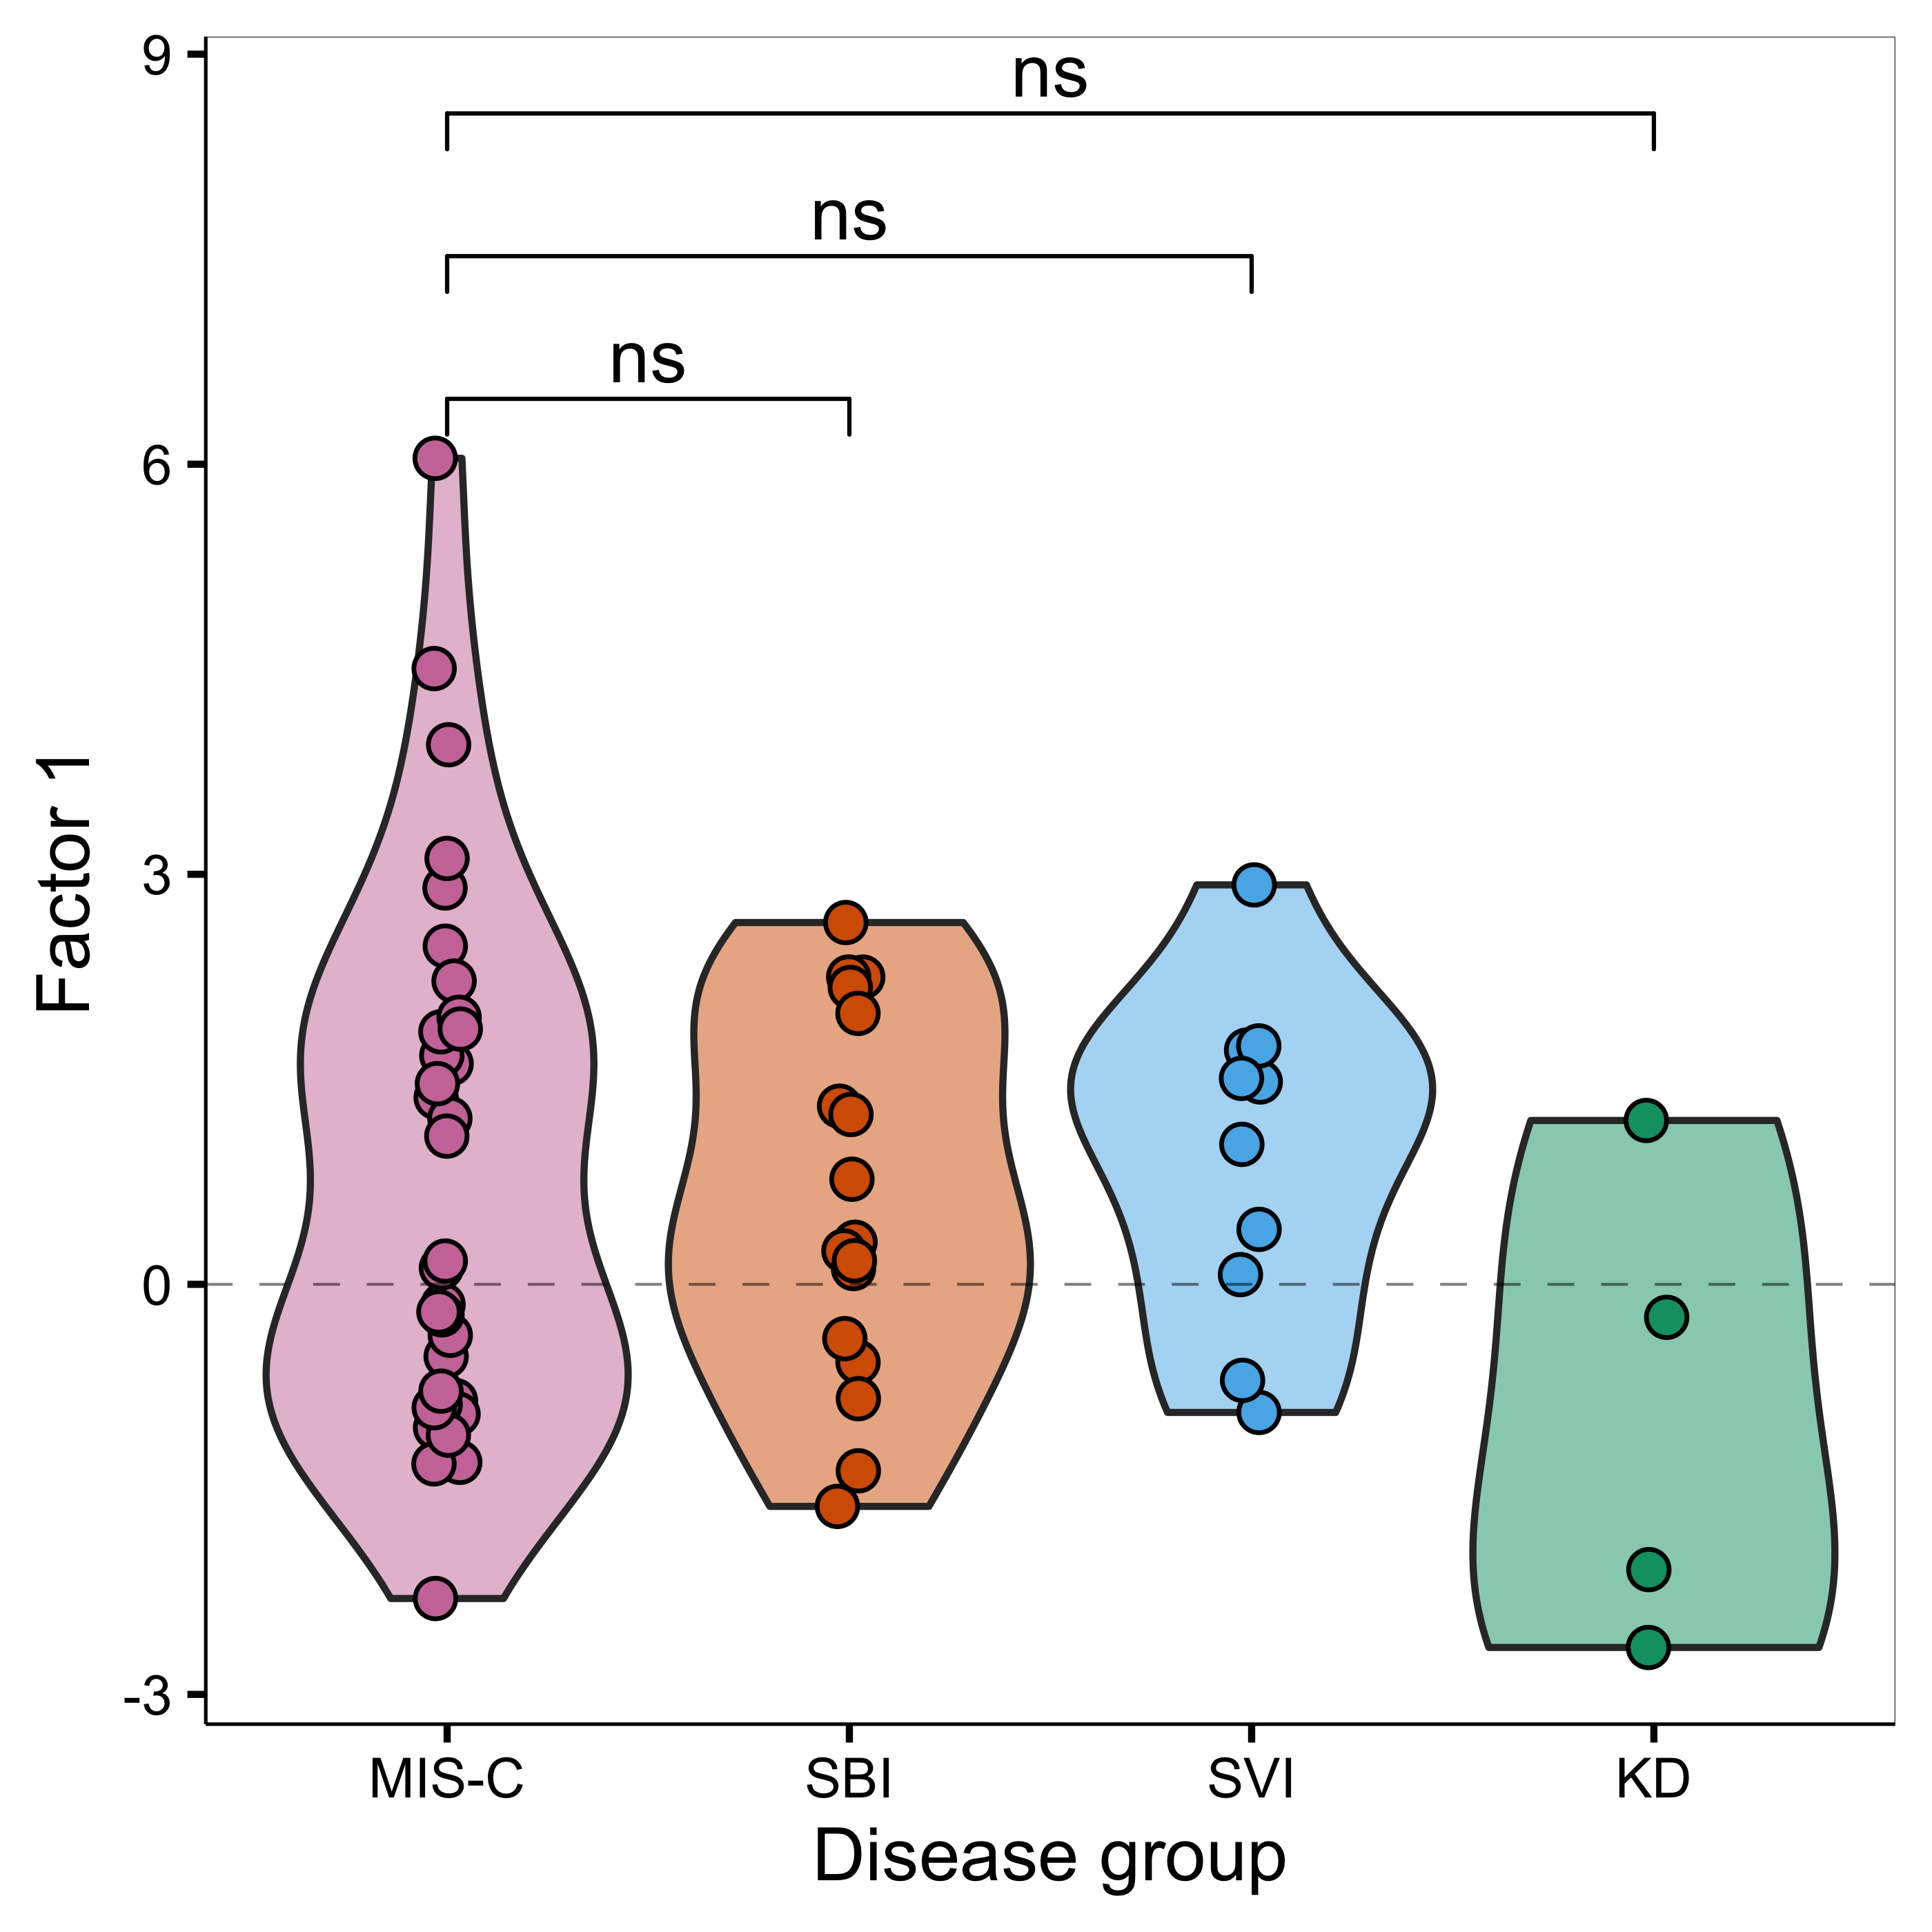
c
b
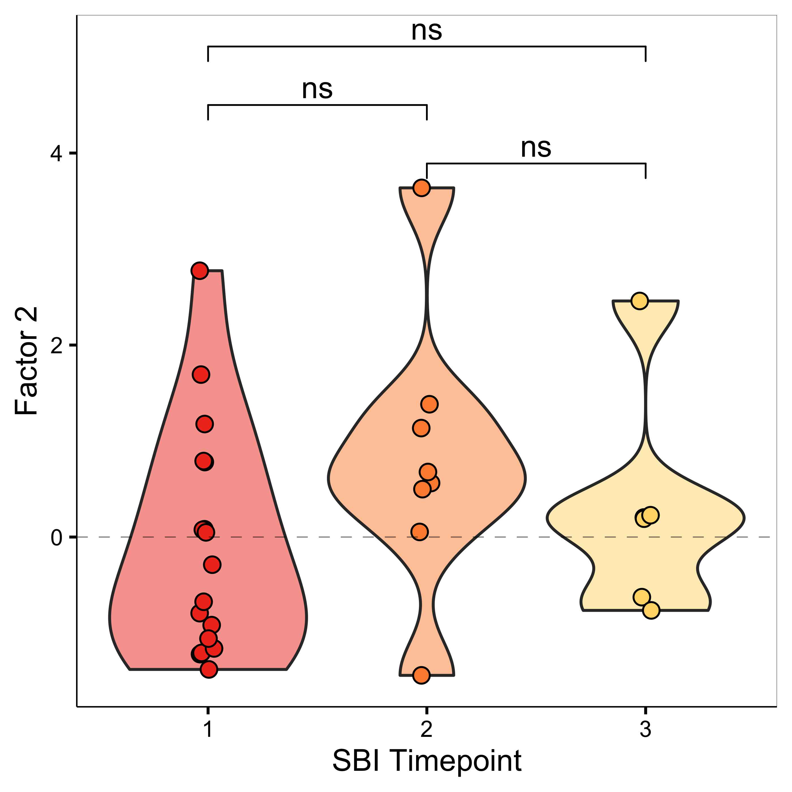
d
d
e
e
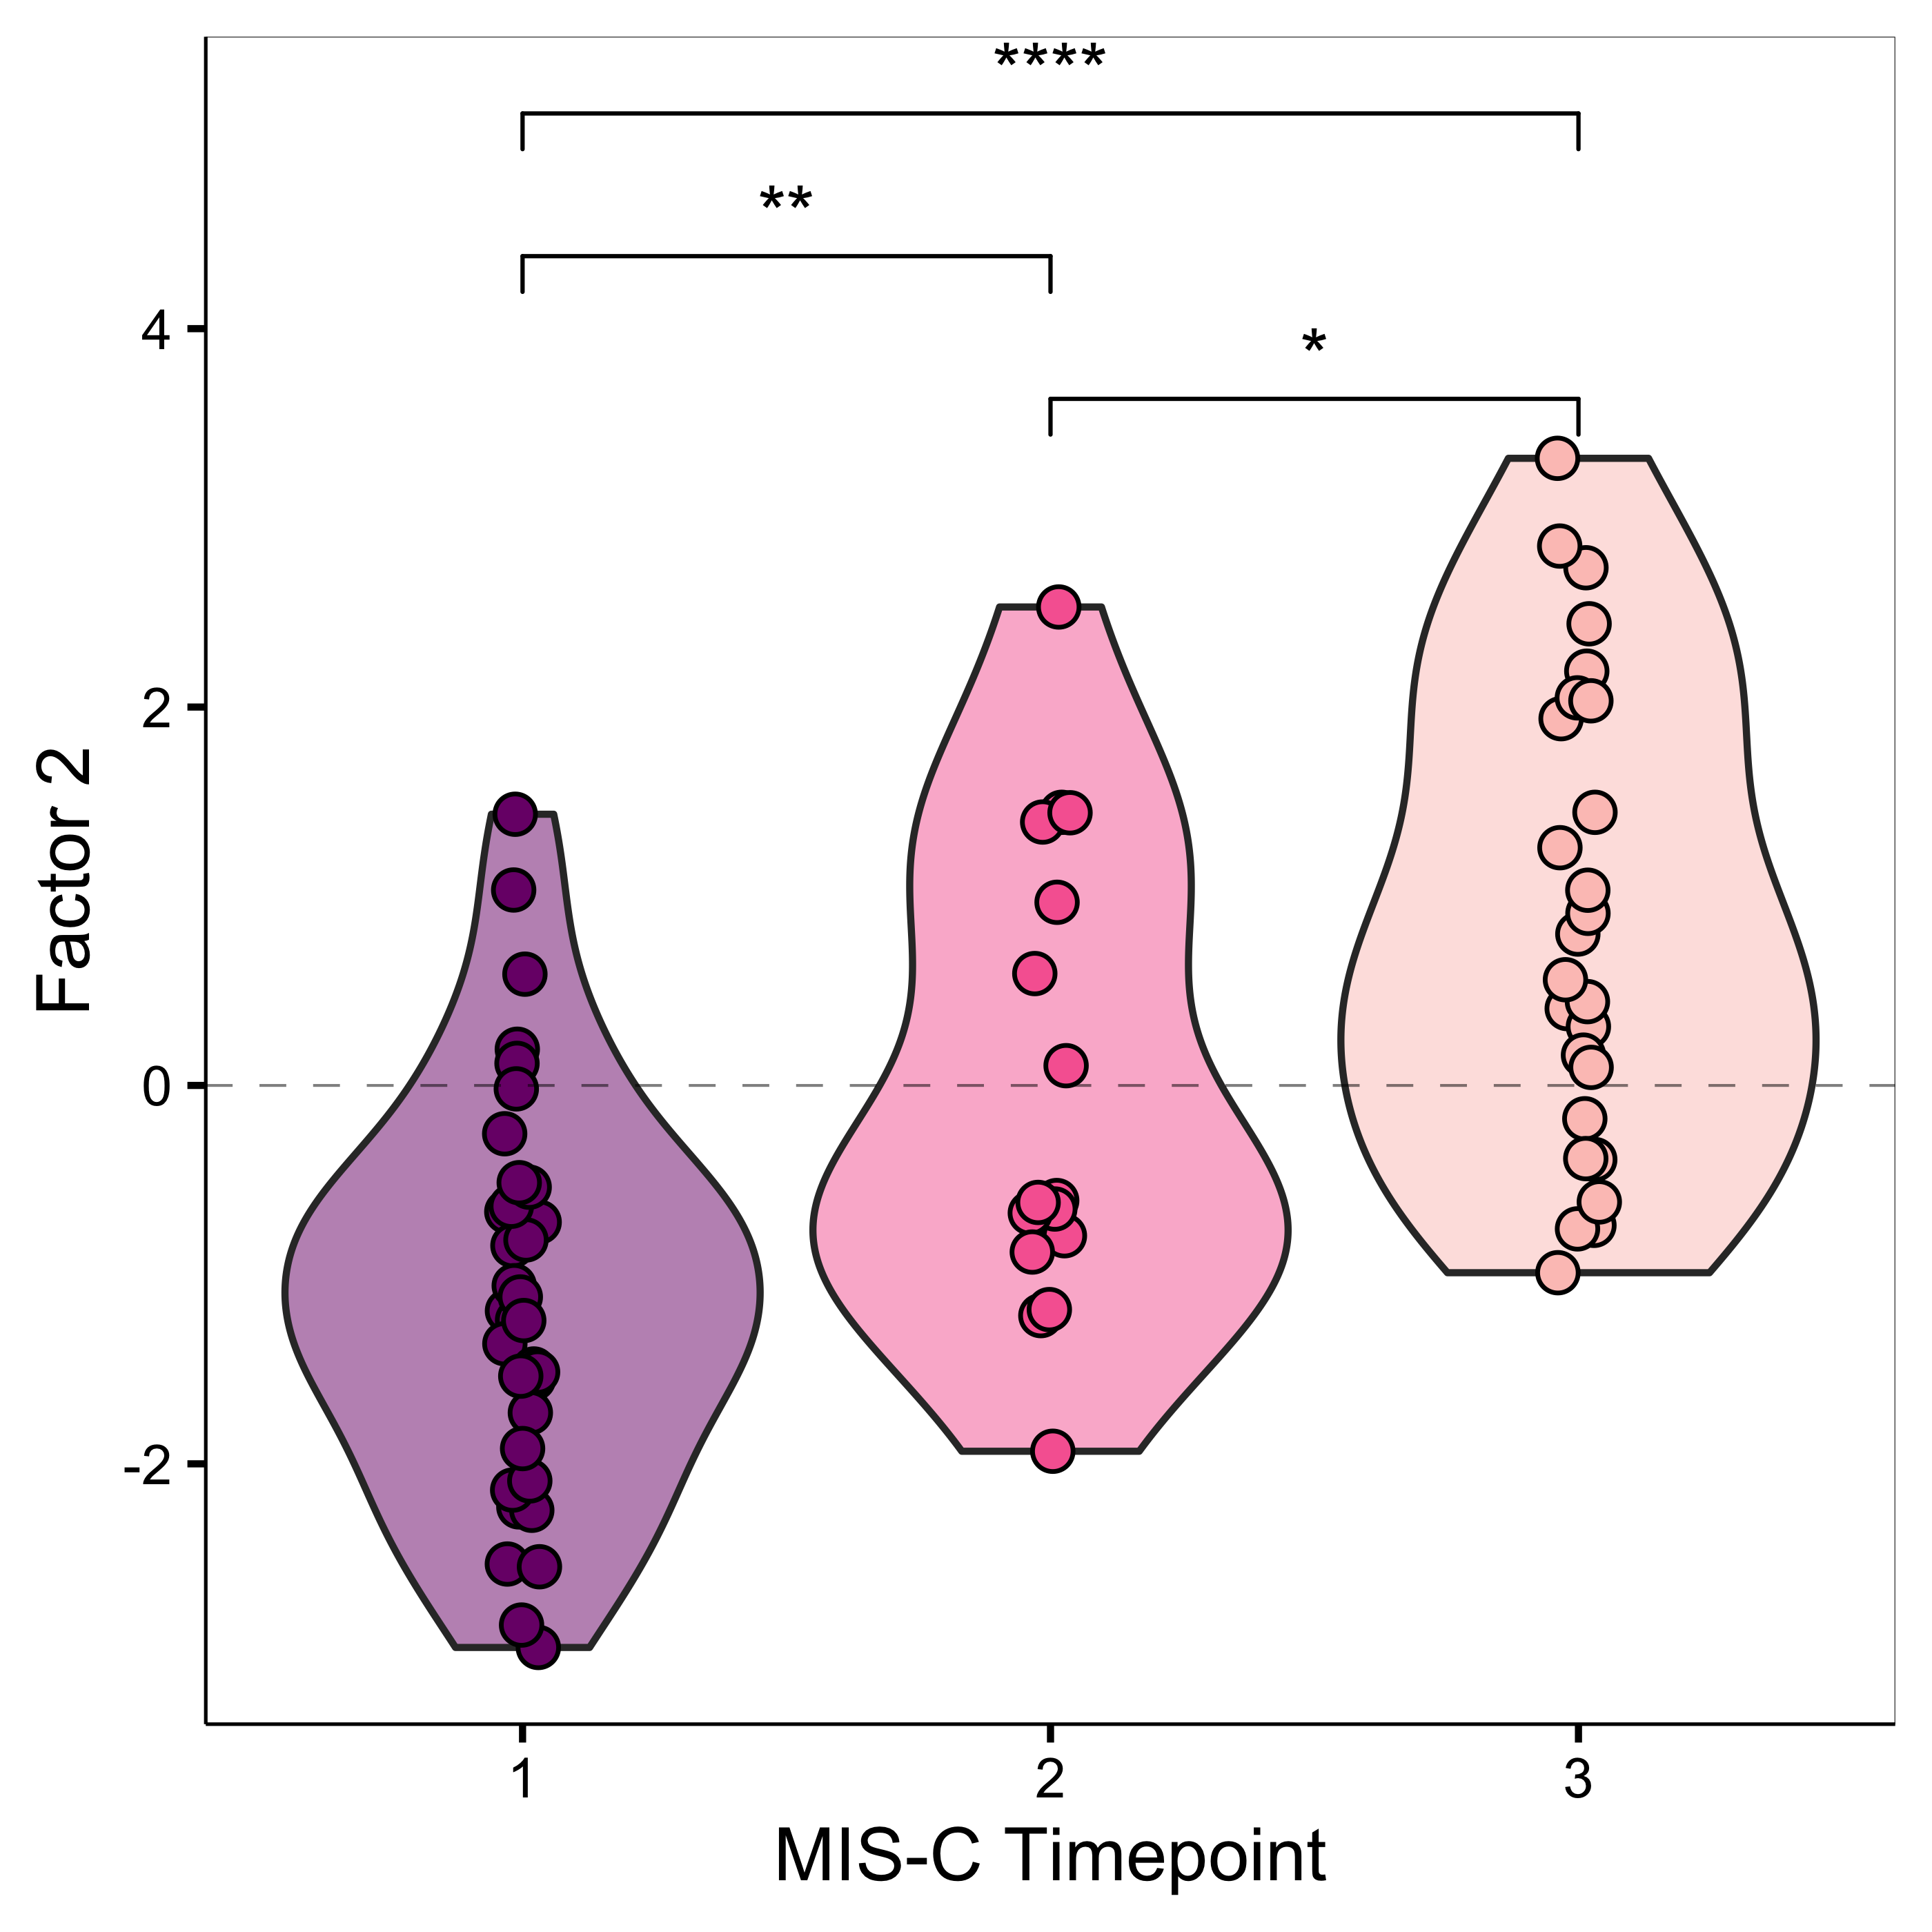
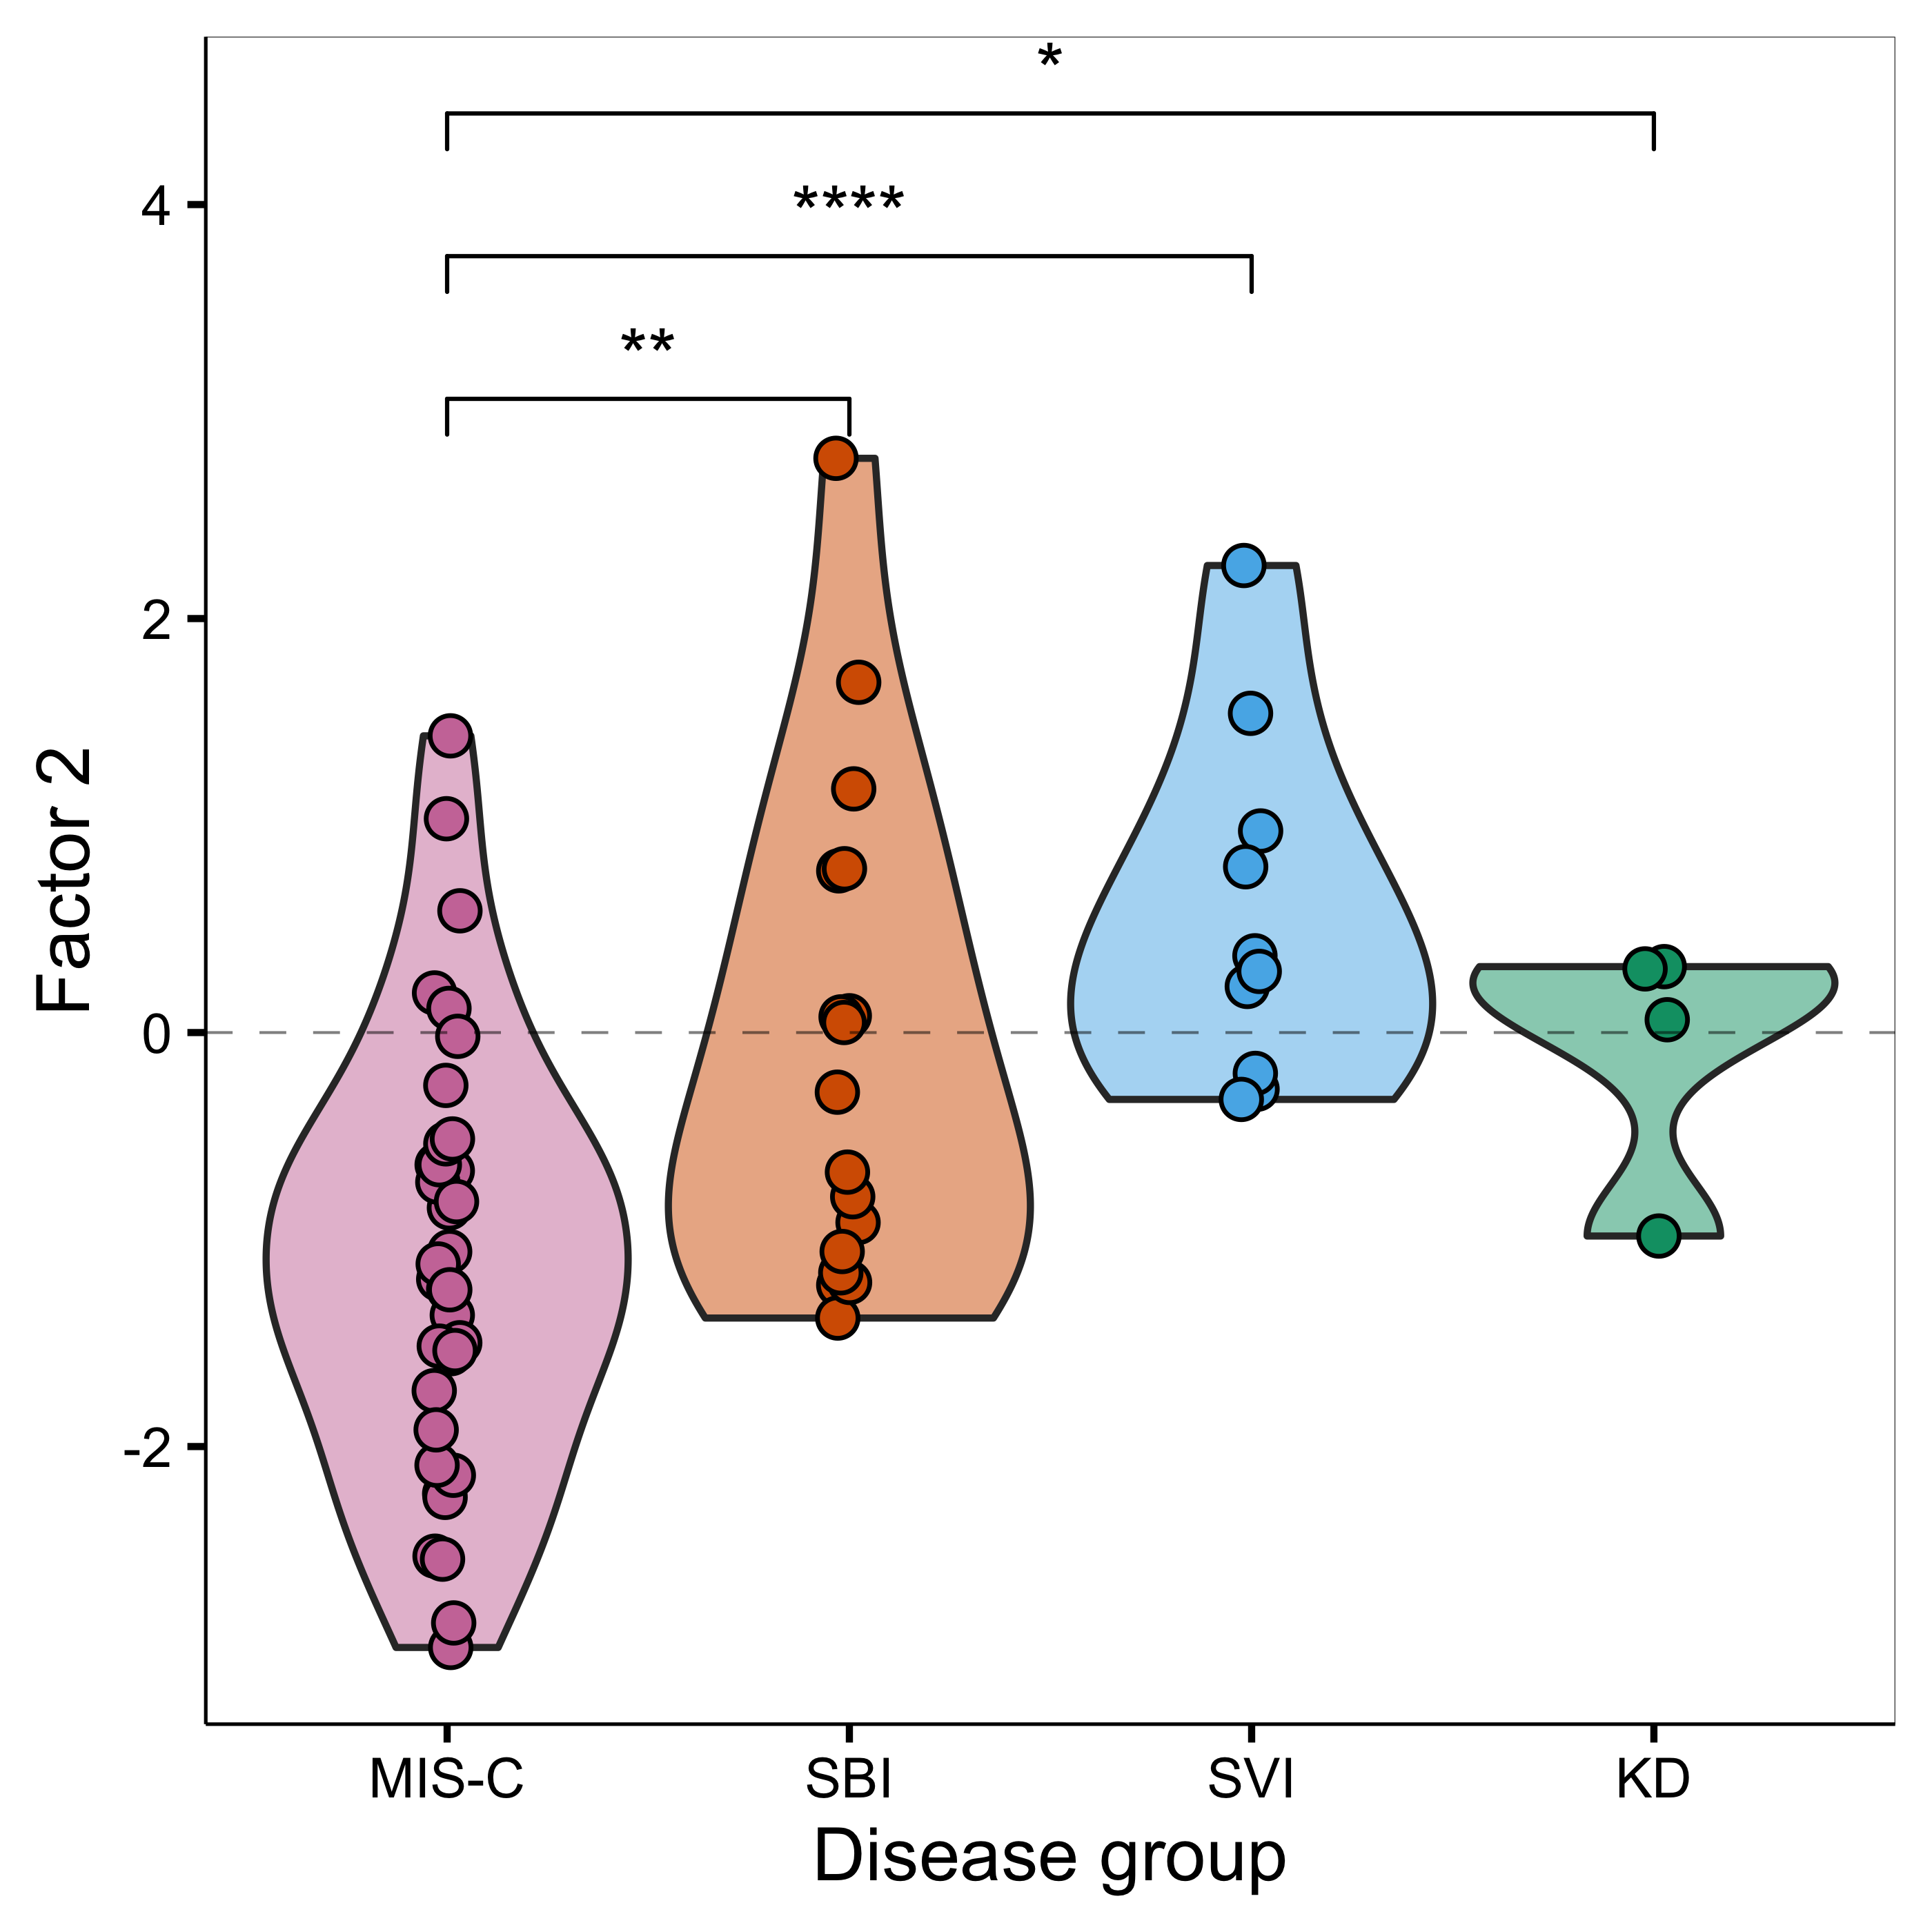
f

g
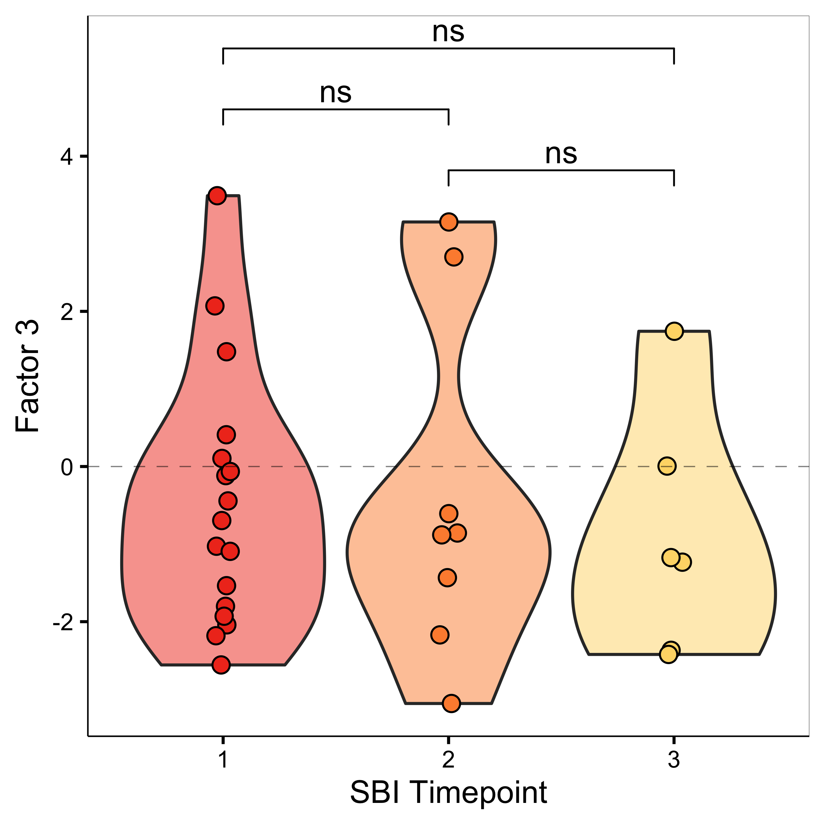
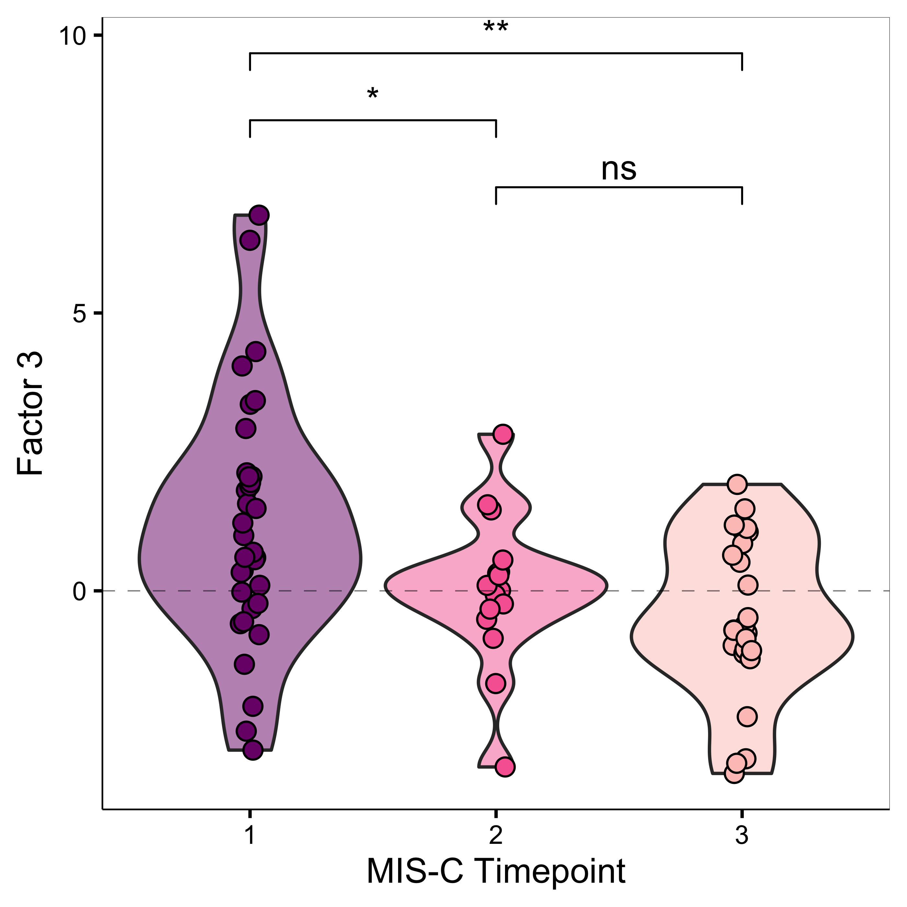
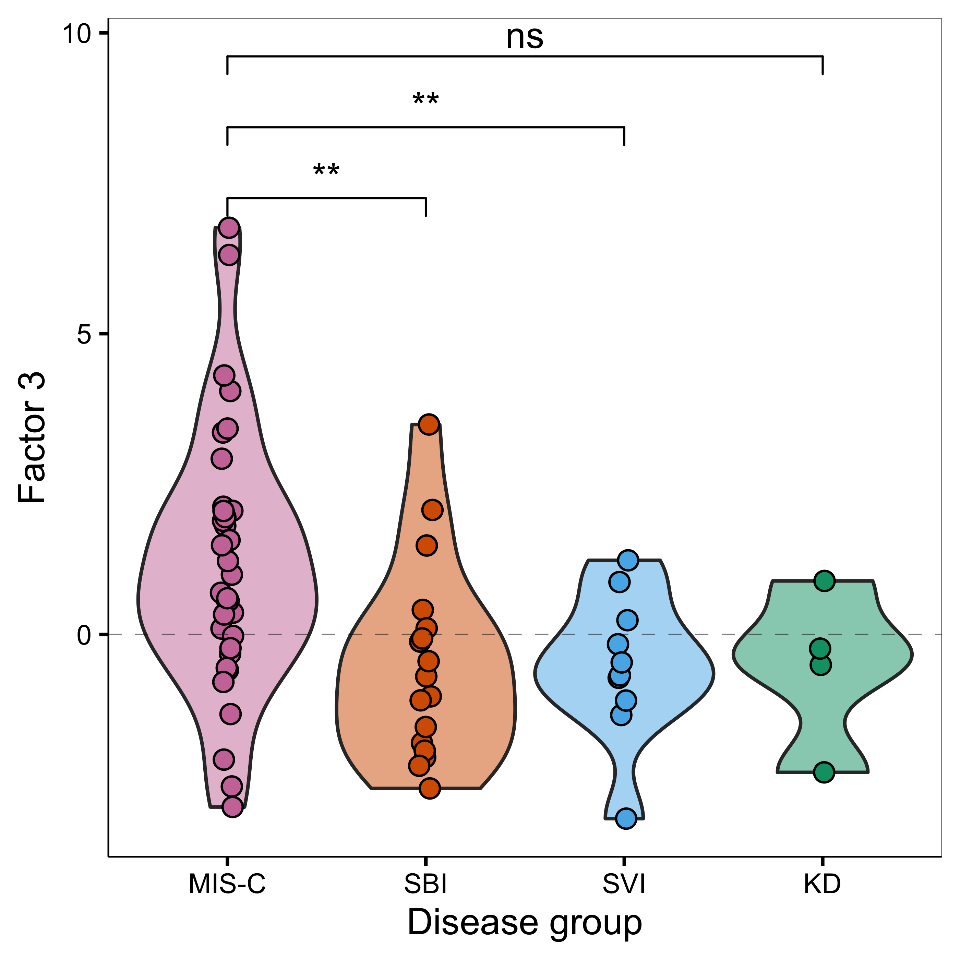
i
h
h

j

Supplementary Figure 4: K-means clustering analysis: effects of immunomodulatory treatment on supernatant cytokines. K-means clustering plots for supernatant cytokines samples with no stimulation (a), stimulation with SARS-CoV-2 antigen (ag1) (b) and stimulation with mitogen (phytohemagglutinin) (c). The clusters and their respective centre points are represented by different colours. The shape of each point represents the treatment received prior to research blood sampling.
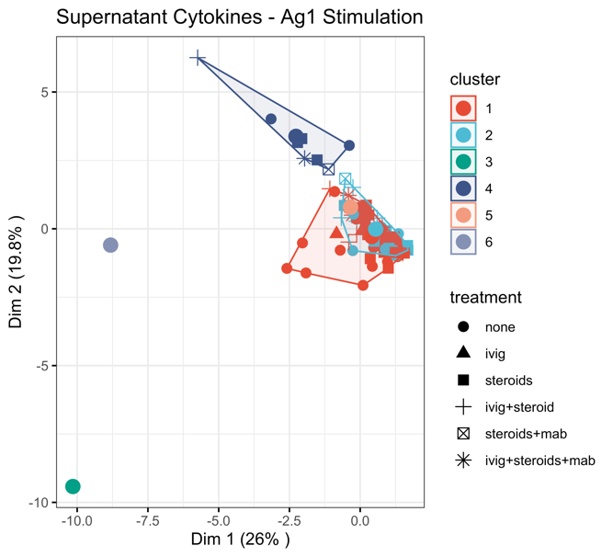
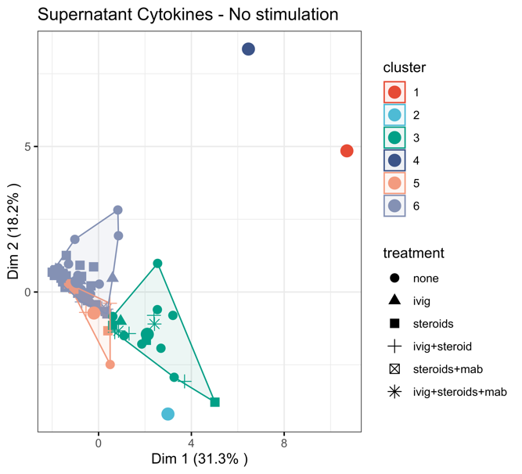

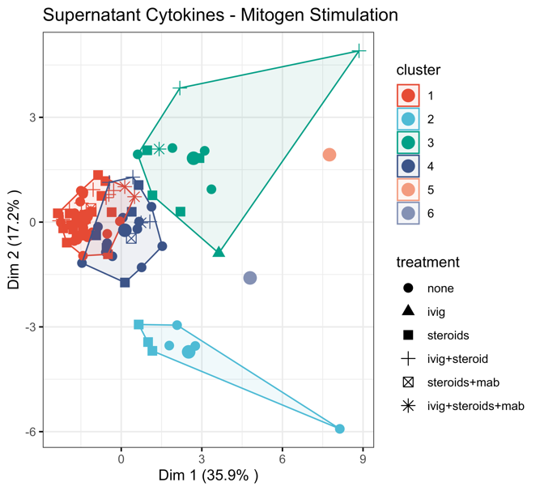

Supplementary Figure 5. Supernatant cytokine analysis 1: interferons
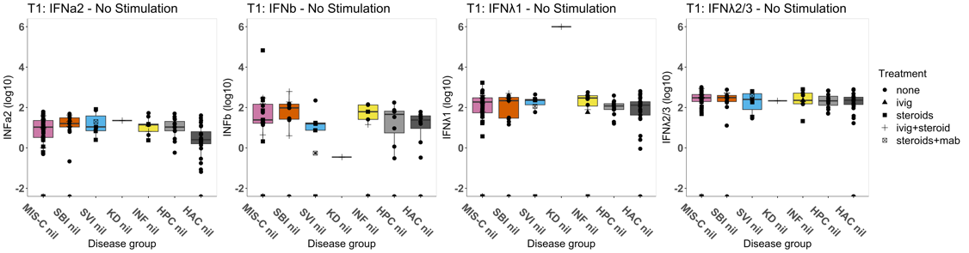
a)

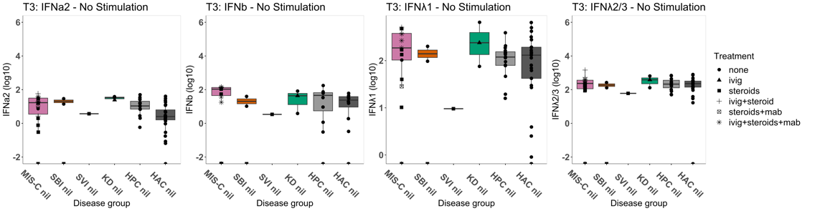

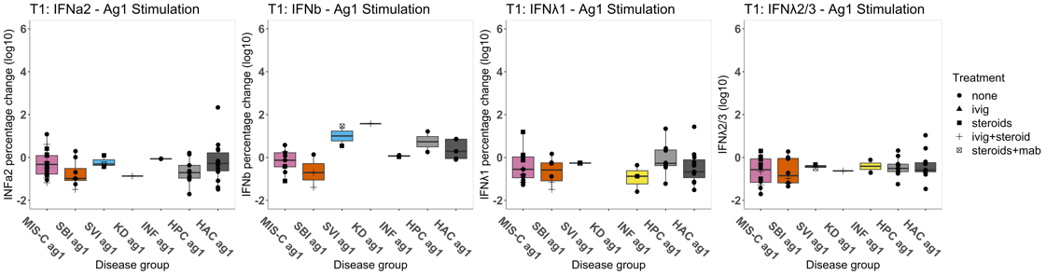
b)

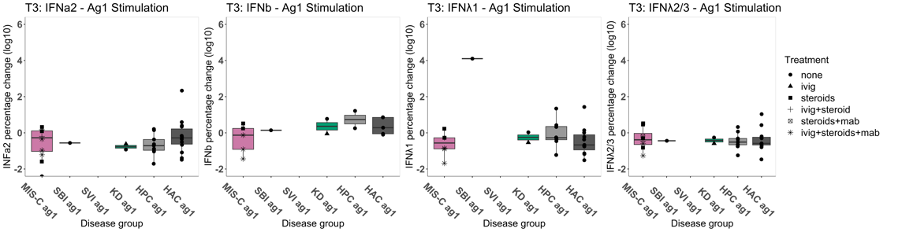

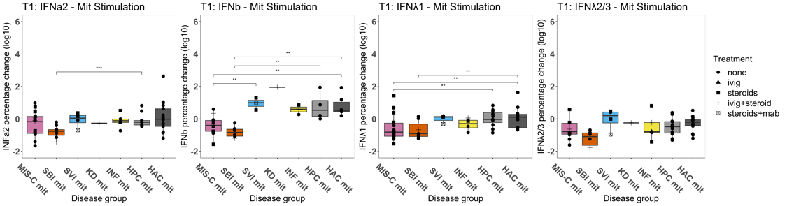
c)

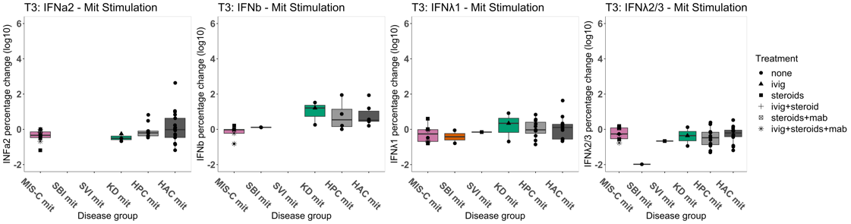

Box plots showing concentration of cell stimulation assay supernatant cytokines levels: interferon (IFN)α2, IFNβ, IFNλ1, IFNλ2/3; Log₁₀ values are shown. Each point representations a participant for the following groups: Multisystem inflammatory syndrome in children (MIS-C), severe bacterial illness (SBI), severe viral illness (SVI), Kawasaki disease (KD), other inflammatory disease. Absolute cytokine levels from acute (T1) and convalescent (T3) samples at baseline – unstimulated (a) percentage increase from baseline following stimulation with mitogen (mit) (b), and absolute increase from baseline following stimulation with SARS-CoV-2 antigen (ag1) (c) are shown. The shape of each point indicates the treatment received prior to sampling.

Supplementary Figure 6: Supernatant cytokine analysis 2: remaining cytokines
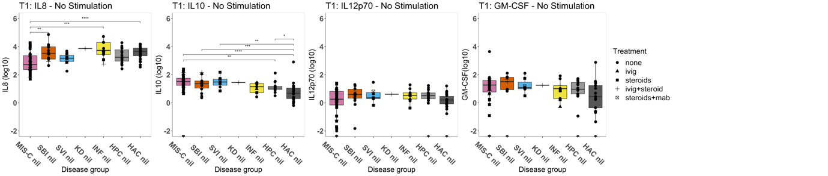
a)

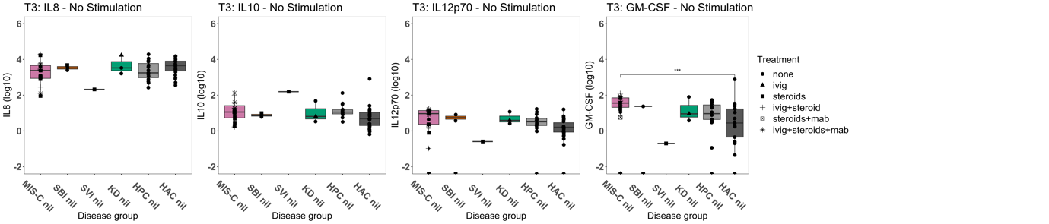

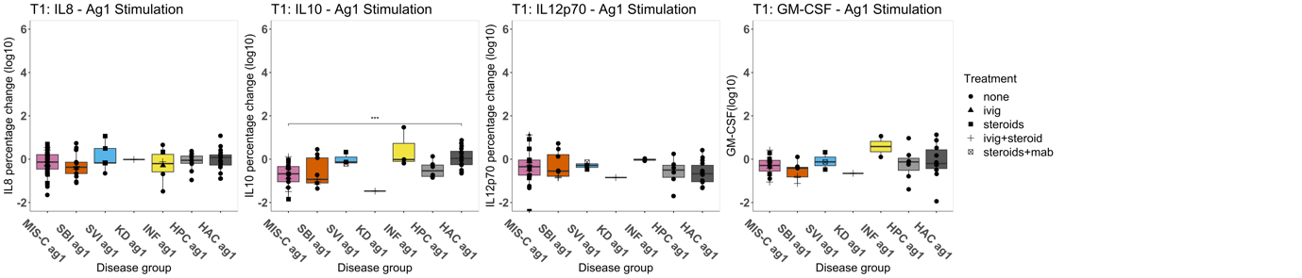
b)

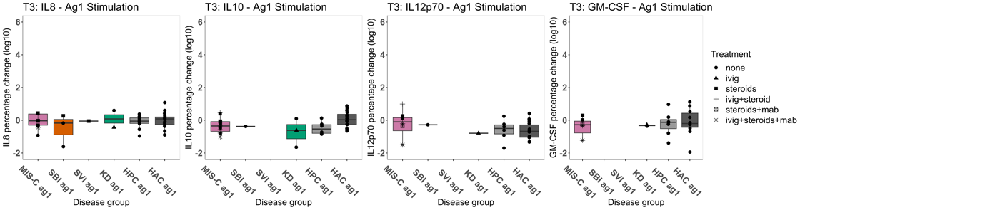

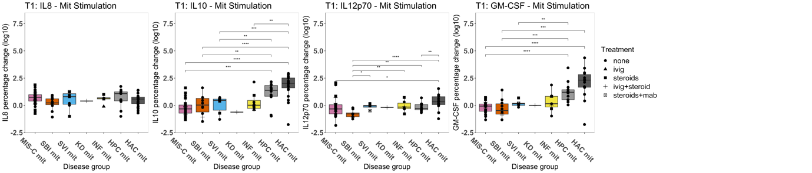
c)

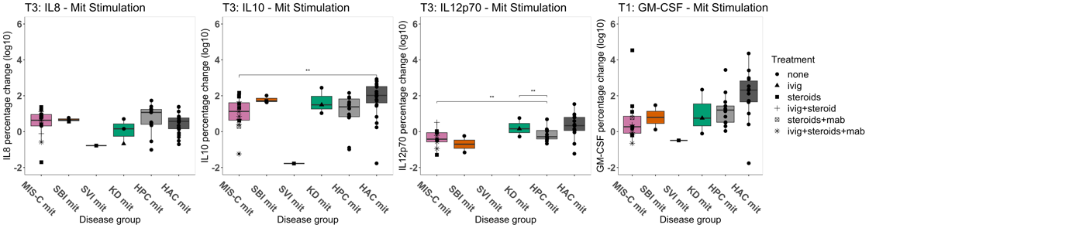

Box plots showing concentration of cell stimulation assay supernatant cytokines levels: interleukin (IL)8, IL10, IL12p70, granulocyte-macrophage colony-stimulating factor (GM-CSF). Log₁₀ values are shown. Each point representations a participant for the following groups: Multisystem inflammatory syndrome in children (MIS-C), severe bacterial illness (SBI), severe viral illness (SVI), Kawasaki disease (KD), other inflammatory disease. Absolute cytokine levels from acute (T1) and convalescent (T3) samples at baseline – unstimulated (a) percentage increase from baseline following stimulation with mitogen (mit) (b), and absolute increase from baseline following stimulation with SARS-CoV-2 antigen (ag1) (c) are shown. The shape of each point indicates the treatment received prior to sampling.
Figure 0-7 K-means clustering plot for supernatant cytokines samples with no stimulation (A), stimulation with SARS-CoV-2 antigen (ag1) (B) and stimulation with mitogen (phytohemagglutinin) (C). The clusters and their respective centre points are represented by different colours. The shape of each point represents the treatment received prior to research blood sampling.

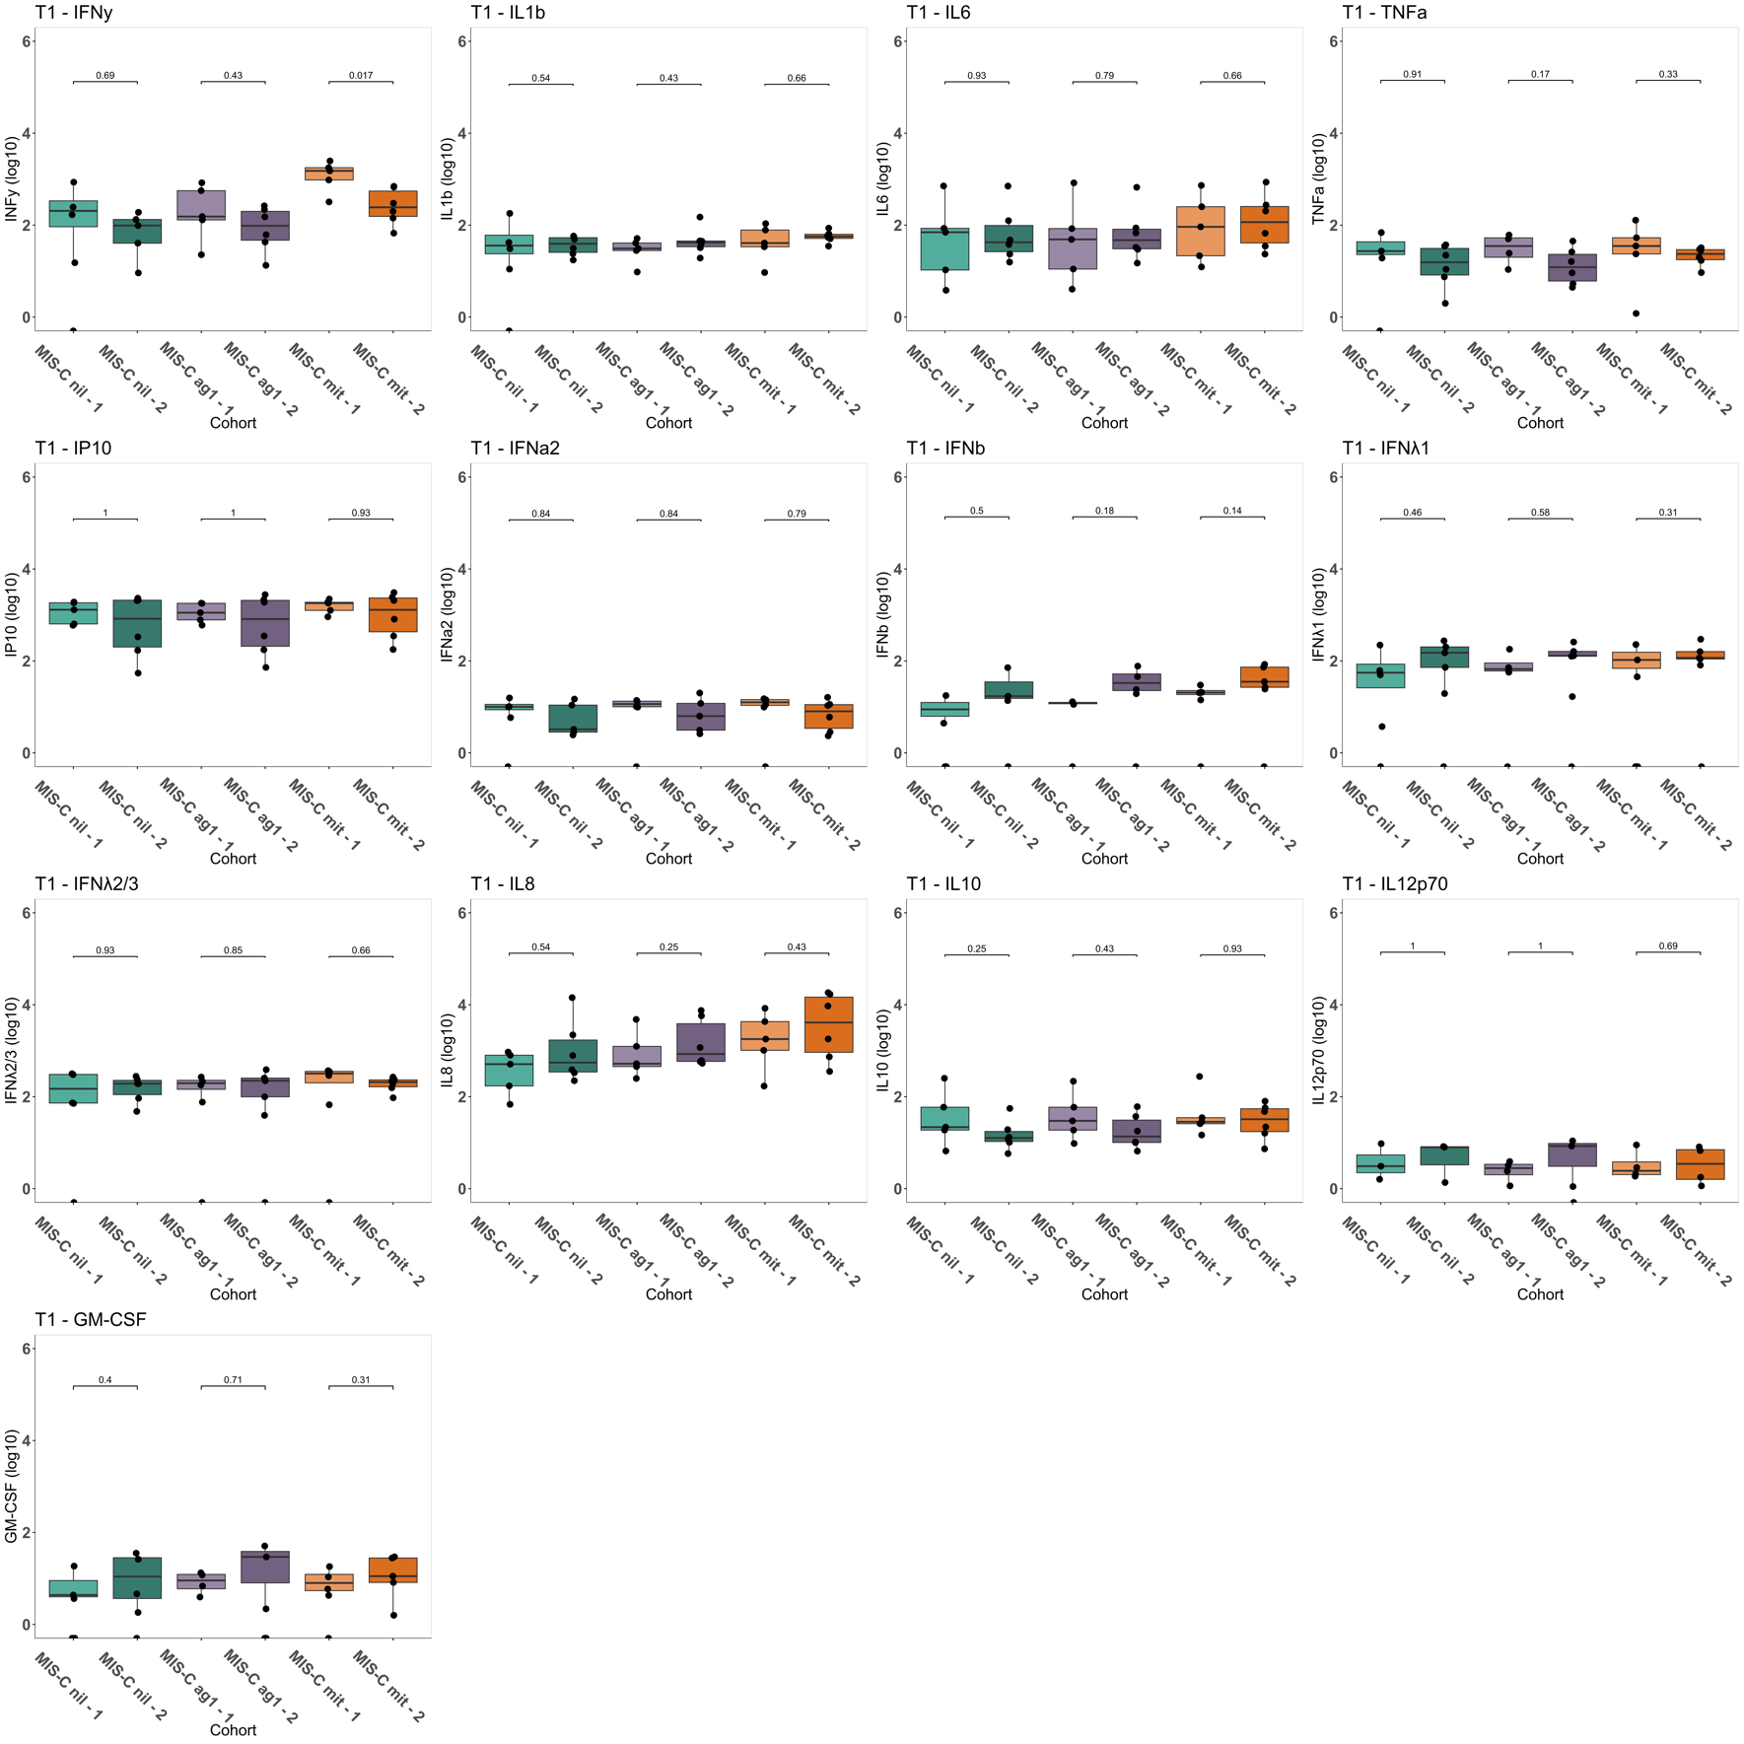
Supplementary Figure 7. Supernatant cytokine sub-analysis of MIS-C T1 by clusters identified on mass cytometry.
Box plots showing concentration of cell stimulation assay supernatant cytokines levels in acute (T1) MIS-C by clusters 1 and 2 identified on mass cytometry: IFNγ, IL1β, IL6, TNFα, IP10, IFNα2, IFNβ, IFNγ, IFNλ1, IFNλ2/3, IL8, IL10, IL12p70 and GM-CSF. Log₁₀ transformed raw data at baseline and following stimulation with SARS-CoV-2 antigen (ag1) and mitogen (mit) are shown. Each point represents a patient sample. P values from Wilcoxon pairwise comparisons are displayed.

Supplementary Figure 8. Heatmap summarising mass cytometry results of stimulated samples: foldchange from baseline following stimulation with SARS-CoV-2 antigen and mitogen for variables related to the a) innate immune response and b) T cell immune response.

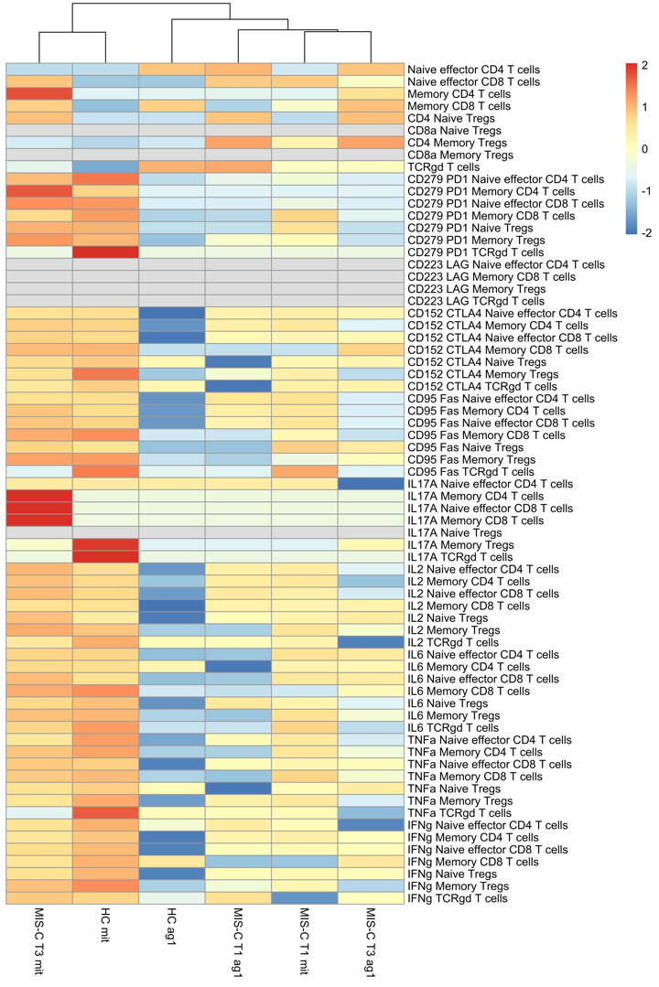
a b
