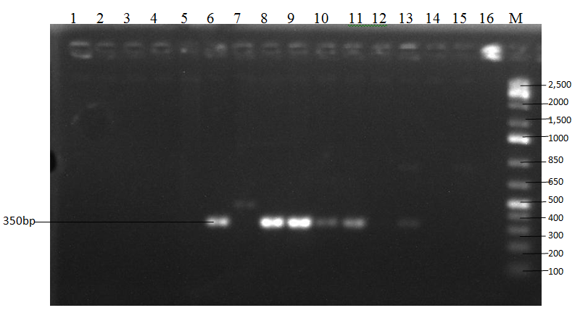
Plate I: Amplicons of Staphylococcal Enterotoxin type A gene (SEA) with 350 base pairs

Lane 6 (SHDFZ 289, S. aureus)
Lane 7 (Negative control, Cocktail: whole mix without DNA)
Lane 8 (SHDFK 401, S. aureus)
Lane 9 (LMDFK 504, S. aureus)
Lane 10 (SHDFK 363, S. hyicus)
Lane 11 ( Positive Control : S. aureus, ATCC 3865)
Lane M: DNA molecular weight marker (100-2500bp)

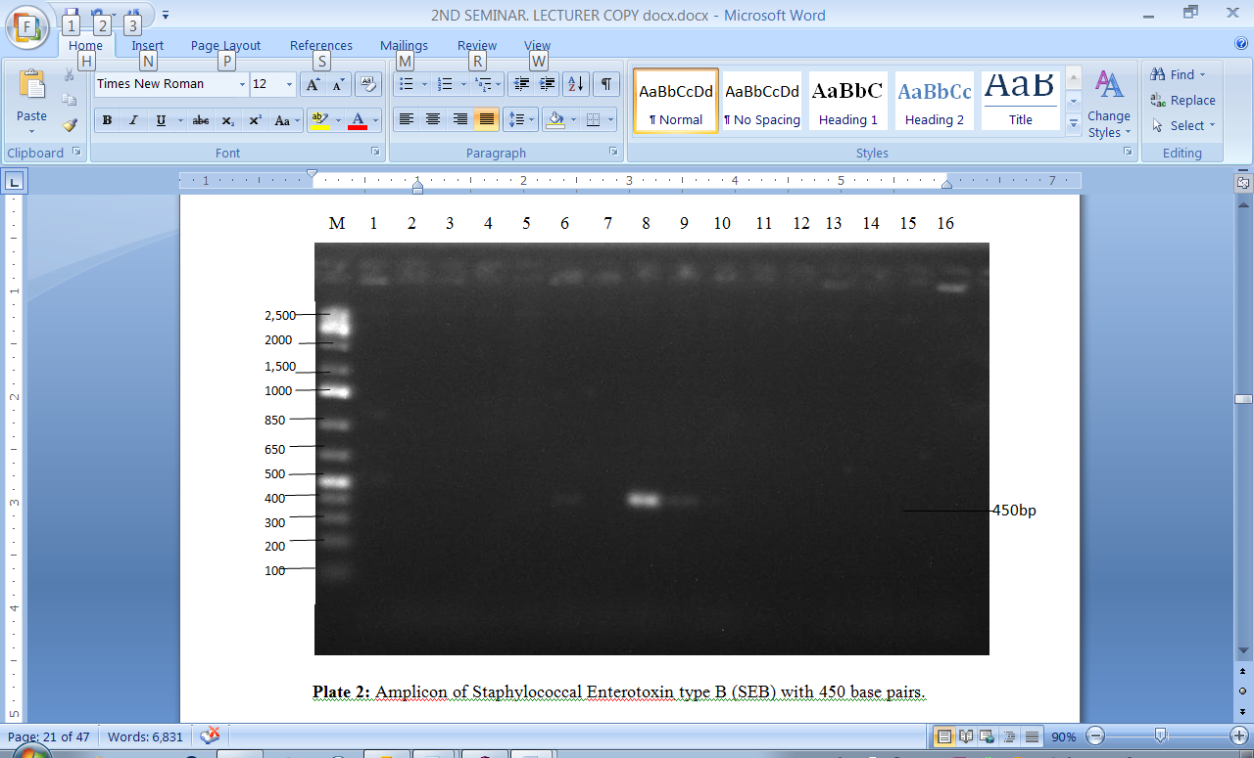
Plate II:Amplicon of Staphylococcal Enterotoxin type B (SEB) with 450 base pairs

Lane 7 (Negative control).
Lane 8 (SHDFK 401, S. aureus)
Lane 9 (LMDFZ 504, S. aureus)
Lane 11 (Positive control: S. aureus,ATCC 3865)
Lane M: DNA Molecular weight marker (100 – 2,500bp)

