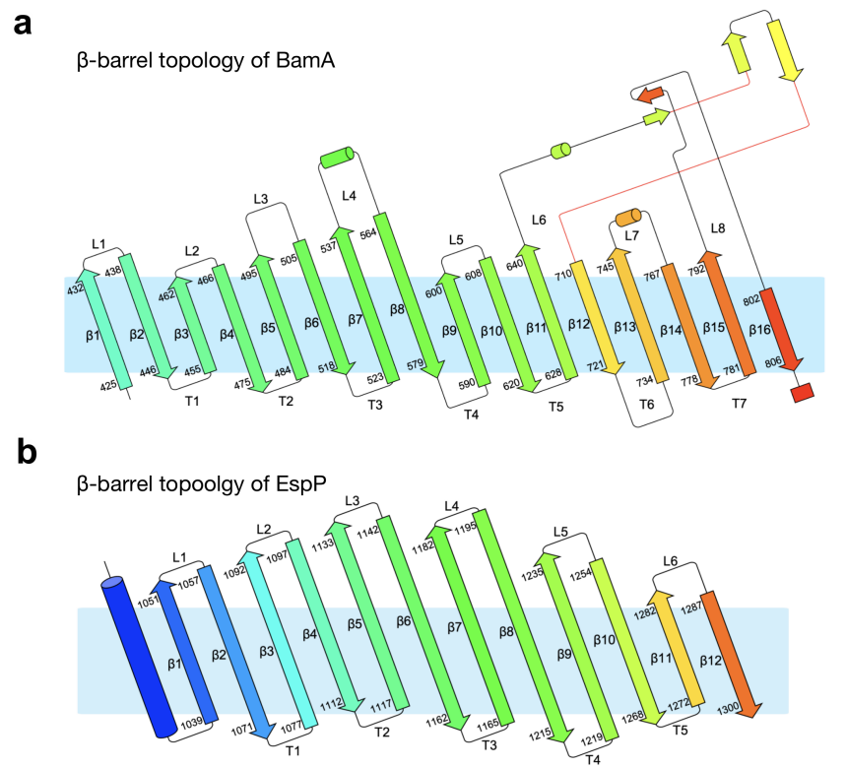
Supplementary Fig. 1 Topology diagram¹ of β barrel domain of BamA (a) and EspP (b) based on secondary structure assignments using STRIDE².
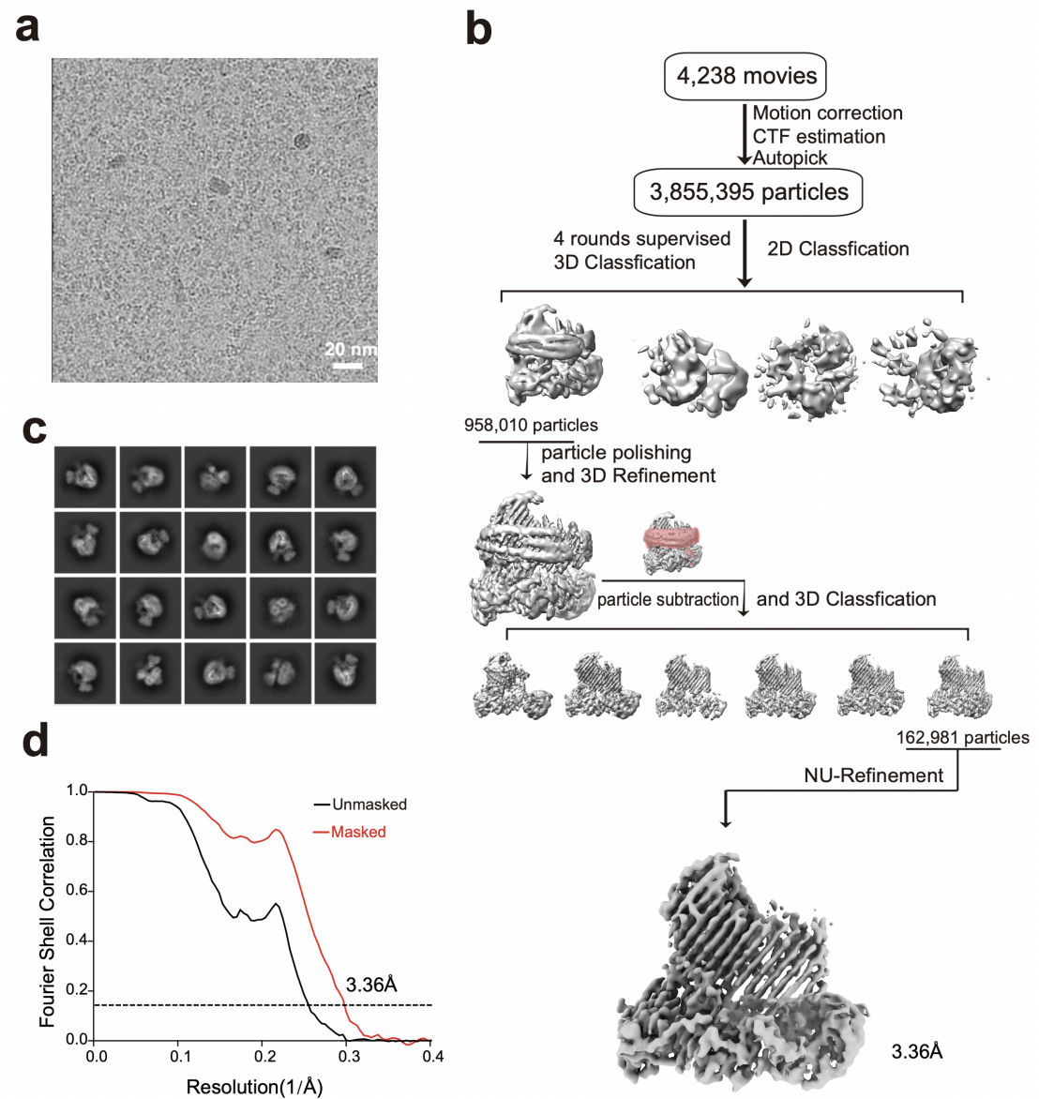
Supplementary Fig. 2 Flow charts for cryo-EM structure determination of the crosslinked BAM/EspP complex in nanodisc. a Cryo-EM microscope image of the BAM/EspP complex carrying the crosslink mutation BamA-G431C/EspP-N1293C. b Scheme of data collection, two- and three- dimensional classifications, refinements and the local cryo-EM resolutions of the density maps. c Selected two-dimensional classification images. d Gold-standard Fourier Shell Correction (FSC) curves for structure resolution determination.

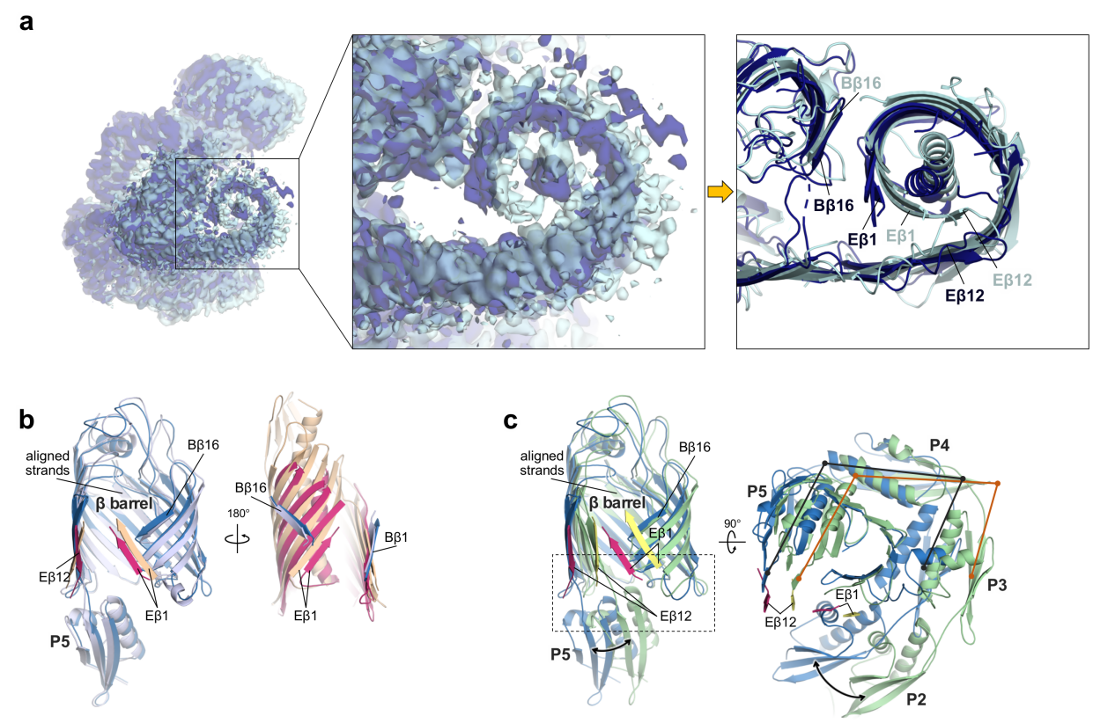

Supplementary Fig. 3 Analysis of the new cryo-EM map and structure of crosslinked BAM/EspP complex. a Comparison between the new map and our previously reported map of the BAM/EspP complex carrying the crosslink mutation BamA-G431C/EspP-N1293C. The enlarge views containing the corresponding atomic models show that the main difference is the degree of EspP barreling. b Comparison between the hybrid barrels with inward-open BamA (skyblue) / barrelized EspP (warmpink) and inward-open BamA (bluewhite) / closing EspP (wheat). c Comparison between the hybrid barrels with inward-open BamA (skyblue) / barrelized EspP (warmpink) and outward-open BamA (palegreen) / closing EspP (paleyellow).

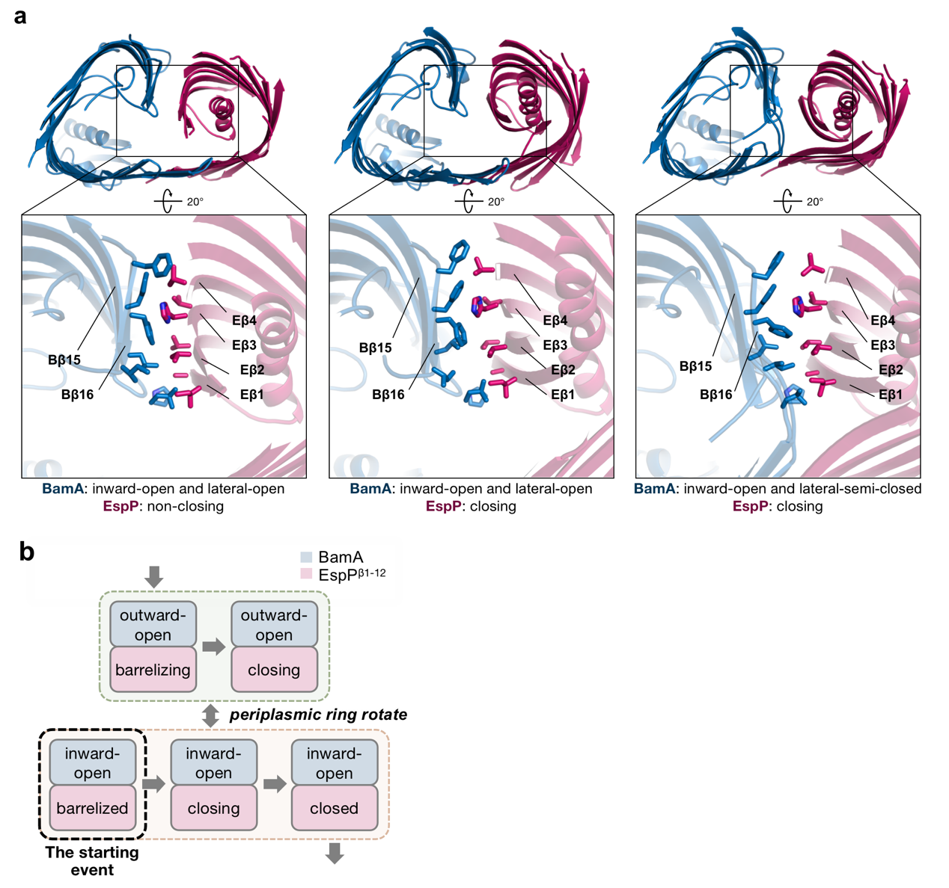

Supplementary Fig. 4 A hydrophobic interface formed with inward-open BamA. a Persistence of the hydrophobic interface in the closing hybrid-barrel. The complexes (from left to right) are the new structure and the two structures we reported previously (PDB IDs 8BNZ and 7YE6). b Schematic diagram of the conformational change process of the hybrid barrel. The new structure may be a starting event for the subsequent closure.

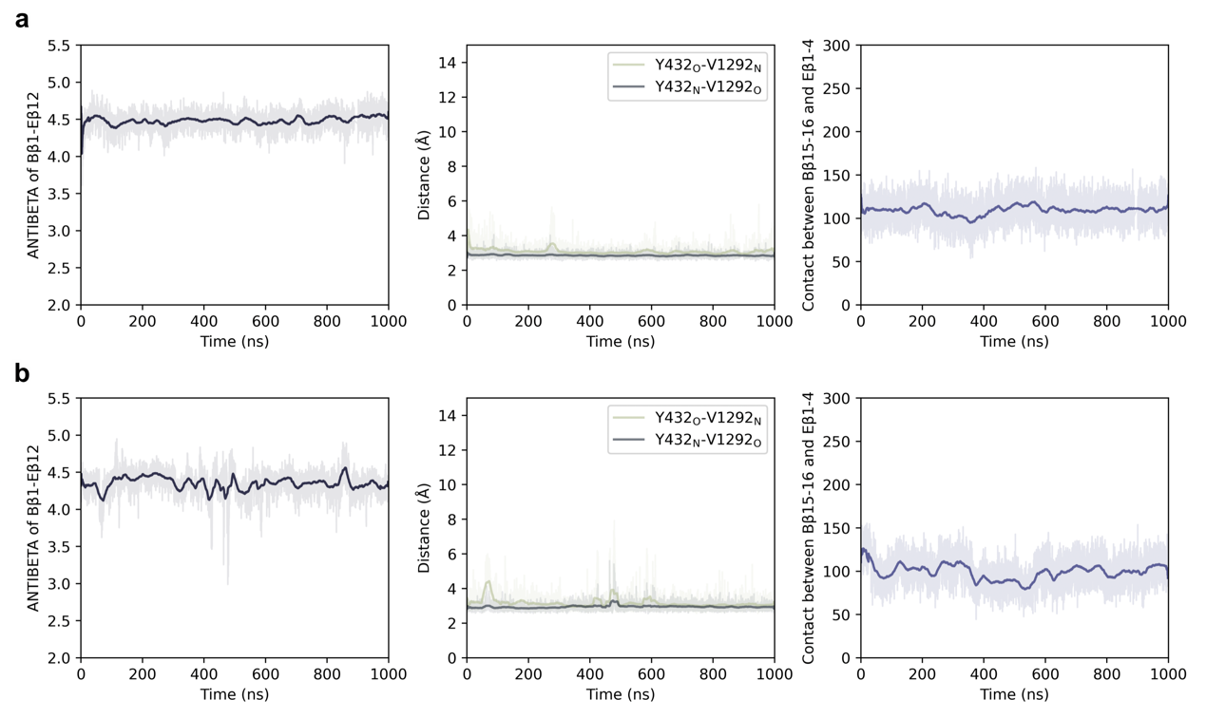
Supplementary Fig. 5 Structure stability analysis of the hybrid barrel with inward-open BamA and barrlized EspP. a-b Structure stability analysis of crosslinked (a) and wild-type the hybrid barrel (b). The CVs (from left to right) monitor the degree of separation of BamA from the β-signal (ANTIBETA of Eβ1 and Eβ12), the stability of the 432Y/V1292 pair (the distances between backbone oxygen and nitrogen atoms forming hydrogen bonds) and the stability of the hydrophobic interface (the number of contact atoms (within 3 Å) between Bβ15-16 and Eβ1-4). See methods for CVs calculation.

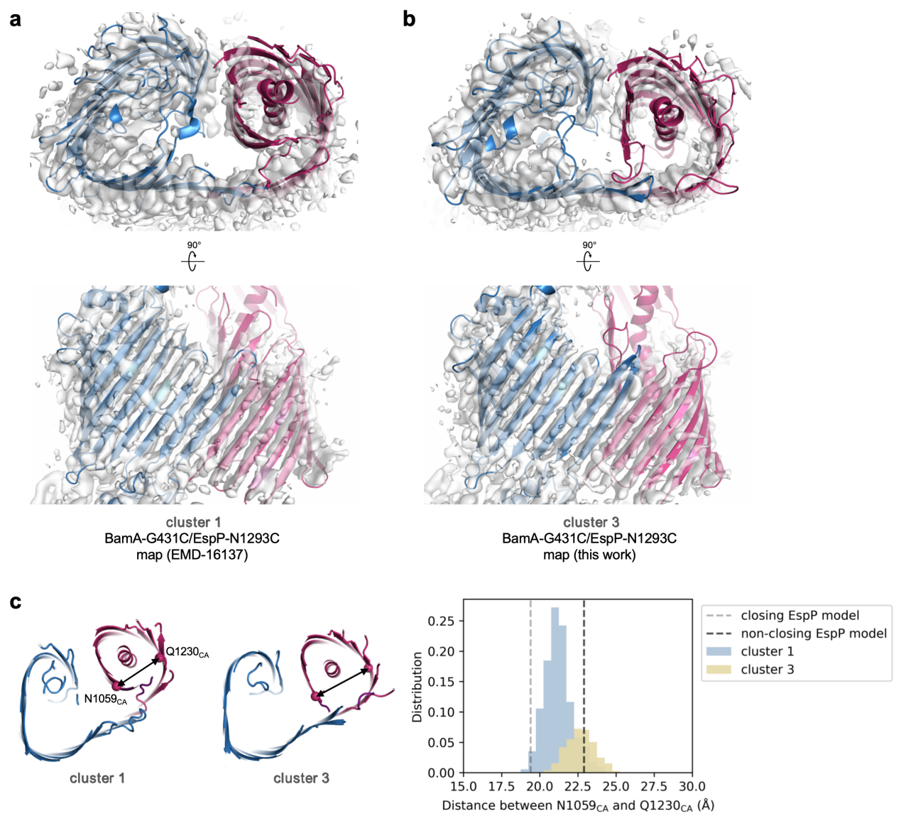
Supplementary Fig. 6 Comparison between the representative conformations of the HREX simulations and the cryo-EM maps of the crosslinked BamA/EspP. a-b Comparison between one representative conformation of cluster 1 and our previously reported map (the cryo-EM map of 8BNZ) (a), and comparison between the conformation of cluster 3 and the map in this work (b). c Distance between N1059_{CA} and Q1230_{CA} showing the degree of EspP closure in cluster 1 and 3. 8BNZ (closing EspP model) and the newly solved structure model in this work (non-closing EspP model) are located in the conformational space of cluster 1 and cluster 3, respectively.
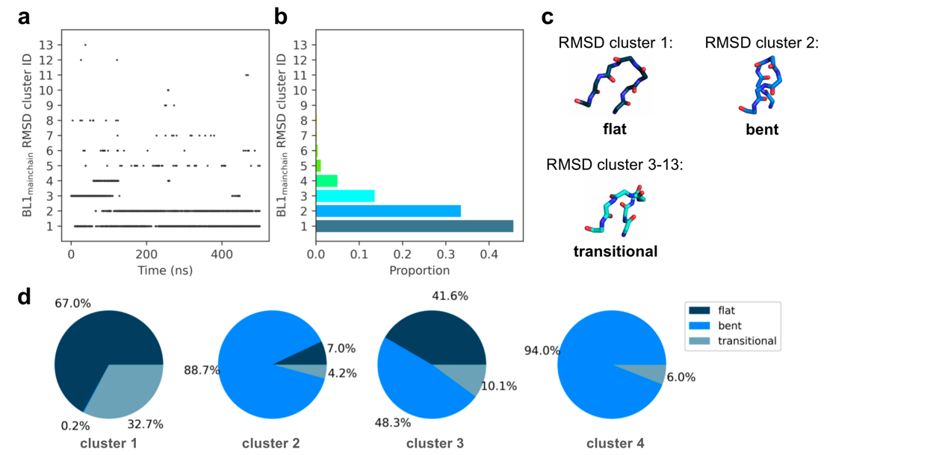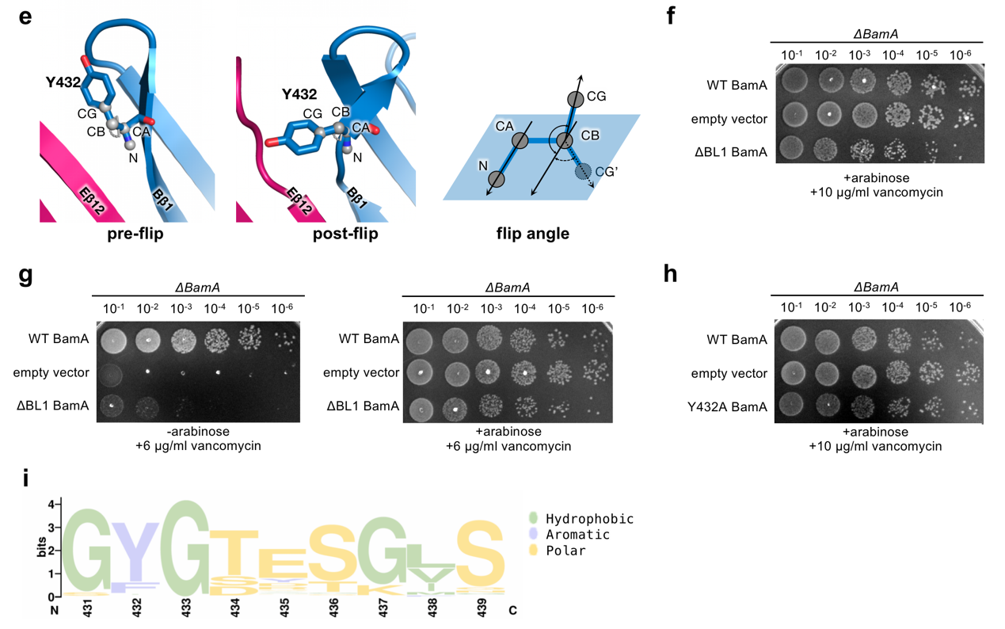

Supplementary Fig. 7 Induced-fit interactions between BL1 and Eβ1 during the HREX simulations. a-c Conformational analysis of BL1 main chains by RMSD clustering³. Three main classes of BL1 conformations (i.e., the flat, the bent and the transitional) are identified. d Proportions of different BL1 conformations in the four clusters shown in Fig. 2c. The great majority of conformations in cluster 2 and 4 have bent BL1. e Definition of flip angle of Y432. The flip angle of Y432 is the angle between the vector connecting CA to N and the vector connecting CB to CG. f,h Cellular viability assays of BamA mutants in the presence of arabinose. The viability assays in the absence of arabinose as shown in Fig. 3e-f. g Cell viability assays in the presence or absence of arabinose when ΔBL1 BamA mutants were treated with a lower concentration of vancomycin. i Analysis of evolutionary conservation of BL1. Data were collected from BamA of different bacteria from UniProt⁴, which showed 45-95% sequence identity with BamA of E. coli.

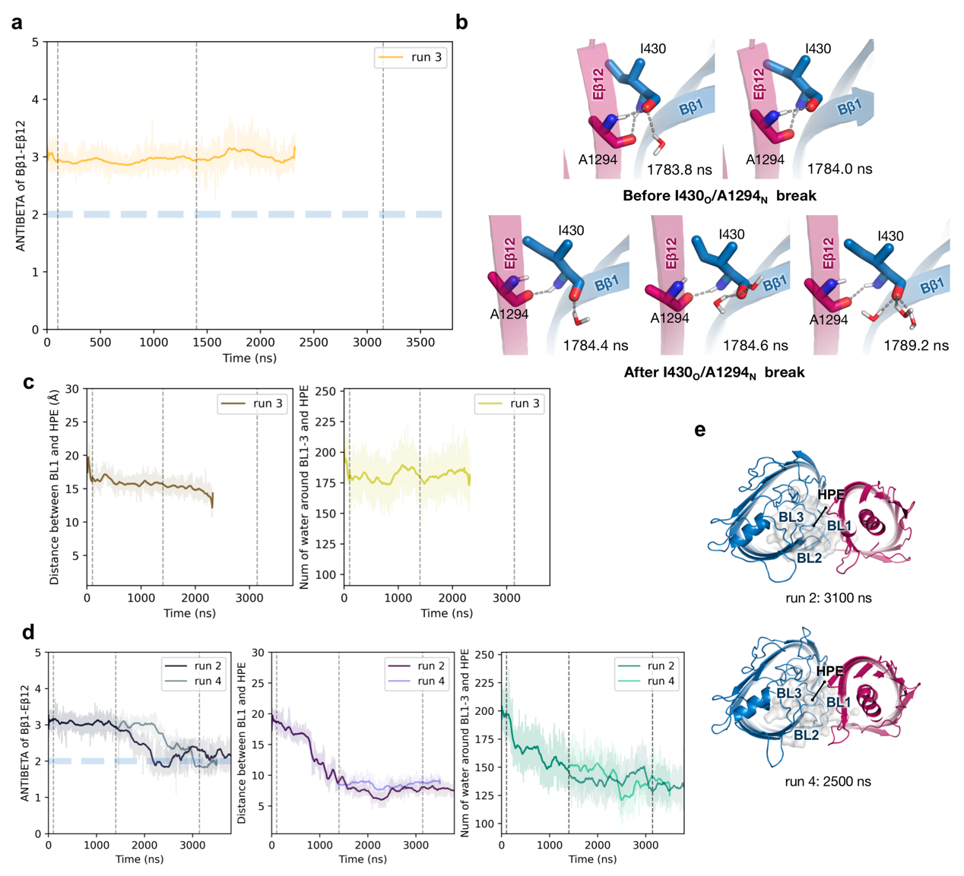
Supplementary Fig. 8 Conformational changes sampled from the ready-to-close state of BamA. a Analysis of antiparallel β sheet between Bβ1 and Eβ12 in run 3. b Snapshots of water molecules around I430/A1294 before and after the break of the hydrogen bond. c Distance between BL1 and HPE, and number of water molecules within 4 Å of BamA extracellular loop 1-3 (BL1-3) and HPE in run 3. d Analysis of the β-signal separation and BamA self-folding in run 4. e Snapshots of the hybrid barrel after the I430/A1294 separation in runs 2 and 4.

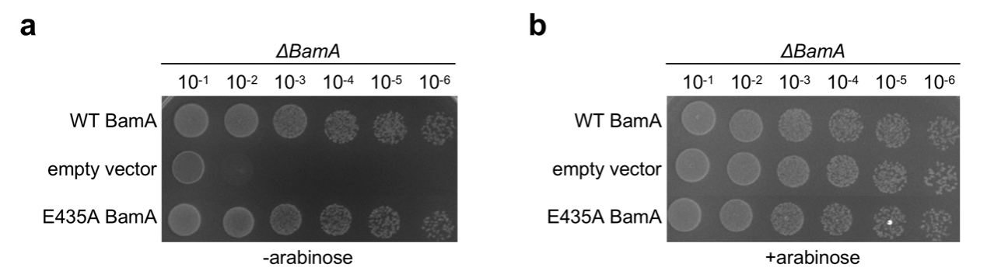
Supplementary Fig. 9 An investigation into the function of the negatively charged residue in BL1. Cellular viability assays of the BamA E435A mutant in the absence of arabinose (a) and the presence of arabinose (b). The viability assays were performed at least in triplicate with representative images shown.
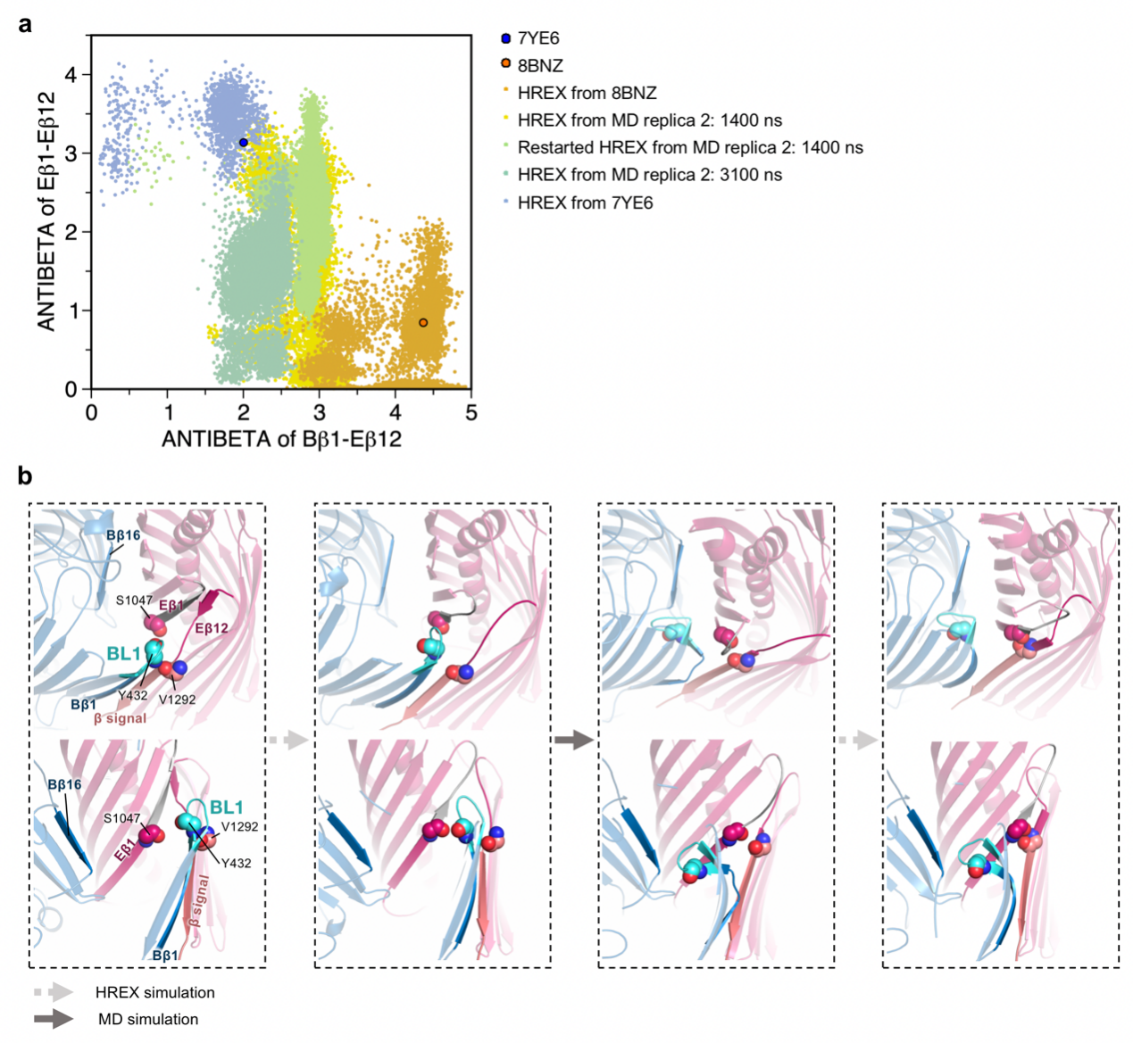
Supplementary Fig. 10 Explorations of pathways of the β-signal separation. a HREX simulations from the complexes during the hybrid barrel closing. b Snapshots of a possible pathway of the spontaneous hybrid barrel closure. The topology changes of hybrid barrel leave room for Eβ1 to bind to β signal.

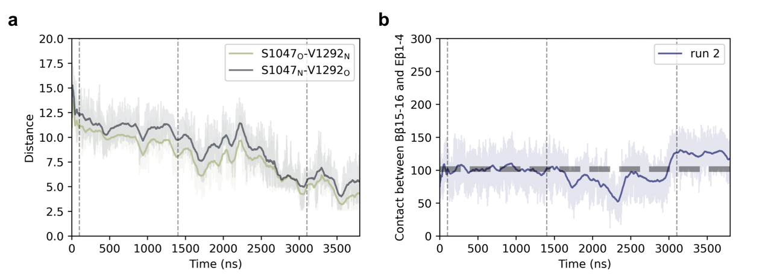
Supplementary Fig. 11 Spontaneous topology changes of BamA facilitate the approach of β1 to β signal. a Distance between backbone oxygen and nitrogen atoms, which can form hydrogen bonds between S1047 (on Eβ1) and V1292 (on β signal) in matured EspP during the hybrid barrel closure (in run 2). b Stability analysis of the hydrophobic interface between BamA and EspP during the closure (in run 2). The grey dotted line represents the number of contact atoms (within 3 Å) between Bβ15-16 and Eβ1-4 of the hybrid barrel without the separation (PDB ID 8BNZ).

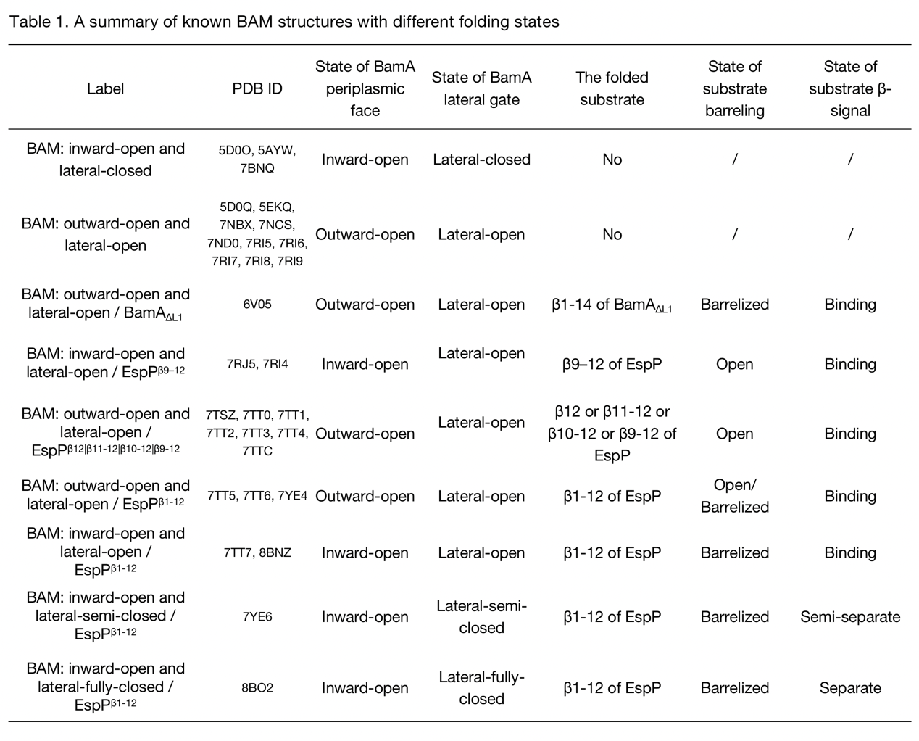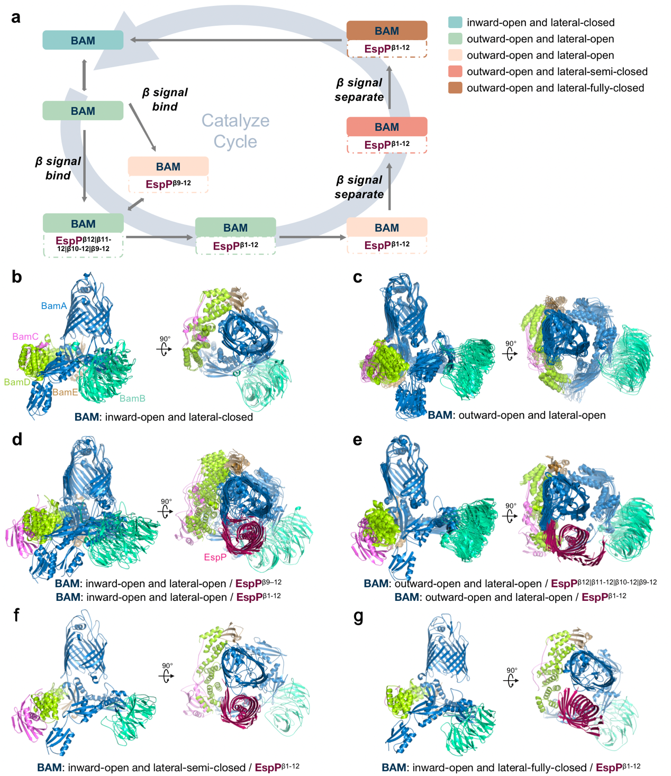
Supplementary Fig. 12 A catalysis cycle based on known structures of BAM-mediated EspP folding. a Schematic diagram showing the order of appearance of the different conformations in the catalysis cycle. b-g Comparisons of BamA-E of known structures with different folding stages summarized in Table 1, colored by subunit, with the views of BAM complexes and the orthogonal views from the top of BAM-EspP complexes.

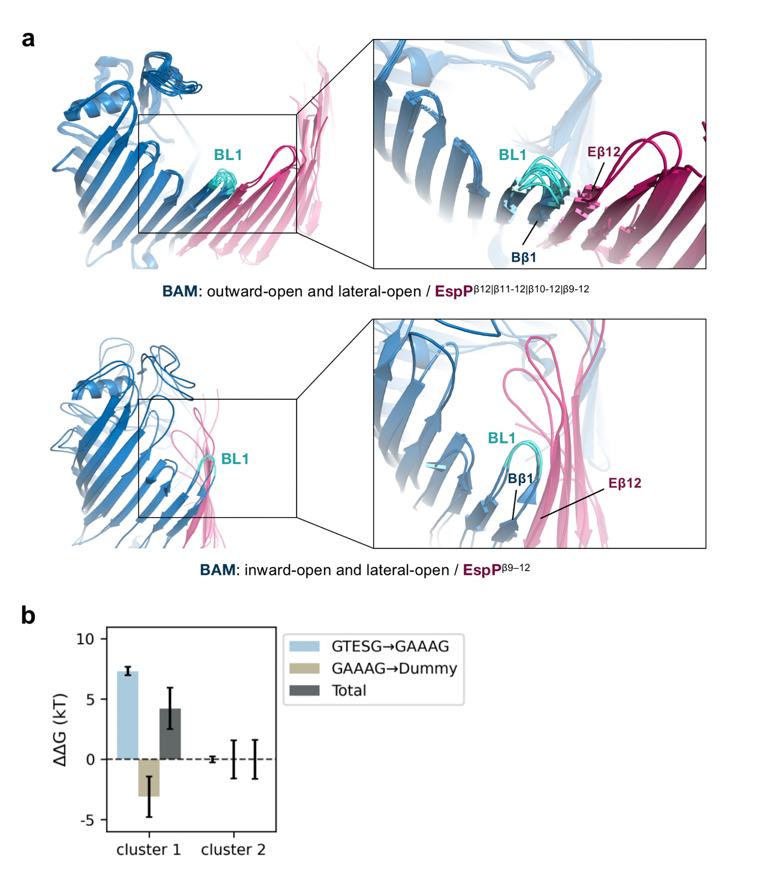
Supplementary Fig. 13 BL1 in different stages of folding. a Position and conformtion of BL1 during the earlier folding stages. b Comparison of binding free energy difference of between no separation (cluster 1) and the initial separation (cluster 2) of Y432/V1292 by FEP/HREX.
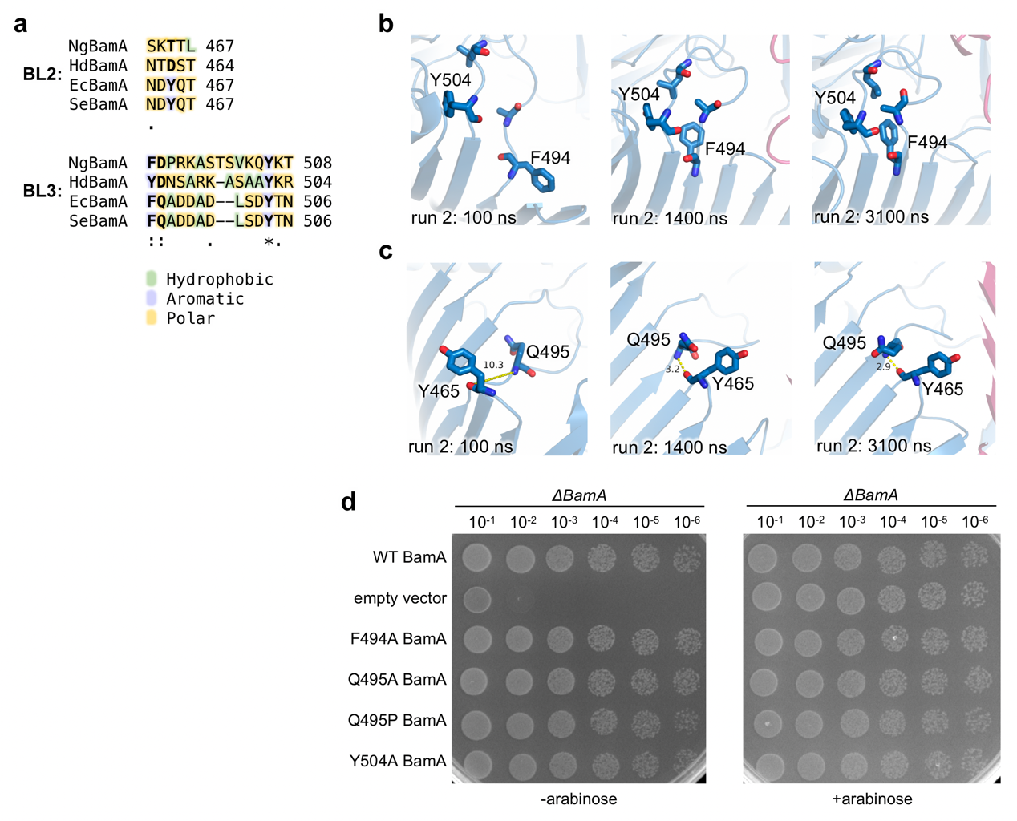
Supplementary Fig. 14 Robustness of BamA in the self-folding process. a Sequence alignment of BL2 and BL3 from Neisseria gonorrhoeae (Ng), Haemophilus ducreyi (Hd), Escherichia coli (Ec) and Salmonella enterica (Se). Hydrophobic, aromatic and polar amino acids are colored in light green, light purple and light orange, respectively. b-c Snapshots of BL3 and interfaces of BL2 and BL3, with the hybrid barrel shown by translucent cartoons, amino acids with changed conformations shown by sticks. d Cell viability assays with mutants mutated according to b-c. Each was performed at least in triplicate with representative images shown.
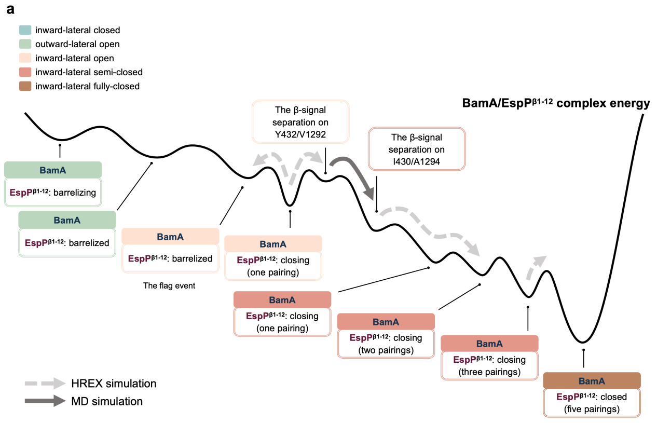
Supplementary Fig. 15 Speculative free energy landscape of the late-stage folding. a A speculative free energy landscape of the hybrid barrel with five BamA conformations and different EspP conformations. Two β-signal separation events occur at the transitional stages of the process.

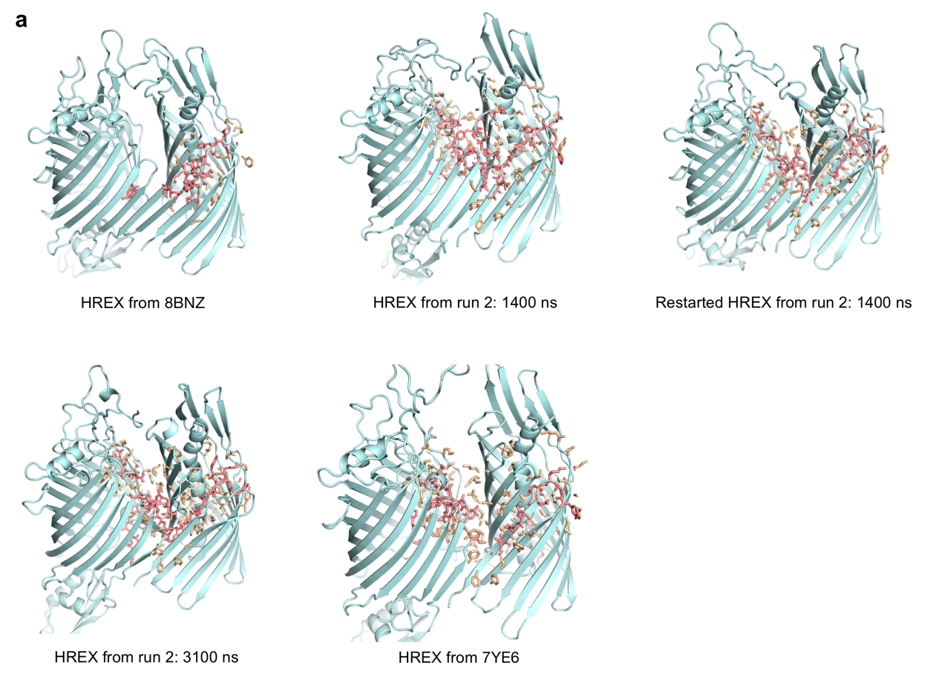
Supplementary Fig. 16 The partial solute selected at the interface between BamA and EspP for HREX simulations. The residues scaled with all atoms are shown by salmon sticks, and the residues scaled with only side chains are shown by light orange sticks.
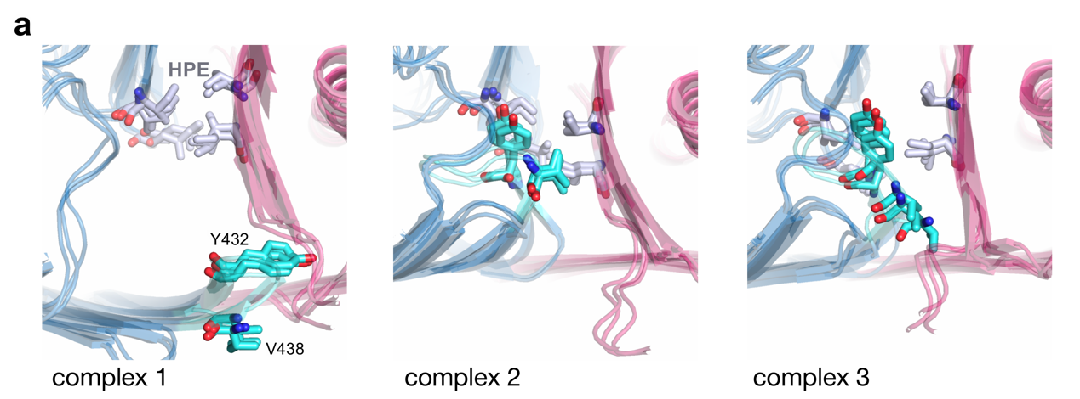
Supplementary Fig. 17 Confirmation of the stability of FEP/HREX simulations. a Comparison of the complexes before the annihilation, after GTESG→GAAAG and after GAAAG→Dummy.

Supplementary References
1. Stivala, A., Wybrow, M., Wirth, A., Whisstock, J. C. & Stuckey, P. J. Automatic generation of protein structure cartoons with Pro-origami. Bioinformatics 27, 3315–3316 (2011).
2. Frishman, D. & Argos, P. Knowledge-based protein secondary structure assignment. Proteins: Structure, Function, and Bioinformatics 23, 566–579 (1995).
3. Daura, X. et al. Peptide Folding: When Simulation Meets Experiment. Angewandte Chemie International Edition 38, 236–240 (1999).
4. The UniProt Consortium. UniProt: the Universal Protein Knowledgebase in 2023. Nucleic Acids Research 51, D523–D531 (2023).

