Supplementary Figure 1. Odds ratios (95% Confidence Intervals) of cross-classified quartiles of C-peptide concentration and quartiles of mammographic density parameters on invasive breast cancer risk

- Percent mammographic density B. Dense area
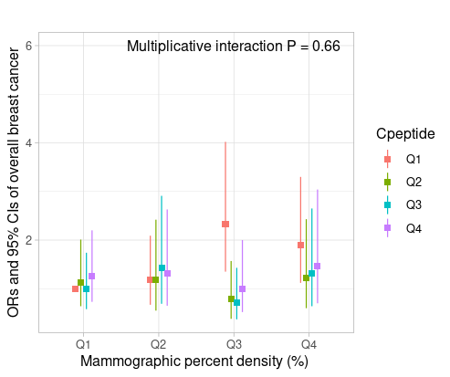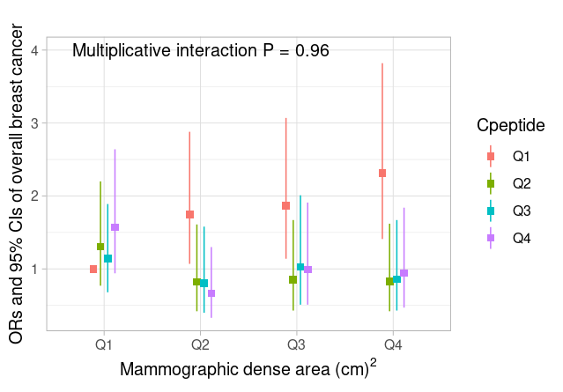
C. Non-dense area D. Texture V measure
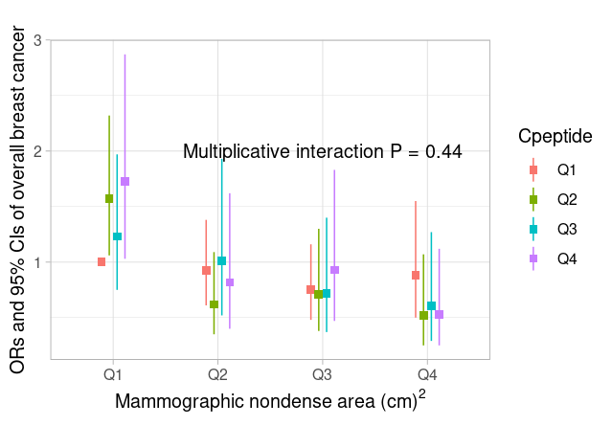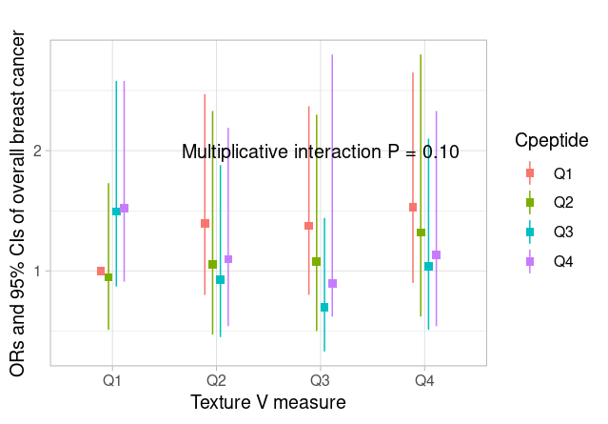

Supplementary Table 1. Batch specific quartiles for all women in Nurses’ Health Study and Nurses’ Health Study II combined
Number of the batch | Q1 | Q2 | Q3 | Q4
1 | < 2.08 | ≥ 2.08 to ≤ 2.89 | >2.89 to ≤ 4.10 | > 4.10
2 | < 1.74 | ≥1.74 to ≤ 2.26 | >2.26 to ≤ 3.24 | > 3.24
3 | < 1.79 | ≥ 1.79 to ≤ 2.53 | >2.53 to ≤ 3.53 | > 3.53
4 | < 1.94 | ≥ 1.94 to ≤2.61 | >2.61 to ≤ 3.61 | > 3.61
5 | < 1.80 | ≥ 1.80 to ≤2.47 | >2.47 to ≤ 3.47 | > 3.47
6 | < 1.28 | ≥ 1.28 to ≤1.84 | >1.84 to ≤ 3.02 | > 3.02
7 | < 1.12 | ≥ 1.13 to ≤1.56 | >1.56 to ≤ 2.41 | > 2.41
8 | < 1.19 | ≥ 1.19 to ≤1.67 | >1.67 to ≤ 2.59 | > 2.59
9 | < 1.00 | ≥ 1.00 to ≤1.40 | >1.40 to ≤ 2.13 | > 2.13
10 | < 0.70 | ≥ 0.68 to ≤1.00 | >1.00 to ≤ 1.67 | > 1.67

Supplementary Table 2. Associations between quartiles of C-peptide concentration, square-root transformed mammographic density parameters, and V measure among controls, Nurses’ Health Study and Nurses’ Health Study II combined (N= 2221): controlling for BMI, WHR, and BMI quadratic

 | Quartile of plasma c-peptide concentration |  |  |  | P-value of trend §
All women | Q1  N= 586 | Q2  N= 571 | Q3  N= 561 | Q4  N= 503
Square root mammographic percent density
Multivariate adjusted + BMI*+ WHR | Ref. | -0.11 (-0.34 to 0.12) | -0.15 (-0.40 to 0.09) | -0.13 (-0.41 to 0.15) |  | 0.07
Multivariate adjusted + BMI + BMI quadratic + WHR | Ref. | -0.10 (-0.33 to 0.13) | -0.13 (-0.37 to 0.12) | -0.12 (-0.40 to 0.16) |  | 0.08
Square root Dense area
Multivariate adjusted + BMI*+ WHR | Ref. | 0.12 (-0.18 to 0.42) | 0.05 (-0.27 to 0.37) | -0.03 (-0.40 to 0.34) |  | 0.47
Multivariate adjusted + BMI + BMI quadratic + WHR |  | 0.10 (-0.21 to 0.40) | -0.00 (-0.31 to 0.33) | -0.04 (-0.41 to 0.33) |  | 0.43
Square root Non dense area (cm²)
Multivariate adjusted + BMI*+ WHR | Ref. | 0.40 (0.07 to 0.72) | 0.34 (-0.01 to 0.69) | 0.41 (0.01 to 0.81) |  | 0.01
Multivariate adjusted + BMI + BMI quadratic + WHR | Ref. | 0.36 (0.03 to 0.69) | 0.28 (-0.07 to 0.62) | 0.39 (-0.01 to 0.79) |  | 0.02
All women ±
V measure
Multivariate adjusted + BMI*+ WHR | Ref. | 0.01 (-0.13 to 0.13) | 0.08 (-0.06 to 0.22) | 0.04 (-0.16 to 0.20) |  | 0.63
Multivariate adjusted + BMI + BMI quadratic + WHR | Ref. | 0.004 (-0.13 to 0.13) | 0.08 (-0.06 to 0.22) | 0.04 (-0.16 to 0.20) |  | 0.63

Abbreviation: BMI = Body mass index, WHR = Waist-to-hip ratio

† Adjusted for age at blood draw (continuous), the batch of mammography density reading (categorical), age at menarche (continuous), age at first birth/parity (nulliparous; 1 or 2 children and <25 years old; 1 or 2 children and 25+ years old; 3+ children and <25 years old; or 3+ children and 25+ years old), physical activity (continuous), benign breast diseases (yes, no), family history of breast cancer (yes, no), menopausal status (premenopausal; postmenopausal and MHT never users; postmenopausal and former MHT users; postmenopausal and current MHT users), fasting status, diabetes status (yes, no) at blood draw
*BMI (continuouse)
± Among women with V measure (N = 2,011).
§ P-value; tests for trend were conducted using the Wald test, where the medians of the quartiles were modeled continuously.
Supplementary Table 3. Associations between quartiles of C-peptide concentration, V measure, and measures of square root transformed mammographic breast density among controls, Nurses’ Health Study and Nurses’ Health Study II combined stratified by menopausal status.

 | Quartile of plasma c-peptide concentration (ng/mL) * |  |  |  | P-value of trend §
Premenopausal women | Q1  N = 283 | Q2  N = 277 | Q3  N = 221 | Q4  N = 212
Square root percent MD (%)
Mean | 6.50 (1.74) | 6.21 (1.79) | 5.65 (1.90) | 5.33 (2.10)
Multivariate adjusted | Ref. | -0.23 (-0.54 to 0.08) | -0.77 (-1.10 to -0.44) | -1.21 (-1.57 to -0.85) |  | <0.0001
Multivariate adjusted + BMI | Ref. | -0.07 (-0.35 to 0.21) | -0.19 (-0.50 to 0.11) | -0.16 (-0.51 to 0.18) |  | 0.14
Square root dense area (cm²)
Mean | 6.62 (1.89) | 6.74 (2.13) | 6.55 (2.67) | 6.33 (2.29)
Multivariate adjusted | Ref. | 0.25 (-0.14 to 0.63) | -0.02 (-0.43 to 0.39) | -0.22 (-0.66 to 0.23) |  | 0.08
Multivariate adjusted + BMI | Ref. | 0.30 (-0.09 to 0.69) | 0.16 (-0.26 to 0.58) | 0.10 (-0.38 to 0.58) |  | 0.67
Square root non-dense area (cm²)
Mean | 7.69 (2.64) | 8.47 (2.78) | 9.72 (3.79) | 10.37 (3.78)
Multivariate adjusted | Ref. | 0.77 (0.23 to 1.30) | 1.89 (1.32 to 2.46) | 2.87 (2.26 to 3.48) |  | <0.0001
Multivariate adjusted + BMI | Ref. | 0.37 (-0.07 to 0.80) | 0.58 (0.10 to 1.06) | 0.55 (0.10 to 0.109) |  | 0.02
V measure
Mean | 0.33 (0.89) | 0.30 (0.92) | 0.26 (0.94) | 0.06 (0.98)
Multivariate adjusted | Ref. | -0.01 (-0.17 to 0.15) | -0.07 (-0.24 to 0.10) | -0.25 (-0.44 to -0.06) |  | 0.001
Multivariate adjusted + BMI | Ref. | 0.05 (-0.11 to 0.20) | 0.13 (-0.05 to 0.30) | 0.09 (-0.11 to 0.28) |  | 0.48
Postmenopausal women | Q1  N = 303 | Q2  N = 294 | Q3  N = 340 | Q4  N = 291
Square root Percent density (%)
Mean | 5.18 (1.80) | 4.64 (1.73) | 4.20 (1.83) | 3.80 (1.74)
Multivariate adjusted $ | Ref. | -0.56 (-0.86 to -0.25) | -0.90 (-0.20 to 0.59) | -1.13 (-1.46 to -0.80) |  | <0.0001
Multivariate adjusted + BMI | Ref. | -0.25 (-0.54 to 0.04) | -0.30(-0.59 to -0.006) | -0.18 (-0.51 to 0.15) |  | 0.14
Square root Dense area (cm²)
Mean | 5.84 (2.14) | 5.65 (2.02) | 5.44 (2.37) | 5.23 (2.23)
Multivariate adjusted | Ref. | -0.20 (-0.60 to 0.20) | -0.35 (-0.74 to 0.04) | -0.39 (-0.81 to 0.03) |  | 0.08
Multivariate adjusted + BMI | Ref. | -0.07 (-0.47 to 0.33) | -0.10 (-0.51 to 0.30) | 0.01 (-0.45 to 0.47) |  | 0.93
Square root Non dense area (cm²)
Mean | 9.6 (2.7) | 11.0 (2.9) | 11.9 (3.0) | 13.3 (3.5)
Multivariate adjusted $ | Ref. | 1.49 (0.95 to 2.02) | 2.20 (1.68 to 2.72) | 3.40 (2.84 to 3.96) |  | <0.0001
Multivariate adjusted + BMI | Ref. | 0.65 (0.24 to 1.07) | 0.65 (0.23 to 1.07) | 0.84 (0.36 to 1.31) |  | 0.01
V measure
Mean | -0.12 (0.93) | -0.25 (0.91) | -0.38 (0.98) | -0.60 (0.92)
Multivariate adjusted $ | Ref. | -0.16 (-0.33 to 0.02) | -0.26 (-0.43 to -0.09) | -0.34 (-0.53 to -0.16) |  | 0.006
Multivariate adjusted + BMI | Ref. | -0.05 (-0.22 to 0.12) | -0.05 (-0.23 to 0.12) | -0.02 (-0.21 to 0.18) |  | 0.56

Abbreviation: BMI = Body mass index
† Adjusted for age at blood draw (continuous), a batch of mammography density reading (categorical), age at menarche (continuous), age at first birth/parity (nulliparous; 1 or 2 children and <25 years old; 1 or 2 children and 25+ years old; 3+ children and <25 years old; or 3+ children and 25+ years old), physical activity (continuous), benign breast diseases (yes, no), family history of breast cancer (yes, no), fasting status, diabetes status (yes, no) at blood drawn.
BMI (Continuous)
± Among women with V measure (N = 1,993).
§ P-value; tests for trend were conducted using the Wald test, where the medians of the quartiles were modeled continuously.

$ adjusted for menopausal hormone therapy (never/former/current use)

* Quartiles re-calculated for pre- and post-menopausal women separately.

Supplementary Table 4. Associations between quartiles of C-peptide concentration and measures of mammographic density and V measures, Nurses’ Health Study and Nurses’ Health Study II combined stratified by BMI (<24.9 vs. 25+kg/m²)
 | Quartile of plasma c-peptide concentration (ng/mL) |  |  |  | P-value of trend §
Normal BMI (≥18.5 to ≤24.9) (kg/m2) | Q1 | Q2 | Q3 | Q4
Square root Percent density (%)
Multivariate adjusted | Ref. | -0.01 (-0.24 to 0.22) | -0.22 (-0.48 to 0.04) | -0.04 (-0.33 to 0.33) |  | 0.13
Square root Dense area (cm²)
Multivariate adjusted | Ref. | 0.12 (-0.19 to 0.44) | 0.03 (-0.32 to 0.39) | 0.04 (-0.41 to 0.50) |  | 0.80
Square root Non-dense area (cm²)
Multivariate adjusted | Ref. | 0.23 (-0.11 to 0.57) | 0.66 (0.28 to 1.05) | 0.18 (-0.31 to 0.67) |  | 0.15
V measure
Multivariate adjusted | Ref. | 0.08 (-0.08 to 0.24) | 0.21 (0.05 to 0.37) | 0.13 (-0.05 to 0.30) |  | 0.15
Obese and overweight (≥25 (kg/m²) | Q1 | Q2 | Q3 | Q4
Square root Percent density (%)
Multivariate adjusted | Ref. | 0.00 (-0.44 to 0.45) | -0.16 (-0.59 to 0.27) | -0.14 (-0.58 to 0.31) |  | 0.09
Square root Dense area (cm²)
Multivariate adjusted | Ref. | 0.07 (-0.56 to 0.69) | -0.19 (-0.80 to 0.41) | -0.01 (-0.63 to 0.60) |  | 0.47
Square root Non dense area (cm²)
Multivariate adjusted | Ref. | 0.16 (-0.51 to 0.84) | 0.17 (-0.47 to 0.82) | 0.63 (0.03 to 1.30) |  | 0.002
V measure
Multivariate adjusted | Ref. | -0.01 (-0.25 to 0.23) | 0.03 (-0.20 to 0.27) | 0.09 (-0.14 to 0.33) |  | 0.38
Abbreviation: BMI = Body mass index,
Multivariate adjusted: Adjusted for age and BMI (continuous) at blood collection, a batch of mammography density reading (categorical), age at menarche (continuous), age at first birth/parity (nulliparous; 1 or 2 children and <25 years old; 1 or 2 children and 25+ years old; 3+ children and <25 years old; or 3+ children and 25+ years old), physical activity (continuous), benign breast diseases (yes, no), family history of breast cancer (yes, no), ), menopausal status (premenopausal; postmenopausal and MHT never users; postmenopausal and former MHT users; postmenopausal and current MHT users, fasting status, diabetes status (yes, no) at blood drawn.

Supplementary Table 5. Odds ratio of invasive breast cancer risk in relation to quartiles of C-peptide concentration, quartiles of mammographic density parameters, and V measure on a multiplicative scale among premenopausal women

 |  | Quartile of plasma c-peptide concentration (ng/mL) |  |  |  | P-value§
 | Q1 |  | Q2 | Q3 | Q4
Percent density (%) |  |  |  |  |  |  | 0.90
Q1, <25.47 | 1.00 (Ref.) |  | 0.86 (0.31 to 2.38) | 1.19 (0.47 to 3.13) | 1.84 (0.81 to 4.52)
Q2, ≥25.47 to < 41.45 | 1.65 (0.68 to 4.22) |  | 1.58 (0.46 to 5.46) | 0.81 (0.24 to 2.69) | 1.00 (0.32 to 3.06)
Q3, ≥ 41.45 to < 58.16 | 1.66 (0.70 to 4.17) |  | 1.37 (0.40 to 4.67) | 0.91 (0.27 to 3.00) | 0.91 (0.27 to 2.89)
Q4, ≥ 58.16 | 1.91 (0.82 to 4.78) |  | 1.53 (0.46 to 5.09) | 1.47 (0.43 to 4.85) | 0.72 (0.22 to 2.24)
Dense area (cm²) |  |  |  |  |  |  | 0.89
Q1, < 29.13 | 1.00 (Ref.) |  | 0.92 (0.41 to 2.03) | 0.79 (0.34 to 1.81) | 1.23 (0.56 to 2.72)
Q2, ≥ 29.13 to < 44.37 | 0.90 (0.42 to 1.92) |  | 1.13 (0.35 to 3.60) | 1.89 (0.62 to 5.90) | 1.71 (0.60 to 4.87)
Q3, ≥ 44.37 to < 63.97 | 1.17 (0.53 to 2.57) |  | 1.86 (0.65 to 5.42) | 1.83 (0.58 to 5.82) | 1.82 (0.61 to 5.53)
Q4, ≥ 63.97 | 1.51 (0.73 to 3.18) |  | 0.98 (0.35 to 2.82) | 1.32 (0.43 to 4.10) | 0.96 (0.32 to 2.83)
Non dense area (cm²) |  |  |  |  |  |  | 0.86
Q1, < 39.68 | 1.00 (Ref.) |  | 1.64 (0.86 to 3.12) | 1.38 (0.61 to 3.01) | 1.46 (0.63 to 3.27)
Q2, ≥3 9.68 to < 65.92 | 0.91 (0.48 to 1.73) |  | 0.82 (0.33 to 2.04) | 1.24 (0.44 to 3.60) | 1.38 (0.44 to 4.38)
Q3, ≥ 65.92 to < 115.36 | 0.73 (0.33 to 1.53) |  | 0.65 (0.24 to 1.78) | 0.82 (0.26 to 2.61) | 1.31 (0.43 to 4.12)
Q4, ≥ 115.36 | 0.80 (0.31 to 1.93) |  | 0.49 (0.15 to 1.63) | 0.48 (0.14 to 1.71) | 0.83 (0.26 to 2.76)
V measure |  |  |  |  |  |  | 0.57
Q1, < -0.27 | 1.00 (Ref.) |  | 1.54 (0.62 to 4.01) | 1.72 (0.68 to 4.53) | 3.03 (1.26 to 7.76)
Q2, ≥ -0.27 to < 0.35 | 2.08 (0.90 to 5.16) |  | 0.75 (0.23 to 2.39) | 0.70 (0.20 to 2.30) | 0.37 (0.11 to 1.16)
Q3, ≥ 0.35 to ≤0.91 | 1.04 (0.38 to 2.84) |  | 1.12 (0.31 to 4.00) | 1.29 (0.35 to 4.73) | 0.74 (0.20 to 2.64)
Q4, > 0.91 | 2.80 (1.21 to 6.91) |  | 0.66 (0.20 to 2.04) | 0.40 (0.11 to 1.31) | 0.34 (0.10 to 1.08)

* Adjusted for age (continuous), BMI (continuous), age at menarche (continuous), age at first birth/parity (nulliparous; 1 or 2 children and <25 years old; 1 or 2 children and 25+ years old; 3+ children and <25 years old; or 3+ children and 25+ years old), physical activity (continuous), benign breast diseases (yes, no), family history of breast cancer (yes, no), fasting status, diabetes status (yes, no) at blood collection and matching factors.

§ Multiplicative interaction was tested with a likelihood ratio test through comparing 2 generalized linear models with and without the interaction term.

Supplementary Table 6. Odds ratio of invasive breast cancer risk in relation to quartiles of C-peptide concentration, quartiles of mammographic density parameters and V measure on multiplicative scale among postmenopausal women

 |  | Quartile of plasma c-peptide concentration (ng/mL) |  |  |  | P-value§
 | Q1 |  | Q2 | Q3 | Q4
Percent density (%) |  |  |  |  |  |  | 0.96
Q1, <11.20 | 1.00 (Ref.) |  | 1.17 (0.54 to 2.61) | 0.89 (0.42 to 1.93) | 1.19 (0.56 to 2.63)
Q2, ≥11.20 to < 22.17 | 1.49 (0.69 to 3.32) |  | 0.74 (0.26 to 2.01) | 1.00 (0.37 to 2.64) | 1.05 (0.40 to 2.73)
Q3, ≥ 22.17 to < 36.33 | 1.63 (0.78 to 3.56) |  | 0.80 (0.30 to 2.09) | 1.17 (0.44 to 3.04) | 1.30 (0.50 to 3.33)
Q4, ≥ 36.33 | 2.16 (1.06 to 4.62) |  | 1.11 (0.42 to 2.85) | 0.95 (0.36 to 2.42) | 1.30 (0.49 to 3.41)
Dense area (cm²) |  |  |  |  |  |  | 0.82
Q1, < 18.72 | 1.00 (Ref.) |  | 0.90 (0.44 to 1.83) | 0.68 (0.35 to 1.36) | 1.42 (0.73 to 2.81)
Q2, ≥ 18.72 to < 32.22 | 1.33 (0.68 to 2.66) |  | 1.22 (0.48 to 3.09) | 1.66 (0.66 to 4.14) | 0.66 (0.26 to 1.67)
Q3, ≥ 32.22 to < 51.82 | 1.61 (0.86 to 3.08) |  | 1.13 (0.46 to 2.80) | 1.20 (0.47 to 3.00) | 0.98 (0.42 to 2.31)
Q4, ≥ 51.82 | 1.87 (0.97 to 3.66) |  | 1.12 (0.44 to 2.81) | 1.38 (0.56 to 3.35) | 1.05 (0.43 to 2.52)
Non dense area (cm²) |  |  |  |  |  |  | 0.61
Q1, < 78.05 | 1.00 (Ref.) |  | 1.65 (0.98 to 2.80) | 0.90 (0.45 to 1.74) | 1.35 (0.69 to 2.63)
Q2, ≥ 78.05 to < 121.71 | 1.03 (0.61 to 1.73) |  | 0.54 (0.25 to 1.15) | 1.00 (0.41 to 2.39) | 1.25 (0.50 to 3.11)
Q3, ≥ 121.71 to < 181.43 | 0.90 (0.50 to 1.62) |  | 0.45 (0.19 to 1.05) | 0.92 (0.37 to 2.31) | 1.02 (0.42 to 2.50)
Q4, ≥ 181.43 | 0.79 (0.32 to 1.84) |  | 0.51 (0.18 to 1.51) | 0.93 (0.31 to 2.90) | 0.76 (0.26 to 2.32)
V measure |  |  |  |  |  |  | 0.57
Q1, < -0.92 | 1.00 (Ref.) |  | 1.07 (0.52 to 2.25) | 1.11 (0.55 to 2.29) | 1.37 (0.68 to 2.83)
Q2, ≥ -0.92 to < -0.30 | 1.33 (0.63 to 2.83) |  | 0.84 (0.31 to 2.24) | 0.61 (0.23 to 1.61) | 1.10 (0.43 to 2.82)
Q3, ≥ -0.30 to ≤ 0.39 | 1.52 (0.77 to 3.07) |  | 0.75 (0.29 to 1.94) | 0.79 (0.31 to 2.00) | 0.71 (0.28 to 1.78)
Q4, > 0.39 | 1.18 (0.59 to 2.42) |  | 1.65 (0.64 to 4.25) | 0.88 (0.34 to 2.27) | 1.52 (0.58 to 3.93)

* Adjusted for age (continuous), BMI (continuous), age at menarche (continuous), age at first birth/parity (nulliparous; 1 or 2 children and <25 years old; 1 or 2 children and 25+ years old; 3+ children and <25 years old; or 3+ children and 25+ years old), physical activity (continuous), benign breast diseases (yes, no), family history of breast cancer (yes, no), fasting status, diabetes status (yes, no), menopausal hormone therapy use (never, former, current use ) at blood collection and matching factors.

§ Multiplicative interaction was tested with a likelihood ratio test through comparing 2 generalized linear models with and without the interaction term.

