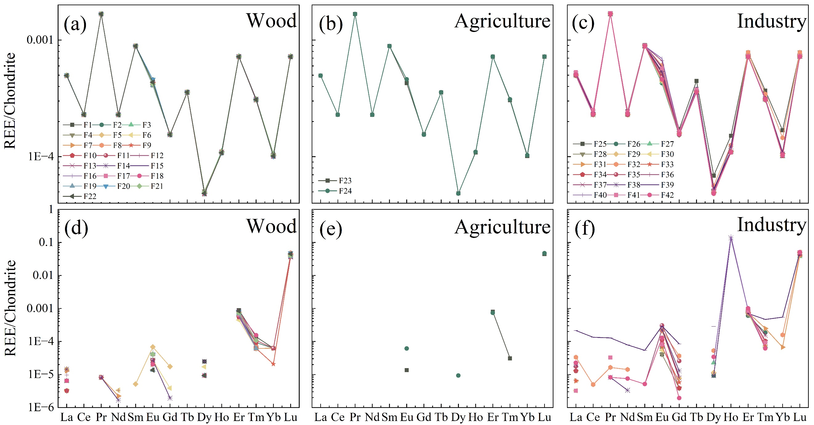

Fig. S1 Chondrite-normalized REE patterns in three regions, (a, b, c) in the dry season, (d, e, f) in the normal season.

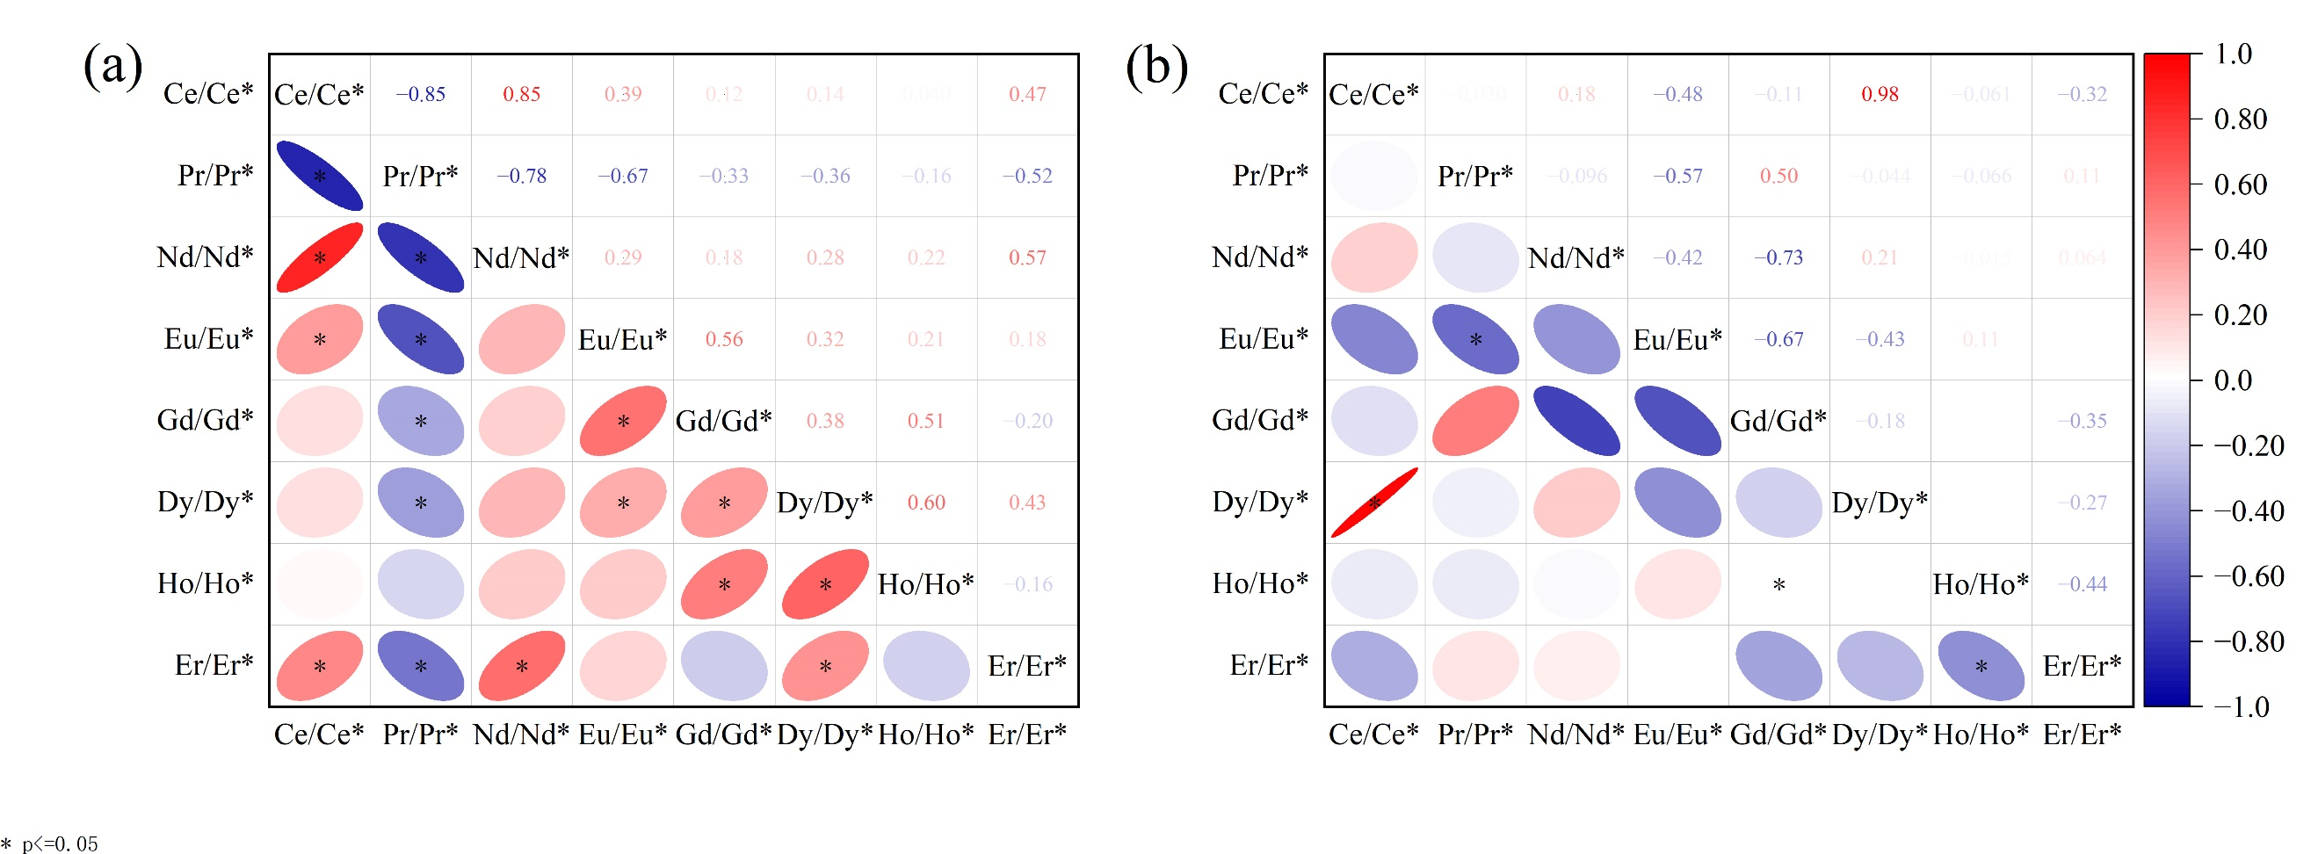

Fig. S2 Correlations between REE anomalies, (a) in the dry season, (b) in the normal season.

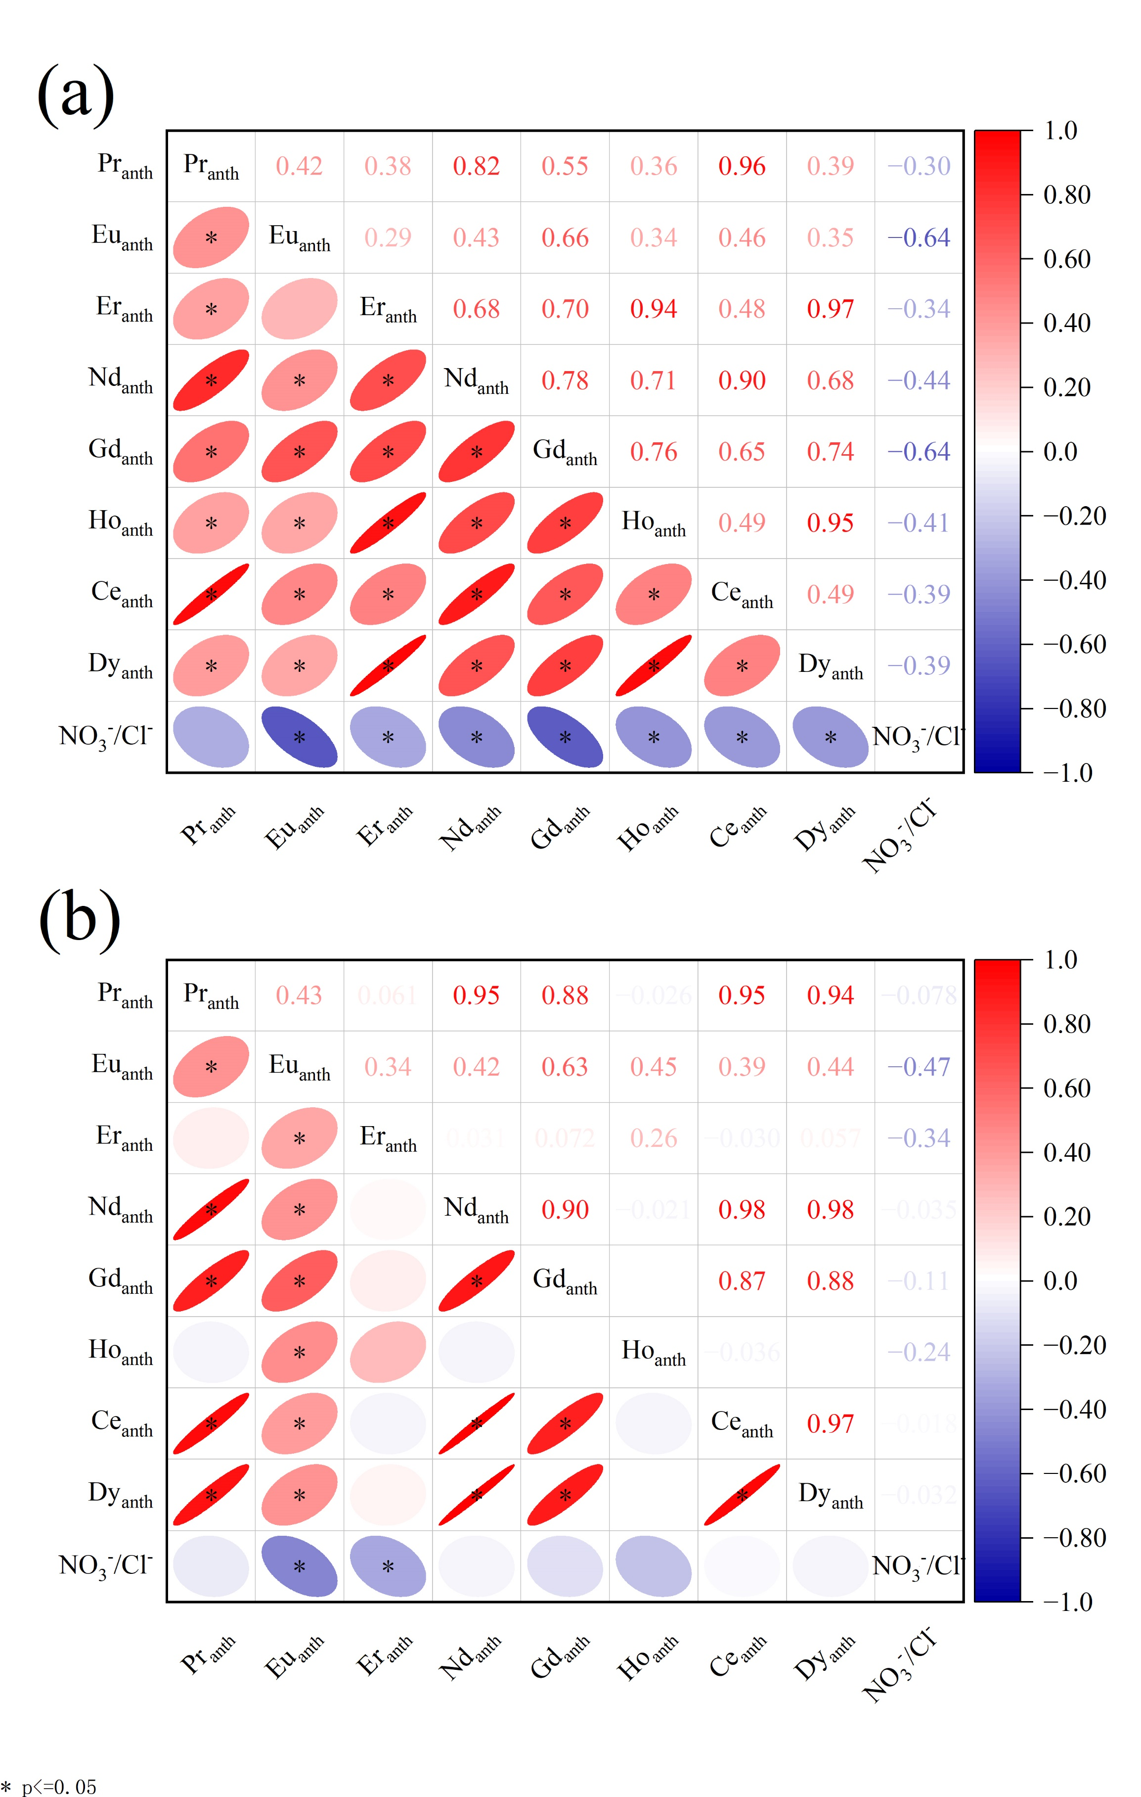

Fig. S3 Correlations between REE_{anth} and NO₃⁻/Cl⁻, (a) in the dry season, (b) in the normal season.

Table S1 Reactions and constants of REE complexation to anions added to PHREEQC database (Ionic strength IS = 0, temperature 25 ℃)
Reactions | Equilibrium constants
Reactions | La | Ce | Pr | Nd | Sm | Eu | Gd | Tb | Dy | Ho | Er | Tm | Yb | Lu
REE³⁺+H₂O=REEOH²⁺+H⁺ | -8.81 | -8.34 | -8.32 | -8.18 | -7.84 | -7.76 | -7.83 | -7.64 | -7.59 | -7.56 | -7.52 | -7.39 | -7.24 | -7.27
REE³⁺+2H₂O=REE(OH)₂⁺+2H⁺ | -18.84 | -17.6 | -17.27 | -17.04 | -16.51 | -16.37 | -16.37 | -16.18 | -16.1 | -16.07 | -15.96 | -15.88 | -15.74 | -16.67
REE³⁺+3H₂O=REE(OH)₃+3H⁺ | -27.9 | -27.23 | -26.63 | -26.4 | -25.91 | -25.41 | -25.28 | -25.08 | -24.83 | -24.56 | -24.35 | -24.18 | -23.85 | -23.85
REE³⁺+CO₃²⁻=REECO₃⁺ | 7.12 | 7.4 | 7.57 | 7.69 | 7.81 | 8 | 7.97 | 8.08 | 8.14 | 8.18 | 8.24 | 8.32 | 8.4 | 8.43
REE³⁺+2CO₃²⁻=REE(CO₃)₂⁻ | 11.3 | 11.76 | 12.08 | 12.17 | 12.53 | 12.63 | 12.48 | 12.78 | 12.91 | 13 | 13.12 | 13.27 | 13.3 | 13.37
REE³⁺+SO₄²⁻=REESO₄⁺ | 3.62 | 3.59 | 3.62 | 3.64 | 3.66 | 3.66 | 3.66 | 3.64 | 3.61 | 3.59 | 3.59 | 3.59 | 3.59 | 3.59
REE³⁺+F⁻=REEF²⁺ | 3.12 | 3.28 | 3.48 | 3.56 | 3.58 | 3.63 | 3.75 | 3.85 | 3.89 | 3.95 | 3.98 | 3.99 | 4.02 | 4.05
REE³⁺+2F⁻=REEF₂⁺ | 3.63 | 3.85 | 3.86 | 3.82 | 4.14 | 4.26 | 4.23 | 4.36 | 4.39 | 4.28 | 4.27 | 4.28 | 4.37 | 4.24
REE³⁺+Cl⁻=REECl²⁺ | 0.74 | 0.68 | 0.71 | 0.71 | 0.67 | 0.69 | 0.71 | 0.67 | 0.7 | 0.71 | 0.7 | 0.71 | 0.69 | 0.67
REE³⁺+2Cl⁻=REECl₂⁺ | 0.51 | 0.46 | 0.45 | 0.47 | 0.42 | 0.44 | 0.46 | 0.43 | 0.43 | 0.45 | 0.45 | 0.46 | 0.44 | 0.43
REE³⁺+NO₃⁻=REE(NO₃)²⁺ | 0.58 | 0.69 | 0.69 | 0.79 | 0.78 | 0.83 | 0.47 | 0.51 | 0.15 | 0.25 | 0.15 | 0.2 | 0.25 | 0.56

