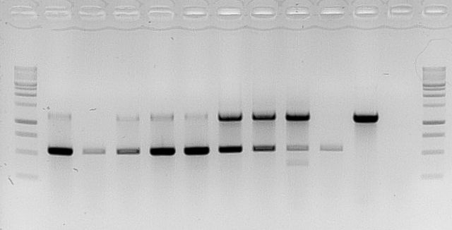
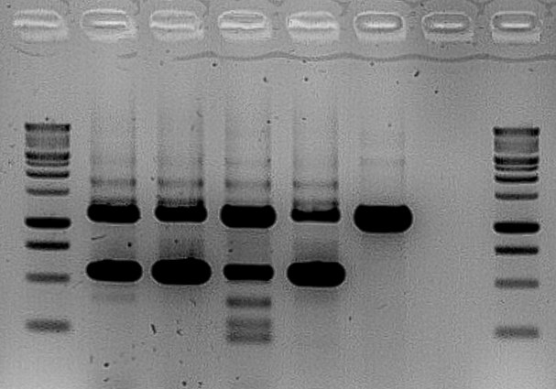
M
1
2
3
4
5
6
M
M
1
2
3
4
5
6
M
7
8
9
10
11
A
B
1000bp
1500bp
500bp
750bp
1000bp
1500bp
500bp
750bp

Fig. S1. Result of PCR amplifications. RoFT amplication of genomic DNA (1110 bp) and transgene cDNA (536 bp).
A: Rosa DELdog Pimprenelle®) : Lane 1, 8.1_1.1, lane 2, 8.1_1.2, lane 3 8.1_1.2, lane 4, 8.2_4.1, lane 5, NT, lane 6, negative control.
B: Rosa DELtrimen Guy Savoy®) :lane 1, A2.1 , lane 2, A2.2, lane 3 , B1.1, lane 4, B1.2, lane 5, B1.3, lane 6, C3.1, lane 7, C3.2, lane 8, C5.1, lane 9, C6.1, lane 10, NT, lane 11, negative control. M molecular weight ladder.

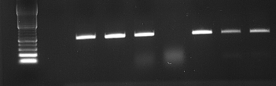
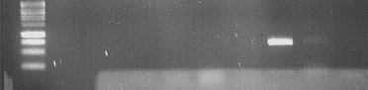
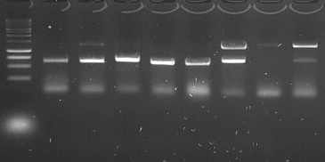
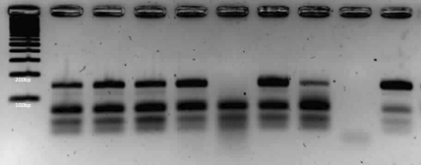
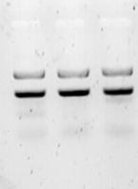
RoCEN
RoKSN^{null}
RoKSN^{copia}
RoKSN^{WT}
Ladder
GS PIMP

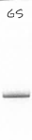

Fig. S2: Genotyping of RoKSN for GS and PIMP. Using different primers, we have genotyped all the known alleles at the RoKSN locus. The genotyping was done based on previous described methods for RoKSN^{copia} (³¹), RoKSN^{null} (³³), RoKSN^{A181} and RoKSNG¹⁸¹ (³⁴). GS is RoKSN^{null} / RoKSN^{copia} whereas PIMP is RoKSN^{copia} / RoKSN^{G181}. The presence of the RoKSN^{G181} allele in GS is explained by the presence of the G at position 181 in the RoKSN^{copia} allele.

