Supplementary Information
Electrically Driven Spin Resonance of 4f Electrons
in a Single Atom on a Surface

Stefano Reale^{1,2,3}, Jiyoon Hwang^{1,4}, Jeongmin Oh^{1,4}, Harald Brune⁵, Andreas J. Heinrich^{1,4}, Fabio Donati^{1,4}*, and Yujeong Bae^{1,4}*
¹ Center for Quantum Nanoscience (QNS), Institute for Basic Science (IBS), Seoul 03760, Republic of Korea
² Ewha Womans University, Seoul 03760, Republic of Korea
³ Department of Energy, Politecnico di Milano, Milano 20133, Italy
⁴ Department of Physics, Ewha Womans University, Seoul 03760, Republic of Korea
⁵ Institute of Physics, Ecole Polytechnique Fédérale de Lausanne, 1015 Lausanne, Switzerland
*corresponding authors: F.D. (donati.fabio@qns.science), Y.B. (bae.yujeong@qns.science)

Table of contents
- Experimental set-up and identification of atomic species
- Atom manipulation to construct Er-Ti dimers
- Electron spin resonance on isolated Ti and Er
- Tip position dependence of ESR signals on the Er-Ti dimer
- Electron spin resonance spectra with out-of-plane magnetic fields
- Electron spin resonance spectra around the energy level crossing
- Rate equation model
- Measurement of Rabi oscillations
- Dimer with ¹⁶⁷Er

- Experimental set-up and identification of atomic species
From the STM image in Fig. S1a, it is possible to distinguish the MgO(100) patch from the Ag(100) substrate by the different apparent height. On top of the MgO patch different atoms are distinguishable by their distinct apparent heights: ~130 pm for Ti on the oxygen site (Ti_{O}), ~210 pm for Ti on the bridge site (Ti_{B}), ~210 pm for Er on the oxygen site (Er_{O}), ~285 pm for Er on the bridge site (Er_{B}), and ~170 pm for Fe on the oxygen site. The species are further identified by their dI/dV spectra (Fig. S1b─k). While most of the atoms are distinguishable from the apparent heights and the spectral features, the Er_{O} and Ti_{B} present a similar apparent height as well as no clear spectral features. To distinguish these two species, we utilize the spin-polarized STM tip. In contrast with Er_{O} (Fig. S1h), the dI/dV spectrum on TiB measured using the spin-polarized STM tip (Fig. S1g) presents a feature characteristic of a spin-flip excitation at around 0 mV (1) similarly to Ti_{O} (Fig. S1f). In the main text and in the following sections, we simply refer to Ti_{B} as Ti and Er_{O} as Er.
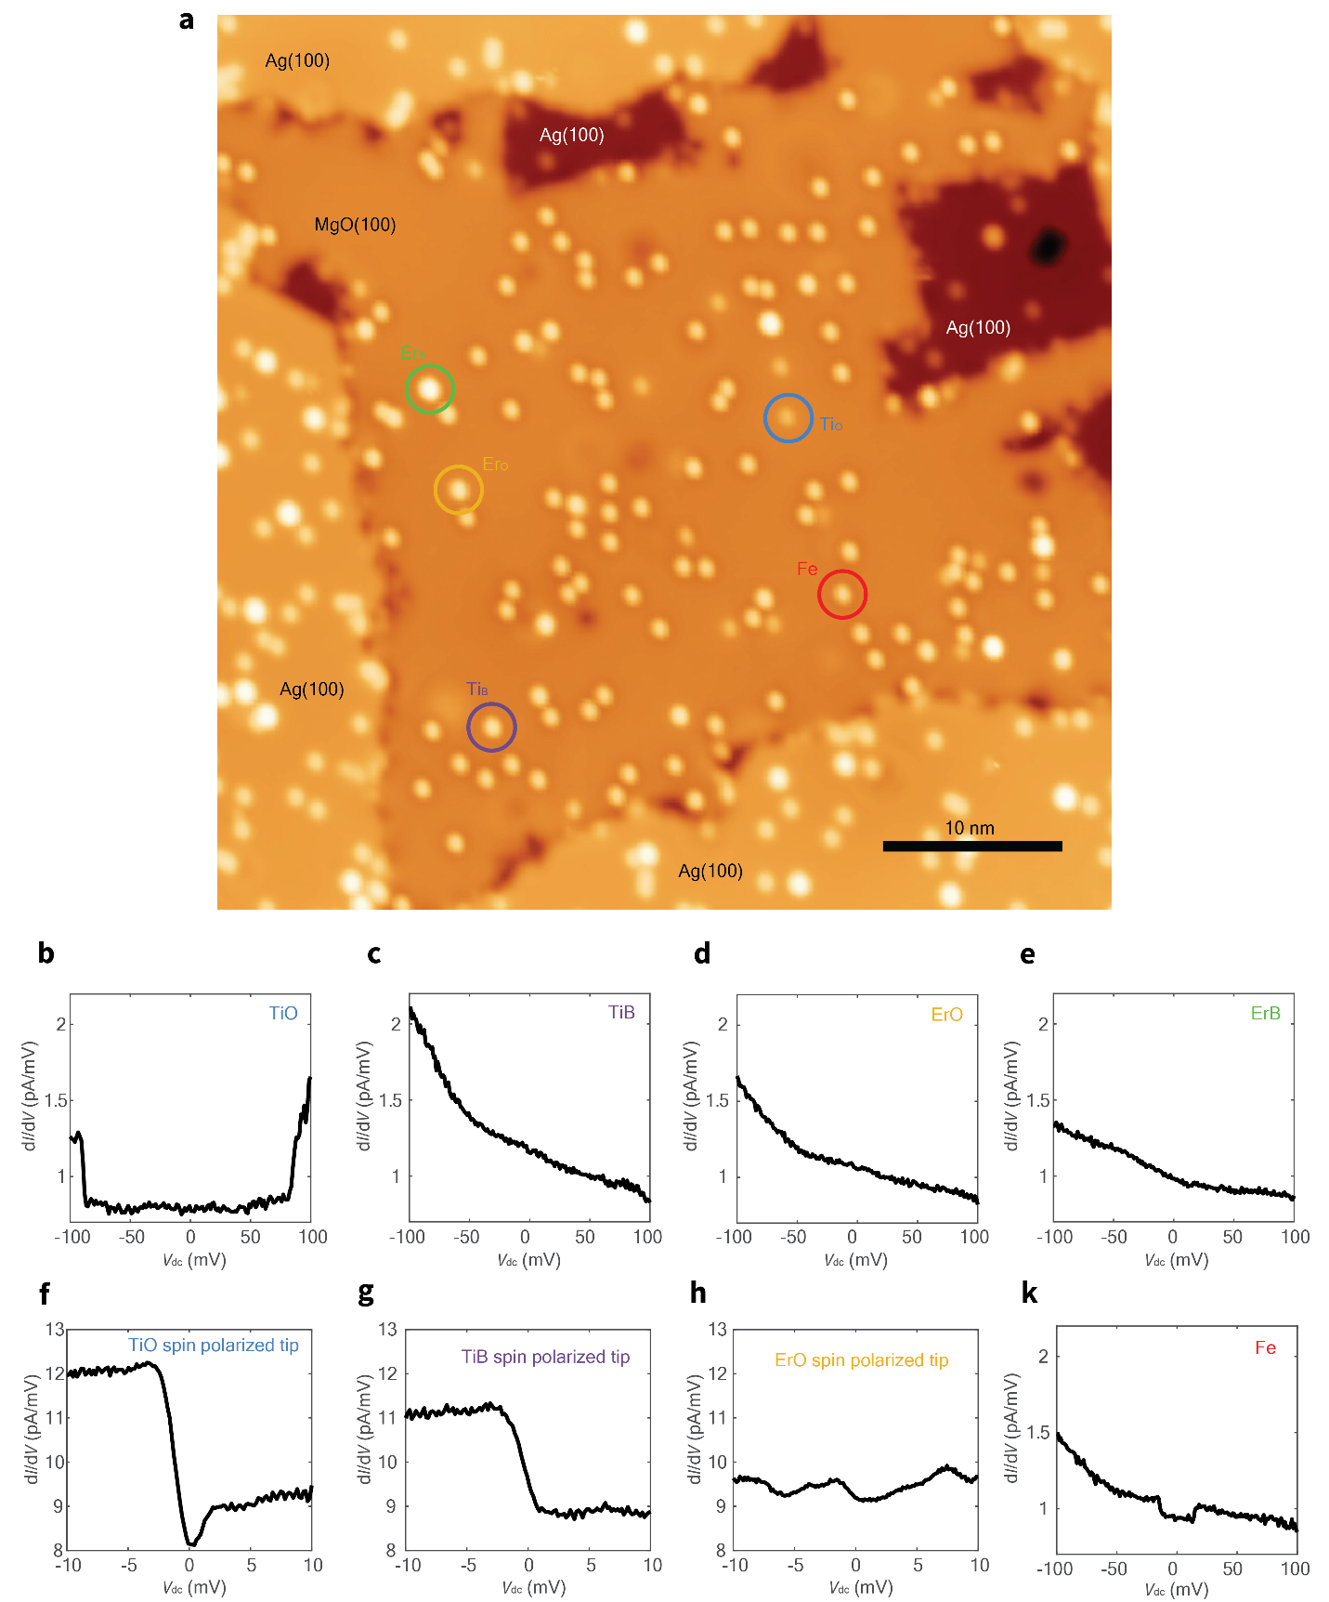
Figure S1 | Characterization of the atomic species. a, Constant current STM image of the Ag(100) surface partially covered by two-monolayers of MgO(100) (set point: V_{dc} = 100 mV, I_{dc} = 20 pA). The different atomic species can be distinguished by their apparent heights and dI/dV features: (b) Ti on the oxygen site (Ti_{O}), (c) Ti on the bridge site (Ti_{B}), (d) Er on the oxygen site (Er_{O}), (e) Er on the bridge site (Er_{B}), Fe (k). (f) Ti_{O} and (g) Ti_{B} present a spin-flip excitation at around 0 mV when measured with a spin polarized tip, while no excitation is present on Er_{O} (h).

- Atom manipulation to construct Er-Ti dimers
The Er-Ti dimer used to acquire the data presented in Fig. 1c,d was built through atom manipulation. After identifying a Ti atom and an Er atom, we manipulated the Ti adsorption site by the following procedure: 1) position the STM tip 1 lattice site away from the Ti center (set point: V_{dc} = 100 mV, I_{dc} = 20 pA), 2) switch off the STM feedback, 3) approach the tip by 330 pm to the surface, 4) apply a voltage pulse of 330 mV, and 5) switch the feedback on. This procedure allows us to move the Ti atom by half lattice sites (from Ti_{O} to Ti_{B} and vice versa) in a controlled manner. We repeated this procedure until we obtained the desired Er-Ti dimer with a distance of 0.928 nm (Fig. S2) with the Ti atom placed at the (-2, 2.5) lattice position from Er. We used a similar procedure to preapare the Er-Ti dimers with 0.72 nm separation with the Ti atom placed at the (±2.5, 0) or (0, ±2.5) lattice position from Er.

Figure S2 | Constant-current STM image of the Er-Ti dimer with 0.928 nm separation (set point: V_{dc} = 100 mV, I_{dc} = 20 pA). The intersection of grids represents the oxygen site of MgO and the lattice vectors (a,b) are superimposed on the grid.
- Electron spin resonance on isolated Ti and Er
In order to perform ESR on an isolated Er atom, we confirmed whether the prepared spin-polarized tip is suitable to perform ESR or not, by measuring the ESR signal on an isolated Ti atom (Fig. S3a). When positioning the same tip over an isolated Er atom, however, no ESR peak was detectable (Fig. S3b)
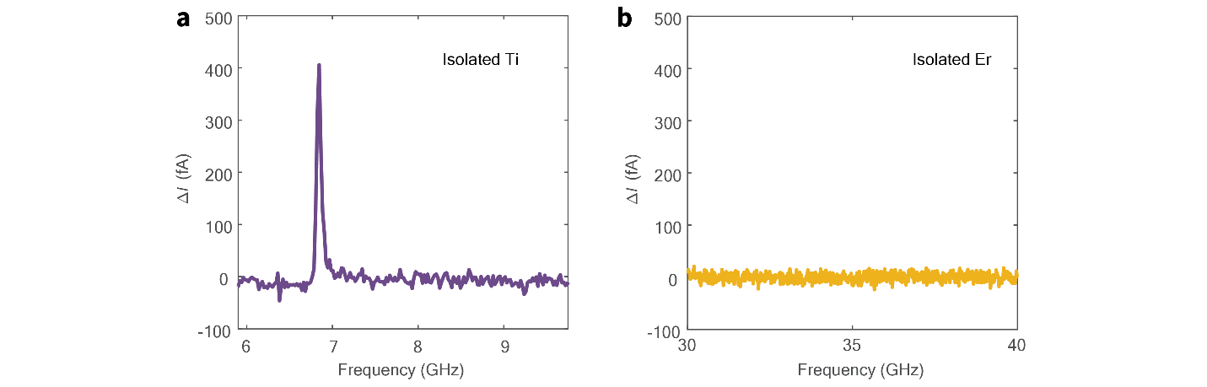
Figure S3 | Electron spin resonances on the isolated atoms. a, ESR spectrum measured with the STM tip positioned above an isolated Ti atom (set point: V_{dc} = 60 mV, I_{dc} = 20 pA, V_{rf} = 20 mV, B = 0.28 T, ϑ = 97°). b, ESR spectrum measured with the STM tip positioned above an isolated Er atom (set point: V_{dc} = 50 mV, I_{dc} = 50 pA, V_{rf} = 20 mV, B = 0.28 T, ϑ = 97°).

- Electron spin resonance spectra with out-of-plane magnetic fields
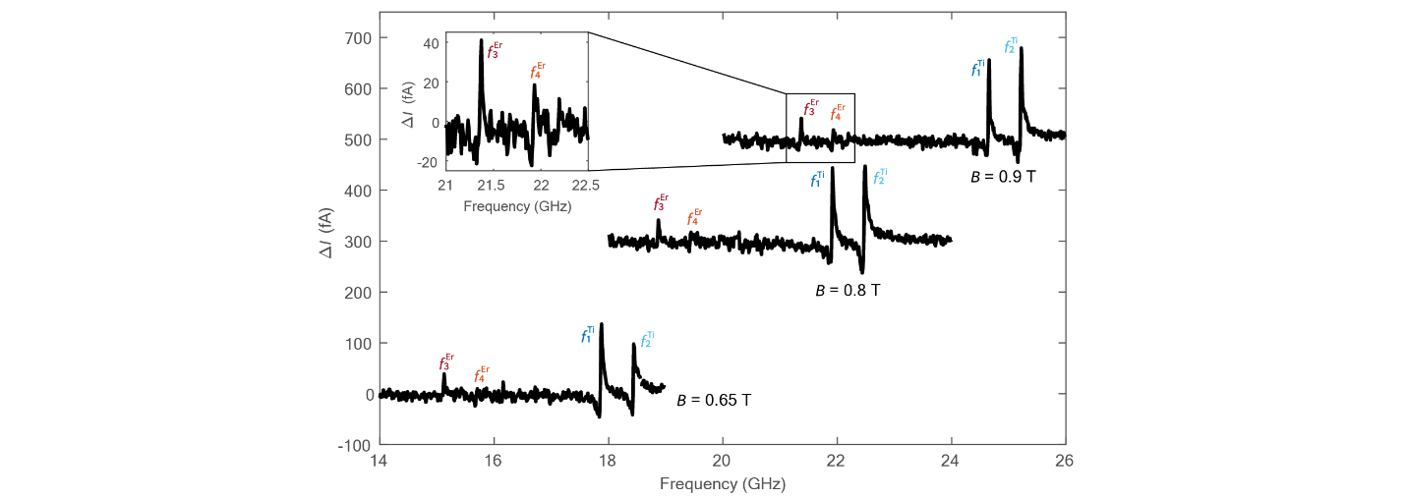
Figure S4 | Electron spin resonance at out-of-plane magnetic fields. ESR spectra measured on the Er-Ti dimer with 0.72 nm separation at different magnetic fields close the out-of-plane direction (ϑ = 7°): B = 0.65 T, 0.8 T, and 0.9 T (set point: V_{dc} = 70 mV, I_{dc} = 20 pA, V_{rf} = 25 mV). The spectra at B = 0.8 T and 0.9 T were shifted in ΔI by 300 fA and 500 fA, respectively, for clarity. The inset on the top left corner shows a zoomed-in spectrum of the peaks f₃ and f₄.
When we applied the magnetic field close to the out-of-plane direction (ϑ = 7°), we observed 4 ESR peaks (Fig. S4). As explained in the main text, when the magnetic field is applied out-of-plane (ϑ = 0°) the expectation value of $J_{Er}$ is ħ/2 similarly to $S_{Ti}$. However, the Er g-factor is 1.2, while Ti has a g-factor of 1.989 (3). The peaks at lower frequencies, thus, correspond to the Er ESR transitions ($f_{3}^{Er}$ and $f_{4}^{Er}$) due to the smaller Zeeman energy of Er than the one of Ti. To further clarify the identification of ESR peaks, we measured the ESR speactra at different magnitudes of magnetic fields at ϑ = 7° and followed the linear dependence of their resonance frequencies on the magnetic field magnitudes.

- Electron spin resonance spectra close to the level crossing
When the magnetic field is applied at about 12° from the normal to the surface (ϑ ~12°), we expect Er and Ti to have similar Zeeman splittings. In this situation, the intermediate energy levels of the Er-Ti dimer with 0.72 nm separation must be regarded as singlet ($\frac{1}{\sqrt{2}}\left|\left.↑\right\rangle \right.-\frac{1}{\sqrt{2}}\left|\left.↑\right\rangle \right.)$ and triplet states ($\frac{1}{\sqrt{2}}\left|\left.↑\right\rangle \right.+\frac{1}{\sqrt{2}}\left|\left.↑\right\rangle \right.)$ (4) as explained in the main text. In Fig. S5, we show three ESR spectra acquired around the expected matching angle, i.e. ϑ = 14.5°, 17°, and 22°. When the ESR spectrum is acquired at ϑ = 22°, all four ESR transitions from $f_{1}^{Ti}$ to $f_{4}^{Er}$ are visible, with $f_{3}^{Er}$ and $f_{4}^{Er}$ observed at higher frequencies than $f_{1}^{Ti}$ and $f_{2}^{Ti}$. In addition, the different peak intensities between $f_{1}^{Ti}$ and $f_{2}^{Ti}$ (with the intensity of $f_{1}^{Ti}$ larger than $f_{2}^{Ti}$) indicate an antiferromagnetic coupling between Er and Ti (5). Conversely, for both ϑ = 17° and ϑ = 14.5° , it is not possible to identify the $f_{3}^{Er}$ and $f_{4}^{Er}$ peaks stemming from Er ESR transitions. Nevertheless, for both spectra measured for ϑ ≤ 17° $f_{1}^{Ti}$ and $f_{2}^{Ti}$, the asymmetry is reversed, suggesting a change of the system configuration possibly due to the close match between the Er and Ti levels at around ϑ = 12°. As discussed in the main text, close to ϑ = 12° the energy levels of the system cannot be represented as Zeeman product states and for this reason the detection mechanism for both the Ti and the Er peaks explained in the main text may not be valid in this range of ϑ.
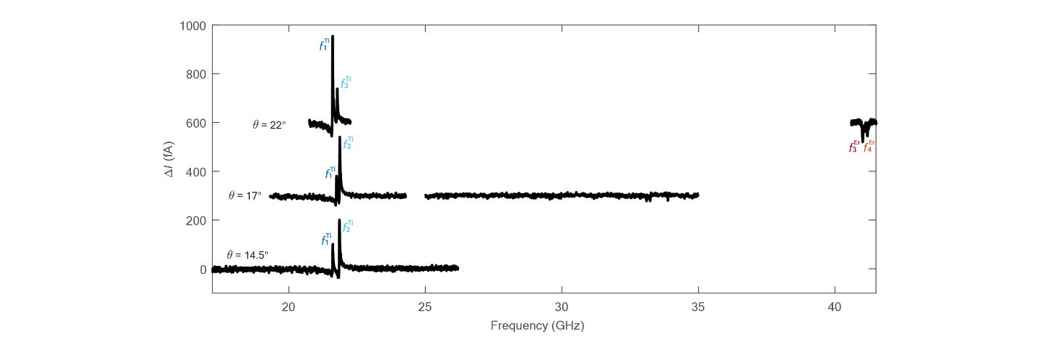
Figure S5 | Electron spin resonance close to the level crossing point. ESR spectra on the Ti atom of the 0.72 nm dimer at ϑ = 14.5°, ϑ = 17° and ϑ = 22° (set point: V_{dc} = 70 mV, I_{dc} = 12 pA, V_{rf} = 20 mV, B = 0.8 T). The spectra at ϑ = 17° and ϑ = 22° were shifted in ΔI by 300 fA and 600 fA respectively for clarity.

- Tip position dependence of ESR signals on the Er-Ti dimer
As mentioned in the main text, when the tip is positioned above the Ti atom in the Er-Ti dimer with 0.72 nm separation, we can resolve up to 5 ESR peaks. However when we move the tip away from the Ti center, the peaks related to the Er ESR transitions decrese in intensity (Fig. S6). When the tip is about 0.3 nm from the Ti center the intensity of the peaks is too low to be resolved (spectrum 2). In a similar way, when the tip is positioned above Er no peaks are detectable (spectrum 1).
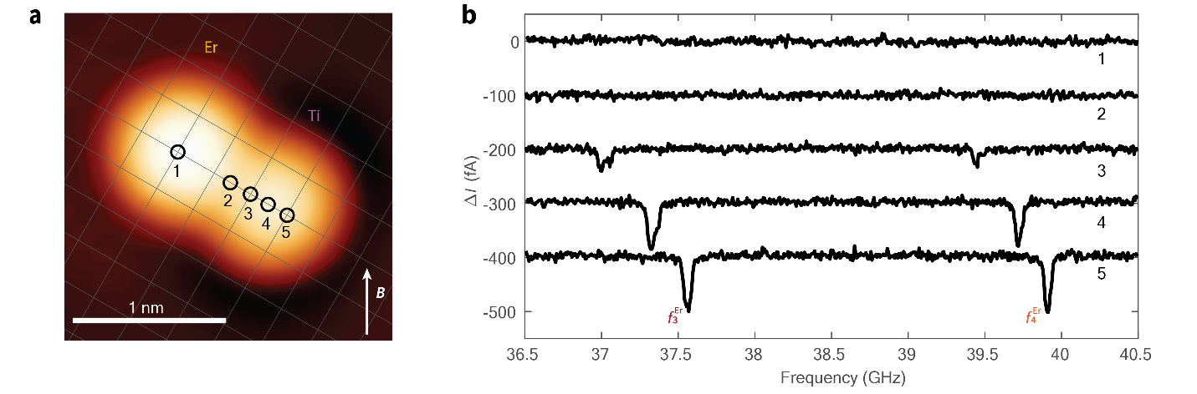
Figure S6 | Electron spin resonance at different tip locations on the Er-Ti dimer. a, STM image of the Er-Ti dimer with spacing of 0.72 nm (set point: V_{dc} = 100 mV, I_{dc} = 20 pA) with a grid superimposed representing the MgO lattice. The different locations where the tip was positioned during the ESR measurement are depicted as black circles numbered from 1 to 5. b, ESR spectra at different tip locations on the dimer (set point: V_{dc} = 70 mV, I_{dc} = 12 pA, V_{rf} = 25 mV, B = 0.28 T, ϑ = 97°), when the tip is approached laterally to the Er atom, the Er ESR peaks, $f_{3}^{Er}$ and $f_{4}^{Er}$, shift to lower frequencies due to the antiferromagnetic interaction between the Er atom and the magnetic tip. The intensity of the peaks decreases with moving the tip away from the Ti atom and no peaks are detectable at a distance of 0.3 nm from its center (spectrum 2). The spectra 2, 3, 4 and 5 were shifted vertically by -100 fA, -200 fA, -300 fA and -400 fA respectively for clarity.

- Rate equation model
To reproduce the different sign of the peaks of the Er’s ESR transitions shown in Fig. 3a, as well as the dependence of the peak intensity as a function of the driving strength (V_{rf}) displayed in Fig. 3b of the main text, we developed a rate equation model based on the four-level scheme picture of Fig. S7a. The rate equations consist of 4 differential equations:
$$\frac{dn_{00}}{dt}=-\left(W_{1}+Γ_{1-}^{Ti}\right)n_{00}-\left(W_{3}+Γ_{3-}^{Er}\right)n_{00}+\left(W_{1}+Γ_{1+}^{Ti}\right)n_{10}+\left(W_{3}+Γ_{3+}^{Er}\right)n_{01}$$
$$\frac{dn_{10}}{dt}=-\left(W_{1}+Γ_{1+}^{Ti}\right)n_{10}-\left(W_{4}+Γ_{4-}^{Er}\right)n_{10}+\left(W_{1}+Γ_{1-}^{Ti}\right)n_{00}+\left(W_{4}+Γ_{4+}^{Er}\right)n_{11}$$
$$\frac{dn_{01}}{dt}=-\left(W_{2}+Γ_{2-}^{Ti}\right)n_{01}-\left(W_{3}+Γ_{3+}^{Er}\right)n_{01}+\left(W_{2}+Γ_{2+}^{Ti}\right)n_{11}+\left(W_{3}+Γ_{3-}^{Er}\right)n_{00}$$
$$\frac{dn_{11}}{dt}=-\left(W_{2}+Γ_{2+}^{Ti}\right)n_{11}-\left(W_{4}+Γ_{4+}^{Er}\right)n_{11}+\left(W_{2}+Γ_{2-}^{Ti}\right)n_{01}+\left(W_{4}+Γ_{4-}^{Er}\right)n_{10}$$
Here, $n_{x}$ is the population of the level $x$, $W_{y}$ is the driving of the transition $y$, and $Γ_{y}$ is the relaxation rate of the levels connected by the transition $y$. The “+” and “–“ superscripts in the relaxation rates indicate if the relaxation is towards a lower energy level (+) or a higher energy level (–), such that the total relaxation can be written as $Γ_{y}=Γ_{y+}-Γ_{y-}$. We distinguish the total relaxation rates for Er and Ti by computing $Γ^{Er}=1/T_{1}^{Er}$ and $Γ^{Ti}=1/T_{1}^{Ti}$. In addition, we conserve the total population, $n_{00}+n_{10}+n_{01}+n_{11}=1$. To obtain the steady state solution we set the derivatives equal to zero. By considering a specific driving $W_{y}$ and solving the system of equations in the steady state, we obtain the population of each level. We included the spin pumping term ($ζ$) as a shift of the population of the levels given by the injection of $\left|\left.↑\right\rangle \right.$ states into Ti, as follows:
$$n_{00}^{spin pumping}=n_{00}-ζ$$
$$n_{10}^{spin pumping}=n_{10}+ζ$$
$$n_{01}^{spin pumping}=n_{01}-ζ$$
$$n_{11}^{spin pumping}=n_{11}+ζ$$
We used the rate equation model to fit the V_{rf} dependence of the peak intensity in Fig. 3b. We set $T_{1}^{Ti}$ = 10 ns (7) and $T_{1}^{Er}$ = 818 ns. We used two different driving terms for Er and Ti transitions: $W^{Ti}=W_{1}=W_{2}=A^{Ti}V_{rf}^{2}$ and $W^{Er}=W_{3}=W_{4}=A^{Er}V_{rf}^{2}$, where $A^{Ti,Er}$ is the respective scaling factor for the driving of Ti and Er ESR. The fitting parameters are $A^{Ti}$, $A^{Er}$and the spin pump term. The fitting yielded $A^{Ti}$ = 14917, $A^{Er}$ = 29338 and a negative spin pump of ─0.94%. The driving term can be expressed as $W= T_{2}Ω^{2}/2$ (8). The rabi rate $Ω$ depends on the strength of the modulation provided by the tip-atom or atom-atom coupling and it is linear with V_{rf} and, thus, the scaling factor $A$. As discussed in the main text and in the previous section, the Er-Ti coupling is 3─4 times smaller than Fe-Ti dimers used for remote ESR of 3d electrons (6, 9). Therefore, we expect a lower Rabi rate for Er since its driving comes from the modulation of its magnetic interaction with Ti. On the other hand, the fit yields a driving factor $A^{Er}$ larger than $A^{Ti}$, which suggests a much longer T₂ of Er compared to other 3d elements, possibly due to the well protected 4f orbitals.
The spin pumping term $ζ$ is required to account for the different sign of the Er peaks observed with different ESR tips, as shown in Fig. 3a in the main text. As discussed in the following, our model indicates that a negative $ζ$ produces negative Er peaks while the opposite is true for a positive $ζ$. In Fig. S7b, we show the effect of $ζ$ on $f_{3}^{Er}$ in the rate equation model. In the absence of spin pumping, a small positive signal is predicted. This is due to the difference in energy between the ESR transitions $f_{1}^{Ti}$ and $f_{2}^{Ti}$ which leads to an intrinsic difference between $Γ_{1}^{Ti}$ and $Γ_{2}^{Ti}$.
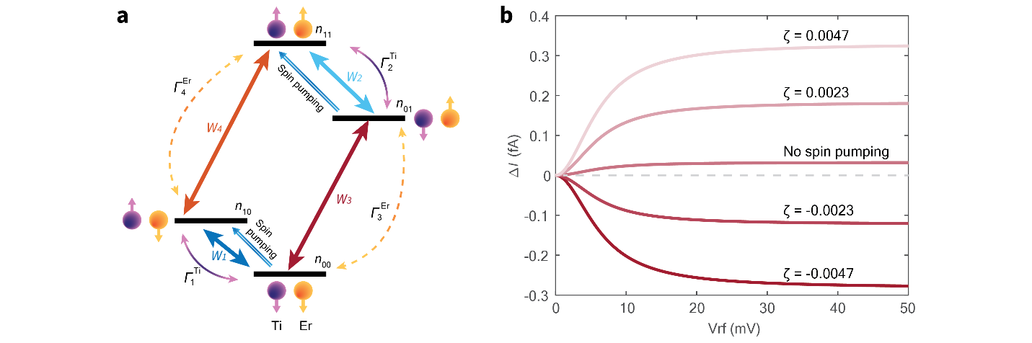
Figure S7 | Rate equation model and spin pumping dependence of the signal. a, 4-level scheme relative to the rate equation model reporting the driving term (W), relaxation rates (Γ) and a positive spin pump term ($ζ$). b, Effect of the spin pump term for the $f_{3}^{Er}$ peak intensity (ΔI) as a function of V_{rf} predicted by the rate equation model. A negative $ζ$ produces a negative ESR signal while a positive $ζ$ produces a positive ESR signal. When the spin pumping is excluded from the model, a slightly positive ESR signal is predicted.

- Measurement of Rabi oscillations
To measure Rabi oscillations on Ti and Er atoms, we followed a procedure similar to the one used in (7). With the STM tip positioned on top of the Ti atom in the Er-Ti dimer with 0.72 nm separation, we applied a series of V_{rf} pulses at the resonance frequency of f₁ (Fig. S8a) and f₃ (Fig. S8b) with increasing pulse widths. We subtracted a linear fit to the data in order to remove the rf rectified current given by the nonlinearity of the I-V curve (10). When we apply rf pulses at the resonance frequency of f₁ we can resolve Rabi oscillations in the Ti spin (Fig. S8a). The fit of the signal measured on a Ti atom with an exponentially decaying sinusoidal function yields a Rabi rate Ω_{Ti} of 435 MHz ± 41 MHz and a $T_{2 Rabi}^{Ti}$ of 9.9 ns ± 3.4 ns. On the other hand, when we apply rf pulses at the resonance frequency of f₃, no Rabi oscillation is observed. The monotonic decrease of the signal is due to the negative sign of the f₃ peak, which reaches saturation for sufficiently long rf pulses.
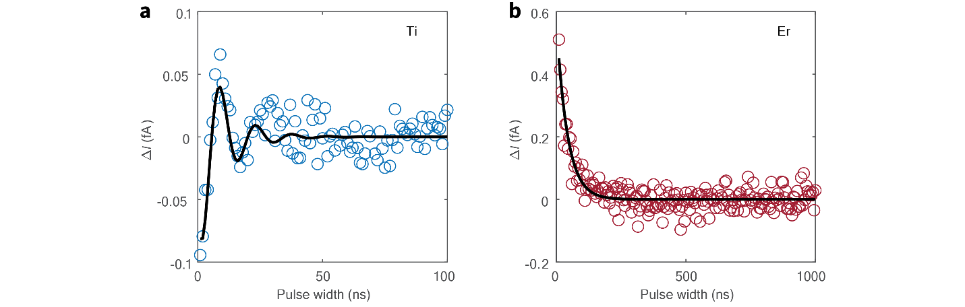
Figure S8 | Rabi measurements. a, Pulsed ESR measured with the STM tip on the Ti atom of the Er-Ti dimer with 0.72 nm separation. With the pulses applied at the resonance frequency of $f_{2}^{Ti}$, Rabi oscillations for the Ti spin are clearly observed (set point: V_{dc} = 20 mV, I_{dc} = 10 pA, V_{rf} = 70 mV, B = 0.288 T, ϑ = 97°). The black line is a fit using an exponentially decaying sine function. b, Pulsed ESR measured with the STM tip on the Ti atom of the same dimer but with the pulses at the resonance frequency of $f_{3}^{Er}$ (set point: V_{dc} = 70 mV, I_{dc} = 50 pA, V_{rf} = 90 mV, B = 0.288 T, ϑ = 97°). The black line is an exponential fit as a guide for the eye.

- Dimer with ¹⁶⁷Er
When measuring different Er-Ti dimers at the same separations (0.72 nm), we observed that a small fraction of them do not show any peak in the Er ESR transition range (Fig. S9). We ascribe this observation to the presence of ¹⁶⁷Er isotopes on the surface, which is the only observationally stable isotope of Er with a non-zero nuclear spin, present with a 22.9% abundancy. This isotope presents a nuclear spin of 7ħ/2. When driving ESR transitions on this atom, a single ESR peak is expected to split into 8 peaks due to its hyperfine interaction with the nuclear spin (11). However, as for this atom the intensity of the Er ESR transition is also reduced by a factor of 8 and, the ESR signal becomes too small to be detected in the present detection scheme. Nevertheless, this observation further supports the interpretation that f₃ and f₄ correspond to ESR transitions in the Er 4f spins since these transitions are the only ones that should be affected by the hyperfine interaction between the Er electron and nuclear spins.
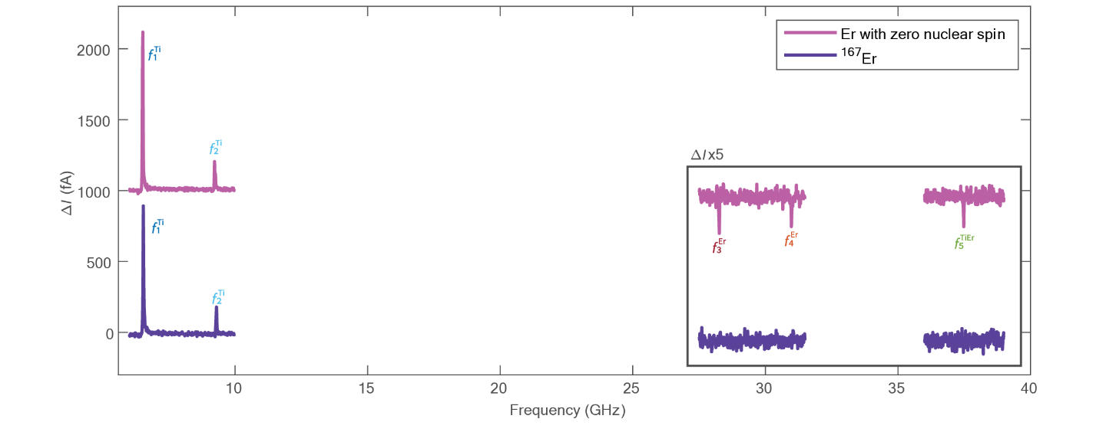
Figure S9 | Electron spin resonance on dimer containing ¹⁶⁷Er. ESR spectra acquired with the same STM tip on top of Ti in two different dimers: in the standard Ti-Er dimer (pink line, shifted in ΔI by -1000 fA for readability) 5 peaks are detectable ($f_{1}^{Ti}$, $f_{2}^{Ti}$, $f_{3}^{Er}$, $f_{4}^{Er}$ and $f_{5}^{TiEr}$) while in the dimer containing ¹⁶⁷Er with nuclear spin 7ħ/2 (purple line), only $f_{1}^{Ti}$ and $f_{2}^{Ti}$ (related to Ti transitions) are detectable (set point: V_{dc} = 60 mV, I_{dc} = 20 pA, V_{rf} = 15 mV, B = 0.3 T, ϑ = 52°).

References

1. S. Loth, K. von Bergmann, M. Ternes, A. F. Otte, C. P. Lutz, A. J. Heinrich, Controlling the state of quantum spins with electric currents. Nature Physics 6, 340-344 (2010).
2. S. Reale, A. Singha, S. L. Ahmed, D. Krylov, L. Colazzo, C. Wolf, C. S. Casari, A. Barla, E. Fernandes, F. Patthey, M. Pivetta, S. Rusponi, H. Brune, F. Donati, Erbium and thulium on MgO(100)/Ag(100) as candidates for single atom qubits. Physical Review B 107, 045427 (2023).
3. J. Kim, W.-j. Jang, T. H. Bui, D.-J. Choi, C. Wolf, F. Delgado, Y. Chen, D. Krylov, S. Lee, S. Yoon, C. P. Lutz, A. J. Heinrich, Y. Bae, Spin resonance amplitude and frequency of a single atom on a surface in a vector magnetic field. Physical Review B 104, 174408 (2021).
4. Y. Bae, K. Yang, P. Willke, T. Choi, A. J. Heinrich, C. P. Lutz, Enhanced quantum coherence in exchange coupled spins via singlet-triplet transitions. Science Advances 4, eaau4159 (2018).
5. K. Yang, Y. Bae, W. Paul, F. D. Natterer, P. Willke, J. L. Lado, A. Ferron, T. Choi, J. Fernandez-Rossier, A. J. Heinrich, C. P. Lutz, Engineering the Eigenstates of Coupled Spin-1/2 Atoms on a Surface. Physical Review Letters 119, 227206 (2017).
6. S.-h. Phark, H. T. Bui, A. Ferrón, J. Fernández-Rossier, J. Reina-Gálvez, C. Wolf, Y. Wang, K. Yang, A. J. Heinrich, C. P. Lutz, Electric-Field-Driven Spin Resonance by On-Surface Exchange Coupling to a Single-Atom Magnet. Advanced Science n/a, 2302033 (2023).
7. K. Yang, W. Paul, S. H. Phark, P. Willke, Y. Bae, T. Choi, T. Esat, A. Ardavan, A. J. Heinrich, C. P. Lutz, Coherent spin manipulation of individual atoms on a surface. Science 366, 509-+ (2019).
8. F. Reiter, A. S. Sørensen, Effective operator formalism for open quantum systems. Phys. Rev. A 85, 032111 (2012).
9. S.-h. Phark, Y. Chen, H. T. Bui, Y. Wang, M. Haze, J. Kim, Y. Bae, A. J. Heinrich, C. Wolf, Double-Resonance Spectroscopy of Coupled Electron Spins on a Surface. ACS Nano 17, 14144-14151 (2023).
10. W. Paul, S. Baumann, C. P. Lutz, A. J. Heinrich, Generation of constant-amplitude radio-frequency sweeps at a tunnel junction for spin resonance STM. Rev. Sci. Instrum. 87, (2016).
11. P. Willke, Y. Bae, K. Yang, J. L. Lado, A. Ferrón, T. Choi, A. Ardavan, J. Fernández-Rossier, A. J. Heinrich, C. P. Lutz, Hyperfine interaction of individual atoms on a surface. Science 362, 336-339 (2018).

