Supporting information
Probing distance effect between Cu and acid sites in zeolite catalysts for oxidation of methane
Peipei Xiao ª ,Yong Wang ª , Kengo Nakamura ª, Yao Lu ª , Jun Huang ^{b}, Lizhuo Wang ^{b}, Samya Bekhti ª, Hermann Gies ^{a, c}, Toshiyuki Yokoi ^{a,d}*
ª Institute of Innovative Research, Tokyo Institute of Technology, 4259 Nagatsuta, Midori-ku, Yokohama 226-8503, Japan
^{b} School of Chemical and Biomolecular Engineering, The University of Sydney, Sydney, New South Wales 2006, Australia
^{c}Institute of Geology, Mineralogy und Geophysics, Ruhr-University Bochum, Bochum 44780, Germany
^{d}iPEACE223 Inc. Konwa Building, 1-12-22 Tsukiji, Chuo-ku, Tokyo, 104-0045, Japan

This PDF file includes:
Supplementary Methods
Supplementary Figures 1 to 29
Supplementary Tables 1 to 3
Supplementary References
Supplementary Methods
Characterization of catalysts
XRD pattern was collected on a Rint-Ultima III (Rigaku) using a Cu Kα X-ray source (40 kV, 40 mA).
Elemental analyses of the sample were performed on an inductively coupled plasma-atomic emission spectrometer (ICP-AES, Shimadzu ICPE-9000).
Field-emission scanning electron microscopic (FE-SEM) images of the powder samples were obtained on SU9000 (Hitachi) microscope operating at 1 kV.
High-angle annular dark field scanning transmission electron microscopy (HAADF-STEM) imaging and energy dispersive spectrometry (EDS) mapping were performed on a FEI Themis Z microscope equipped with an XFEG field electron source and double aberration corrector operated on 300 keV. The HAADF-STEM images were acquired with camera length as 115 mm while the beam convergence was 25.1 mrads. The pixle size is 37 pm and the dwell time is 2 us/pixle. The collection angle of HAADF detector was set to 48–200 mrads. STEM-EDS elemental maps were acquired with 4 us/pixel acquisition time using Velox software
Nitrogen adsorption and desorption measurements to obtain information on the micro- and meso-porosities were conducted at -196 ºC on a Belsorp-mini II (MicrotracBEL).
Solid-state ²⁹Si and ²⁷Al MAS NMR spectra were measured on a JEOL ECA-600 spectrometer at a resonance frequency of 156.4 MHz using a 4 mm sample rotor with a spinning rate of 15.0 kHz. The ²⁹Si and ²⁷Al chemical shifts were referenced to -34.12 and -0.54 ppm, polydimethylsiloxane (PDMS) and AlNH₄(SO₄)₂·12H₂O, respectively.
Temperature-programmed ammonia desorption (NH₃-TPD) profiles were recorded on Multitrack TPD equipment (Japan BEL). Typically, 25 mg of catalyst was pretreated at 600 ºC in He (50 mL·min⁻¹) for 1 h and then cooled to 100 ºC. Prior to the adsorption of NH₃, the sample was evacuated at 100 ºC for 1 h. Approximately 2500 Pa of NH₃ was allowed to contact with the sample at 100 ºC for 10 min. Subsequently, the sample was evacuated to remove weakly adsorbed NH₃ at the same temperature for 30 min. Finally, the sample was cooled to 100 ºC and heated from 100 to 600 ºC at a ramping rate of 10 ºC min⁻¹ in a He flow (50 mL·min⁻¹). A thermal conductivity detector (TCD) was used to monitor desorbed NH₃. The amount of acid sites was determined by the fitting peak area of the profiles.
UV-vis spectra were collected in the range of 190-600 nm on a V-650DS spectrometer (JASCO). The diffuse reflectance spectra were converted into the absorption spectra using the Kubelka-Munk function.
Fourier Transform Infrared (FTIR) spectra were obtained by using a JASCO 4100 FTIR spectrometer equipped with a triglycine sulfate (TGS) detector. IR spectra of the clean disk were recorded in vacuo at 25 ºC to obtain background spectra. The sample was pressed into a self-supporting disk (20 mm diameter, 30−60 mg) and placed in an IR cell attached to a closed-gas circulation system. The sample was pretreated by evacuation at 500 ºC for 1 h, and measured the hydroxyl vibration at 25 ºC.
The same FTIR system was used to adsorb NO and CO. The sample was pretreated by evacuation at 500 ºC for 1 h, followed by adsorption of 5−120 Pa NO or 5−1000 Pa CO at -120 ºC. The IR spectra resulting from the subtraction of the background spectra from those with NO or CO adsorbed are shown unless otherwise noted.

Catalytic evaluation

Direct oxidative methane
The continuous oxidation of methane reaction was performed in a fixed-bed flow reactor. The online-reaction-analysis system was equipped with two six-port inlet valves. In a typical test, 100 mg of catalyst in a granular form (400−600 μm) was charged into a quartz tube (inner diameter 4 mm), which was placed in an electric tube furnace. The catalyst was pretreated at 500 °C for 1 h in the Argon flow. The reaction was conducted at 350 °C in a flowing gas mixture of CH₄, N₂O, H₂O, and Ar with flow rates of 10, 10, 2, and 3 mL·min⁻¹. The outlet gas, containing the products, unreacted CH₄ and N₂O, was analyzed using two on-line gas chromatographs (GC; GC-2014, Shimadzu). One of the GCs was used with a Shin carbon ST 50/80 packed column (Agilent Technologies, inner diameter 3 mm, length 6 m) and a TCD detector. Specifically, GC-TCD was used to detect H₂, N₂O, CO, CO₂ and CH₄. The other GC was equipped with a Porapak Q 80/100 packed column (Agilent Technologies, inner diameter 3 mm, length 6 m), a flame ionization detector (FID), and a methanizer. The GC-FID was used to investigate CH₄, and the produced methanol (MeOH), dimethyl ether (DME), alkanes, and alkenes. The yield of each carbon-containing product was calculated by considering the number of carbon atoms. The methane conversion in this study was defined as the total obtained products, and calculated as:
C_{CH4} =$\frac{\sum{(i*Ci})}{\sum{(i*Ci)+CH4}}$
where C_{CH4} is the CH₄ conversion, i is the number of carbon atoms in product C_{i}, Σ(i*C_{i}) is the total amount of carbon of all the products, and CH4 is the amount of CH₄ detected at the same time.
The N₂O conversion was calculated as:
C_{N2O} =$\frac{ni-na}{ni}$
where C_{N2O} is the N₂O conversion, n_{i} is the initial N₂O molar weight, n_{a} is the N₂O molar weight after reaction.
Note that, CH₄ and N₂O conversion were calculated according to different methods, thus they were not equal in value.
The product selectivity is calculated as:
S_{Ci} =$\frac{i*Ci}{\sum{(i*Ci)}}$
where S_{Ci} is the selectivity of the product C_{i}, Σ(i*C_{i}) is the total amount of carbon of all the products.
The product yield is calculated as:
Y_{Ci} =$\frac{i*Ci}{\sum{(i*Ci)+CH4}}$
where Y_{Ci} is the yield of the product C_{i}, Σ(i*C_{i}) is the total amount of carbon of all the products, and CH4 is the amount of CH₄ detected at the same time.
The products formation rates are calculated as:
R_{Ci} = Y_{Ci *}F_{CH4}/m_{cat}
where R_{Ci} is the formation rate of product C_{i}, F_{CH4} is the initial flow rate of CH₄, m_{cat} is the mass of catalyst. The total formation rate r_{CH4}= r_{CO}+ r_{CO2}+ r_{CH3OH} + 2*r_{DME} + 2*(r_{C2H4} + r_{C2H6})+ 3*(r_{C3H6} + r_{C3H8}) + 4*(r_{C4H8} + r_{C4H10}) + 5*r_{C5+}.

Methanol to hydrocarbons (MTH) reaction
The MTH reaction was performed using a fixed-bed reactor connected to an online gas-chromatograph (GC-2014, Shimadzu) equipped with a HP-PLOT/Q capillary column and a flame ionization detector. The 50/80 mesh zeolite pellets without a binder were placed in a 6 mm quartz tubular flow reactor. The pretreatment was conducted at 500 °C for 30 min under Ar (20 mL·min⁻¹). After the pretreatment, the reactor was cooled to 350 °C and the MTH reaction was started. The pressure of methanol was set at 5 kPa with Ar gas as the carrier; the weight-to-feed ratio (W/F) for methanol was 68 g·h·mol⁻¹. The product stream was analyzed using a system that automatically injected the product into a gas chromatograph connected directly to the outlet of the reactor via a heated transfer line.
The conversion and selectivity were calculated as:
𝐶𝑜𝑛𝑣𝑒𝑟𝑠𝑖𝑜𝑛 𝑜𝑓 𝑚𝑒𝑡ℎ𝑎𝑛𝑜𝑙 [%] = 1 ‒ $\frac{Amount of methanol (in reacted gas)}{Amount of detected compounds (in reacted gas)}$ × 100
𝑃𝑟𝑜𝑑𝑢𝑐𝑡 𝑠𝑒𝑙𝑒𝑐𝑡𝑖𝑣𝑖𝑡𝑦 [%] = $\frac{Amount of the target product}{Amount of detected products (in reacted gas)}$ × 100

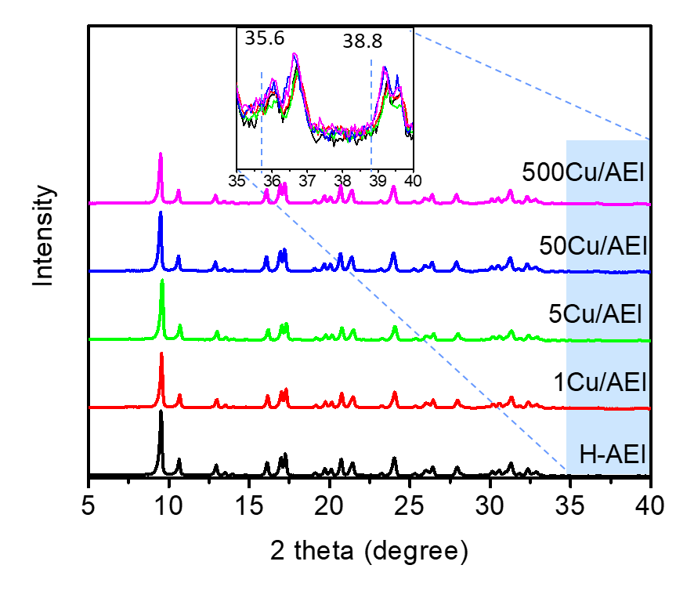
Supplementary Figure 1. XRD patterns of xCu/AEI zeolite catalysts.

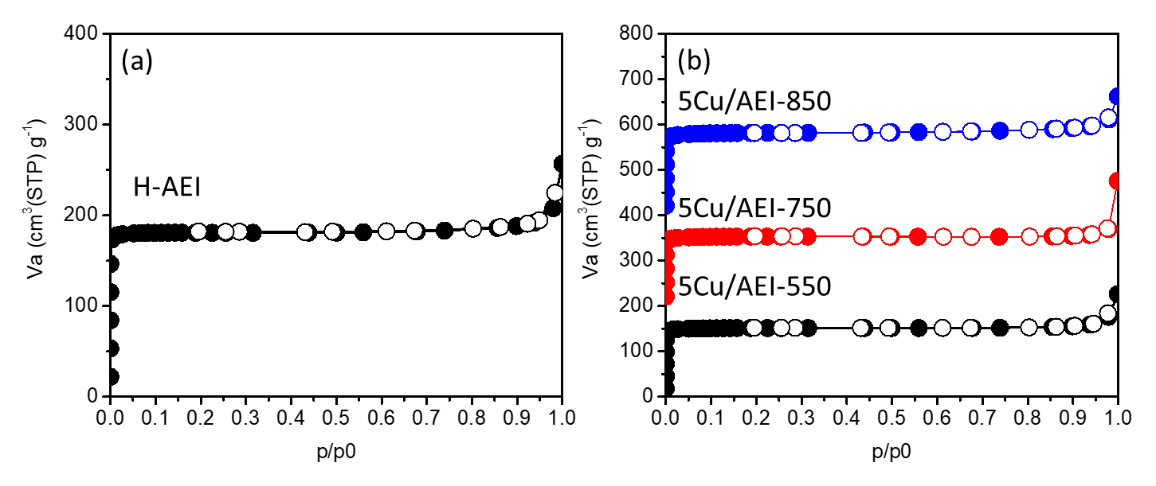
Supplementary Figure 2. N₂ adsorption and desorption of (a) H-AEI and (b) 5Cu/AEI-t zeolite catalysts.
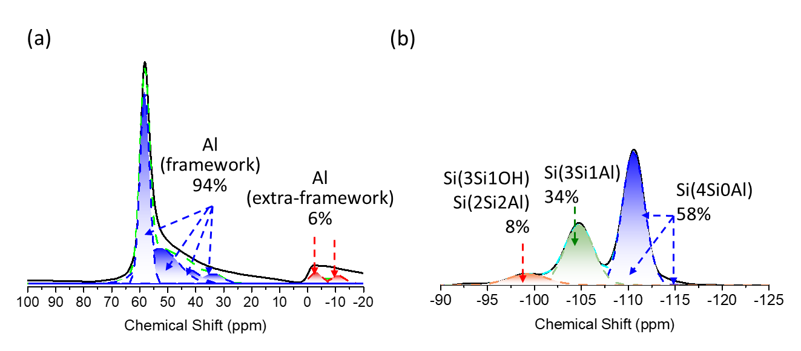
Supplementary Figure 3. (a) Deconvolution of ²⁷Al MAS NMR and (b) deconvolution of ²⁹Si MAS NMR for H-AEI zeolite.

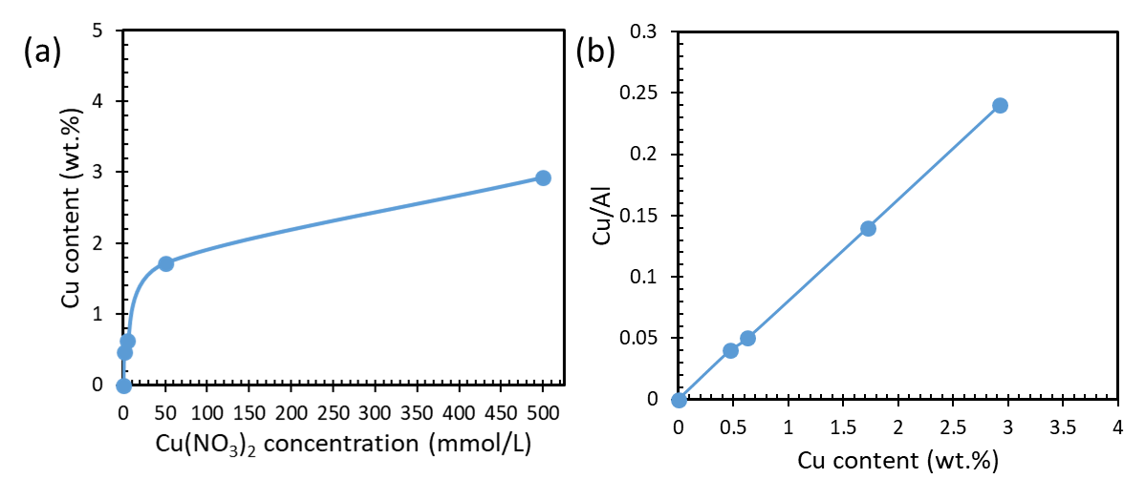
Supplementary Figure 4. (a) Cu(NO₃)₂ concentration in the solution as a function of Cu content in the Cu/AEI zeolite catalysts. (b) Cu content as a function of Cu/Al in the Cu/AEI zeolite catalysts.

Supplementary Figure 5. UV-vis spectra of the xCu/AEI zeolite catalysts.

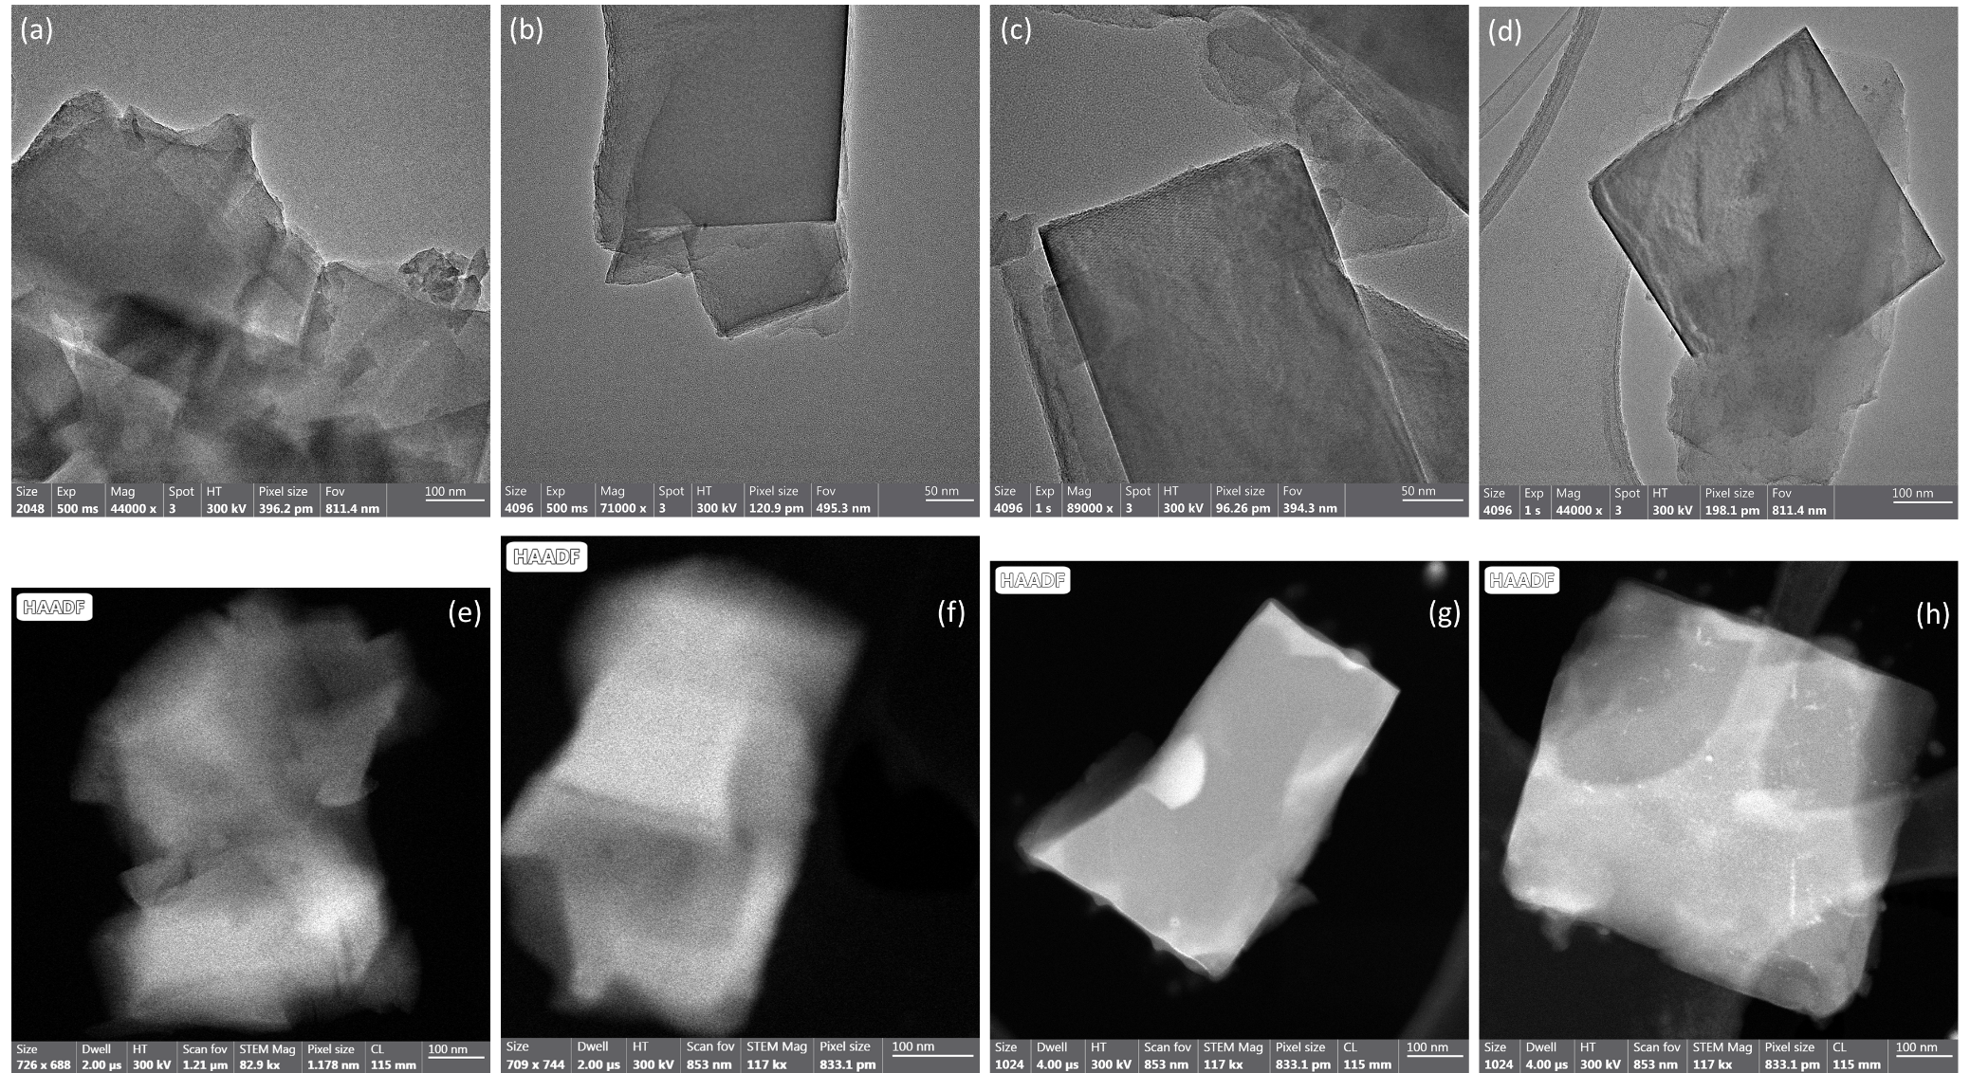
Supplementary Figure S6. HRTEM images of (a) 1Cu/AEI, (b) 5Cu/AEI, (c) 50Cu/AEI, (d) 500Cu/AEI zeolite catalysts. HAADF-STEM images of (e) 1Cu/AEI, (f) 5Cu/AEI, (g) 50Cu/AEI, (h) 500Cu/AEI zeolite catalysts.
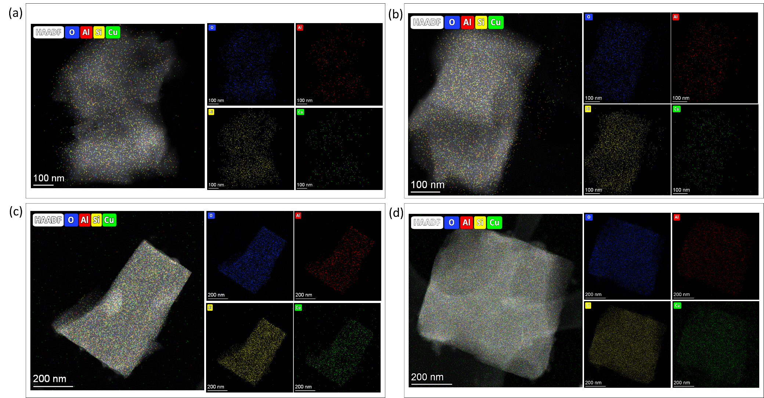
Supplementary Figure 7. EDS elemental mapping images of overlay of O, Al, Si, Cu, and independent O, Al, Si, Cu for (a) 1Cu/AEI, (b) 5Cu/AEI, (c) 50Cu/AEI, (d) 500Cu/AEI zeolite catalysts.

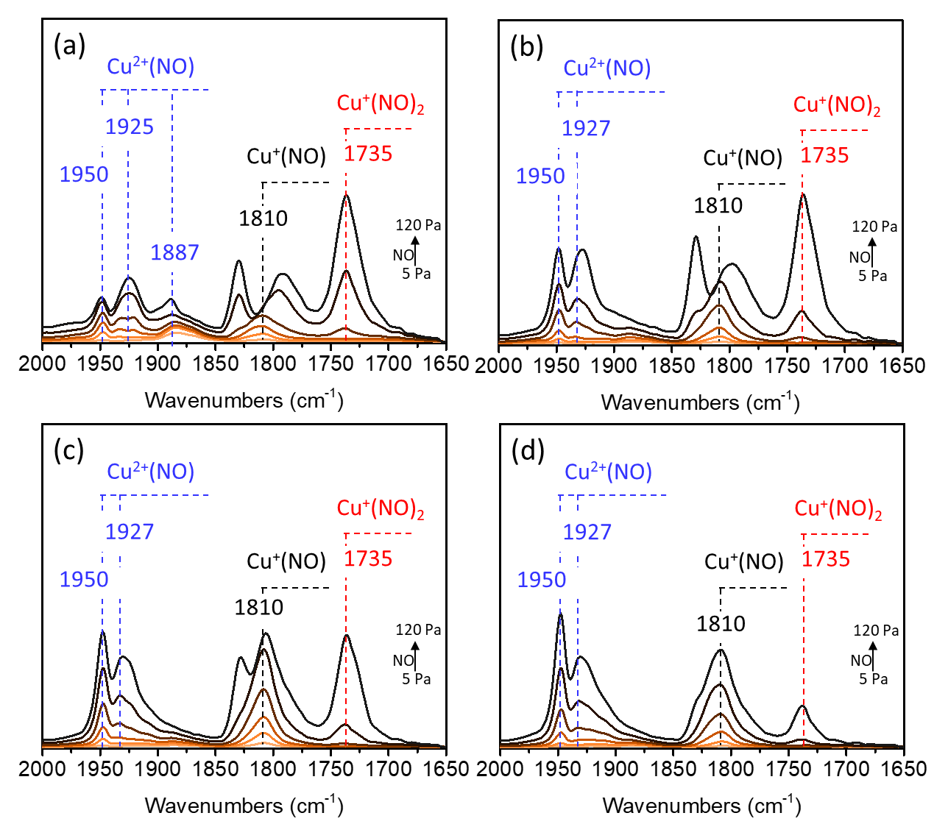
Supplementary Figure 8. FTIR spectra of adsorbed NO (5-120 Pa) at -120 ºC over (a) 1Cu/AEI, (b) 5Cu/AEI, (c) 50Cu/AEI, (d) 500Cu/AEI zeolite catalysts evacuated at 500 ºC for 1 h.
Supplementary Figure 8 shows the NO adsorption FTIR spectra of xCu/AEI-550 zeolites. The bands at 1828, 1752, 1735, and 1787 cm^{–1} are associated with NO bound to Cu⁺ sites, as well as 1887, 1900, 1927, and 1950 cm^{–1} are assigned to diverse Cu²⁺ species. Specifically, the adsorption of a single NO molecule on the [Cu(OH)]⁺ species yields two configurations, with the NO and OH species either oriented in opposite directions (1887 cm⁻¹) or aligned in the same direction (1900 cm⁻¹) with respect to the plane of the 8MR pore.¹ The bands at 1950 and 1927 cm⁻¹ were thought to adsorb NO with different coordinated states.¹ Based on the assignment and intensity of the bands, the Cu species could be distinguished and quantified. Besides, no band at 1990 cm⁻¹ was detected, which was assigned to the adsorption of NO molecule at the trimeric Cu species, suggesting that no trimeric Cu species formed in all the Cu/AEI samples.¹ With the Cu content increase, the intensity of bands at 1950 and 1927 cm⁻¹ gradually grow and the band at 1887 cm⁻¹ disappear, indicating the increased dicopper species.

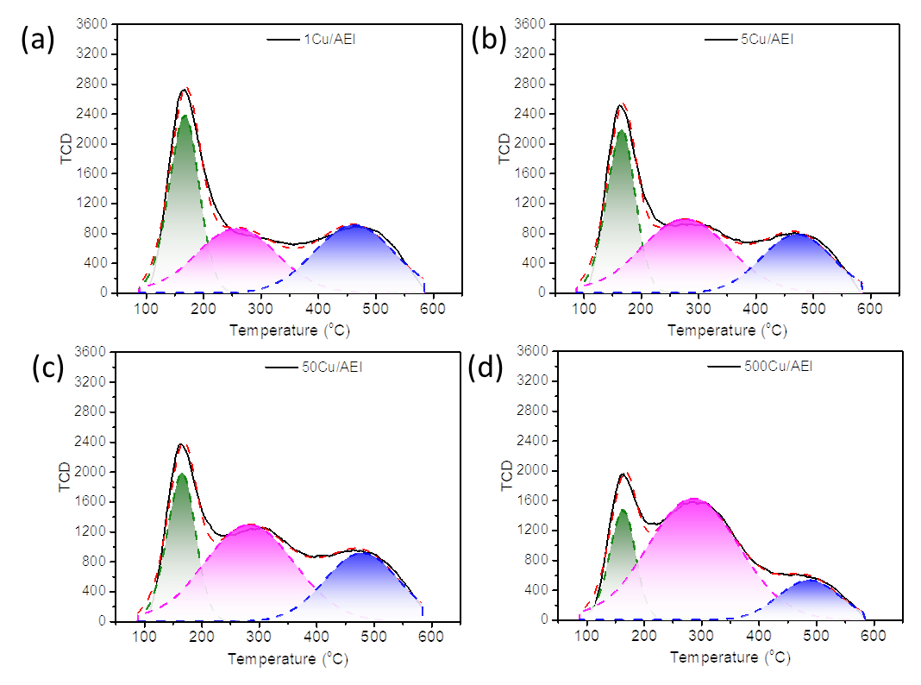
Supplementary Figure 9. NH₃-TPD curves of (a) 1Cu/AEI, (b) 5Cu/AEI, (c) 50Cu/AEI, (d) 500Cu/AEI zeolite catalysts.
Supplementary Figure 9 shows the deconvolution of NH₃-TPD curves. The NH₃-TPD curves were deconvoluted into three peaks centered at 150 °C (A), 300 °C (B), and 475 °C (C).² The A acid sites correspond to the physically adsorbed NH₃. The B acid sites are attributed to the adsorbed NH₃ on the Lewis acid sites (LAS) derived from the introduced Cu²⁺ ions and part of non-framework Al. The C acid sites or strong acid sites related to the NH₃ adsorbed on the Brønsted acid sites (BAS) (Si−OH−Al). The amounts of the acid sites estimated based on the NH₃-TPD profiles are listed in Table 2. For xCu/AEI samples, there was an alleviation in the strong acid amount due to the replacement of proton in Si−OH−Al by Cu²⁺ ions, and an elevation in the B acid amount along with the Cu loading.

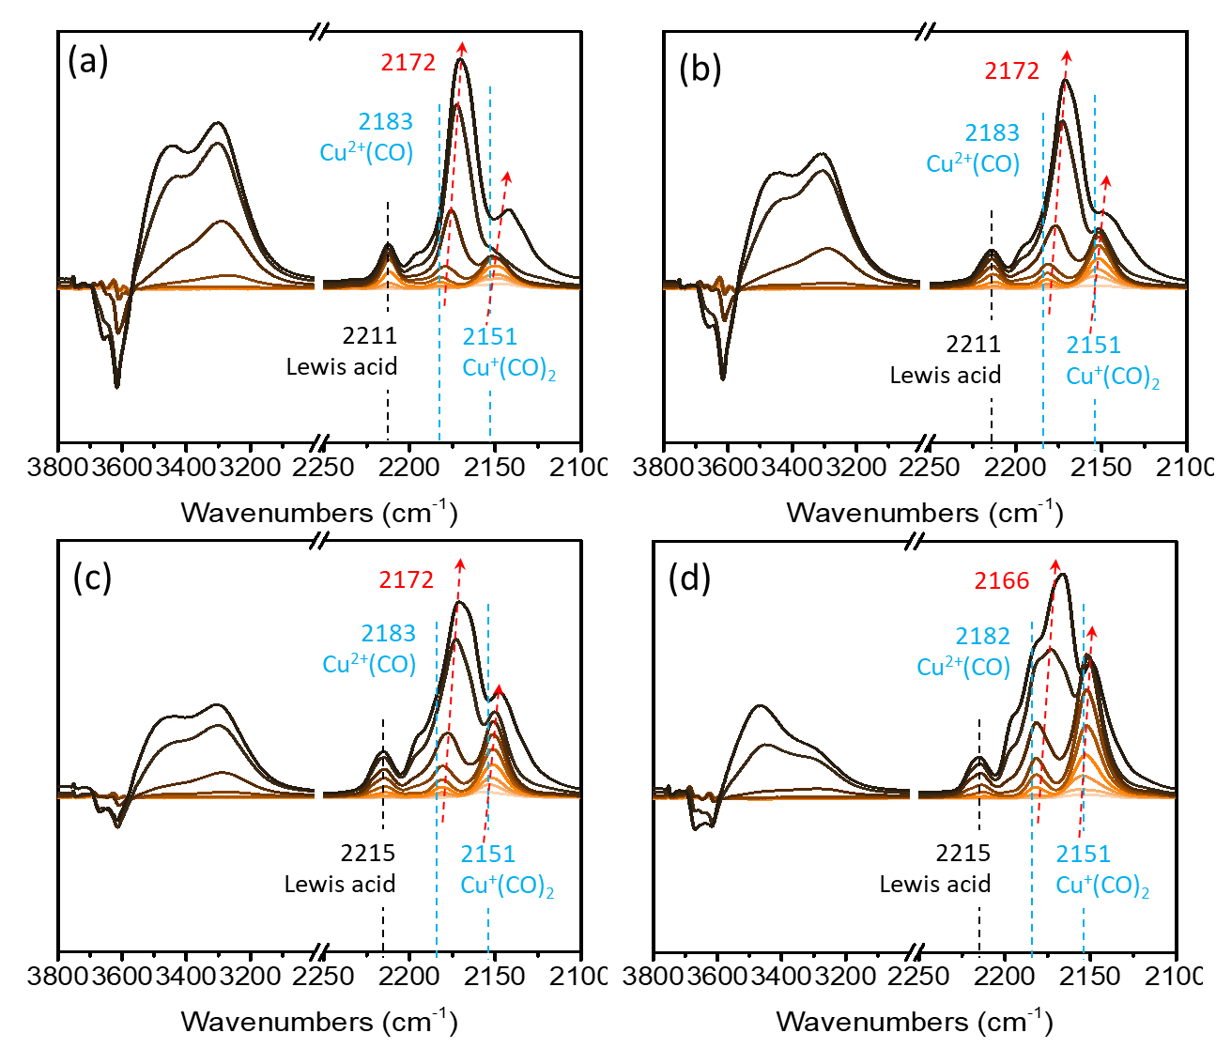
Supplementary Figure 10. FTIR spectra of adsorbed CO (5-1000 Pa) at -120 ºC over (a) 1Cu/AEI, (b) 5Cu/AEI, (c) 50Cu/AEI, (d) 500Cu/AEI zeolite catalysts evacuated at 500 ºC for 1 h.
Supplementary Figure 10 shows the CO adsorption of FTIR spectra. At low CO coverages, the exclusive formation of Cu⁺(CO)₂ at 2151 cm⁻¹ and Cu²⁺CO at 2183 cm⁻¹ were observed.^{3, 4} Increasing the CO pressure led to the appearance of a new band at 2215 cm⁻¹ assigned to the Lewis acid sites.⁵ With the CO pressure increasing, the band at 2183 cm⁻¹ blue-shifted to 2172 cm⁻¹, which was assigned to the υC–O vibration of adsorbed CO interacting with zeolitic OH groups via the weak hydrogen bonds. Concomitant with the development of these bands was the appearance of a broad feature centered at 3300 and 3430 cm⁻¹, and the negative features in the vibrational region of zeolitic OH groups centered at 3600 and 3640 cm⁻¹.⁵ For xCu/AEI zeolites, the intensity of band at 2151 cm⁻¹ increased with the Cu content growing, suggesting the amended Cu⁺(CO)₂ species. Consistent with the result of NH₃-TPD, the intensity of bands at 3300 and 3600 cm⁻¹ was markedly reduced with Cu content growing due to the replacement of Brønsted acidic protons by Cu ions.
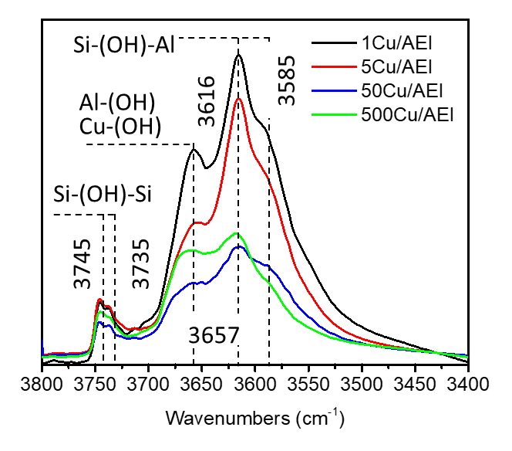
Supplementary Figure 11. FTIR spectra in the OH region of (a) xCu/AEI(Na) and (b) xCu/AEI(Na free) samples collected at -120 ºC after activation at 500 ºC in vacuum for 1 h.
Supplementary Figure 11 shows the FTIR spectra in the region of hydroxyl stretching vibration of the xCu/AEI zeolites. The bands at 3745 and 3735 cm⁻¹ were assigned to the external and internal silanol groups, respectively.⁶ The intense band at 3616 cm⁻¹ with a shoulder at 3585 cm⁻¹ was attributed to the Si–OH–Al bridging hydroxyl groups. The intensity of the bands of xCu/AEI samples severely declined with x increasing since the hydrogen of bridging hydroxyl was replaced by Cu ions. The band at 3616 cm⁻¹ was assigned to Al(OH) and Cu(OH) on the extra framework or related with the framework. Its intensity of 1Cu/AEI, 5Cu/AEI, 50 Cu/AEI decreased with the Cu content growth due to the replacement of Brønsted acidic protons by Cu ions and the formed binuclear Cu species with fewer hydroxyls. As for 500Cu/AEI, the intensity of the band at 3616 cm⁻¹ was higher than that of 50Cu/AEI, a possibility due to the increased Al(OH) and Cu(OH) species for some unclear reasons, however, it is possible on the mechanism.

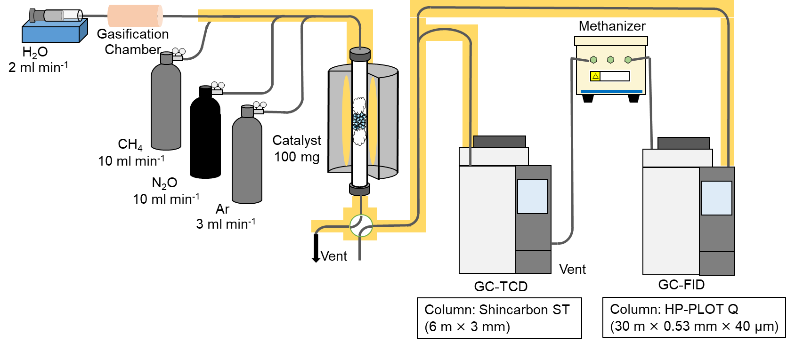
Supplementary Figure 12. Schematic diagram of the online-analysis system for continuous direct conversion of methane.
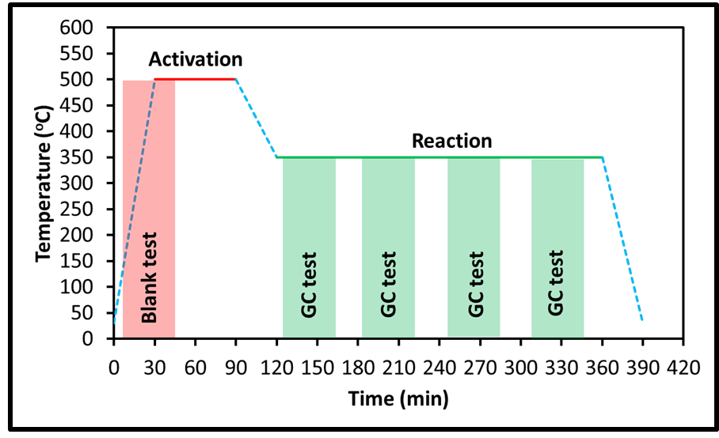
Supplementary Figure 13. Temperature program of the continuous oxidation of methane reaction under 350 ºC.
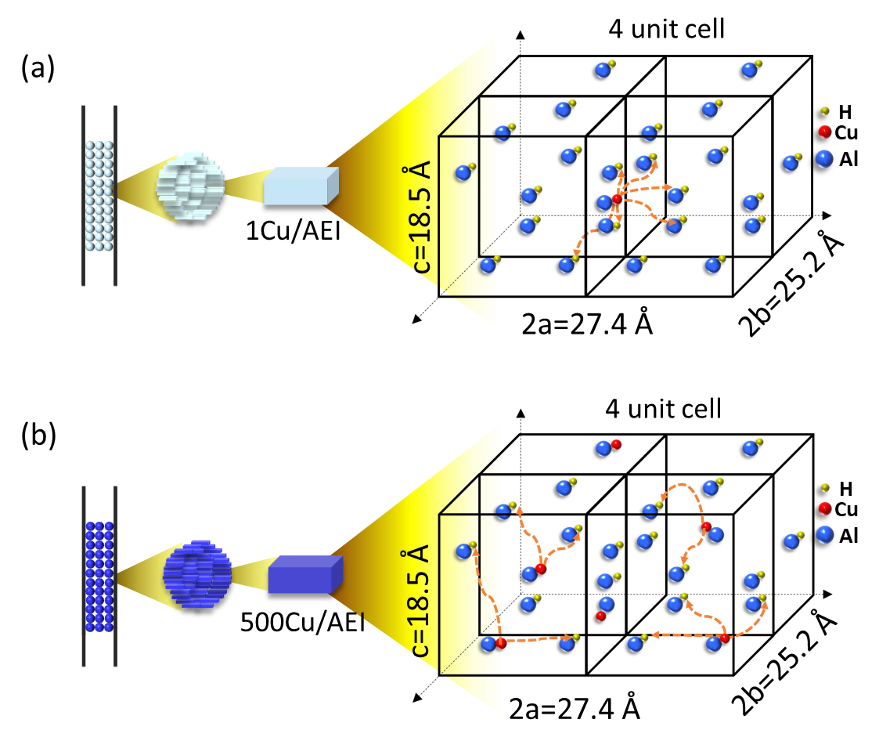
Supplementary Figure 14. Schematic diagram of intimacy of Cu and acid sites for (a) 1Cu/AEI and (b) 500Cu/AEI zeolite.

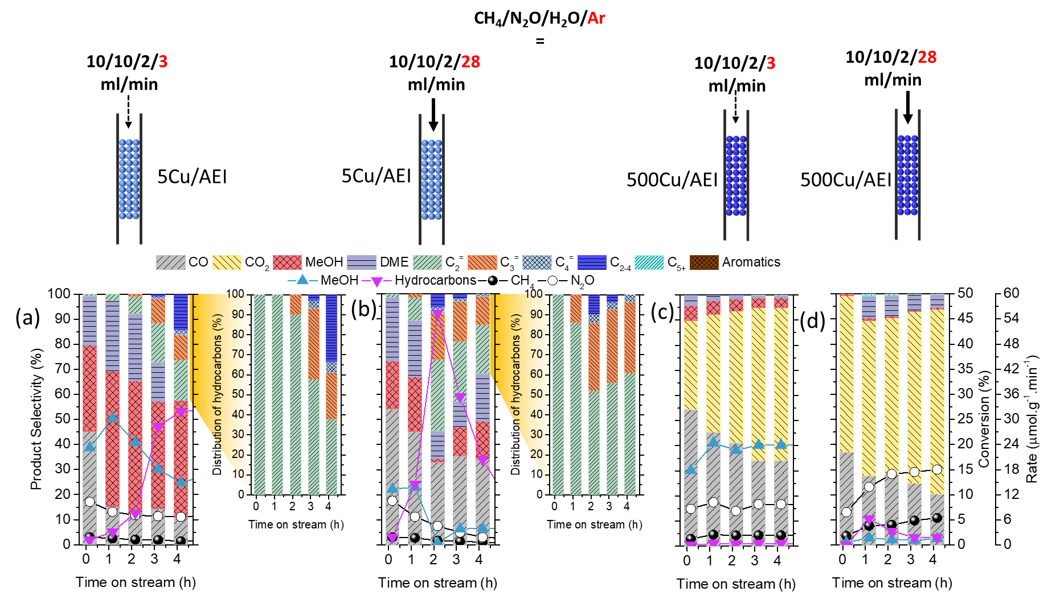
Supplementary Figure 15. Effect of weight hour space velocity (WHSV) by adjusting the flow rate on reaction performance of direct oxidative methane at 350 ºC of (a) 100 mg 5Cu/AEI, CH₄/N₂O/H₂O/Ar=10/10/2/3 ml·min⁻¹, WHSV=15000 ml·g⁻¹·h⁻¹. (b) 100 mg 5Cu/AEI, CH₄/N₂O/H₂O/Ar=10/10/2/28 ml·min⁻¹, WHSV=30000 ml·g⁻¹·h⁻¹. (c) 100mg 500Cu/AEI, CH₄/N₂O/H₂O/Ar=10/10/2/3 ml·min⁻¹, WHSV=15000 ml·g⁻¹·h⁻¹. (d) 100mg 500Cu/AEI, CH₄/N₂O/H₂O/Ar=10/10/2/28 ml·min⁻¹, WHSV=30000 ml·g⁻¹·h⁻¹.

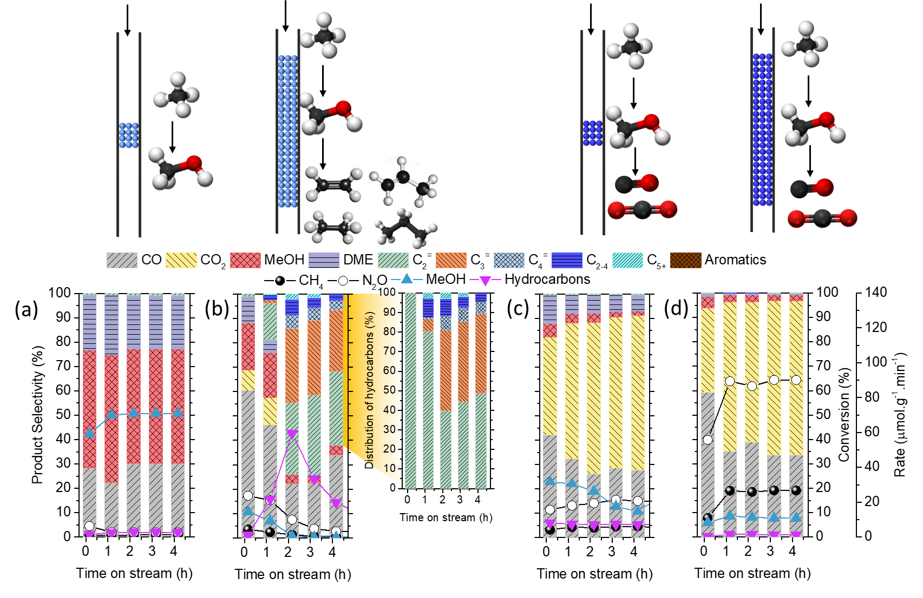
Supplementary Figure 16. Effects of weight hour space velocity (WHSV) by adjusting catalyst amount (a) 25 mg 5Cu/AEI (WHSV=60000 ml·g⁻¹·h⁻¹), (b) 200 mg 5Cu/AEI (WHSV=7500 ml·g⁻¹·h⁻¹), (c) 25 mg 500Cu/AEI (WHSV=60000 ml·g⁻¹·h⁻¹), and (d) 200 mg 500Cu/AEI (WHSV=7500 ml·g⁻¹·h⁻¹) in direct oxidative methane at 350 ºC, CH₄/N₂O/H₂O/Ar = 10/10/2/3 ml·min⁻¹.
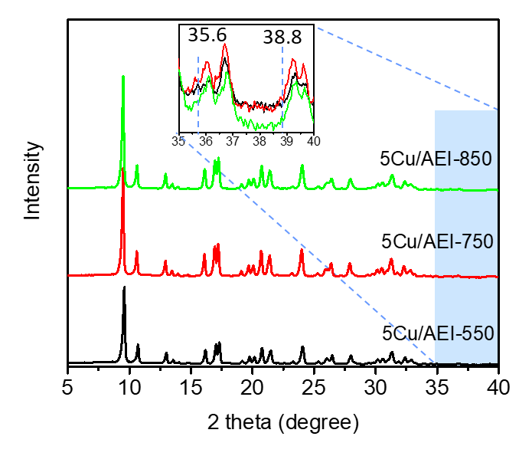
Supplementary Figure 17. XRD patterns of 5Cu/AEI-t zeolite catalysts.

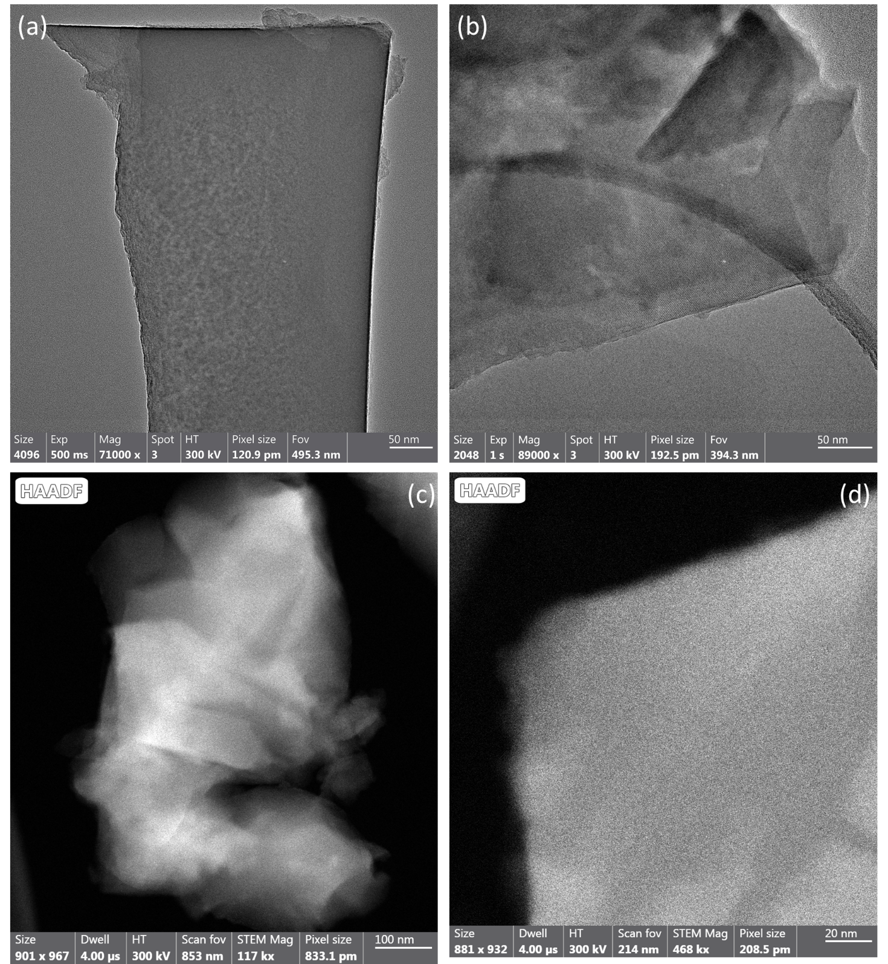Supplementary Figure 18. HRTEM images of (a) 5Cu/AEI-750 and (b) 5Cu/AEI-850 zeolite catalysts. HAADF-STEM images of (c) 5Cu/AEI-750 and (d) 5Cu/AEI-850 zeolite catalysts.
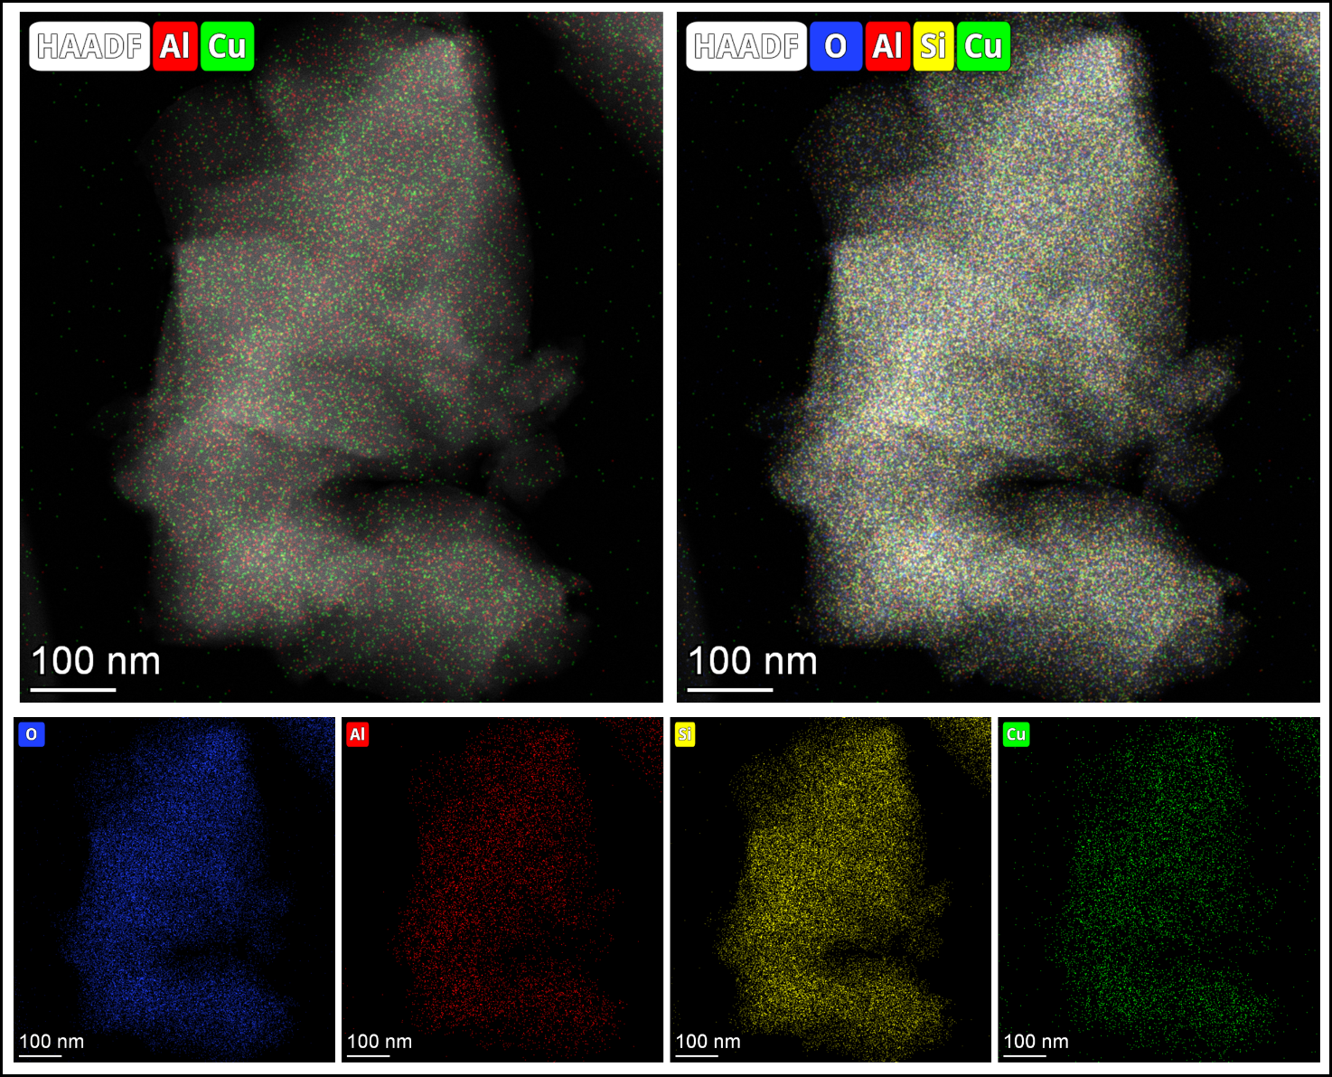
Supplementary Figure 19. EDS elemental mapping images of overlay Cu and Al, overlay all the elements, and independent O, Al, Si, Cu for 5Cu/AEI-750 zeolite catalyst.

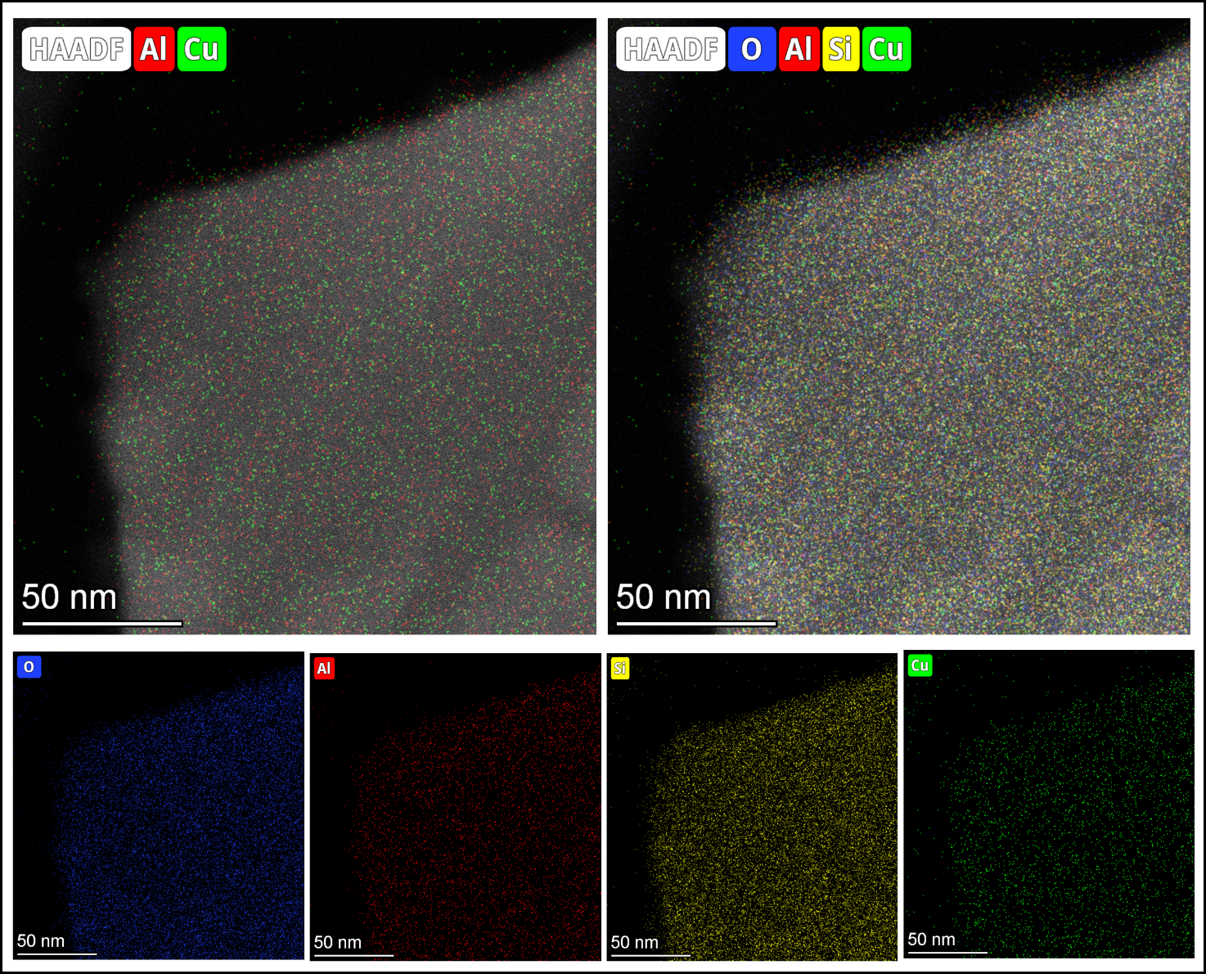
Supplementary Figure 20. EDS elemental mapping images of overlay Cu and Al, overlay all the elements, and independent O, Al, Si, Cu for 5Cu/AEI-850 zeolite catalyst.
Supplementary Figure 21. UV-vis spectra of 5Cu/AEI-t zeolite catalysts.

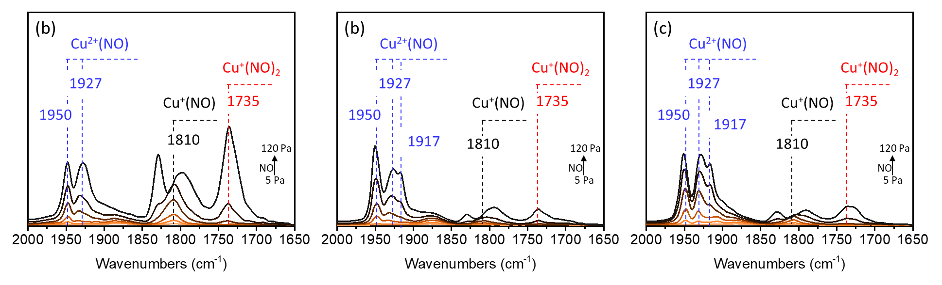
Supplementary Figure 22. FTIR spectra of adsorbed NO (5-120 Pa) at -120 ºC over (a) 5Cu/AEI-550, (b) 5Cu/AEI-750, (c) 5Cu/AEI-850 zeolite catalysts evacuated at 500 ºC for 1 h.
Supplementary Figure 20 shows the NO adsorption FTIR spectra of 5Cu/AEI-t zeolites. The bands at 1735 and 1810 cm^{–1} are associated to NO bound to Cu⁺ sites, as well as 1917, 1927, and 1950 cm^{–1} are assigned to diverse Cu²⁺ species. The bands at 1950 and 1927 cm⁻¹ were thought to adsorb NO with different coordinated states on the binuclear Cu species.¹ With the calcination temperature growing, the intensity of bands at 1950 and 1927 cm⁻¹ was not reduced, indicating that proportion of binuclear was not affected by the increased temperature.
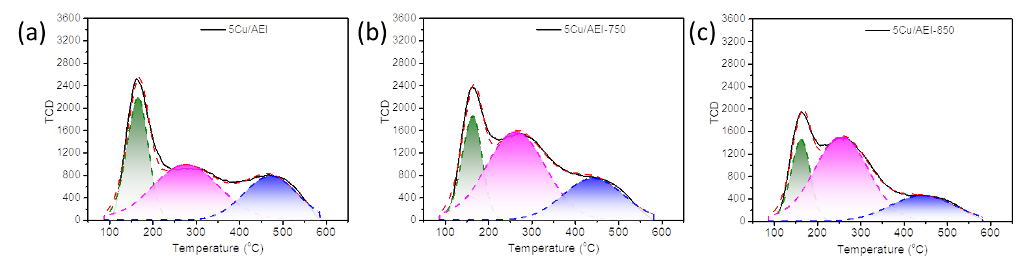
Supplementary Figure 23. NH₃-TPD curves of (a) 5Cu/AEI-550, (b) 5Cu/AEI-750, (c) 5Cu/AEI-850 zeolite catalysts.
The amount of strong acid sites of 5Cu/AEI-t reclined with t increasing due to the dealumination. The amount of medium (B) acid sites first increased with t raising from 550 to 750 and then decreased with t growing from 750 to 850 owing to the formed Al(OH) or Cu(OH) related with framework at 750 ºC, which was able to be evidenced by Figure 2e.

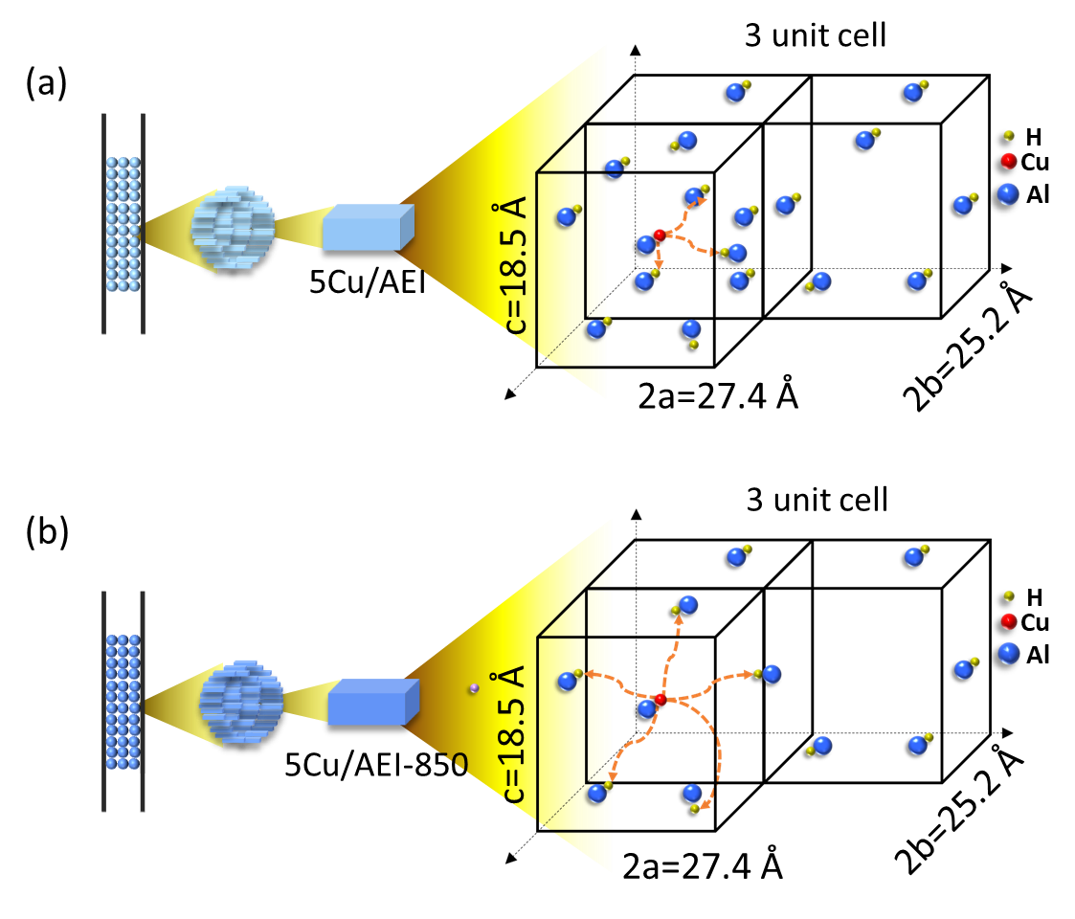
Supplementary Figure 24. Schematic diagram of intimacy of Cu and acid sites for (a) 5Cu/AEI (i.e. 5Cu/AEI-550) and (b) 5Cu/AEI-850 zeolite catalysts.
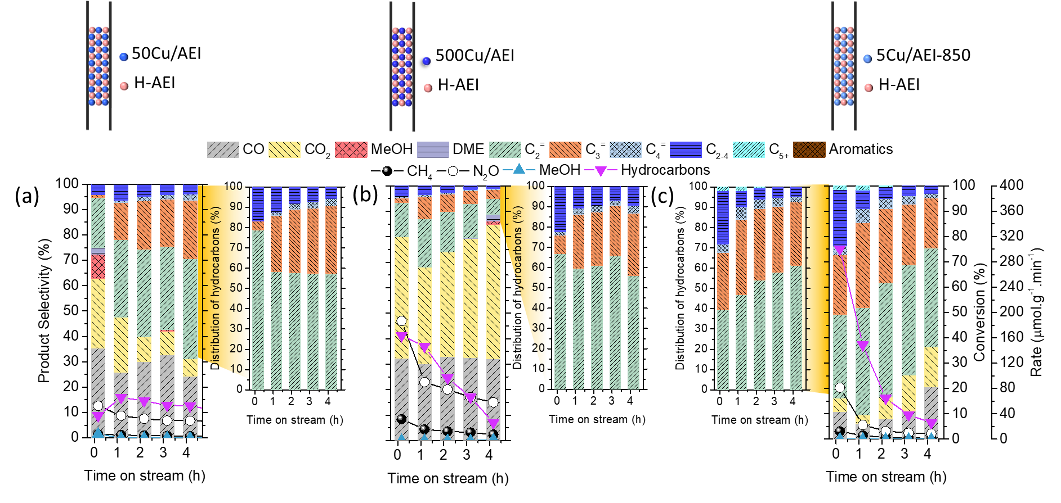
Supplementary Figure 25. Effect of Cu component on the reaction performance of oxidative methane by granule-stacking of (a) 50 mg 50Cu/AEI and 50 mg H-AEI, (b) 50 mg 500Cu/AEI and 50 mg H-AEI, and (c) 50 mg 5Cu/AEI-850 and 50 mg H-AEI. Reaction conditions: 350 ºC, CH₄/N₂O/H₂O/Ar=10/10/2/3 ml·min⁻¹, WHSV=15000 ml·g⁻¹·h⁻¹.
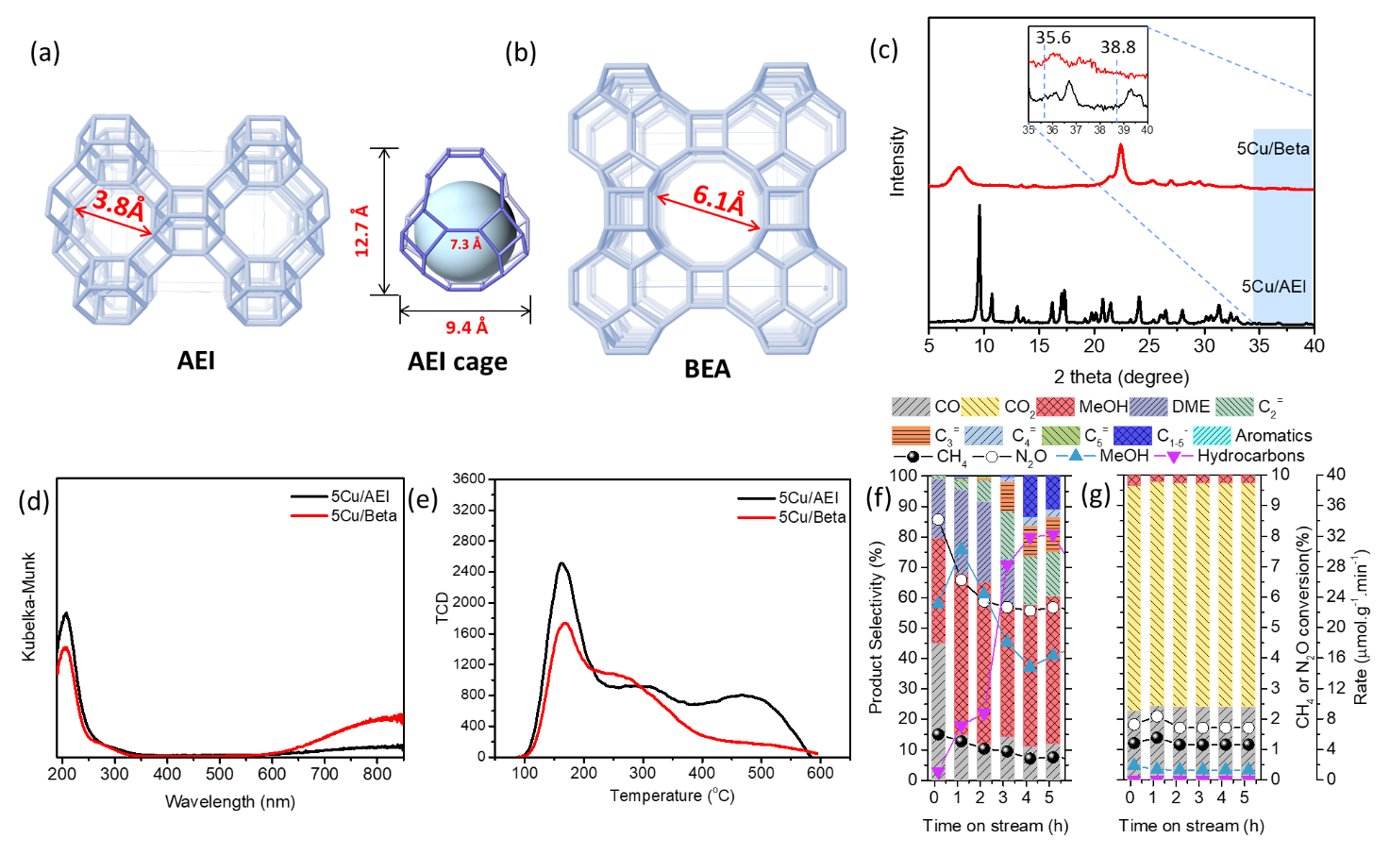
Supplementary Figure 26. Effects of zeolite structure on reaction performance of direct oxidative methane. (a) Framework of AEI zeolite and the maximum diameter of a sphere that can diffuse along, and the AEI cage size that can included the maximum diameter. (b) Framework of BEA zeolite and the maximum diameter of a sphere that can diffuse along. (c) XRD patterns, (d) UV-vis spectra, (e) NH₃-TPD curves of the 5Cu/AEI and 5Cu/Beta zeolites. Reaction performance in the direct oxidative methane of (f) 5Cu/AEI and (g) 5Cu/Beta. Reaction conditions: 100 mg catalyst, 350 ºC, CH₄/N₂O/H₂O/Ar=10/10/2/3 ml·min⁻¹, WHSV=15000 ml·g⁻¹·h⁻¹.

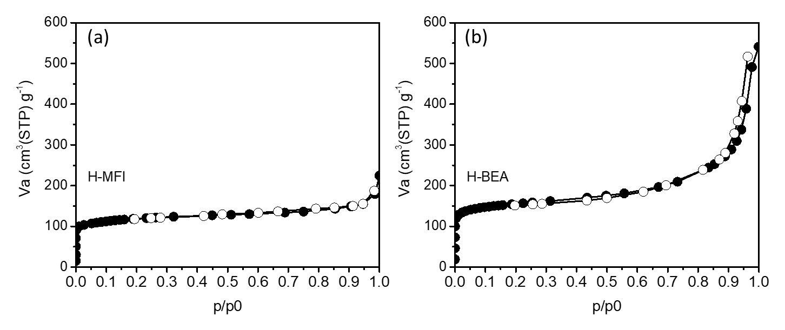
Supplementary Figure 27. N₂ adsorption and desorption of (a) H-MFI (Zeolyst, CBV2314) and (b) H-BEA (Zeolyst, CP814E*) zeolites.
Supplementary Figure S28. Time courses of the MTH reaction at 350 °C on H-AEI zeolite catalyst. Reaction condition: 50 mg catalyst, F_{MeOH} = 1 ul/min, F_{He} = 11.6 ml/min, W/F_{MeOH} = 33.7 g h/mol, P_{methanol}= 5 kPa.
Supplementary Figure 29. Hydrocarbons distribution of 5Cu/AEI-550 in the Figure 2a.
Supplementary Table 1. Chemical composition of the zeolites.
Sample | Chemical Compositions ª |  |  | Al content |  |  | Cu content
Sample | Si/Al | Cu/Al | Cu (wt.%) | Al/cage | Al /1000Å³ | Al/unit cell | Cu/cage | Cu /1000Å³ | Cu/unit cell | Cu/4 unit cells
H-AEI | 6.9 | - | - | 1.52 | 1.91 | 6.08 | 0 | 0 | 0 | 0
1Cu/AEI | 6.8 | 0.04 | 0.47 | 1.54 | 1.94 | 6.15 | 0.06 | 0.08 | 0.24 | 0.96
5Cu/AEI | 6.7 | 0.05 | 0.63 | 1.56 | 1.96 | 6.23 | 0.08 | 0.10 | 0.32 | 1.28
50Cu/AEI | 6.9 | 0.14 | 1.72 | 1.52 | 1.91 | 6.08 | 0.21 | 0.27 | 0.84 | 3.36
500Cu/AEI | 7.0 | 0.24 | 2.92 | 1.50 | 1.89 | 6.00 | 0.36 | 0.45 | 1.44 | 5.76
5Cu/Beta | 13.0 | 0.10 | 0.73 | - | 2.17 | 4.60 | - | 0.22 | 0.46 | 1.84
ª by ICP-AES.
Supplementary Table 2. Acid amount of the zeolites measured by NH₃-TPD.
Sample | NH₃-TPD(mmol/g) ª
Sample | Weak | Medium | Strong | Total
H-AEI (BASF SE) | 0.66 | 0.47 | 0.64 | 1.76
1Cu/AEI | 0.57 | 0.57 | 0.58 | 1.73
5Cu/AEI (i.e. 5Cu/AEI-550) | 0.50 | 0.75 | 0.52 | 1.77
50Cu/AEI | 0.44 | 0.96 | 0.50 | 1.91
500Cu/AEI | 0.31 | 1.23 | 0.26 | 1.79
5Cu/AEI-750 | 0.38 | 1.03 | 0.49 | 1.90
5Cu/AEI-850 | 0.28 | 0.89 | 0.32 | 1.49
5Cu/Beta | 0.26 | 0.58 | 0.27 | 1.11
H-MFI (Zeolyst, CBV2314) | 0.68 | 0.55 | 0.29 | 1.52
H-BEA (Zeolyst, CP814E*) | 0.27 | 0.24 | 0.74 | 1.25
ª Determined by NH₃-TPD; fitting curves of the weak, medium, and strong acid amount were calculated at approximately 150, 300 and 400-450 °C, respectively.
Supplementary Table 3 Texture properties of the zeolites measured by N₂ adsorption and desorption.
Sample | Textual Properties ª
Sample | S_{BET}/m²·g^{−1 a} | S_{EXT}/m²·g^{−1 b} | V_{micro}/cm³·g^{−1 c}
H-AEI | 770 | 17 | 0.36
5Cu/AEI-550 | 735 | 18 | 0.36
5Cu/AEI-750 | 729 | 20 | 0.36
5Cu/AEI-850 | 727 | 22 | 0.37
H-MFI | 443 | 46 | 0.17
H-Beta | 583 | 257 | 0.11
ª Calculated using the Brunauer–Emmett–Teller (BET) equation on the N₂ adsorption isotherms.
^{b,c} Calculated by the t-plot method based on the adsorption isotherms.

1. Palagin, D. et al. Mapping Vibrational Spectra to the Structures of Copper Species in Zeolites Based on Calculated Stretching Frequencies of Adsorbed Nitrogen and Carbon Monoxides. J. Phys. Chem. C 125, 12094−12106 (2021).
2. Lobree, L. J. et al. Investigations of the State of Fe in H–ZSM-5. J. Catal. 186, 242-253 (1999).
3. Zdravkova, V. et al. Surprising Coordination Chemistry of Cu+ Cations in Zeolites: FTIR Study of Adsorption and Coadsorption of CO, NO, N2, and H2O on Cu−ZSM‑5. J. Phys. Chem. C 119, 15292−15302 (2015).
4. Kefirov, R. et al. Stabilization of Cu+ ions in BEA zeolite: Study by FTIR spectroscopy of adsorbed CO and TPR. Micropor. Mesopor. Mater. 116, 180–187 (2008).
5. Szanyi, J. et al. Characterization of Fe(2)(+) ions in Fe,H/SSZ-13 zeolites: FTIR spectroscopy of CO and NO probe molecules. Phys. Chem. Chem. Phys. 18, 10473-10485 (2016).
6. Giordanino, F. et al. Characterization of Cu-exchanged SSZ-13: a comparative FTIR, UV-Vis, and EPR study with Cu-ZSM-5 and Cu-beta with similar Si/Al and Cu/Al ratios. Dalton Trans 42, 12741–12761 (2013).

