Supplementary Online Material (SOM)

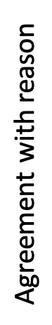
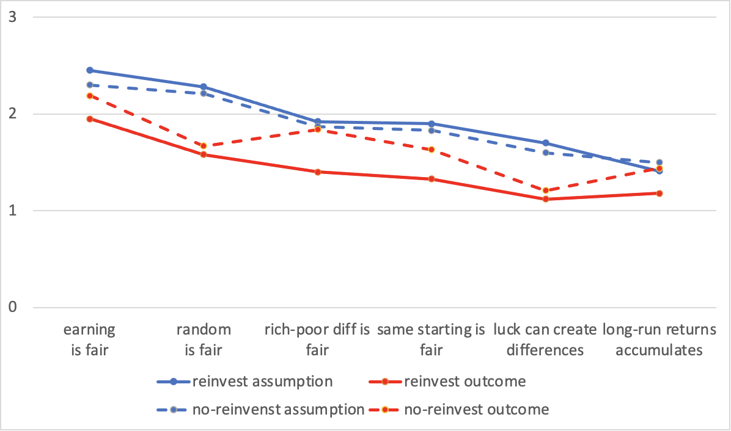

SOM Fig. 1. Agreement on reasons for fairness judgments. The y-axis shows the mean agreement with reasons for participants' fairness judgments.

Condition | Question | N | df | d' | ass. | out.
reinvest | earning is fair | 99 | .0000 | .61 | 2.45 | 1.95
reinvest | random is fair | 72 | .0000 | .80 | 2.28 | 1.58
reinvest | rich-poor diff is fair | 105 | .0000 | .69 | 1.92 | 1.40
reinvest | same starting is fair | 133 | .0000 | 1.14 | 1.90 | 1.33
reinvest | luck creates differences | 123 | .0000 | -1.02 | 1.30 | 1.88
reinvest | long-run returns accumulates | 94 | .0000 | .50 | 1.41 | 1.18
no-reinvest | earning is fair | 97 | .3484 | .13 | 2.30 | 2.19
no-reinvest | random is fair | 77 | .0000 | .52 | 2.12 | 1.67
no-reinvest | rich-poor diff is fair | 100 | .0962 | .05 | 1.87 | 1.84
no-reinvest | long-run returns accumulates | 94 | .2225 | .12 | 1.50 | 1.44
no-reinvest | same starting is fair | 132 | .0000 | .37 | 1.83 | 1.63
no-reinvest | luck can create differences | 124 | .0000 | -.54 | 1.40 | 1.79

SOM Table 1. Agreement with reasons for the fairness judgements. The rows represent the reasons divided into the reinvestment and the no-reinvestment conditions. The p-values shows the t-test for the probability (p) that the assumption condition (ass.) and the outcome (out.) conditions differs, the effect size (Cohens d’), and degrees of freedom (df).

SOM Appendix A: Extended method and specification of the conditions

Participants were informed that they would participate in a study to investigate conceptions of wealth distributions. They were given informed consent to participate and told that they could cancel the study at any time without providing any reasons for this.

In the reinvest assumption condition a scenario was presented where investments were repeatedly made and where the returns were reinvested, whereas in the no reinvest case the returns were not reinvested (see exact phrasing below). The outcome conditions consisted of a figure showing the simulated density distribution of accumulated wealth after all investments. In each condition, the respondents are asked “How fair would you rate this scenario?” and asked to respond on a five graded scale from complete [completely fair (1), somewhat fair (2), neither fair nor unfair (3), somewhat unfair (4), completely unfair (5)] while viewing the information related to the condition.

In each condition, the fairness evaluation was followed by a set of questions aimed to probe the respondents on what they based their fairness judgments on. They were first given an open ended question “Describe briefly why you answered the way you did in the previous question”. This was followed by six multiple choice questions probing whether their fairness responses depended on concepts such as: random returns, earning from investments, thoughts about how much money the richest/poorest person had, effect of long run, luck, and starting conditions (see Multiple choice questions below for details). On each of these questions they could choose that “this was not relevant”, or to what extent they agreed with the statements. They were also asked “How many times richer do you think that the richest person will be compared to the poorest in this scenario?” and “How much money do you think that the people have on average (i.e. they started with 1000 units each)? Please answer with a number stating the units of money” in the assumption scenario, and “How much money people on average had in each scenario after all investments”. After the assumption and the outcome conditions, the respondents were asked “You have rated the fairness of two wealth distributions. How similar do you find the first wealth distribution compared to the second wealth distribution?”. There were five response alternatives from completely dissimilar to completely similar. The same phasing was used independently of the presentation order of the conditions.

Finally, respondents were asked for their demographic and related data: gender (male, female, other, prefer not to say), age (years), education (primary school, secondary school, some college or further education, bachelor degree, master degree, PhD), nationality (American, United Kingdom, other), political orientation (clearly liberal, somewhat liberal, independent, somewhat conservative, clearly conservative), economic situation (considerably below average, below average, average, above average, considerably above average), knowledge in economic investments (1-5) and mathematics (1-5), understanding of the survey (1-5), and make comments on the survey.

Reinvest assumption condition
Participants were presented with the following text:
“In a market economy, people can invest money and gain interest returns from the investment. Some investments yield higher results than others. Read the scenario below and rate how fair you think the distribution of wealth becomes after the investments are done.

1000 people are investing money. Every person starts out with an investment of 1000 units of money and every time they make an investment they invest all of their capital. After every investment they earn either 2 or 4 percent interest, with equal probability. Investors can not influence their chances of getting the higher interest. The interest is then added to their capital, and after this they invest all of the money again. For example, if a person received 4 percent interest on their first investment, he/she can invest 1040 units of money in the second investment. Every person makes 60000 investments.”

Reinvest outcome condition

The participants were given the following text and figure (SOM Fig. 2):
“The graph below shows the wealth distribution of 1000 people. The y-axis shows the amount of accumulated wealth in units of money. The x-axis shows the people ordered by their wealth. The line shows how the money is distributed per individual. “

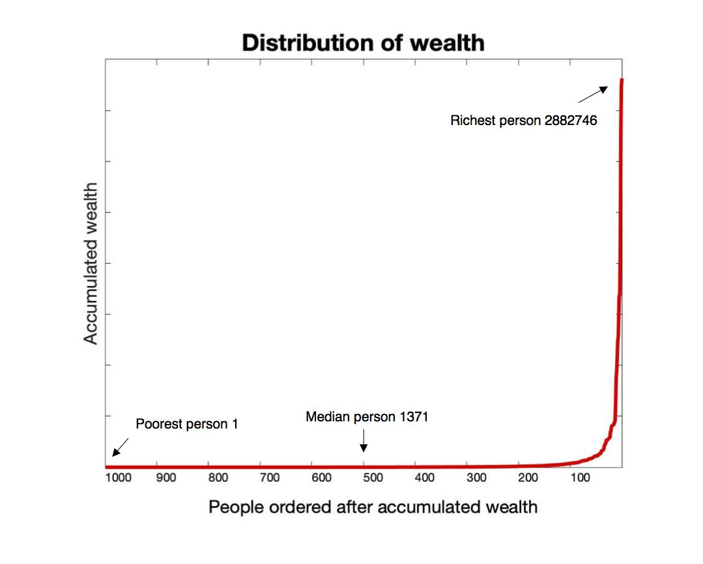
SOM Fig. 2. Stimulus material for the reinvestment outcome condition.

No reinvest assumption condition
Participants were presented with the following text:
“In a market economy, people can invest money and gain interest returns from the investment. Some investments yield higher results than others. Read the scenario below and rate how fair you think the distribution of wealth becomes after the investments are done.

1000 people are investing money. Every person invests 1000 units of money. Each investment yields an interest of either 20 or 40 units of money, with equal probability. There is no way for a person to increase their chances of getting the higher interest. Every person makes 60000 investments.”

No reinvest outcome condition
The participants were given the following text and figure (SOM Fig. 2):
“The graph below shows the wealth distribution of 1000 people. The y-axis shows the amount of accumulated wealth in units of money. The x-axis shows the people ordered by their wealth. The line shows how the money is distributed per individual. “


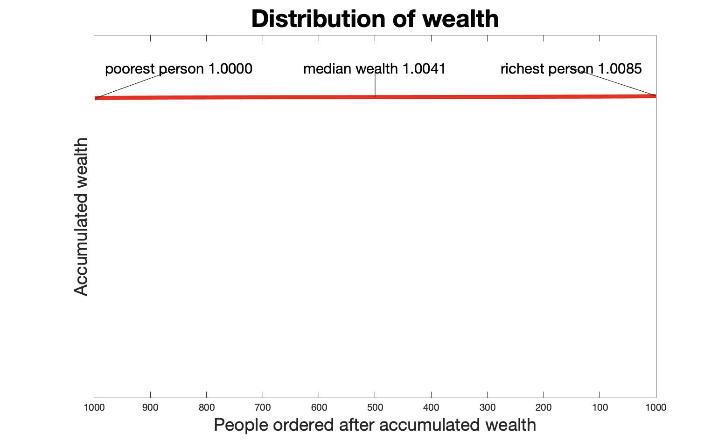

SOM Fig. 3. Stimulus material for the no-reinvestment outcome condition.

Multiple choice questions:
This instruction was:
“Why did you think the previous scenario was fair or unfair? Checkmark all the alternatives that fit with how you thought when you responded. If you did not think about the particular statement while making your fairness choice, then select "did not influence my choice". “

This wealth distribution is based on random returns from investments: [Did not influence my choice/Agree/Disagree]:

Differences in wealth distributions due to random returns from investments are: [Did not influence my choice/Unfair/Neither fair or unfair/Fair/Depends on the situation]

The richest person have much more money than the poorest: [Did not influence my choice/Unfair/Neither fair or unfair/Fair]

In the long run, random returns from investments tends to: [Did not influence my choice/Cancel out, so that large differences in distributions can not occur/Accumulate to a large difference in wealth distributions]

Luck can create large differences in wealth: [Did not influence my choice/Agree/Disagree]

The wealth distributions is fair because I believe that the starting conditions and chances of capital gain were the same for all participants:[Did not influence my choice/Agree/Disagree]

SOM Appendix B. Calculation of accumulated wealth distribution in the no-reinvest condition.

The expected accumulated wealth is W = W_{o} + N * W_{e} = 1801000, where N is the number of investments, W_{o} is the starting capital, W_{e} = p*I₁ + (1 - p) * I₂ is the expected wealth accumulation per investment, p is the probability of the low return I₁ and (1 - p) the probability of the high return I₂. The ratio of accumulated wealth for the richest W_{r} = W - W_{b} compared to wealth of the poorest investor W_{p} = W - W_{b} is R = W_{r} / W_{p}, where W_{b} = norminv(1-1/N_{i},0,s), N_{i} is the number of investors, and norminv is the inverse of the normal distribution with a standard deviation of s² = (I₂ - I₁) * p * (1 - p). The parameters were set according to the experimental conditions (i.e., p = .5, I₁ = 20, I₂ = 40, N = 60000, N_{i} = 1000). The reinvest condition can be simulated as described in the experimental conditions.

