Induced Superconductivity in Hybrid Au/YBa₂Cu₃O_{7-x} Electrodes on Vicinal Substrates

Irina I. Gundareva^{1,3*}, Jose Martinez-Castro^{2,3,4}, F. Stefan Tautz^{2,3,5}, Detlev Grützmacher^{1,3}, Thomas Schäpers^{1,3}, Matvey Lyatti^{1,3}

¹ Peter Grünberg Institute (PGI-9), Forschungszentrum Jülich, 52425 Jülich, Germany
² Peter Grünberg Institute (PGI-3), Forschungszentrum Jülich, 52425 Jülich, Germany
³ Jülich Aachen Research Alliance, Fundamentals of Future Information Technology, 52425 Jülich, Germany
⁴Institute of Experimental Physics II B, RWTH Aachen, 52074 Aachen, Germany
⁵Institute of Experimental Physics IV A, RWTH Aachen, 52074 Aachen, Germany.

STM measurements
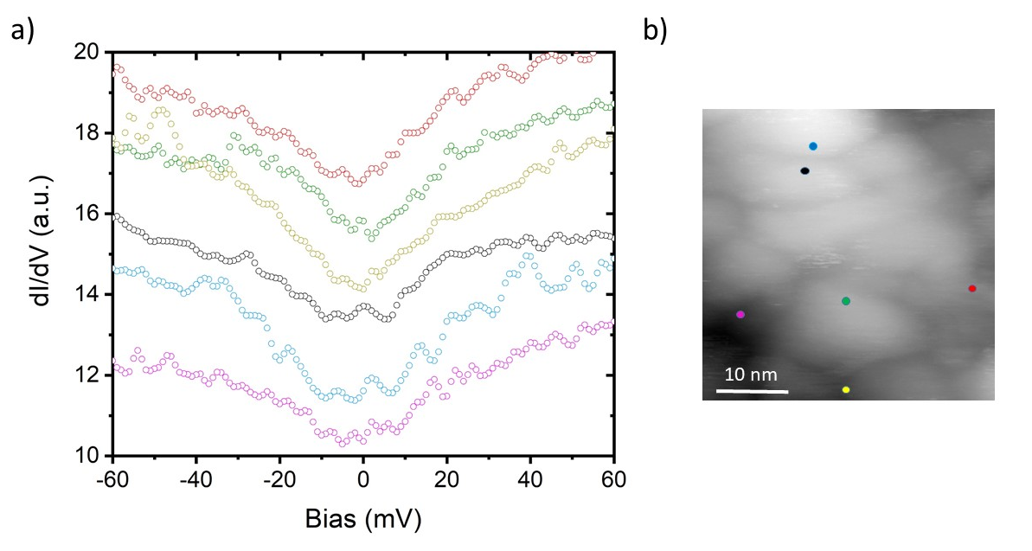
Figure S1. STM measurements. (a) Differential conductance spectra taken at different positions of the sample. The spectra are offset vertically for clarity. (b) The map of the measurement points (V_{set} = 80 mV, I_{set} = 2 nA, V_{mod} = 1 mV). The colour of each dot corresponds to the colour of differential conductance spectra taken at this point.

Multiple Andreev reflections in Au/YBCO nanoconstrictions
YBa₂Cu₃O_{7-x} (YBCO) possesses d-wave symmetry of the order parameter with different superconducting energy gaps in the a-axis and b-axis directions, Δ_{a} =29 meV and Δ_{b} =44 meV.¹ One can observe conductance steps corresponding either to the superconducting energy gap Δ_{a} or Δ_{b} due to the twinning of the YBCO films. The simultaneous appearance of the conductance steps related to both superconducting energy gaps Δ_{a} and Δ_{b} in Figure 2a may be explained by the broader angle of trajectories for wider nanoconstrictions. We assume that the energy gaps in gold Δ_{a}^{Au} = 11.5 meV and Δ_{b}^{Au} = 15.3 meV identified in Figure 2a are induced by corresponding energy gaps in YBCO Δ_{a} = 28 meV and Δ_{b} = 42 meV.
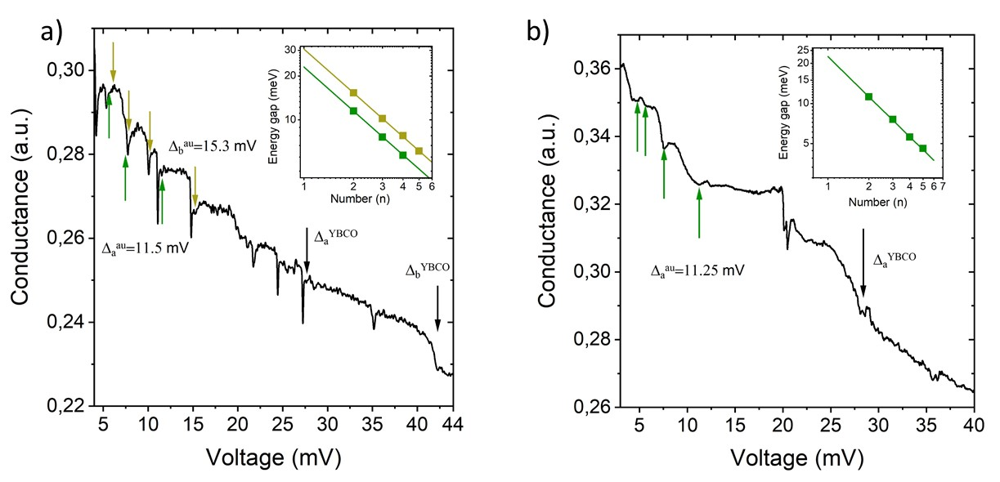
Figure S2. Andreev spectroscopy of the superconducting energy gaps in Au/YBCO heterostructure. (a) Conductance of a 90-nm-wide Au/YBCO nanoconstriction at the temperature of T = 4.2 K. Inset shows the positions of the conductance dips indicated by green and dark-yellow arrows, respectively. The solid green and dark-yellow lines represent V_{n} = 2Δ/ne dependence with Δ_{a}^{Au} = 11.5 meV and Δ_{b}^{Au} = 15.3 meV, respectively. (b) Conductance of a 60-nm-wide Au/YBCO nanoconstriction at T = 4.2 K. Inset shows the positions of the conductance dips indicated by the green arrows. The solid green line represents V_{n} = 2Δ/ne dependence with Δ_{a}^{Au} = 11.25 meV.

References
1. Lu, D.H. et al. Superconducting gap and strong in-plane anisotropy in untwinned YBa₂Cu₃O_{7-d}. Phys Rev Lett 86, 4370-4373 (2001).

