Supplementary information for the article title:

Integration of two different satellite imagery to get a detailed Land cover Land use classification for find the fine scale suitable habitat of Himalayan Ibex.

Table S1: Class accuracy metrices on best classified image i.e., ML classifies the Integrated image. The class accuracy metrices evaluated by Omission rate, Commission rate, Producer’s accuracy, User’s accuracy and F – statistics.
 | LCLU Class | LISS-IV | Sentinel 2A | Integrated |  | LCLU Class | LISS-IV | Sentinel 2A | Integrated
Omission | Agriculture | 50 | 31 | 34 | Commission | Agriculture | 53 | 35 | 31
Omission | Alpine pasture | 49 | 53 | 56 | Commission | Alpine pasture | 18 | 32 | 45
Omission | Barren | 14 | 20 | 17 | Commission | Barren | 47 | 36 | 37
Omission | Scrub | 46 | 28 | 38 | Commission | Scrub | 52 | 35 | 40
Omission | Juniper patch | 34 | 22 | 22 | Commission | Juniper patch | 57 | 31 | 33
Omission | Settlement | 80 | 40 | 41 | Commission | Settlement | 53 | 29 | 28
Omission | Permafrost | 17 | 0 | 0 | Commission | Permafrost | 4 | 0 | 2
Omission | Water | 19 | 7 | 8 | Commission | Water | 18 | 1 | 1
Omission | Road | 74 | 41 | 39 | Commission | Road | 67 | 38 | 35
 | LCLU Class | LISS-IV | Sentinel 2A | Integrated |  | LCLU Class | LISS-IV | Sentinel 2A | Integrated
Producer's Accuracy (PA) | Agriculture | 50 | 69 | 66 | User's accuracy (UA) | Agriculture | 47 | 65 | 69
Producer's Accuracy (PA) | Alpine pasture | 51 | 47 | 44 | User's accuracy (UA) | Alpine pasture | 82 | 68 | 55
Producer's Accuracy (PA) | Barren | 86 | 80 | 83 | User's accuracy (UA) | Barren | 53 | 64 | 63
Producer's Accuracy (PA) | Scrub | 54 | 72 | 62 | User's accuracy (UA) | Scrub | 48 | 65 | 60
Producer's Accuracy (PA) | Juniper patch | 66 | 78 | 78 | User's accuracy (UA) | Juniper patch | 43 | 69 | 67
Producer's Accuracy (PA) | Settlement | 20 | 60 | 59 | User's accuracy (UA) | Settlement | 47 | 71 | 72
Producer's Accuracy (PA) | Permafrost | 83 | 100 | 100 | User's accuracy (UA) | Permafrost | 96 | 100 | 98
Producer's Accuracy (PA) | Water | 81 | 93 | 92 | User's accuracy (UA) | Water | 82 | 99 | 99
Producer's Accuracy (PA) | Road | 26 | 59 | 61 | User's accuracy (UA) | Road | 33 | 62 | 65
 | LCLU Class | LISS-IV | Sentinel 2A | Integrated
F-statistics | Agriculture | 48 | 67 | 67
F-statistics | Alpine pasture | 63 | 55 | 49
F-statistics | Barren | 66 | 71 | 72
F-statistics | Scrub | 51 | 68 | 61
F-statistics | Juniper patch | 52 | 73 | 72
F-statistics | Settlement | 28 | 65 | 65
F-statistics | Permafrost | 89 | 100 | 99
F-statistics | Water | 82 | 96 | 95
F-statistics | Road | 29 | 60 | 63
Table S2: Class accuracy metrices on best classified image i.e., GMM classifies the Integrated image. The class accuracy metrices evaluated by Omission rate, Commission rate, Producer’s accuracy, User’s accuracy and F-statistics.
 | LCLU Class | LISS-IV | Sentinel 2A | Integrated |  | LCLU Class | LISS-IV | Sentinel 2A | Integrated
Omission | Agriculture | 56 | 36 | 38 | Commission | Agriculture | 52 | 33 | 37
Omission | Sparse vegetation | 77 | 56 | 59 | Commission | Sparse vegetation | 19 | 17 | 31
Omission | Barren | 9 | 7 | 7 | Commission | Barren | 60 | 48 | 52
Omission | Scrub | 44 | 21 | 31 | Commission | Scrub | 63 | 37 | 43
Omission | Juniper patch | 31 | 16 | 17 | Commission | Juniper patch | 63 | 37 | 34
Omission | Settlement | 93 | 44 | 53 | Commission | Settlement | 50 | 22 | 26
Omission | Permafrost | 7 | 0 | 0 | Commission | Permafrost | 33 | 1 | 3
Omission | Water | 47 | 10 | 10 | Commission | Water | 4 | 1 | 1
Omission | Road | 98 | 69 | 76 | Commission | Road | 33 | 38 | 44
 | LCLU Class | LISS-IV | Sentinel 2A | Integrated |  | LCLU Class | LISS-IV | Sentinel 2A | Integrated
Producer's Accuracy (PA) | Agriculture | 44 | 64 | 62 | User's accuracy (UA) | Agriculture | 48 | 67 | 63
Producer's Accuracy (PA) | Sparse vegetation | 23 | 44 | 41 | User's accuracy (UA) | Sparse vegetation | 81 | 83 | 69
Producer's Accuracy (PA) | Barren | 91 | 93 | 93 | User's accuracy (UA) | Barren | 40 | 53 | 48
Producer's Accuracy (PA) | Scrub | 56 | 79 | 69 | User's accuracy (UA) | Scrub | 37 | 63 | 57
Producer's Accuracy (PA) | Juniper patch | 69 | 84 | 83 | User's accuracy (UA) | Juniper patch | 37 | 63 | 66
Producer's Accuracy (PA) | Settlement | 7 | 56 | 47 | User's accuracy (UA) | Settlement | 50 | 78 | 74
Producer's Accuracy (PA) | Permafrost | 93 | 100 | 100 | User's accuracy (UA) | Permafrost | 67 | 99 | 97
Producer's Accuracy (PA) | Water | 53.3333 | 90 | 90 | User's accuracy (UA) | Water | 96 | 99 | 99
Producer's Accuracy (PA) | Road | 2 | 31 | 24 | User's accuracy (UA) | Road | 67 | 62 | 56
 | LCLU Class | LISS-IV | Sentinel 2A | Integrated
F-statistics | Agriculture | 46 | 66 | 63
F-statistics | Sparse vegetation | 36 | 58 | 51
F-statistics | Barren | 55 | 67 | 64
F-statistics | Scrub | 44 | 70 | 63
F-statistics | Juniper patch | 48 | 72 | 74
F-statistics | Settlement | 12 | 65 | 57
F-statistics | Permafrost | 78 | 99 | 98
F-statistics | Water | 69 | 94 | 94
F-statistics | Road | 4 | 41 | 34

Table S3: Class accuracy metrices on best classified image i.e., KNN classifies the Integrated image. The class accuracy metrices evaluated by Omission rate, Commission rate, Producer’s accuracy, User’s accuracy and F-statistics.
 | LCLU Class | LISS-IV | Sentinel 2A | Integrated |  | LCLU Class | LISS-IV | Sentinel 2A | Integrated
Omission | Agriculture | 49 | 38 | 23 | Commission | Agriculture | 51 | 48 | 29
Omission | Alpine pasture | 52 | 29 | 20 | Commission | Sparse vegetation | 25 | 24 | 14
Omission | Barren | 9 | 0 | 4 | Commission | Barren | 57 | 43 | 26
Omission | Scrub | 39 | 13 | 21 | Commission | Scrub | 60 | 29 | 27
Omission | Juniper patch | 26 | 20 | 19 | Commission | Juniper patch | 55 | 46 | 28
Omission | Settlement | 91 | 72 | 38 | Commission | Settlement | 27 | 7 | 15
Omission | Permafrost | 3 | 0 | 0 | Commission | Permafrost | 21 | 1 | 0
Omission | Water | 36 | 14 | 4 | Commission | Water | 2 | 0 | 3
Omission | Road | 98 | 81 | 33 | Commission | Road | 0 | 19 | 14
 | LCLU Class | LISS-IV | Sentinel 2A | Integrated |  | LCLU Class | LISS-IV | Sentinel 2A | Integrated
Producer's Accuracy (PA) | Agriculture | 51 | 62 | 77 | User's accuracy (UA) | Agriculture | 49 | 52 | 71
Producer's Accuracy (PA) | Alpine pasture | 48 | 71 | 80 | User's accuracy (UA) | Alpine pasture | 75 | 76 | 86
Producer's Accuracy (PA) | Barren | 91 | 100 | 96 | User's accuracy (UA) | Barren | 43 | 57 | 74
Producer's Accuracy (PA) | Scrub | 61 | 87 | 79 | User's accuracy (UA) | Scrub | 40 | 71 | 73
Producer's Accuracy (PA) | Juniper patch | 74 | 80 | 81 | User's accuracy (UA) | Juniper patch | 45 | 54 | 72
Producer's Accuracy (PA) | Settlement | 9 | 28 | 62 | User's accuracy (UA) | Settlement | 73 | 93 | 85
Producer's Accuracy (PA) | Permafrost | 97 | 100 | 100 | User's accuracy (UA) | Permafrost | 79 | 99 | 100
Producer's Accuracy (PA) | Water | 64 | 86 | 96 | User's accuracy (UA) | Water | 98 | 100 | 97
Producer's Accuracy (PA) | Road | 2 | 19 | 67 | User's accuracy (UA) | Road | 100 | 81 | 86
 | LCLU Class | LISS-IV | Sentinel 2A | Integrated
F-statistics | Agriculture | 50 | 57 | 74
F-statistics | Alpine pasture | 59 | 74 | 83
F-statistics | Barren | 58 | 72 | 83
F-statistics | Scrub | 48 | 78 | 76
F-statistics | Juniper patch | 56 | 65 | 76
F-statistics | Settlement | 16 | 43 | 72
F-statistics | Permafrost | 87 | 99 | 100
F-statistics | Water | 78 | 92 | 96
F-statistics | Road | 4 | 31 | 75

Table S4: Class accuracy metrices on best classified image i.e., SVM classifies the Integrated image. The class accuracy metrices evaluated by Omission rate, Commission rate, Producer’s accuracy, User’s accuracy and F-statistics.
 | LCLU Class | LISS-IV | Sentinel 2A | Integrated |  | LCLU Class | LISS-IV | Sentinel 2A | Integrated
Omission | Agriculture | 36 | 51 | 48 | Commission | Agriculture | 53 | 47 | 44
Omission | Sparse vegetation | 47 | 34 | 26 | Commission | Alpine pasture | 26 | 14 | 22
Omission | Barren | 20 | 7 | 19 | Commission | Barren | 34 | 21 | 14
Omission | Scrub | 47 | 21 | 24 | Commission | Scrub | 48 | 22 | 20
Omission | Juniper patch | 39 | 26 | 27 | Commission | Juniper patch | 56 | 27 | 30
Omission | Settlement | 70 | 30 | 34 | Commission | Settlement | 48 | 41 | 40
Omission | Permafrost | 18 | 4 | 0 | Commission | Permafrost | 4 | 0 | 4
Omission | Water | 18 | 8 | 7 | Commission | Water | 16 | 3 | 3
Omission | Road | 61 | 30 | 24 | Commission | Road | 56 | 30 | 30
 | LCLU Class | LISS-IV | Sentinel 2A | Integrated |  | LCLU Class | LISS-IV | Sentinel 2A | Integrated
Producer's Accuracy (PA) | Agriculture | 64 | 49 | 52 | User's accuracy (UA) | Agriculture | 47 | 53 | 56
Producer's Accuracy (PA) | Alpine pasture | 53 | 66 | 74 | User's accuracy (UA) | Alpine pasture | 74 | 86 | 78
Producer's Accuracy (PA) | Barren | 80 | 93 | 81 | User's accuracy (UA) | Barren | 66 | 79 | 86
Producer's Accuracy (PA) | Scrub | 53 | 79 | 76 | User's accuracy (UA) | Scrub | 52 | 78 | 80
Producer's Accuracy (PA) | Juniper patch | 61 | 74 | 73 | User's accuracy (UA) | Juniper patch | 44 | 73 | 70
Producer's Accuracy (PA) | Settlement | 30 | 70 | 66 | User's accuracy (UA) | Settlement | 52 | 59 | 60
Producer's Accuracy (PA) | Permafrost | 82 | 96 | 100 | User's accuracy (UA) | Permafrost | 96 | 100 | 96
Producer's Accuracy (PA) | Water | 82 | 92 | 93 | User's accuracy (UA) | Water | 84 | 97 | 97
Producer's Accuracy (PA) | Road | 39 | 70 | 76 | User's accuracy (UA) | Road | 44 | 70 | 70
 | LCLU Class | LISS-IV | Sentinel 2A | Integrated
F-statistics | Agriculture | 54 | 51 | 54
F-statistics | Alpine pasture | 62 | 74 | 76
F-statistics | Barren | 72 | 86 | 83
F-statistics | Scrub | 52 | 78 | 78
F-statistics | Juniper patch | 51 | 74 | 72
F-statistics | Settlement | 38 | 64 | 63
F-statistics | Permafrost | 89 | 98 | 98
F-statistics | Water | 83 | 94 | 95
F-statistics | Road | 41 | 70 | 73

Table S5: Independent variables utilised to forecast Himalayan Ibex distribution in Jispa valley landscape using ensemble modelling. The correlation test used 19 independent predictors from three key categories: land cover land use classes, radiometric Indices, and topographic variables. The chosen variables for the ensemble modelling are denoted by ‘#, ‘*’, ‘$’. ‘#’ denotes variables used in LISS IV derived LCLU SDM, with other variables, ‘*’ denotes variables used in Sentinel 2A derived LCLU SDM, with other variables, ‘$’ denotes variables used in integrated image derived LCLU SDM, with other variables.
Data type | Variable name | Code
Land Cover Land Use classes | Euclidian distance from agriculture | agriculture
Land Cover Land Use classes | Euclidian distance from sparse vegetation | sparse_veg*$
Land Cover Land Use classes | Euclidian distance from barren | barren#*$
Land Cover Land Use classes | Euclidian distance from juniper patch | juniper_patch#*$
Land Cover Land Use classes | Euclidian distance from road | road
Land Cover Land Use classes | Euclidian distance from scrub | scrub#*$
Land Cover Land Use classes | Euclidian distance from settlement | settlement#*$
Land Cover Land Use classes | Euclidian distance from water | water#*$
Radiometric Indices | Brightness Index | bi
Radiometric Indices | Colour Index | ci#*$
Radiometric Indices | Normalized Difference Moisture Index | ndmi#*$
Radiometric Indices | Normalized Difference Vegetation Index | ndvi
Radiometric Indices | Soil Adjusted Vegetation Index | savi#*$
Topographical variables | Elevation | dem#*$
Topographical variables | Terrain ruggedness | ruggedness#*$
Topographical variables | Heat Load Index | hli
Topographical variables | Slope | slope#*$
Topographical variables | Aspect | aspect#*$
Topographical variables | Compound Topographic Index | cti

Table S6: Area of suitable habitat of Himalayan Ibex, calculation from different classified image (viz. LISS IV, Sentinel 2A and integrated image) and the predicted suitable common area between the three classified image. The area calculated from the highest model agreement.

 | LISS-IV | Sentinel 2A | Integrated
LISS-IV | 63.80 | 41.51 | 44.92
Sentinel 2A | 41.51 | 72.42 | 54.14
Integrated | 44.92 | 54.14 | 78.42

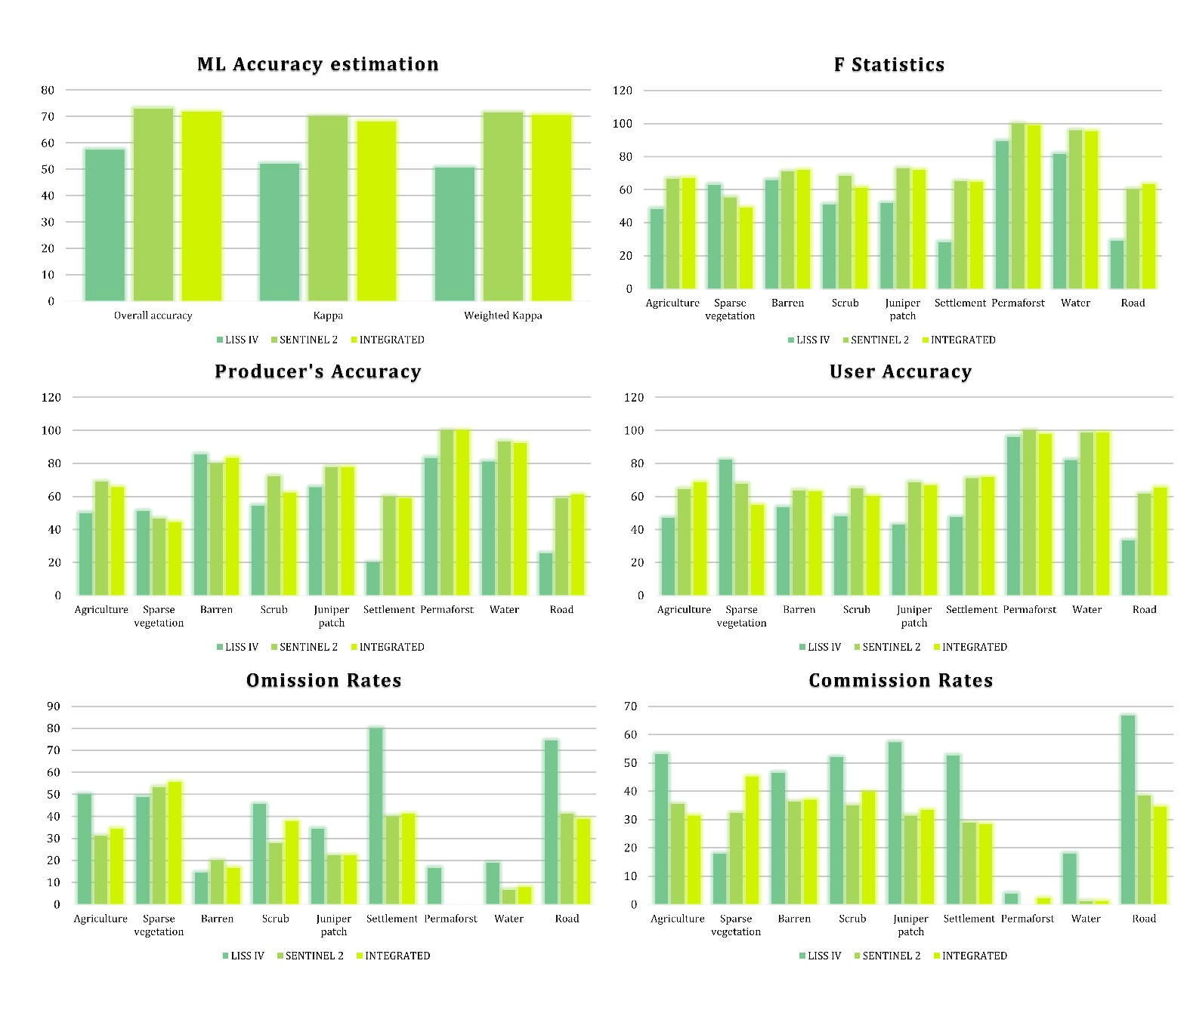
Figure S1: Accuracy estimation of ML classifier algorithm and class accuracy estimation by this algorithm by different statistics viz. F-statistics, Producer’s accuracy, User’s accuracy, Omission rates and Commission rates.
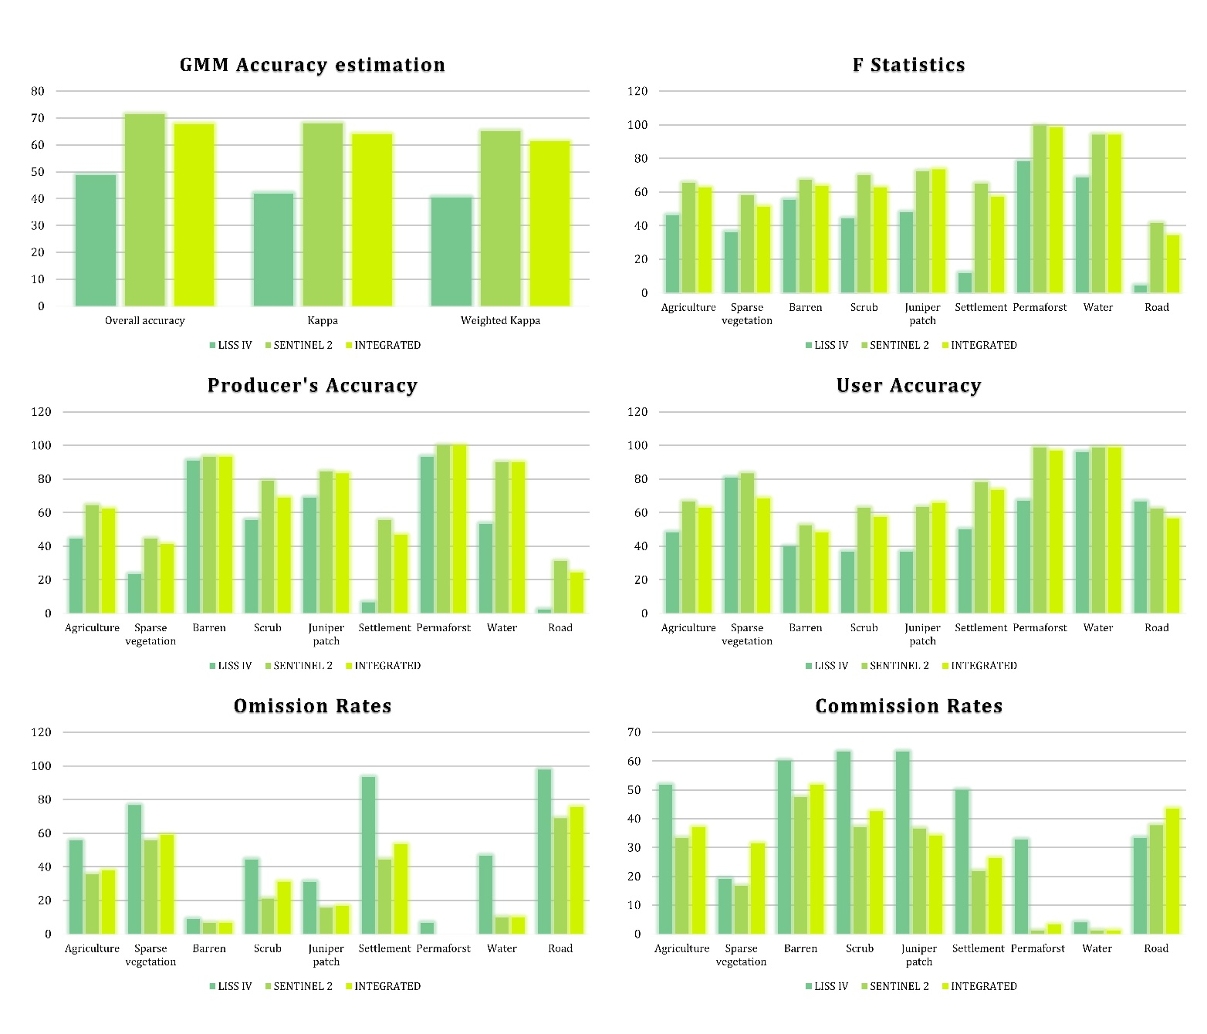
Figure S2: Accuracy estimation of GMM classifier algorithm and class accuracy estimation by this algorithm by different statistics viz. F-statistics, Producer’s accuracy, User’s accuracy, Omission rates and Commission rates.
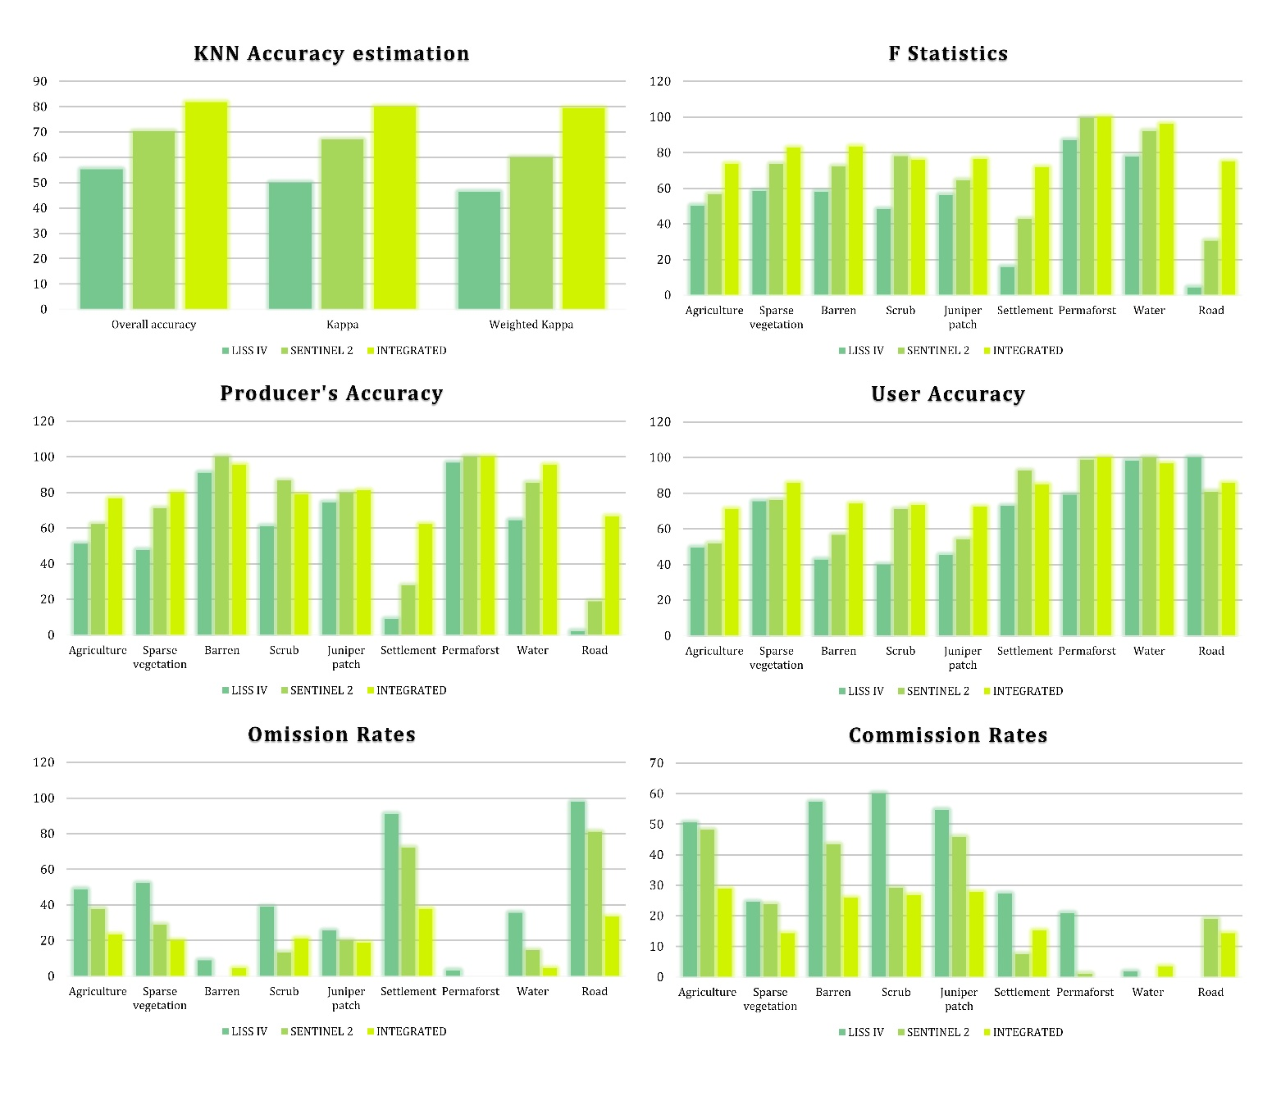
Figure S3: Accuracy estimation of KNN classifier algorithm and class accuracy estimation by this algorithm by different statistics viz. F-statistics, Producer’s accuracy, User’s accuracy, Omission rates and Commission rates.
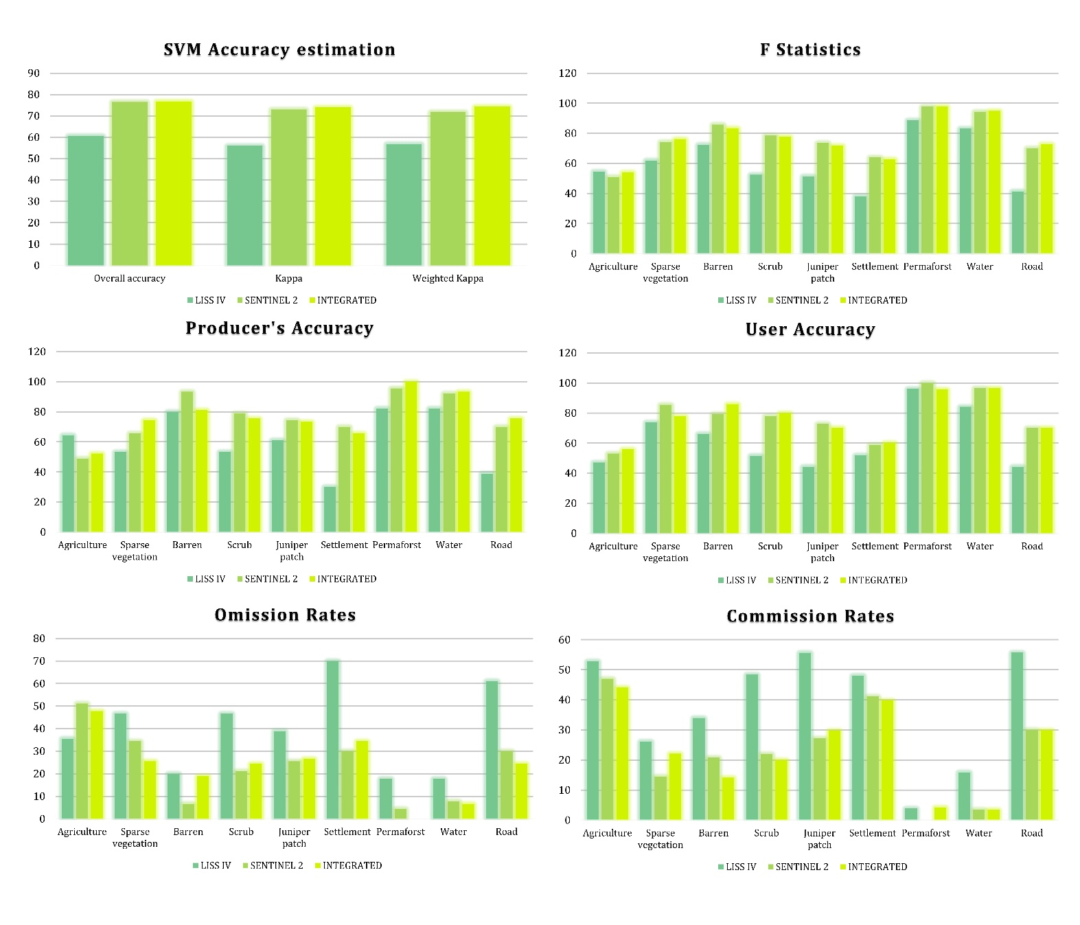
Figure S4: Accuracy estimation of SVM classifier algorithm and class accuracy estimation by this algorithm by different statistics viz. F-statistics, Producer’s accuracy, User’s accuracy, Omission rates and Commission rates.
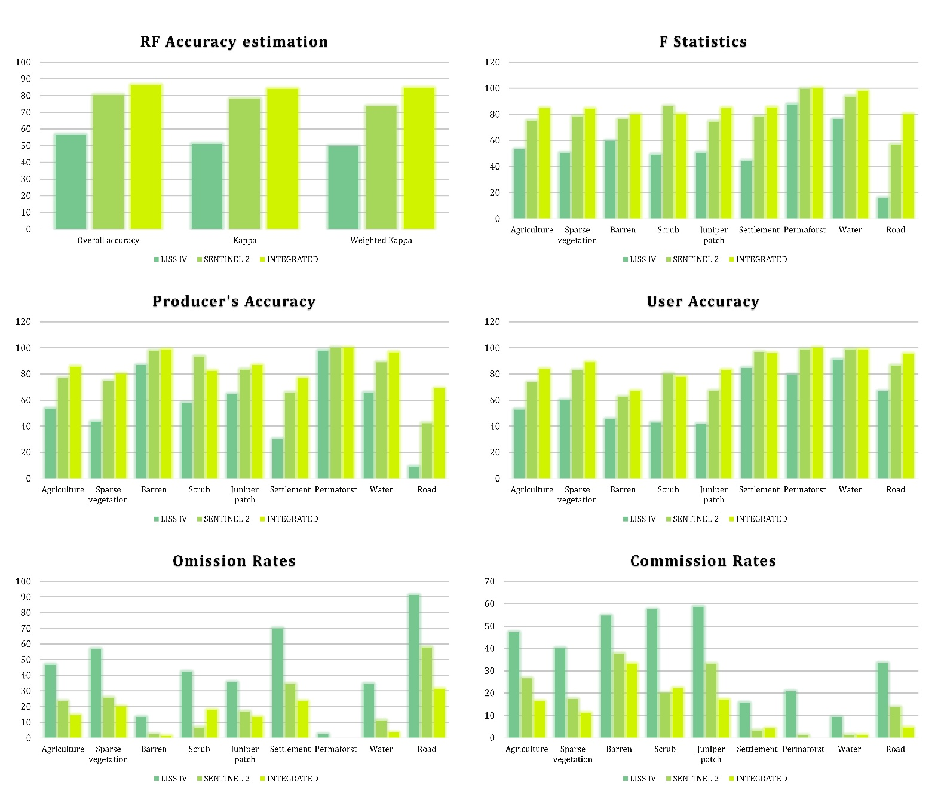
Figure S5: Accuracy estimation of RF classifier algorithm and class accuracy estimation by this algorithm by different statistics viz. F-statistics, Producer’s accuracy, User’s accuracy, Omission rates and Commission rates.

Figure S6: Correlation matrix among the all variables and final variable selection based on <0.8 for the predicting final species distribution models of Himalayan Ibex. The distribution of the predictors and the locations of presence and absence indicated by red and blue dots, respectively. The respective predictor shown on the response curve and in the percentage of deviation in the matrix on the left is indicated. Note: Best classified LISS IV derived LCLU classes used for this model building with other topographic and radiometric variables.

Figure S7: Correlation matrix among the all variables and final variable selection based on <0.8 for the predicting final species distribution models of Himalayan Ibex. The distribution of the predictors and the locations of presence and absence indicated by red and blue dots, respectively. The respective predictor shown on the response curve and in the percentage of deviation in the matrix on the left is indicated. Note: Best classified Sentinel 2A derived LCLU classes used for this model building with other topographic and radiometric variables.

Figure S8: Correlation matrix among the all variables and final variable selection based on <0.8 for the predicting final species distribution models of Himalayan Ibex. The distribution of the predictors and the locations of presence and absence indicated by red and blue dots, respectively. The respective predictor shown on the response curve and in the percentage of deviation in the matrix on the left is indicated. Note: Best classified Integrated image derived LCLU classes used for this model building with other topographic and radiometric variables.

Figure S9. Different models confusion matrix: Represents the confusion matrix for each of the five models. The observed vs. predicted results are presented, and the quantification of specific pair types is shown by the colour ramp from 0% (white) to 100% (red) while using LISS IV classified image along with other topographic and radiometric variables.
Figure S10. Different models confusion matrix: Represents the confusion matrix for each of the five models. The observed vs. predicted results are presented, and the quantification of specific pair types is shown by the colour ramp from 0% (white) to 100% (red) while using Sentinel 2A classified image along with other topographic and radiometric variables.

Figure S11. Different models confusion matrix: Represents the confusion matrix for each of the five models. The observed vs. predicted results are presented, and the quantification of specific pair types is shown by the colour ramp from 0% (white) to 100% (red) while using Integrated image classified image along with other topographic and radiometric variables.
Figure S12. Residual plots and Calibration plots of Model. Column A: The spatial pattern of residuals, where the size and colour of the ramp indicate the quantity and magnitude of the deviation, respectively. Column B: 5 separate models' model calibration plots for the cross-validation division. On the right side of the plots, each model's name is displayed. The model build with LISS IV classified LCLU along the topographic and radiometric variables.
Figure S13. Residual plots and Calibration plots of Model. Column A: The spatial pattern of residuals, where the size and colour of the ramp indicate the quantity and magnitude of the deviation, respectively. Column B: 5 separate models' model calibration plots for the cross-validation division. On the right side of the plots, each model's name is displayed. The model build with Sentinel 2A classified LCLU along the topographic and radiometric variables.
Figure S14. Residual plots and Calibration plots of Model. Column A: The spatial pattern of residuals, where the size and colour of the ramp indicate the quantity and magnitude of the deviation, respectively. Column B: 5 separate models' model calibration plots for the cross-validation division. On the right side of the plots, each model's name is displayed. The model build with Integrated image classified LCLU along the topographic and radiometric variables.
Figure S15. When each predictor is permuted for training and cross-validation data, the change in AUC is used to assess the variable's significance, when using the LCLU LISS IV image classified image along with other topographic and radiometric variables.
.
Figure S16. When each predictor is permuted for training and cross-validation data, the change in AUC is used to assess the variable's significance, when using the LCLU Sentinel 2A image classified image along with other topographic and radiometric variables.
Figure S17. When each predictor is permuted for training and cross-validation data, the change in AUC is used to assess the variable's significance, when using the LCLU Integrated image classified image along with other topographic and radiometric variables.

Figure S18. Representation of the response curves of the selected variables used by BRT model using LISS IV LCLU classes and other variables.
Figure S19. Representation of the response curves of the selected variables used by GLM model using LISS IV LCLU classes and other variables.
Figure S20. Representation of the response curves of the selected variables used by MARS model using LISS IV LCLU classes and other variables.
Figure S21. Representation of the response curves of the selected variables used by MaxEnt model using LISS IV LCLU classes and other variables.

Figure S22. Representation of the response curves of the selected variables used by RF model using LISS IV LCLU classes and other variables.

Figure S23. Representation of the response curves of the selected variables used by BRT model using Sentinel 2A LCLU classes and other variables.
Figure S24. Representation of the response curves of the selected variables used by GLM model using Sentinel 2A LCLU classes and other variables.

Figure S25. Representation of the response curves of the selected variables used by MARS model using Sentinel 2A LCLU classes and other variables.

Figure S26. Representation of the response curves of the selected variables used by MaxEnt model using Sentinel 2A LCLU classes and other variables.
Figure S27. Representation of the response curves of the selected variables used by RF model using Sentinel 2A LCLU classes and other variables.

Figure S28. Representation of the response curves of the selected variables used by BRT model using Integrated image LCLU classes and other variables.
Figure S29. Representation of the response curves of the selected variables used by GLM model using Integrated image LCLU classes and other variables.
Figure S30. Representation of the response curves of the selected variables used by MARS model using Integrated image LCLU classes and other variables.

Figure S31. Representation of the response curves of the selected variables used by MaxEnt model using Integrated image LCLU classes and other variables.
Figure S32. Representation of the response curves of the selected variables used by RF model using Integrated image LCLU classes and other variables.

