Supplementary Material

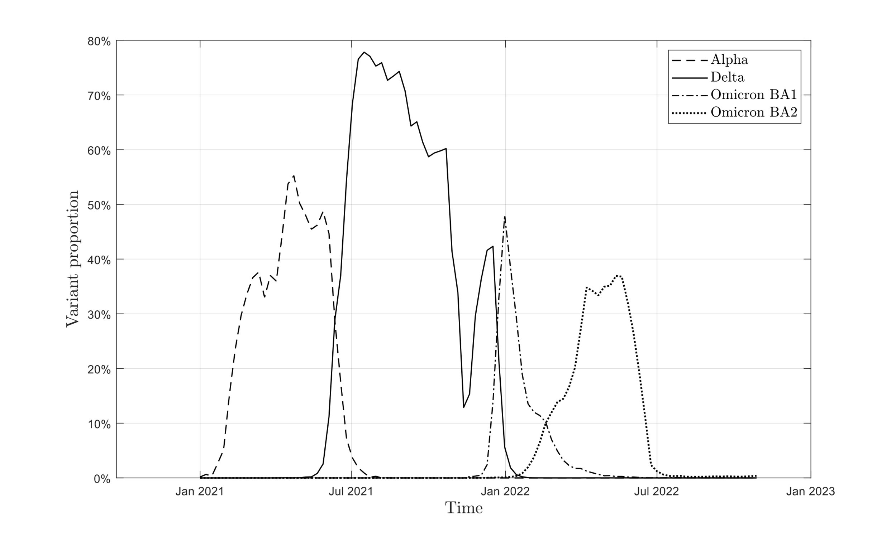
Figure S1: Occurrence of dominant variants expressed as fractions of documented active Infection cases.

Table S1: Left: Pairwise similarity of the model estimates of R-values and Right: pairwise similarity with R-value of documented new infections (N_{INF})

