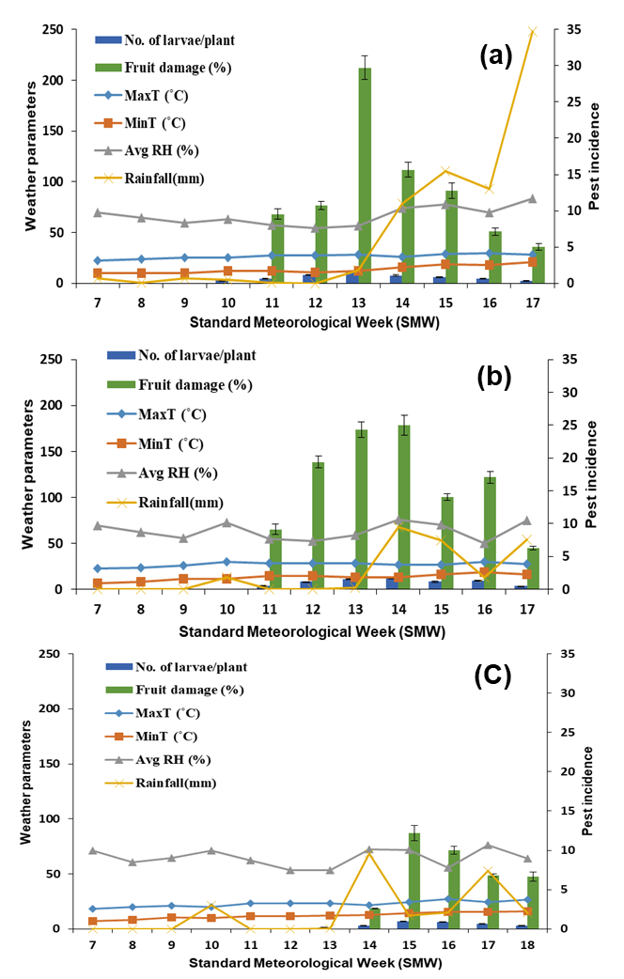
Fig. S1. Weather parameter and seasonal incidence of H. armigera in tomato during 2016 at Location-I (a), II (b), and III (c).

