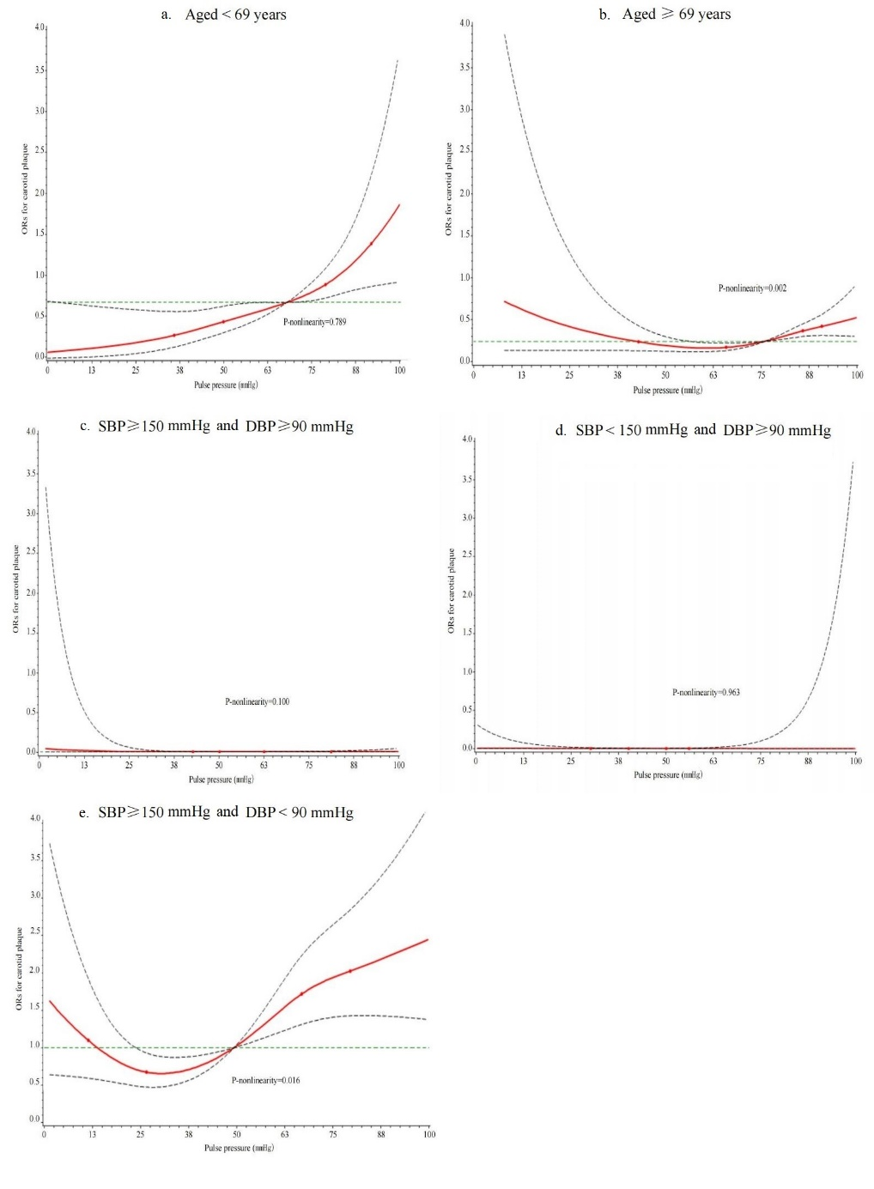

Supplemental figure 1. Dose-response relationship between pulse pressure levels and the risk of carotid plaque by age and BP. SBP, systolic blood pressure; DBP, diastolic blood pressure.

Supplemental table 1 Multinomial Logistic regression with Odds Ratios (95% CIs) for plaque number.
Outcomes | Tertiles of PP |  |  | PP, per 1-SD mmHg
Outcomes | T1 | T2 | T3 | PP, per 1-SD mmHg
Plaque number
≥2 plaques vs. 1 plaque | Ref. | 1.280 (0.843–1.943) | 1.763 (1.074–2.895) | 1.446 (1.101–1.898)
≥2 plaques vs. no plaque  1 plaque vs. no plaque | Ref.  Ref. | 1.222 (0.853–1.751)  0.955 (0.675–1.351) | 2.172 (1.412–3.341)  1.232 (0.797–1.902) | 1.658 (1.306–2.105)  1.147 (0.899–1.464)
Multinomial Logistic regression model was adjusted as model 3 in table 2. PP, pulse pressure.

Supplemental table 2 Sensitivity analysis in patient without history of TIA or stroke (n=1478)
ORs (95% CI) | Tertiles of PP |  |  | PP, per 1-SD mmHg
ORs (95% CI) | T1  (< 64 mmHg) | T2 (64–78 mmHg) | T3 (≥ 78 mmHg) | PP, per 1-SD mmHg
Model 1 | Ref. | 1.355 (1.069–1.717) | 2.466 (1.935–3.142) | 1.483 (1.339–1.642)
Model 2 | Ref. | 1.158 (0.889–1.508) | 1.888 (1.422–2.506) | 1.364 (1.219–1.527)
Model 3 | Ref. | 1.045 (0.774–1.411) | 1.603 (1.101–2.335) | 1.360 (1.100–1.681)
Model 1: unadjusted, Model 2: Adjusted for age, sex, smoking, regular exercise, BMI, family history of stroke，Atrial fibrillation/valvular heart disease, and diabetes. Model 3: Adjusted for the same variables as model 2 and for SBP, blood glucose, Triglycerides, TC, HDLC, LDLC. OR, odds ratio; CI, confidence interval; PP, pulse pressure BMI, body mass index; TIA, transient ischemic attacks; SBP, systolic blood pressure; TC, total cholesterol; HDLC, high density lipoprotein cholesterol; LDLC, low-density lipoprotein cholesterol.

