Supplementary Figure 2: Differential gene expression analysis
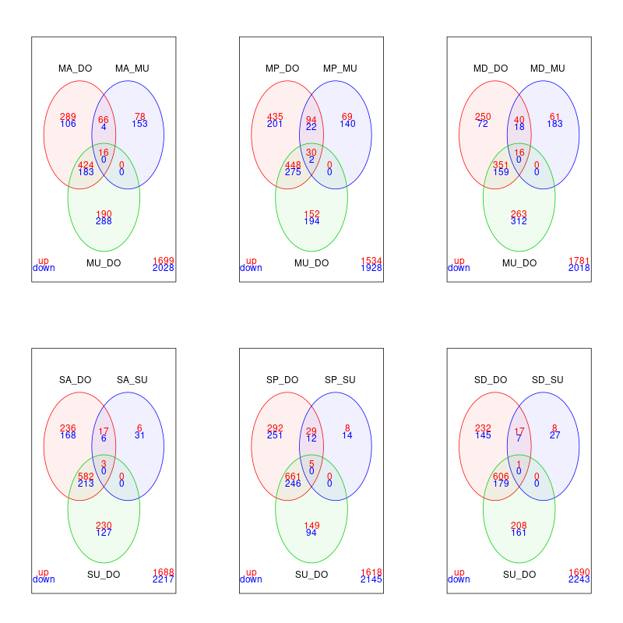
A
B

Venn diagrams showing the differentially expressed genes in the Res-Sus, Res-Con and Con-Sus pairwise comparisons from both Siaya and Migori (logFC = >=1 or <= -1, FDR = < 0.01). A) Migori B) Siaya alphacypermethrin, primiphosmethyl and deltamethrin experiments, respectively. Up regulated genes are shown in red while down regulated genes are shown in blue.
SA = Siaya alphacypermethrin, SD= Siaya deltamethrin, SP= Siaya primiphosmethyl, SU= Siaya unexposed, MA= Migori alphacypermethrin, MD= Migori deltamethrin, MP= Migori primiphosmethyl, MU= Migori unexposed, DO= Dongola (An. arabiensis susceptible strain), DE = differentially expressed, FC = Fold change

