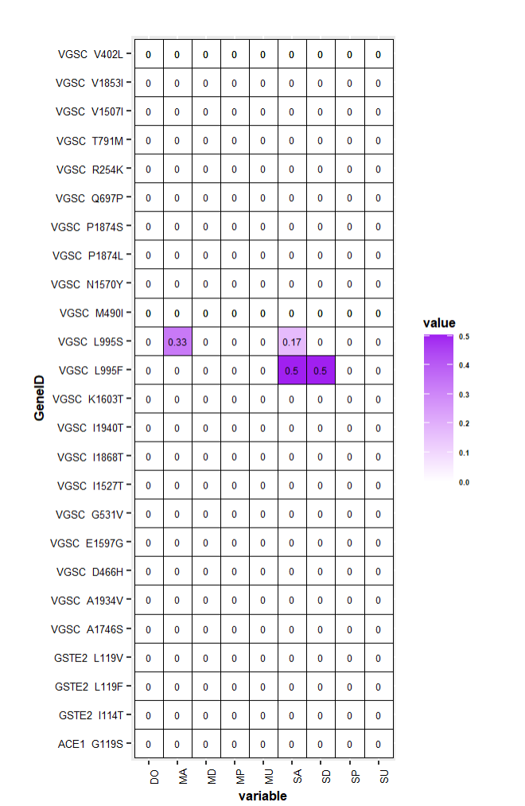
Heatmap showing the allele frequencies of kdr, ACE1 and GSTE2 genes in insecticide resistant samples. Mutant alleles were only present in the kdr gene at positions L995S and L995F.

