Supplement: Table 1 Change of clinical outcomes between two groups in baseline and LFU.
items | Baseline |  |  | Follow-up (Stimulation ON) |  |  | Change from Baseline to FU
items | RP | SP | p value | RP | SP | p value | RP | SP | p value
MDS-UPDRS III* | 52.5 (47.0-65.0) | 60.5 (51.0-65.5) | 0.577 | 27.0 (24.0-37.5) | 37.0 (25.5-43.5) | 0.188 | 25.0 (19.5-29.5) | 23.0 (18.0-27.0) | 0.512
-Rigidity | 13.5 (11.0-16.0) | 13.0 (11.5-15.5) | 0.617 | 4.5 (1.5-10.5) | 6.0 (3.5-9.0) | 0.653 | 7.0 (4.0-11.0) | 7.0 (5.5-9.5) | 0.907
-Tremor | 7.5 (3.0-16.5) | 11.5 (2.5-15.0) | 0.977 | 2.0 (1.0-3.5) | 2.0 (0-3.5) | 0.567 | 5.5 (1.5-10.5) | 8.0 (2.0-13.0) | 0.775
-Bradykinesia | 23.0 (21.5-28.0) | 22.5 (21.0-28.5) | 0.553 | 13.0 (9.5-19.5) | 18.5 (14.5-23.0) | 0.062 | 11.0 (5.5-13.5) | 5.5 (2.0-13.0) | 0.347
-Axial symptoms | 8.5 (6.5-13.0) | 10.0 (7.0-13.0) | 0.713 | 7.0 (6.0-9.0) | 9.0 (5.5-11.0) | 0.444 | 2.5 (0.5-4.0) | 2.0 (-0.5-4.0) | 0.818
pdq-8 | 11.0 (8.0-19.0) | 14.0 (11.0-20.0) | 0.586 | 6.0 (4.0-10.0) | 7.0 (6.0-12.0) | 0.495 | 4.0 (0-12.0) | 4.0 (1-15.0) | 1.000
LEDD (mg) | 712.5 (512.5-900.0) | 587.5 (425.0-875.0) | 0.707 | 400.0 (312.5-425.0) | 339.3 (200.0-425.0) | 0.269 | 225.0 (100.0-512.5) | 325.0 (150.0-537.5) | 0.820
*Videos of UPDRS III were recorded without medication.
Values are median (IQR: P25, P75) or n (%).

Supplement: Table 2 Variables included in this study.
items | Cost
Travel fare, TF (¥/ km) | Train: 0.46
 | Taxi: 2.7
Lost income for in-person visits, LI (¥/ day) | 101.5
Registration fee, RF (¥) | 100
Accommodation, AC (¥) | 300
Cost of each SP (¥) | TF*4+LI+RF+AC
Fee of each RP (¥) | 200

A
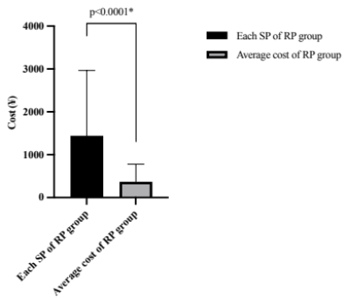
B
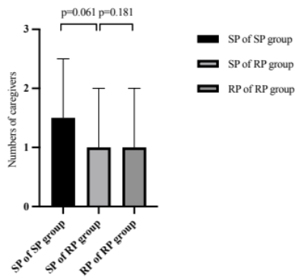
C
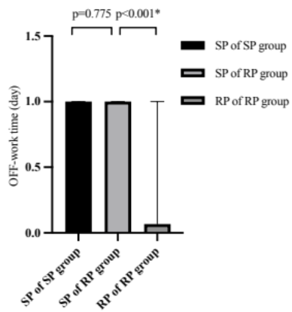
Supplement: Fig. 1 Cost and burden of caregivers analysis between two groups. A) cost comparison of cost between each SP session and average cost in RP group. B) Numbers of caregivers required for each programming session. C) OFF-work time required for each programming sessions. Bars represent the medians, and whiskers represent the range.
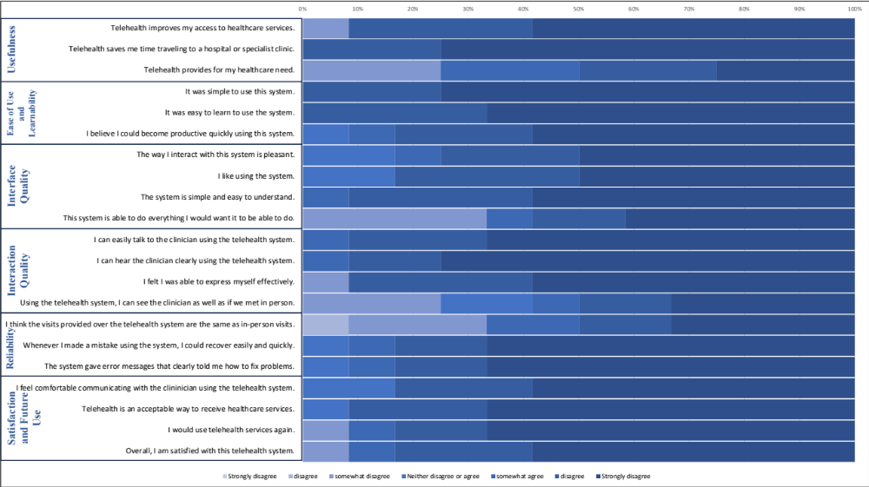
Supplement: Fig. 2 Patient rating of PR according to the Telehealth Usability Questionnaire (TUQ) (n=12). This questionnaire assesses the RP system through six domains: Usefulness, Ease of Use and Learnability, Interface Quality, Interaction Quality, Reliability, and Satisfaction and Future Use, most features of RP system were agreed with by patients except for some items (with relatively lower scores, including a. “Telehealth provides for my healthcare need.”; b. “This system is able to do everything I would want it to be able to do.”; c. “Using the telehealth system, I can see the clinician as well as if we met in person.”; and d. “I think the visits provided over the telehealth system are the same as in-person visits.”)
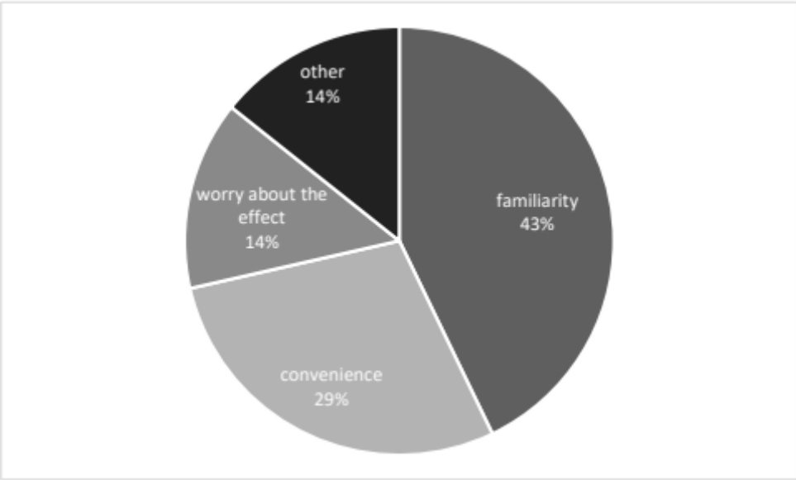
Supplement: Fig. 3 The reasons why patients in the SP group gave up the RP system. (n=7)

