Supplementary Information for:

Larval precompetency and settlement behaviour in 25 Indo-Pacific coral species

Carly J Randall^{1,2*}, Christine Giuliano¹, Briony Stephenson¹, Taylor N Whitman^{1,2},
Cathie A Page¹, Eric A Treml³, Murray Logan¹, Andrew P Negri¹

¹Australian Institute of Marine Science, Townsville QLD, Australia
²AIMS@JCU, Townsville QLD, Australia
³Australian Institute of Marine Science, Perth WA, Australia

*Correspondence to: c.randall@aims.gov.au

Supplementary Tables

Table S 1. Table of known or estimated precompetency periods and maximum pelagic larval durations (PLD) for broadcast spawning scleractinian species.
Species | Precompetency period (d) | Maximum pelagic larval duration (PLD) (d) | Reference(s)
Acanthastrea lordhowensis | - | 78 | ¹
Acropora clathrata | 5 | - | ²
Acropora cytherea | 6 | - | ²
Acropora gemmifera | 3.8 | 34 | ^{3,4}
Acropora humilis | 2.6 | - | ⁴
Acropora hyacinthus | 3 | 91+ | ^{5,6}
Acropora latistella | - | 209 | ⁷
Acropora longicyathus | 4 | - | ⁶
Acropora lordhowensis | 12 | - | ¹
Acropora millepora | 3.5; 4 | 60 | ^{3,4,8}
Acropora nasuta | - | 100+ | ⁷
Acropora spathulata | - | 100+ | ⁷
Acropora tenuis | - | 20 (modelled); 100+ | ^{9,10}
Acropora valida | 1.9; 4 | 110 | ^{3,4,8}
Cyphastrea serailia | - | 26 | ¹
Dipsastraea (Favia) favus | 7 | - | ¹¹
Dipsastraea (Favia) pallida | 4.5 | 195 | ^{7,12}
Fungia scutaria | 5 | - | ¹³
Galaxea fascicularis | 4.5 |  | ¹²
Goniastrea aspera | 4.5 | 35; 215 | ^{7,10,12}
Goniastrea australensis | 17 | 56 | ¹,¹⁴
Goniastrea favulus | 2.25; 6 | - | ^{12,15}
Goniastrea retiformis | 1.4; 5 | 36 | ^{3,4,12}
Heliopora coerulea | - | 30 | ¹⁶
Montastraea magnistellata | - | 244 | ⁷
Montipora digitata | 4 | 89+ | ^{12,17}
Orbicella franski | 20 | 120 | ¹⁸
Pectinia Paeonia | - | 209 | ⁷
Platygyra daedalea | 2.5, 3.1; 3 | 34; 105 | ^{3,4,15,19}
Platygyra lamellina | 8-9 | - | ¹¹
Pocillopora damicornis | - | 100, 103 | ^{9,16,20}
Pseudodiploria strigosa | 3 | 20 | ¹⁸

Table S 2. Metadata for spawning, including the population, spawn date and spawn time for each species, and the number of broodstock colonies that contributed to each culture.
Species | Population | Spawn Date | Spawn Start Time | # Broodstock
Acropora austera | Davies and Backnumbers Reefs | 28/11/2018 | 19:58 | 5
Acropora glauca | Keppel Islands | 20/11/2019 | 21:10-21:40 | 7
Acropora hyacinthus | Keppel Islands | 20/11/2019 | 22:07 | 7
Acropora intermedia | Keppel Islands | 20/11/2019 | 20:57-21:50 | 4
Acropora longicyathus | Palm Islands | 31/10/2018 | 19:05 | 6
Acropora loripes | Davies and Backnumbers Reefs | 28/11/2018 | 19:40 | 6
Acropora micropthalma | Davies and Backnumbers Reefs | 28/11/2018 | 20:26 | 3
Acropora millepora | Palm Islands | 28/10/2018 | 20:40 | 7
Acropora muricata | Davies and Backnumbers Reefs | 27/11/2018 | 21:16-21:40 | 5
Acropora tenuis | Palm Islands | 28/10/2018 | 18:25 | 15
Diploastrea heliopora | Davies and Backnumbers Reefs | 27/11/2018 | 22:55-23:15 | 3+ ♂, 2 ♀
Dipsastraea (Favia) matthaii | Davies and Backnumbers Reefs | 28/11/2018 | 21:20 | 3
Dipsastraea (Favia) matthaii | Davies and Backnumbers Reefs | 27/11/2018 | 22:05 | 2+
Dipsastraea (Favia) pallida | Davies and Backnumbers Reefs | 28/11/2018 | 23:35 | 3
Galaxea fascicularis | Palm Islands | 17/11/2019 | 19:14-20:00 | 3 ♂, 3 ♀
Goniastrea retiformis | Palm Islands | 29/10/2018 | 20:50 | 9
Goniastrea retiformis | Davies and Backnumbers Reefs | 27/11/2018 | 20:35 | 5
Goniastrea retiformis | Palm Islands | 16/11/2019 | 20:00 (est) | 6
Goniastrea retiformis | Palm Islands | 17/11/2019 | 20:00 (est) | not recorded
Lobophyllia corymbosa | Davies and Backnumbers Reefs | 28/11/2018 | 19:00 | 2
Lobophyllia corymbosa | Davies and Backnumbers Reefs | 29/11/2018 | 19:00 (est) | not recorded
Lobophyllia hemprichii | Davies and Backnumbers Reefs | 28/11/2018 | 19:10 | 5
Montipora aequituberculata | Palm Islands | 31/10/2018 | 20:00 | 4
Montipora aequituberculata | Keppel Islands | 20/11/2019 | 19:45 | 6
Montipora digitata | Orpheus Island | 4/04/2018 | 19:21 | 9
Mycedium elephantotus | Davies and Backnumbers Reefs | 28/11/2018 | 21:06 | 4
Oulophyllia crispa | Palm Islands | 20/11/2019 | 21:35 | 3
Pachyseris speciosa | Davies and Backnumbers Reefs | 28/11/2018 | 19:00-20:50 | 1 ♂, 2 ♀
Platygyra daedalea | Palm Islands (13) +  SeaSim experimental (originated from Palm Islands) (3) | 29/10/2018 | 18:45 | 16
Platygyra daedalea | SeaSim experimental (originated from Palm Islands) | 28/11/2018 | 18:20 | not recorded
Porites cylindrica | Palm Islands | 28/10/2018 | 21:05 | 1+ ♂, 1 ♀
Porites lobata | Palm Islands | 18/11/2019 | 21:40 | 2 ♂, 2 ♀

Supplementary Figures
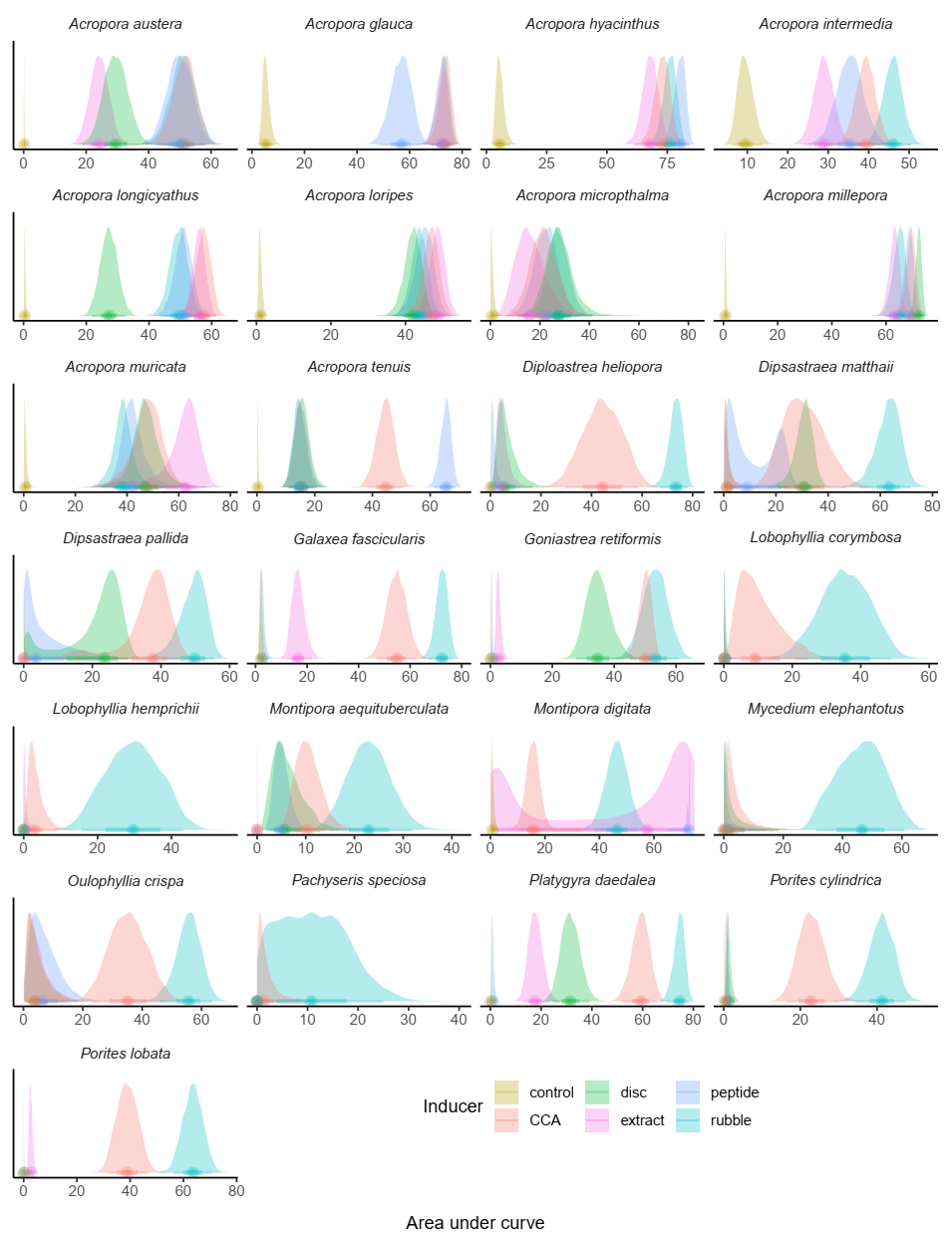
Figure S 1. Posterior distributions of the areas under the curve, for each cue and species, from a Bayesian generalized additive hierarchical model and calculated by numerical integration under each spline (Figure 4). Generally, the larger the area, the more effective the cue at inducing settlement. Areas whose posterior distributions overlap are likely not significantly different from one another (see pairwise exceedance probabilities in Supplementary Code).
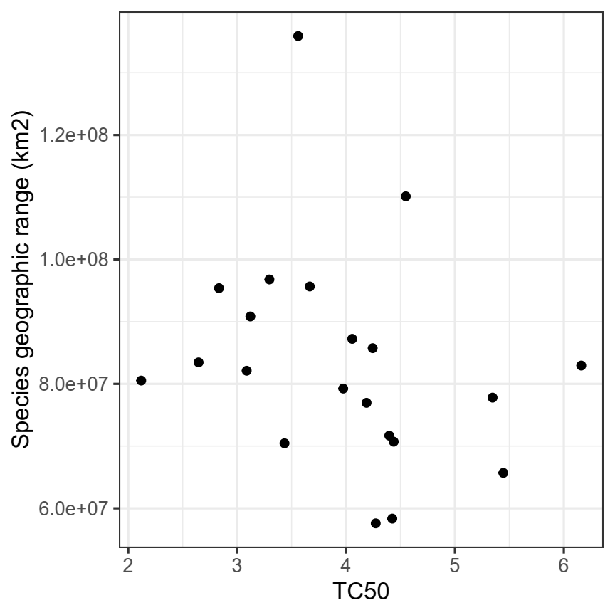
Figure S 2. Modelled time to settlement competency (TC50) plotted against species geographic range estimates from ²¹. No significant correlation was observed.

Supplementary Code: R Studio code for the precompetency and cue comparison analyses are provided in an html output.

References

1. Wilson, J. R. & Harrison, P. L. Settlement-competency periods of larvae of three species of scleractinian corals. Marine Biology 131, 339–345 (1998).
2. Mohd Hanapiah, M. F. et al. Broadcast spawning pattern and pelagic larval duration of Acropora cytherea and A. Clathrata from inshore reef area in Kuantan coastal region. Sci. herit. j. 4, 51–55 (2020).
3. Connolly, S. R. & Baird, A. H. Estimating dispersal potential for marine larvae: dynamic models applied to scleractinian corals. Ecology 91, 3572–3583 (2010).
4. Figueiredo, J., Baird, A. H. & Connolly, S. R. Synthesizing larval competence dynamics and reef-scale retention reveals a high potential for self-recruitment in corals. Ecology 94, 650–659 (2013).
5. Harrison, P. L. et al. Mass spawning in tropical reef corals. Science 223, 1186–1189 (1984).
6. Harrison, P. L. Settlement competency periods and dispersal potential of scleractinian reef coral larvae. in Proceedings of the 10th International Coral Reef Symposium 78–82 (2006).
7. Graham, E. M., Baird, A. H. & Connolly, S. R. Survival dynamics of scleractinian coral larvae and implications for dispersal. Coral Reefs 27, 529–539 (2008).
8. Ayre, D. J. & Hughes, T. P. Genotypic diversity and gene flow in brooding and spawning corals along the Great Barrier Reef, Australia. Evolution 54, 1590–1605 (2000).
9. Richmond, R. H. Competency and dispersal potential of planula larvae of a spawning versus brooding coral. in Proceedings of the 6th International Coral Reef Symposium vol. 2 827–831 (1988).
10. Graham, E. M., Baird, A. H., Connolly, S. R., Sewell, M. A. & Willis, B. L. Rapid declines in metabolism explain extended coral larval longevity. Coral Reefs 32, 539–549 (2013).
11. Shlesinger, Y. & Loya, Y. Larval development and survivorship in the corals Favia favus and Platygyra lamellina. in Coelenterate Biology: Recent Research on Cnidaria and Ctenophora (eds. Williams, R. B., Cornelius, P. F. S., Hughes, R. G. & Robson, E. A.) 101–108 (Springer Netherlands, 1991). doi:10.1007/978-94-011-3240-4_14.
12. Babcock, R. C. & Heyward, A. J. Larval development of certain gamete-spawning scleractinian corals. Coral Reefs 5, 111–116 (1986).
13. Schwarz, J. A., Krupp, D. A. & Weis, V. M. Late larval development and onset of symbiosis in the scleractinian coral Furgia scutaria. Biological Bulletin 196, 70–79 (1999).
14. Kojis, B. L. & Quinn, N. J. Aspects of sexual reproduction and larval development in the shallow water hermatypic coral, Goniastrea australensis (Edwards and Haime, 1857). Bulletin of Marine Science 31, 558–573 (1981).
15. Miller, K. & Mundy, C. Rapid settlement in broadcast spawning corals: implications for larval dispersal. Coral Reefs 22, 99–106 (2003).
16. Harii, S., Kayanne, H., Takigawa, H., Hayashibara, T. & Yamamoto, M. Larval survivorship, competency periods and settlement of two brooding corals, Heliopora coerulea and Pocillopora damicornis. Marine Biology 141, 39–46 (2002).
17. Randall, C. J., Giuliano, C., Mead, D., Heyward, A. J. & Negri, A. P. Immobilisation of living coral embryos and larvae. Sci Rep 9, 14596 (2019).
18. Davies, S. W., Strader, M. E., Kool, J. T., Kenkel, C. D. & Matz, M. V. Modeled differences of coral life-history traits influence the refugium potential of a remote Caribbean reef. Coral Reefs 36, 913–925 (2017).
19. Nozawa, Y. & Harrison, P. L. Larval settlement patterns, dispersal potential, and the effect of temperature on settlement of larvae of the reef coral, Platygyra daedalea, from the Great Barrier Reef. in Proceedings of the 9th International Coral Reef Symposium vol. 1 409–416 (2000).
20. Richmond, R. Energetics, competency, and long-distance dispersal of planula larvae of the coral Pocillopora damicornis. Marine Biology 93, 527–533 (1987).
21. Hughes, T. P., Connolly, S. R. & Keith, S. A. Geographic ranges of reef corals (Cnidaria: Anthozoa: Scleractinia) in the Indo-Pacific: Ecological Archives E094-150. Ecology 94, 1659 (2013).

