Appendix A

CONSENT TO PARTICIPATE IN RESEARCH STUDY
High School AP® Research Course

TITLE OF STUDY: The Last Documentary Impact on the environmental sensitivity and Knowledge of the Severity of the Water Crisis of students

This consent form is part of an informed consent process for a research study, and it will provide information that will help you decide whether you want to take part in this study. The Principal Investigator of the research study is “head researcher”. It is your choice to take part or not.

The purpose of the research is to test the impact that the documentary “The Last Drop” has on environmental sensitivity and on knowledge of the severity of the water crisis.

If you take part in the research, you will be asked to take a pre-survey, watch a documentary about the water crisis, and then take a post-survey. Your time in the study will take one hour.

Potential harms or burdens of taking part in the study may be probing for potential political sensitivity relating to the environment.

There are no direct benefits to participants from the research; however, it will help researchers better understand the correlation between environmental documentaries and environmental sensitivity.

If you have any questions now or during the study, if you choose to take part, you should feel free to ask them and should expect to be given answers you completely understand.

- I will not collect any information that can identify you or other subjects. Completed forms will be stored on the platform Survey Monkey. Responses may be converted to digital format and stored on a password-protected computer that can only be accessed by me. Paper copies will then be destroyed. I plan to delete the data after researching by February.

By signing this form and continuing with the study, you have acknowledged that you have read the entire informed consent and are at least 18 years of age. Also, you acknowledge that you agree to take part in the study and have the right to not to answer any or all of the questions in the study. Finally, you understand your participation is completely voluntary, and you may quit the study at any time without penalty.

AGREEMENT TO PARTICIPATE
1. Subject consent:
I have read this entire consent form, or it has been read to me, and I believe that I understand what has been discussed. All of my questions about this form and this study have been answered. I agree to take part in this study.

Subject Name (printed):

Subject Signature: Date:

2. Signature of Investigator/Individual Obtaining Consent:
To the best of my ability, I have explained and discussed all the important details about the study including all of the information contained in this consent form.

Investigator/Person Obtaining Consent (printed): ________

Signature: _ Date:

The researcher is a high school student who is enrolled in the AP® Research course. If you have any questions or concerns, please contact the course instructor.

Appendix B
Title of Study: “The Last Drop” documentary impact on the environmental sensitivity and knowledge of students

Researcher’s Name: Head Researcher

You are being asked to be in a research study, you are volunteering to take part and you may stop at any time.

The research study looks at the impact that the documentary “The Water Crisis” has on environmental sensitivity and on public perception of the severity of the water crisis and persuading change in outlook.

Your part in this study will be to take a pre-survey, watch a documentary about the water crisis, and then take a post-survey and nothing bad will happen to you during the study.
The study will take about one hour for you to do. Your parent/guardian has been told about the study and knows you are being asked to take part, but it is up to you to decide if you want to do the study.
Your answers will only be seen by the researcher and will not be shown to your teachers or parents.
You understand that you are volunteering to take part in the study and that you do not have to be in this study unless you want to. You do not have to answer any questions you do not want to, and you can stop being in the study whenever you want. If you choose not to answer a question or to stop taking part in the study, it is okay, and no one will be upset with you. If you want to stop taking part in the study, you just need to tell the researcher that you want to stop. If you do not want to be in the study or if you want to quit the study once you have started, no one will be mad or upset at you.
If you have any questions about the study, you may ask now or at any time during the study. After the study, if anything about what you did worries or upsets you, you should talk to your parent/guardian about it.
I agree to be in this study, have had all my questions about the study answered, and know I can stop at any time.

_________________________________ _____________
Signature of the Subject Date

Appendix C

Pre-Documentary Survey:
Answer the following questions using a 1-5 scale, which mean

1-Never
2-Rarely
3-Sometimes
4-Often
5-Always

1) I watch environmental programs that are broadcast on TV or the internet.
2) I read about environmental issues in daily newspapers, on social media, or on the internet.
3) I watch environmental documentaries.
4) I read books about environmental issues apart from textbooks.
5) I read popular environmental journals.
6) I read scientific articles about the environment.
7) I warn a person who is damaging the environment without hesitation.
8) I want to voluntarily participate in any activity organized related to the
natural environment at school.
9) My friends see me as a person who is sensitive to the environment.
10) If necessary, I am willing to work for a livable environment for a long time
with low pay.

Answer the following on a 1-5 scale, which mean
1- Strongly disagree
2- Somewhat disagree
3- Neutral
4- Somewhat agree
5- Strongly disagree

- I know the meaning of the United States water crisis.
- I believe that documentaries enhance learning.
- The major issues and concerns of the Water Crisis are essential and important. cite
- I have a sense of involvement, hope, and excitement to reduce my water consumption.
- I want to share my knowledge of the water crisis with my peers.
- I believe that documentaries generally tell “the truth”.
- I believe that documentaries enhance learning.
- I believe documentaries enhance my understanding of environmental issues.

Post-Documentary Survey:
Answer the following on a 1-5 scale, with 5 being the highest

- I know the meaning of the United States water crisis.
- I believe that documentaries enhance learning.
- The major issues and concerns of the Water Crisis are essential and important.
- I have a sense of involvement, hope, and excitement to reduce my water consumption.
- I want to share my knowledge of the water crisis with my peers.
- I believe that documentaries generally tell “the truth”.
- I believe that documentaries enhance learning.
- I believe documentaries enhance my understanding of environmental issues.
- I feel that this documentary was engaging, captivating, and interesting.
- This documentary, in particular, was relevant in enhancing my sensitivity to environmental issues.

Appendix D
Z-Value Environmental Subscale Graphical Data
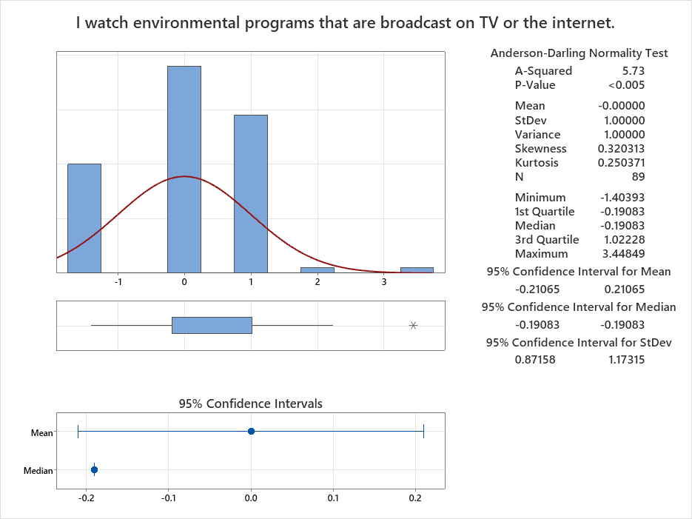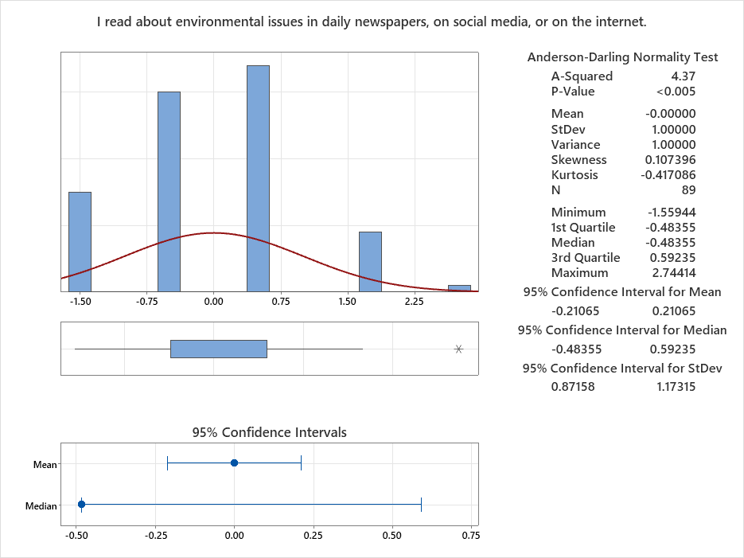
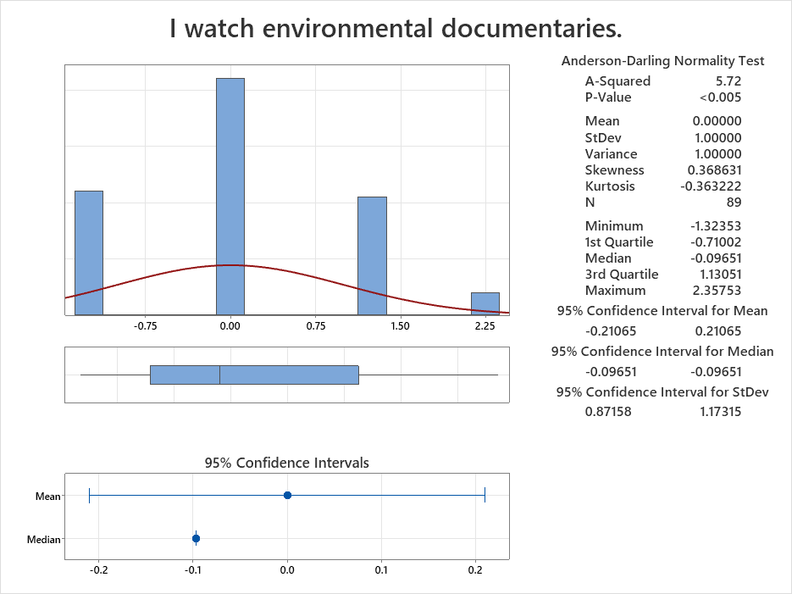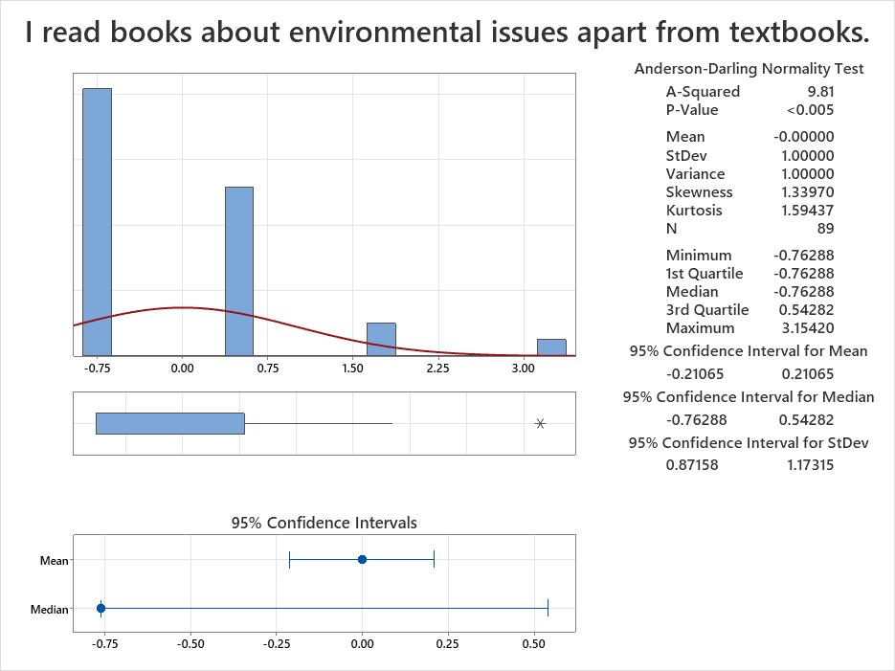
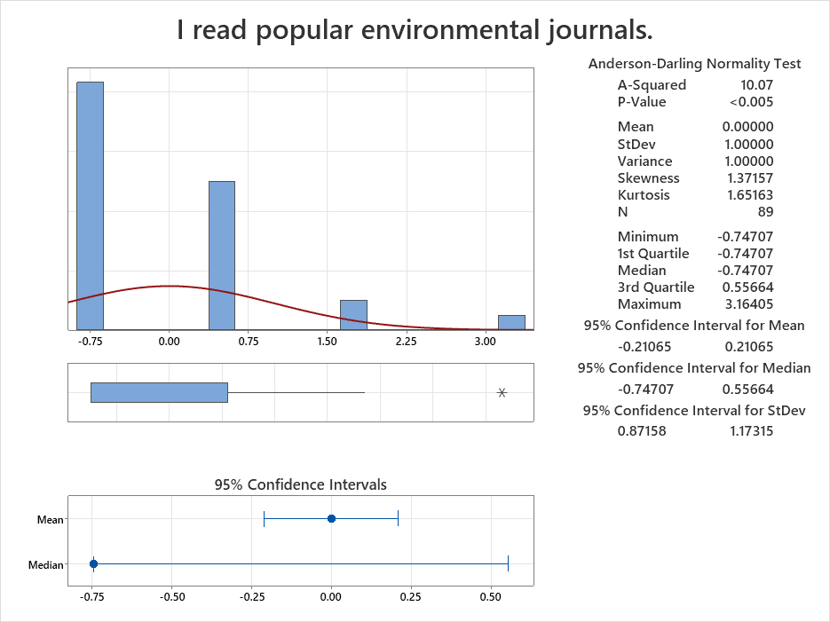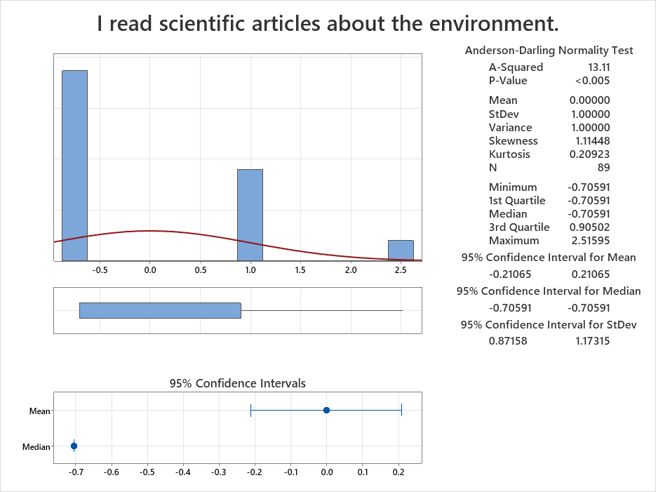

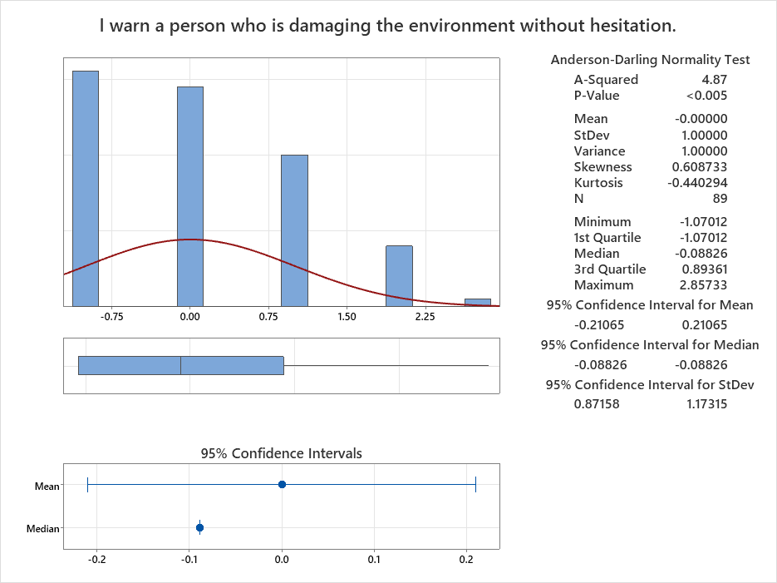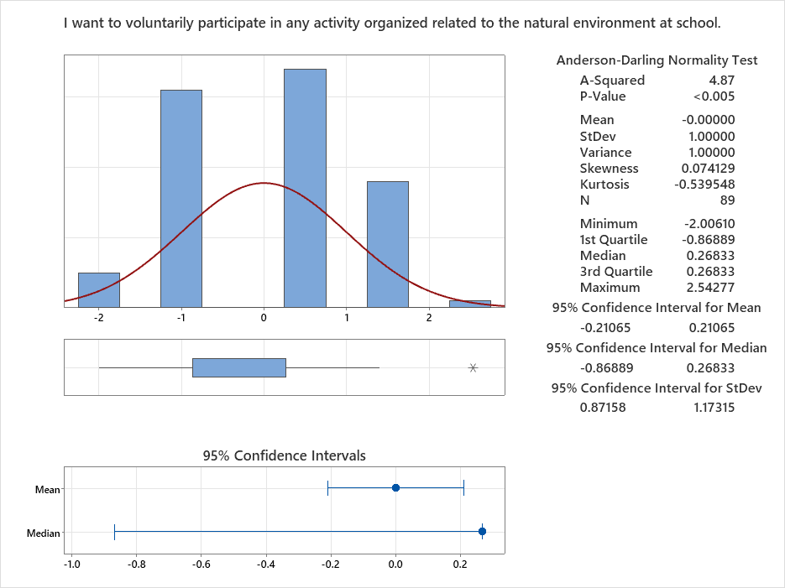
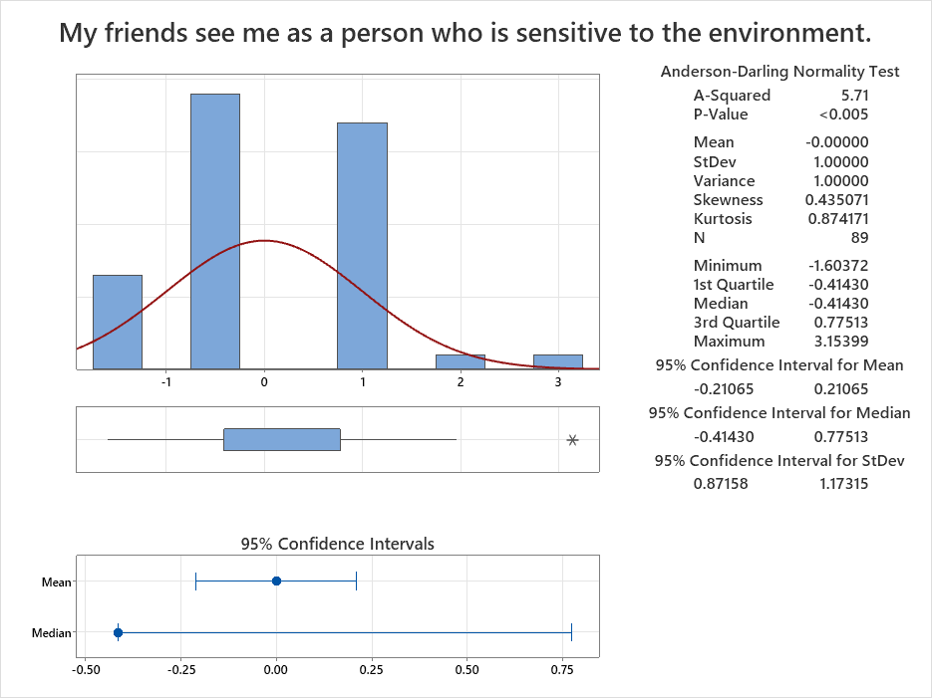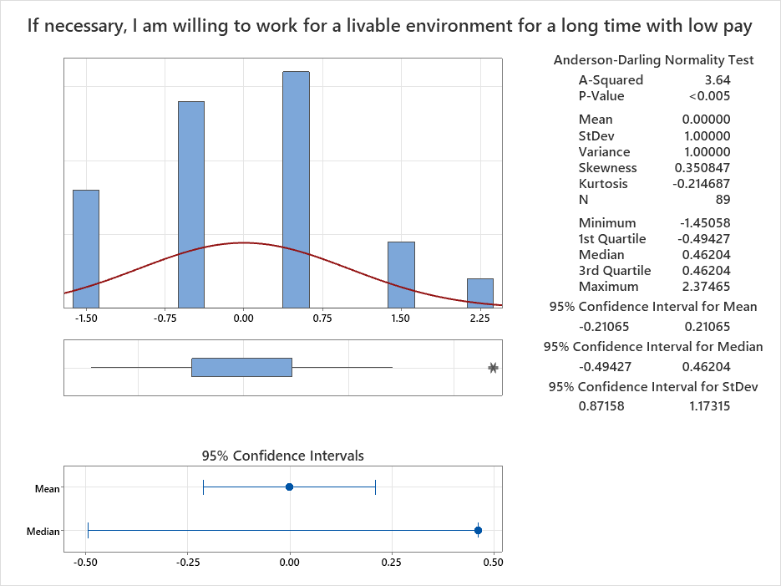
Appendix E
Pre and Post Survey Graphical Data



