Supplementary Figures
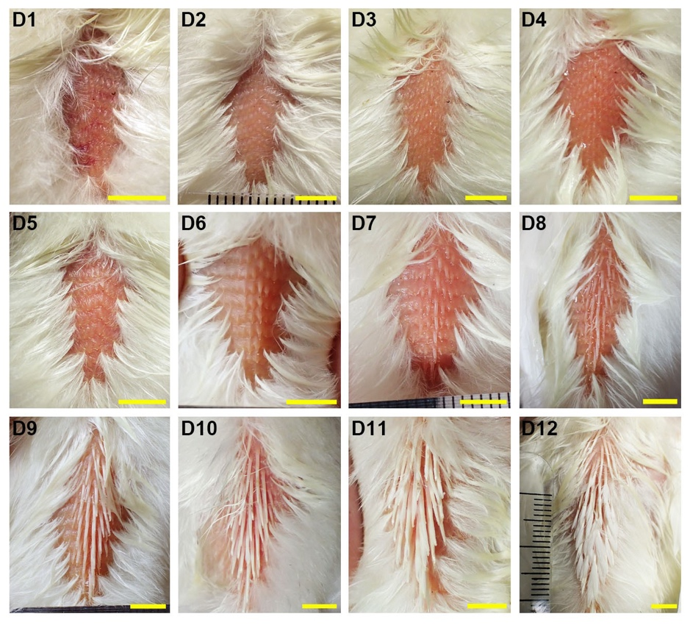
Supplementary Figure 1. Dorsal views of developing chicken juvenile feathers. The posterior dorsal natal downs were removed to visualize the beneath juvenile feather germs. D: posthatch days. Scale bar: 1 cm.

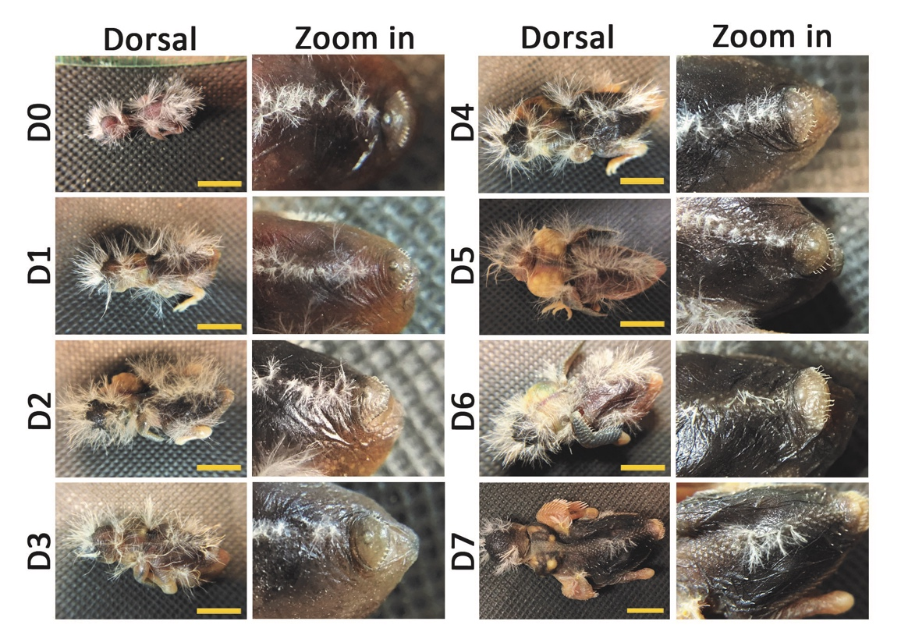
Supplementary Figure 2. Dorsal views and the enlargements of developing zebra finch juvenile feathers. The natal downs in the enlargement views were trimmed to visualize the beneath juvenile feather germs. D: posthatch days. Scale bar: 1 cm.

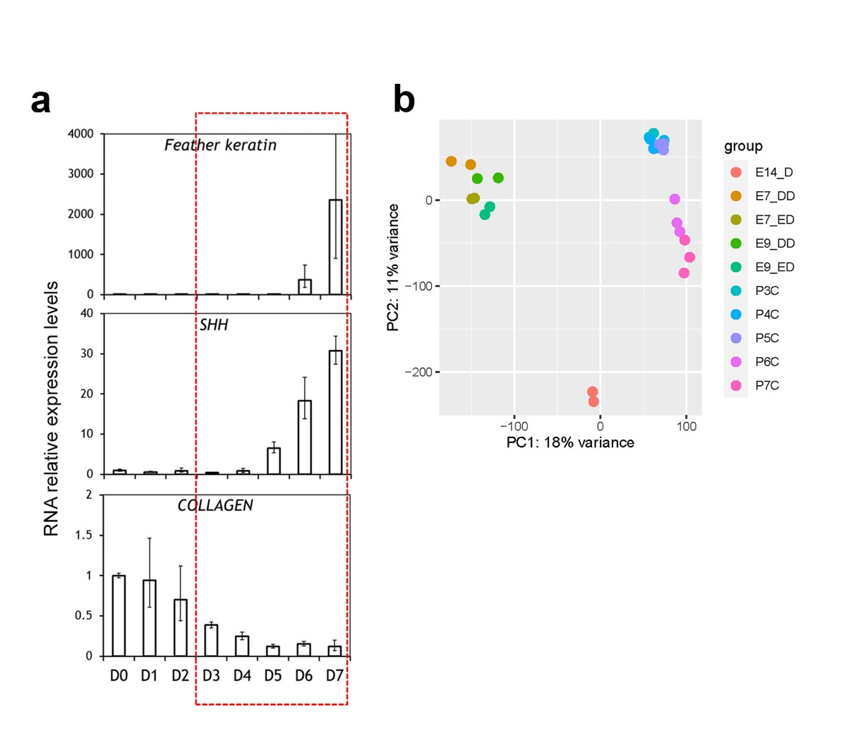
Supplementary Figure 3. Quality controls of the samples in transcriptomic analysis. a Quantitative PCR detection of sevral morphogems at different developmental stages of chicken dorsal skins. b PCA analysis of all the RNA-seq libraries used in this study. E14: E14 feather filament; E7D: E7 dermis; E7E: E7 epidermis; E9D: E9 dermis; E9E: E9 epidermis; D3, 4, 5, 6, 7: posthatch day 3, 4, 5, 6, 7, respectively.

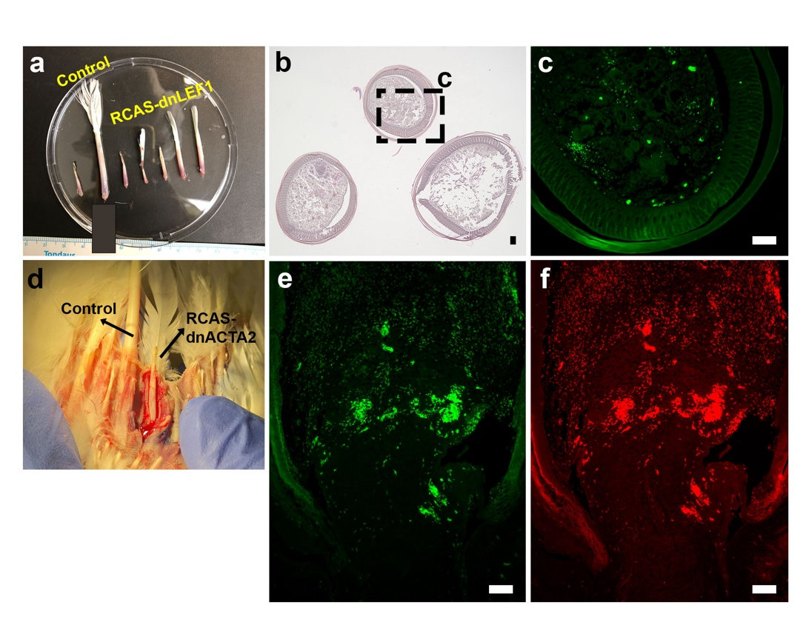
Supplementary Figure 4. a The dissected flight feather follicles with or without RCAS-dnLEF1 treatment. b H&E staining of the three cross sections of flight feather follicles with RCAS-dnLEF1 injection. The top one lost the entire rachis while the bottom two showed abnormal small rachis. c The virus staining (AMV3C2) of the squre in b. d The dissected flight feather follicles with or without RCAS-dnACTA2 treatment. e and f IHC with AMV3C2 (e) and LCAM (f) of the longitudinal sections of a regenerated flight feather follicle with RCAS-dnACTA2 injection.

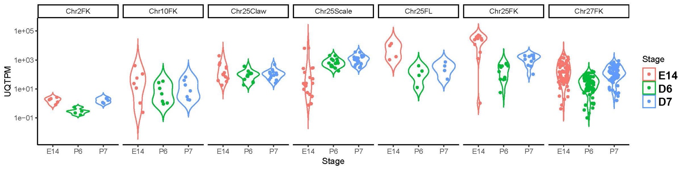
Supplementary Figure 5. Violin plots of the expression levels of β-keratin gene in different β-keratin subfamilies. UQTPM: upper quartile TPM values. FK: feather keratin; Claw: claw keratin; Scale: scale keratin; FL: feather keratin like protein; E14: E14 feather filament; D6: posthatch day 6; D7: posthatch day 7.

