Supplementary Figure S1 Survival plot for patients over 70 years old (green line) compared to patients who younger than 70 years old (blue line), duration since illness onset.
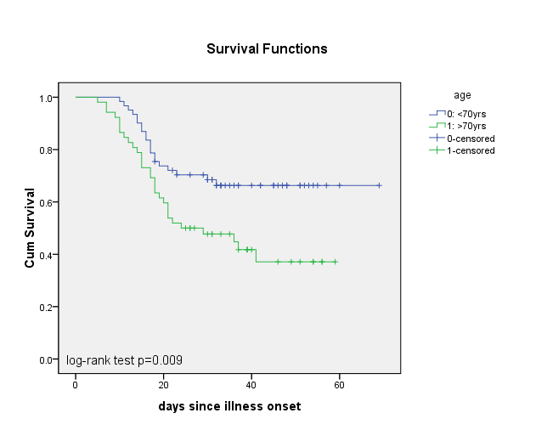

Supplementary Figure S2 Survival plot for patients with initial neutrophil count > 6.5×10⁹/L (green line) compared to patients with initial neutrophil count < 6.5×10⁹/L (blue line), duration since illness onset.
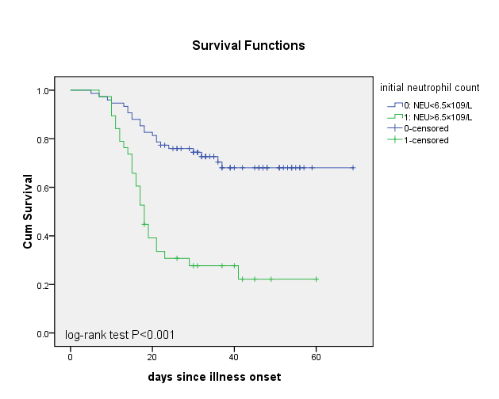

Supplementary Figure S3 Survival plot for patients with C-reactive protein > 100mg/L (green line) compared to patients with C-reactive protein < 100mg/L (blue line), duration since illness onset.
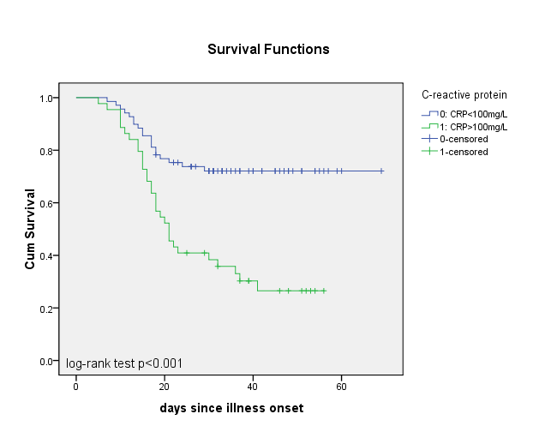

Supplementary Figure S4 Survival plot for patients with lactate dehydrogenase > 300U/L (green line) compared to patients with lactate dehydrogenase < 300U/L (blue line), duration since illness onset.
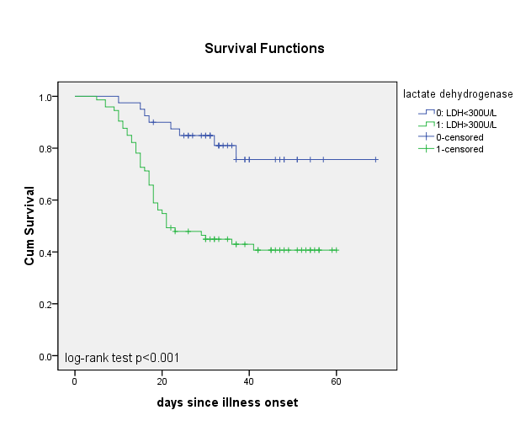

Supplementary Figure S5 Survival plot for patients with immunoglobulin treatment (green line) compared to patients without immunoglobulin treatment (blue line), duration since illness onset.

