Supplemental information
Intestinal persistence of Bifidobacterium infantis is determined by interaction of host genetics and antibiotic exposure

Table S1: Reagent and resource list
REAGENT OR RESOURCE | SOURCE | IDENTIFIER
Antibiotics
Ampicillin | Sigma-Aldrich | N1876
Neomycin | Sigma-Aldrich | A1593
Bacterial and Virus strains
Bifidobacterium bifidum | Japan Collection of Microorganisms | JCM 1255
Bifidobacterium breve | Japan Collection of Microorganisms | JCM 1192
Bifidobacterium longum subspecies infantis | Japan Collection of Microorganisms | JCM 1222
Chemicals, Peptides, and Recombinant Proteins
2'-Fucosyllactose (98% purity) | Layer Origin, New York, USA | PureHMO
Lactobacilli MRS Agar 500G | BD, New Jersey, USA | Cat# 288210
Lactobacilli MRS Broth 500g | BD, New Jersey, USA | Cat# 288130
Critical Commercial Assays
DNeasy PowerLyzer PowerSoil Kit | QIAGEN, Hilden, Germany | Cat# 12855-100
PowerUp SYBR Green Master Mix | Life Technologies | Cat# A25777
MiSeq Reagent Kit v3 (600-cycle) | Illumina | Cat# MS-102-3003
Nextera XT Index Kit v2 Set A | Illumina | Cat# FC-131-2001
NextSeq 500/550 Mid Output Kit v2.5  (300 Cycles) | Illumina | Cat# 20024905
Illumina® DNA Prep, (M) Tagmentation | Illumina | Cat# 20018704
Nextera™ DNA CD Indexes | Illumina | Cat# 20018708
Nextera XT DNA Library Preparation Kit | Illumina | Ca# FC-131-1096

Continued
REAGENT OR RESOURCE | SOURCE | IDENTIFIER
Experimental Models: Organisms/Strains
Fut2^{+/+} C57BL/6JSah  (Males and females 6 weeks of age) | SAHMRI, Australia | N/A
Fut2^{-/-} C57BL/6JSah  (Males and females 6 weeks of age) | SAHMRI, Australia | N/A
Oligonucleotides
Primers for genotyping mFut2_KO_F:  5'- GGCACAATGCAGATGATTAG -3' | Designed in this study | N/A
Primers for genotyping mFut2_KO_R1:  5'- GCTTCACTATTCGTTGCTGG -3' | Designed in this study | N/A
Primers for genotyping mFut2_KO_R2:  5'- AGTTTTCAGGAACAGGAGCC -3' | Designed in this study | N/A
16S V4 Amplicon PCR Forward Primer | ¹ | N/A
16S V4 Amplicon PCR Reverse Primer | ¹ | N/A
Miseq Illumina sequencing Index primer
Deposited Data
Sequence data | NCBI | PRJNA1011386
Software and Algorithms
QIIME 2 version 2021.11.0 | ² | N/A
R studio 4.1.0 | N/A | N/A
GraphPad Prism 9.0.0 | GraphPad Software, California, USA | N/A
PRIMER 6.1.16 & PERMANOVA+ 1.0.6 | PRIMER-e, Auckland, NZ | N/A

Table S2. qPCR primers and cycling conditions
Target | Standard DNA | Primer sequences | Cycling conditions | Reference
16S | E. coli ATCC | qB331F: TCCTACGGGAGGCAGCAGT  qB797R: GGACTACCAGGGTATCTAATCCTGTT | 40 cycles:  95°C for 15 s  60°C for 1 min | ³
B. longum sp. infantis | JCM 1222 | BIN-F: CGCGAGCAAAACAATGGTT  BIN-R: AACGATCGAAACGAACAATAGAGTT | 40 cycles:  95°C for 15 s  60°C for 1 min | ⁴
B. bifidum | JCM 1255 | B_bif-f: CTCCGCAGCCGACCCCGAGGTT  B_bif-r: TGGAAACCTTGCCGGAGGTCAGG | 40 cycles:  94°C for 15 s  64°C for 15 s  72°C for 15 s  83°C for 15 s | ⁵
B. breve | JCM 1192 | BBR-F: GTGGTGGCTTGAGAACTGGATAG  BBR-R: CAAAACGATCGAAACAAACACTAAA | 40 cycles:  95°C for 15 s  60°C for 1 min | ⁴
Fut2 | N/A | mFut2KO_F: GGCACAATGCAGATGATTAG  mFut2KO_R1: GCTTCACTATTCGTTGCTGG  mFut2KO_R2: AGTTTTCAGGAACAGGAGCC | 45 cycles:  95°C for 15 s  60°C for 1 min | This study

Table S3. Genotype and sex effect on Microbiome composition
Model | Covariates | R² | F value | P values
PERMANOVA | Genotype | 0.028 | 2.74 | 0.028
 | Sex | 0.022 | 2.14 | 0.072
 | Cage (nested in Genotype + Sex) | 0.49 | 3.05 | 0.0001
 | Residual | 0.46
 | Total | 1
Pair-wise PERMANOVA | Genotype x Sex | 0.11 | 2.38 | 0.0068
Pair-wise PERMANOVA | Residual | 0.89
 | Male (WT vs KO) | 0.12 | 4.28 | 0.021*
 | Female (WT vs KO) | 0.037 | 1.14 | 0.38*
 | WT (Male vs Female) | 0.040 | 1.24 | 0.38*
 | KO (Male vs Female) | 0.12 | 4.02 | 0.021*
* P value after FDR correction

Taxa | Treatment | Median colony counts  (IQR, log10 CFU/mL) | p value
Escherichia coli | mBasal | 8.93 [IQR=8.84, 9.00] | 0.030
Escherichia coli | mBasal + 2ˈ-FL | 7.57 [IQR=7.28, 7.76] | 0.030
Enterococcus faecalis | mBasal | 7.54 [IQR=7.54, 7.57] | 0.029
Enterococcus faecalis | mBasal + 2ˈ-FL | 8.32 [IQR=8.27, 8.37] | 0.029
Lactobacillus murinus/reuteri | mBasal | 6.94 [IQR=6.89, 6.96] | 0.030
Lactobacillus murinus/reuteri | mBasal + 2ˈ-FL | 7.72 [IQR=7.61, 7.84] | 0.030
Table S4. In vitro culture of faecal bacteria following by glycan exposure

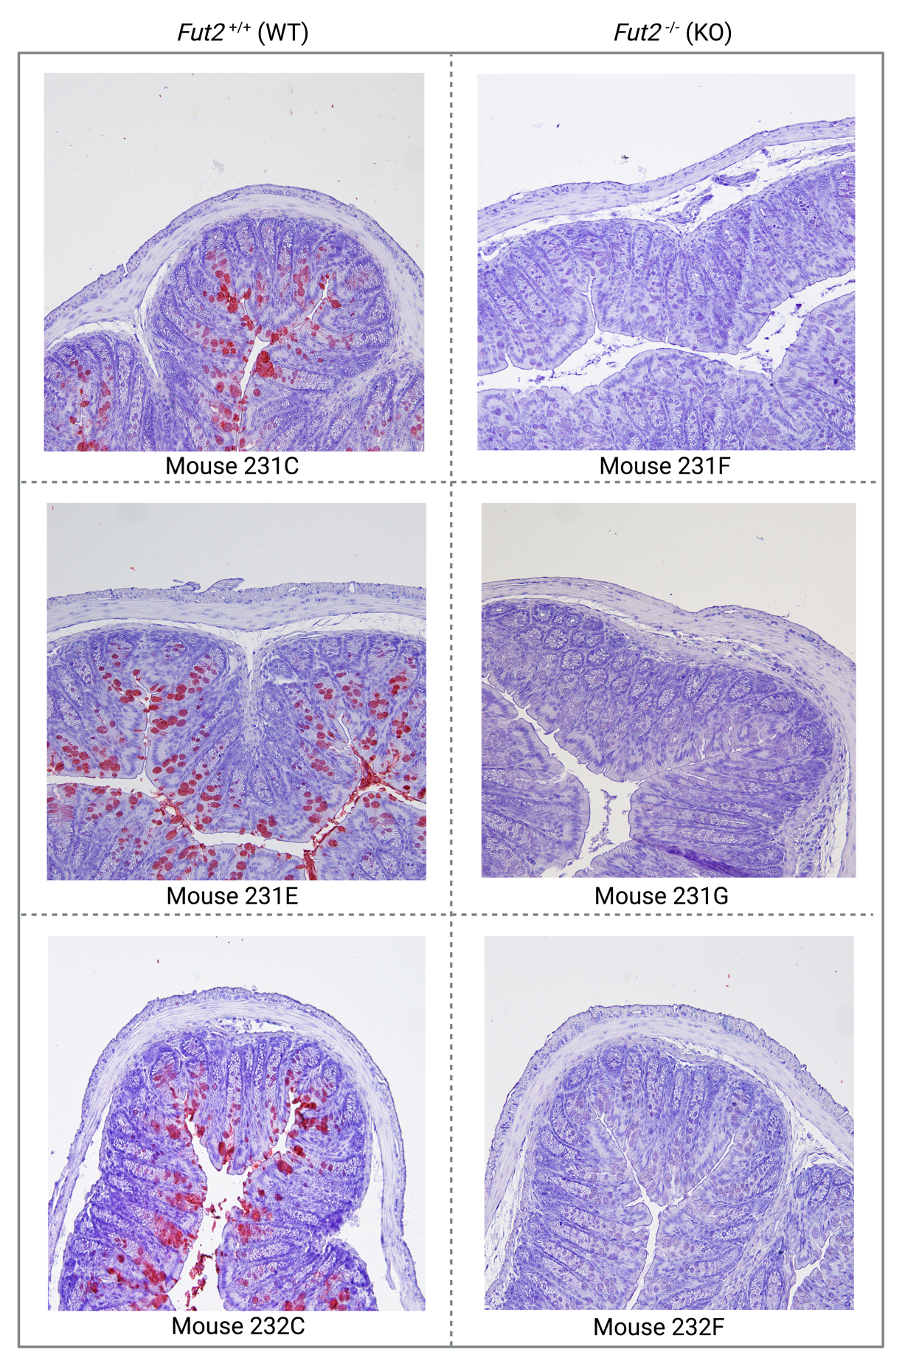
Figure S1. Representative images of large intestine tissue from Fut2^{WT} and Fut2^{KO} mice stained with HRP-conjugated UEA-1 lectin. Confirming loss of α(1,2)-fucosylated glycan production in KO mice.

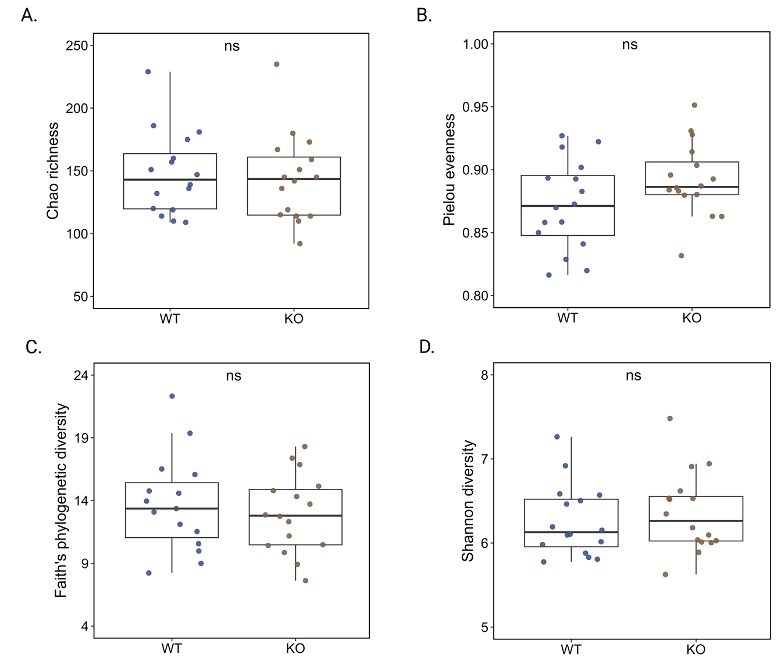
Figure S2. Faecal microbiota α-diversity metrics in male Fut2^{WT} and Fut2^{KO} mice.

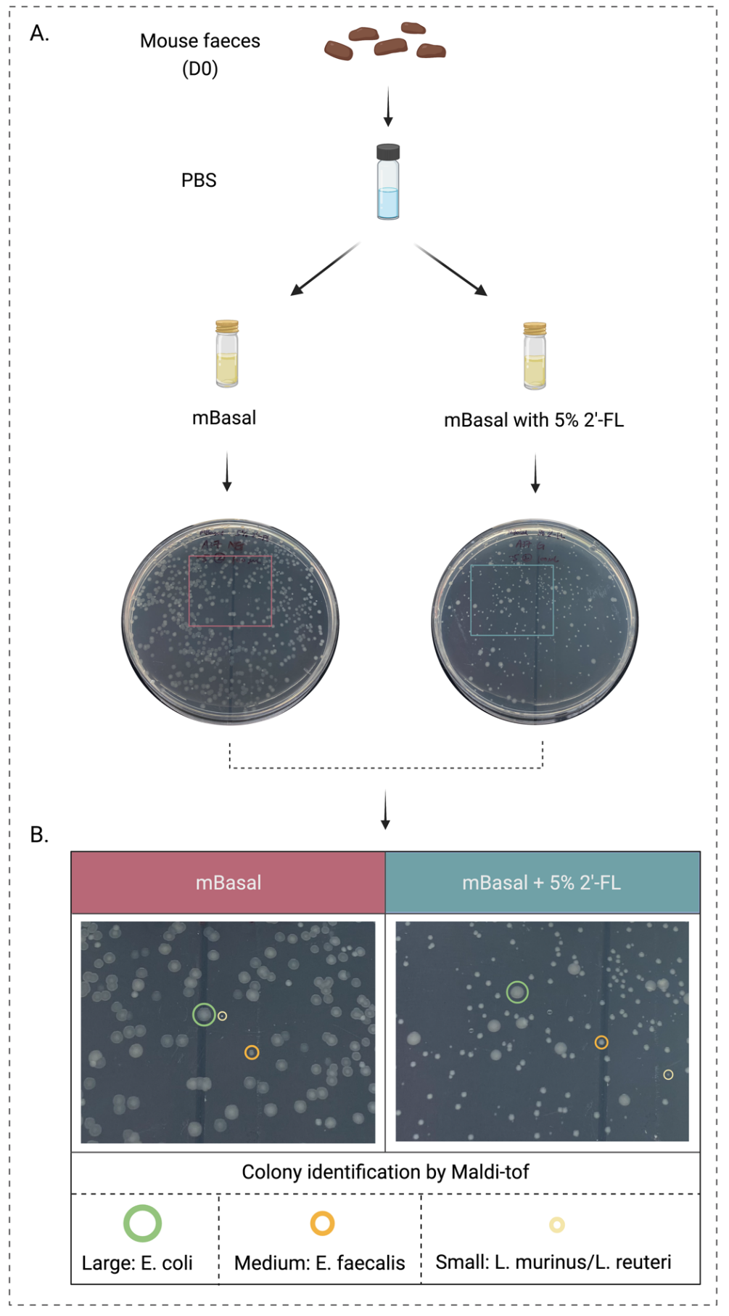
Figure S3. Anaerobic in vitro growth of faecal bacteria from Fut2^{WT} mice either with or without 2ˈ-fucosyllactose (2ˈ-FL) supplementation. Colonies characterised by size as small medium and large, with representative colony identification confirmed by matrix-assisted laser desorption/ionization time-of-flight mass spectrometry (MALDI-TOF).

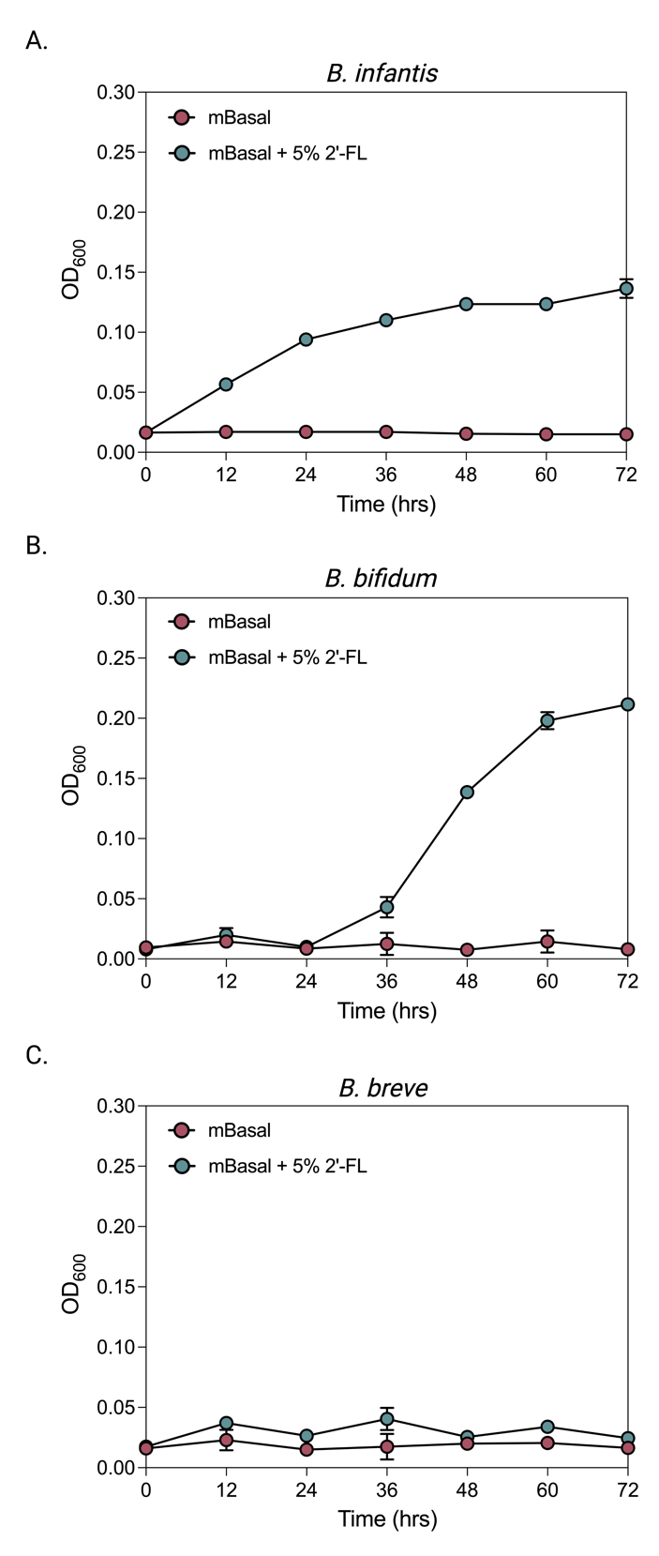
Figure S4. Anaerobic in vitro growth of Bifidobacterium species either with or without 2ˈ-fucosyllactose (2ˈ-FL) supplementation. Showing immediate enhanced growth of B. infantis with supplementation, reflecting genetic ability to internalise and metabolise 2ˈ-FL. B. bifidum shows longer duration until enhanced growth suggesting delayed internalisation/ metabolisation of 2ˈ-FL. B. breve shows no enhanced growth with 2ˈ-FL.

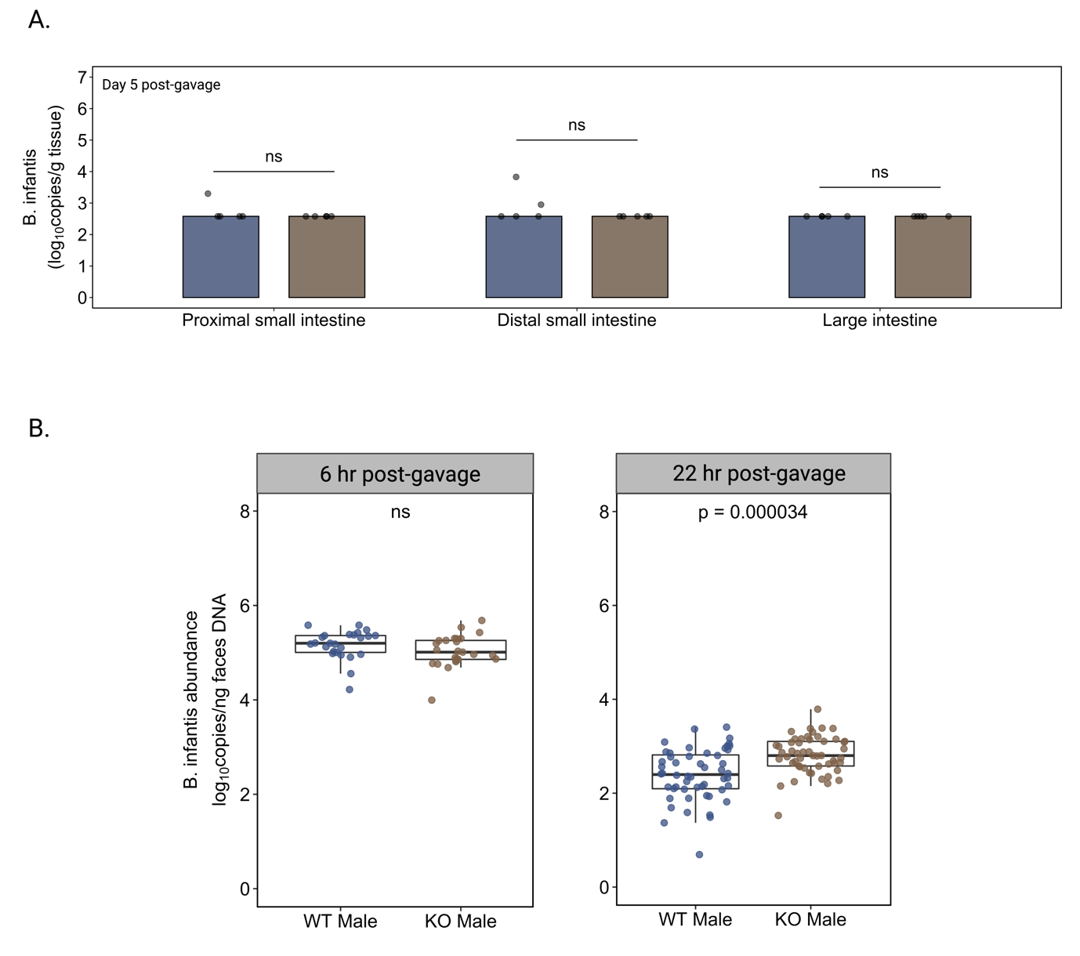
Figure S4. Abundance of Bifidobacterium infantis of Fut2^{WT} and Fut2^{KO} mice following B. infantis gavage. A) Intestinal mucosal tissue 5 days post B. infantis gavage. B) Faecal B. infantis abundance during gavage period. Showing both Fut2^{WT} and Fut2^{KO} have similarly high levels of B. infantis 6 hours after gavage, however Fut2^{KO} mice have significantly higher B. infantis abundance at 22 hours after gavage.

References
1. Choo, J.M., Leong, L.E. & Rogers, G.B. Sample storage conditions significantly influence faecal microbiome profiles. Scientific reports 5, 16350 (2015).
2. Bolyen, E., et al. Reproducible, interactive, scalable and extensible microbiome data science using QIIME 2. Nat Biotechnol 37, 852-857 (2019).
3. Nadkarni, M.A., Martin, F.E., Jacques, N.A. & Hunter, N. Determination of bacterial load by real-time PCR using a broad-range (universal) probe and primers set. Microbiology 148, 257-266 (2002).
4. Haarman, M. & Knol, J. Quantitative real-time PCR assays to identify and quantify fecal Bifidobacterium species in infants receiving a prebiotic infant formula. Applied and environmental microbiology 71, 2318-2324 (2005).
5. Junick, J. & Blaut, M. Quantification of human fecal bifidobacterium species by use of quantitative real-time PCR analysis targeting the groEL gene. Applied and environmental microbiology 78, 2613-2622 (2012).

