Supplementary Information

Unravelling the Amorphous Structure, Nanoscale Effects, and Crystallization Mechanism of GeTe Phase Change Memory Material

Simon Wintersteller¹, Olesya Yarema², Dhananjeya Kumaar¹, Florian M. Schenk¹, Olga Safonova³, Paula M. Abdala⁴, Vanessa Wood², and Maksym Yarema^{1,}*

¹ Chemistry and Materials Design, Institute for Electronics, Department of Information Technology and Electrical Engineering, ETH Zürich, 8092 Zürich, Switzerland
² Materials and Device Engineering, Institute for Electronics, Department of Information Technology and Electrical Engineering, ETH Zürich, 8092 Zürich, Switzerland
³ Paul Scherrer Institute, 5232 Villigen, Switzerland
⁴ Laboratory of Energy Science and Engineering, Department of Mechanical and Process Engineering, ETH Zurich, 8092 Zurich, Switzerland

* Correspondence to yaremam@ethz.ch

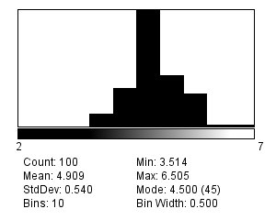
Supplementary Figure 1 | Size quantification of ZnS-coated GeTe nanoparticles from transmission electron microscopy (TEM) images. The nanoparticles have a mean diameter of 4.9 nm with a standard deviation of 0.54 nm.

Supplementary Table 1 | EDX quantification of GeTe microparticles and nanoparticles. Both cases demonstrate good 1:1 stoichiometry of Ge and Te atoms as well as a low concentration of Zn and S atoms for the nanoparticles, indicating a thin ZnS surface shell.
 | GeTe microparticles |  | ZnS-coated GeTe nanoparticles
Element | Composition (at. %) | Error (%) | Composition (at. %) | Error (%)
Ge | 51.35 | 1.14 | 45.97 | 1.74
Te | 48.65 | 2.11 | 47.17 | 1.23
Zn | – | – | 5.38 | 5.59
S | – | – | 1.47 | 31.35

- GeTe microparticles
- GeTe nanoparticles
Supplementary Figure 2 | Normalized XAS spectra of amorphous and crystalline GeTe, measured at room temperature: (a) GeTe microparticles and (b) GeTe nanoparticles. Data are presented for both the Ge and Te K-edges.

- Amorphous GeTe microparticles
- Crystalline GeTe microparticles
Supplementary Figure 3 | Fittings of XAS spectra, measured at room temperature for (a) amorphous and (b) crystalline GeTe microparticles for both the Ge and Te K-edge. In total 5 scattering paths are fitted: homopolar GeGe bond, short and elongated GeTe bondd, and in addition the second nearest neighbors for the Te edge (two TeTe bonds).

- Amorphous GeTe nanoparticles
- Crystalline GeTe nanoparticles
Supplementary Figure 4 | Fittings of XAS spectra, measured at room temperature for (a) amorphous and (b) crystalline GeTe nanoparticles for both the Ge and Te K-edge. In total 5 scattering paths are fitted: homopolar GeGe bond, short and elongated GeTe bondd, and in addition the second nearest neighbors for the Te edge (two TeTe bonds).

Supplementary Table 2 | EXAFS fitting results of crystalline GeTe microparticles, measured at room temperature and for the Ge and Te K-edge.
 |  |  | Crystalline GeTe microparticles
Edge | Scattering  path | CN |  |  | σ²  (10 ^{–3} Å^{–2}) |  | Δe₀  (eV) |  | R  (Å)
Ge edge | Ge-Ge | 0.53 |  | ±0.05 | 0.70 | - | 7.51 | ±1.04 | 2.57 | ±0.01
Ge edge | Ge-Te1 | 2.03 |  | ±0.40 | 17.29 | ±3.09 | 7.51 | ±1.04 | 2.83 | ±0.01
Ge edge | Ge-Te2 | 1.82 |  | ±0.71 | 27.34 | ±4.88 | 7.51 | ±1.04 | 3.21 | ±0.02
Te edge | Ge-Te1 | 2.03 |  | ±0.40 | 7.54 | ±1.50 | 3.09 | ±1.39 | 2.83 | ±0.01
Te edge | Ge-Te2 | 1.82 |  | ±0.71 | 11.92 | ±2.36 | 3.09 | ±1.39 | 3.21 | ±0.02
Te edge | Te-Te1 | 5.40 |  | ±1.37 | 10.95 | ±2.17 | 3.09 | ±1.39 | 4.18 | ±0.02
Te edge | Te-Te2 | 5.40 |  | ±1.37 | 13.38 | ±2.65 | 3.09 | ±1.39 | 4.32 | ±0.04
R factor |  | 0.0391

Supplementary Table 3 | EXAFS fitting results of crystalline GeTe nanoparticles, measured at room temperature and for the Ge and Te K-edge.
 |  |  | Crystalline GeTe nanoparticles
Edge | Scattering  path | CN |  |  | σ²  (10 ^{–3} Å^{–2}) |  | Δe₀  (eV) |  | R  (Å)
Ge edge | Ge-Ge | 0.61 |  | ±0.05 | 0.70 | - | 3.00 | ±1.01 | 2.53 | ±0.01
Ge edge | Ge-Te1 | 3.10 |  | ±0.53 | 12.15 | ±1.65 | 3.00 | ±1.01 | 2.79 | ±0.01
Ge edge | Ge-Te2 | 2.55 |  | ±0.94 | 19.20 | ±2.61 | 3.00 | ±1.01 | 3.14 | ±0.02
Te edge | Ge-Te1 | 3.10 |  | ±0.53 | 11.54 | ±4.85 | -0.60 | ±4.30 | 2.79 | ±0.01
Te edge | Ge-Te2 | 2.55 |  | ±0.94 | 18.23 | ±7.66 | -0.60 | ±4.30 | 3.14 | ±0.02
Te edge | Te-Te1 | 8.09 |  | ±9.53 | 16.75 | ±7.04 | -0.60 | ±4.30 | 4.23 | ±0.15
Te edge | Te-Te2 | 8.09 |  | ±9.53 | 20.47 | ±8.60 | -0.60 | ±4.30 | 4.09 | ±0.17
R factor |  | 0.0754

Supplementary Table 4 | EXAFS fitting results of amorphous GeTe microparticles, measured at room temperature and for the Ge and Te K-edge.
 |  |  | Amorphous GeTe microparticles
Edge | Scattering  path | CN |  |  | σ²  (10 ^{–3} Å^{–2}) |  | Δe₀  (eV) |  | R  (Å)
Ge edge | Ge-Ge | 1.27 |  | ±0.06 | 3.74 | - | 2.49 | ±0.59 | 2.36 | ±0.00
Ge edge | Ge-Te1 | 1.47 |  | ±0.10 | 5.89 | ±0.64 | 2.49 | ±0.59 | 2.62 | ±0.00
Ge edge | Ge-Te2 | 0.12 |  | ±0.11 | 9.31 | ±1.00 | 2.49 | ±0.59 | 3.11 | ±0.06
Te edge | Ge-Te1 | 1.47 |  | ±0.10 | 5.30 | ±0.55 | -0.15 | ±1.03 | 2.62 | ±0.00
Te edge | Ge-Te2 | 0.12 |  | ±0.11 | 8.38 | ±0.87 | -0.15 | ±1.03 | 3.11 | ±0.06
Te edge | Te-Te1 | 0.09 |  | ±0.50 | 7.69 | ±0.80 | -0.15 | ±1.03 | 4.22 | ±0.28
Te edge | Te-Te2 | 0.09 |  | ±0.50 | 9.40 | ±0.98 | -0.15 | ±1.03 | 4.47 | ±0.47
R factor |  | 0.0074

Supplementary Table 5 | EXAFS fitting results of amorphous GeTe nanoparticles, measured at room temperature and for the Ge and Te K-edge.
 |  |  | Amorphous GeTe nanoparticles
Edge | Scattering  path | CN |  |  | σ²  (10 ^{–3} Å^{–2}) |  | Δe₀  (eV) |  | R  (Å)
Ge edge | Ge-Ge | 1.75 |  | ±0.10 | 3.74 | - | 3.16 | ±0.85 | 2.46 | ±0.00
Ge edge | Ge-Te1 | 1.66 |  | ±0.17 | 5.74 | ±0.88 | 3.16 | ±0.85 | 2.60 | ±0.01
Ge edge | Ge-Te2 | 0.27 |  | ±0.18 | 9.07 | ±1.40 | 3.16 | ±0.85 | 3.10 | ±0.05
Te edge | Ge-Te1 | 1.66 |  | ±0.17 | 3.30 | ±1.05 | 1.82 | ±1.62 | 2.60 | ±0.01
Te edge | Ge-Te2 | 0.27 |  | ±0.18 | 5.22 | ±1.66 | 1.82 | ±1.62 | 3.10 | ±0.05
Te edge | Te-Te1 | 0.20 |  | ±1.05 | 4.79 | ±1.53 | 1.82 | ±1.62 | 4.30 | ±0.33
Te edge | Te-Te2 | 0.20 |  | ±1.05 | 5.86 | ±1.87 | 1.82 | ±1.62 | 4.59 | ±0.50
R factor |  | 0.0118

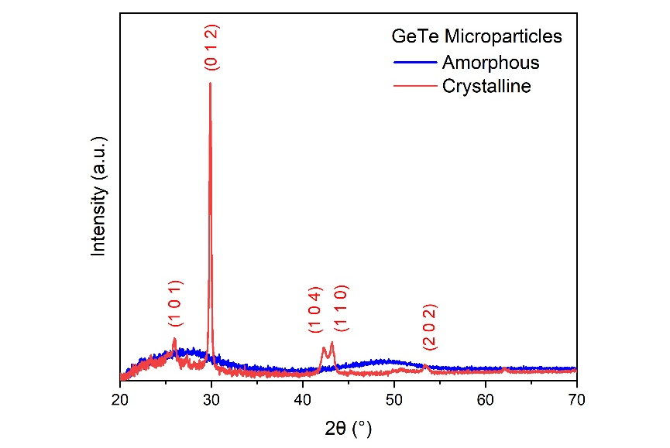
Supplementary Figure 5 | X-ray diffractogram of amorphous and crystalline GeTe microparticles. At room temperature, the crystalline GeTe is a rhombohedral phase with the space group R3mH.

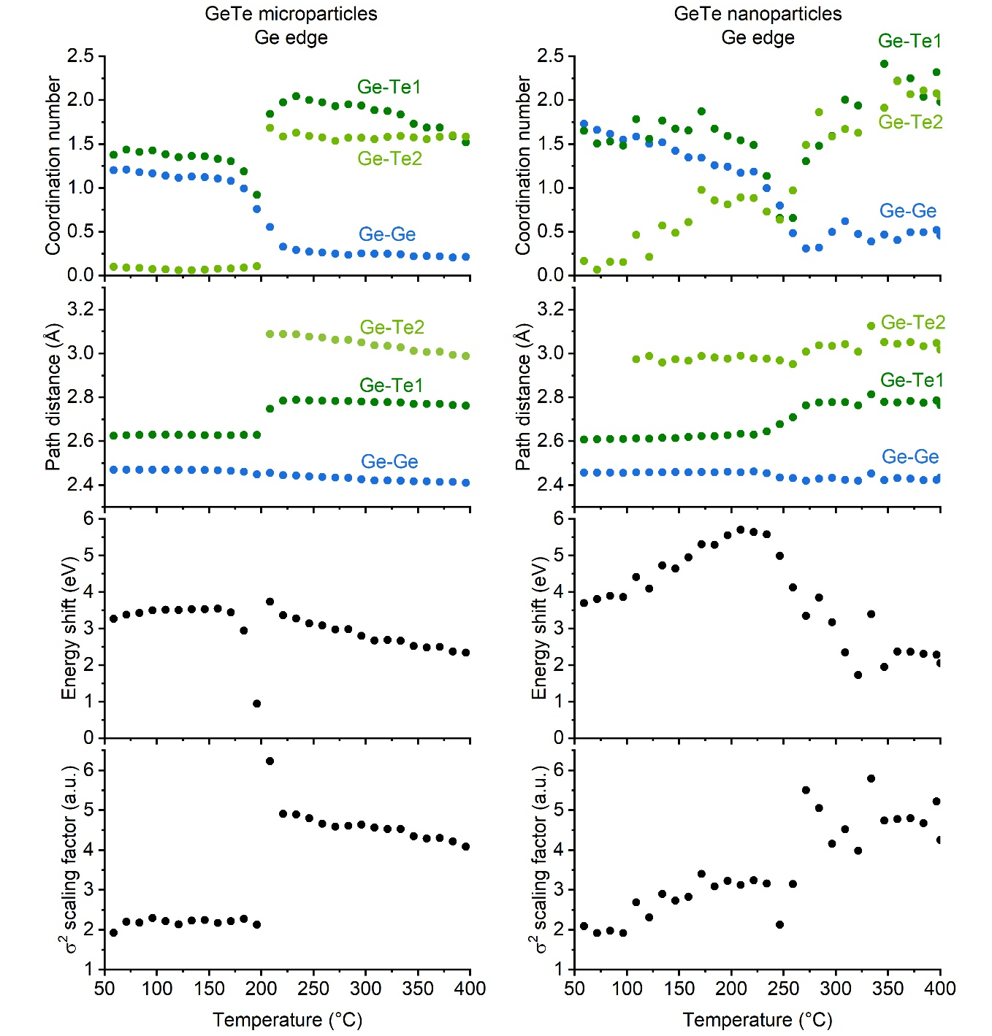
Supplementary Figure 6 | EXAFS fittings for GeTe microparticles and nanoparticles, while heating with the constant 5 °C/min ramp. Fitting results include the global coordination numbers and path distances as well as edge dependent energy shift and scaling factor of the mean square relative displacements (MSRDs). Ramp measurements were performed only on the Ge K-edge and hence only the GeGe, GeTe1 and GeTe2 paths can be fitted.

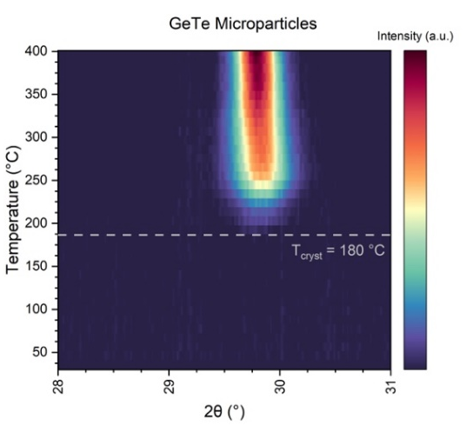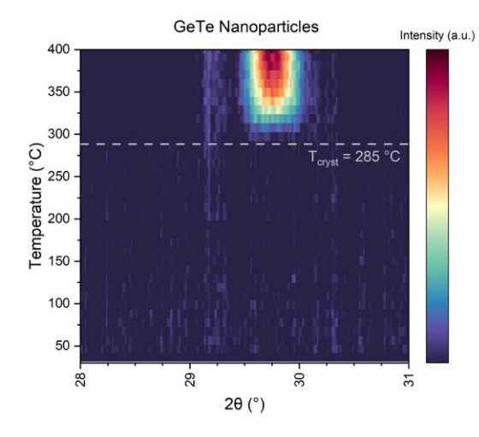
Supplementary Figure 7 | High-temperature X-ray diffraction (HTXRD) measurement of amorphous GeTe microparticles and nanoparticles, while heating with the constant 5 °C/min ramp. The HTXRD measurements determine crystallization temperature as the intensity onset of the main crystalline (202) diffraction peak. In a good agreement with XAS data, we observe notably higher crystallization temperature for GeTe nanoparticles. Small temperature offsets between XRD and XAS can be explained by a thermal lag during the XAS ramp measurements as well as by different heating set-ups for the two methods.

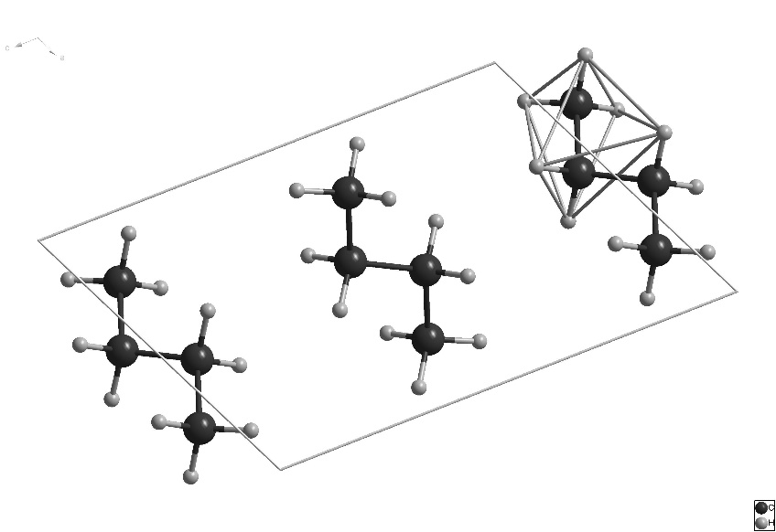
Supplementary Figure 8 | Unit cell of butane C₄H₁₀ with highlighted distorted octahedral cage, made of H atoms. C atoms in black, H atoms in gray.
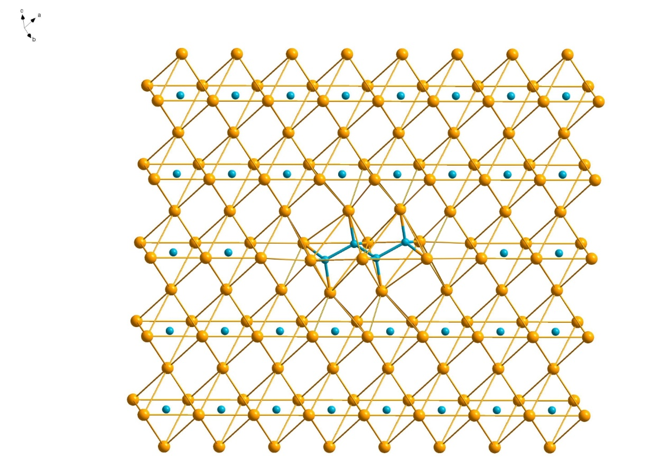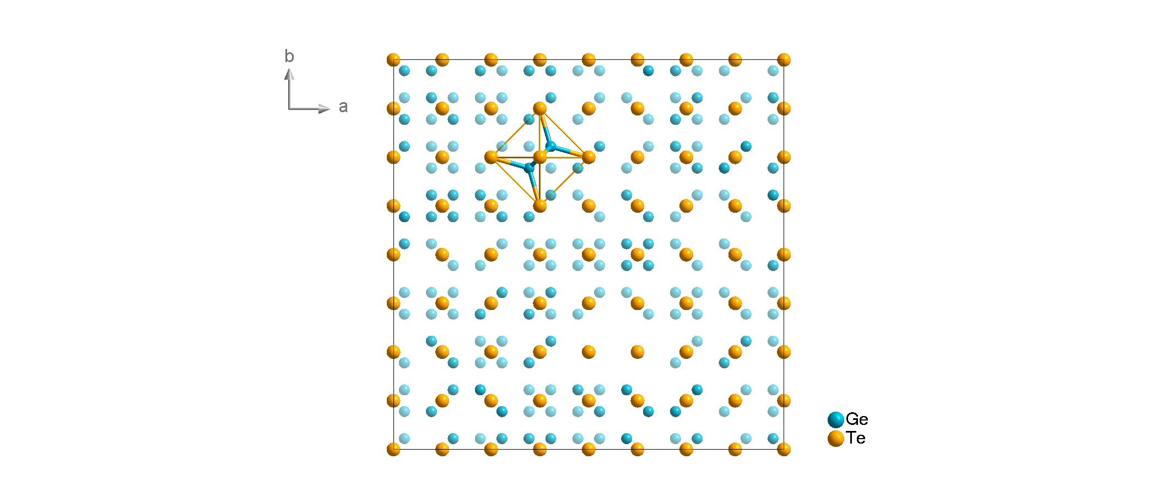
Supplementary Figure 9 | Butane-like Ge₄Te₁₀ structural unit within the distorted rock-salt GeTe structure. Note two empty Te₆ octahedra next to two Te₆ disordered octahedra hosting 2 Ge atoms. Importantly, the tunneling of Ge atom to the neighboring octahedron is associated with relatively slight distortions of very few Te atoms.

Supplementary Figure 10 | The 512-atom starting structure for the amorphous GeTe modelling with 25.3244 Å lattice vectors, comprising a 4×4×4 net of Te octahedra. Half of Te₆ octahedra is empty, while the other half is populated with 2 Ge atoms, forming prototypical Ge₂Te₆ ethane-like units (highlighted).

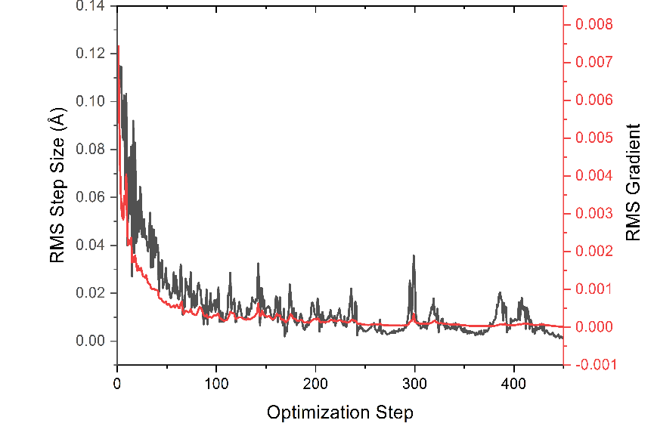
Supplementary Figure 11 | Geometry optimization of the 512-atom model with 0.031524 atom/Å³ atomic density and PBC. During geometry optimization the structure converges after 464 steps reaching the CP2K default convergence values of 0.00045 RMS step size and 0.0003 RMS gradient.
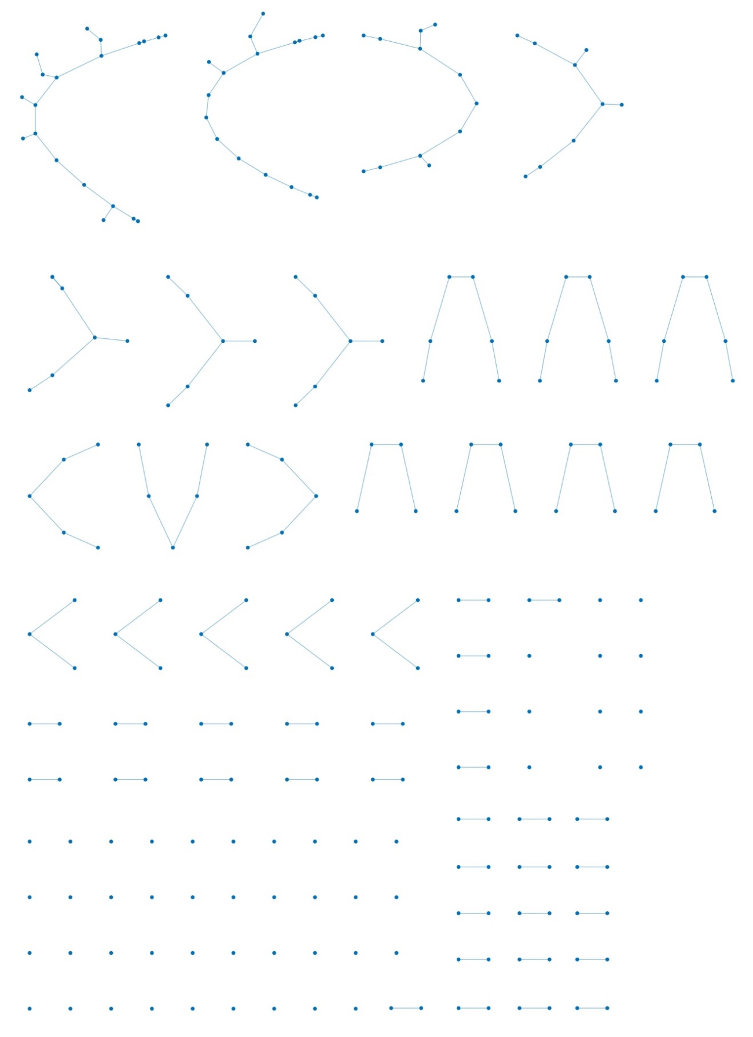
Supplementary Figure 12 | Distribution of Ge chains in one of 512-atom GeTe amorphous structures. Bond length and branching are reminiscent of organic chains (distances between Ge atoms are not to scale).
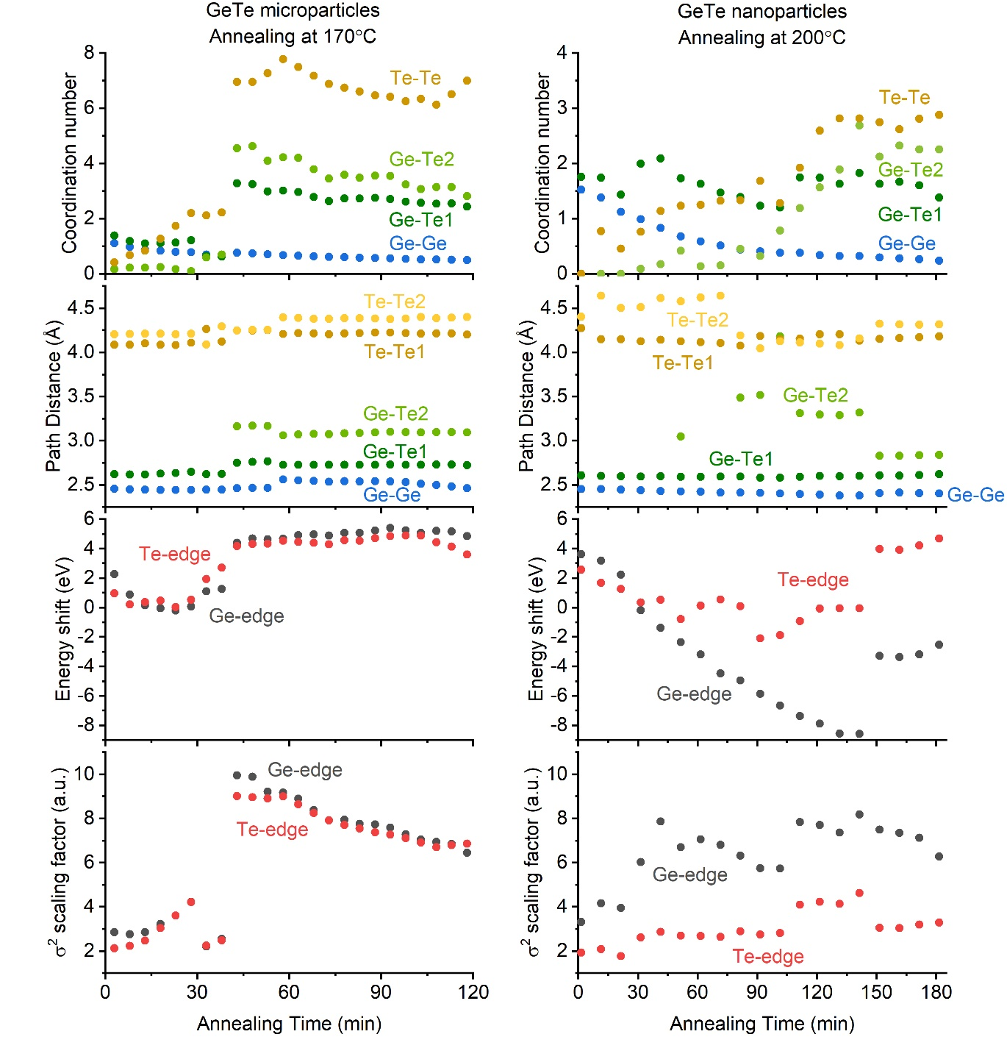
Supplementary Figure 13 | EXAFS fittings for GeTe microparticles and nanoparticles, while annealing at 170 and 200°C, respectively. Fitting results include the global coordination numbers and path distances as well as edge dependent energy shift and scaling factors of the mean square relative displacements (MSRDs). For the annealing measurements, both Ge and Te K-edges are measured allowing the fitting of the 2nd nearest neighbors for the Te atoms (TeTe1 and TeTe2). Furthermore, multi-edge global fittings enable the coupling of path parameters, such as coordination number and path distance for the GeTe1 and GeTe2 bonds, and hence, more accurate fits.

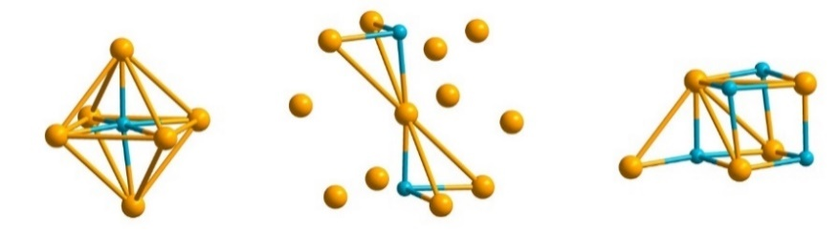
Supplementary Figure 14 | Hypothetic structural units of the ideal glass GeTe, where 1/3 of Te atoms attain the ordering of crystalline GeTe phase (i.e., 4-out-of-12 Te-Te bonds become like in crystalline GeTe).
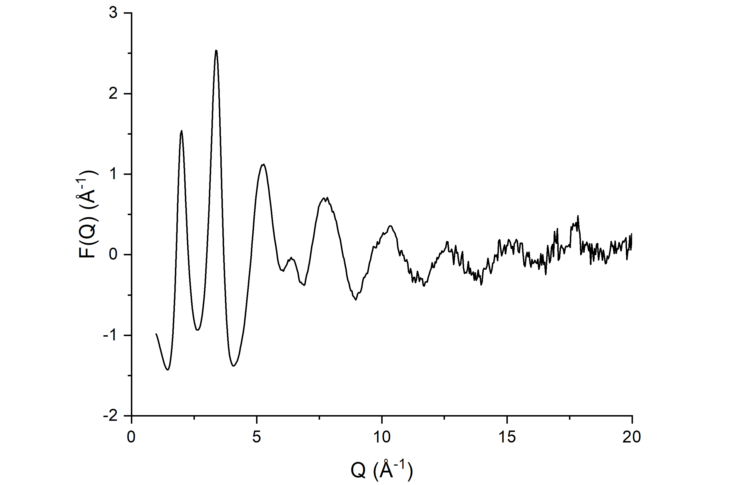
Supplementary Figure 15 | Normalized X-ray scattering function F(Q) of amorphous GeTe microparticles.
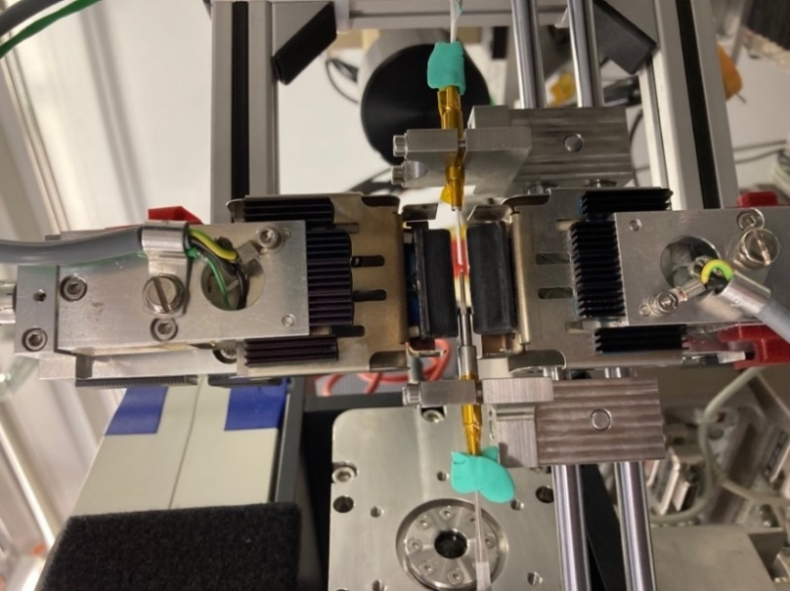
Supplementary Figure 16 | In-situ temperature X-ray absorption measuring setup. Sample capillary (left) is measured in parallel to boron nitride reference capillary (right), as placed symmetrically between two infrared heaters. Thermocouple is placed in boron nitride filled capillary and temperature is controlled using a PID controller.

