Supplementary material
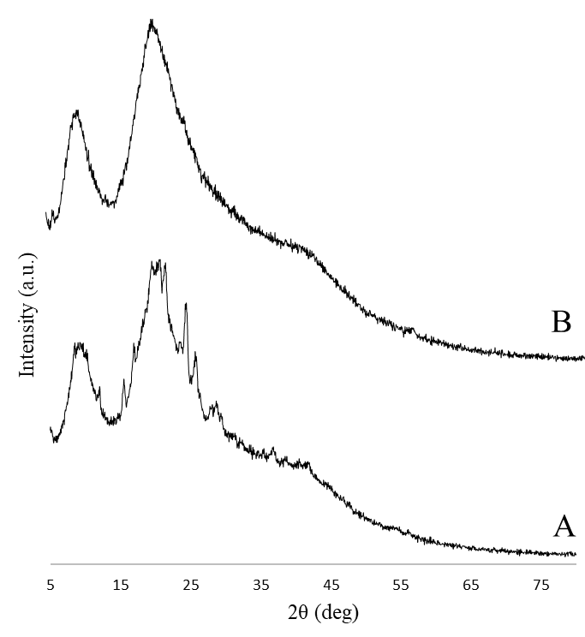
S1. XRD diffractogram of physical mixture of EGCG, alginate, chitosan and zein (A) and GTE, alginate, chitosan and zein (B).

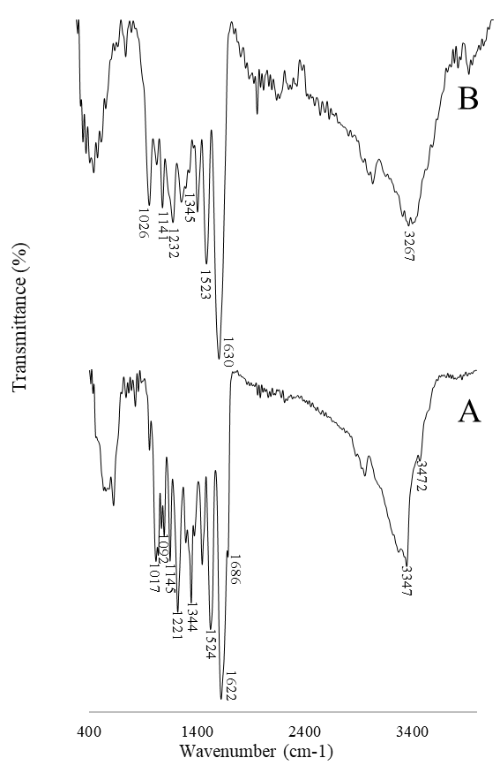
S2. FTIR spectrum of physical mixture of EGCG, alginate, chitosan and zein (A) and GTE, alginate, chitosan and zein (B).

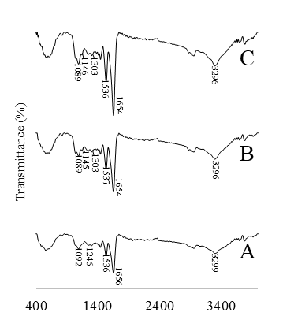
S3. FTIR spectrum of ALG/CS-ZNP (A), ALG/CS-ZNP-E (B) and ALG/CS-ZNP-T (C)

