Supplementary Table 1 List of germplasms
Sl no. | Germplasm | Parentage | Specification
1 | Sahabhagidhan | IR 55419-4*2/WAY RAREM (www.rkbodisha.in ) | Drought tolerant
2 | DRR44 | IR 71700-247-1-1-2/IR 03 L120 (www.rkbodisha.in ) | Drought tolerant
3 | DRR42 | Aday Sel/*3 IR 64 (www.rkbodisha.in) | Drought tolerant
4 | Vandana | C22/Kalakeri | Drought tolerant
5 | Nagina 22 | Selection from landrace Rajbhog (Stephen et al. 2022) | Drought tolerant
6 | Swarna | Vasista/Mahsuri (http://riceportal.in) | Drought susceptible
7 | Lalat | Obs 677/IR2071//Bikram/W 1263 (Panda et al. 1987) | High Yielding Variety
8 | Kerala Sundari | Unknown | Landrace
9 | Bhuri | Unknown | Landrace
10 | Maniksal | Unknown | Landrace
11 | Chhotodidi | Unknown | Landrace
12 | Lohasal | Unknown | Landrace
13 | Aswinsal | Unknown | Landrace
14 | Morogjhota | Unknown | Landrace
15 | Sonagori | Unknown | Landrace
16 | Tulsikamal | Unknown | Landrace
17 | Bhundi | Unknown | Landrace
18 | Bhadoi | Unknown | Landrace
19 | Kelesh | Unknown | Landrace
20 | Vasamanik-i | Unknown | Landrace
21 | Velchi-i | Unknown | Landrace
22 | Langalmathi | Unknown | Landrace
23 | Bhramarmali | Unknown | Landrace
24 | Chandrakanti | Unknown | Landrace
25 | Kalpana | Unknown | Landrace
26 | Neta | Unknown | Landrace
27 | Lakkansal | Unknown | Landrace
28 | Vutmuri | Unknown | Landrace
29 | Kashiphool | Unknown | Landrace

Supplementary Table 2 List of Primers
Sl no. | Primer | QTL/Chr no | Forward sequence | Reverse sequence | References
1 | RM279 | qDTY_{2.2} | GCGGGAGAGGGATCTCCT | GGCTAGGAGTTAACCTCGCG | Mishra et al. 2018; Roy et al. 2021
2 | RM555 | qDTY_{2.2} | TTGGATCAGCCAAAGGAGAC | CAGCATTGTGGCATGGATAC | Mishra et al. 2018; Roy et al. 2021
3 | RM263 | qDTY_{2.2}  qDTY_{2.3} | CCCAGGCTAGCTCATGAACC | GCTACGTTTGAGCTACCACG | Panda et al. 2019; Roy et al. 2021
4 | RM431 | qDTY_{1.1} | TCCTGCGAACTGAAGAGTTG | AGAGCAAAACCCTGGTTCAC | Mishra et al. 2018; Roy et al. 2021
5 | RM324 | qDTY_{2.1} | CTGATTCCACACACTTGTGC | GATTCCACGTCAGGATCTTC | Mishra et al. 2018
6 | RM3549 | qDTY_{2.1} | GATCCTCCACACCCAACAAC | GATTCCACGTCAGGATCTTC | Mishra et al. 2018
7 | RM250 | qDTY_{2.3} | GGTTCAAACCAAGCTGATCA | GATGAAGGCCTTCCACGCAG | Roy et al. 2021
8 | RM3212 | qDTY_{2.3} | AGACGACAAACACCTGCCTC | CAAACACAAACGCAGCCTC | Roy et al. 2021
9 | RM416 | qDTY_{3.1} | GGGAGTTAGGGTTTTGGAGC | TCCAGTTTCACACTGCTTCG | Mishra et al. 2018; Roy et al. 2021
10 | RM16030 | qDTY_{3.1} | GCGAACTATGAGCATGCCAACC | GGATTACCTGGTGTGTGCAGTGTCC | Mishra et al. 2018
11 | RM19367 | qDTY_{6.1} | CGTCATGTCGCGGAGGTAAGC | AGGCGTACGTGGAGCAGAGTGC | Mishra et al. 2018
12 | RM3805 | qDTY_{6.1} | AGAGGAAGAAGCCAAGGAGG | CATCAACGTACCAACCATGG | Mishra et al. 2018
13 | RM589 | qDTY_{6.1} | ATCATGGTCGGTGGCTTAAC | CAGGTTCCAACCAGACACTG | Roy et al. 2021
14 | RM204 | qDTY_{6.1} | GTGACTGACTTGGTCATAGGG | GCTAGCCATGCTCTCGTACC | Roy et al. 2021
15 | RM28166 | qDTY_{12.1} | TGCTTGCAAACATTGCTTCTGG | ACTGATGTACTGAACACGGGAAGG | Mishra et al. 2018; Roy et al. 2021
16 | RM28052 | 12 | ACTAAAGATCTTCGAGCTGACC | GCTACATGGAGTATGGGTTCC | Panda et al. 2019
17 | RM28048 | qDTY_{12.1} | TTCAGCCGATCCATTCAATTCC | GCTATTGGCCGGAAAGTAGTTAGC | Panda et al. 2019; Roy et al. 2021
18 | RM28199 | qDTY_{12.1} | CGGCTTAGGGAGCGTCTGTAGG | GCATGCTAGTATGGCCACCATATTCC | Panda et al. 2019; Roy et al. 2021
19 | RM28076 | 12 | GGGACTTGGGACCAGTTTATGG | TCAGGTCTGTTGGATTCCATGC | Panda et al. 2019
20 | RM1261 | 12 | GTCCATGCCCAAGACACAAC | GTTACATCATGGGTGACCCC | Panda et al. 2019

Supplementary Table 3 Analysis of Variance (ANOVA) for agro-morphological characters under drought condition
Source | SL | RL | SVI | RFW | RDW | LR | LD | SP | DF | DM | 100 SW | SY/P
Germplasm | 3.40* | 5.47 ** | 5.41 ** | 43.73 ** | 171.4 ** | 3.71 ** | 15.77 ** | 103.32** | 728.09** | 2114.91** | 1071.37** | 67.45 **
Replication | 0.09 NS | 1.87 NS | 0.95 NS | 1.44 NS | 2.00 NS | 0.36 NS | 0.23 NS | 0.03 NS | 1.74 NS | 2.73 NS | 0.38 NS | 1.27 NS
Note: *significant at 5% level, ** significant at 1% level, NS Not significant

Supplementary Table 4 Mean, SD, Range, CD and CV value of all the parameters
 |  | SL | RL | SVI | RFW | RDW | LR | LD | SP | DF | DM | 100 SW | SY/P
Mean |  | 44.33 | 29.72 | 7064.71 | 0.432 | 0.117 | 6.16 | 4.72 | 65.01 | 79.70 | 104.05 | 2.05 | 16.38
SD |  | 12.13 | 9.74 | 1624.04 | 0.276 | 0.122 | 1.86 | 2.56 | 32.42 | 40.34 | 50.35 | 1.03 | 8.23
Range | Max | 60.45 | 51.50 | 9277.80 | 1.03 | 0.46 | 9.00 | 8.33 | 89.47 | 142 | 168 | 3.76 | 24.58
Range | Min | 15.17 | 16.00 | 3660.00 | 0.03 | 0.00 | 3.00 | 1.00 | 0.00 | 0.00 | 0.00 | 0.00 | 0.00
CD (5%) |  | 14.87 | 10.06 | 1692.85 | 0.12 | 0.03 | 1.62 | 1.66 | 8.54 | 4.25 | 3.12 | 0.09 | 2.81
CV |  | 20.75 | 20.94 | 14.82 | 16.66 | 13.99 | 13.91 | 22.13 | 8.14 | 3.30 | 1.85 | 2.71 | 10.62

Supplementary Table 5 Rank of germplasms based on the CD value of Seed yield/plant under drought stress
Rank 1 | Morogjhota (24.58 g)  DRR 44 (24.56 g) [Check]  Vandana (24.00 g) [Check]  DRR 42 (22.81 g) [Check]  Sahabhagidhan (22.21 g) [Check]  Lakkansal (21.916 g)
Rank 2 | Tulsikamal (21.72 g)  Kelesh (21.56 g)  Bhundi (21.51 g)  Velchi (21.00 g)  Vutmuri (21.00 g)  Nagina 22 (20.55 g) [Check]  Chhotodidi (20.08 g)  Maniksal (20.02 g)  Sonagori (19.99 g)  Aswinsal (19.92 g)

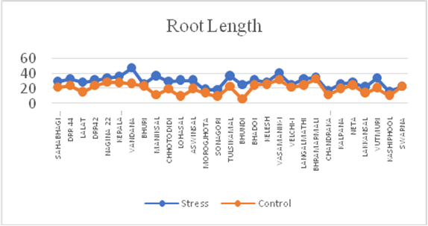
Supplementary Fig. 1 Root length under stress and control for 29 germplasms
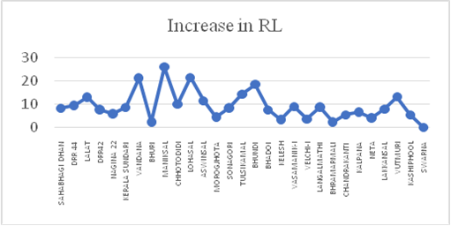
Supplementary Fig. 2 Increase in root length under stress for 29 germplasms
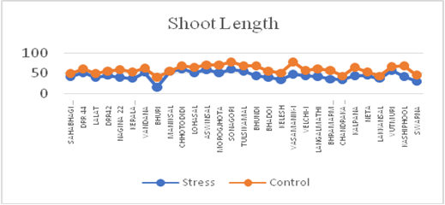
Supplementary Fig. 3 Shoot length under stress and control for 29 germplasms
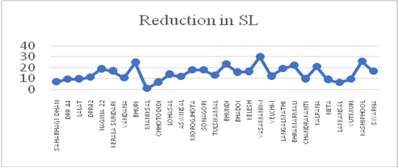
Supplementary Fig. 4 Decrease in shoot length under stress for 29 germplasms
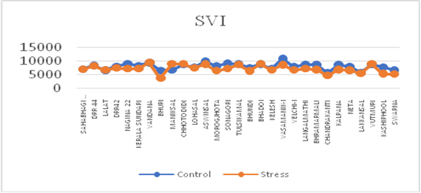
Supplementary Fig. 5 Seedling Vigour Index under stress and control for 29 germplasms

Supplementary Fig. 6 Root fresh weight under stress and control for 29 germplasms
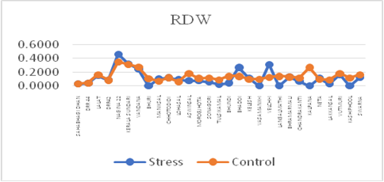
Supplementary Fig. 7 Root dry weight under stress and control for 29 germplasms

