Supplementary Figures

Recovery of radiation induced defects via nanovoids in bulk pure Fe
F. A. Selim,^{1,2}* F. Granberg,³ S. Agarwal,⁴ D. Kaoumi,⁵ J. Cooper,⁵ M. Butterling,⁶ M. O. Liedke,⁶ E. Hirschmann,⁶ Jon Baldwin,⁷ N. Li,⁷ Y. Q. Wang,^{2,7} A. Wagner,⁶ and B. P. Uberuaga ²

¹School for Engineering of Matter, Transport and Energy, Arizona State University, Tempe, AZ, 85287, USA
²Materials Science and Technology Division, Los Alamos National Laboratory, Los Alamos, NM 87545, USA.
³Department of Physics, University of Helsinki, 00014 University of Helsinki, Finland.
⁴Center for Photochemical Sciences, Bowling Green State University, Bowling Green, OH 43403, USA.
⁵Department of Nuclear Engineering, North Carolina State University, Raleigh, NC 27695, USA.
⁶ Institute of Radiation Physics, Helmholtz-Zentrum Dresden-Rossendorf, Bautzner Landstr. 400, 01328 Dresden, Germany.
⁷Center for Integrated Nanotechnologies, Los Alamos National Laboratory, Los Alamos, NM 87545, USA .
*Farida.Selim@asu.edu

Positron annihilation lifetime spectra¹ are collected at each positron energy and fitted via PALSFit². They are presented as a function of depth and dose in Fig.1S.

Figure 1S: PALS measurements as a function of depth for all irradiation doses featuring lifetime of small and large clusters: (a) T₁ as a function of implantation energy and mean depth; (b) T₂ as a function of implantation energy and mean depth; (c) I₁ as a function of implantation energy and mean depth; (d) I₂ as a function of implantation energy and mean depth.

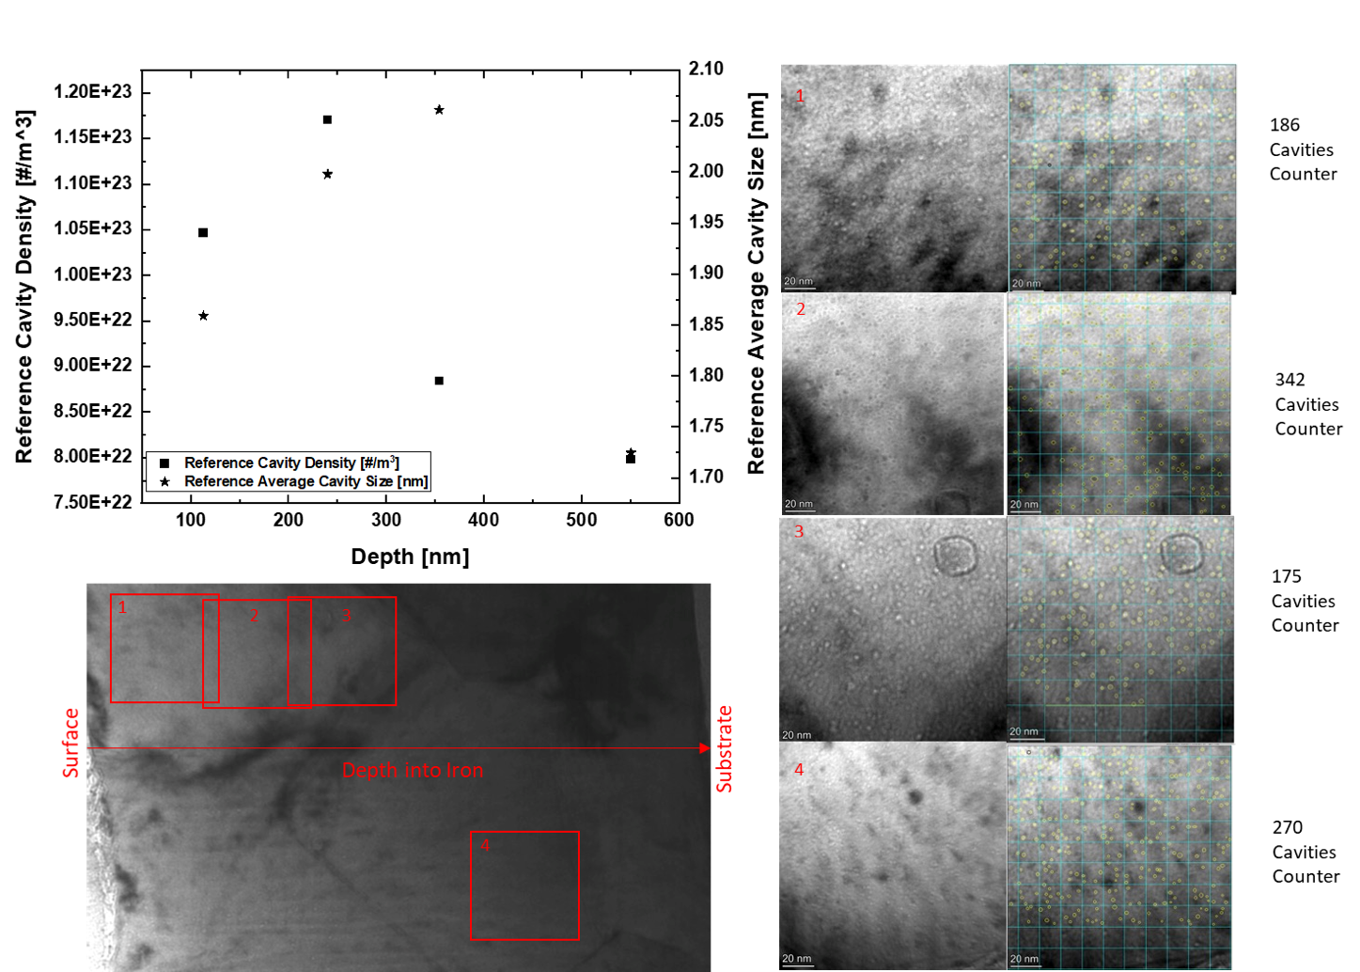

Figure 2S: TEM micrographs showing distribution of cavities in pristine films. Images exhibit cavity counters at various depths.

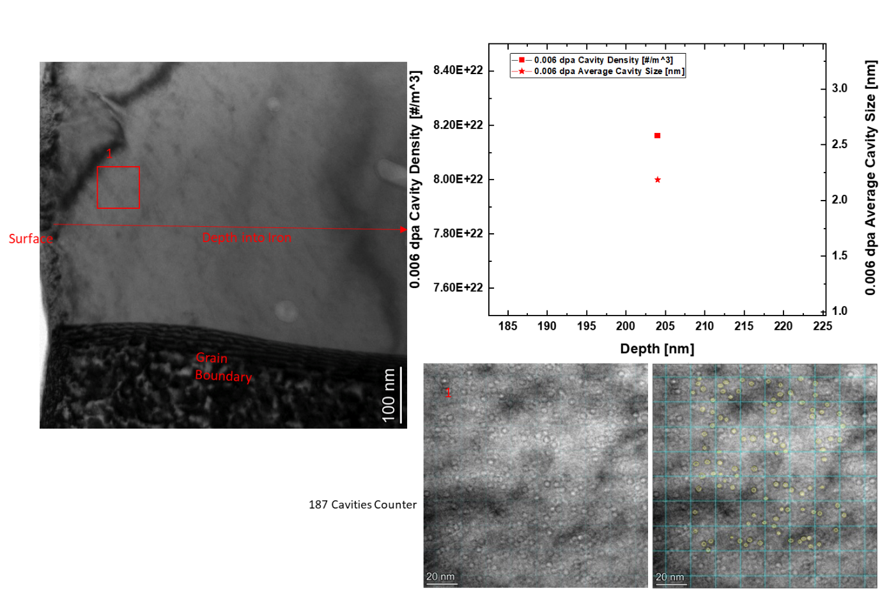

Figure 3S: TEM micrographs showing distribution of cavities in 0.006 dpa irradiated films. Images exhibit cavity counters at various depths.

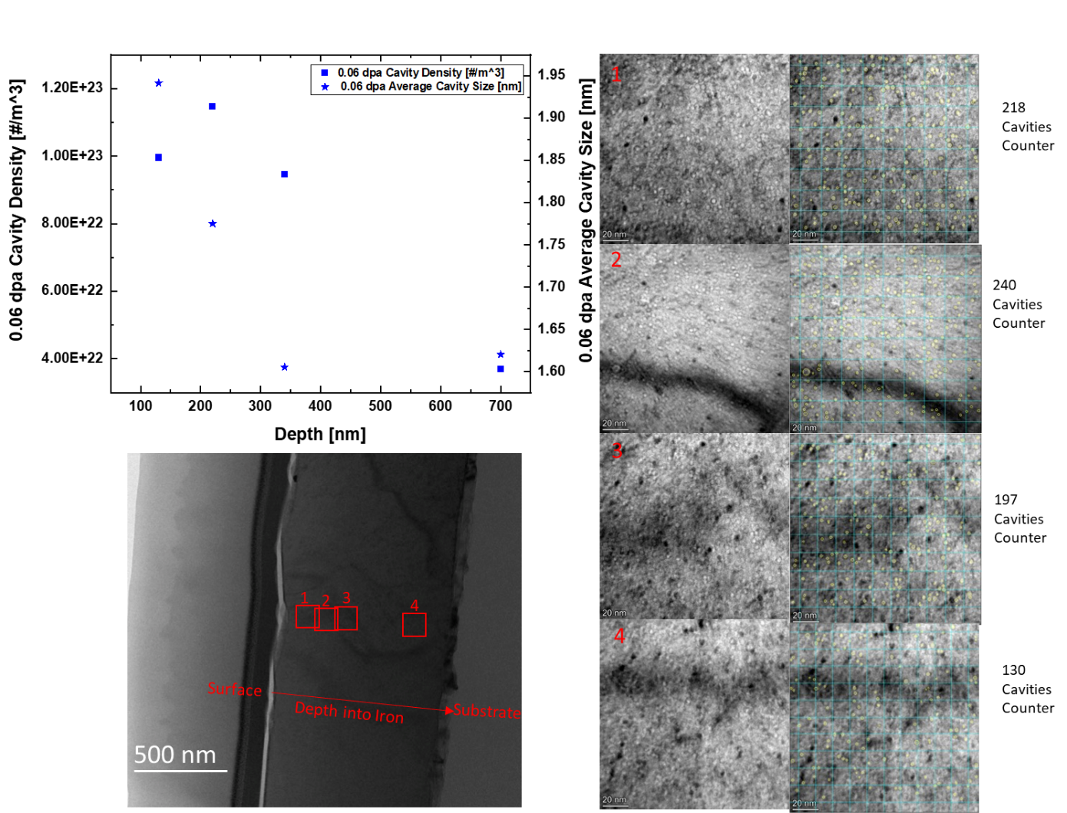

Figure 4S: TEM micrographs showing distribution of cavities in 0.06 dpa irradiated films. Images exhibit cavity counters at various depths.

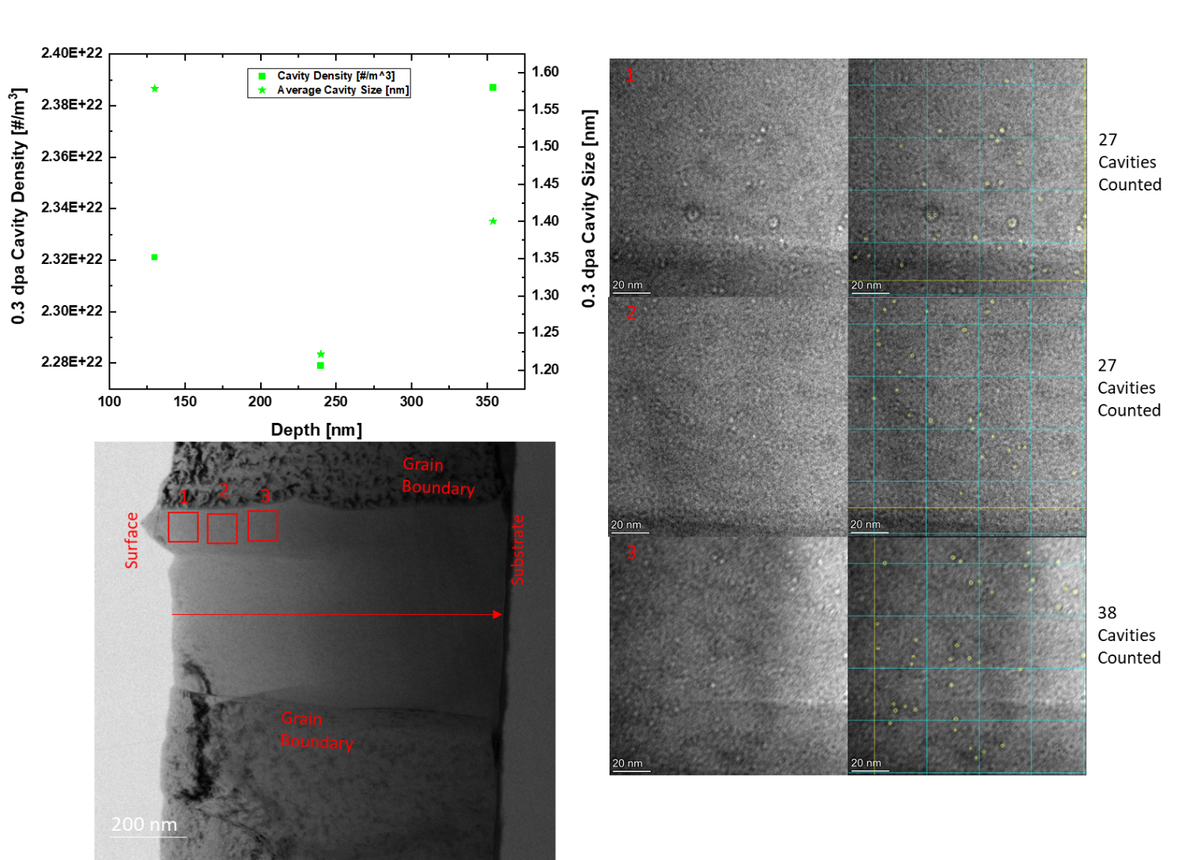

Figure 5S: TEM micrographs showing distribution of cavities in 0.3 dpa irradiated films. Images exhibit cavity counters at various depths.

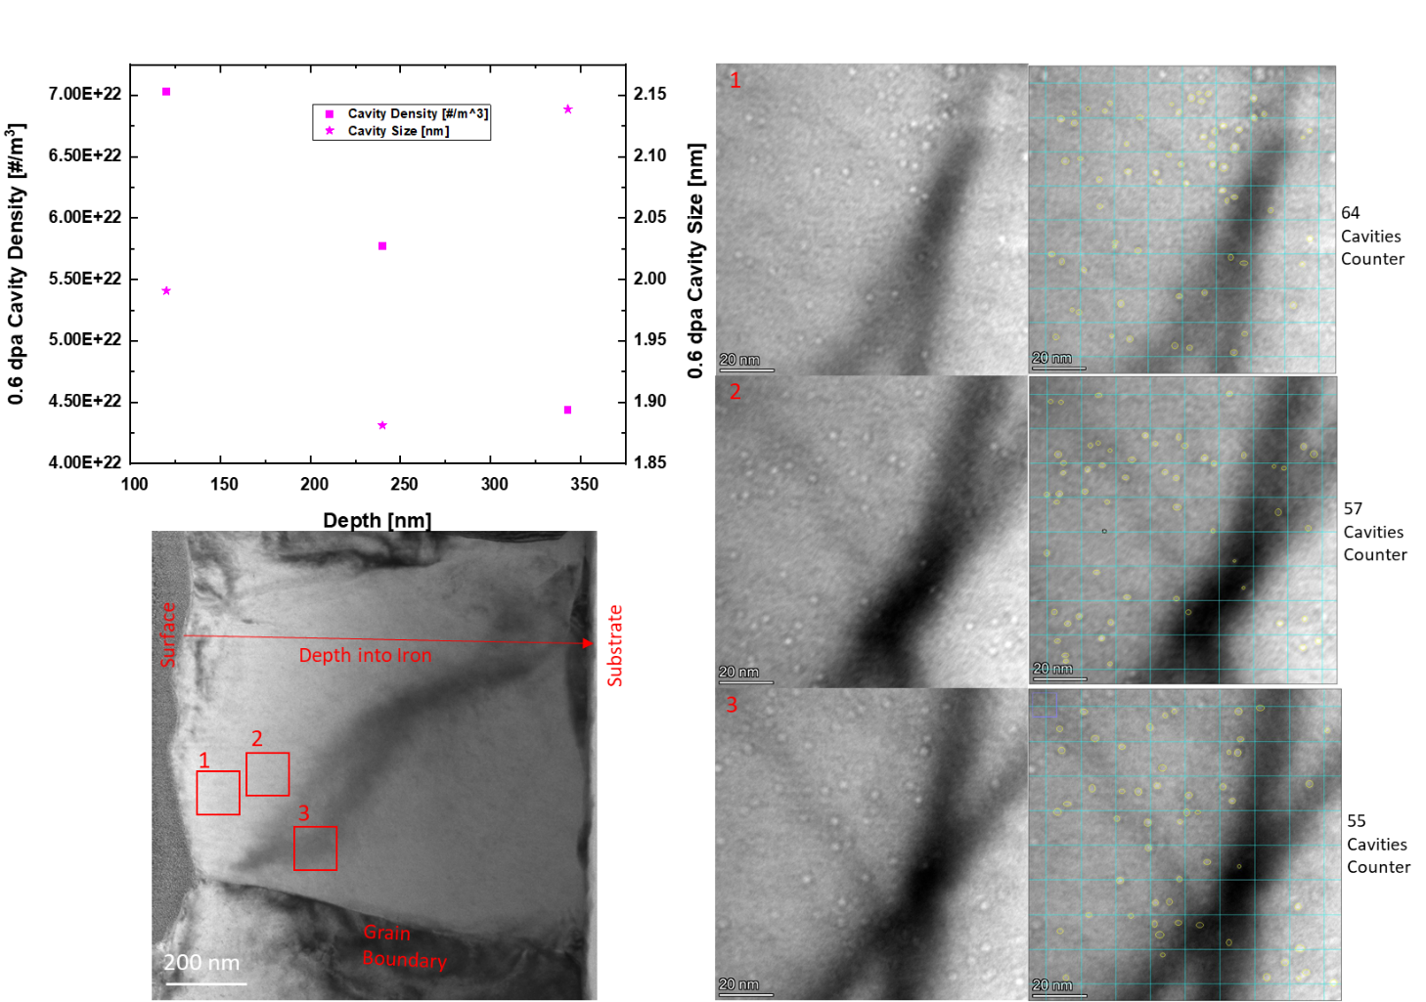

Figure 6S: TEM micrographs showing distribution of cavities in 0.6 dpa irradiated films. Images exhibit cavity counters at various depths.

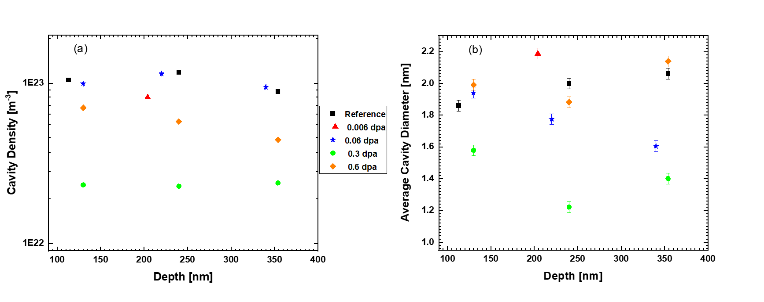
Figure 7S: TEM measurements of cavities in both pristine and irradiated samples: (a) Average cavity density as a function of depth; (b) Average cavity diameter as a function of depth.

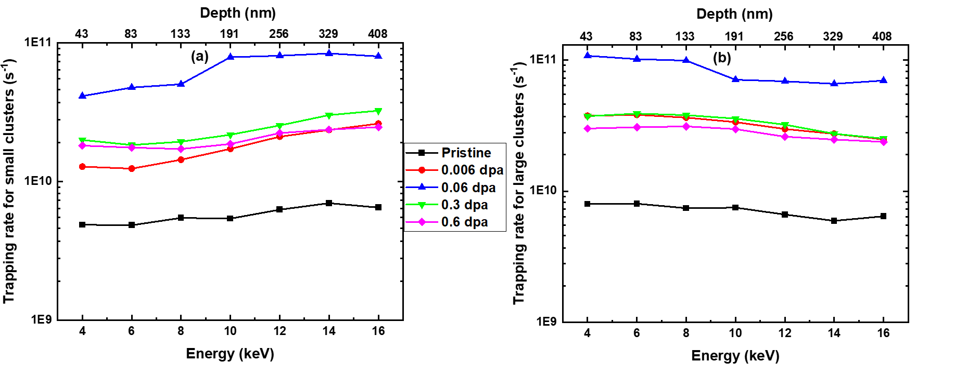Figure 8S: Trapping rates for pristine and irradiated samples as a function of implantation energy and mean depths, featuring (a) trapping rates for small clusters and (b) trapping rates for large clusters.
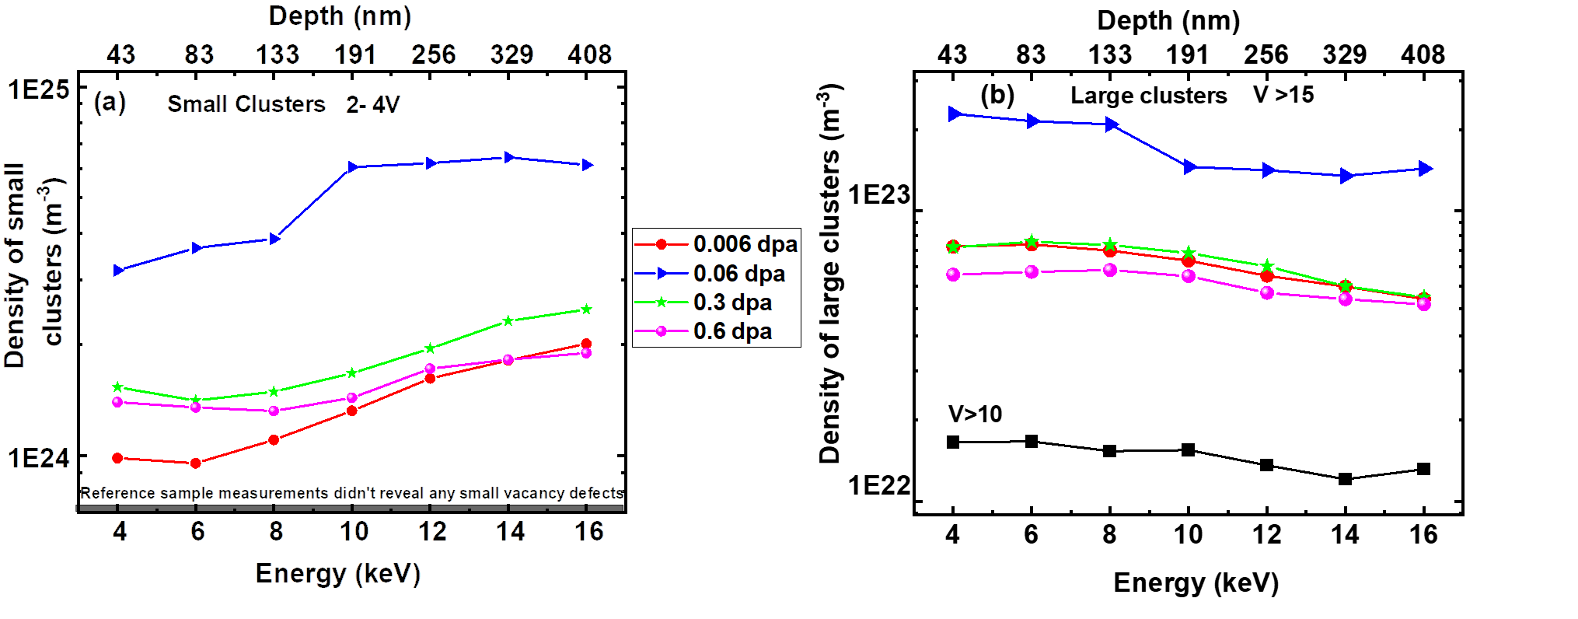
Figure 9S: Defect densities for pristine and irradiated samples as a function of implantation energy and mean depths, featuring (a) trapping rates for small clusters and (b) trapping rates for large clusters. The black squares in (b) represent the pristine sample

Interstitial clusters in the MD simulations

In Fig. 10S (a) the evolution of number of different sized interstitial clusters are presented for the large simulations cell. In Fig 10S (b) the number of interstitials in different sized clusters is presented for the large cell. In both figures the solid lines represent the cells containing the 7 voids (void density of 1.1 x 10²³ m⁻³) and the dotted lines the initially pristine cell. From the figures we can see that there are more large interstitial clusters in the initially pristine cell, and especially the number of interstitials in the large clusters are higher for the initially pristine sample. This is in line with the overall higher amount of retained defects in the pristine sample compared to the cells with pre-existing voids.
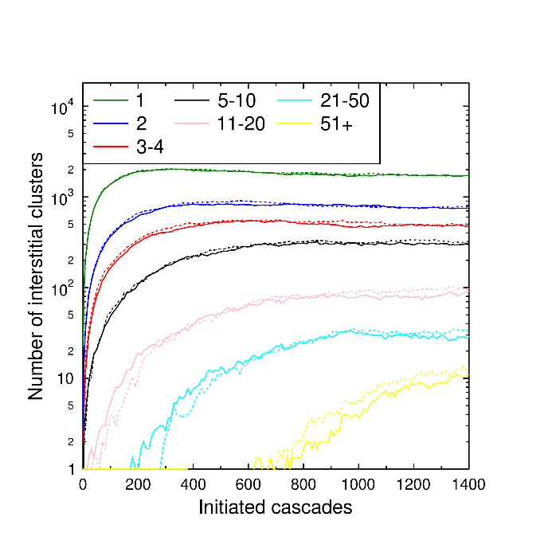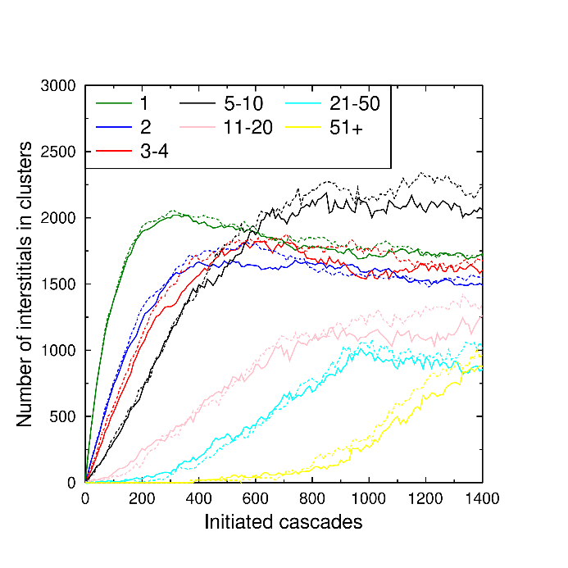
Figure 10S: (a) Number of interstitial clusters in different size intervals for the large cell with voids (solid line) and in the pristine sample (dotted line). (b) Number of interstitials in clusters of certain size for the large cell with voids (solid line) and in the pristine sample (dotted line).

Results for the small cell

A smaller MD cell of the size 20 x 20 x 20 nm³, consisting of 686,000 atoms was subjected to 1500 5keV cascades. Three runs for a pristine sample, a cell with 1 2-nm void and 4 2-nm voids were conducted. The corresponding void densities are 1.25x10²³ m⁻³ void density and 5x10²³ m⁻³. The simulations were carried out in the same manner as the larger cell. In Fig. 11S the created defects as a function of initiated cascades is shown. It can be seen the adding one void will lower the defect amount and adding four voids will further decrease the number of created FPs. Both in line with the results for the larger cell. In Fig. 12S the evolution of the largest void in the pristine and 1 2-nm void cells are shown (a) and for the four largest voids in the pristine and cell containing 4 voids (b). In Fig. 13S the evolution of interstitial clusters in the 1-void sample (a) and 4-void sample are presented. In Fig. 14S the number of interstitials in clusters are shown for the 1-void sample (a) and 4-void sample (b). Figs 13S and 14S show the same trend as the large cell, where we can observe more large interstitial clusters and especially number of interstitials in large clusters in the initially pristine cell, compared to the cells with voids.
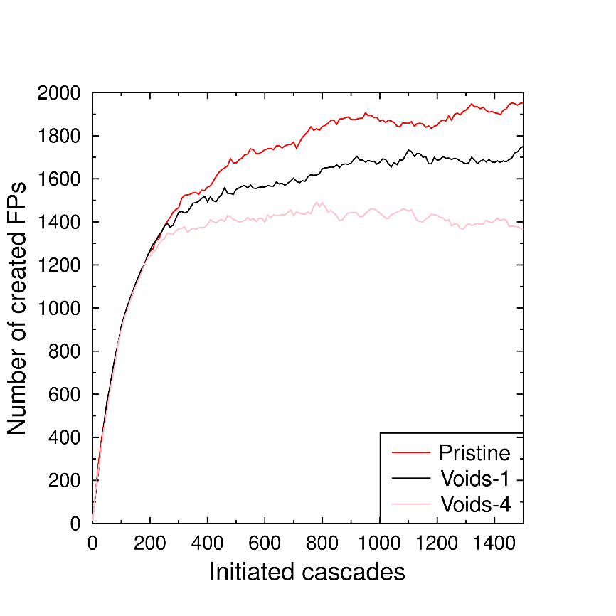
Figure 11S: Number of created defects as a function of initiated 5keV PKAs in a pristine sample containing approx. 686,000 atoms, red line, and in same sized samples with one 2nm-void (1.25x10²³ m⁻³ void density), black line, and four 2-nm voids (5x10²³ m⁻³ void density), pink line.
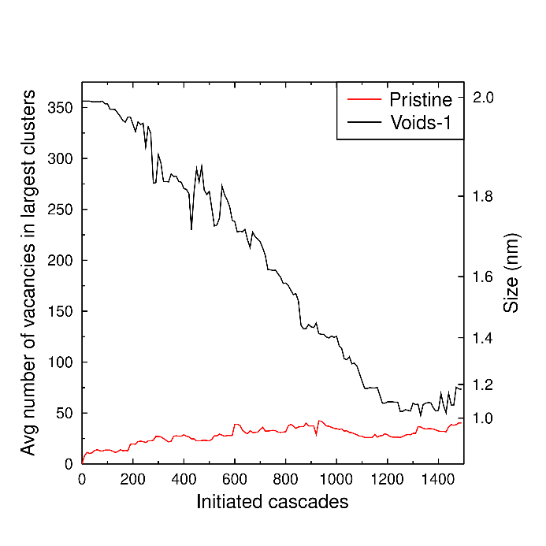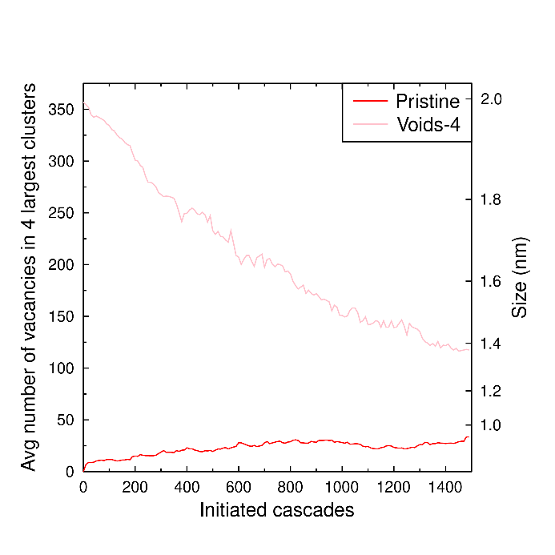
Figure 12S: Evolution of the largest void in the pristine sample and in the cell with one void (1.25x10²³ m⁻³ void density) in the smaller cell (a). (b) Average size of the four largest voids in the pristine sample and in the cell with four voids (5x10²³ m⁻³ void density) in the smaller cell. The size is calculated by assuming a spherical shape, which is not be representative of planar voids/dislocation loop sizes.
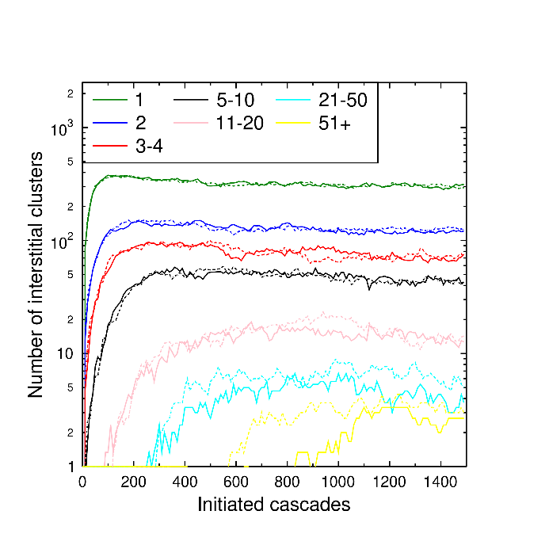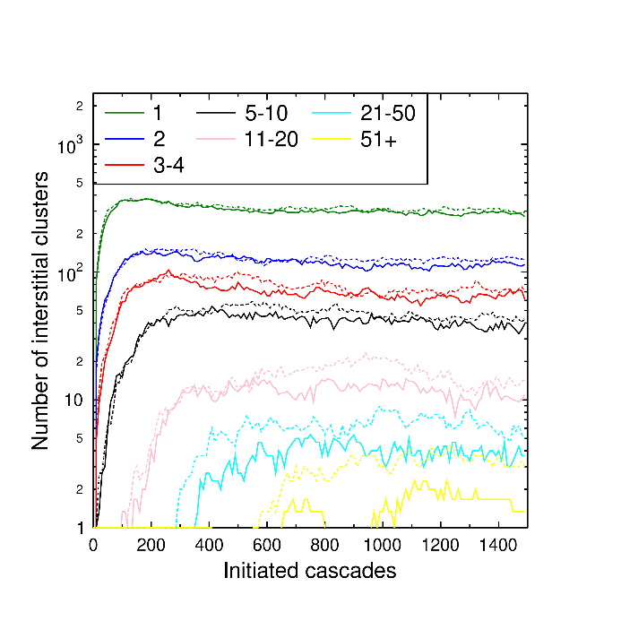
Figure 13S: (a) Number of interstitial clusters in different size intervals for the small cell with 1 void (solid line) and in the pristine sample (dotted line). (b) Number of interstitial clusters in different size intervals for the small cell with 4 voids (solid line) and in the pristine sample (dotted line).
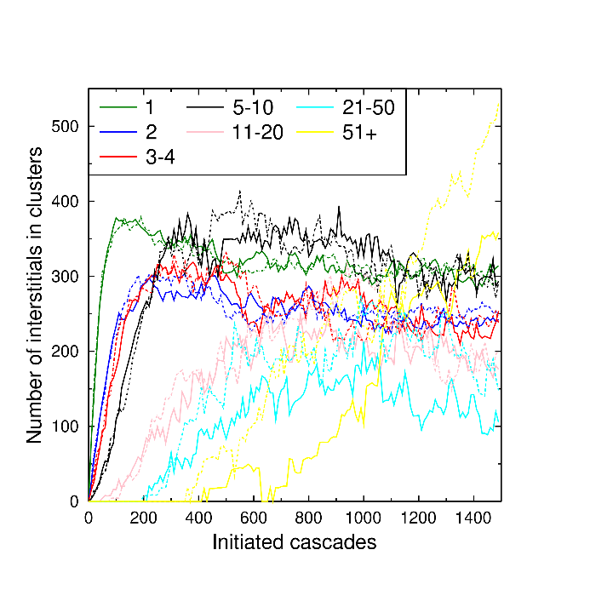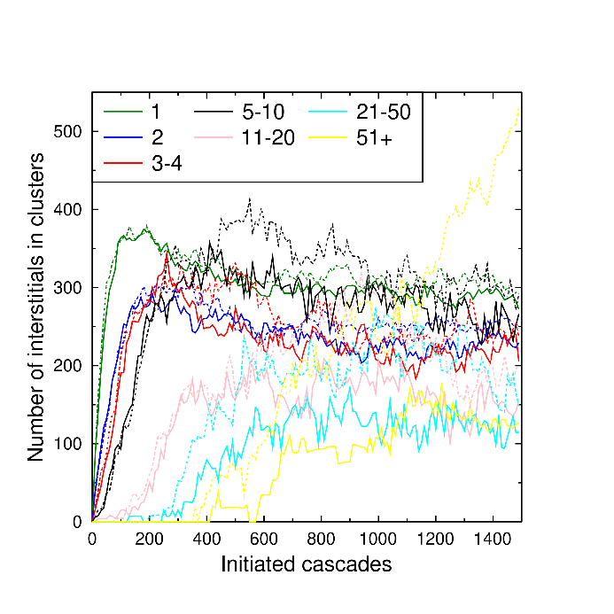
Figure 14S: (a) Number of interstitials in clusters of certain size for the small cell with 1 void (solid line) and in the pristine sample (dotted line). (b) Number of interstitials in clusters of certain size for the small cell with 4 voids (solid line) and in the pristine sample (dotted line).

Table-1S: Positron lifetimes for different vacancy sizes in Fe. The table is constructed from the previous calculations and reported values in references [3,4].
Number of  Vacancies | Positron Lifetime  (ps)
1 | 190
2 | 197
3 | 232
4 | 262
6 | 304
10 | 334
15 | 386
20 | 396
25 | 409
30 | 420
40 | 433

References
- Selim, F.A., Wells, D.P., Harmon, J.F., Kwofie, J., Erikson, G. and Roney, T. New positron annihilation spectroscopy techniques for thick materials. Radiation Physics and Chemistry, 68, 427(2003).
- Selim, F.A., Wells, D.P., Harmon, J.F. Positron lifetime measurements by proton capture. Review of scientific instruments, 76, 033905 (2005).
- Puska, M. J., Nieminen, R. M. Defect spectroscopy with positrons: a general calculational method. Journal of Physics F: Metal Physics. 13, 333 (1983).
- Čížek, J. "Characterization of lattice defects in metallic materials by positron annihilation spectroscopy: A review," Journal of Materials Science & Technology 34, 577 (2018).

