Supplementary material
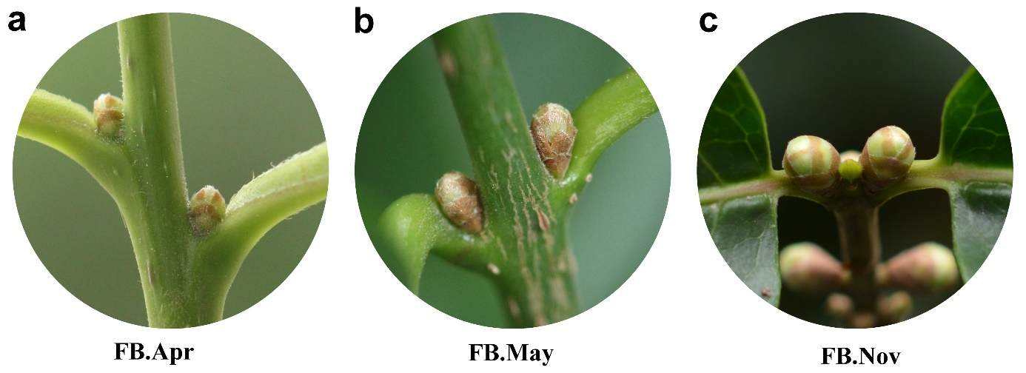
Fig.S1 The flower bud morphology during April, May and November a-b April and May. During this period, the flower buds are in developmental stage, especially the floral organs (perianth segment, stamen and pistil) primordium begins to differentiate. c November. By this time, the development of flower bud has been completed.

