Analysis of the Plasma Lipidome Following the Intravenous and Oral Administration of Gefitinib to C57Bl/6JRj Mice

Robert S Plumb¹, Lee A Gethings², Giorgis Isaac¹, Ian D Wilson³

- Waters Corporation, Scientific Operations, Immerse, Cambridge, MA 02142, USA
- Scientific Operations, Waters Corporation, Stamford Ave, Wilmslow, SK9 4AX, UK
- Computational & Systems Medicine, Department of Metabolism, Digestion and Reproduction, Imperial College, Exhibition Rd, London, SW7 2AZ, UK

Legends

Figure S1: Structure of Gefitinib

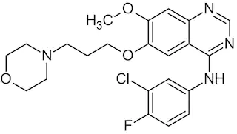

Figure S2: Pharmacokinetics of Gefitinib following IV administration at 10mg/kg to male C57Bl/6JRj mice

Figure S3: Pharmacokinetics of Gefitinib following PO administration at 50mg/kg to male C57Bl/6JRj mice

Figure S4: Positive ion LC-MS ESi chromatogram of pooled plasma QC sample formed from male C57Bl6 mice dosed with gefitinib 10mg/Kg (IV), 50mg/Kg (PO) and vehicle only.

Figure S5: Negative ion LC-MS ESi chromatogram of pooled plasma QC sample formed from male C57Bl6 mice dosed with gefitinib 10mg/Kg (IV), 50mg/Kg (PO) and vehicle only

Figure S6: PCA of negative ion LC-MS ESI data for plasma obtained from male C57Bl6 mice dosed with vehicle for the periods of predose, 0.25, 0.5, 0.75, 1, 2, 3, 6, 8 and 24 h. These data were obtained following triplicate analysis of plasma samples. Animal cages are identified using the notation (A) and (B). The results demonstrate the absence of any time related trajectory in the data.

Figure S7: PCA of positive ion LC-MS ESI data for plasma obtained from male C57Bl6 mice dosed with vehicle for the periods of predose, 0.25, 0.5, 0.75, 1, 2, 3, 6, 8 and 24 h. These data were obtained following triplicate analysis of plasma samples. Animal cages are identified using the notation (A) and (B). The results demonstrate the absence of any time related trajectory in the data.

Figure S8: PCA of positive ion LC-MS ESI data for plasma obtained from male C57Bl6 mice following the IV administration of gefitinib at 10mg/Kg for the periods of predose, 0.25, 0.5, 0.75, 1, 2, 3, 6, 8 and 24 h. These data were obtained following triplicate analysis of plasma samples. Animal cages are identified using the notation (A) and (B). The results show a clear time related trajectory in the data, from predose to 6 h with the 8 and 24 h samples returning close to the predose position.

Figure S9: PCA of negative ion LC-MS ESI data for plasma obtained from male C57Bl6 mice following the oral administration of gefitinib at 50mg/Kg for the periods of predose, 0.25, 0.5, 0.75, 1, 2, 3, 6, 8 and 24 h. These data were obtained following triplicate analysis of plasma samples. Animal cages are identified using the notation (A) and (B). The data shows the cage effects and a time related trajectory in the data following dosing, note that after 24 h the samples have not returned to their predose levels.

Figure S10: PCA of positive ion LC-MS ESI data for plasma obtained from male C57Bl6 mice following the oral administration of gefitinib at 50mg/Kg for the periods of predose, 0.25, 0.5, 0.75, 1, 2, 3, 6, 8 and 24 h. These data were obtained following triplicate analysis of plasma samples. Animal cages are identified using the notation (A) and (B). The data shows the cage effects and clear presence of a time related trajectory in the data following dosing.

Figure S11: PCA (Pc1 vs Pc2 vs PC3) of positive ion LC-MS ESi data for plasma obtained from male C57Bl6 mice following the IV administration of gefitinib at 10mg/Kg for the periods of predose, 0.25, 0.5, 0.75, 1, 2, 3, 6, 8 and 24 h. The data illustrates that after 24 h (pale blue circles) the lipid chemistry of the mice has not returned to it predose (black circles) values.

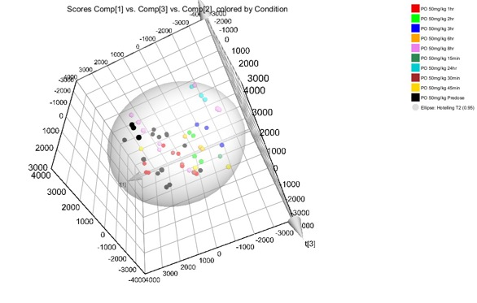

Figure S12: OPLS DA of negative ion LC-MS ESI data for plasma obtained from male C57Bl6 mice following the IV administration of gefitinib at 10mg/Kg for the periods of predose vs 0.1 + 0.25 h. These data were obtained following triplicate analysis of plasma samples. Area in red represents signals elevated in the 0.1 and 0.25h samples, area in blue represents signal elevated in the predose samples.

Figure S13: OPLS DA of negative ion LC-MS ESI data for plasma obtained from male C57Bl6 mice following the IV administration of gefitinib at 10mg/Kg for the periods of predose vs 1 + 3 h time points. These data were obtained following triplicate analysis of plasma samples. Area in red represents signals elevated in the 1 and 3 h samples, area in blue represents signal elevated in the predose samples.

Figure S14: OPLS DA of negative ion LC-MS ESI data for plasma obtained from male C57Bl6 mice following the oral administration of gefitinib at 50mg/Kg for the periods of predose vs 3 h time points. These data were obtained following triplicate analysis of plasma samples. Area in red represents signals elevated in the 1 and 3 h samples, area in blue represents signal elevated in the predose samples.

Figure S15: MS2 Spectra obtained from for the peak eluting at t_{R} = 3.27 min from the negative ion LC-MS ESi analysis of plasma from C57Bl6 mice following the oral administration gefitinib at 50mg/Kg. The MS/MS spectra obtained for PC 40:2 was compared to that of an authentic standard in Lipostar database.

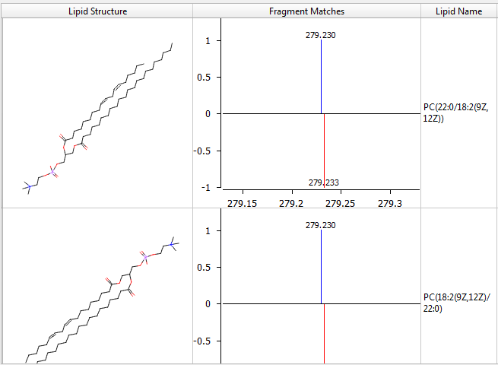

Figure S16: MS2 Spectra obtained from for the peak eluting at t_{R} = 3.27 min from the negative ion LC-MS ESi analysis of plasma from C57Bl6 mice following the oral administration gefitinib at 50mg/Kg. The MS/MS spectra obtained for PC 40: 10 was compared to that of an authentic standard in Lipostar database.

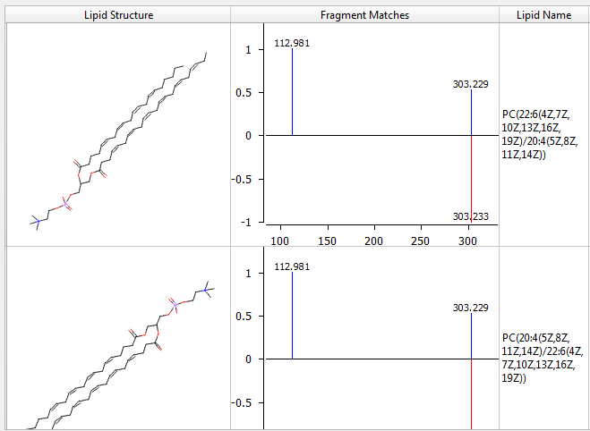

Figure S17: MS2 Spectra obtained from for the peak eluting at t_{R} = 1.97 min from the -ve ESI analysis of plasma from C57Bl6 mice following the oral administration of gefitinib at 50mg/Kg. The MS/MS spectra obtained for PC(38:6) was compared to that of an authentic standard in the Lipostar database.

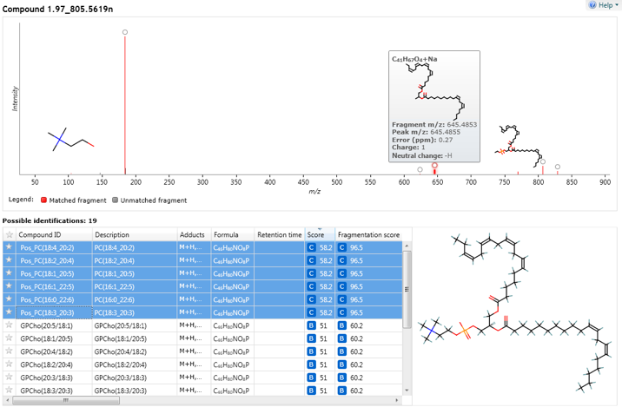

Analysis of this feature showed that this lipid had a precursor neutral mass of 805.5619, giving an elemental composition of C46H80NO8P, with a mass error of 0.3 mDa. Two major fragment ions were obtained for thei lipid, one at m/z = 184.0740 which was attributed to the loss of the choline headgroup and the other, of m/z = 645.4853, which was considered to be the sodium adduct of C41H67O4 with a mass error of 0.27 ppm. The top six database lipid identifications for this feature returned the same result, a PC (38:6) with various different combinations of the position of unsaturation. The two combinations of alkyl chain lengths were suggested as 16:22 and 20:18.
Figure S18: MS2 Spectra obtained from for the peak eluting at t_{R} = 4.55 min from the negative ion LC-MS ESi analysis of plasma from C57Bl6 mice following the oral administration gefitinib at 50mg/Kg. The MS/MS spectra obtained for TG 56: 8 was compared to that of an authentic standard in Lipostar database

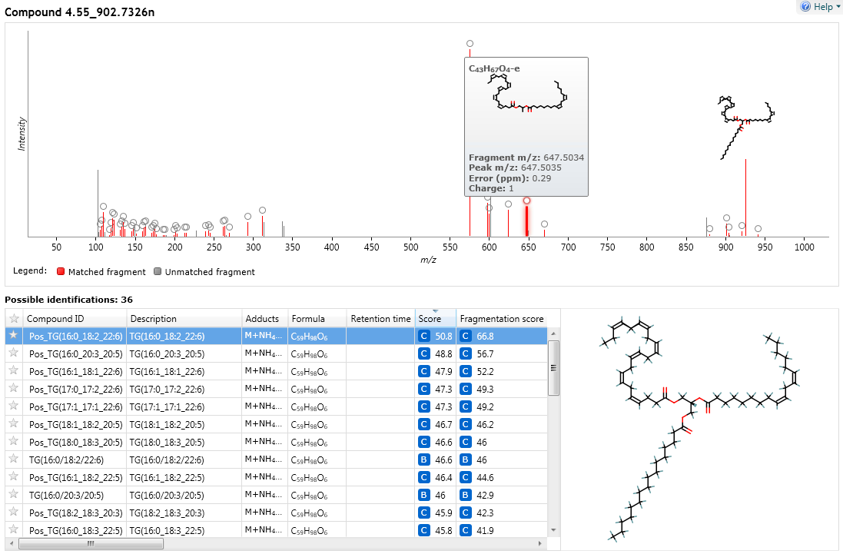

Figure S19: Change in lipid concentration following the oral administration of gefitinib at 50 mg/Kg

Figure S20: Change in response for lipid PE 40:2 following the oral administration of gefitinib. Pharmacokinetic profile for the oral administration of gefitinib included for reference.

Figure S21: Change in response for lipid PE 34:0 following the oral administration of gefitinib. Pharmacokinetic profile for the oral administration of gefitinib included for reference.

