Supporting Information
Composition-rheology relationships of polymer composite-type precursors

Table S1. Complete list of shear rheology inks.

Table S2. Complete list of extensional rheology inks.

Table S3. Complete list of characteristic flow models
Shear Models
Model Name | Equation | Variables
Herschel-Bulkley-Papanastasiou | τ=τy*1-e-mγ+kγn | τ = stress  τ_{y} = yield stress  m = exponential stress growth  k = consistency  γ = shear stress
Carreau-Yasuda | τ=γ η∞+η0-η∞1+λγan-1a | τ = stress  γ = shear stress  η∞ = infinite-rate viscosity  η0 = zero-rate viscosity  λ = consistency  a = constant  n = rate index
Power law (Shear) | τ =ηxn | τ = stress  η = viscosity  n = rate index
Extensional Models
Model Name | Equation | Variables
Elastic fluid | R(t)R(0)=n=1N(AnR0)1/3exp⁡(-t3λn) for N=1, 2 or 3 | R = radius  t = time  A = constant  λ = viscoelastic time scale
Power law (Extensional) | R(t)R(0)=a*tc-tn for 0<n≤1 | R = radius  a = constant  t = time  t_{c} = critical time to failure  n = rate index
Bingham plastic | R(t)R(0)=aR01-expbt-tc | R = radius  t = time  a = constant  b = constant  t_{c} = critical time to failure
Yielding | Yielding: R(t)R(0)=C | R = radius  C = constant

Figure S1. 3D yield stress plots for (left) LMW and (right) HMW inks.

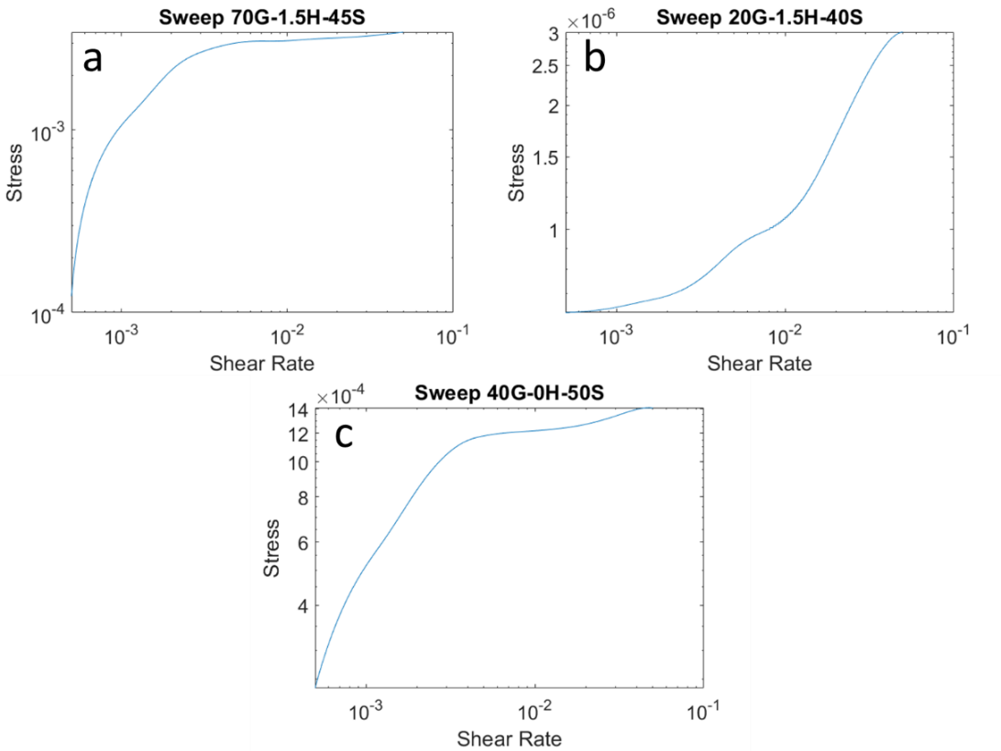
Figure S2. Three distinct behaviors found in yielding materials, including (a) the lack of the shear thinning region, (b) the lack of the exponential stress growth region, and (c) the inclusion of
both regions.

Three distinct HBP-type behaviors appeared during flow sweep experiments. The first type of fit, shown in Figure S1(a) has only the exponential stress growth region and the yield stress plateau. The second type, shown in Figure S1(b) has the yield stress plateau and the shear thinning region. The final type, shown in Figure S1(c) has both regions as well as the yield stress plateau. Because the strain rate range is held constant through all compositions, one can conclude that this behavior can be attributed to composition.
Like extensional rheology, AIC was implemented to determine the best fit shear rheology model. Previously, we used 2 different versions of the HBP model: the full HBP equation presented as well as a truncated version (HBP-t) shown below.

$$τ=τ_{y}*\left(1-e^{-m\dot{γ}}\right)$$

This version of the model was used in scenarios such as that shown in Figure S1(a), where only the exponential stress growth region and yield stress plateau are present. This was done to account for the fact that the shear thinning portion of the equation ($k{\dot{γ}}^{n}$) does not have sufficient data to fit.
When comparing the HBP fit to HBP-t using AIC, they are indistinguishable. As such, we implemented Bayesian Information Criterion (BIC) to determine the better fit model. BIC is

$$BIC=nln\left(\frac{RSS}{n}\right)+kln(n)$$

where n is the sample size and k is the number of free parameters in the model. Thus, if the AIC values of HBP and HBP-t were within 2 of each other for a given ink, BIC was used. BIC illuminated that inks with the behavior trend seen in Figure S1(a) did indeed fit better to HBP-t than HBP. Due to the lack of data in the power law region of the model, the values for K and n are mathematical constructs rather than physical parameters for inks with this trend. As such, these inks have been removed from the quantitative analysis maps for K and n.

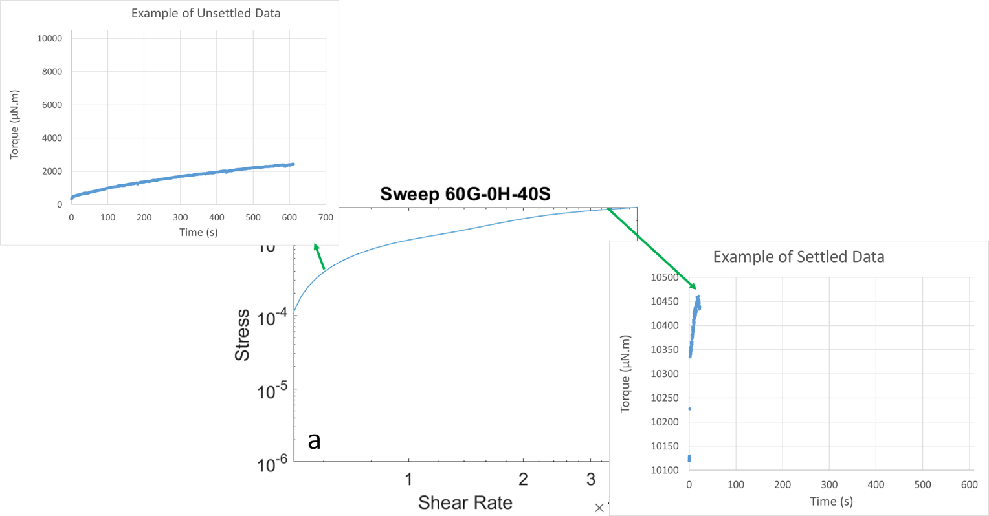
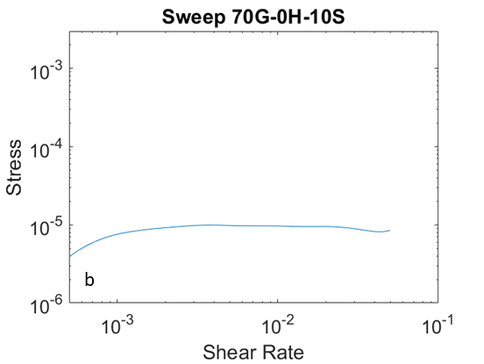
Figure S3. The distinction between (a) a large exponential stress growth region and (b) a short exponential stress growth region. The larger region indicates more time to reach steady state.

Figure S3(a) demonstrates the slow stress growth that coincides with a high value of m. The second point in the 60G-0H-40S flow sweep, indicated with an arrow, is a transient point, so settling does not occur. Steady-state sensing was not used on this point, so it was sheared for the full 600 s. Transience such as this is indicative of a lower m value. More stress is required to induce yielding, thus there is a larger degree of stress growth during the transient period, as seen in the first 3 points of the flow sweep plot. In particular, 60G-0H-40S has m = 431.87, whereas an ink with a higher value of m (and a shorter region) such as 70G-0H-10S, shown in Fig. S3(b), has m = 1468.7. Within the first 3 points of the 60G-0H-40S flow sweep, the stress grows by approximately 1000 Pa. In comparison, the initial stress growth of 70G-0H-10S is only approximately 40 Pa. Data collection for the final point in the 60G-0H-40S flow sweep utilized steady-state sensing. This point settled within the 600 s maximum allotted time, showing steady state was effectively reached.

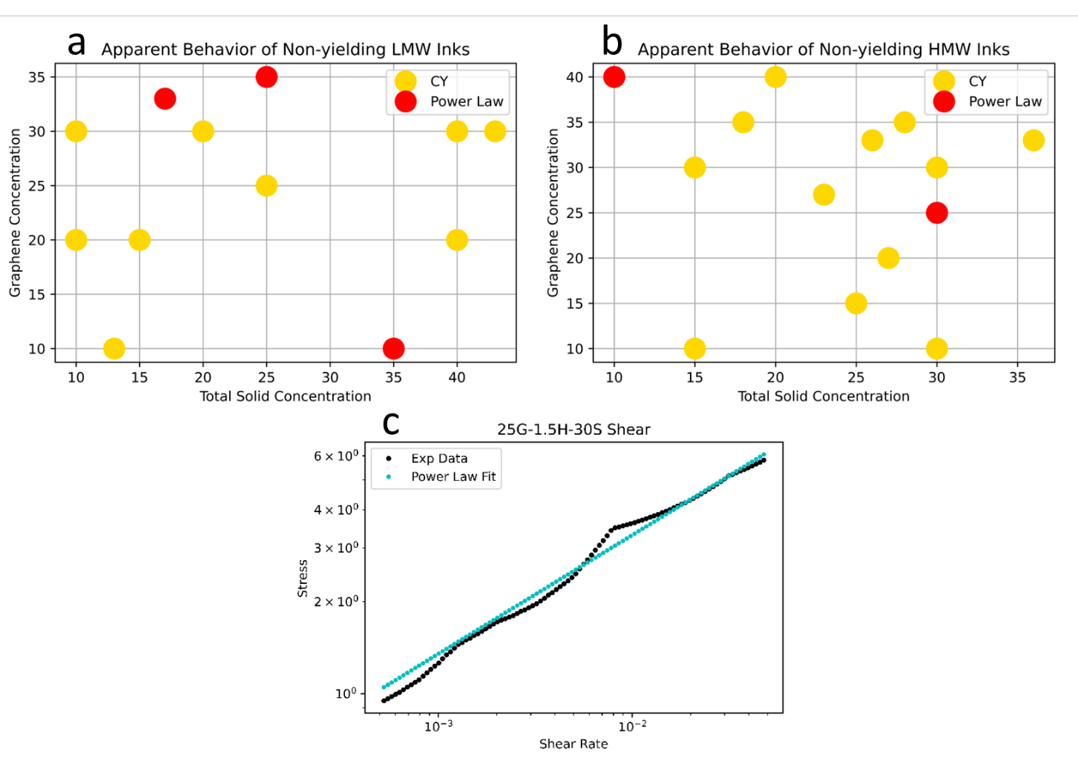
Figure S4. Dot maps for (a) LMW inks and (b) HMW inks, depicting Carreau-Yasuda points (yellow) and power law points (red). An example of the power law fit is shown in (c).

