Authors’ Profiles
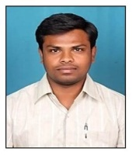
Usikela.Naresh, Research Scholar, Department of Computer Science & Technology, Sri Krishnadevaraya University, Anantapuramu, A.P. His research interests are in the field of image Processing, Machine Learning, Deep Learning. He completed his M.Tech in computer Science and Engineering from Jawaharlal Nehru Technological University, Hyderabad, Telangana.

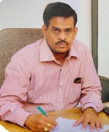
Dr. T. Bhaskara Reddy, Professor. Department of Computer Science & Technology, Sri Krishnadevaraya University, Anantapuramu A.P. He completed his Ph.D from S.K. University, Anantapuramu, A.P. He has more than 28 years of Teaching and Research experience. He has published more than 100 papers in National, International journals and conferences. Under his guide ship 29 Ph.D and 6 M.Phil students are awarded. His research interests are in the field of AI, Data science, image Processing, computer networks, data mining and data ware house.

