Supplementary Information of
Examining Planetary Boundary Layer Height Climatology, Trends, and Variability over India using High-Resolution Indian Reanalysis

Krishna Kumar Shukla^{1*}, Raju Attada^{1*}, Akash Pathaikara¹
¹Department of Earth and Environmental Sciences, Indian Institute of Science Education and Research Mohali, Punjab-140306, India

*Corresponding author:
Raju Attada and Krishna K Shukla
Department of Earth and Environmental Sciences,
Indian Institute of Science Education and Research Mohali, India.
Email: rajuattada@iisermohali.ac.in; kkshukla@iisermohali.ac.in

Figure S1. Different geographical sub-regions over Indian subcontinent.

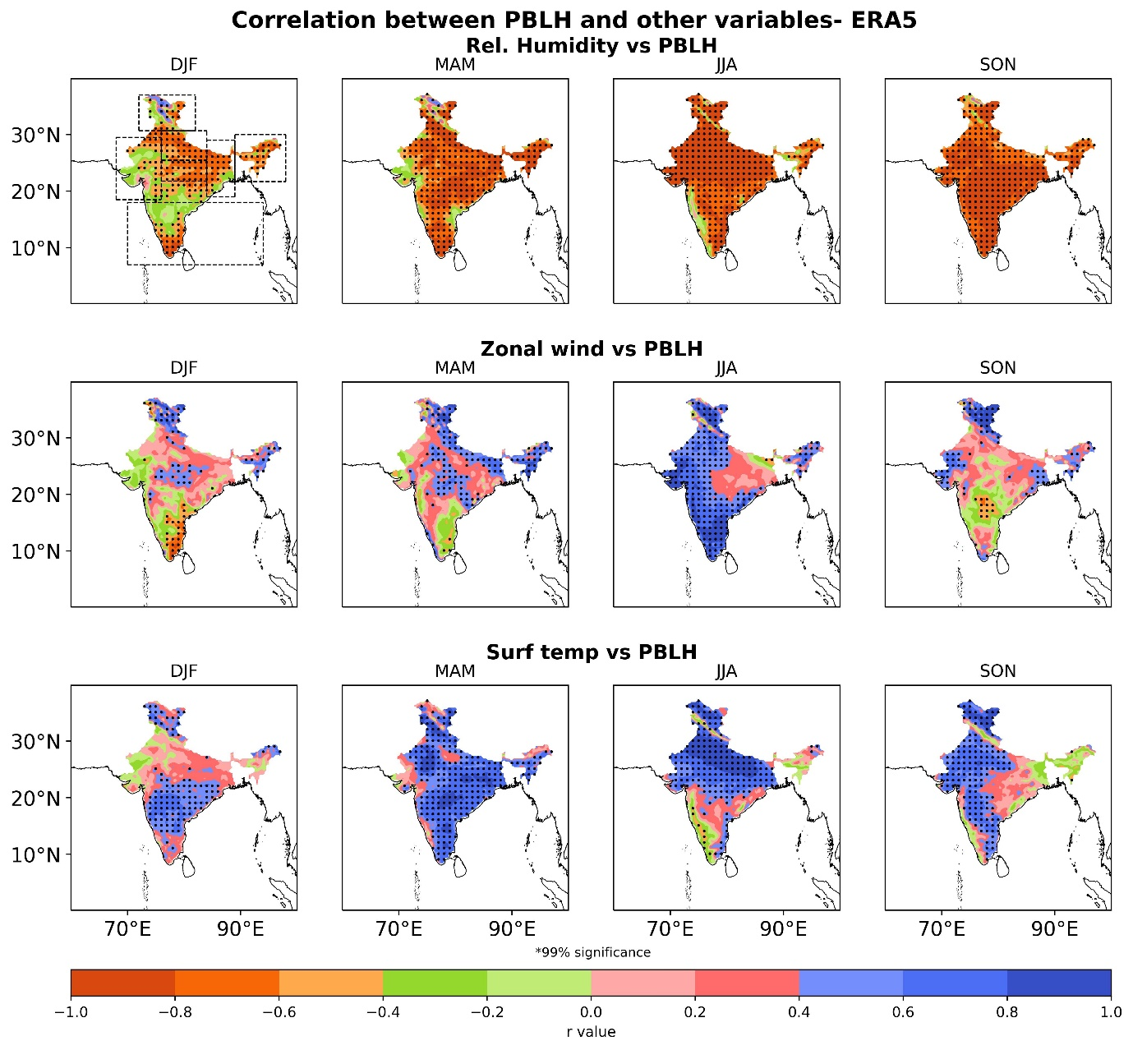

Figure S2. Spatial distribution of correlation between ERA5 PBLH and relative humidity (top panels), between ERA5 PBLH and zonal wind (middle panels), and between ERA5 PBLH and surface temperature (bottom panels) during different seasons winter (DJF), pre-monsoon (MAM), monsoon (JJA), and post-monsoon (SON). Dots denote correlations are significant at the 99% level. The dotted line in the top first panel represents the different Indian sub-regions.

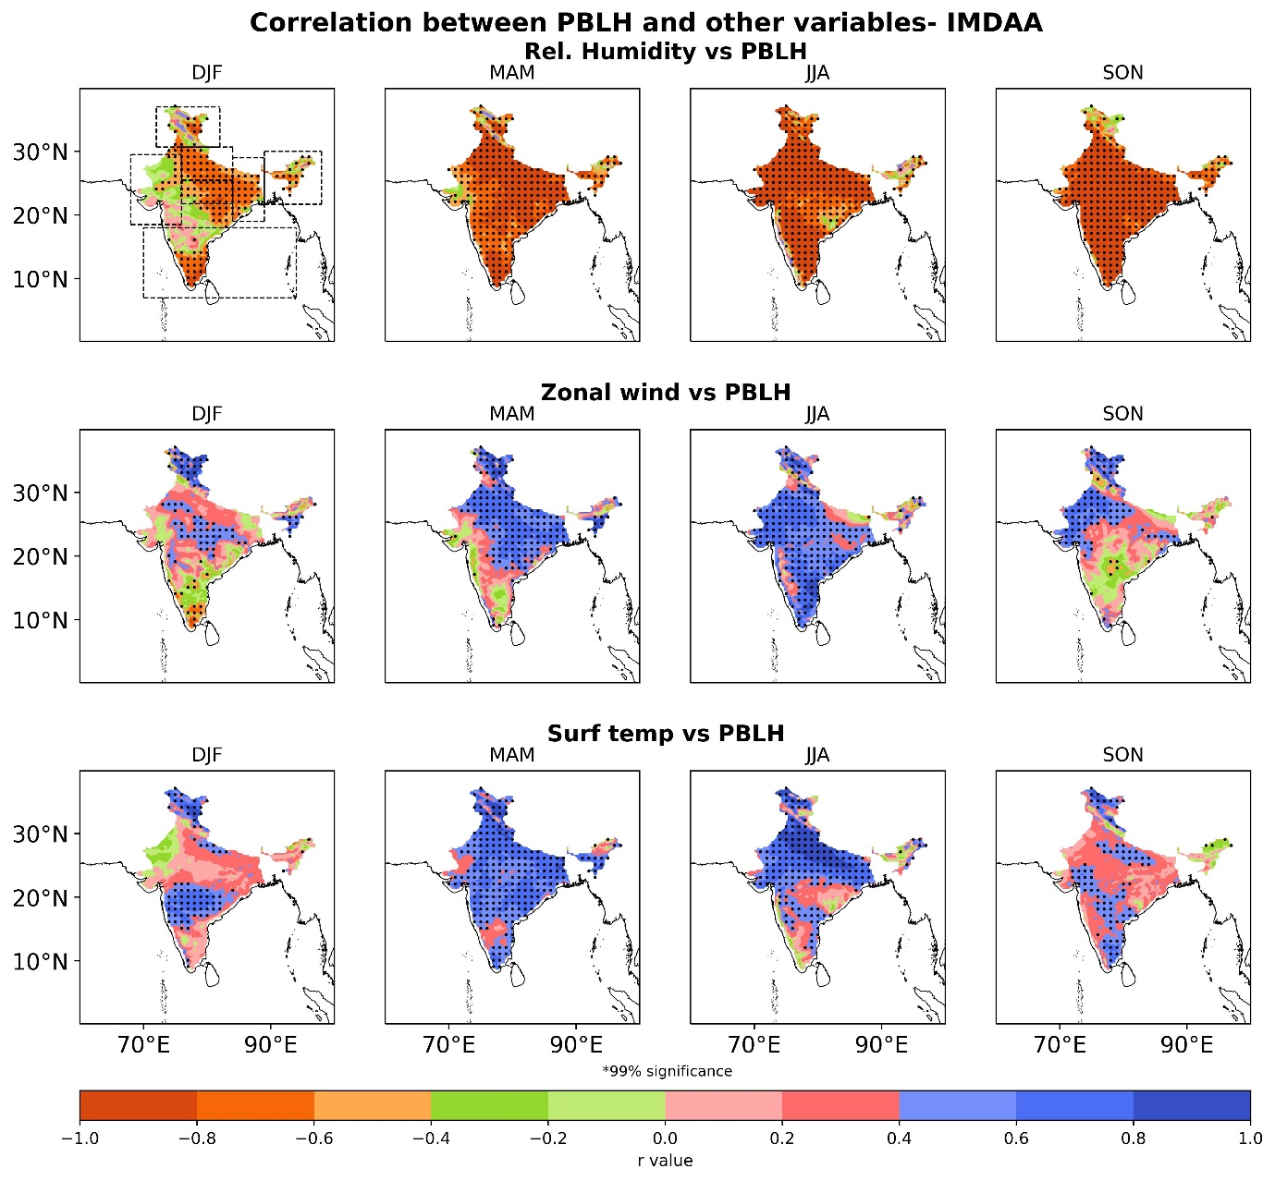
Figure S3. Same as Figure S2 but for IMDAA

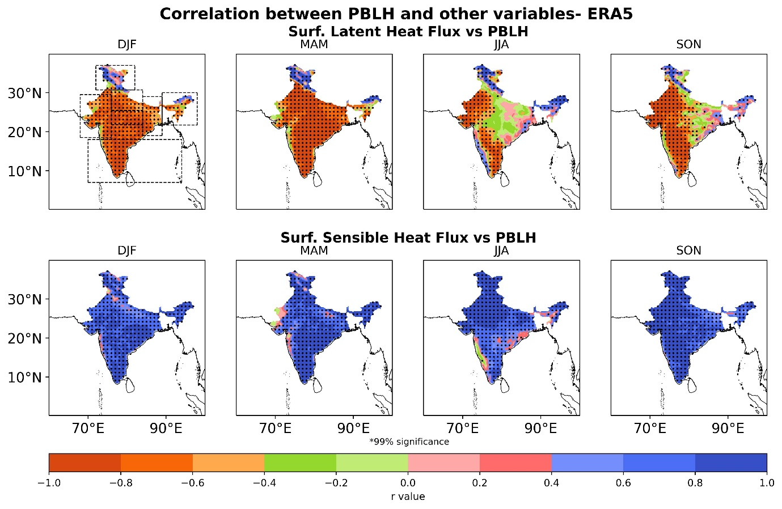
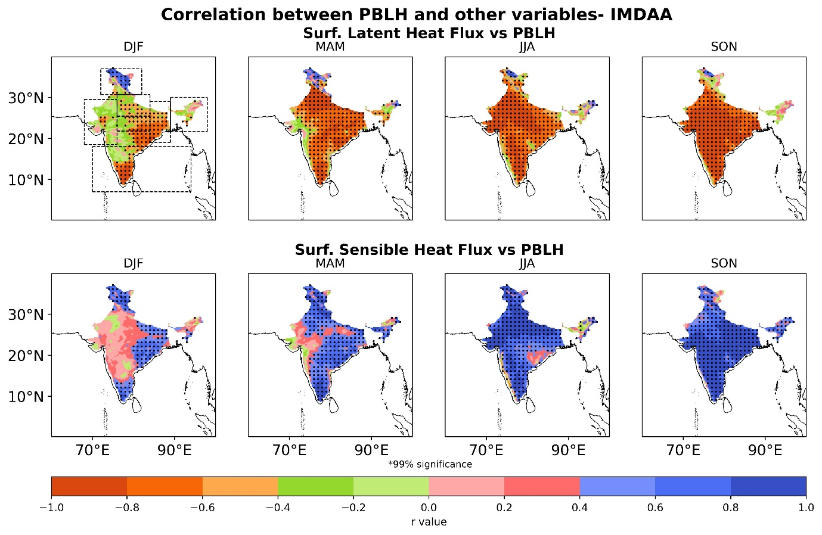
Figure S4. Spatial distribution of correlation between ERA5 and IMDAA PBLH and respective surface fluxes (Surface latent heat flux and surface sensible heat flux) during different seasons winter (DJF), pre-monsoon (MAM), monsoon (JJA), and post-monsoon (SON). Dots denote correlations are significant at the 99% level. The dotted line in the top first panel represents the different Indian sub-regions.
The spatial distribution of correlation between PBLH and other meteorological parameters (RH, surface temperature, zonal winds) from ERA5 and IMDAA is shown in Figure S2-S3 during different season’s winter, pre-monsoon, monsoon, and post-monsoon over a period of 1980-2019. The correlations are significant at the 99% level. The spatial correlation between PBLH (IMDAA and ERA5) and RH shows a significant negative correlation during different seasons across the entire Indian region (Figure S2-S3). In contrast, it significantly correlates positively with the surface temperature and zonal wind. In addition, the spatial pattern of correlation between PBLH and surface fluxes such as SLHF and SSHF is shown in Figure S4 during different seasons. Figure S4 shows that IMDAA and ERA5 PBLH negatively correlate with SLHF during different seasons while positively correlating with SSHF. The results show that IMDAA successfully captures the correlation pattern for meteorological and surface fluxes similar to ERA5.

