Supporting Information

Driving Fiber Diameters to the Limit: Nanoparticle-induced Diameter Reductions in Electrospun Photoactive Nanofibers for Organic Photovoltaics
R. M. Schofield, B. M. Maciejewska, S. Dong, G. T. Tebbutt, D. McGurty, R. S. Bonilla, H. E. Assender* and N. Grobert*
Department of Materials, University of Oxford, Parks Road, Oxford, OX1 3PH, UK

*Corresponding Authors
Hazel Assender (hazel.assender@matierials.ox.ac.uk)
Nicole Grobert (nicole.grobert@materials.ox.ac.uk)

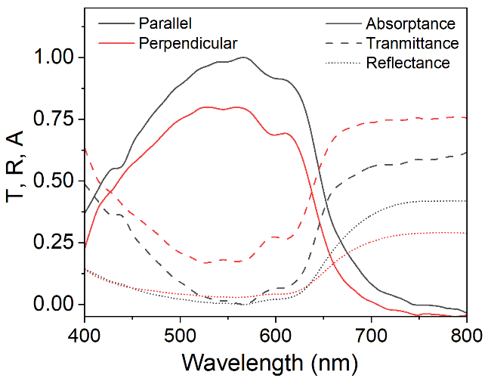
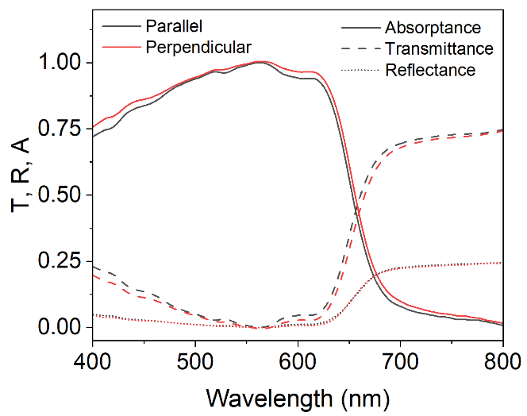
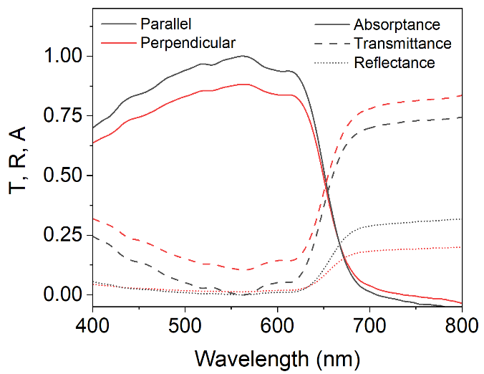
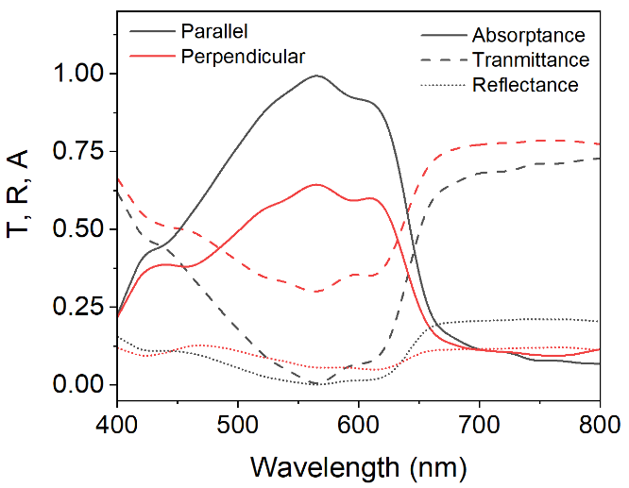
a)
b)
c)
d)
e)
10 µm

Fig. S1 Polarised absorptance, transmittance and reflectance spectra of a) randomly orientated PEO-reduced AgNP nanofibres, spun after 96 hours aging onto a static collector, b) aligned P3HT nanofibres, and aligned PEO-reduced AgNP-containing P3HT nanofibres spun after c) 24 and d) 96 hours of aging. Light was polarised parallel (along) and perpendicular (across) the fibre axes direction. A greater absorption in parallel polarisation suggests that polymer chains are orientated along the axis of the electrospun fibres. e) SEM micrograph of an aligned PEO-reduced AgNP-containing P3HT nanofibre mat, spun onto a rotating drum collector

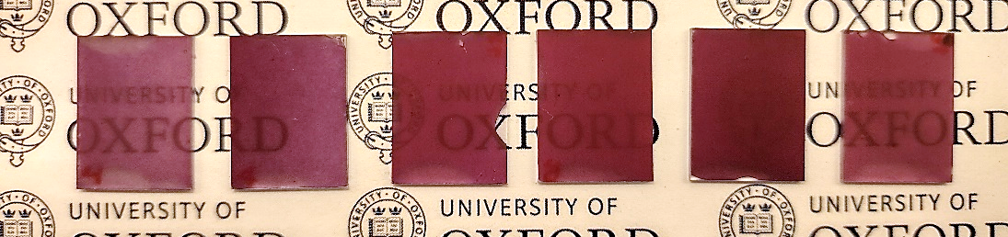
0h
24h
168h
96h
72h
48h
b)

Fig. S2 Nanofibre-based films electrospun from the same spinning solution as it ages. The absorption is easily observed to increase to a maximum after 72 - 96 h

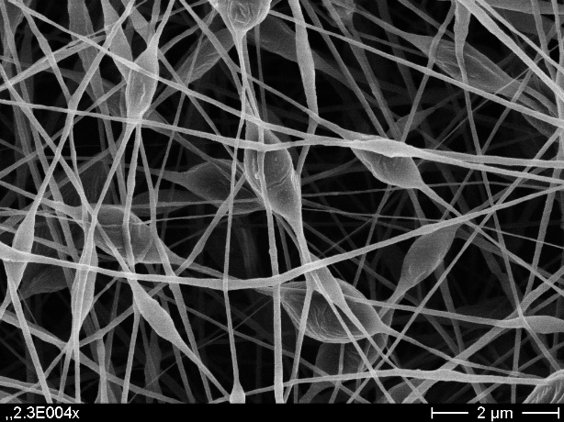
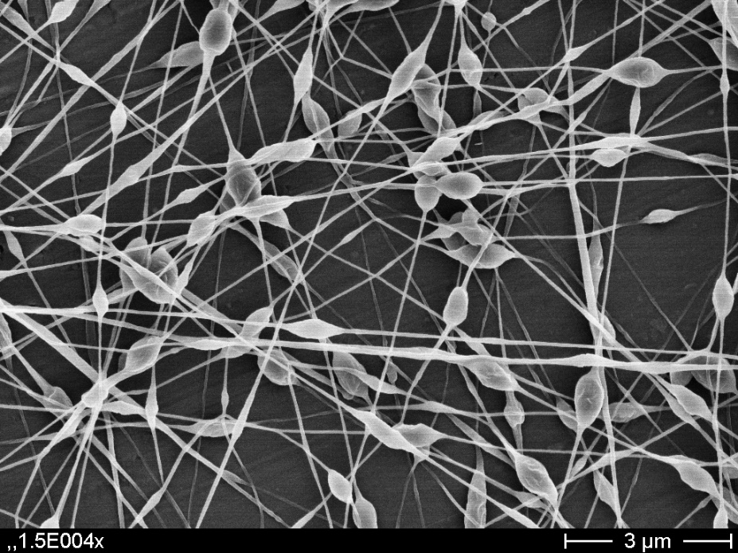
b)
a)
2 µm
2 µm

Fig. S3 a) Beaded PEO nanofibres electropsun from 0.35 wt% PEO solutions in chloroform: DMF (90.6: 9.4 w/w), and b) chloroform: DMF: acetic acid (86.7: 9.4: 3.9 w/w/w), determining that DMF additions had to limited to 8 wt% yielding 140 nm fibres in the absence of nanoparticles

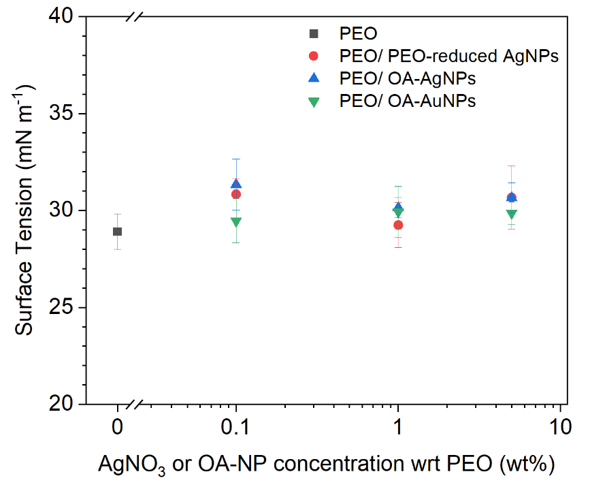
Fig. S4 Surface tension of NP-containing 0.35% PEO spinning solutions in chloroform: DMF (92:8 w/w) reveals that nanoparticle addition has no measurable influence upon surface tension

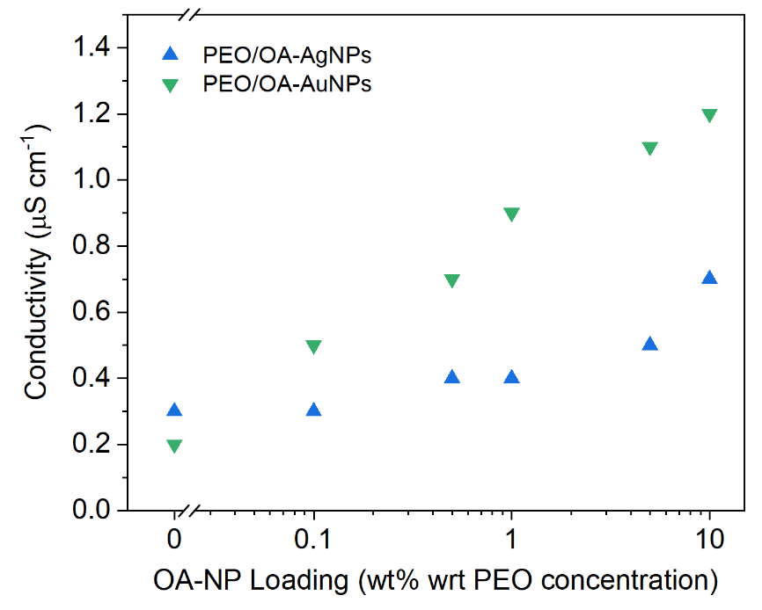

Fig. S5 Electrical conductivity enhancement induced by the addition of OA-capped Ag and Au NPs to 0.35 wt% PEO spinning solutions measured after 48 hours. The enhancement is less than that produced through the addition of PEO-reduced AgNPs

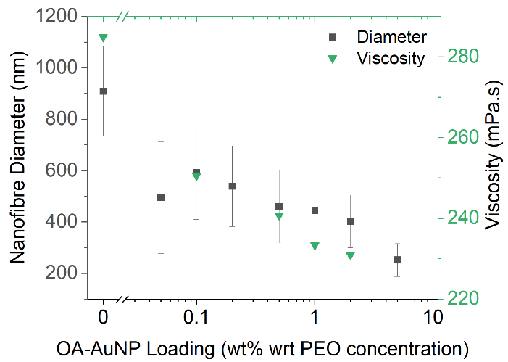
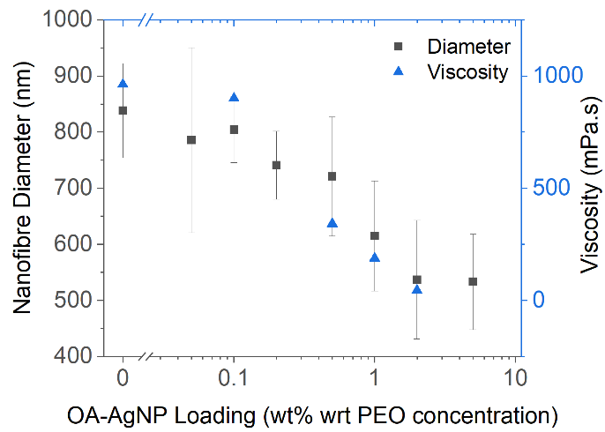
a)
b)

Fig. S6 Reducing viscosities of 1.5 wt% PEO spinning solutions and diameters of nanofibres spun from those solutions, as a function of OA-capped a) Ag or b) AuNPs

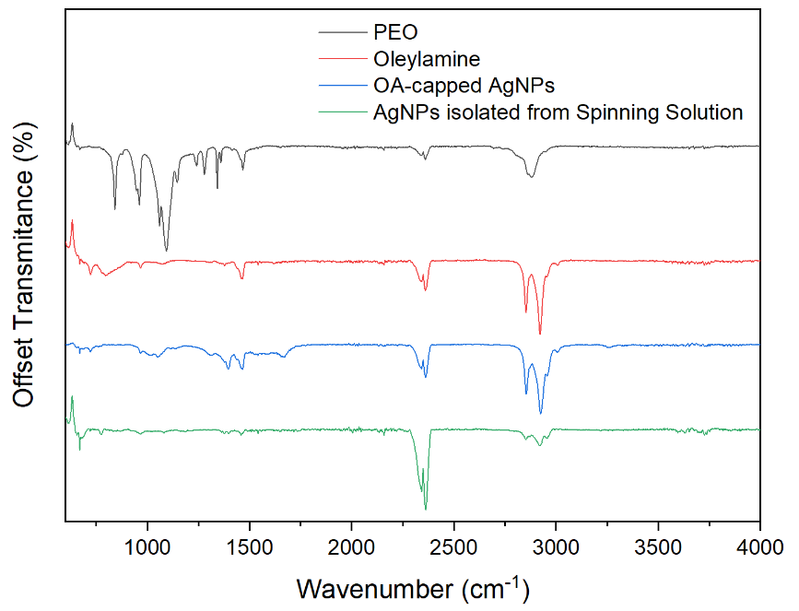

Fig. S7 FTIR spectra from the OA-capped AgNPs as-synthesised and after isolation by centrifugation after addition to the spinning solution and aging for 48 hours. Both the before and after spectra reveal oleylamine content in the capping layer, and no evidence of PEO adsorption

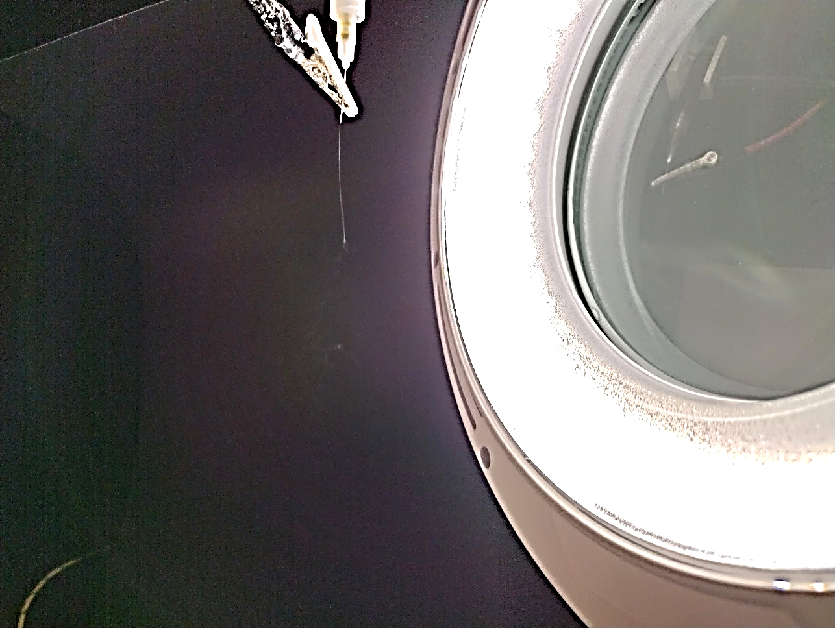
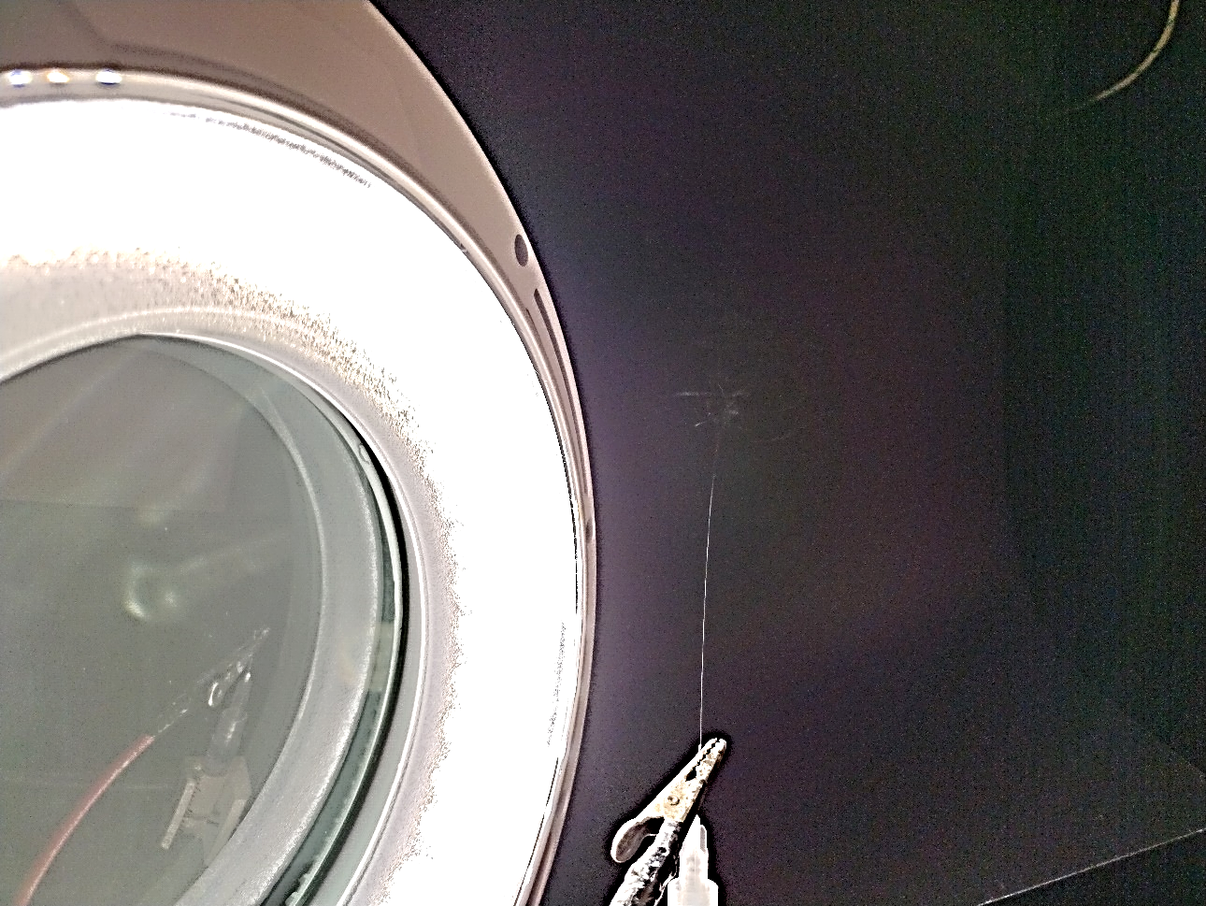
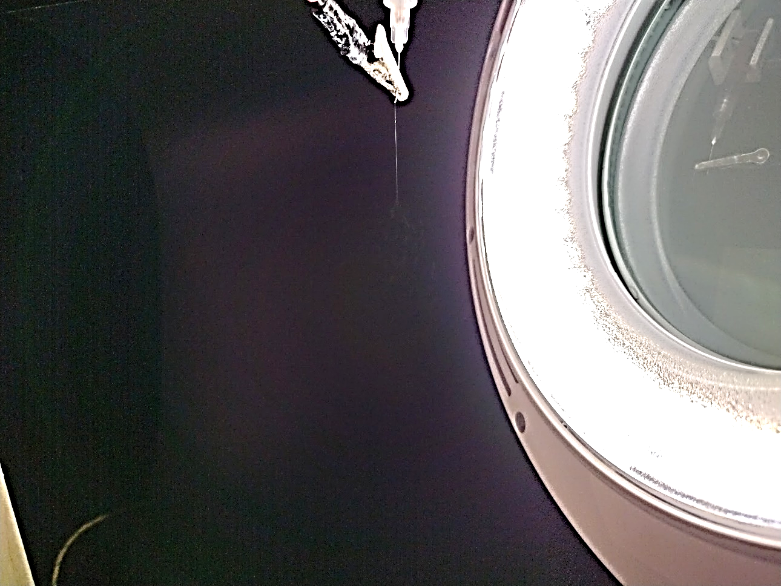
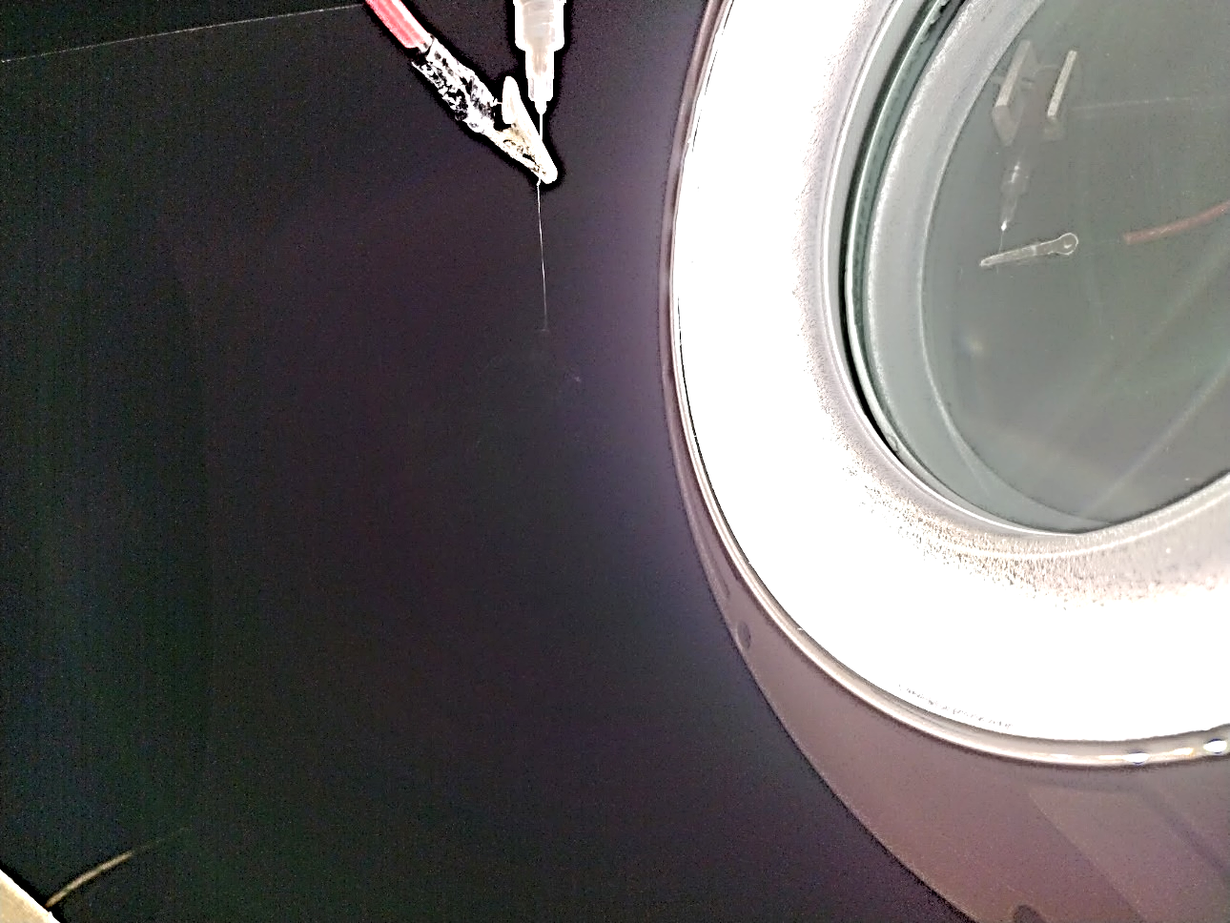
5.4 cm
2.6 cm
2.9 cm
2.3 cm
5 cm
a)
b)
c)
d)

Fig. S8 Optical photographs of the first whipping onset during the electrospinning of a) 0.35 wt% PEO spinning solutions, and the shortening of the linear jet section upon the addition of b) PEO-reduced AgNPs, c) OA-capped AgNPs or d) OA-capped AuNPs
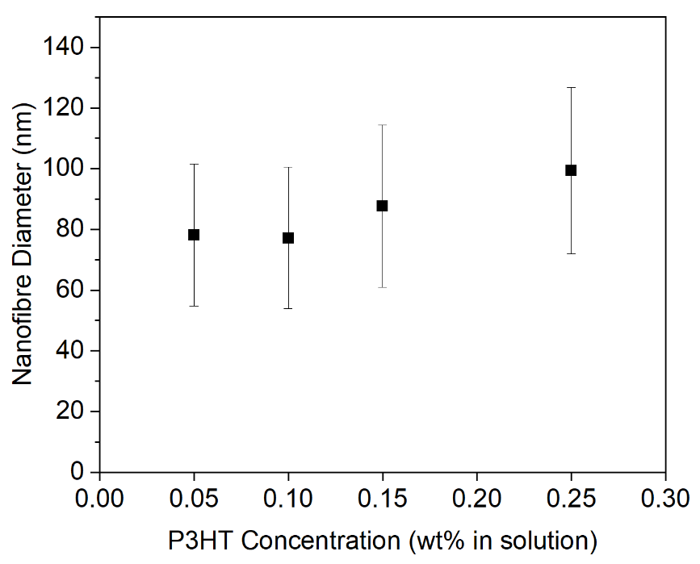

Fig. S9 Achievable diameters of PEO-reduced AgNP-containing P3HT/PEO nanofibres as a function of the P3HT concentration in solution, spun at the optimal aging time for the individual spinning solution

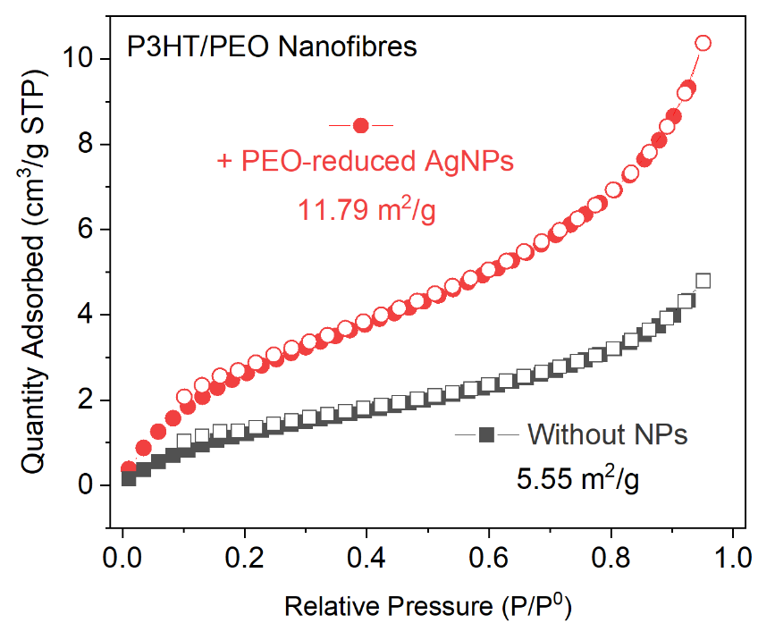
Fig. S10 BET specific surface area analysis of as-spun P3HT/PEO and PEO-reduced AgNP-containing P3HT/PEO nanofibre showing a doubling of the fibre surface area upon nanoparticle addition

a)
b)
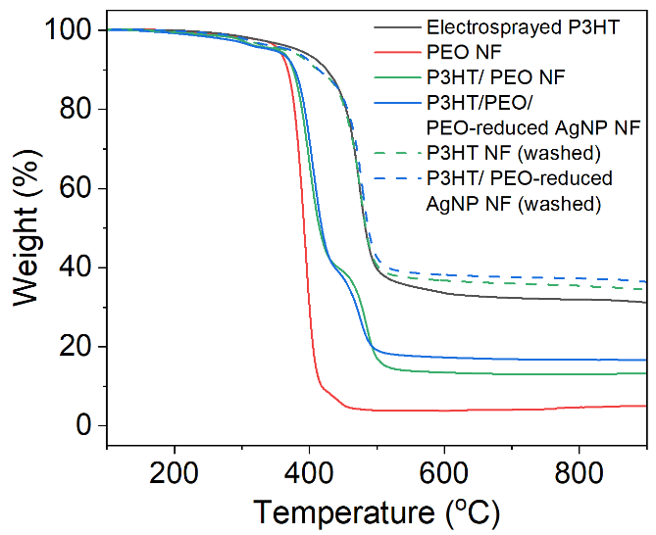
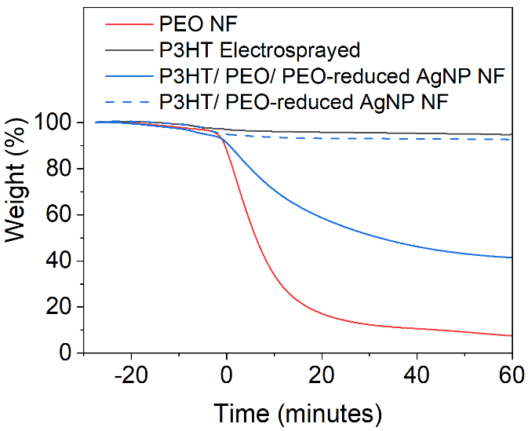
c)
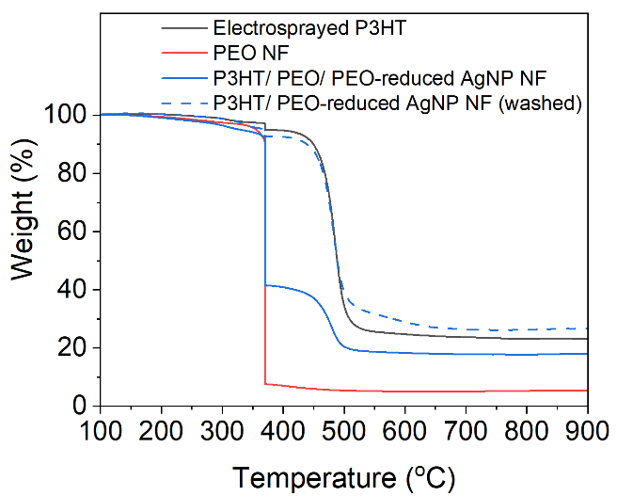

Fig. S11 TGA thermograms of nanofibres run under nitrogen with an a) temperature scan of 100°C to 900 °C at 10°C min⁻¹, and b) an isotherm at 370 °C for 1 h, in order to examine the efficiency of PEO removal from P3HT/PEO composite fibres by washing in IPA at 70 °C for 1 h. c) The isothermal analysis presented as a function of temperature

a)
b)
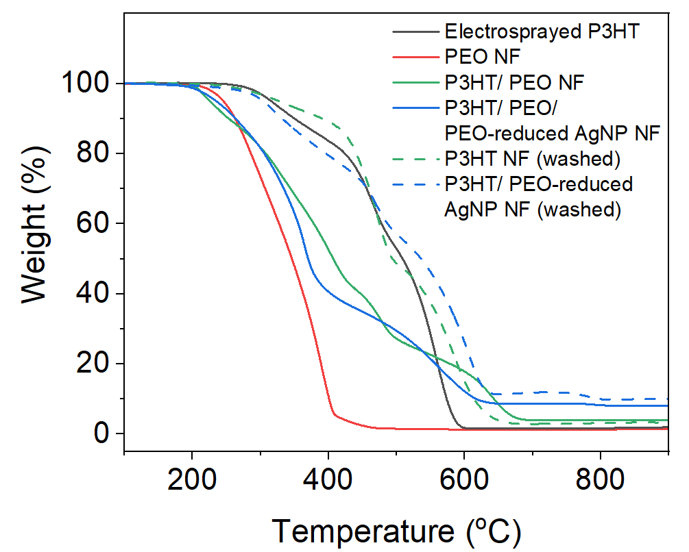
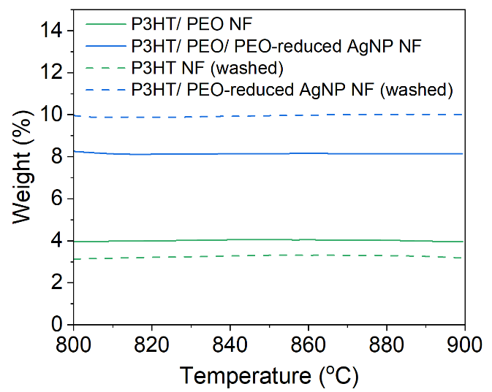

Fig. S12 a) TGA thermograms of nanofibres run under air with a temperature scan from 100 °C to 900 °C at 10 °C min⁻¹, and b) a close-up of the 800 °C – 900 °C region, from which we can estimate nanoparticle retention upon PEO removal from the residuals at 900 °C. AgNO₃ additions to the spinning solution were 10 wt% wrt PEO

Table S1 Average residuals from the washed undoped and nanoparticle-containing fibres and details of the calculation of nanoparticle retention upon washing
Sample | Residual at 900 °C [%]
ª Washed P3HT NF | 4.48 ± 1.78
^{b} Washed P3HT/PEO-reduced AgNP NF | 11.18 ± 1.18
Difference in residual (%) | 6.70 %
Estimated Ag content (%)* | 7.0 %
Ag content at 100% retention | 8.2%
Nanoparticle retention (%) | 85%

$$*{Residual}_{b}=x_{Ag}+{Residual}_{a}\left(1- \frac{x_{Ag}}{100}\right) [Equation 1]$$
Where ${Residual}_{a} and {Residual}_{b}$ are the residuals at 900 °C of washed P3HT and P3HT/PEO-reduced AgNP NFs and $x_{Ag}$ is the estimated wt% of Ag inside of the washed P3HT/PEO-reduced AgNP NF

Table S2 Fibre dimensions of as-spun and washed P3HT nanofibres. The as-spun fibres are cylindrical, however upon washing the fibres have a greater width than height. Heights are determined by AFM and widths by SEM analysis

Sample | As-spun | After PEO Removal
Sample | Height/Width [nm] | Height [nm] | Width [nm]
P3HT/PEO NF (0.35%/0.25%) | 219.2 ± 49.9 | 101.0 ± 39.8 | 329.4 ± 90.7
P3HT/PEO/PEO-reduced AgNP NF (0.35%/0.25%) | 98.9 ± 32.6 | 73.1 ± 24.6 | 115.9 ± 33.2
P3HT/PEO/PEO-reduced AgNP NF (0.35%/0.15%) | 87.7 ± 26.7 | 55.1 ± 13.2 | 96.4 ± 14.1

b)
a)

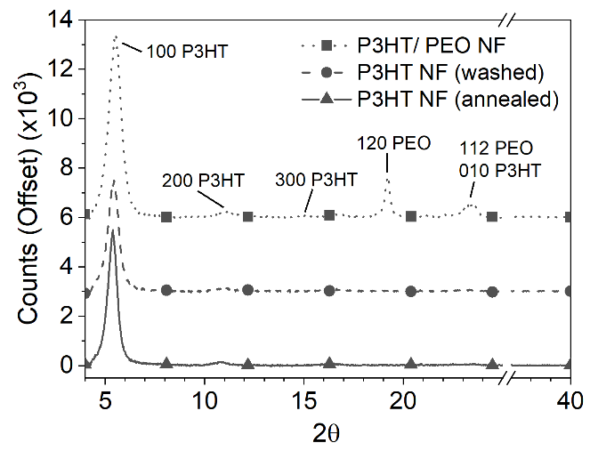
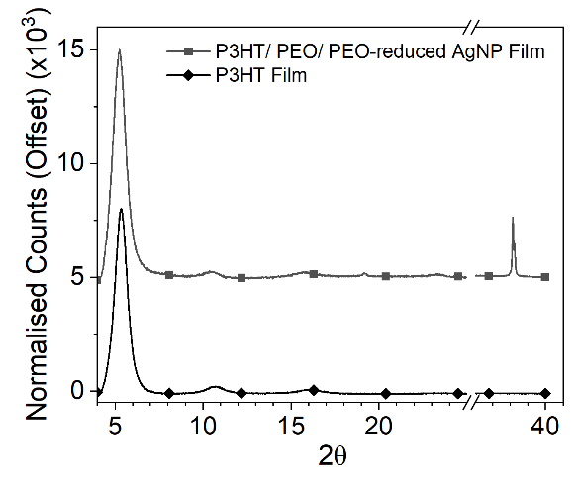

Fig. S13 a) XRD spectra of the as-spun, washed and annealed undoped P3HT nanofibres, showing similar behaviours to nanoparticle-containing fibres in Figure 5c, and b) films spin-cast from the PEO-reduced AgNP-containing P3HT/PEO spinning solution and a solution of P3HT dissolved in chloroform. All samples were prepared to contain the same mass of P3HT.

Table S3 Details of key parameters extracted from the XRD analysis of P3HT films and nanofibres.

Sample | Peak Position | D-Spacing | FWHM | Crystallite Size
 | [°] | [nm] | [°] | [nm]
P3HT
Thin Film | 5.38 | 1.64 | 0.85 | 9.4
P3HT/ PEO-reduced AgNP Nanofibre
As-Spun | 5.19 | 1.70 | 1.11 | 7.1
Washed | 5.18 | 1.70 | 0.78 | 10.2
Annealed | 5.12 | 1.72 | 0.66 | 12.1
Film Cast from Solution | 5.24 | 1.69 | 0.85 | 9.4
P3HT Nanofibre
As-Spun | 5.51 | 1.60 | 0.75 | 10.6
Washed | 5.43 | 1.63 | 0.64 | 12.3
Annealed | 5.39 | 1.64 | 0.64 | 12.3
P3HT/OA-capped AgNP Nanofibre
Washed | 5.46 | 1.62 | 0.53 | 14.9
P3HT/OA-capped AuNP Nanofibre
Washed | 5.45 | 1.62 | 0.61 | 13.0

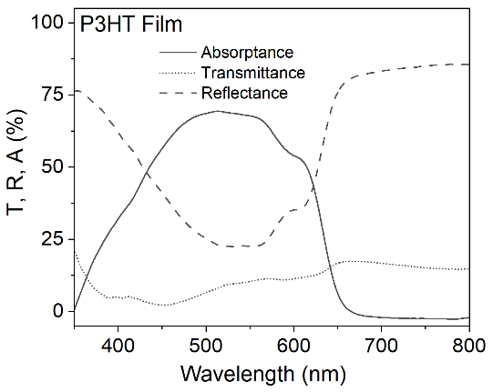
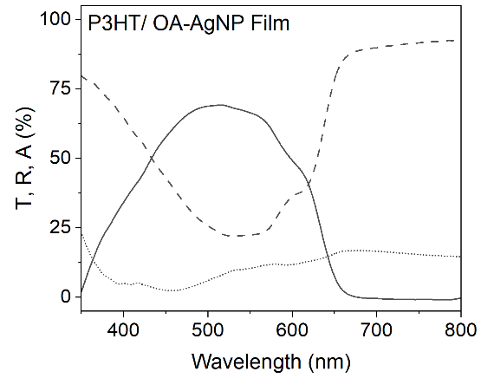
a)
b)

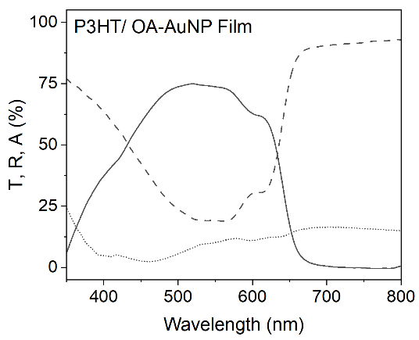
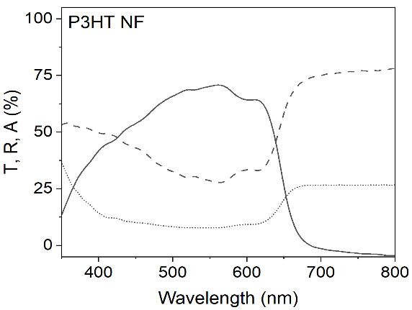
d)
c)

f)
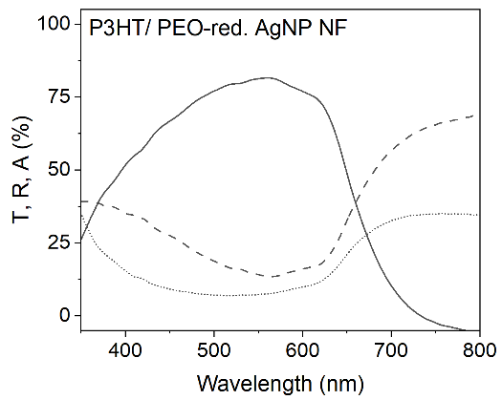
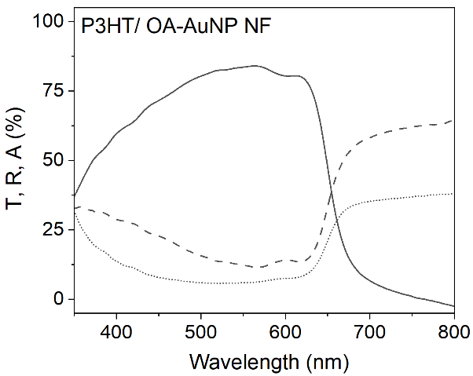
e)

g)
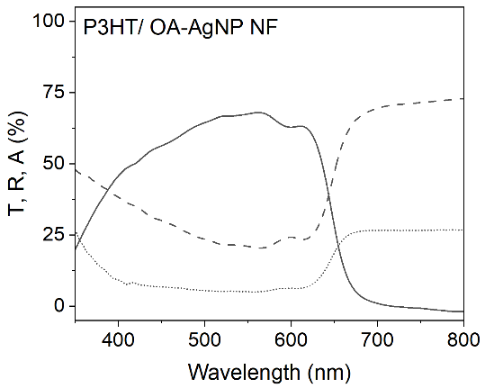

Fig. S14 Total transmittance, reflectance and absorptance spectra obtained with use of an integrating sphere for a) P3HT film, b)-c) NP-containing P3HT films, d) P3HT nanofibres and e)-g) NP-containing P3HT nanofibres. The near-zero absorptance beyond 700 nm shows successful consideration of diffuse light scattering
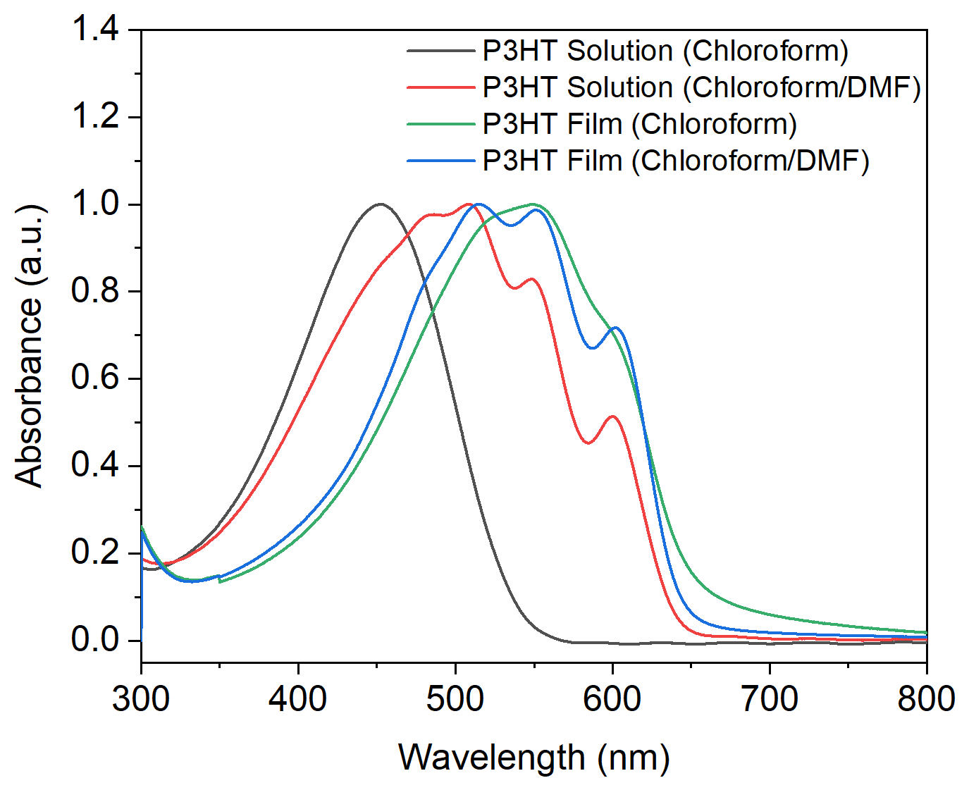

Fig. S15 Absorption spectra of spinning solution with and without the addition of DMF and thin films spin-cast from those solutions. This reveals that DMF addition causes the formation of P3HT aggregates prior to electrospinning

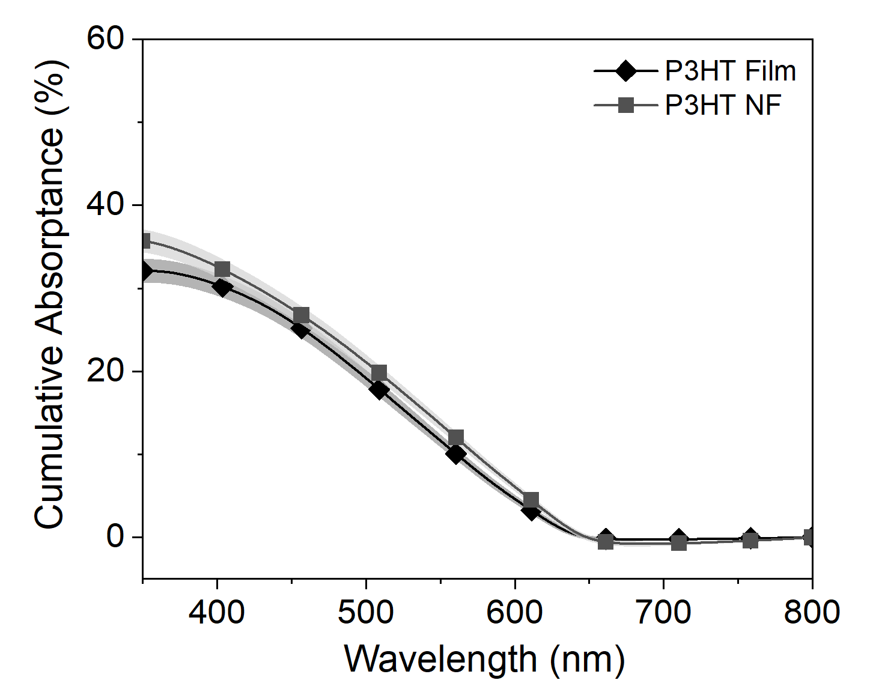
a)

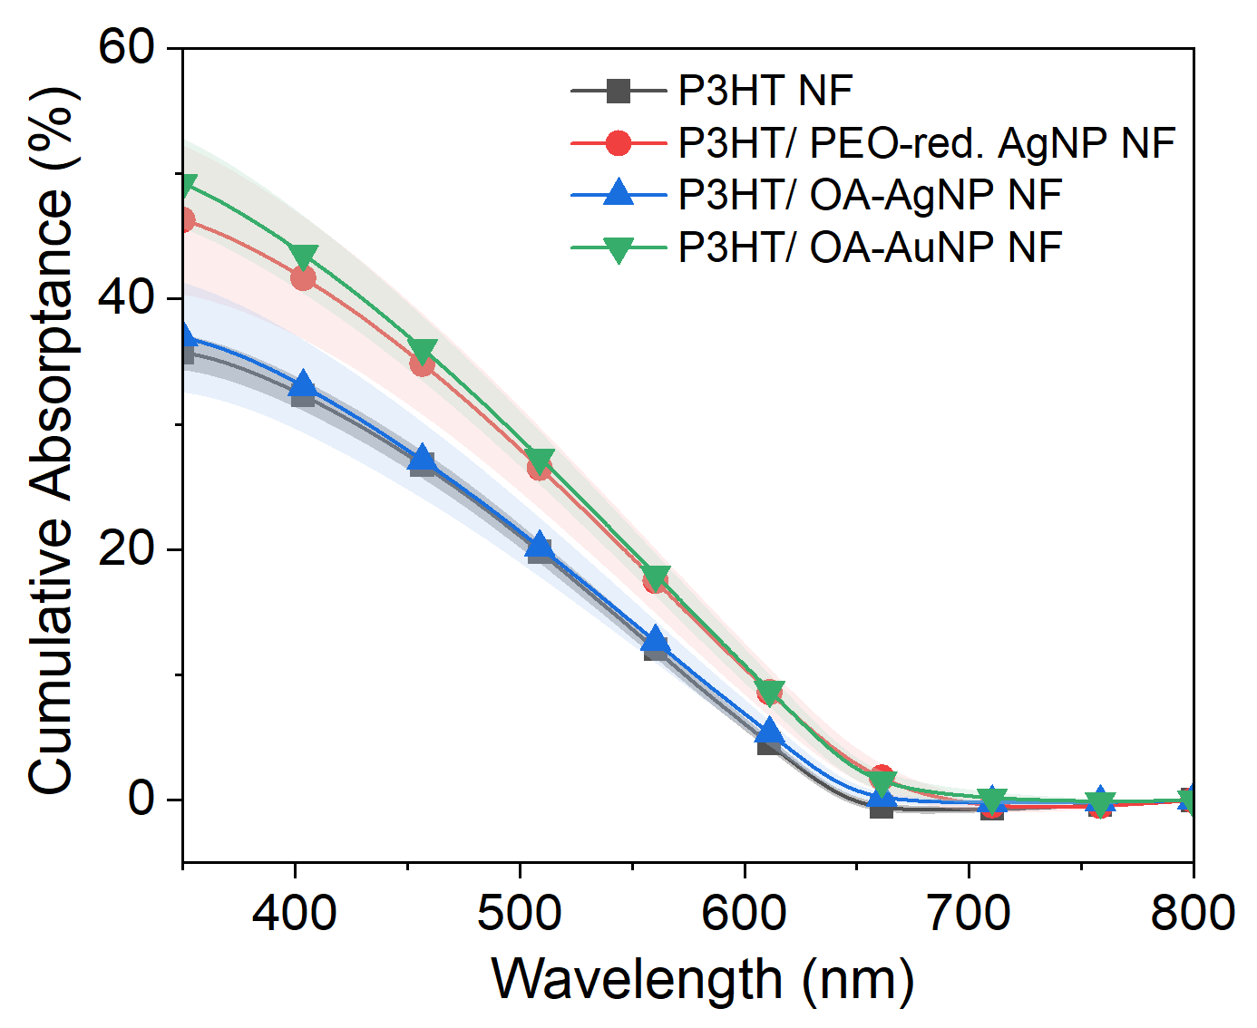
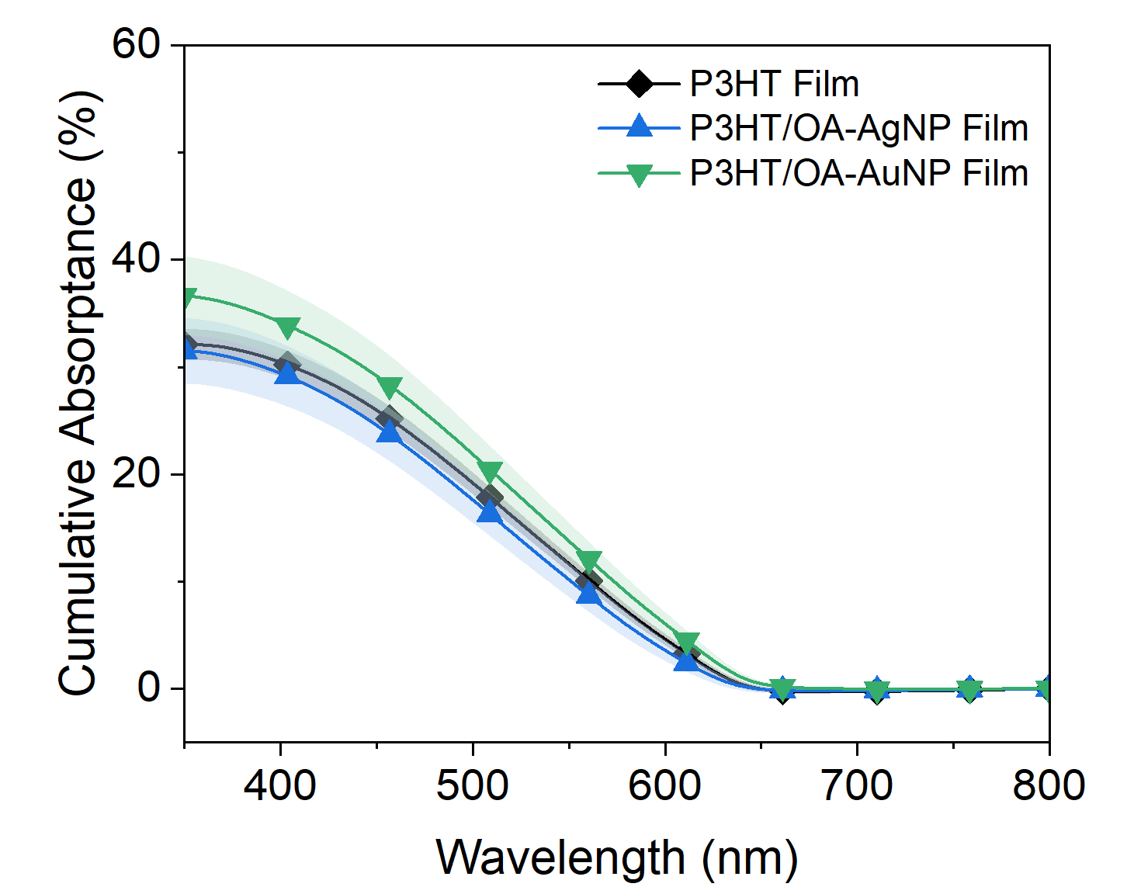
c)
b)

Fig. S16 Integrated total light harvesting of the impinging light from the absorptance spectra in Figure S14. a) The cumulative absorptance of P3HT films and nanofibres, b) P3HT and NP-containing P3HT nanofibres and c) P3HT and NP-containing P3HT spin-coated films

Table S4 Total light harvesting for film and fibre samples. determined by integrating of the absorptance trace between 305 and 800 nm as shown in Figure S16, and the absorption enhancement versus to their undoped counterparts

Sample | Integrated Absoprtance (350-800nm) (%) | Enhancement over P3HT thin-film | Enhancement over P3HT Nanofibre
P3HT Thin-film | 31.2 | - | 0.87
P3HT Nanofibre | 35.7 | 1.14 | -
P3HT/PEO-reduced AgNP Nanofibre | 46.3 | 1.48 | 1.30
P3HT/OA-capped AgNP Nanofibre | 37.0 | 1.19 | 1.04
P3HT/OA-capped AuNP Nanofibre | 49.2 | 1.58 | 1.38
P3HT/OA-capped AgNP  Thin-film | 31.5 | 1.01 | 0.88
P3HT/OA-capped AuNP  Thin-film | 36.6 | 1.17 | 1.03

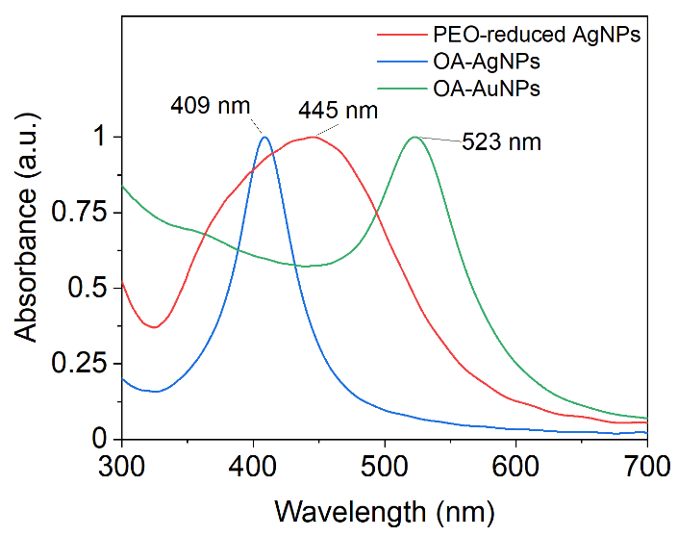
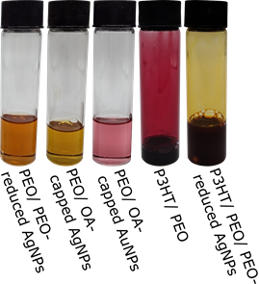
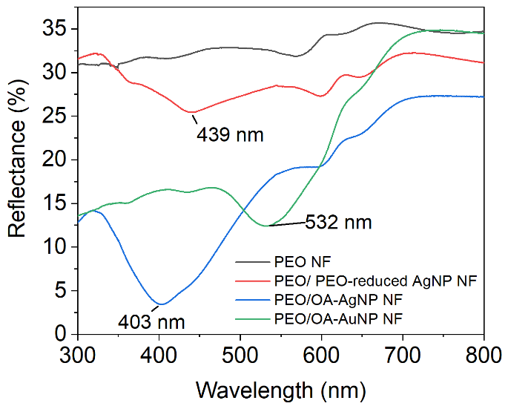
a)
b)
c)

Fig. S17 a) Digital photography of NP-containing PEO spinning solutions. b) UV-Vis absorption spectra of NPs dispersed in chloroform, measured in linear transmission mode, and c) absorption spectra of nanoparticle-containing PEO nanofibres measured by diffuse reflectance demonstrating plasmonic absorptions for each nanoparticle type

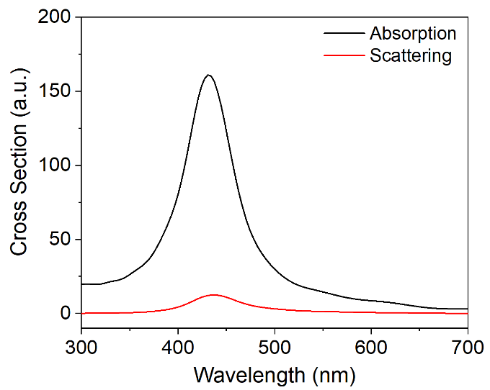
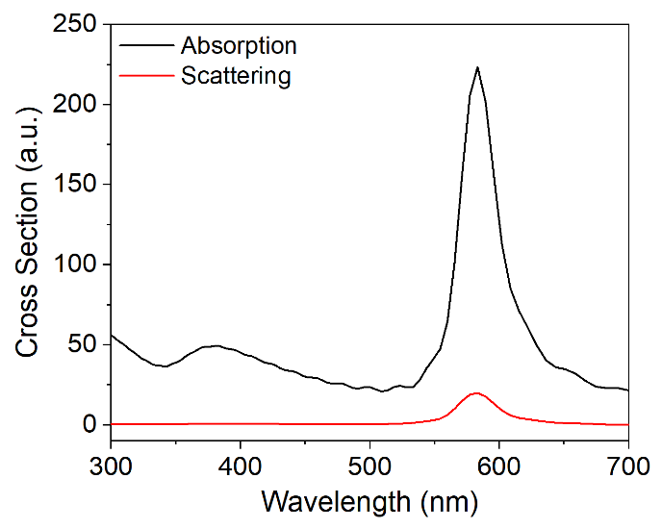
Fig. S18 Scattering and absorption spectra of OA-capped a) Ag and b) Au NPs dispersed within a P3HT refractive environment (1.95) as simulated by FDTD

20 nm
a)
100 nm
b)

100 nm
d)
20 nm
c)

Fig. S19 TEM micrographs at a) high and b) low magnification of 9.1 ± 2.7 nm OA-capped AgNPs, and c) high and d) low magnification of 10.4 ± 2.5 nm OA-capped AuNPs

