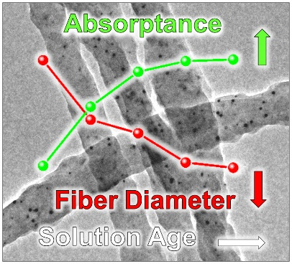
Table of Contents

A dramatic reduction in the diameters of electrospun photoactive nanofibers is achieved by introducing nanoparticles, offering shorter exciton pathways towards the heterojunction in nanofibrous OPVs. Diameter reductions deliver improved alignment of the polymer chains along the fiber, manifesting in greater photon absorption. Alongside plasmonic effects, the dual-mode enhancement within the fibers offers 58% additional light harvesting versus their thin-film counterparts.
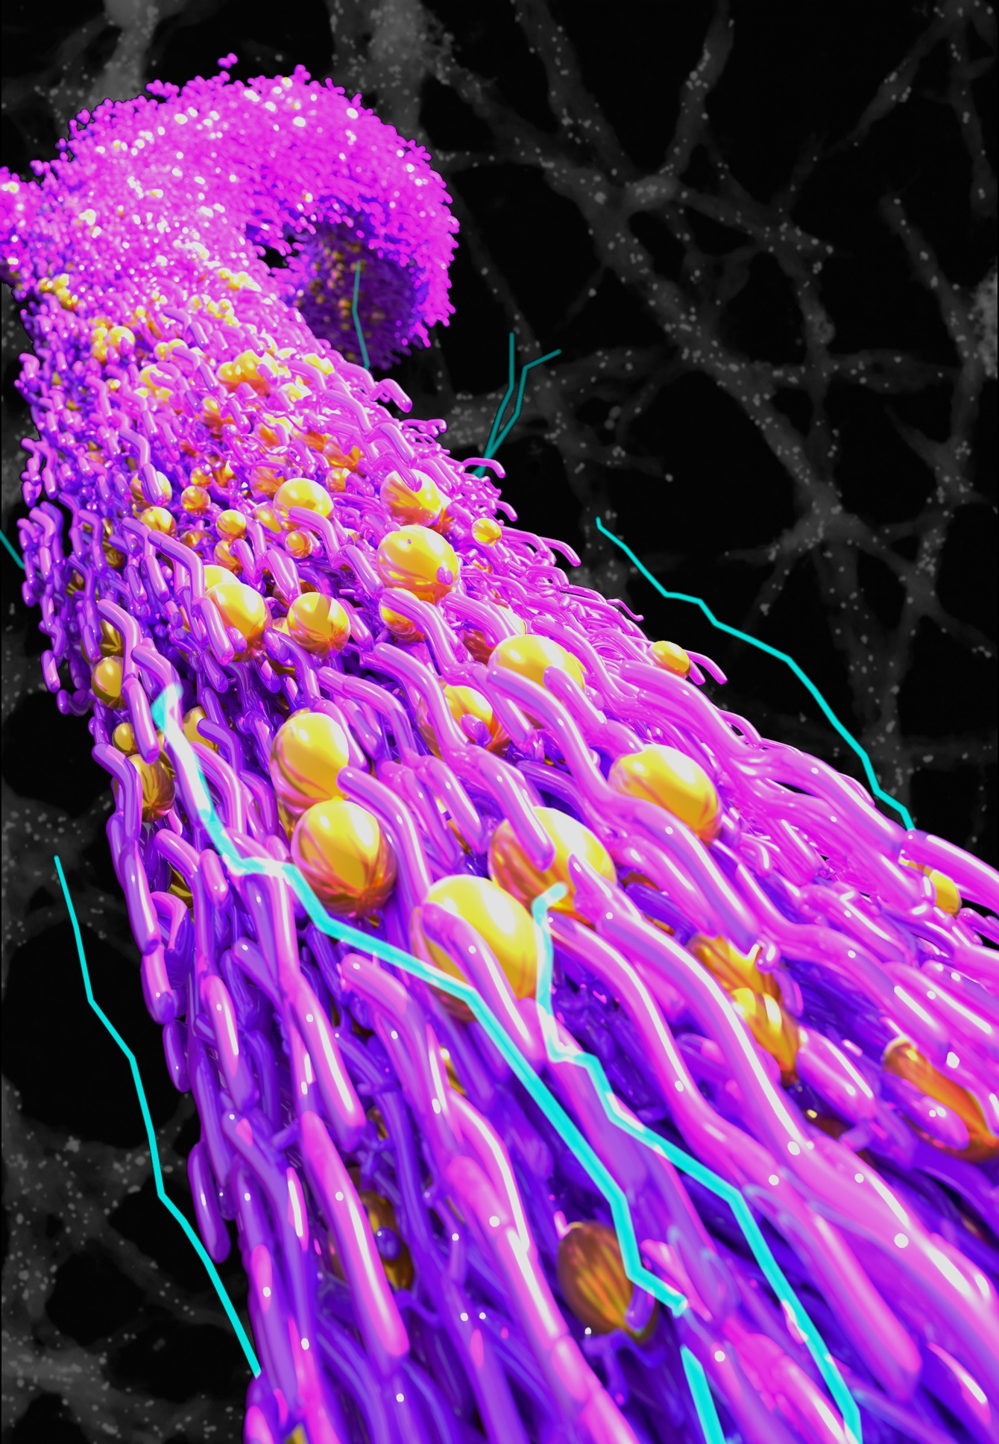
Cover Suggestion

