Supplementary information
Péter Ábrányi-Balogh^{1,2,3§}, Dávid Bajusz^{1,2§}, Zoltán Orgován^{1,2§}, Aaron B. Keeley¹, László Petri^{1,2}, Nikolett Péczka^{1,2,3}, Tibor Viktor Szalai^{1,2,4}, Gyula Pálfy⁵, Márton Gadanecz^{2,5}, Emma K. Grant⁶, Tímea Imre^{2,7}, Tamás Takács^{2,8,9}, Ivan Ranđelović^{10,11}, Marcell Baranyi^{11,12}, András Marton^{13,14}, Gitta Schlosser¹⁵, Qirat F. Ashraf¹⁶, Elvin de Araujo¹⁷, Tamás Karancsi^{13,14}, László Buday,^{2,8} József Tóvári¹⁰, András Perczel^{2,5}, Jacob Bush⁶, György M. Keserű*^{1,2,3}
See full list of affiliations in the article.
§These authors contributed equally to this work.
*Corresponding author: György M. Keserű, email: keseru.gyorgy@ttk.hu

Table of contents
1. Compound characterization 2
2. Supplementary Figure 1. MS spectrum of the photocatalyst-labeled STAT5B N-terminal domain. 19
3. Intact MS protocols and results 20
3.1 Screening against BRD4-BD1 and KRas^{G12D} 20
3.2 Screening against STAT5B-NTD 21
3.3 Intact MS spectra of hit fragments vs. BRD4-BD1 22
3.4 Intact MS spectra of hit fragments vs. KRas^{G12D} 22
3.5 Intact MS spectra of hit fragments vs. STAT5B-NTD 24
4. Binding site identification by LC-MS/MS peptide mapping 25
4.1 Sample preparation and data acquisition for BRD4-BD1 25
4.2 Sample preparation and data acquisition for STAT5B-NTD 26
4.3 MS spectra of digested BRD4-BD1 after labeling by hit fragments 27
4.4 MS spectra of digested KRas^{G12D} after labeling by hit fragments 29
4.5 MS spectra of digested STAT5B-NTD after labeling by hit fragments 31
5. HSQC NMR spectra of fragment hits against KRas^{G12D} 33
6. Supplementary references 34

Compound characterization
The PhP library was synthesized following the general procedures available in the Methods section, based on our previous work.¹ Compounds PhP006, PhP015, PhP051, PhP056, PhP057 and PhP099 were provided, courtesy of GSK.
Structures of the compounds are provided as SMILES strings and figures in the Supplementary Data file, as the “core fragment” (fragment without the amine handle, included in pharmacophore screening during library selection), “amine” (fragment with the amine handle), and “PhP” (fragment with the diazirine-type photoaffinity tag attached to the amine handle).
PhP001: Ethyl-6-benzyl-2-(3-(3-methyl-3H-diazirin-3-yl)propanamido)-4,5,6,7-tetrahydrothieno[2,3-c]pyridine-3-carboxylate (0.014 mmol, 6 mg, 9%) as an off-white solid. ¹H NMR (700 MHz, DMSO-d₆) δ ppm 0.88 - 1.03 (s, 3 H), 1.31 (br t, J = 6.99 Hz, 2 H), 1.69 (br t, J = 7.42 Hz, 2 H), 2.46 (br t, J = 7.42 Hz, 2 H), 2.68 (br t, J = 5.51 Hz, 2 H), 2.73 - 2.81 (m, 3 H), 3.49 (br s, 2 H), 3.64 - 3.67 (s, 2 H), 4.26 - 4.31 (m, 2 H), 7.25 - 7.30 (m, 1 H), 7.34 (br d, J = 4.24 Hz, 4 H), 8.47 - 8.50 (br s, 1 H); LC-MS: t_{R} = 0.77 min, 100% by UV, HRMS m/z: [M + H]⁺ calcd for C₂₂H₂₇N₄O₃S, 427.1803; found, 427.1811.
PhP002: N-(1-(3,4-dihydroxyphenyl)propan-2-yl)-3-(3-methyl-3H-diazirin-3-yl)propanamide (0.141 mmol, 39 mg, 94%) as an off-white solid. ¹H NMR (600 MHz, DMSO-d₆) δ ppm 0.89 - 1.03 (m, 6 H), 1.52 (br t, J = 7.70 Hz, 2 H), 1.88 - 1.96 (m, 2 H), 2.33 - 2.38 (m, 1 H), 2.55 - 2.60 (m, 1 H), 3.79 - 3.88 (m, 1 H), 6.39 - 6.43 (m, 1 H), 6.54 - 6.57 (s, 1 H), 6.59 - 6.63 (m, 1 H), 7.71 - 7.76 (m, 1 H), 8.60 - 8.63 (br s, 1 H), 8.69 - 8.72 (br s, 1 H); LC-MS: t_{R} = 0.73 min, 97% by UV, HRMS m/z: [M + H]⁺ calcd for C₁₄H₂₀N₃O₃, 278.1504; found, 278.1505.
PhP003: N-(2-(1-methyl-1H-imidazol-2-yl)ethyl)-3-(3-methyl-3H-diazirin-3-yl)propanamide (0.049 mmol, 11.5 mg, 33%) as an yellow solid. ¹H NMR (700 MHz, DMSO-d₆) δ ppm 0.94 (s, 3 H), 1.51 (dd, J = 8.48, 7.21 Hz, 2 H), 1.89 - 1.97 (m, 2 H), 3.05 (t, J = 6.47 Hz, 2 H), 3.41 (q, J = 6.46 Hz, 2 H), 3.75 (s, 3 H), 7.47 - 7.49 (m, 1 H), 7.50 - 7.53 (m, 1 H), 8.07 - 8.12 (m, 1 H); LC-MS: t_{R} = 1.45 min, 90% by NMR, HRMS m/z: [M + H]⁺ calcd for C₁₁H₁₈N₅O, 236.1511; found, 236.1512.
PhP004: N-((2,3-dimethyl-1H-indol-5-yl)methyl)-3-(3-methyl-3H-diazirin-3-yl)propanamide (0.134 mmol, 38.3 mg, 89%) as an off-white solid. ¹H NMR (700 MHz, DMSO-d₆) δ ppm 0.89 - 1.00 (s, 3 H), 1.49 - 1.64 (m, 2 H), 1.92 - 2.08 (m, 2 H), 2.12 (br s, 3 H), 2.20 - 2.34 (s, 3 H), 4.30 (br d, J = 5.51 Hz, 2 H), 6.89 (br d, J = 8.05 Hz, 1 H), 7.12 - 7.17 (m, 1 H), 7.22 - 7.26 (s, 1 H), 8.19 - 8.30 (m, 1 H); LC-MS: t_{R} = 1.01 min, 100% by UV, HRMS m/z: [M + H]⁺ calcd for C₁₆H₂₁N₄O, 285.1715; found, 285.1718.
PhP005: ethyl (R)-2-(3-(3-methyl-3H-diazirin-3-yl)propanamido)-2-phenylacetate (0.135 mmol, 39 mg, 90%) as an off-white solid. ¹H NMR (700 MHz, DMSO-d₆) δ ppm 0.96 - 0.99 (m, 3 H), 1.10 - 1.14 (m, 3 H), 1.54 - 1.58 (m, 2 H), 2.09 - 2.14 (m, 2 H), 4.03 - 4.14 (m, 2 H), 5.35 - 5.39 (m, 1 H), 7.33 - 7.44 (m, 5 H), 8.70 - 8.74 (m, 1 H); LC-MS: t_{R} = 1.03 min, 97% by UV, HRMS m/z: [M + H]⁺ calcd for C₁₅H₂₀NO₃, 262.1443; found, 262.1440.
PhP007: N-(4-methyl-3-oxo-3,4-dihydro-2H-benzo[b][1,4]oxazin-6-yl)-3-(3-methyl-3H-diazirin-3-yl)propanamide (0.127 mmol, 36.7 mg, 85%) as an off-white solid. ¹H NMR (600 MHz, DMSO-d₆) δ ppm 1.03 (s, 3 H), 1.66 - 1.72 (m, 2 H), 2.17 - 2.22 (m, 2 H), 3.21 - 3.26 (s, 3 H), 4.58 - 4.62 (s, 2 H), 6.91 - 6.96 (m, 1 H), 7.11 - 7.18 (m, 1 H), 7.44 - 7.49 (s, 1 H), 9.93 - 9.98 (s, 1 H); LC-MS: t_{R} = 0.84 min, 100% by UV, HRMS m/z: [M + H]⁺ calcd for C₁₄H₁₇N₄O₃, 289.13; found, 289.1305.
PhP008: N-(isoquinolin-4-ylmethyl)-3-(3-methyl-3H-diazirin-3-yl) propanamide (0.150 mmol, 40.2 mg, 100%) as a yellow solid. ¹H NMR (600 MHz, DMSO-d₆) δ ppm 0.94 - 0.99 (s, 3 H), 1.61 (br t, J = 7.64 Hz, 2 H), 2.04 (br t, J = 7.64 Hz, 2 H), 4.69 - 4.74 (m, 2 H), 7.71 - 7.76 (m, 1 H), 7.85 (m, 1 H), 8.03 - 8.15 (m, 1 H), 8.18 (br d, J = 8.07 Hz, 1 H), 8.41 - 8.49 (s, 1 H), 9.25 - 9.30 (s, 1 H); LC-MS: t_{R} = 0.46 min, 86% by UV, HRMS m/z: [M + H]⁺ calcd for C₁₅H₁₆N₄O, 268.1324; found, 268.1321.
PhP009: N-(4-(4-(hydroxymethyl)piperidin-1-yl)benzyl)-3-(3-methyl-3H-diazirin-3-yl)propanamide (0.015 mmol, 4.9 mg, 10%) as an off-white solid. ¹H NMR (700 MHz, DMSO-d₆) δ ppm 0.97 (s, 3 H), 1.16 - 1.24 (m, 4 H), 1.47 - 1.52 (m, 1 H), 1.56 - 1.60 (m, 2 H), 1.98 - 2.02 (m, 2 H), 2.53 - 2.62 (m, 4 H), 3.25 - 3.29 (m, 2 H), 4.11 - 4.15 (m, 2 H), 6.85 (d, J = 8.90 Hz, 2 H), 7.07 (d, J = 8.90 Hz, 2 H), 8.22 - 8.27 (m, 1 H), 8.40 - 8.43 (m, 1 H); LC-MS: t_{R} = 0.42 min, 84.7% by UV, HRMS m/z: [M + H]⁺ calcd for C₁₈H₂₇N₄O₂, 331.2134; found, 331.2134.
PhP010: N-((5-methyl-1H-imidazol-4-yl)methyl)-3-(3-methyl-3H-diazirin-3-yl)propanamide (0.131 mmol, 29 mg, 87%) as an off-white solid. ¹H NMR (700 MHz, DMSO-d₆) δ ppm 0.92 - 1.02 (s, 3 H), 1.52 - 1.61 (m, 2 H), 1.91 - 2.02 (m, 2 H), 2.14 (s, 3 H), 4.09 - 4.16 (m, 2 H), 7.66 - 7.71 (m, 1 H), 8.05 - 8.11 (s, 1 H); LC-MS: t_{R} = 1.19 min, 85% by UV, HRMS m/z: [M + H]⁺ calcd for C₁₀H₁₆N₅O, 222.1354; found, 222.1353.
PhP011: 4-(2-(3-(3-methyl-3H-diazirin-3-yl)propanamido)thiazol-4-yl)-1H-pyrrole-2-carboxamide (0.137 mmol, 43.7 mg, 91%) as an off-white solid. ¹H NMR (600 MHz, DMSO-d₆) δ ppm 1.04 - 1.07 (s, 3 H), 1.58 - 1.67 (m, 2 H), 2.25 (td, J = 7.79, 2.75 Hz, 2 H), 7.91 - 7.98 (m, 1 H), 10.53 - 10.61 (s, 1 H), 11.59 - 11.67 (s, 1 H); LC-MS: t_{R} = 0.79 min, 86% by NMR, HRMS m/z: [M + H]⁺ calcd for C₁₃H₁₅N₆O₂S, 319.0977; found, 319.0980.
PhP012: N-(1-(4-fluorophenyl)piperidin-4-yl)-3-(3-methyl-3H-diazirin-3-yl)propanamide (0.027 mmol, 8.3 mg, 18%) as an yellow solid. ¹H NMR (700 MHz, DMSO-d₆) δ ppm 0.96 - 0.98 (s, 3 H), 1.43 - 1.51 (m, 2 H), 1.54 - 1.58 (m, 2 H), 1.78 - 1.83 (m, 2 H), 1.94 - 1.98 (m, 2 H), 2.69 - 2.75 (m, 2 H), 3.48 - 3.53 (m, 2 H), 3.66 - 3.70 (m, 1 H), 6.92 - 6.95 (m, 2 H), 6.99 - 7.03 (m, 2 H), 7.87 - 7.92 (m, 1 H); LC-MS: t_{R} = 0.7 min, 90% by UV, HRMS m/z: [M + H]⁺ calcd for C₁₆H₂₂N₄OF, 305.1777; found, 305.1783.
PhP013: N-(1-(3-(benzyloxy)phenyl)propan-2-yl)-3-(3-methyl-3H-diazirin-3-yl)propanamide (0.049 mmol, 17.2 mg, 33%) as an off-white solid. ¹H NMR (700 MHz, DMSO-d₆) δ ppm 0.92 (s, 3 H), 0.99 (d, J = 6.78 Hz, 3 H), 1.47 - 1.51 (m, 2 H), 1.88 - 1.93 (m, 2 H), 2.54 - 2.59 (m, 1 H), 2.65 - 2.71 (m, 1 H), 3.90 - 3.98 (m, 1 H), 5.05 (s, 2 H), 6.75 - 6.78 (m, 1 H), 6.80 - 6.84 (m, 2 H), 7.17 (s, 1 H), 7.30 - 7.34 (m, 1 H), 7.38 (s, 2 H), 7.41 - 7.44 (m, 2 H), 7.81 - 7.85 (m, 1 H); LC-MS: t_{R} = 1.25 min, 87% by UV, HRMS m/z: [M + H]⁺ calcd for C₂₁H₂₆N₃O₂, 352.2025; found, 352.2026.
PhP014: (3-(3-methyl-3H-diazirin-3-yl)propanoyl)tryptophanate (0.037 mmol, 12 mg, 25%) as an off-white solid. ¹H NMR (700 MHz, DMSO-d₆) δ ppm 0.92 (s, 3 H), 1.42 - 1.53 (m, 4 H), 1.98 - 2.03 (m, 2 H), 3.57 (s, 3 H), 4.48 - 4.53 (m, 1 H), 6.97 - 7.01 (m, 1 H), 7.05 - 7.09 (m, 1 H), 7.14 (d, J = 2.12 Hz, 1 H), 7.33 (s, 1 H), 7.46 - 7.49 (m, 1 H), 8.32 - 8.37 (m, 1 H), 10.80 - 10.84 (m, 1 H); LC-MS: t_{R} = 0.98 min, 100% by UV, HRMS m/z: [M + H]⁺ calcd for C₁₇H₂₁N₄O₃, 329.1613; found, 329.1611
PhP016: N-(2-(tert-butyl)-5,6,7,8-tetrahydroimidazo[1,2-a]pyridin-6-yl)-3-(3-methyl-3H-diazirin-3-yl)propanamide (0.069 mmol, 20.9 mg, 46%) as an off-white solid. ¹H NMR (700 MHz, DMSO-d₆) δ ppm 0.98 (s, 3 H), 1.17 (s, 9 H), 1.54 - 1.62 (m, 2 H), 1.85 (td, J = 13.78, 8.05 Hz, 2 H), 2.01 (m, 2 H), 3.65 (br dd, J = 12.29, 6.78 Hz, 2 H), 4.05 (br dd, J = 12.50, 4.87 Hz, 2 H), 4.16 (br s, 1 H), 6.64 (s, 1 H); LC-MS: t_{R} = 0.49 min, 99% by UV, HRMS m/z: [M + H]⁺ calcd for C₁₆H₂₆N₅O, 304.2137; found, 304.2144.
PhP017: N-(2-methyl-1-phenyl-1H-benzo[d]imidazol-5-yl)-3-(3-methyl-3H-diazirin-3-yl)propanamide (0.146 mmol, 48.7 mg, 97%) as an yellow solid. ¹H NMR (600 MHz, DMSO-d₆) δ ppm 1.04 (s, 3 H), 1.23 - 1.29 (m, 1 H), 1.71 (br t, J = 7.52 Hz, 2 H), 2.20 - 2.25 (m, 2 H), 2.42 (s, 3 H), 7.04 - 7.07 (m, 1 H), 7.30 - 7.33 (m, 1 H), 7.52 - 7.55 (m, 2 H), 7.55 - 7.58 (m, 1 H), 7.62 - 7.67 (m, 2 H), 7.95 - 7.98 (m, 1 H), 9.91 - 9.94 (br s, 1 H); LC-MS: t_{R} = 0.65 min, 96% by UV, HRMS m/z: [M + H]⁺ calcd for C₁₉H₂₀N₅O, 334.1667; found, 334.1671.
PhP018: N-(1-((4-methoxyphenyl)sulfonyl)piperidin-4-yl)-3-(3-methyl-3H-diazirin-3-yl)propanamide (0.025 mmol, 9.7 mg, 17%) as an off-white solid. ¹H NMR (700 MHz, DMSO-d₆) δ ppm 0.94 (s, 3 H), 1.36 - 1.44 (m, 1 H), 1.52 (t, J = 7.42 Hz, 2 H), 1.74 - 1.81 (m, 4 H), 1.91 (t, J = 7.63 Hz, 2 H), 2.38 - 2.45 (m, 4 H), 3.84 (s, 3 H), 7.15 (d, J = 8.90 Hz, 2 H), 7.66 (d, J = 8.90 Hz, 2 H), 7.84 - 7.88 (m, 1 H); LC-MS: t_{R} = 0.97 min, 90% by UV, HRMS m/z: [M + H]⁺ calcd for C₁₇H₂₅N₄O₄S, 381.1596; found, 381.1598.
PhP019: methyl 2-(3-(3-methyl-3H-diazirin-3-yl)propanamido)-2-(p-tolyl)acetate (0.135 mmol, 39 mg, 90%) as an off-white solid. ¹H NMR (700 MHz, DMSO-d₆) δ ppm 0.90 - 0.98 (s, 3 H), 1.55 (d, J = 7.58 Hz, 2 H), 2.06 - 2.15 (m, 2 H), 2.27 - 2.30 (s, 3 H), 3.59 - 3.61 (s, 3 H), 5.32 - 5.35 (m, 1 H), 7.19 (br d, J = 8.05 Hz, 2 H), 7.22 - 7.30 (m, 2 H), 8.67 - 8.71 (m, 1 H); LC-MS: t_{R} = 1.04 min, 87% by UV, HRMS m/z: [M + H]⁺ calcd for C₁₅H₂₀N₃O₃, 290.1504; found, 290.1503.
PhP020: N-(2-(1-methyl-1H-benzo[d]imidazol-2-yl)ethyl)-3-(3-methyl-3H-diazirin-3-yl)propanamide (0.145 mmol, 41.5 mg, 97%) as an off-white solid. ¹H NMR (700 MHz, DMSO-d₆) δ ppm 0.91 - 0.96 (m, 3 H), 1.49 - 1.56 (m, 2 H), 1.91 - 1.98 (m, 2 H), 3.06 (t, J = 7.21 Hz, 2 H), 3.57 - 3.71 (m, 2 H), 3.73 - 3.82 (s, 3 H), 7.22 - 7.30 (m, 2 H), 7.54 - 7.62 (m, 2 H), 8.05 - 8.12 (br s, 1 H); LC-MS: t_{R} = 0.44 min, 100% by UV, HRMS m/z: [M + H]⁺ calcd for C₁₅H₂₀N₅O, 286.1667; found, 286.1674.
PhP021: N-((1,3-dimethyl-1H-pyrazol-4-yl)methyl)-3-(3-methyl-3H-diazirin-3-yl)propanamide (0.074 mmol, 17.5 mg, 49%) as an yellow solid. ¹H NMR (700 MHz, DMSO-d₆) δ ppm 0.91 - 0.98 (s, 3 H), 1.56 (t, J = 7.84 Hz, 2 H), 1.96 (t, J = 7.84 Hz, 2 H), 2.07 (s, 3 H), 3.68 (s, 3 H), 4.01 (d, J = 5.51 Hz, 2 H), 7.42 (s, 1 H), 8.02 (br s, 1 H); LC-MS: t_{R} = 0.61 min, 96% by NMR, HRMS m/z: [M + H]⁺ calcd for C₁₁H₁₈N₅O, 236.1511; found, 236.1513.
PhP022: 3-(3-methyl-3H-diazirin-3-yl)-N-(4-morpholinobutyl)propanamide (0.077 mmol, 21 mg, 51%) as an off-white solid. ¹H NMR (700 MHz, DMSO-d₆) δ ppm 0.94 - 1.03 (m, 3 H), 1.36 - 1.43 (m, 2 H), 1.53 - 1.59 (m, 2 H), 1.91 - 1.97 (m, 2 H), 2.22 - 2.34 (m, 6 H), 2.51 (s, 2 H), 3.01 - 3.05 (m, 2 H), 3.54 - 3.57 (m, 4 H); LC-MS: t_{R} = 0.41 min, 85.8% by NMR, HRMS m/z: [M + H]⁺ calcd for C₁₃H₂₅N₄O₂, 269.1977; found, 269.1980.
PhP023: N-((7-methyl-1H-benzo[d]imidazol-2-yl)methyl)-3-(3-methyl-3H-diazirin-3-yl)propanamide (0.147 mmol, 40 mg, 98%) as an off-white solid. ¹H NMR (600 MHz, DMSO-d₆) δ ppm 1.01 (s, 3 H), 1.59 - 1.65 (m, 2 H), 2.06 - 2.14 (m, 2 H), 2.48 - 2.50 (s, 3 H), 4.46 - 4.50 (m, 2 H), 6.92 - 6.97 (m, 1 H), 7.01 - 7.07 (m, 1 H), 7.27 - 7.33 (m, 1 H), 8.14 - 8.24 (br s, 1 H), 8.48 - 8.54 (m, 1 H); LC-MS: t_{R} = 0.49 min, 98% by UV, HRMS m/z: [M + H]⁺ calcd for C₁₄H₁₈N₅O, 272.1511; found, 272.1515.
PhP024: tert-butyl 3-((3-(3-methyl-3H-diazirin-3-yl)propanamido)methyl)benzoate (0.040 mmol, 12.6 mg, 27%) as an off-white solid. ¹H NMR (700 MHz, DMSO-d₆) δ ppm 0.97 (s, 3 H), 1.53 (s, 9 H), 1.59 - 1.63 (m, 2 H), 2.04 (d, J = 8.05 Hz, 2 H), 4.30 (d, J = 5.93 Hz, 2 H), 7.42 - 7.45 (m, 1 H), 7.48 - 7.50 (m, 1 H), 7.75 - 7.78 (m, 2 H), 8.44 - 8.49 (m, 1 H); LC-MS: t_{R} = 1.15 min, 86% by UV, HRMS m/z: [M + H]⁺ calcd for C₁₇H₂₄N₃O₃, 318.1817; found, 318.1819.
PhP025: 3-(3-methyl-3H-diazirin-3-yl)-N-(3-oxo-2,5,6,7,8,9-hexahydro-3H-[1,2,4]triazolo[4,3-a]azepin-7-yl)propanamide (0.070 mmol, 19.4 mg, 47%) as an off-white solid. ¹H NMR (700 MHz, DMSO-d₆) δ ppm 0.96 - 1.00 (s, 3 H), 1.38 (br d, J = 11.87 Hz, 2 H), 1.53 - 1.63 (m, 2 H), 1.97 (m, 2 H), 2.70 (br dd, J = 15.05, 7.42 Hz, 1 H), 3.10 - 3.15 (m, 2 H), 3.73 - 3.89 (m, 2 H), 3.92 (br d, J = 9.75 Hz, 2 H), 7.97 - 8.04 (m, 1 H), 8.19 - 8.33 (br s, 1 H); LC-MS: t_{R} = 0.53 min, 87% by NMR, HRMS m/z: [M + H]⁺ calcd for C₁₂H₁₉N₆O₂, 279.1569; found, 279.1569.
PhP026: 3-(3-methyl-3H-diazirin-3-yl)-N-(pyridin-2-yl(p-tolyl)methyl)propanamide (0.040 mmol, 12.2 mg, 27%) as an off-white solid. ¹H NMR (700 MHz, DMSO-d₆) δ ppm 0.95 (s, 3 H), 1.55 - 1.59 (m, 2 H), 2.12 - 2.17 (m, 2 H), 2.23 (s, 3 H), 6.06 - 6.09 (m, 1 H), 7.09 (d, J = 8.05 Hz, 2 H), 7.17 (d, J = 8.05 Hz, 2 H), 7.23 - 7.27 (m, 1 H), 7.42 (m, 1 H), 7.75 (d, J = 2.12 Hz, 1 H), 8.47 - 8.50 (m, 1 H), 8.76 - 8.80 (m, 1 H); LC-MS: t_{R} = 0.94 min, 100% by UV, HRMS m/z: [M + H]⁺ calcd for C₁₈H₂₁N₄O, 309.1715; found, 309.1724.
PhP027: 4-chloro-N-(2-(3-(3-methyl-3H-diazirin-3-yl)propanamido)ethyl)benzamide (0.142 mmol, 43.7 mg, 95%) as an off-white solid. ¹H NMR (700 MHz, DMSO-d₆) δ ppm 0.93 - 1.00 (s, 3 H), 1.56 (br t, J = 7.84 Hz, 2 H), 1.97 (t, J = 7.84 Hz, 2 H), 3.17 - 3.26 (m, 2 H), 3.31 (q, J = 6.36 Hz, 2 H), 7.51 - 7.56 (m, 2 H), 7.80 - 7.87 (m, 2 H), 7.96 - 8.00 (m, 1 H), 8.51 - 8.55 (m, 1 H); LC-MS: t_{R} = 0.89 min, 98% by UV, HRMS m/z: [M + H]⁺ calcd for C₁₄H₁₈N₄O₂Cl, 309.1118; found, 309.1118.
PhP028: N-(2-hydroxybenzyl)-3-(3-methyl-3H-diazirin-3-yl)propanamide (0.039 mmol, 9.2 mg, 26%) as an off-white solid. ¹H NMR (700 MHz, DMSO-d₆) δ ppm 0.97 (s, 3 H), 1.56 - 1.63 (m, 2 H), 2.03 - 2.09 (m, 2 H), 4.18 (d, J = 5.51 Hz, 2 H), 6.73 - 6.80 (m, 2 H), 7.04 - 7.11 (m, 2 H), 8.28 (br t, J = 5.51 Hz, 2 H); LC-MS: t_{R} = 0.86 min, 88% by UV, HRMS m/z: [M + H]⁺ calcd for C₁₂H₁₆N₃O₂, 234.1242; found, 234.1246
PhP029: 3-(3-methyl-3H-diazirin-3-yl)-N-(1-(3-oxo-3,4-dihydropyrazin-2-yl)piperidin-3-yl)propanamide (0.147 mmol, 45 mg, 98%) as an yellow solid. ¹H NMR (600 MHz, DMSO-d₆) δ ppm 0.96 - 1.01 (s, 3 H), 1.55 - 1.60 (m, 2 H), 1.94 - 2.00 (m, 2 H), 2.17 - 2.21 (m, 4 H), 2.32 - 2.36 (m, 4 H), 2.90 (br dd, J = 19.07, 11.00 Hz, 1 H), 7.77 - 7.84 (m, 2 H); LC-MS: t_{R} = 0.59 min, 98% by UV, HRMS m/z: [M + H]⁺ calcd for C₁₄H₂₁N₆O₂, 305.1725; found, 305.1725.
PhP030: N-((5-methyl-1H-benzo[d]imidazol-2-yl)methyl)-3-(3-methyl-3H-diazirin-3-yl)propanamide (0.151 mmol, 41 mg, 100%) as an off-white solid. ¹H NMR (700 MHz, DMSO-d₆) δ ppm 0.94 - 1.00 (s, 3 H), 1.59 - 1.66 (m, 2 H), 2.08 - 2.15 (m, 2 H), 4.45 (br d, J = 5.51 Hz, 2 H), 6.96 - 7.01 (m, 1 H), 7.23 - 7.36 (s, 1 H), 7.37 (br d, J = 8.05 Hz, 1 H) 8.50 (br t, J = 5.51 Hz, 1 H); LC-MS: t_{R} = 0.49 min, 100% by UV, HRMS m/z: [M + H]⁺ calcd for C₁₄H₁₈N₅O, 272.1511; found, 272.1517.
PhP031: N-(2-(1H-benzo[d]imidazol-2-yl)ethyl)-3-(3-methyl-3H-diazirin-3-yl)propanamide (0.148 mmol, 40.1 mg, 99%) as an off-white solid. ¹H NMR (600 MHz, DMSO-d₆) δ ppm 0.93 - 0.95 (s, 3 H), 1.22 - 1.29 (m, 2 H), 1.54 (t, J = 7.70 Hz, 2 H), 1.95 (t, J = 7.70 Hz, 2 H), 3.07 (t, J = 6.97 Hz, 2 H), 7.30 (dd, J = 6.05, 3.12 Hz, 2 H), 7.60 (dd, J = 5.87, 2.93 Hz, 2 H), 8.07 - 8.13 (m, 1 H); LC-MS: t_{R} = 0.41 min, 97% by UV, HRMS m/z: [M + H]⁺ calcd for C₁₄H₁₈N₅O, 272.1511; found, 272.1516.
PhP032: N-(1-(2-methoxyphenyl)propyl)-3-(3-methyl-3H-diazirin-3-yl)propanamide (0.106 mmol, 29.2 mg, 71%) as an off-white solid. ¹H NMR (700 MHz, DMSO-d₆) δ ppm 0.83 (t, J = 7.21 Hz, 3 H), 0.95 - 0.97 (s, 3 H), 1.48 - 1.66 (m, 4 H), 1.99 - 2.09 (m, 2 H), 3.79 (s, 3 H), 5.04 (td, J = 8.69, 5.09 Hz, 1 H), 6.90 (t, J = 7.42 Hz, 1 H), 6.95 (d, J = 8.05 Hz, 1 H), 7.17 - 7.30 (m, 2 H), 8.10 - 8.20 (m, 1 H); LC-MS: t_{R} = 1.08 min, 96% by UV, HRMS m/z: [M + H]⁺ calcd for C₁₅H₂₂N₃O₂, 276.1712; found, 276.1712.
PhP033: N-(4-(1H-imidazol-1-yl)benzyl)-3-(3-methyl-3H-diazirin-3-yl)propanamide (0.101 mmol, 29 mg, 67%) as an off-white solid. ¹H NMR (700 MHz, DMSO-d₆) δ ppm 0.94 - 1.00 (s, 3 H), 1.62 (br t, J = 7.63 Hz, 2 H), 2.06 (t, J = 7.63 Hz, 2 H), 4.30 (br d, J = 5.51 Hz, 2 H), 7.09 - 7.24 (s, 1 H), 7.39 (br d, J = 8.05 Hz, 2 H), 7.57 - 7.64 (m, 2 H), 7.69 - 7.84 (m, 1 H), 8.23 (s, 1 H), 8.39 - 8.50 (m, 1 H); LC-MS: t_{R} = 0.39 min, 99% by UV, HRMS m/z: [M + H]⁺ calcd for C₁₅H₁₈N₅O, 284.1511; found, 284.1519.
PhP034: N-(2-(4-methoxynaphthalen-1-yl)ethyl)-3-(3-methyl-3H-diazirin-3-yl)propanamide (0.060 mmol, 18.6 mg, 40%) as an off-white solid. ¹H NMR (700 MHz, DMSO-d₆) δ ppm 0.97 (s, 3 H), 1.54 - 1.58 (m, 2 H), 1.93 - 1.98 (m, 2 H), 3.06 - 3.10 (m, 2 H), 3.29 - 3.34 (m, 2 H), 3.92 - 3.94 (s, 3 H), 6.86 - 6.89 (m, 1 H), 7.25 - 7.28 (m, 1 H), 7.48 - 7.52 (m, 1 H), 7.55 - 7.59 (m, 1 H), 8.02 - 8.06 (m, 1 H), 8.07 - 8.10 (m, 1 H), 8.15 - 8.20 (m, 1 H); LC-MS: t_{R} = 1.16 min, 100% by UV, HRMS m/z: [M + H]⁺ calcd for C₁₈H₂₂NO₂, 284.165; found, 284.1651.
PhP035: 3-(3-methyl-3H-diazirin-3-yl)-N-(2-((3-nitrophenyl)sulfonamido)ethyl)propanamide (0.120 mmol, 42.5 mg, 80%) as an off-white solid. ¹H NMR (700 MHz, DMSO-d₆) δ ppm 0.95 (s, 3 H), 1.46 - 1.61 (m, 2 H), 1.86 - 1.92 (m, 2 H), 2.84 (q, J = 6.36 Hz, 2 H), 3.07 (q, J = 6.36 Hz, 2 H), 7.85 - 7.97 (m, 2 H), 8.03 (br t, J = 5.72 Hz, 1 H), 8.19 - 8.33 (m, 1 H), 8.47 - 8.60 (m, 2 H); LC-MS: t_{R} = 0.88 min, 93% by UV, HRMS m/z: [M + H]⁺ calcd for C₁₃H₁₈N₅O₅S, 356.1028; found, 356.1029
PhP036: methyl (3-(3-methyl-3H-diazirin-3-yl)propanoyl)-D-tryptophanate (0.067 mmol, 22.1 mg, 45%) as an off-white solid. ¹H NMR (700 MHz, DMSO-d₆) δ ppm 0.91 (s, 3 H), 1.42 - 1.52 (m, 2 H), 1.97 - 2.04 (m, 2 H), 2.99 - 3.06 (m, 1 H), 3.10 - 3.19 (m, 1 H), 3.57 (s, 3 H), 4.48 - 4.52 (m, 1 H), 6.99 (m, 1 H), 7.05 - 7.09 (m, 1 H), 7.13 - 7.15 (s, 1 H), 7.32 - 7.36 (m, 1 H), 7.46 - 7.49 (m, 1 H), 8.33 - 8.36 (m, 1 H); LC-MS: t_{R} = 0.98 min, 85% by UV, HRMS m/z: [M + H]⁺ calcd for C₁₇H₂₁N₄O₃, 329.1613; found, 329.1616
PhP037: 3-(3-methyl-3H-diazirin-3-yl)-N-((5-(m-tolyl)-1H-imidazol-2-yl)methyl)propanamide (0.118 mmol, 35.2 mg, 79%) as an off-white solid. ¹H NMR (700 MHz, DMSO-d₆) δ ppm 0.94 - 1.04 (s, 3 H), 1.52 - 1.65 (m, 2 H), 2.00 - 2.10 (m, 2 H), 2.31 (s, 3 H), 4.32 (d, J = 5.51 Hz, 2 H), 7.02 (br d, J = 7.40 Hz, 1 H), 7.23 (br t, J = 7.40 Hz, 1 H), 7.47 (m, 2 H), 7.55 (br s, 1 H), 8.38 (br t, J = 5.51 Hz, 1 H); LC-MS: t_{R} = 0.58 min, 97% by UV, HRMS m/z: [M + H]⁺ calcd for C₁₆H₂₀N₅O, 298.1667; found, 298.1675.
PhP038: N-(1-(2,5-dimethoxyphenyl)-1-hydroxypropan-2-yl)-3-(3-methyl-3H-diazirin-3-yl)propanamide (0.135 mmol, 43.4 mg, 90%) as an off-white solid. ¹H NMR (600 MHz, DMSO-d₆) δ ppm 0.84 (d, J = 6.60 Hz, 3 H), 0.91 - 0.98 (s, 3 H), 1.45 - 1.53 (m, 2 H), 1.97 (br dd, J = 16.87, 8.07 Hz, 2 H), 3.67 - 3.69 (s, 3 H), 3.70 - 3.73 (s, 3 H), 4.82 (br t, J = 4.40 Hz, 1 H), 5.19 - 5.36 (m, 1 H), 6.74 - 6.78 (m, 1 H), 6.86 (br d, J = 8.80 Hz, 1 H), 6.94 - 6.99 (s, 1 H), 7.61 (br d, J = 8.44 Hz, 1 H); LC-MS: t_{R} = 0.86 min, 93% by UV, HRMS m/z: [M + H]⁺ calcd for C₁₆H₂₄N₃O₄, 322.1766; found, 322.1762.
PhP039: N-((6-methoxypyridin-3-yl)methyl)-3-(3-methyl-3H-diazirin-3-yl)propanamide (0.024 mmol, 6 mg, 16%) as an off-white solid. ¹H NMR (700 MHz, DMSO-d₆) δ ppm 0.96 (s, 3 H), 1.56 - 1.62 (m, 2 H), 1.98 - 2.03 (m, 2 H), 3.84 (s, 3 H), 4.18 - 4.21 (m, 2 H), 6.84 - 6.86 (m, 1 H), 7.65 - 7.67 (m, 1 H), 8.05 - 8.07 (s, 1 H), 8.35 - 8.39 (t, 1 H); LC-MS: t_{R} = 0.72 min, 87% by UV, HRMS m/z: [M + H]⁺ calcd for C₁₂H₁₇N₄O₂, 249.1351; found, 249.1354.
PhP040: N-((1H-indol-2-yl)methyl)-3-(3-methyl-3H-diazirin-3-yl)propanamide (0.126 mmol, 32.3 mg, 84%) as an off-white solid. ¹H NMR (700 MHz, DMSO-d₆) δ ppm 0.93 - 1.01 (s, 3 H), 1.53 - 1.64 (m, 2 H), 2.07 (t, J = 7.84 Hz, 2 H), 4.40 (br d, J = 5.51 Hz, 2 H), 6.24 - 6.27 (s, 1 H), 6.94 (m, 1 H), 7.03 (br t, J = 7.42 Hz, 1 H), 7.32 (br dd, J = 8.05, 0.85 Hz, 1 H), 7.37 - 7.49 (m, 1 H), 8.32 - 8.39 (br s, 1 H), 10.84 (br s, 1 H); LC-MS: t_{R} = 0.98 min, 88% by UV, HRMS m/z: [M + H]⁺ calcd for C₁₄H₁₇N₄O, 257.1402; found, 257.1404.
PhP041: N-(1-(4-fluorophenyl)-6-methyl-1H-pyrazolo[3,4-d]pyrimidin-4-yl)-3-(3-methyl-3H-diazirin-3-yl)propanamide (0.040 mmol, 14.2 mg, 27%) as an yellow solid. ¹H NMR (700 MHz, DMSO-d₆) δ ppm 1.01 - 1.09 (s, 3 H), 1.76 (br t, J = 7.42 Hz, 2 H), 2.37 - 2.53 (m, 2 H), 2.60 - 2.66 (s, 3 H), 8.19 (br dd, J = 9.11, 4.87 Hz, 4 H), 8.60 - 8.64 (s, 1 H), 11.28 - 11.41 (br s, 1 H); LC-MS: t_{R} = 1.26 min, 99% by UV, HRMS m/z: [M + H]⁺ calcd for C₁₇H₁₇N₇OF, 354.1478; found, 354.1489.
PhP042: N-(3-(1H-tetrazol-1-yl)phenyl)-3-(3-methyl-3H-diazirin-3-yl)propanamide (0.076 mmol, 20.7 mg, 51%) as an off-white solid. ¹H NMR (700 MHz, DMSO-d₆) δ ppm 1.04 (s, 3 H), 1.72 (t, J = 7.63 Hz, 2 H), 2.27 (t, J = 7.63 Hz, 2 H), 7.55 - 7.64 (m, 3 H), 7.64 - 7.69 (m, 1 H), 8.27 (s, 1 H), 10.05 - 10.09 (s, 1 H), 10.33 (s, 1 H); LC-MS: t_{R} = 0.85 min, 100% by UV, HRMS m/z: [M + H]⁺ calcd for C₁₂H₁₄N₇O, 272.1259; found, 272.1263.
PhP043: N-(5-(1-methyl-1H-imidazol-2-yl)-1H-pyrazol-3-yl)-3-(3-methyl-3H-diazirin-3-yl)propanamide (0.041 mmol, 11.1 mg, 27%) as an off-white solid. ¹H NMR (700 MHz, DMSO-d₆) δ ppm 1.01 - 1.06 (s, 3 H), 1.60 - 1.73 (m, 2 H), 2.23 (t, J = 7.63 Hz, 2 H), 3.81 (br s, 3 H), 6.93 - 7.04 (m, 1 H), 7.19 - 7.34 (m, 1 H), 8.42 - 8.49 (s, 1 H); LC-MS: t_{R} = 0.4 min, 100% by UV, HRMS m/z: [M + H]⁺ calcd for C₁₂H₁₆N₇O, 274.1416; found, 274.1423.
PhP044: N-(2-(2-methoxyphenoxy)ethyl)-3-(3-methyl-3H-diazirin-3-yl)propanamide (0.134 mmol, 37.3 mg, 89%) as an off-white solid. ¹H NMR (600 MHz, DMSO-d₆) δ ppm 0.98 (s, 3 H), 1.53 - 1.60 (m, 2 H), 1.99 - 2.04 (m, 2 H), 3.73 - 3.77 (s, 3 H), 3.96 (br t, J = 5.87 Hz, 2 H), 4.11 - 4.16 (m, 2 H), 6.85 - 6.99 (m, 4 H), 8.13 (br s, 1 H); LC-MS: t_{R} = 0.9 min, 84% by UV, HRMS m/z: [M + H]⁺ calcd for C₁₄H₂₀N₃O₃, 278.1504; found, 278.1508.
PhP045: N-(2-methyl-2-(methylsulfonamido)propyl)-3-(3-methyl-3H-diazirin-3-yl)propanamide (0.132 mmol, 36.5 mg, 88%) as an off-white solid. ¹H NMR (600 MHz, DMSO-d₆) δ ppm 1.00 (s, 3 H), 1.21 (s, 6 H), 1.53 - 1.67 (m, 2 H), 2.00 - 2.06 (m, 2 H), 2.96 (s, 3 H), 3.17 (br d, J = 6.24 Hz, 2 H), 6.78 (s, 1 H), 7.80 - 7.89 (m, 1 H); LC-MS: t_{R} = 0.64 min, 85% by NMR, HRMS m/z: [M + H]⁺ calcd for C₁₀H₂₀N₄O₃S, 277.1256; found, 277.1257.
PhP046: N-((4-isobutylmorpholin-2-yl)methyl)-3-(3-methyl-3H-diazirin-3-yl)propanamide (0.138 mmol, 39.1 mg, 92%) as an off-white solid. ¹H NMR (700 MHz, DMSO-d₆) δ ppm 0.85 - 0.92 (m, 6 H), 0.98 (s, 3 H), 1.25 (m, 7 H), 1.55 - 1.59 (m, 2 H), 1.97 - 2.02 (m, 2 H), 3.08 - 3.18 (m, 3 H), 3.83 - 3.91 (m, 2 H), 8.00 - 8.06 (m, 1 H); LC-MS: t_{R} = 0.37 min, 84.5% by NMR, HRMS m/z: [M + H]⁺ calcd for C₁₄H₂₇N₄O₂, 283.2134; found, 283.2138
PhP047: 3-(3-methyl-3H-diazirin-3-yl)-N-(5,6,7,8-tetrahydroimidazo[1,2-a]pyridin-6-yl)propanamide (0.059 mmol, 14.6 mg, 39%) as an off-white solid. ¹H NMR (700 MHz, DMSO-d₆) δ ppm 0.96 - 0.99 (m, 3 H), 1.55 - 1.62 (m, 2 H), 1.83 - 1.92 (m, 2 H), 2.02 (m, 2 H), 2.72 - 2.79 (m, 1 H), 2.82 - 2.90 (m, 1 H), 3.72 (br dd, J = 12.29, 6.78 Hz, 1 H), 4.12 (br dd, J = 12.29, 4.66 Hz, 1 H), 4.15 - 4.21 (m, 1 H), 6.80 - 6.82 (m, 1 H), 6.96 - 6.98 (m, 1 H); LC-MS: t_{R} = 1.04 min, 86% by UV, HRMS m/z: [M + H]⁺ calcd for C₁₂H₁₈N₅O, 248.1511; found, 248.1510.
PhP048: N-(3-(ethyl(phenyl)amino)propyl)-3-(3-methyl-3H-diazirin-3-yl)propanamide (0.126 mmol, 36.3 mg, 84%) as an off-white solid. ¹H NMR (700 MHz, DMSO-d₆) δ ppm 0.99 (s, 3 H), 1.05 (td, J = 6.99, 1.70 Hz, 3 H), 1.57 - 1.61 (m, 2 H), 1.62 - 1.68 (m, 2 H), 1.97 (t, J = 7.63 Hz, 2 H), 3.09 (q, J = 5.93 Hz, 2 H), 3.17 - 3.27 (m, 2 H), 3.27 - 3.37 (m, 2 H), 6.51 - 6.59 (m, 1 H), 6.64 (br d, J = 8.05 Hz, 2 H), 7.12 (br t, J = 8.05 Hz, 2 H), 7.92 (br s, 1 H); LC-MS: t_{R} = 0.54 min, 83% by UV, HRMS m/z: [M + H]⁺ calcd for C₁₆H₂₄N₄O, 289.2028; found, 289.2032.
PhP049: 6-(tert-butyl)-2-(3-(3-methyl-3H-diazirin-3-yl)propanamido)-4,5,6,7-tetrahydrobenzo[b]thiophene-3-carboxamide (0.046 mmol, 16.7 mg, 31%) as an off-white solid. ¹H NMR (700 MHz, DMSO-d₆) δ ppm 0.92 (s, 9 H), 0.95 - 1.10 (s, 3 H), 1.42 (br d, J = 2.97 Hz, 2 H), 1.67 (t, J = 7.63 Hz, 2 H), 1.97 (br s, 2 H), 2.32 - 2.39 (m, 3 H), 2.65 (br dd, J = 16.11, 4.66 Hz, 2 H); LC-MS: t_{R} = 1.34 min, 100% by UV, HRMS m/z: [M + H]⁺ calcd for C₁₈H₂₇N₄O₂S, 363.1854; found, 363.1855.
PhP050: N-(3-(1H-imidazol-1-yl)propyl)-3-(3-methyl-3H-diazirin-3-yl)propanamide (0.066 mmol, 15.6 mg, 44%) as an off-white solid. ¹H NMR (700 MHz, DMSO-d₆) δ ppm 0.95 - 0.99 (s, 3 H), 1.59 (t, J = 7.63 Hz, 2 H), 1.82 (quin, J = 6.94 Hz, 2 H), 1.96 (t, J = 7.63 Hz, 2 H), 2.92 - 3.05 (m, 2 H), 3.97 (t, J = 6.94 Hz, 2 H), 6.89 (s, 1 H), 7.17 (s, 1 H), 7.63 (s, 1 H), 7.92 (br s, 1 H); LC-MS: t_{R} = 1.04 min, 95% by NMR, HRMS m/z: [M + H]⁺ calcd for C₁₁H₁₈N₅O, 236.1511; found, 236.1511.
PhP052: 3-(3-methyl-3H-diazirin-3-yl)-N-(4-(pyrimidin-5-yl)benzyl)propanamide (0.018 mmol, 5.4 mg, 12%) as an off-white solid. ¹H NMR (700 MHz, DMSO-d₆) δ ppm 0.99 (s, 3 H), 1.62 (m, 2 H), 2.06 (m, 2 H), 4.32 (d, J = 5.93 Hz, 2 H), 7.41 (d, J = 8.05 Hz, 2 H), 7.75 (d, J = 8.05 Hz, 2 H), 8.44 - 8.49 (s, 1 H), 9.10 (s, 2 H), 9.15 - 9.16 (m, 1 H); LC-MS: t_{R} = 0.78 min, 90% by UV, HRMS m/z: [M + H]⁺ calcd for C₁₆H₁₈N₅O, 296.1511; found, 296.1517.
PhP053: N-((1H-imidazo[4,5-b]pyridin-2-yl)methyl)-3-(3-methyl-3H-diazirin-3-yl)propanamide (0.126 mmol, 32.5 mg, 84%) as an off-white solid. ¹H NMR (700 MHz, DMSO-d₆) δ ppm 0.95 - 1.04 (s, 3 H), 1.58 - 1.68 (m, 2 H), 2.08 - 2.16 (m, 2 H), 4.50 (d, J = 5.51 Hz, 2 H), 7.18 - 7.22 (m, 1 H), 7.88 - 7.92 (m, 1 H), 8.22 - 8.31 (m, 2 H), 8.52 - 8.56 (m, 1 H); LC-MS: t_{R} = 0.42 min, 98% by UV, HRMS m/z: [M + H]⁺ calcd for C₁₂H₁₅N₆O, 259.1307; found, 259.1310.
PhP054: 2-(3-(3-methyl-3H-diazirin-3-yl)propanamido)-5-(piperidin-1-yl)benzamide (0.130 mmol, 42.8 mg, 87%) as an off-white solid. ¹H NMR (600 MHz, DMSO-d₆) δ ppm 1.02 (s, 3 H), 1.49 - 1.56 (m, 2 H), 1.63 - 1.71 (m, 6 H), 2.17 - 2.22 (m, 2 H), 2.80 - 2.85 (m, 4 H), 7.19 - 7.24 (m, 1 H), 7.48 - 7.56 (s, 1 H), 7.70 - 7.77 (m, 1 H), 7.98 - 8.02 (s, 1 H), 9.08 - 9.15 (s, 1 H), 9.94 - 10.00 (br s, 1 H); LC-MS: t_{R} = 0.57 min, 100% by UV, HRMS m/z: [M + H]⁺ calcd for C₁₇H₂₄N₅O₂, 330.193; found, 330.1938.
PhP055: N-(2-((dimethylamino)methyl)benzo[d]oxazol-6-yl)-3-(3-methyl-3H-diazirin-3-yl)propanamide (0.122 mmol, 36.8 mg, 81%) as an off-white solid. ¹H NMR (600 MHz, DMSO-d₆) δ ppm 1.02 (s, 3 H), 1.66 (br t, J = 7.52 Hz, 2 H), 2.09 - 2.21 (m, 2 H), 2.98 (s, 6 H), 4.68 - 4.74 (s, 2 H), 6.78 - 6.84 (m, 2 H), 6.96 (br d, J = 8.44 Hz, 2 H), 7.15-7.20 (s, 1 H), 9.73 - 9.76 (br s, 1 H); LC-MS: t_{R} = 0.45 min, 93% by UV, HRMS m/z: [M + H]⁺ calcd for C₁₅H₂₀N₅O₂, 302.1617; found, 302.1620.
PhP058: (S)-N-(1-amino-3-(4-hydroxyphenyl)-1-oxopropan-2-yl)-3-(3-methyl-3H-diazirin-3-yl)propanamide (0.035 mmol, 10.3 mg, 23%) as an off-white solid. ¹H NMR (600 MHz, DMSO-d₆) δ ppm 1.04 (s, 3 H), 1.72 (br t, J = 7.34 Hz, 2 H), 2.26 (br t, J = 7.52 Hz, 2 H), 7.53 - 7.69 (m, 4 H), 8.24 - 8.30 (br s, 1 H), 10.04 - 10.09 (br s, 2 H), 10.30 - 10.37 (m, 1 H); LC-MS: t_{R} = 0.59 min, 100% by UV, HRMS m/z: [M + H]⁺ calcd for C₁₄H₁₉N₄O₃, 291.1457; found, 291.1463.
PhP059: 3-((3-(3-methyl-3H-diazirin-3-yl)propanamido)methyl)benzamide (0.076 mmol, 19.7 mg, 51%) as an off-white solid. ¹H NMR (600 MHz, DMSO-d₆) δ ppm 0.99 (s, 3 H), 1.61 (t, J = 7.70 Hz, 2 H), 2.06 (t, J = 7.70 Hz, 2 H), 4.30 (d, J=5.87 Hz, 2 H), 7.33 (br s, 1 H), 7.36 - 7.47 (m, 2 H), 7.70 - 7.82 (m, 2 H), 7.95 (br s, 1 H), 8.41 (br s, 1 H); LC-MS: t_{R} = 0.62 min, 94% by UV, HRMS m/z: [M + H]⁺ calcd for C₁₃H₁₇N₄O₂, 261.1351; found, 261.1346
PhP060: N-(4-(3-hydroxypyridin-2-yl)phenyl)-3-(3-methyl-3H-diazirin-3-yl)propanamide (0.143 mmol, 42.5 mg, 95%) as an off-white solid. ¹H NMR (600 MHz, DMSO-d₆) δ ppm 1.02 - 1.06 (s, 3 H), 1.67 - 1.74 (m, 2 H), 2.21 - 2.27 (m, 2 H), 7.14 - 7.18 (m, 1 H), 7.28 - 7.32 (m, 1 H), 7.63 (br d, J = 8.44 Hz, 2 H), 7.97 - 8.01 (m, 2 H), 8.11 - 8.14 (m, 1 H), 10.01 - 10.04 (s, 1 H), 10.10 - 10.13 (s, 1 H); LC-MS: t_{R} = 0.52 min, 98% by UV, HRMS m/z: [M + H]⁺ calcd for C₁₆H₁₇N₄O₂, 297.1351; found, 297.1361
PhP061: N-(2-(3,5-dimethyl-1H-pyrazol-4-yl)ethyl)-3-(3-methyl-3H-diazirin-3-yl)propanamide (0.150 mmol, 37.4 mg, 100%) as an off-white solid. ¹H NMR (600 MHz, DMSO-d₆) δ ppm 0.98 (s, 3 H), 1.53 - 1.57 (m, 2 H), 1.94 (t, J = 7.70 Hz, 2 H), 2.08 (s, 6 H), 2.40 (t, J = 7.52 Hz, 2 H), 3.01 - 3.09 (m, 2 H), 7.87 - 7.94 (m, 1 H), 8.14 - 8.25 (s, 1 H); LC-MS: t_{R} = 0.41 min, 87% by UV, HRMS m/z: [M + H]⁺ calcd for C₁₂H₂₀N₅O, 250.1667; found, 250.1673.
PhP062: N-(1-(2,5-dimethoxyphenyl)ethyl)-3-(3-methyl-3H-diazirin-3-yl)propanamide (0.117 mmol, 34.1 mg, 78%) as an off-white solid. ¹H NMR (600 MHz, DMSO-d₆) δ ppm 0.97 (s, 3 H), 1.22 (br d, J=6.97 Hz, 3 H), 1.56 (br d, J = 1.83 Hz, 2 H), 2.02 (br d, J = 1.83 Hz, 2 H), 3.39 (m, 1 H), 3.69 (s, 3 H), 3.71 - 3.86 (s, 3 H), 6.72 - 6.90 (m, 3 H), 8.20 - 8.25 (m, 1 H); LC-MS: t_{R} = 1.00 min, 93% by UV, HRMS m/z: [M + H]⁺ calcd for C₁₅H₂₂N₃O₃, 292.1661; found, 292.1671.
PhP063: 3-(3-methyl-3H-diazirin-3-yl)-N-(2-(4-methyl-4H-1,2,4-triazol-3-yl)ethyl)propanamide (0.077 mmol, 18.3 mg, 51%) as an off-white solid. ¹H NMR (700 MHz, DMSO-d₆) δ ppm 0.95 - 0.97 (s, 3 H), 1.52 - 1.56 (m, 2 H), 1.93 - 1.97 (m, 2 H), 2.83 - 2.86 (m, 2 H), 3.38 - 3.43 (m, 2 H), 3.58 - 3.60 (s, 3 H), 8.02 - 8.07 (br s, 1 H), 8.38 - 8.41 (s, 1 H); LC-MS: t_{R} = 0.39 min, 85% by NMR, HRMS m/z: [M + H]⁺ calcd for C₁₀H₁₇N₆O, 237.1463; found, 237.1459
PhP064: N-(1-hydroxy-3-(1H-indol-3-yl)propan-2-yl)-3-(3-methyl-3H-diazirin-3-yl)propanamide (0.032 mmol, 9.5 mg, 21%) as an off-white solid. ¹H NMR (700 MHz, DMSO-d₆) δ ppm 0.95 (s, 3 H), 1.51 (br t, J =7.63 Hz, 2 H), 1.96 (td, J = 7.64, 2.97 Hz, 2 H), 2.74 (br dd, J = 14.41, 7.21 Hz, 2 H), 2.91 (br dd, J = 14.41, 6.36 Hz, 2 H), 3.97 (br dd, J =13.35, 6.57 Hz, 1 H), 6.97 (br t, J = 7.42 Hz, 1 H), 7.05 (br t, J = 7.42 Hz, 1 H), 7.08 - 7.24 (s, 1 H), 7.32 (br d, J = 8.05 Hz, 1 H), 7.59 (br d, J = 7.63 Hz, 1 H), 7.70 (br d, J = 8.05 Hz, 1 H), 10.70 - 10.77 (br s, 1 H); LC-MS: t_{R} = 0.81 min, 100% by UV, HRMS m/z: [M + H]⁺ calcd for C₁₇H₂₄N₆OF₃, 301.1664; found, 301.1669.
PhP065: N-(2-((2-methyl-1H-indol-3-yl)thio)ethyl)-3-(3-methyl-3H-diazirin-3-yl)propanamide (0.062 mmol, 19.5 mg, 41%) as an off-white solid. ¹H NMR (700 MHz, DMSO-d₆) δ ppm 0.94 (s, 3 H), 1.49 - 1.53 (m, 2 H), 1.89 - 1.93 (m, 2 H), 2.43 - 2.45 (s, 3 H), 2.59 - 2.62 (m, 2 H), 3.05 - 3.10 (m, 2 H), 7.02 - 7.08 (m, 2 H), 7.30 - 7.32 (m, 1 H), 7.49 - 7.52 (m, 1 H), 7.91 - 7.95 (m, 1 H); LC-MS: t_{R} = 1.07 min, 100% by UV, HRMS m/z: [M + H]⁺ calcd for C₁₆H₂₁N₄OS, 317.1436; found, 317.1444.
PhP066: N-(3-(1H-1,2,4-triazol-3-yl)propyl)-3-(3-methyl-3H-diazirin-3-yl)propanamide (0.147 mmol, 34.7 mg, 98%) as an off-white solid. ¹H NMR (600 MHz, DMSO-d₆) δ ppm 0.96 - 1.01 (s, 3 H), 1.57 (br t, J = 7.70 Hz, 2 H) 1.79, (dt, J = 14.58, 7.20 Hz, 2 H), 1.96 (br t, J = 7.70 Hz, 2 H), 2.70 (br t, J = 7.70 Hz, 2 H), 3.05 - 3.12 (m, 2 H), 7.90 - 7.97 (m, 1 H), 8.12 - 8.24 (m, 2 H); LC-MS: t_{R} = 0.46 min, 87% by NMR, HRMS m/z: [M + H]⁺ calcd for C₁₀H₁₇N₆O, 237.1463; found, 237.1465.
PhP067: N-(3-(5,6-dimethyl-1H-benzo[d]imidazol-1-yl)-2-hydroxypropyl)-3-(3-methyl-3H-diazirin-3-yl)propanamide (0.020 mmol, 6.7 mg, 13%) as an off-white solid. ¹H NMR (700 MHz, DMSO-d₆) δ ppm 0.99 - 1.02 (s, 3 H), 1.59 - 1.63 (m, 2 H), 2.01 - 2.06 (m, 2 H), 2.29 - 2.31 (s, 3 H), 2.32 - 2.34 (s, 3 H), 3.83 - 3.87 (m, 1 H), 4.00 - 4.06 (m, 2 H), 4.20 - 4.25 (m, 2 H), 7.32 - 7.34 (s, 1 H), 7.39 - 7.42 (s, 1 H), 7.98 - 8.00 (s, 1 H), 8.02 - 8.05 (m, 1 H); LC-MS: t_{R} = 053 min, 100% by UV, HRMS m/z: [M + H]⁺ calcd for C₁₇H₂₄N₅O₂, 330.193; found, 330.1938.
PhP068: N-((2-methoxy-4,6-dimethylpyridin-3-yl)methyl)-3-(3-methyl-3H-diazirin-3-yl)propanamide (0.104 mmol, 28.8 mg, 69%) as an off-white solid. ¹H NMR (600 MHz, DMSO-d₆) δ ppm 0.93 - 0.97 (s, 3 H), 1.51 - 1.57 (m, 2 H), 1.93 - 1.98 (m, 2 H), 2.24 (s, 3 H), 2.28 - 2.41 (s, 3 H), 3.81 - 3.85 (s, 1 H), 4.16 - 4.22 (m, 2 H), 6.65 - 6.70 (s, 1 H), 7.81 - 7.88 (m, 1 H); LC-MS: t_{R} = 0.96 min, 97% by UV, HRMS m/z: [M + H]⁺ calcd for C₁₄H₂₁N₄O₂, 277.1664; found, 277.1668.
PhP069: N-(3-(1H-benzo[d]imidazol-2-yl)propyl)-3-(3-methyl-3H-diazirin-3-yl)propanamide (0.143 mmol, 41 mg, 95%) as an off-white solid. ¹H NMR (700 MHz, DMSO-d₆) δ ppm 0.93 - 1.03 (s, 3 H), 1.51 - 1.59 (m, 2 H), 1.85 - 2.01 (m, 4 H), 2.77 - 2.87 (m, 2 H), 3.10 - 3.16 (m, 2 H), 7.14 - 7.18 (m, 2 H), 7.47 - 7.51 (m, 2 H), 7.95 - 8.00 (s, 1 H); LC-MS: t_{R} = 0.45 min, 100% by UV, HRMS m/z: [M + H]⁺ calcd for C₁₅H₂₀N₅O, 286.1667; found, 286.1673.
PhP070: N-((1S,2R)-1-hydroxy-1-(3-hydroxyphenyl)propan-2-yl)-3-(3-methyl-3H-diazirin-3-yl)propanamide (0.032 mmol, 9 mg, 21%) as an off-white solid. ¹H NMR (700 MHz, DMSO-d₆) δ ppm 0.89 (d, J = 6.78 Hz, 3 H), 0.96 (s, 3 H), 1.46 - 1.53 (m, 2 H), 1.91 - 1.99 (m, 2 H), 3.83 - 3.92 (m, 1 H), 4.47 - 4.52 (m, 1 H), 6.57 - 6.61 (m, 1 H), 6.66 - 6.74 (m, 1 H), 6.76 (s, 1 H), 7.08 (br t, J = 7.84 Hz, 1 H), 7.74 - 7.79 (m, 1 H), 9.23 - 9.29 (br s, 1 H); LC-MS: t_{R} = 0.68 min, 99% by UV, HRMS m/z: [M + H]⁺ calcd for C₁₄H₂₀N₃O₃, 278.1504; found, 278.1507.
PhP071: N-(2,4-dioxo-1,4-dihydroquinazolin-3(2H)-yl)-3-(3-methyl-3H-diazirin-3-yl)propanamide (0.115 mmol, 33.1 mg, 77%) as an off-white solid. ¹H NMR (600 MHz, DMSO-d₆) δ ppm 1.05 (s, 3 H), 1.54 - 1.67 (m, 2 H), 2.21 - 2.27 (m, 2 H), 7.21 - 7.28 (m, 4 H), 10.58 - 10.62 (s, 1 H), 11.62 - 11.65 (s, 1 H); LC-MS: t_{R} = 0.67 min, 87% by UV, HRMS m/z: [M + H]⁺ calcd for C₁₃H₁₄N₅O₃, 288.1096; found, 288.1098.
PhP072: N-((3-hydroxy-5-(hydroxymethyl)-2-methylpyridin-4-yl)methyl)-3-(3-methyl-3H-diazirin-3-yl)propanamide (0.031 mmol, 8.7 mg, 21%) as an off-white solid. ¹H NMR (600 MHz, DMSO-d₆) δ ppm 0.94 - 0.96 (s, 3 H), 1.54 - 1.60 (m, 2 H), 2.03 - 2.10 (m, 2 H), 2.32 - 2.36 (s, 3 H), 4.25 - 4.30 (m, 2 H), 4.54 - 4.58 (m, 2 H), 7.89 - 7.93 (s, 1 H), 8.13 - 8.26 (br s, 1 H), 8.78 - 8.86 (m, 1 H), 9.93 - 10.07 (br s, 1 H); LC-MS: t_{R} = 0.4 min, 100% by UV, HRMS m/z: [M + H]⁺ calcd for C₁₃H₁₉N₄O₃, 279.1457; found, 279.1468.
PhP073: N-(2-(2-methyl-1H-benzo[d]imidazol-1-yl)ethyl)-3-(3-methyl-3H-diazirin-3-yl)propanamide (0.120 mmol, 34.2 mg, 80%) as an off-white solid. ¹H NMR (600 MHz, DMSO-d₆) δ ppm 0.93 (s, 3 H), 1.33 - 1.50 (m, 2 H), 1.85 (br t, J = 7.70 Hz, 2 H), 2.53 - 2.59 (s, 3 H), 3.29 - 3.47 (m, 2 H), 4.26 (br t, J = 5.87 Hz, 2 H), 7.10 - 7.28 (m, 2 H), 7.54 (br dd, J = 16.87, 8.07 Hz, 2 H), 8.06 (br t, J = 5.87 Hz, 1 H); LC-MS: t_{R} = 0.41 min, 95% by UV, HRMS m/z: [M + H]⁺ calcd for C₁₅H₂₀N₅O, 286.1667; found, 286.1672.
PhP074: N-(4-methoxy-6-methylpyrimidin-2-yl)-3-(3-methyl-3H-diazirin-3-yl)propanamide (0.083 mmol, 20.6 mg, 55%) as an off-white solid. ¹H NMR (600 MHz, DMSO-d₆) δ ppm 0.99 - 1.06 (s, 3 H), 1.66 (m, 2 H), 2.30 (s, 3 H), 2.45 (m, 2 H), 3.84 - 3.92 (s, 3 H), 6.45 (br s, 1 H), 10.28 - 10.34 (m, 1 H); LC-MS: t_{R} = 0.66 min, 90% by UV, HRMS m/z: [M + H]⁺ calcd for C₁₁H₁₆N₅O₂, 250.1303; found, 250.1309.
PhP075: 3-(3-methyl-3H-diazirin-3-yl)-N-(2-oxo-1,2,3,4-tetrahydroquinolin-7-yl)propanamide (0.061 mmol, 16.5 mg, 41%) as an off-white solid. ¹H NMR (600 MHz, DMSO-d₆) δ ppm 1.01 (s, 3 H), 1.66 (t, J = 7.70 Hz, 2 H), 2.18 (t, J = 7.52 Hz, 2 H), 2.41 (t, J = 7.70 Hz, 2 H), 2.79 (t, J = 7.52 Hz, 2 H), 7.01 - 7.11 (m, 2 H), 7.22 (s, 1 H), 9.88 (s, 1 H), 10.08 (s, 1 H); LC-MS: t_{R} = 0.77 min, 97% by UV, HRMS m/z: [M + H]⁺ calcd for C₁₄H₁₇N₄O₂, 273.1351; found, 273.1357.
PhP076: N-(6-ethyl-2-methylpyrimidin-4-yl)-3-(3-methyl-3H-diazirin-3-yl)propanamide (0.099 mmol, 24.4 mg, 66%) as an off-white solid. ¹H NMR (600 MHz, DMSO-d₆) δ ppm 1.01 (s, 3 H), 1.16 - 1.22 (m, 3 H), 1.64 - 1.69 (m, 2 H), 2.31 (br t, J = 7.52 Hz, 2 H), 2.46 - 2.49 (s, 3 H), 2.61 - 2.68 (m, 2 H), 7.71 - 7.79 (s, 1 H), 10.72 - 10.77 (br s, 1 H); LC-MS: t_{R} = 0.63 min, 97% by UV, HRMS m/z: [M + H]⁺ calcd for C₁₂H₁₈N₅O, 248.1511; found, 248.1516.
PhP077: N-(3-(5-methyl-2-oxo-2,3-dihydro-1H-imidazol-1-yl)benzyl)-3-(3-methyl-3H-diazirin-3-yl)propanamide (0.094 mmol, 30 mg, 63%) as an off-white solid. ¹H NMR (700 MHz, DMSO-d₆) δ ppm 0.94 - 0.99 (s, 3 H), 1.49 - 1.63 (m, 2 H), 1.85 (s, 3 H), 2.05 (t, J = 7.63 Hz, 2 H), 4.31 (br d, J = 5.93 Hz, 2 H), 6.25 (s, 1 H), 7.13 - 7.21 (m, 1 H), 7.21 - 7.32 (m, 1 H), 7.41 (t, J = 7.63 Hz, 1 H), 8.43 (br s, 1 H), 9.88 (br s, 1 H); LC-MS: t_{R} = 0.72 min, 96% by UV, HRMS m/z: [M + H]⁺ calcd for C₁₆H₂₀N₅O₂, 314.1617; found, 314.1616
PhP078: N-(2-((2,6-dimethylmorpholino)methyl)phenyl)-3-(3-methyl-3H-diazirin-3-yl)propanamide (0.083 mmol, 27.4 mg, 54%) as an off-white solid. ¹H NMR (700 MHz, DMSO-d₆) δ ppm 0.99 - 1.07 (m, 9 H), 1.68 - 1.74 (m, 2 H), 2.22 (br t, J = 7.63 Hz, 2 H), 2.68 (br d, J = 10.60 Hz, 4 H), 3.56 (s, 2 H), 3.58 - 3.66 (m, 2 H), 7.04 (m, 1 H), 7.21 - 7.32 (m, 2 H), 7.96 - 7.99 (m, 1 H), 10.39 - 10.43 (br s, 1 H); LC-MS: t_{R} = 0.54 min, 98% by UV, HRMS m/z: [M + H]⁺ calcd for C₁₈H₂₇N₄O₂, 331.2134; found, 331.2142.
PhP079: (S)-N-(1-(1,3-dioxoisoindolin-2-yl)-3-(3-fluorophenyl)propan-2-yl)-3-(3-methyl-3H-diazirin-3-yl)propanamide (0.140 mmol, 57.3 mg, 93%) as an yellow solid. ¹H NMR (600 MHz, DMSO-d₆) δ ppm 0.78 (s, 2 H), 1.25 (td, J = 7.79, 4.95 Hz, 3 H), 1.75 (br t, J = 7.70 Hz, 3 H), 2.68 (br dd, J = 13.94, 9.90 Hz, 1 H), 2.91 (br dd, J = 13.94, 4.77 Hz, 2 H), 3.52 - 3.71 (m, 5 H), 4.26 - 4.35 (m, 1 H), 6.95 - 7.00 (m, 1 H), 7.04 - 7.08 (m, 2 H), 7.25 - 7.30 (m, 1 H), 7.80 - 7.87 (m, 3 H), 7.88 - 7.93 (m, 1 H); LC-MS: t_{R} = 1.11 min, 95% by UV, HRMS m/z: [M + H]⁺ calcd for C₂₂H₂₂N₄O₃F, 409.1675; found, 409.1683.
PhP080: N-(4-(3,5-dimethylisoxazol-4-yl)benzyl)-3-(3-methyl-3H-diazirin-3-yl)propanamide (0.062 mmol, 19.4 mg, 41%) as an off-white solid. ¹H NMR (700 MHz, DMSO-d₆) δ ppm 0.98 (s, 3 H), 1.60 - 1.64 (m, 2 H), 2.04 - 2.08 (m, 2 H), 2.19 (s, 3 H), 2.37 (s, 3 H), 4.30 (d, J = 5.93 Hz, 2 H), 7.30 - 7.36 (m, 4 H), 8.40 - 8.46 (m, 1 H); LC-MS: t_{R} = 0.99 min, 84.8% by UV, HRMS m/z: [M + H]⁺ calcd for C₁₇H₂₁N₄O₂, 313.1664; found, 313.1669.
PhP081: N-(2-(5-(benzyloxy)-1H-indol-3-yl)ethyl)-3-(3-methyl-3H-diazirin-3-yl)propanamide (0.134 mmol, 50.3 mg, 89%) as an off-white solid. ¹H NMR (700 MHz, DMSO-d₆) δ ppm 0.97 (s, 3 H), 1.56 (br t, J = 7.63 Hz, 2 H), 1.96 (br t, J = 7.63 Hz, 2 H), 2.77 (br t, J = 7.21 Hz, 2 H), 3.26 - 3.34 (m, 2 H), 5.08 (s, 2 H), 6.79 (br dd, J = 8.69, 2.33 Hz, 1 H), 7.09 (br s, 1 H), 7.12 (br s, 1 H), 7.23 (br d, J = 8.48 Hz, 1 H), 7.29 - 7.34 (m, 1 H), 7.39 (br t, J = 7.42 Hz, 2 H), 7.48 (br d, J = 7.21 Hz, 2 H), 7.93 - 7.99 (m, 1 H), 10.59 - 10.64 (m, 1 H); LC-MS: t_{R} = 1.16 min, 96% by UV, HRMS m/z: [M + H]⁺ calcd for C₂₂H₂₅N₄O₂, 377.1977; found, 377.1986.
PhP082: 1-methyl-4-(3-(3-methyl-3H-diazirin-3-yl)propanamido)-3-propyl-1H-pyrazole-5-carboxamide (0.140 mmol, 40.9 mg, 93%) as an off-white solid. ¹H NMR (600 MHz, DMSO-d₆) δ ppm 0.87 (br t, J = 7.52 Hz, 3 H), 1.03 (s, 3 H), 1.53 (br d, J = 7.34 Hz, 2 H), 1.60 - 1.72 (m, 2 H), 2.20 (br t, J = 7.52 Hz, 2 H), 2.29 - 2.45 (m, 2 H), 3.85 - 3.89 (s, 3 H), 7.12 - 7.23 (br s, 1 H), 7.67 - 7.75 (br s, 1 H), 9.28 (s, 1 H); LC-MS: t_{R} = 0.73 min, 85% by UV, HRMS m/z: [M + H]⁺ calcd for C₁₃H₂₁N₆O₂, 293.1725; found, 293.1725.
PhP083: N-((6,7-dihydro-5H-pyrrolo[2,1-c][1,2,4]triazol-3-yl)methyl)-3-(3-methyl-3H-diazirin-3-yl)propanamide (0.133 mmol, 33 mg, 89%) as an off-white solid. ¹H NMR (700 MHz, DMSO-d₆) δ ppm 0.93 - 1.00 (s, 3 H), 1.59 (br t, J = 7.63 Hz, 2 H), 2.01 - 2.05 (m, 2 H), 2.59 - 2.72 (m, 2 H), 2.81 (br t, J = 7.63 Hz, 2 H), 3.90 - 3.94 (m, 2 H), 4.34 - 4.37 (m, 2 H), 8.46 - 8.50 (m, 1 H); LC-MS: t_{R} = 0.42 min, 87% by UV, HRMS m/z: [M + H]⁺ calcd for C₁₁H₁₇N₆O, 249.1463; found, 249.1464.
PhP084: N-(2-(3-(3-methyl-3H-diazirin-3-yl)propanamido)ethyl)isonicotinamide (0.087 mmol, 24 mg, 58%) as an off-white solid. ¹H NMR (700 MHz, DMSO-d₆) δ ppm 0.94 - 1.00 (s, 3 H), 1.53 - 1.59 (m, 2 H), 1.97 (t, J = 7.84 Hz, 2 H), 3.23 (q, J = 6.36 Hz, 2 H), 3.28 - 3.37 (m, 2 H), 7.71 - 7.77 (m, 2 H), 7.99 (br t, J = 5.30 Hz, 1 H), 8.70 - 8.80 (m, 3 H); LC-MS: t_{R} = 0.45 min, 99% by UV, HRMS m/z: [M + H]⁺ calcd for C₁₃H₁₈N₅O₂, 276.146; found, 276.1477.
PhP085: 3-(3-methyl-3H-diazirin-3-yl)-N-(4,5,6,7-tetrahydro-1H-benzo[d]imidazol-5-yl)propanamide (0.020 mmol, 5 mg, 13%) as an off-white solid. ¹H NMR (700 MHz, DMSO-d₆) δ ppm 0.97 (s, 3 H), 1.57 (t, J = 7.63 Hz, 2 H), 1.98 (t, J = 7.42 Hz, 2 H), 2.33 - 2.42 (m, 1 H), 2.55 (br d, J = 5.51 Hz, 4 H), 2.71 - 2.78 (m, 1 H), 3.93 - 4.02 (m, 1 H), 7.49 (s, 1 H); LC-MS: t_{R} = 0.32 min, 86.4% by UV, HRMS m/z: [M + H]⁺ calcd for C₁₂H₁₈N₅O, 248.1511; found, 248.1510.
PhP086: benzyl O-benzyl-N-(3-(3-methyl-3H-diazirin-3-yl)propanoyl)serinate (0.047 mmol, 18.5 mg, 31%) as an off-white solid. ¹H NMR (700 MHz, DMSO-d₆) δ ppm 0.96 (s, 3 H), 1.48 - 1.58 (m, 2 H), 2.06 - 2.13 (m, 2 H), 3.62 - 3.66 (m, 1 H), 3.74 - 3.79 (m, 1 H), 4.42 - 4.51 (m, 2 H), 4.59 - 4.63 (m, 1 H), 5.09 - 5.17 (m, 2 H), 7.24 - 7.35 (m, 10 H), 8.43 - 8.48 (m, 1 H); LC-MS: t_{R} = 1.25 min, 84.6% by UV, HRMS m/z: [M + H]⁺ calcd for C₂₂H₂₆N₃O₄, 396.1923; found, 396.1933.
PhP087: N-(3-(N-(4-methoxyphenyl)sulfamoyl)phenyl)-3-(3-methyl-3H-diazirin-3-yl)propanamide (0.055 mmol, 21.2 mg, 37%) as an off-white solid. ¹H NMR (600 MHz, DMSO-d₆) δ ppm 1.02 (s, 3 H), 1.68 (t, J = 7.64 Hz, 2 H), 2.22 (t, J = 7.64 Hz, 2 H), 3.66 - 3.67 (s, 3 H), 6.75 - 6.85 (m, 2 H), 6.93 - 7.04 (m, 2 H), 7.33 (br d, J = 7.70 Hz, 1 H), 7.45 (br t, J = 8.07 Hz, 1 H), 7.69 (br d, J = 8.07 Hz, 1 H), 8.07 - 8.13 (s, 1 H); LC-MS: t_{R} = 1.04 min, 100% by UV, HRMS m/z: [M + H]⁺ calcd for C₁₈H₂₁N₄O₄S, 389.1283; found, 389.1286.
PhP088: N-((4'-hydroxy-[1,1'-biphenyl]-4-yl)methyl)-3-(3-methyl-3H-diazirin-3-yl)propanamide (0.067 mmol, 20.6 mg, 45%) as an off-white solid. ¹H NMR (700 MHz, DMSO-d₆) δ ppm 1.00 (s, 3 H), 1.62 (dd, J = 8.48, 7.21 Hz, 2 H), 2.05 (dd, J = 8.48, 7.21 Hz, 2 H), 4.28 (d, J = 5.93 Hz, 2 H), 6.83 - 6.85 (m, 2 H), 7.29 (d, J = 8.05 Hz, 2 H), 7.36 - 7.50 (m, 2 H), 7.50 - 7.57 (m, 2 H), 8.36 (m, 1 H), 9.51 - 9.62 (br s, 1 H); LC-MS: t_{R} = 0.95 min, 100% by UV, HRMS m/z: [M + H]⁺ calcd for C₁₇H₂₄N₆OF₃, 310.1555; found, 310.1562.
PhP089: N-(2-(furan-2-yl)-2-morpholinoethyl)-3-(3-methyl-3H-diazirin-3-yl)propanamide (0.042 mmol, 13 mg, 28%) as an off-white solid. ¹H NMR (600 MHz, DMSO-d₆) δ ppm 0.96 - 1.01 (s, 3 H), 1.62 (br t, J = 7.52 Hz, 2 H), 2.02 - 2.08 (m, 2 H), 2.19 - 2.26 (m, 4 H), 2.35 - 2.41 (m, 4 H), 3.11 - 3.17 (m, 1 H), 4.30 - 4.34 (m, 2 H), 7.15 - 7.28 (m, 2 H), 7.42 (br t, J = 7.70 Hz, 1 H), 8.38 - 8.44 (m, 1 H); LC-MS: t_{R} = 0.41 min, 99% by UV, HRMS m/z: [M + H]⁺ calcd for C₁₅H₂₃N₄O₃, 307.177; found, 307.1775.
PhP090: 3-(3-methyl-3H-diazirin-3-yl)-N-(1-(5-methyl-4H-1,2,4-triazol-3-yl)ethyl)propanamide (0.144 mmol, 34 mg, 96%) as an off-white solid. ¹H NMR (600 MHz, DMSO-d₆) δ ppm 0.98 (s, 3 H), 1.36 (d, J = 6.97 Hz, 3 H) 1.55 (t, J = 7.89 Hz, 2 H), 1.99 - 2.06 (m, 2 H), 2.30 (s, 3 H), 4.97 (quin, J = 7.24 Hz, 1 H), 8.29 (br d, J = 8.07 Hz, 1 H); LC-MS: t_{R} = 0.46 min, 85% by NMR, HRMS m/z: [M + H]⁺ calcd for C₁₀H₁₇N₆O, 237.1463; found, 237.1461.
PhP091: N-(2-(1-methyl-1H-imidazol-4-yl)ethyl)-3-(3-methyl-3H-diazirin-3-yl)propanamide (0.111 mmol, 26 mg, 74%) as an off-white solid. ¹H NMR (700 MHz, DMSO-d₆) δ ppm 0.91 - 1.00 (s, 3 H), 1.56 (br t, J = 7.63 Hz, 2 H), 1.95 (br t, J = 7.63 Hz, 2 H), 2.68 (br t, J = 7.21 Hz, 2 H), 3.24 - 3.40 (m, 2 H), 3.73 (s, 3 H), 7.20 - 7.26 (s, 1 H), 7.92 - 7.98 (br s, 1 H), 8.39 - 8.45 (s, 1 H); LC-MS: t_{R} = 1.8 min, 90% by NMR, HRMS m/z: [M + H]⁺ calcd for C₁₇H₂₄N₆OF₃, 236.1511; found, 236.1512.
PhP092: N-(2-(4,5-dimethylthiazol-2-yl)ethyl)-3-(3-methyl-3H-diazirin-3-yl)propanamide (0.091 mmol, 24 mg, 61%) as an off-white solid. ¹H NMR (700 MHz, DMSO-d₆) δ ppm 0.93 - 0.99 (s, 3 H), 1.55 (t, J = 7.63 Hz, 2 H), 1.90 - 2.00 (m, 2 H), 2.20 (s, 3 H), 2.24 - 2.33 (s, 2 H), 2.96 (t, J = 6.99 Hz, 2 H), 3.26 - 3.42 (m, 2 H), 8.00 - 8.08 (br s, 1 H); LC-MS: t_{R} = 0.67 min, 98% by UV, HRMS m/z: [M + H]⁺ calcd for C₁₂H₁₉N₄OS, 267.1280; found, 267.1279.
PhP093: 3-(3-methyl-3H-diazirin-3-yl)-N-((5-methyl-4H-1,2,4-triazol-3-yl)methyl)propanamide (0.139 mmol, 31 mg, 93%) as an off-white solid. ¹H NMR (700 MHz, DMSO-d₆) δ ppm 0.95 - 1.00 (s, 3 H), 1.56 (br t, J = 7.84 Hz, 2 H), 1.99 - 2.06 (m, 2 H), 2.27 (br s, 3 H), 4.18 - 4.29 (m, 2 H); LC-MS: t_{R} = 0.43 min, 86% by NMR, HRMS m/z: [M + H]⁺ calcd for C₉H₁₅N₆O, 223.1307; found, 223.1304.
PhP094: 3-(3-methyl-3H-diazirin-3-yl)-N-(2-(3-phenylureido)ethyl)propanamide (0.074 mmol, 21.3 mg, 49%) as an off-white solid. ¹H NMR (600 MHz, DMSO-d₆) δ ppm 0.97 (s, 3 H), 1.53 - 1.61 (m, 2 H), 1.93 - 2.00 (m, 2 H), 3.09 - 3.17 (m, 4 H), 6.09 - 6.16 (br s, 1 H), 6.85 - 6.93 (m, 1 H), 7.18 - 7.26 (m, 2 H), 7.33 - 7.40 (m, 2 H), 7.91 - 8.00 (br s, 1 H), 8.48 - 8.54 (br s, 1 H); LC-MS: t_{R} = 0.77 min, 100% by UV, HRMS m/z: [M + H]⁺ calcd for C₁₄H₂₀N₅O₂, 290.1617 found, 290.1627.
PhP095: 1-methyl-N-(2-(3-(3-methyl-3H-diazirin-3-yl)propanamido)ethyl)-1H-pyrazole-5-carboxamide (0.139 mmol, 38.7 mg, 93%) as an off-white solid. ¹H NMR (700 MHz, DMSO-d₆) δ ppm 0.93 - 1.01 (m, 3 H), 1.52 - 1.59 (m, 2 H), 1.91 - 1.99 (m, 2 H), 3.15 - 3.23 (m, 2 H), 3.26 (q, J = 6.08 Hz, 2 H), 3.99 - 4.07 (s, 3 H), 6.76 - 6.80 (m, 1 H), 7.42 - 7.45 (m, 1 H), 7.95 - 8.00 (m, 1 H), 8.40 - 8.45 (m, 1 H); LC-MS: t_{R} = 0.62 min, 96% by UV, HRMS m/z: [M + H]⁺ calcd for C₁₂H₁₉N₆O₂, 279.1569; found, 279.1570.
PhP096: 3-(3-methyl-3H-diazirin-3-yl)-N-(2-(4-(5-(trifluoromethyl)pyridin-2-yl)piperazin-1-yl)ethyl)propanamide (0.030 mmol, 11.7 mg, 20%) as an orange solid. ¹H NMR (700 MHz, DMSO-d₆) δ ppm 0.97 (s, 3 H), 1.53 - 1.58 (m, 2 H), 1.95 - 2.00 (m, 2 H), 2.37 - 2.41 (m, 2 H), 2.44 - 2.48 (m, 4 H), 2.51 (m, 4 H), 3.16 - 3.22 (m, 2 H), 6.91 - 6.94 (m, 1 H), 7.74 - 7.78 (m, 1 H), 7.83 - 7.87 (m, 1 H), 8.36 - 8.39 (m, 1 H); LC-MS: t_{R} = 0.63 min, 89% by UV, HRMS m/z: [M + H]⁺ calcd for C₁₇H₂₄N₆OF₃, 385.1963; found, 385.1970.
PhP097: 3-(3-methyl-3H-diazirin-3-yl)-N-(2-(2-phenylthiazol-4-yl)ethyl)propanamide (0.130 mmol, 41 mg, 87%) as an off-white solid. ¹H NMR (700 MHz, DMSO-d₆) δ ppm 0.91 - 1.00 (s, 3 H), 1.52 - 1.58 (m, 2 H), 1.96 (t, J = 7.63 Hz, 2 H), 2.90 (br t, J = 6.90 Hz, 2 H), 3.60 (br dd, J = 6.90, 3.60 Hz, 2 H), 7.36 (s, 1 H), 7.45 - 7.55 (m, 3 H), 7.89 - 7.96 (m, 2 H); LC-MS: t_{R} = 1.06 min, 95% by UV, HRMS m/z: [M + H]⁺ calcd for C₁₆H₁₉N₄OS, 315.1279; found, 315.1288.
PhP098: N-((5-(4-methoxyphenyl)-1H-imidazol-2-yl)methyl)-3-(3-methyl-3H-diazirin-3-yl)propanamide (0.150 mmol, 47 mg, 100%) as an off-white solid. ¹H NMR (700 MHz, DMSO-d₆) δ ppm 0.96 - 1.01 (s, 3 H), 1.60 (t, J = 7.84 Hz, 2 H), 2.02 - 2.10 (m, 2 H), 3.73 - 3.77 (s, 3 H), 4.30 (d, J = 5.51 Hz, 2 H), 6.92 (d, J = 8.70 Hz, 2 H), 7.33 (s, 1 H), 7.63 (br d, J = 8.70 Hz, 2 H), 8.35 (br t, J = 5.51 Hz, 1 H); LC-MS: t_{R} = 0.54 min, 100% by UV, HRMS m/z: [M + H]⁺ calcd for C₁₆H₂₀N₅O₂, 314.1617; found, 314.1829.
PhP100: N-(3-(2-(dimethylamino)acetamido)phenyl)-3-(3-methyl-3H-diazirin-3-yl)propanamide (0.045 mmol, 13.8 mg, 30%) as an off-white solid. ¹H NMR (700 MHz, DMSO-d₆) δ ppm 1.03 (s, 3 H), 1.68 (t, J = 7.63 Hz, 2 H), 2.21 (br t, J = 7.64 Hz, 2 H), 2.25 - 2.34 (s, 6 H), 3.06 (s, 2 H), 7.18 - 7.22 (m, 1 H), 7.25 - 7.32 (m, 1 H), 7.93 - 7.96 (s, 1 H), 9.65 - 9.69 (br s, 1 H), 9.91 - 9.94 (br s, 1 H); LC-MS: t_{R} = 0.44 min, 100% by UV, HRMS m/z: [M + H]⁺ calcd for C₁₅H₂₂N₅O₂, 304.1773; found, 304.1777.

Supplementary Figure 1. MS spectrum of the photocatalyst-labeled STAT5B N-terminal domain.

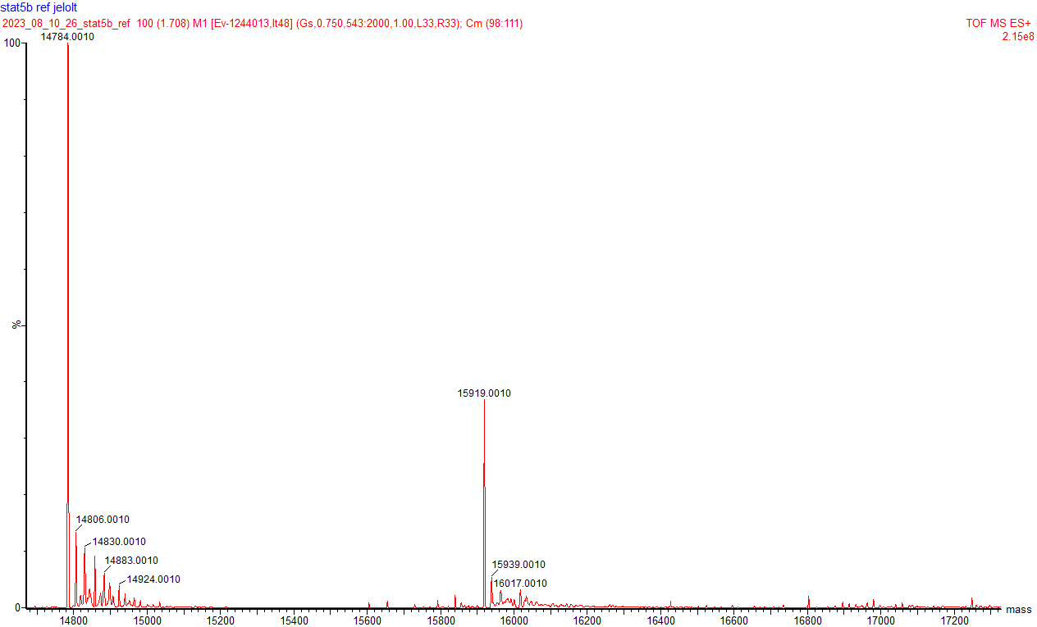

Intact MS protocols and results

Screening against BRD4-BD1 and KRas^{G12D}
Intact protein masses were recorded by LC-MS using an Agilent G6224 time-of-flight (ToF) Accurate Mass Series mass spectrometer, interfaced with an Agilent 1200 series liquid chromatography and sample handling system. The protein sample was injected using an Agilent 1200 series AutoSampler (Model No. G1367B) with a 10 µL injection volume and maintained at a temperature of 10 °C. Chromatography was carried out on an Agilent Bio-HPLC PLRP-S (1000Å, 5 µm × 50 mm × 1.0 mm, PL1312-1502) reverse phase HPLC column at 70 °C. Using an Agilent 1200 series binary pump system (Model No. G1312B) the sample was eluted at 0.5 mL/min using a gradient system from Solvent A (water, 0.2% (v/v) formic acid) to Solvent B (acetonitrile, 0.2% (v/v) formic acid) according to the following conditions:
Supplementary Table 2: Elution gradient (% B) used for intact protein LC-MS
Time (min) | % B
0 | 20
0.5 | 20
0.51 | 40
2.5 | 80
2.51 | 100
4 | 100
4.01 | 20
4.5 | 20

The eluent was injected directly into an Agilent ToF mass spectrometer (Model No. G6224A) using a dual ESI source and scanning between 600-3200 Da with a scan rate of 1.03 s in positive mode. The following MS parameters were used: capillary voltage limit – 4200; desolvation temperature – 340 °C; drying gas flow – 8.0 l/min. Data acquisition was carried out in 2 GHz Extended Dynamic range mode. Spectra were processed using Mass Hunter Qualitative Analysis™ B06.00 (Agilent) software with the Maximum Entropy method employed. The total ion chromatograms (TIC) were extracted (region containing protein) and the summed scans were deconvoluted (using a maximum entropy algorithm) over a m/z range with an expected mass range dependent on the protein.

Screening against STAT5B-NTD
For screening against STAT5B-NTD, we have used a UPLC-MS system that consisted of a Waters ACQUITY UPLC I-Class setup coupled with a Waters ACQUITY UPLC Peptide BEH C18 Column (130Å, 1.7 µm, 2.1 mm X 100 mm), connected to a Waters Xevo G2-XS QToF instrument equipped with a Waters Z-spray ESI source. During the analysis, the column temperature was maintained at a constant 60°C, and a sample volume of 3 µL was injected for each analysis. We utilized a gradient elution method with two eluents: eluent A, which consisted of 0.1% formic acid in water, and eluent B, composed of 0.1% formic acid in acetonitrile. The flow rate was set at 0.6 mL/min, and each measurement run lasted for 5.4 minutes. High-quality LC-MS grade solvents were sourced from Merck (Darmstadt, Germany). The gradient program is included below. Data acquisition was conducted in positive ion mode within the 100-2000 m/z (mass-to-charge ratio) range. The MS parameters were configured as follows: a source temperature of 150°C, a capillary voltage of 3.0 kV, and a desolvation temperature of 550°C. Nitrogen was employed as the atmospheric pressure ionization gas, supplied by a Genius 3020 Nitrogen generator from Peak Scientific. To control the analytical equipment and process the acquired data, we utilized the Waters Masslynx V4.2 SCN996 software package. Spectrum deconvolution was performed using Maximum Entropy modelling (MaxEnt) with the following parameters: a mass range of 7000-30000 Da, 1.00 Da/channel, a 0.75 Da width at half height with a uniform Gaussian damage model, and iterative refinement to convergence (approximately 40 iterations).
Supplementary Table 2. Gradient program for the MS screening against STAT5B-NTD
Time (min) | %A (0.1% formic acid in water) | %B (0.1% formic acid in acetonitrile)
0.0 | 95.0 | 5.0
5.0 | 0.60 | 70.0
1.80 | 0.0 | 100.0
2.20 | 0.0 | 100.0
2.70 | 95.0 | 5.0
3.00 | 30.0 | 70.0
3.00 | 70.0 | 30.0
3.60 | 30.0 | 70.0
3.90 | 70.0 | 30.0
4.20 | 30.0 | 70.0
4.50 | 70.0 | 30.0
4.80 | 5.0 | 95.0
5.40 | 95.0 | 5.0

Intact MS spectra of hit fragments vs. BRD4-BD1
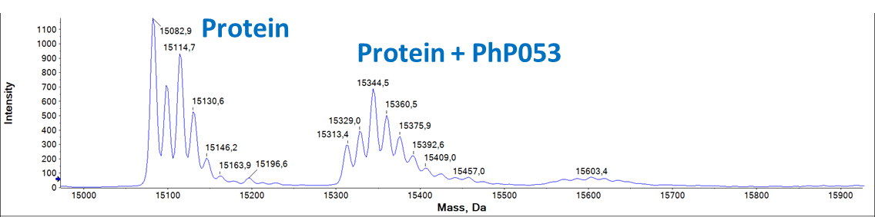
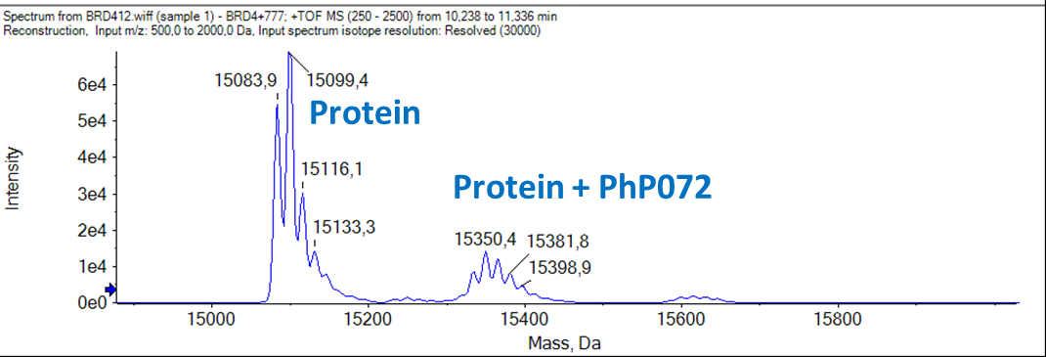

Intact MS spectra of hit fragments vs. KRas^{G12D}
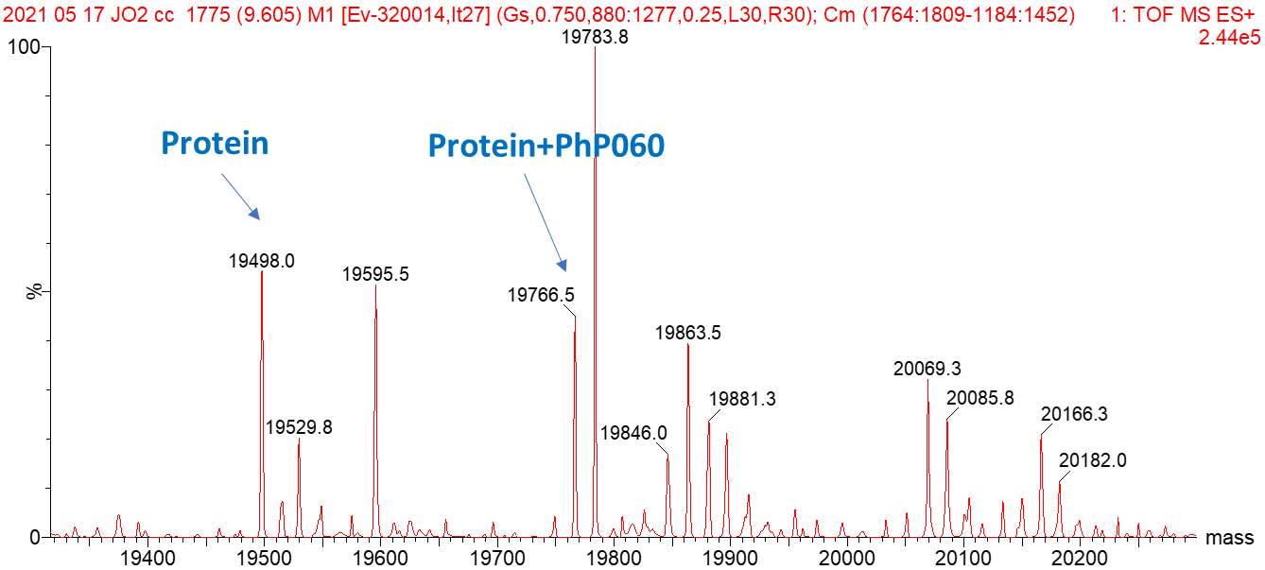

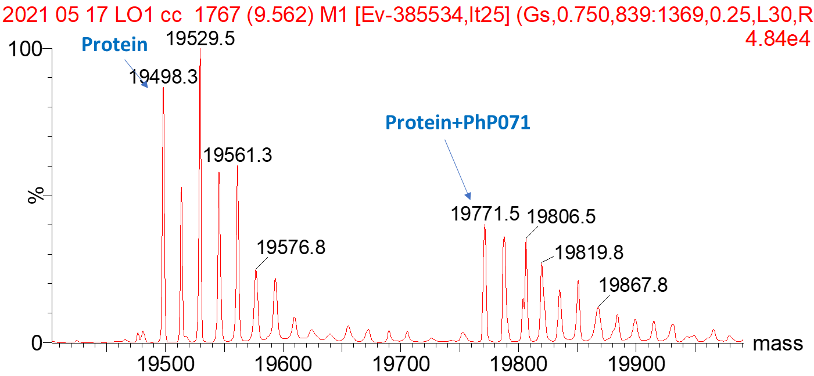
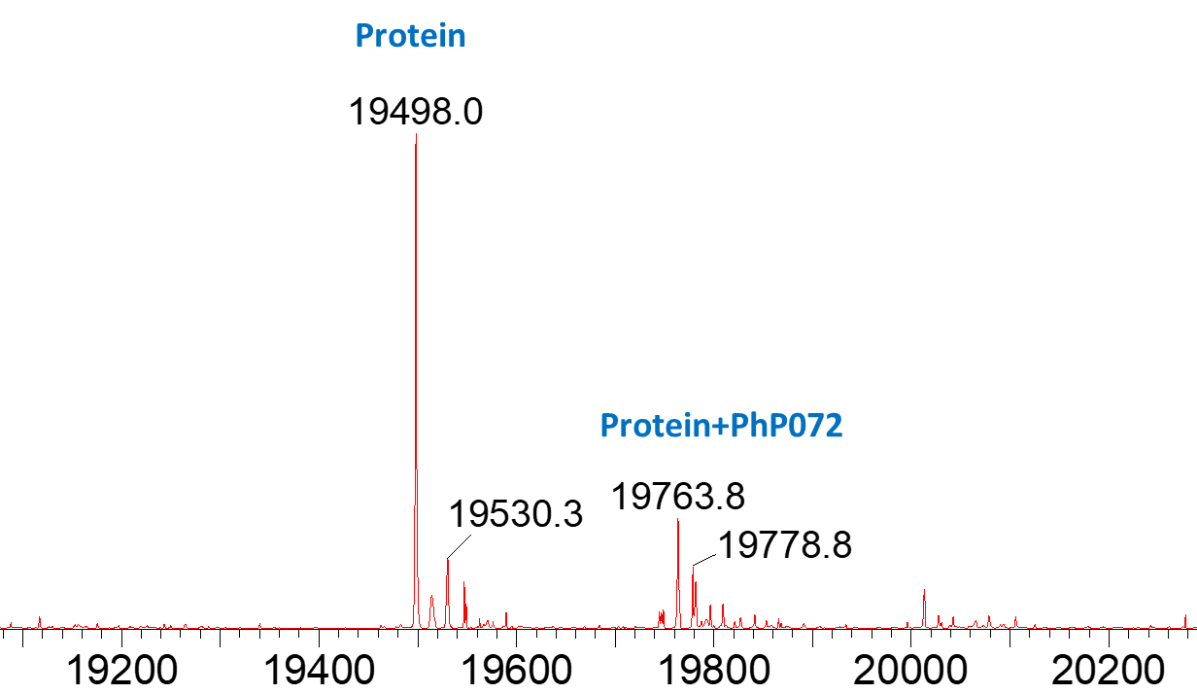

Intact MS spectra of hit fragments vs. STAT5B-NTD
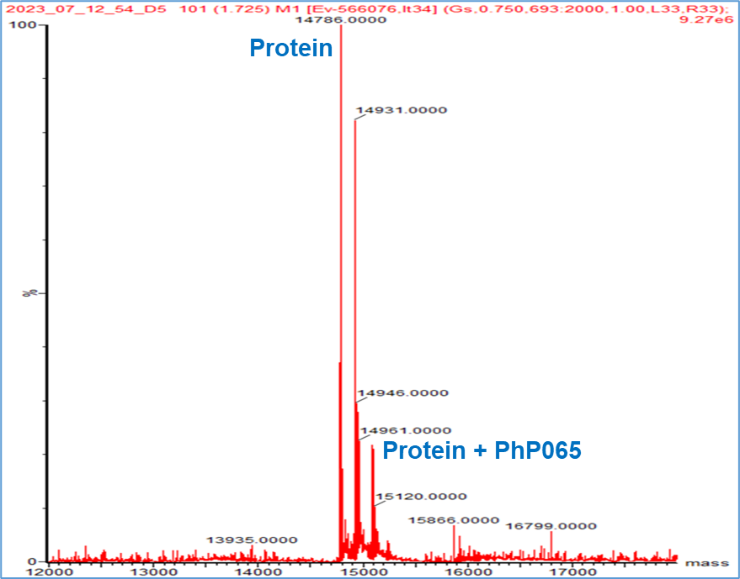
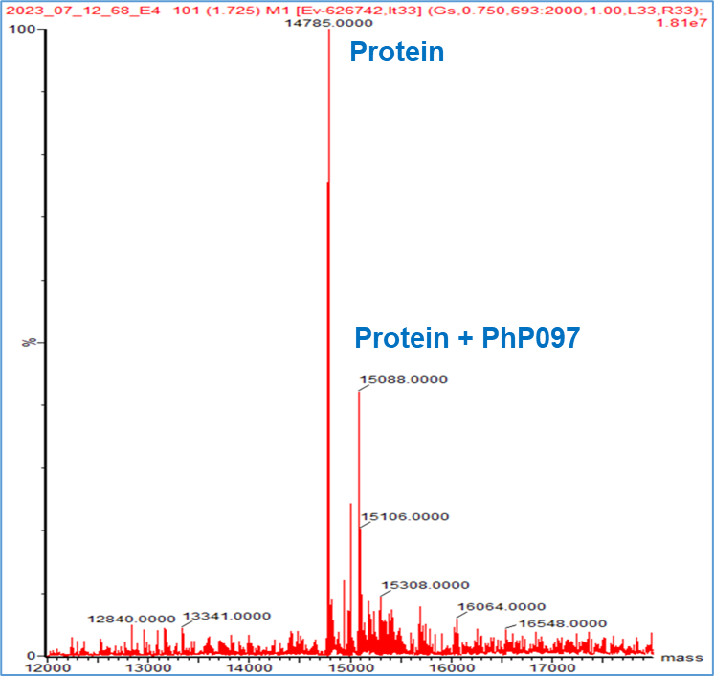

Binding site identification by LC-MS/MS peptide mapping

Sample preparation and data acquisition for BRD4-BD1
After the labelling was completed, 45 μL of the sample and 10 μL 0.2% (w/v) RapiGest SF (Waters, Milford, USA) solution buffered with 50 mM ammonium bicarbonate were mixed (pH=7.8) and 6.8 μL of 45 mM dithio-treitol (DTT) in 100 mM NH4HCO3 were added and kept at 37.5 °C for 30 min. After cooling the sample to room temperature, 8 μL of 100 mM iodoacetamide in 100 mM NH4HCO3 were added and placed in the dark at room temperature for 30 min. The reduced and alkylated protein was then digested by 5,5 μL (1 mg/mL) Trypsin/Lys C mix (the enzyme-to-protein ratio was 1:10) (Promega, Madison, USA). The sample was incubated at 37 °C for overnight. To degrade the surfactant, 6.8 μL of formic acid (500 mM) solution was added to the digested protein sample to obtain the final 40 mM concentration (pH ≈ 2) and was incubated at 37 °C for 45 min. For LC-MS analysis, the acid treated sample was centrifuged for 5 min at 13 000 rpm and the supernatant was pipetted into a microvial.
To get more precise information on the structure, samples were further analyzed by a Triple TOF 5600+ hybrid Quadrupole-TOF LC/MS/MS system (Sciex, MA, USA) equipped with a DuoSpray IonSource coupled with a Shimadzu Prominence LC20 UFLC (Shimadzu, Japan) system consisting of quaternary pump, an autosampler and a thermostated column compartment.
Data acquisition and processing were performed using Analyst TF software version 1.7.1 (AB Sciex Instruments, CA, USA). Chromatographic separation was achieved on the Discovery® BIO Wide Pore C-18-5 (250 mm × 2.1mm, 5 μm, 300 Å) HPLC column. Sample was eluted in gradient elution mode using solvent A (0.1% formic acid in water) and solvent B (0.1% formic acid in ACN). The initial condition was 5% B for 7 min, followed by a linear gradient to 90% B by 48 min, from 55 to 63 min 90% B was retained; and from 63 to 65 min back to initial condition with 5 % eluent B and retained for 10 min. Flow rate was set to 0.2 ml/min. The column temperature was 40 °C and the injection volume was 15 µl. Nitrogen was used as the nebulizer gas (GS1), heater gas (GS2), and curtain gas with the optimum values set at 35, 35 and 35 (arbitrary units), respectively. The source temperature was 350 °C and the spray voltage was set to 5000 V.
Advanced Information Dependent Acquisition (IDA) mode was used on the TripleTOF 5600+ system to obtain MS/MS spectra on the 8 most abundant parent ions present in the TOF survey scan. In IDA LC-MS/MS experiment the mass spectra and tandem mass spectra were recorded in “high-sensitivity” mode with a resolution of ~35,000 full-width half-maximum.
In first period (positive TOF MS mode) the data were acquired in the mass range of m/z=300 to 2500, with 0.1 s accumulation time. Declustering potential value was set to 60 V. The intensity threshold for precursor ion selection in TOF survey scan mode was 1000 cps. In MS2 experiment (Product Ion scan mode): the mass range was m/z=50 to 3000, with an accumulation time of 0.1 sec.
PeakView® V.2.2 software (version 2.2, Sciex) and Biologics Explorer software (version 3.0.3, Sciex) were used to assign and evaluate the peaks in the MSMS spectra.

Sample preparation and data acquisition for STAT5B-NTD
After the labelling was completed, 50 μL of the sample and 10 μL 0.2% (w/v) RapiGest SF (Waters, Milford, USA) solution buffered with 50 mM ammonium bicarbonate were mixed (pH=7.8) and 3.5 μL of 45 mM dithio-treitol (DTT) in 100 mM NH4HCO3 were added and kept at 37.5 °C for 30 min. After cooling the sample to room temperature, 4.5 μL of 100 mM iodoacetamide in 100 mM NH4HCO3 were added and placed in the dark at room temperature for 30 min. The reduced and alkylated protein was then digested by 7 μL (1 mg/mL) trypsin (the enzyme-to-protein ratio was 1:10) (Sigma, St Louis, MO, USA). The sample was incubated at 37 °C for overnight. To degrade the surfactant, 6 μL of formic acid (500 mM) solution was added to the digested protein sample to obtain the final 40 mM concentration (pH ≈ 2) and was incubated at 37 °C for 45 min. For LC-MS analysis, the acid treated sample was centrifuged for 5 min at 13 000 rpm and the supernatant was pipetted into a microvial.
To get more precise information on the structure, samples were further analyzed by a Triple TOF 5600+ hybrid Quadrupole-TOF LC/MS/MS system (Sciex, MA, USA) equipped with a DuoSpray IonSource coupled with a Shimadzu Prominence LC20 UFLC (Shimadzu, Japan) system consisting of quaternary pump, an autosampler and a thermostated column compartment.
Data acquisition and processing were performed using Analyst TF software version 1.7.1 (AB Sciex Instruments, CA, USA). Chromatographic separation was achieved on the Discovery® BIO Wide Pore C-18-5 (250 mm × 2.1mm, 5 μm, 300 Å) HPLC column. Sample was eluted in gradient elution mode using solvent A (0.1% formic acid in water) and solvent B (0.1% formic acid in ACN). The initial condition was 5% B for 7 min, followed by a linear gradient to 90% B by 48 min, from 55 to 63 min 90% B was retained; and from 63 to 65 min back to initial condition with 5 % eluent B and retained for 10 min. Flow rate was set to 0.2 ml/min. The column temperature was 40 °C and the injection volume was 15 µl. Nitrogen was used as the nebulizer gas (GS1), heater gas (GS2), and curtain gas with the optimum values set at 35, 35 and 35 (arbitrary units), respectively. The source temperature was 350 °C and the spray voltage was set to 5000 V.
Advanced Information Dependent Acquisition (IDA) mode was used on the TripleTOF 5600+ system to obtain MS/MS spectra on the 8 most abundant parent ions present in the TOF survey scan. In IDA LC-MS/MS experiment the mass spectra and tandem mass spectra were recorded in “high-sensitivity” mode with a resolution of ~35,000 full-width half-maximum.
In first period (positive TOF MS mode) the data were acquired in the mass range of m/z=300 to 2500, with 0.1 s accumulation time. Declustering potential value was set to 60 V. The intensity threshold for precursor ion selection in TOF survey scan mode was 1000 cps. In MS2 experiment (Product Ion scan mode): the mass range was m/z=50 to 3000, with an accumulation time of 0.1 sec.
PeakView® V.2.2 software (version 2.2, Sciex) and Biologics Explorer software (version 3.0.3, Sciex) were used to assign and evaluate the peaks in the MSMS spectra.

MS spectra of digested BRD4-BD1 after labeling by hit fragments
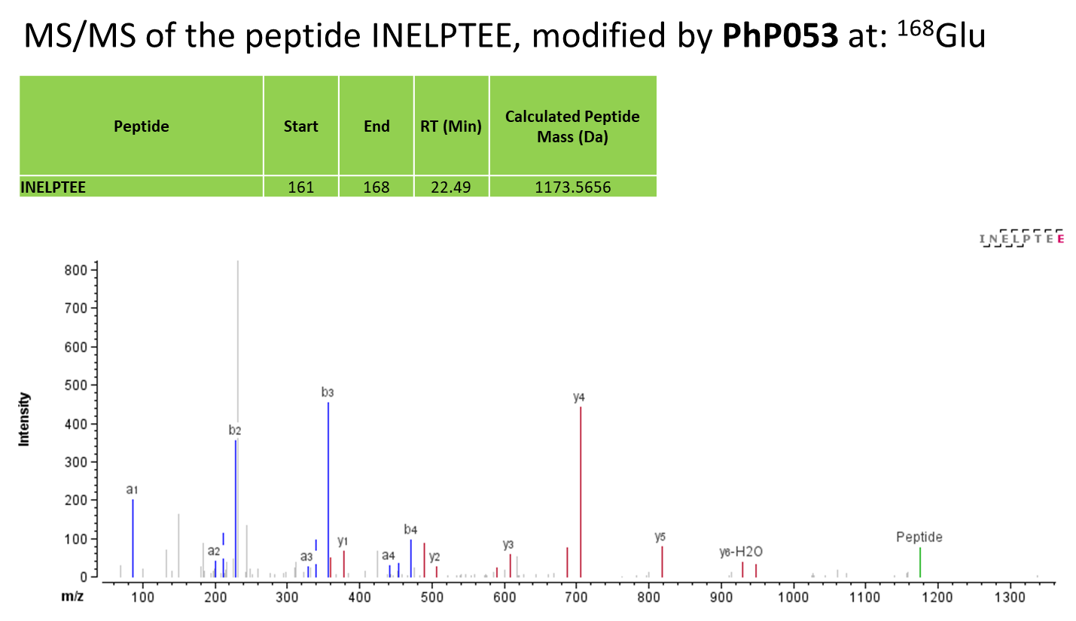
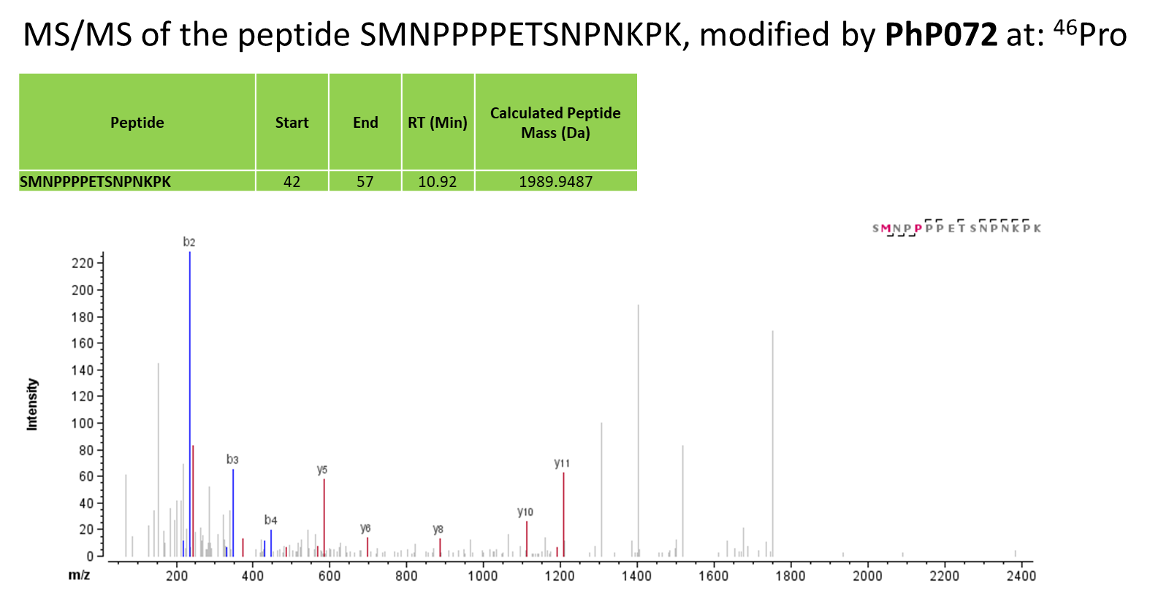
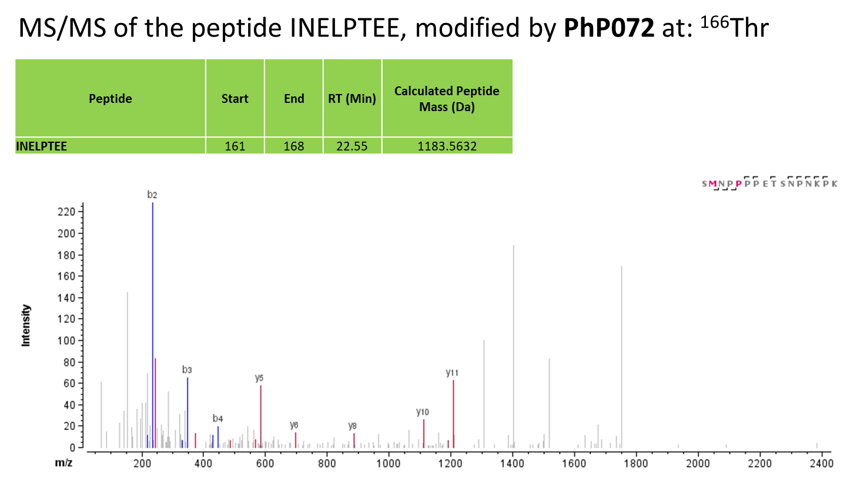

MS spectra of digested KRas^{G12D} after labeling by hit fragments
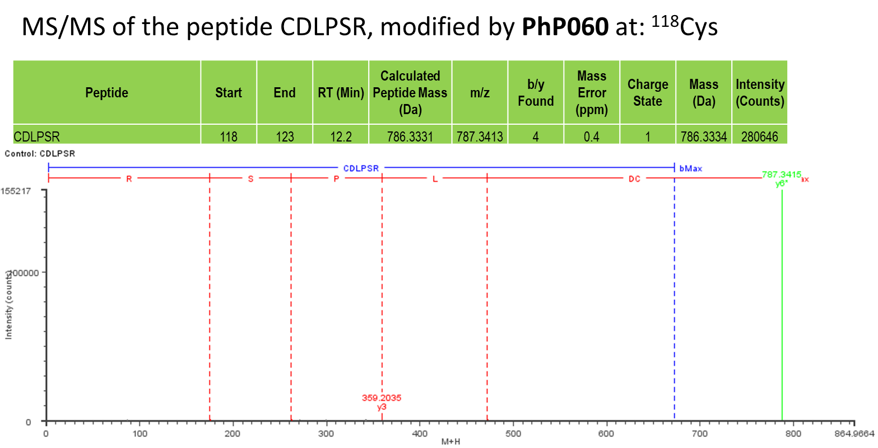
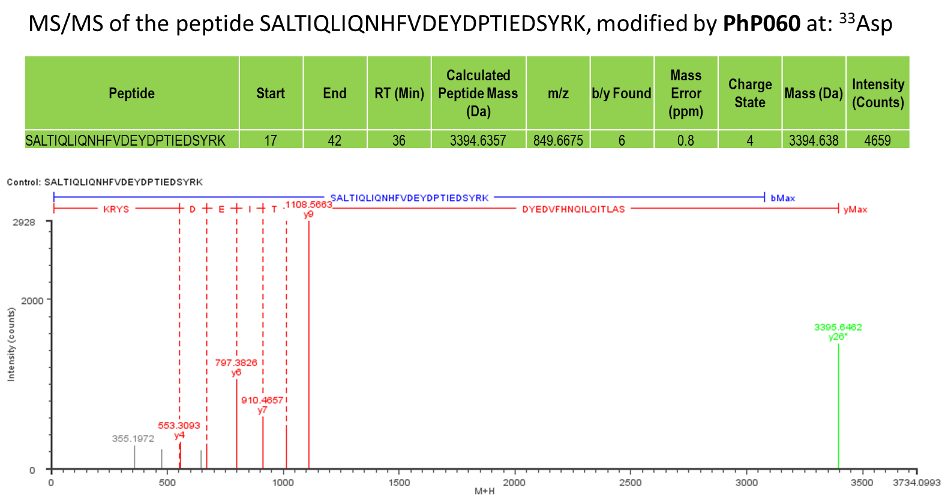
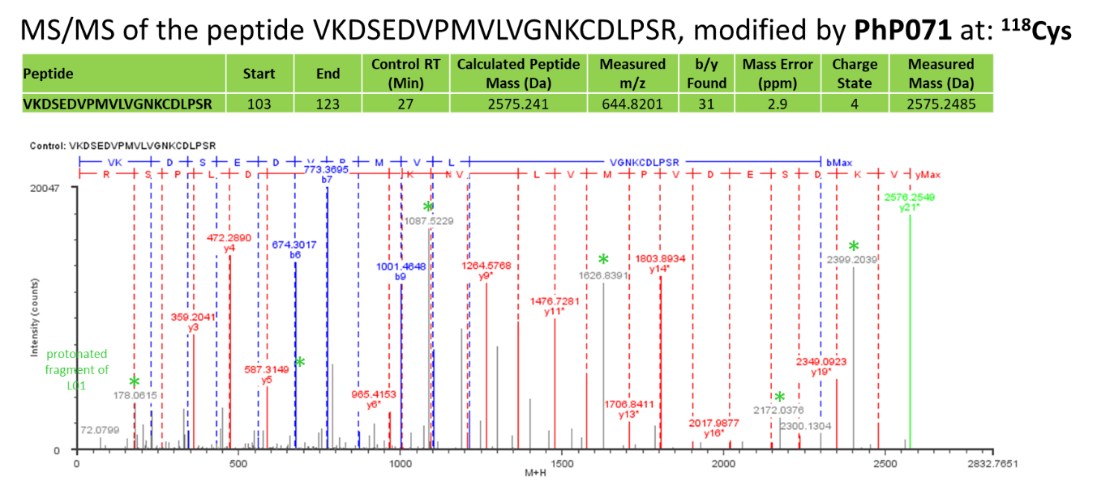
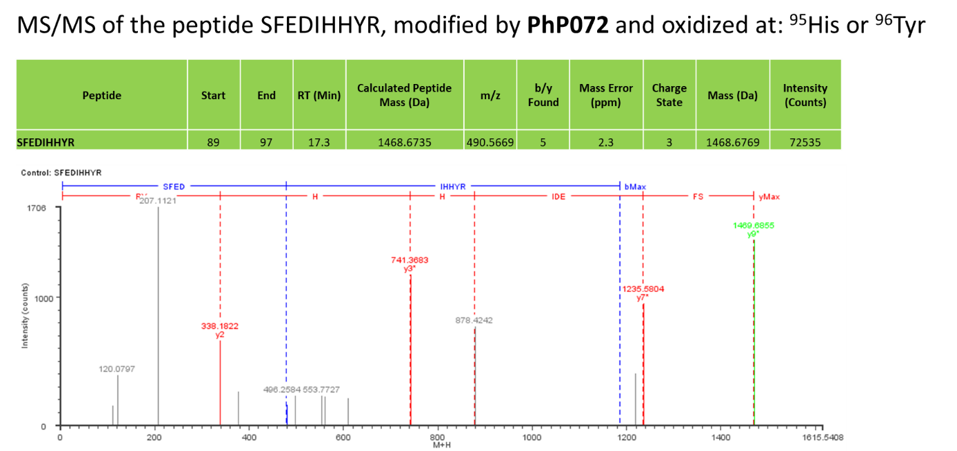
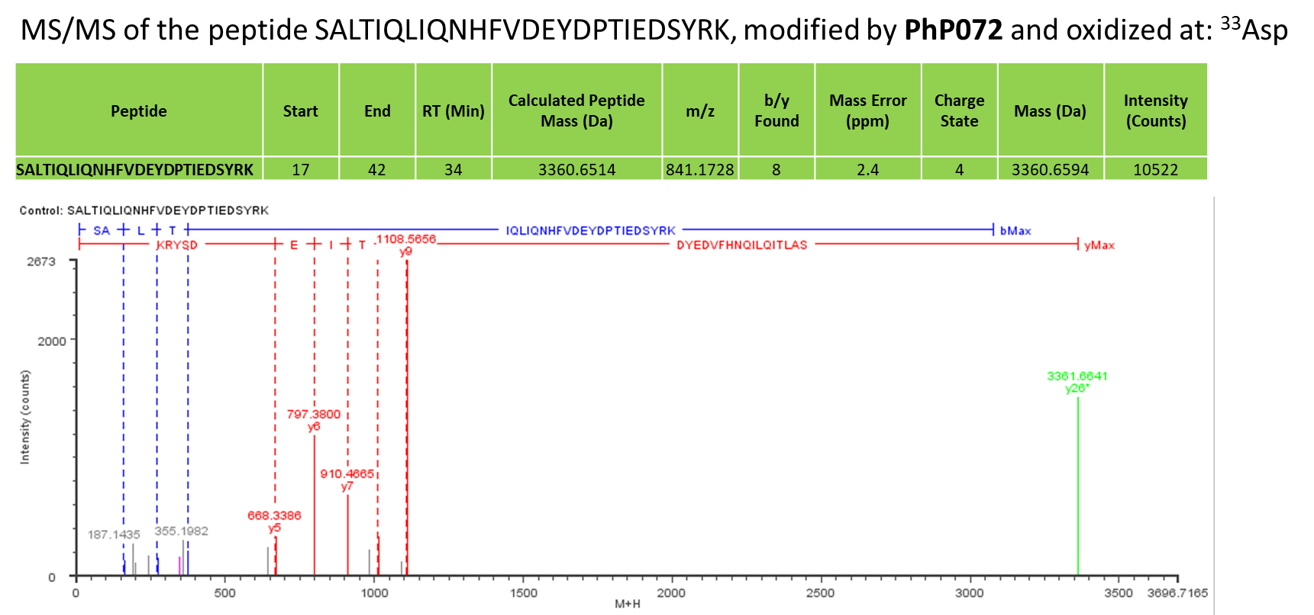

MS spectra of digested STAT5B-NTD after labeling by hit fragments
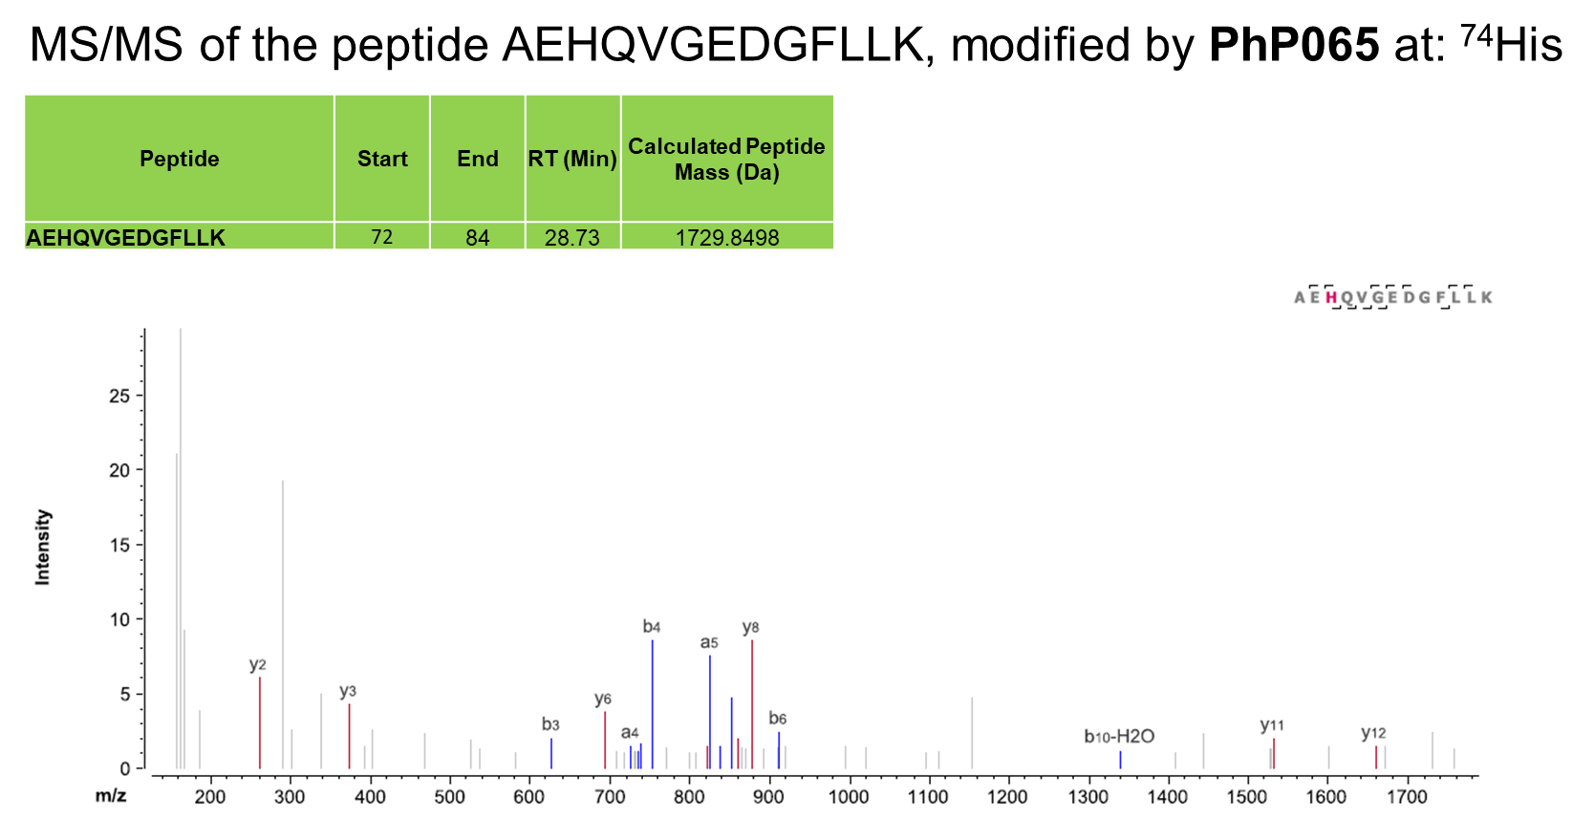
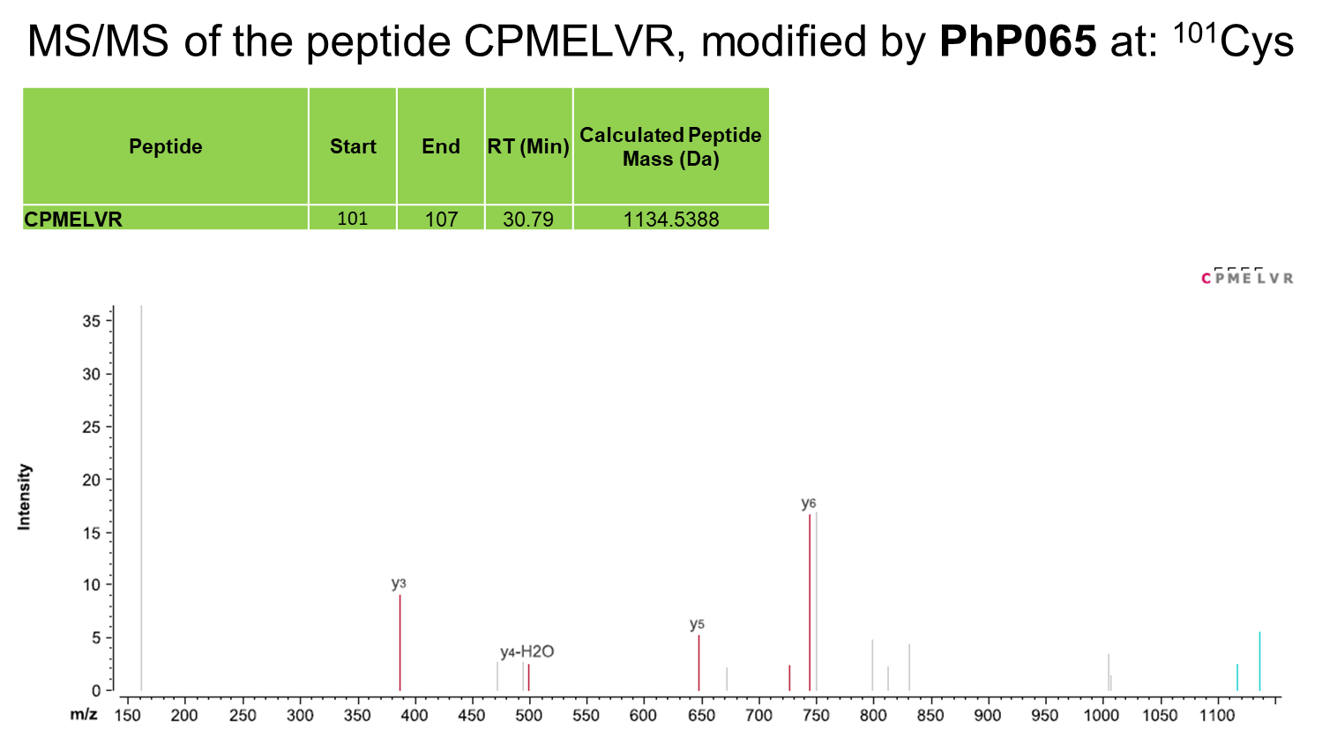
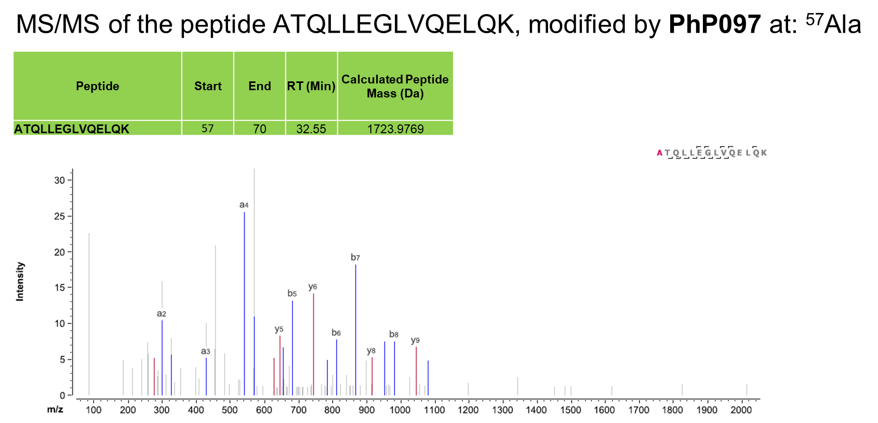
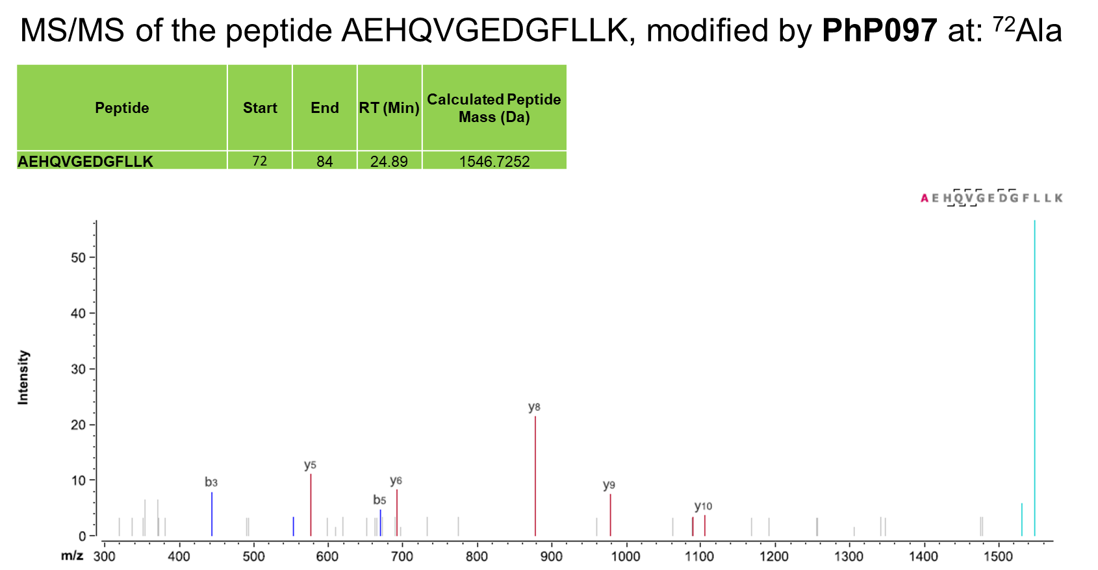
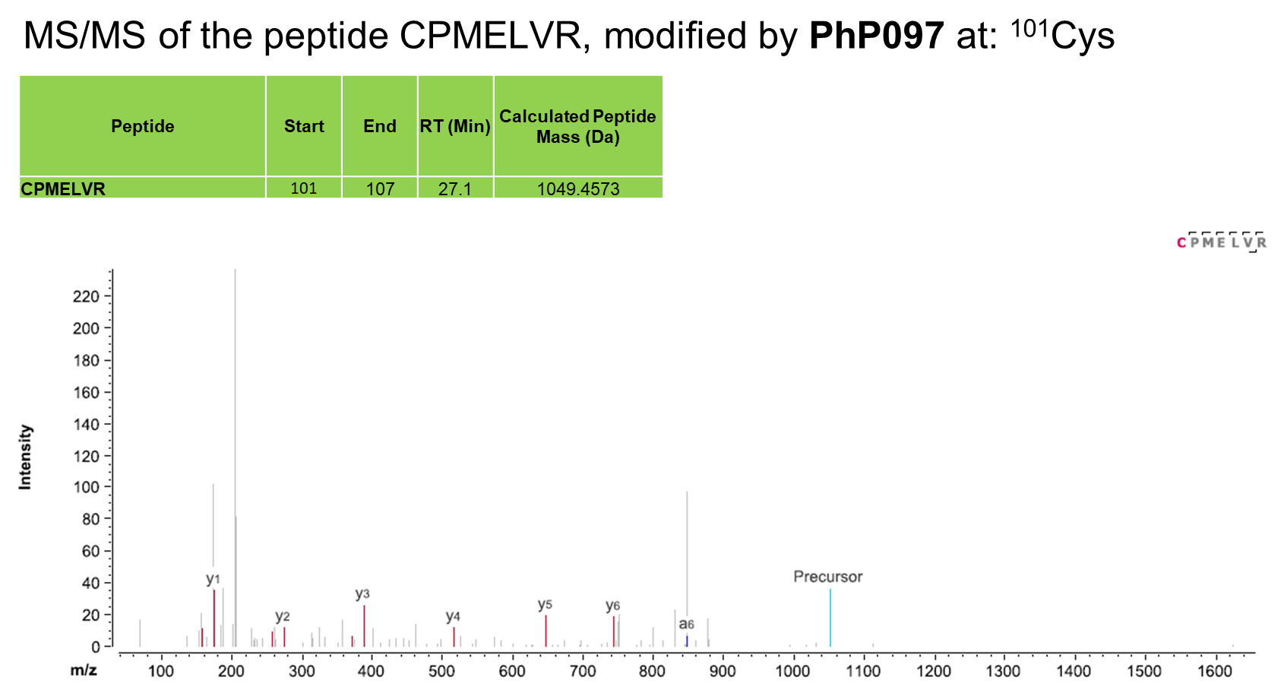

HSQC NMR spectra of fragment hits against KRas^{G12D}
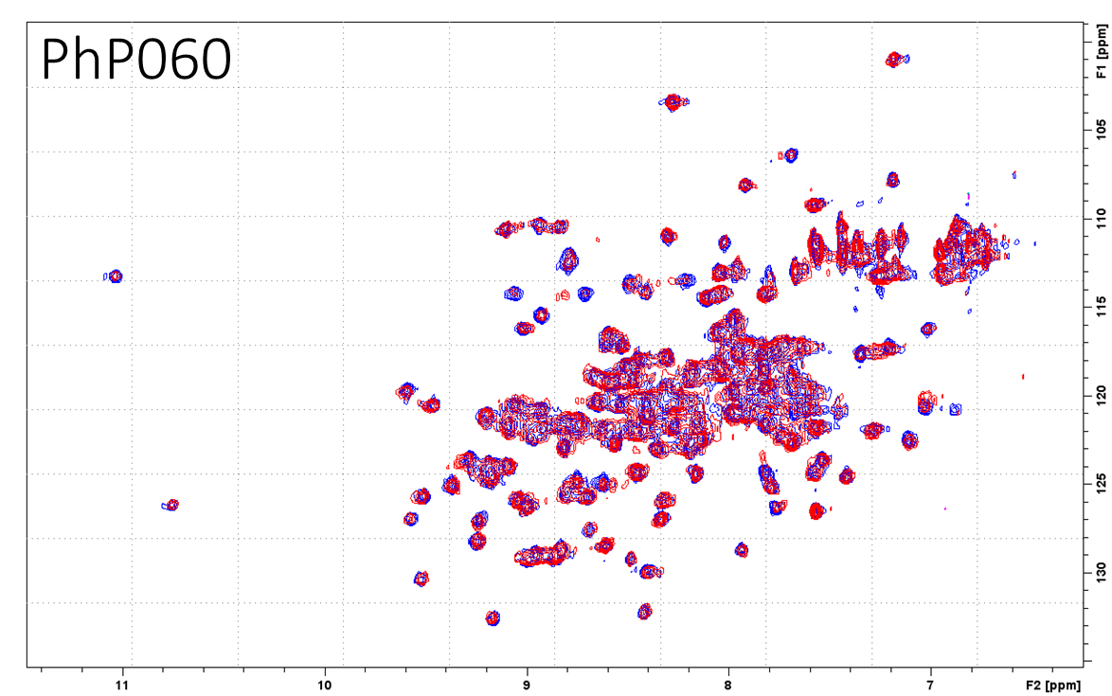
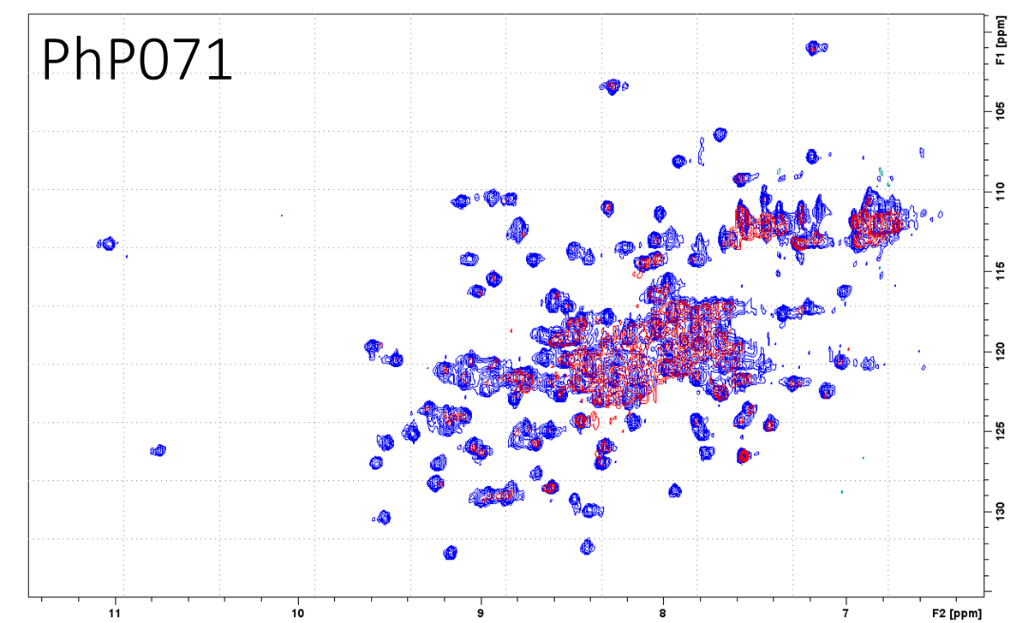
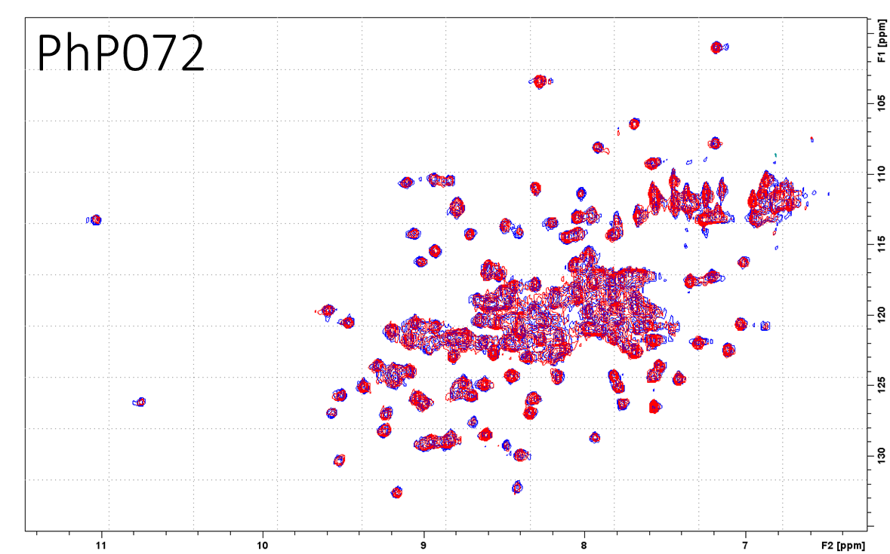

Supplementary references

1. Grant, E. K. et al. A Photoaffinity-Based Fragment-Screening Platform for Efficient Identification of Protein Ligands. Angewandte Chemie International Edition 59, 21096–21105 (2020).

