Additional file 10.
File format: Additional_file10.docx
Description of data: a-f) Bayesian paired t-test comparison of ROH by pairs of groups (feral Australia, feral Hawaii, domestic and wild cats; g) Stacked box plot of the inbreeding coefficients inferred from runs of homozygosity indicating the length of ROH per group.

- Australia vs Domestic
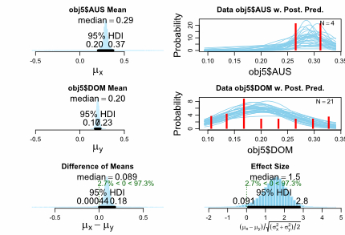
- Australia vs Hawaii
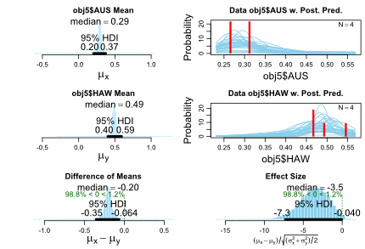
- Australia vs Wild
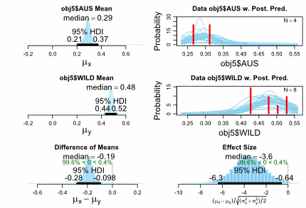

- Domestic vs Wild
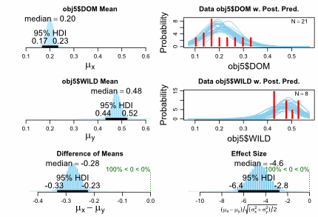
- Hawaii vs Domestic
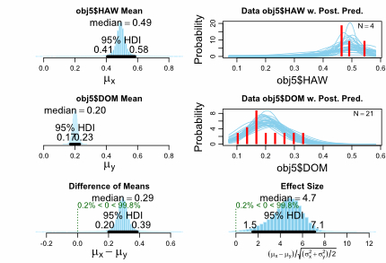

- Hawaii vs Wild
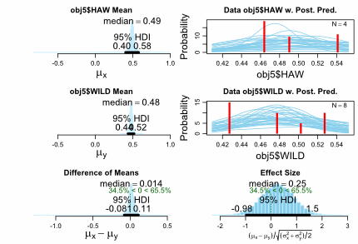

g)
