Additional file 9.
File format: Additional_file9.docx
Description of data: a-f) Bayesian paired t-test comparison of recombination rates by pairs of groups (feral Australia, feral Hawaii, domestic and wild cats).

- Australia vs Domestic
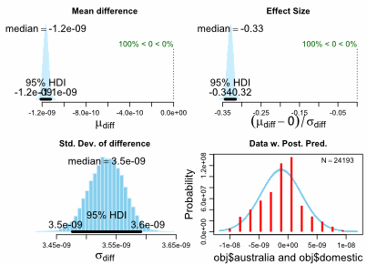
- Australia vs Hawaii
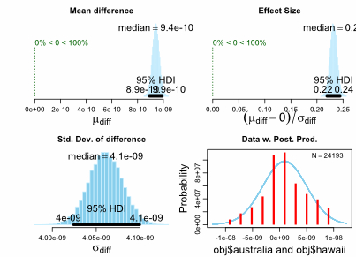

- Australia vs Wild
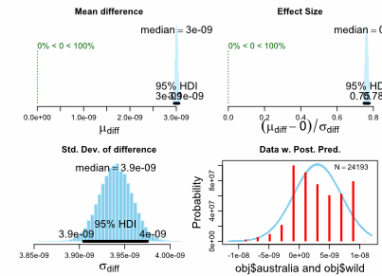

- Domestic vs Wild
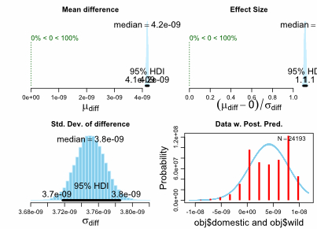

- Hawaii vs Domestic
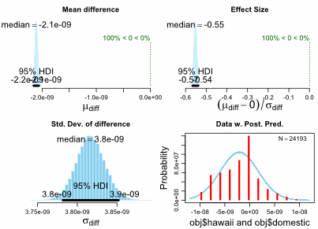

- Hawaii vs Wild

