Supporting Information

Unlocking the High Photosensitivity Direct Laser Writing: Designing Structures and Observing Atomic Clustering in Glass

Wenyan Zheng^{‡1}, Zhuo Wang^{‡2}, Weilin Chen¹,Qiang Xu³, Xvsheng Qiao*¹, Dezhi Tan*⁴, Junjie Zhang⁵, Jianrong Qiu^{2,6}, Guodong Qian¹, and Xianping Fan^{1,3}
¹ State Key Laboratory of Silicon Materials & School of Materials Science and Engineering, Zhejiang University, Hangzhou, 310027, China
² State Key Laboratory of Modern Optical Instrumentation College of Optical Science and Engineering, Zhejiang University, Hangzhou, 310027, China
³ Hainan Institute of Zhejiang University, Sanya, 572025, China
⁴ Zhejiang Lab, Hangzhou, 311100, China
⁵ College of Optical and Electronic Technology, China Jiliang University, Hangzhou, 310018, China
⁶ CAS Center for Excellence in Ultra-Intense Laser Science Chinese Academy of Sciences, Shanghai, 201800, China
‡Wenyan Zheng and Zhuo Wang contributed equally to this work
* E-mail: qiaoxus@zju.edu.cn, wctdz@zju.edu.cn

Materials and methods

Glass preparation
Glass samples, (95-x)Al(PO₃)₃-xMF₂-5Ag₂O (M = Mg, Ca, Sr) were prepared by the melt-quenching method, using Al(PO₃)₃, MgF₂, CaF₂, SrF_{2,} and AgNO₃ as raw materials. The PFx denoted the fluorophosphate glass with x mol% MF₂ (x = 5-30). A batch of 30 g for each glass composition was weighed and mixed homogenously in the agate mortar. Then, the mixture was melted in alumina crucibles with a closed-lip to minimize fluorine loss at 1450 °C for 60 min. The melt was then poured onto a cold stainless-steel plate to be annealed and immediately pressed with another plate to increase the cooling rate and promote glass formation. The obtained glasses were then cut, ground, and finely polished for subsequent measurements.

Molecular dynamics simulations
Molecular dynamics simulations were carried out on a cubic sample made up of approximately 1000 atoms with random coordinates by Packmol. Two compositions, the 70Al(PO₃)₃-5Ag₂O-25CaO (without fluorine) and 70Al(PO₃)₃-5Ag₂O-25CaF₂ (with fluorine) were studied. Notably, Ca was chosen to represent the alkaline earth metals (Mg, Ca, Sr), as they all exert as the glass modifier. These two systems were subjected to structural optimization using the DFT method based on DZVP-MOLOPT-SR-GTH. Starting from the initial configurations, Born-Oppenheimer Molecular Dynamics (BOMD) was applied. ¹ The high-temperature melt at 2000 K was quenched to 300 K over a period of 300 ps in NPT ensemble (constant number of atoms, constant pressure, and constant temperature). The glass was relaxed at 300 K under atmospheric pressure for 5 ps. Periodic boundary conditions were applied in all directions. The visualization of local atomic structure was facilitated by VESTA.

Direct laser writing in glasses
Single-pulsed direct laser writing was conducted on regeneratively amplified Ti: sapphire laser with a central wavelength of 1030 nm, pulse duration of 220 fs, and repetition rate of 1 kHz. The laser was focused 100 μm beneath the glass surface through 50× (NA = 0.8) objective lens. The diameter of the laser spot was about 2 μm.

Characterizations
X-ray powder diffraction (XRD) was carried out in an X-ray diffractometer (Shimadzu XRD-6000) with a 5°∙min⁻¹ scanning speed. The UV-Vis absorption spectra were recorded in UV-Vis spectrophotometer (Hitachi U-4100). The glass transition temperature (Tg) and crystallization temperature (Tc) were collected from the differential scanning calorimeter (DSC, Q100 TA). The heating rate was 10°C∙min⁻¹. Photoluminescence (PL), Photoluminescence excitation (PLE), and lifetime decay spectra were recorded by Edinburgh Instruments FLSP920 spectrophotometer. The pH of the glass leachate solutions was determined by a pH meter (FiveEasy PlusTM, FB28). Optical pictures of the laser-modified regions were captured by a CCD camera attached to a Nikon microscope (Eclipse 80i). PL spectra of the laser-modified region were taken from a confocal microscope (λ_{exc} = 405 nm, LSM780, Zeiss). The PL of Ag QCs after DLW was carried out on a homemade confocal microscope. Raman spectra and mapping were collected by Raman spectrometer (LabRAM HR Evolution) with a 532 nm laser excitation. The ²⁷Al nuclear magnetic resonance (NMR) spectra were recorded on an Agilent 600 DD2 spectrometer at a frequency of 156.25 MHz (14.1 T), using 3.6 μs pulses and 10 s recycle time in a 4 mm double-resonance probe. The ³¹P NMR spectra were collected at a frequency of 242.76 MHz (14.1 T) using 3.0 μs pulses and 5 s recycle delays. The AlCl₃ and H₃PO₃ were chosen as the chemical shift reference. SEM images and EMPA were carried out on EMPA-1720 (SHIMADZU) at an accelerating voltage of 15 kV and a current of 10 nA. Electron paramagnetic resonance (EPR) spectra were recorded on a Bruker A300 ESR spectrometer in X-ban. The samples were loaded into a quartz tube at 120 K. A dual-beam SEM/FIB (FEI Helios Nanolab 600i) was used to fabricate lift-out samples. The APT was performed using a Local Electrode Atom Probe (LEAP) 4000X HR (CAMECA Instrument Inc., Madison, WI, USA) in the laser pulse mode at 355 nm. The data reconstruction and cluster analysis were performed on the CAMECA IVAS software (3.4.4).
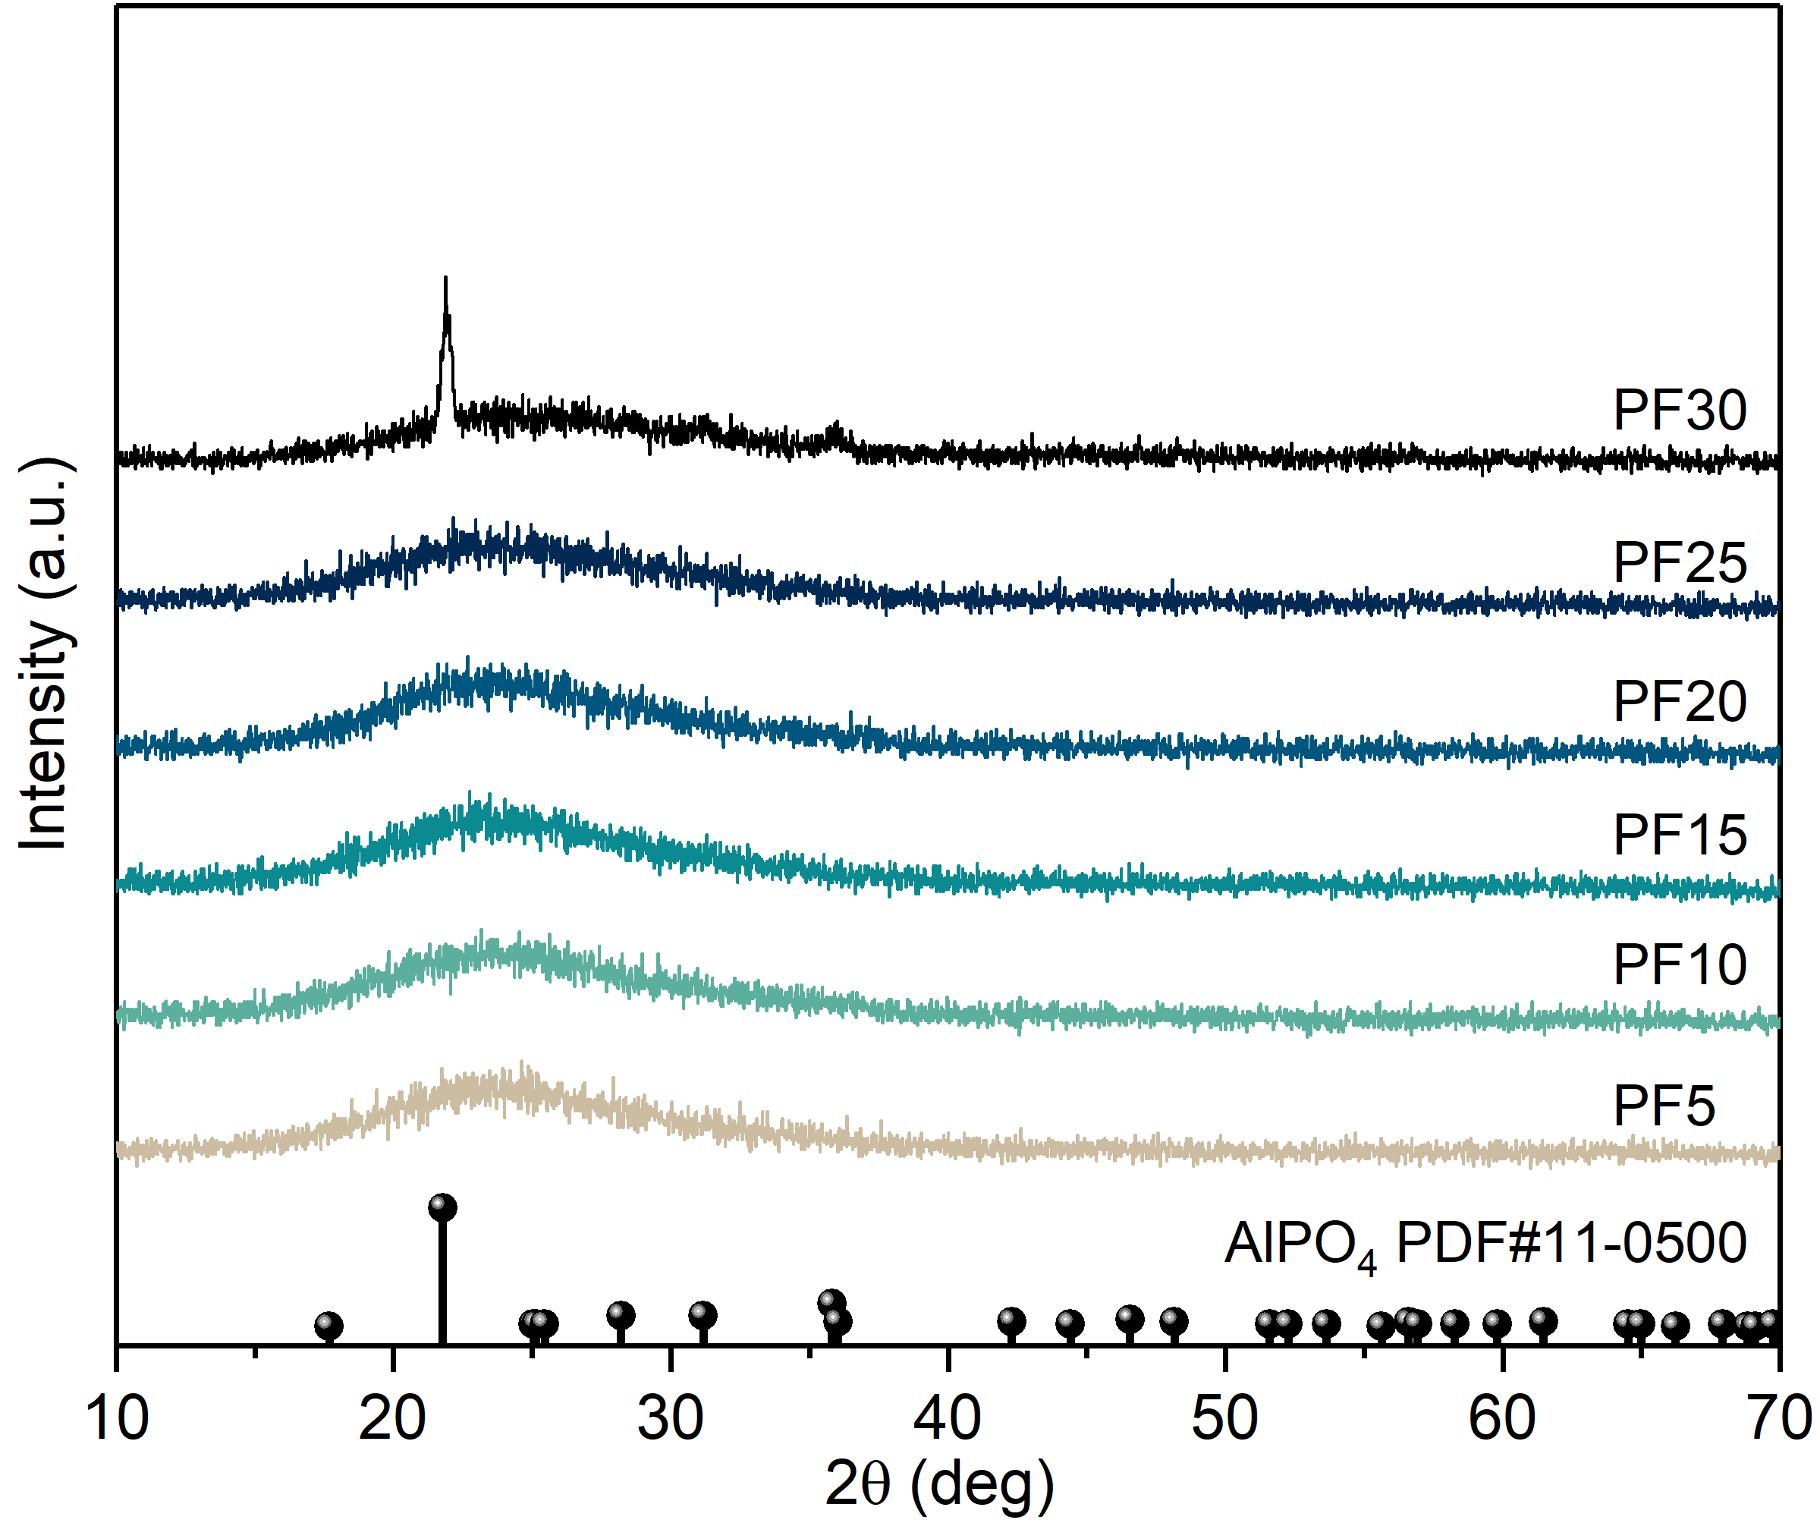

Fig S1. XRD patterns of PFx glasses (x = 5-30 mol%), 30 mol% fluorine content resulted in the precipitation of AlPO₄ crystals and loss of transparency.

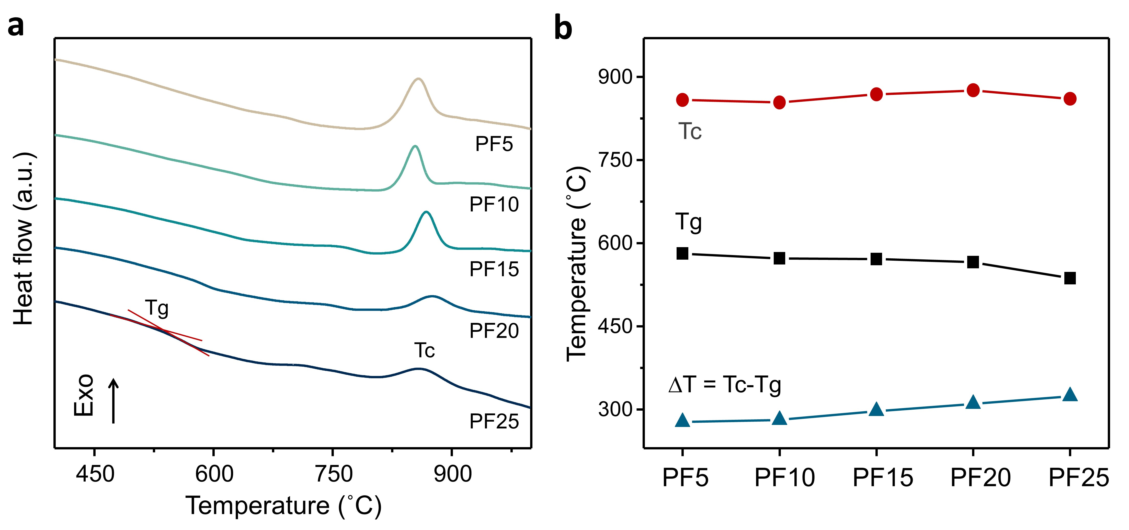

Fig S2. a DTA curves of PFx glasses at a heating rate of 10°C ∙min⁻¹ (x = 5-25 mol%); b Tg (glass transition temperature), Tc (crystallization temperature), and ∆T (Tc - Tg); A high value of ΔT is desirable since it indicates the thermal stability against crystallization. ^{2, 3}

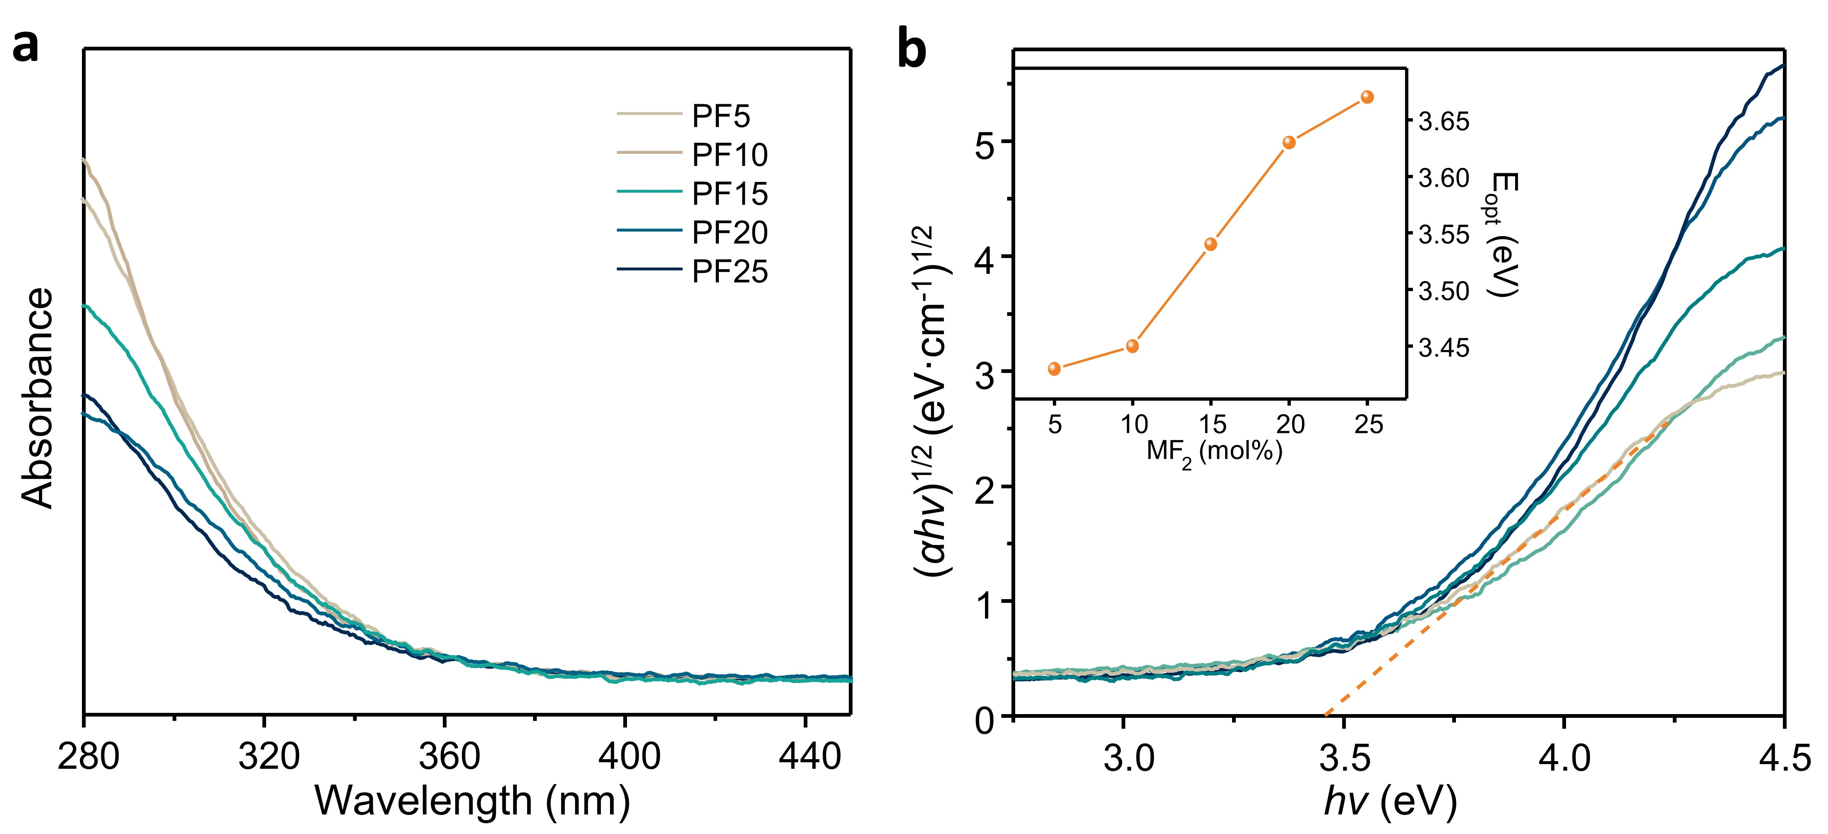

Fig S3. a UV-Vis absorption spectra of PFx glasses (x = 5-25 mol%); b Band gap determination using the Tauc plot, the dotted line is the linear fitting part of PF5.

Note S1
The optical bandgap E_{opt} is calculated according to the Tauc plot (Fig S4):⁴
$$α\left(ν\right)=A\frac{{\left(hν-E_{opt}\right)}^{n}}{hν}$$
where α(ν) is the absorption coefficient; A is a constant; hν is the incident photon energy; index n is values of 1/2, 3/2, 2, and 3, depending on the nature of the transition. For the indirect transitions in glasses, the value of 2 gives the best fit.⁵
The band gap of a material depends on the relative electronegativities of its constituents and electron count, and glasses are no exception.⁶ In theory, the optical bandgap is strongly related to the polarizability of the glass - the indicator of how tightly the electrons are bound to the anions. The fluorine ions are smaller than the oxide and feature in strong electron-holding ability. The replacement of fluorine ions would cause a decrease in the electron contribution and more energy is needed to promote the electrons from the valence to conduction band, consequently, giving rise to a large optical bandgap.⁷ A similar increase in E_{opt} has been reported in the CaO-CaF₂-P₂O₅ glass series.⁸
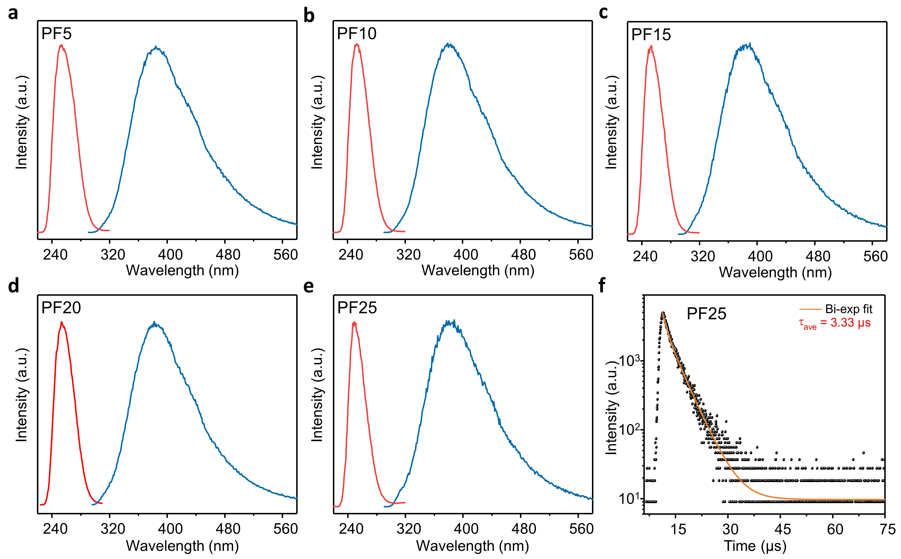

Fig S4. a-e Normalized PL and PLE spectra of PFx glasses, all the glasses presented an emission peak at 380 nm from Ag⁺ ions (λ_{ex} = 254 nm); f Emission decay curve monitoring at 380 nm in PF25, with a calculated lifetime of 3.33 µs corresponding to the electronic transition of 4d¹⁰ → 4d⁹s¹ in Ag⁺ ions. ⁹

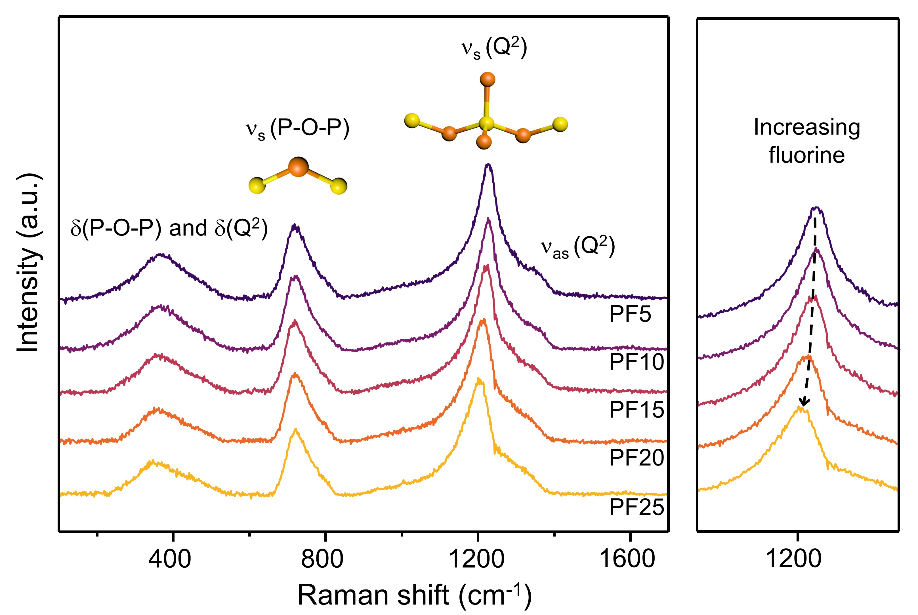

Fig S5. Raman spectra of PFx glasses (x = 5 - 25 mol%).

Table S1 Raman band assignments^{10, 11}
Structural unit | Symbol | Wavenumber (cm⁻¹)
Internal bending modes of phosphate chains | δ(P-O-P) and δ(Q²) | 200 - 600
Symmetric stretching mode of bridging oxygen (P-O-P) between two Q² tetrahedra | ν_{s}(P-O-P) | 700
Symmetric stretching of the O-P-O non-bridging oxygens on Q² | ν_{s}(Q²) | 1210
Asymmetric stretching of the O-P-O non-bridging oxygens on Q² | ν_{as}(Q²) | 1300

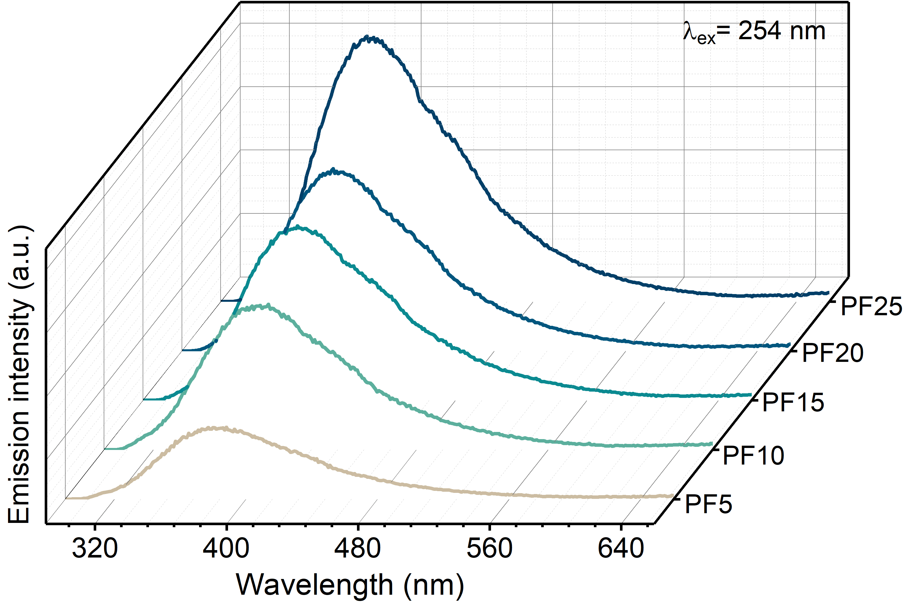

Fig S6 PL spectra of PFx glasses, λ_{ex} = 254 nm

Note S2
The chemical stability of glass is typically assessed by examining the extent of glass erosion under an aqueous solution at a given temperature, either through measurement of pH, conductivity, or weight loss.^{12, 13} In this work, the pH method was selected.
The experiment was conducted as follows: Each PFx glass was ground into powder form. 2 g of the powder was immersed in 150 mL of deionized water following 20 min ultrasonic treatment. The solution was transferred to a three-necked flask situated in an oil bath at 98 °C for 150 min with magnetic stirring (Fig S7(a)). Afterward, it was cooled to room temperature, and 100 mL of the supernatant was collected to determine its pH value. This test was performed in triplicate for each sample to obtain the average pH value and error bars. For comparison, this experiment was also carried out on a commercial slide (CITOTEST® Scientific), a type of borosilicate glass, that is well-known for excellent chemical, thermal, and mechanical durability.¹⁴
As depicted in Fig. S7(b), a smaller pH value was observed with higher fluorine introduction, indicating reduced leaching of alkaline earth ions into the deionized water. The instability of phosphate glasses comes from distorted PO₄ tetrahedra due to the bond strength difference between the P=O and P-O-P (with P=O double bond shorter than P-O-P), resulting in facile fracture and deformation.¹⁵ Increasing fluorine led to the transformation of Al⁶ to Al⁴ and a reduction in the phosphate stoichiometry, increasing more durable P-O-Al bonds while decreasing P-O-P bonds. Moreover, the pH of PF25 approached that of slide-glass, demonstrating potential for long-term application and broad commercial viability.
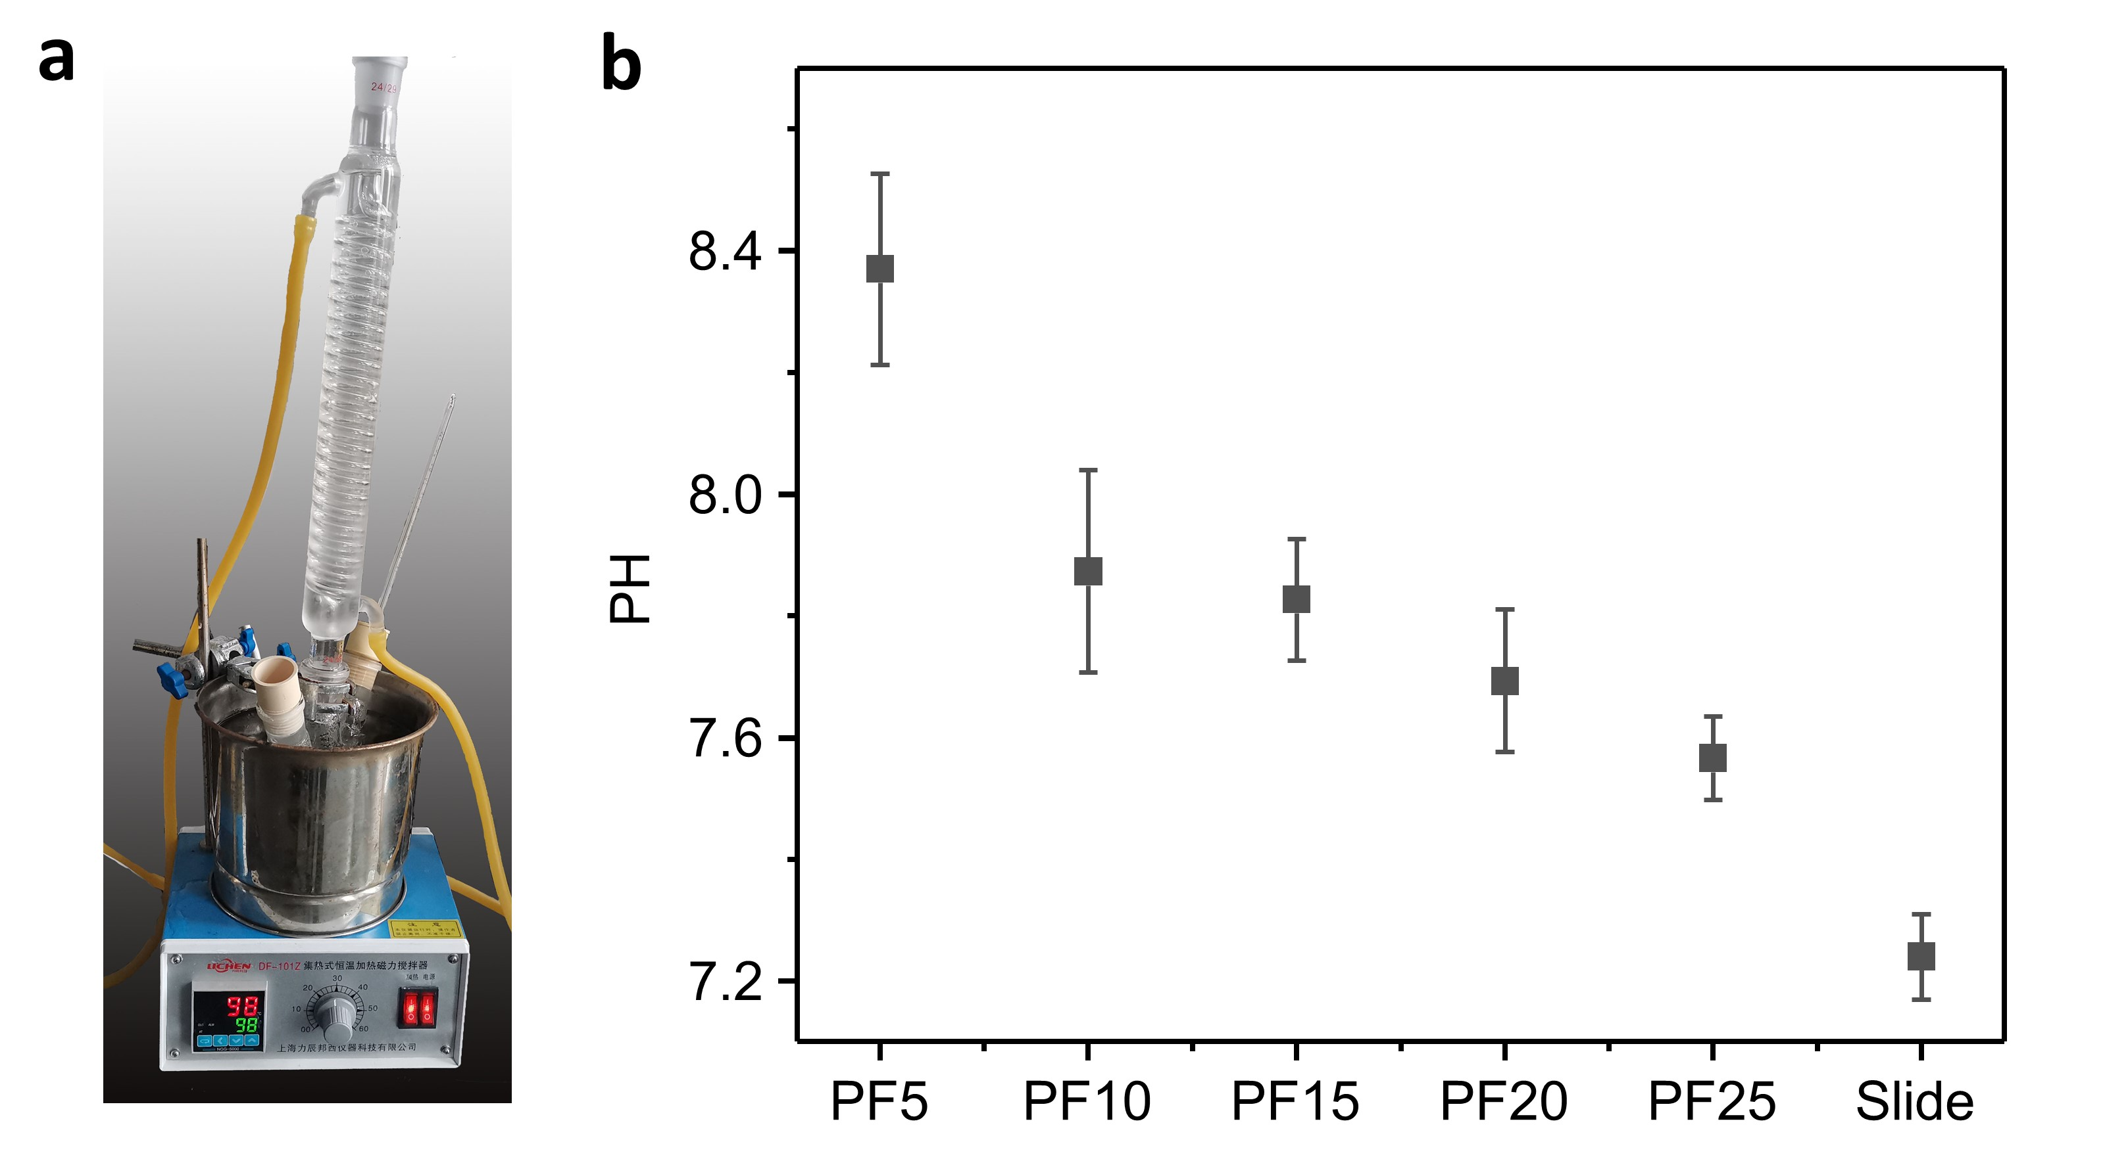

Fig S7 a The experimental setup for chemical stability; b pH values of leachate solutions from tested glasses after 150 Minutes at 98 °C.

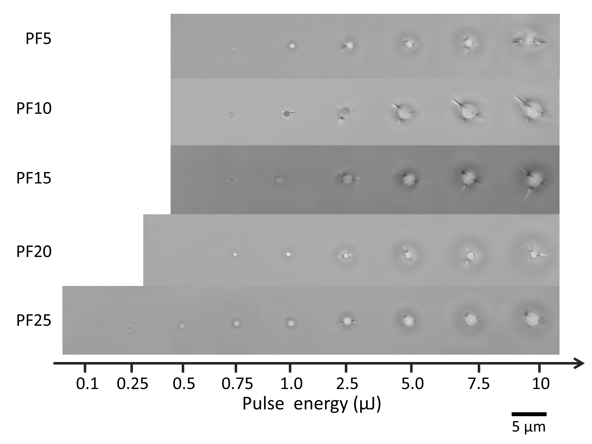

Fig S8 Optical images of the PFx glasses under various pulse energies.

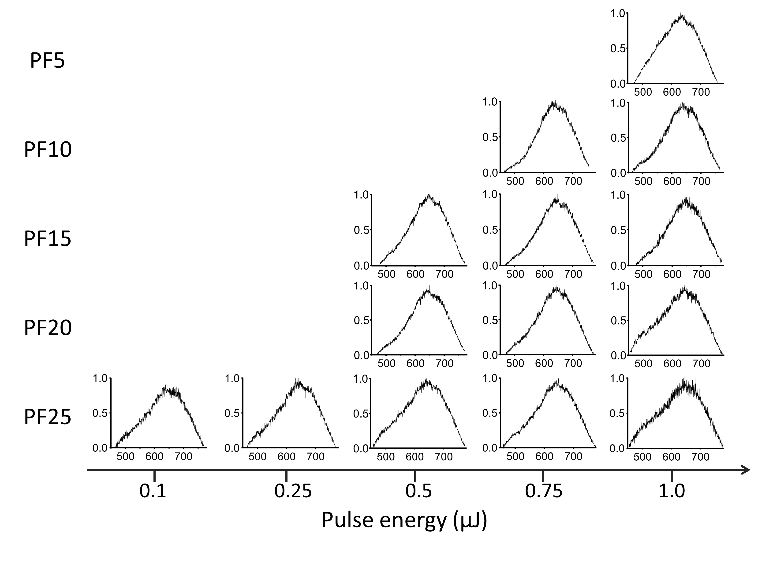

Fig S9 PL spectra of dots written below 1 µJ, the horizontal and vertical axis is the wavelength and normalized PL intensity, λ_{exc} = 405 nm.

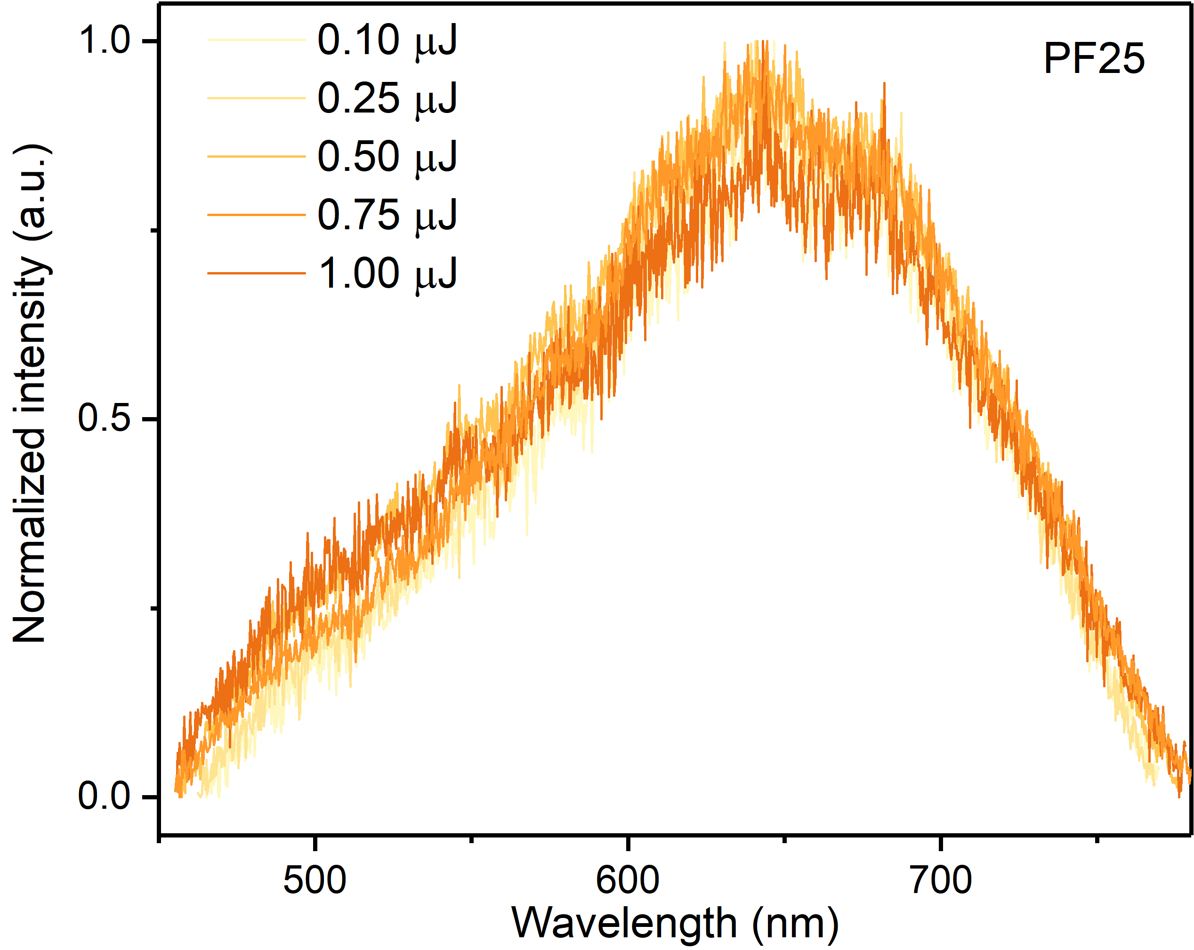

Fig S10 PL spectra of dots written by different laser energy in PF25, λ_{exc} = 405 nm
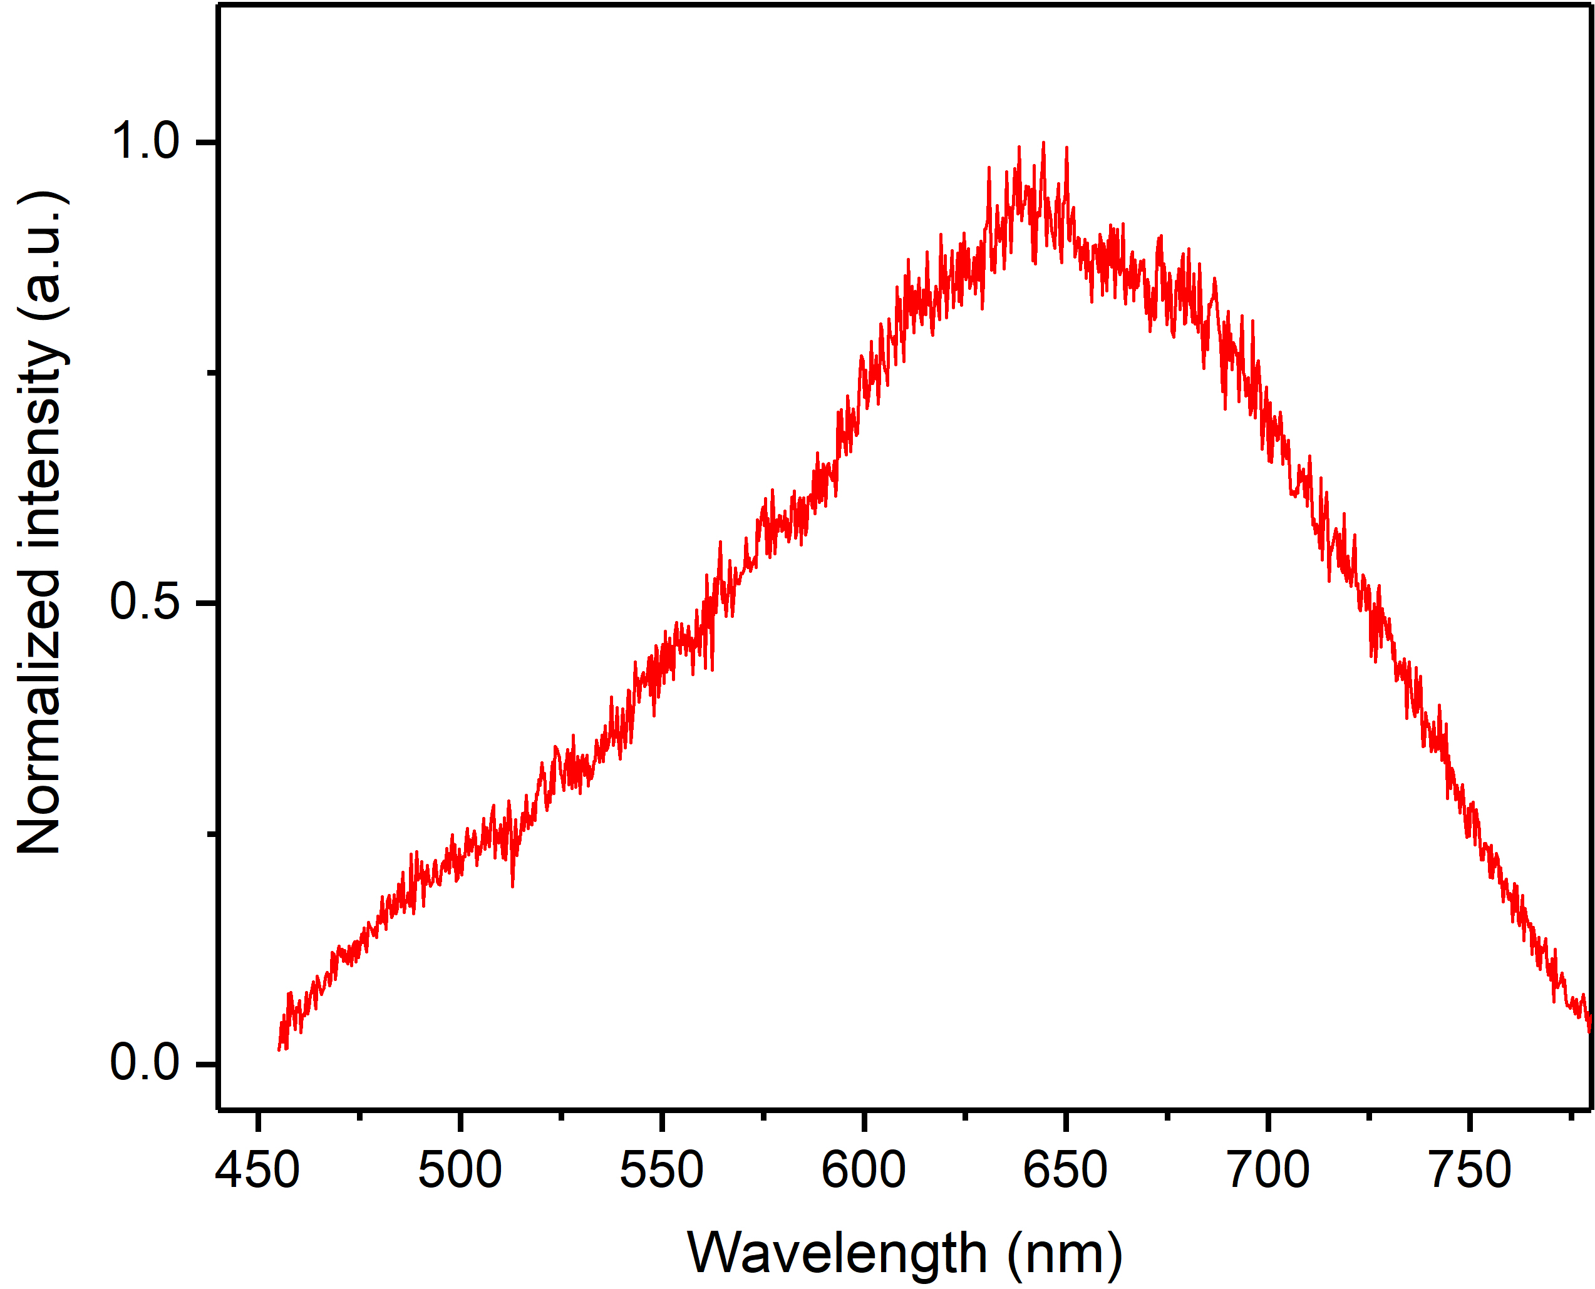

Fig S11 PL spectra of outer ring written by 10 µJ in PF25, λ_{exc} = 405 nm.

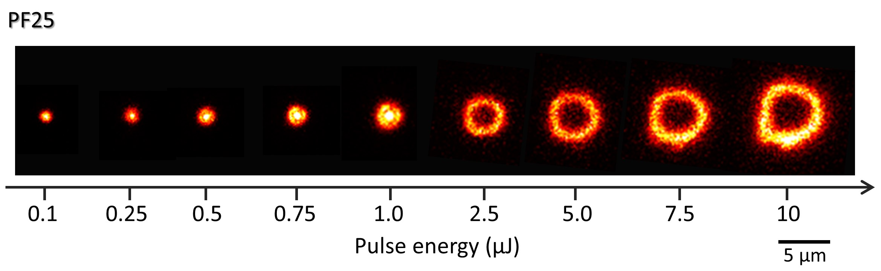

Fig S12 Confocal microscopic image of PF25 in Fig 2a after annealing at 400 °C for 12 hours, λ_{exc} = 405 nm.

Note S3
Defects in glass refer to the points of unsatisfied electron valence, which has unpaired electrons that could resonate at a certain magnetic field under EPR scan. ^{16, 17, 18, 19} According to investigations before, PF glasses share similar defects as their phosphate counterparts because fluorine-related defects are unstable.²⁰ In present case, the g factor can be calculated from the equation:
hν = gHβ
where h = 4.135×10⁻¹⁵ eV is the Planck constant, ν = 9.40 GHz is the microwave frequency of X-band spectrometer, H is the magnetic field, and β = 5.788×10⁻⁵ eV·T⁻¹ is the Bohr magneton. The g factor is determined to be 2.008, which is larger than that of the free electrons (2.002), indicating the formation of hole-type defects within the DLW area.²¹

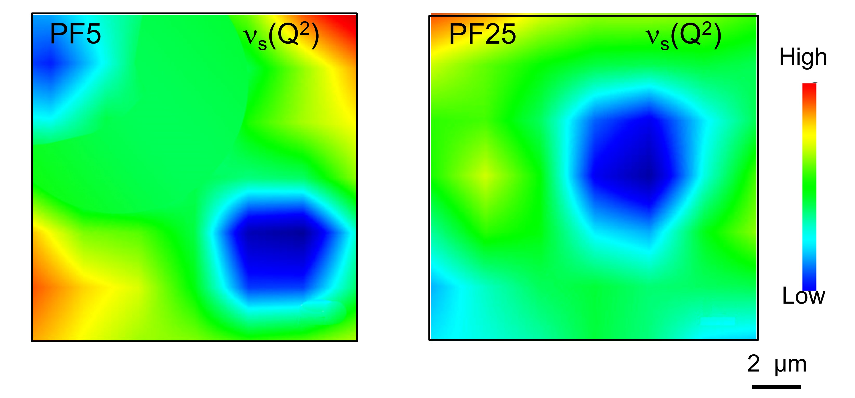

Fig S13 Raman mapping of ν_{s}(Q²) band in PF5 and PF25.

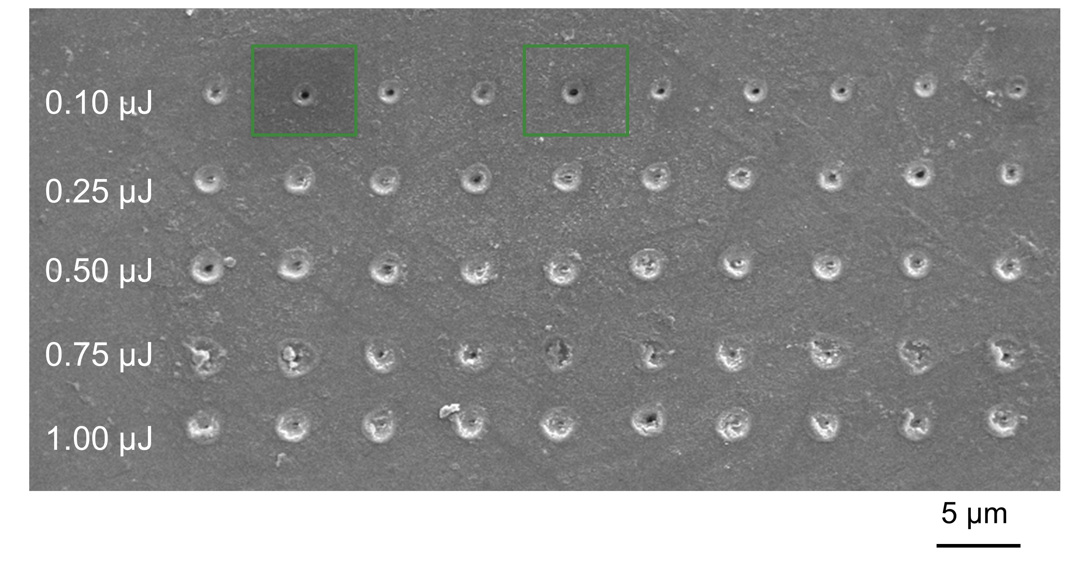

Fig S14 SEM image of PL dots writing under various pulse energy with a focus on a depth of 1 µm beneath the glass surface in PF25, and two green-squared regions are selected for APT specimens.
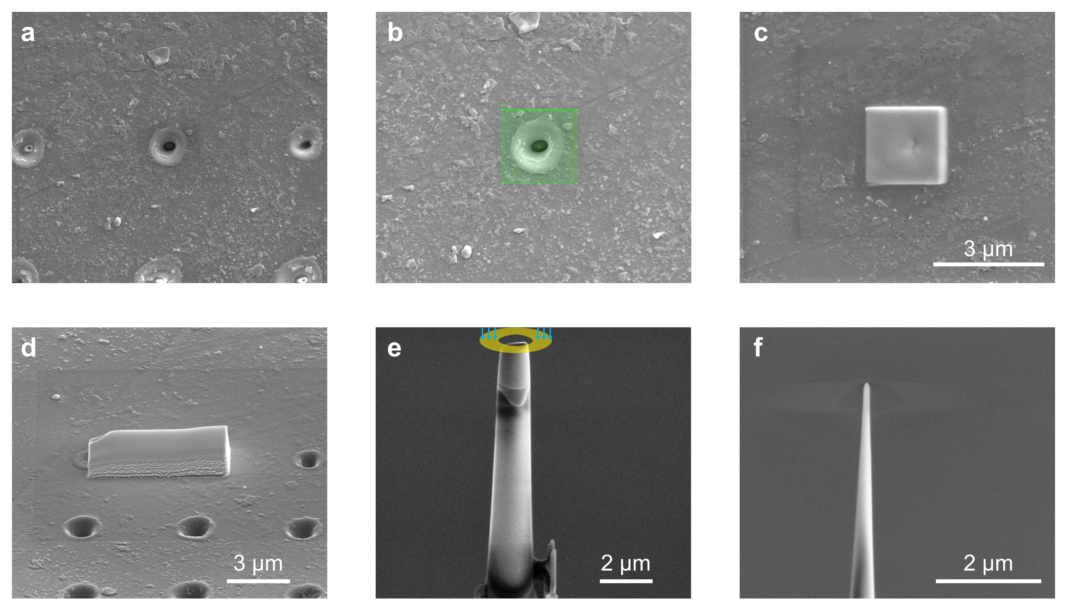

Fig S15 FIB-based w-DLW specimen preparation for APT analysis: a-b SEM images of the region of interest (ROI); c-d a protective Pt cap over the ROI; e sharpening of the tip anchored on Si microtip by annular milling patterns; f final FIB-cut needle specimen of w-DLW ready for APT test.

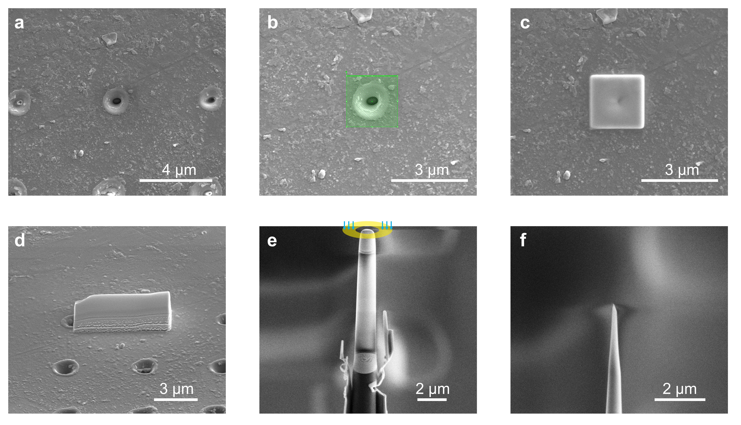

Fig S16 FIB-based w/o-DLW specimen preparation for APT analysis: a-b SEM images of the region of interest (ROI); c-d a protective Pt cap over the ROI; e sharpening of the tip anchored on Si microtip by annular milling patterns; f final needle specimen of w/o-DLW ready for APT test.
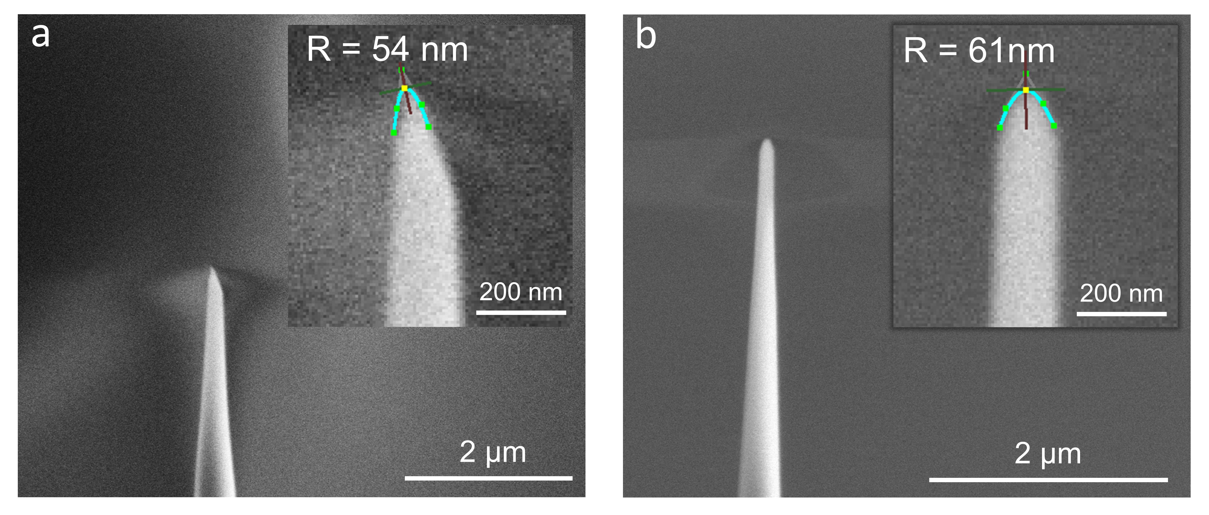

Fig S17 The low- and high-magnification SEM images of w/o-DLW (a) w -DLW (b) for APT. The green and brown line was the tangent and the normal vector, R was the radius of curvature at the tip apex.
Due to the lack of noticeable imaging contrast between w-DLW and w/o DLW, tip preparation was carefully taken to differentiate these two regions. To ensure coverage of the laser processing areas, a shallow grinding process was applied during the sample preparation for the w-DLW sample (Fig S15(e)). As a result, the apex of the w-DLW sample exhibited a relatively larger radius of curvature (R = 61 nm, Fig S17(b)). Conversely, the sample without DLW (w/o DLW) underwent a deeper milling process to exclude the DLW region (Fig S16(e)), resulting in a sharper needle tip with a smaller radius of curvature (R = 54 nm, Fig S17(a)).

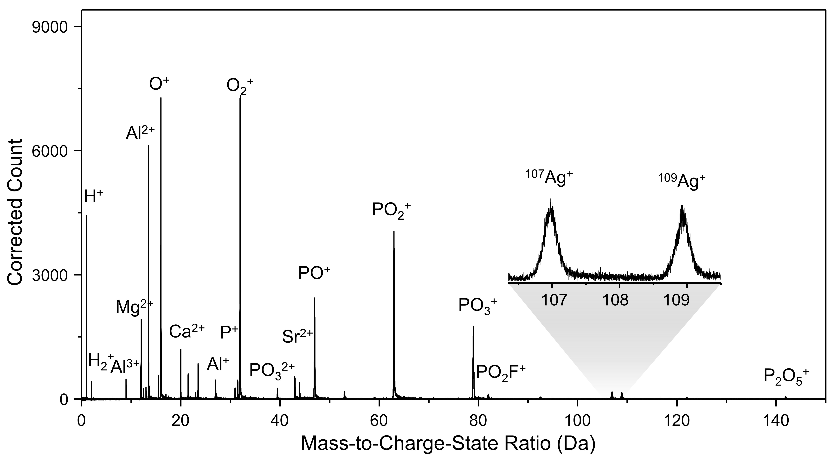

Fig S18 Mass spectrum of w/o DLW tip.

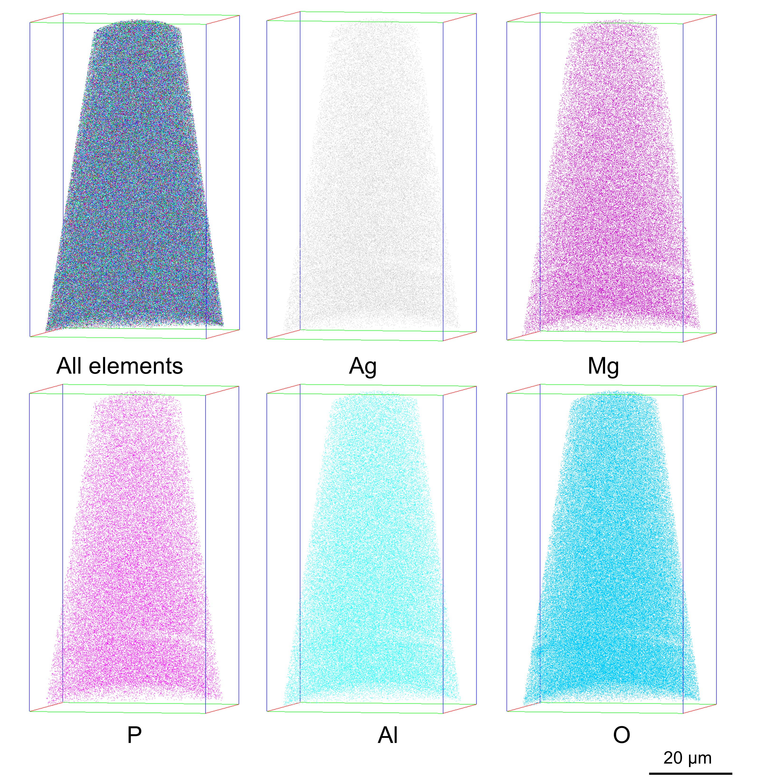

Fig S19. APT reconstruction of different ions in the w/o-DLW tip, the volume of tip was 537574 nm³.
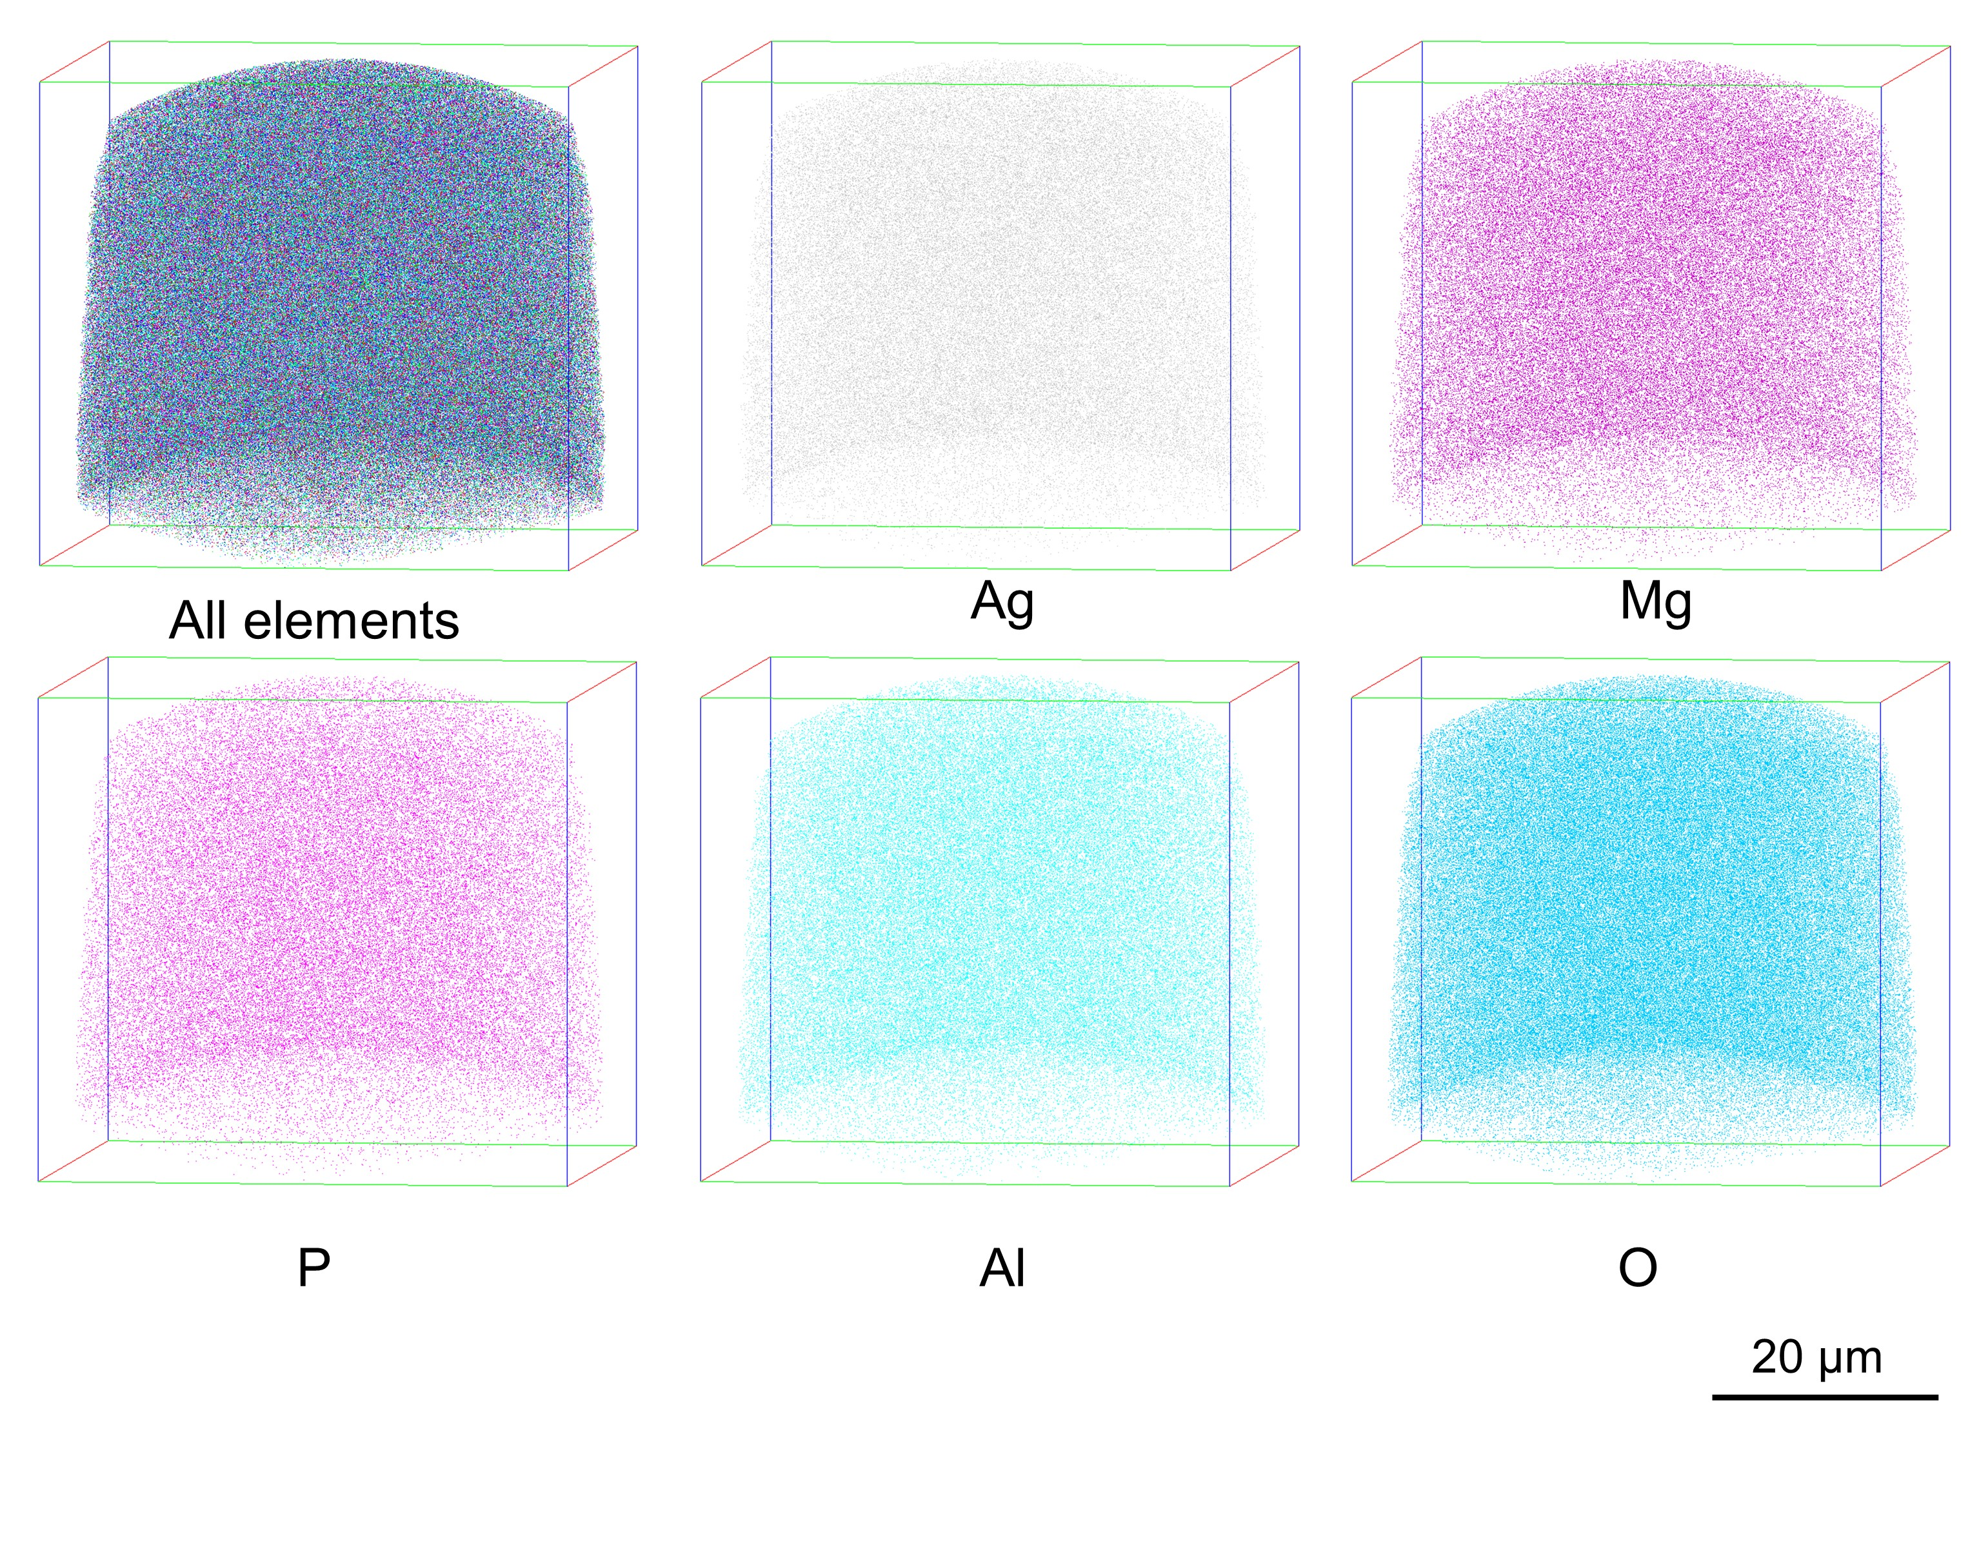

Fig S20. APT reconstruction of different ions in the w-DLW tip, the volume of tip was 57821 nm³.

Note S4
The maximum separation method (MSM) is a widely used clustering algorithm in APT. ^{22, 23} It works on the premise that the distance between two nearest-neighbor solute atoms in a cluster is shorter than that in the matrix. (Fig S21(a)). Additionally, a user-defined parameter known as the minimum number of solute atoms (N_{min}), representing the minimum requirement for an entity to be classified as a cluster, is also utilized. Then the algorithm groups together atoms that are separated by no more than a distance d_{max} (Fig S21(b)). Further, if one of this pair is also connected to another solute, then all three can be designated as part of the same cluster (Fig S21(c)). In this way, a larger network of linked solutes can be built, ultimately, defining a population of clusters (Fig S21(d))
To determine the optimal value of d_{max}, we followed the procedure used in previous study, where the number of clusters against different values of d_{max} was plotted. ²⁴ The optimum d_{max}, was determined by locating the peak of the curve (as shown in Fig S22, where d_{max} = 0.53 nm). This choice avoided splitting a cluster into smaller ones by setting d too small, or including matrix atoms as part of a cluster by setting d too large. In the present study, the values of d_{max}, and N_{min} were set at 0.53 and 2.
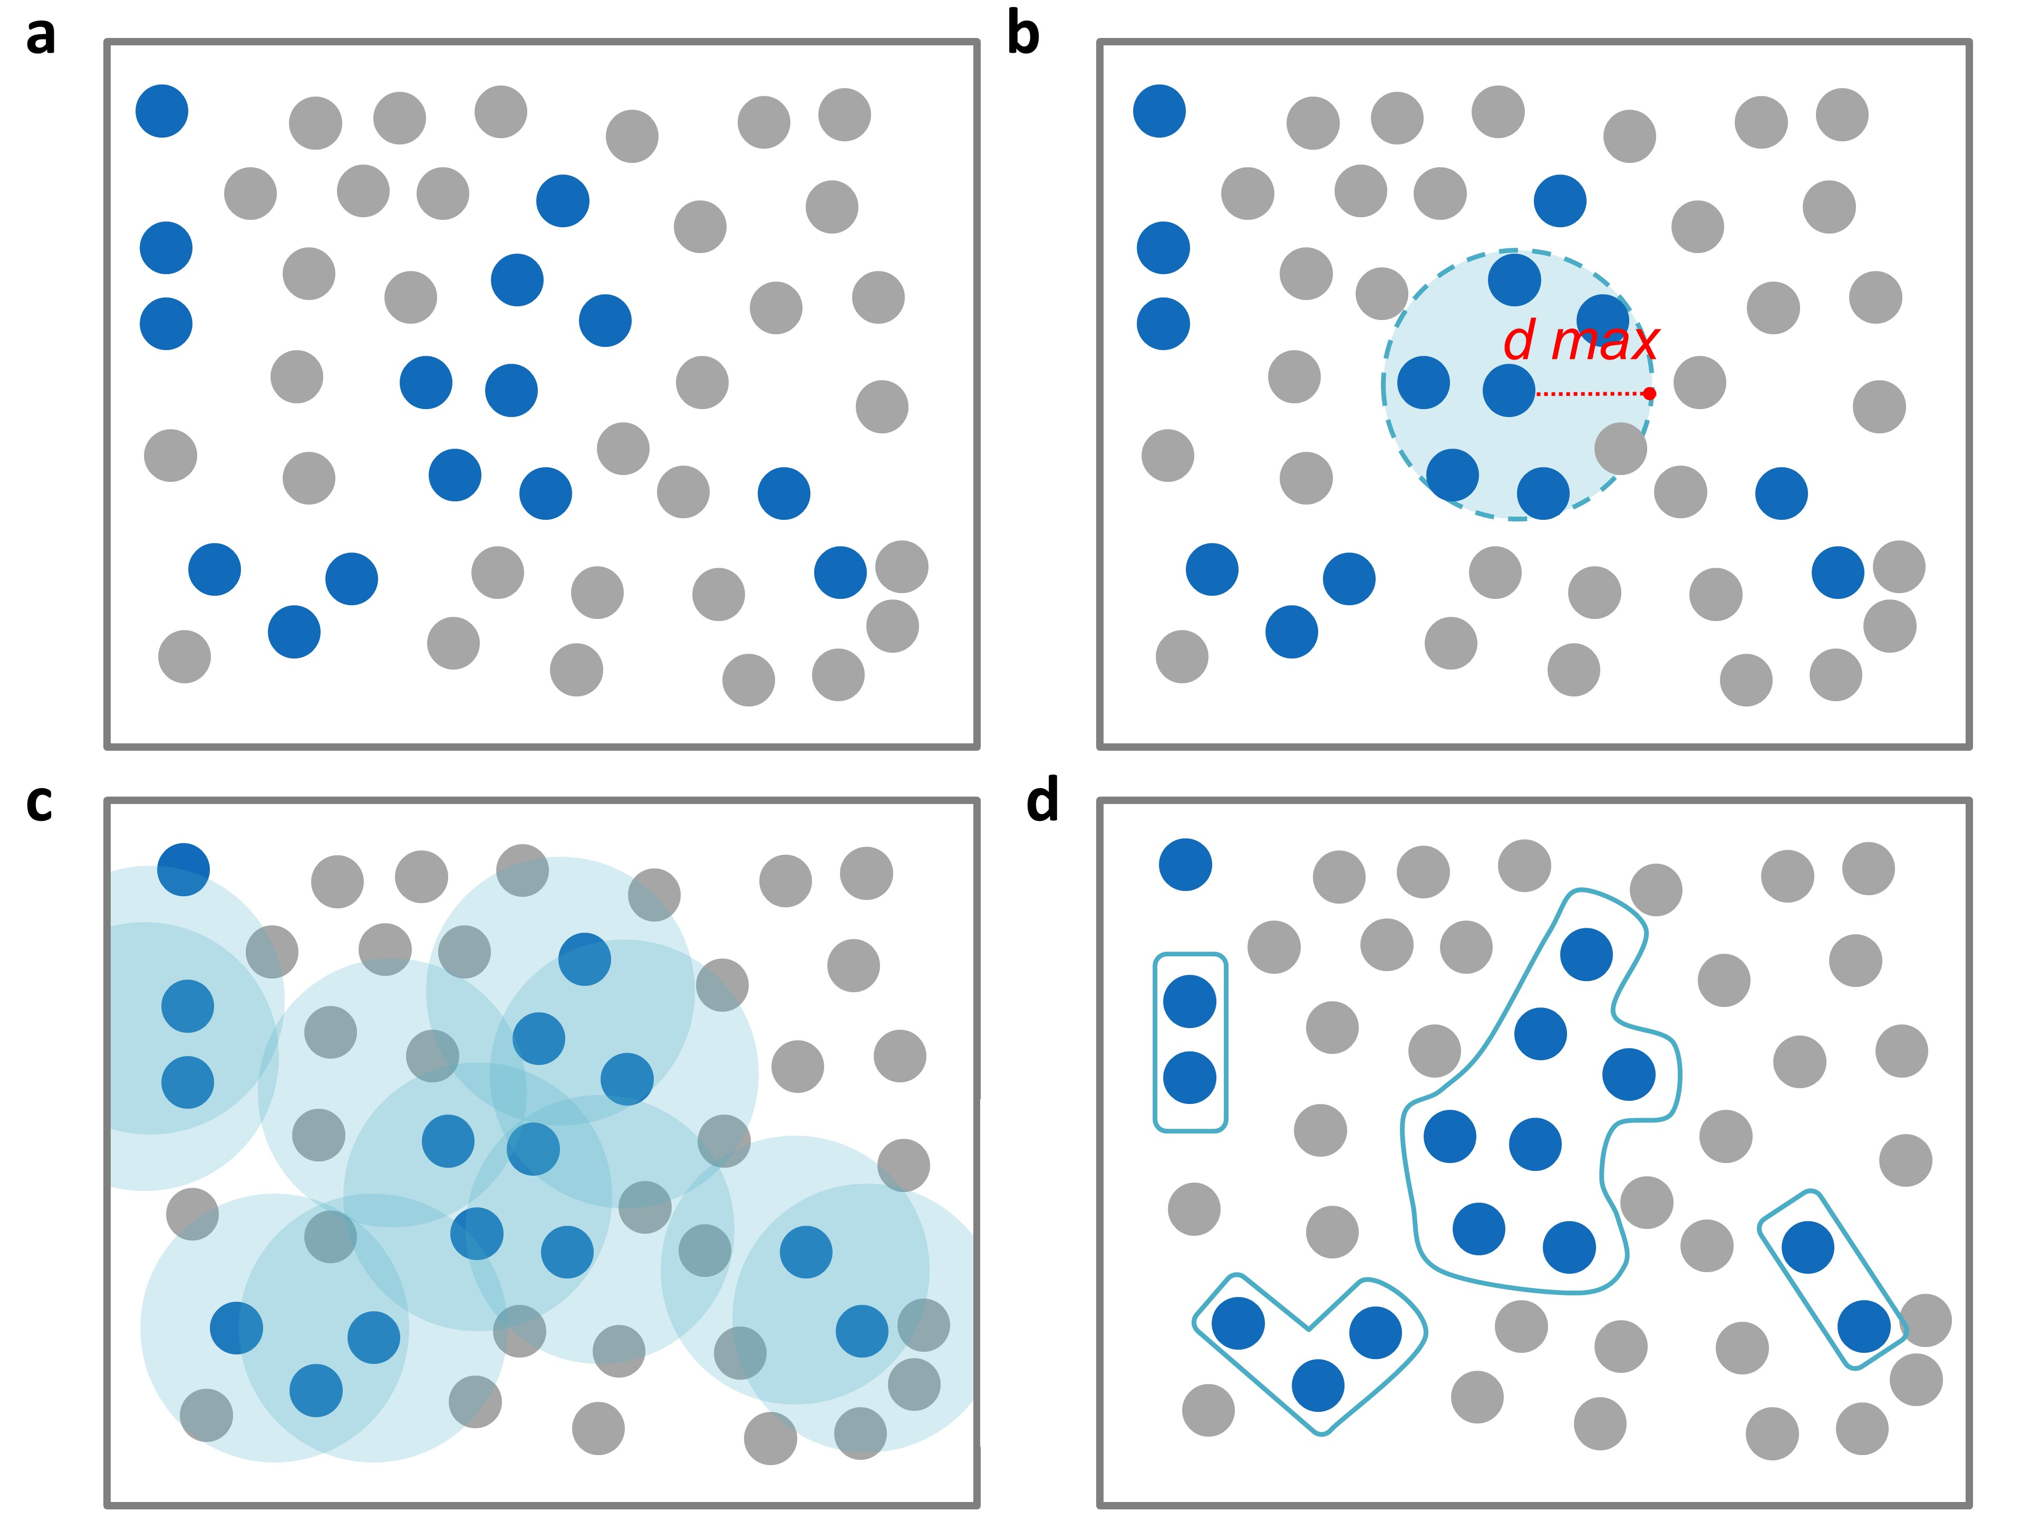

Fig S21 The schematic drawing of Maximum separation method: a Solute (blue) and matrix (gray) atom; b Maximum separation concept looks for nearest-neighbors within a given distance of d_{max}; c Link nearest-neighbor atoms of separation distance less than d_{max}; d Group linked atoms into individual clusters

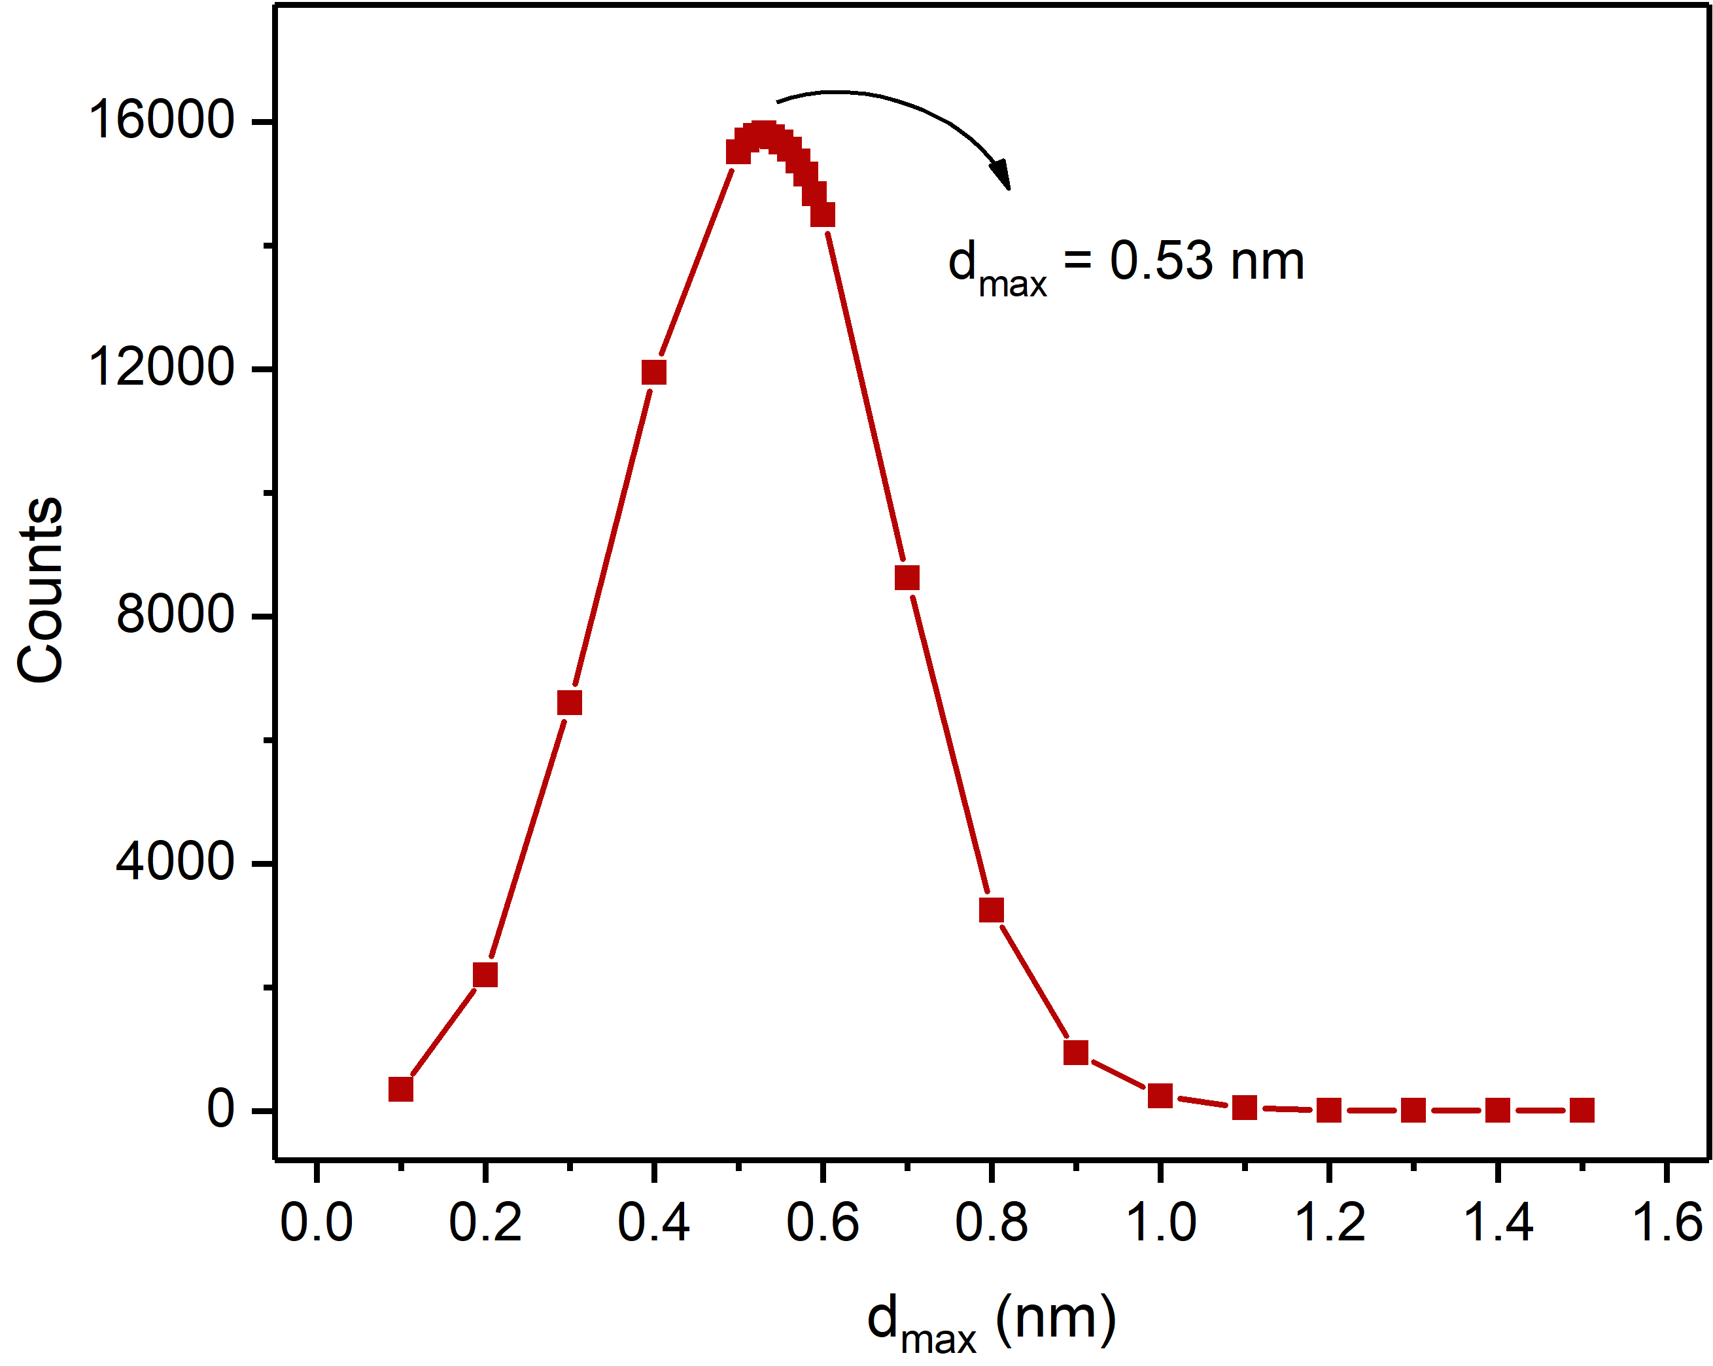

Fig S22 Counts of Ag QCs as a function of maximum separation distance (d_{max}) during MSM analysis of w-DLW

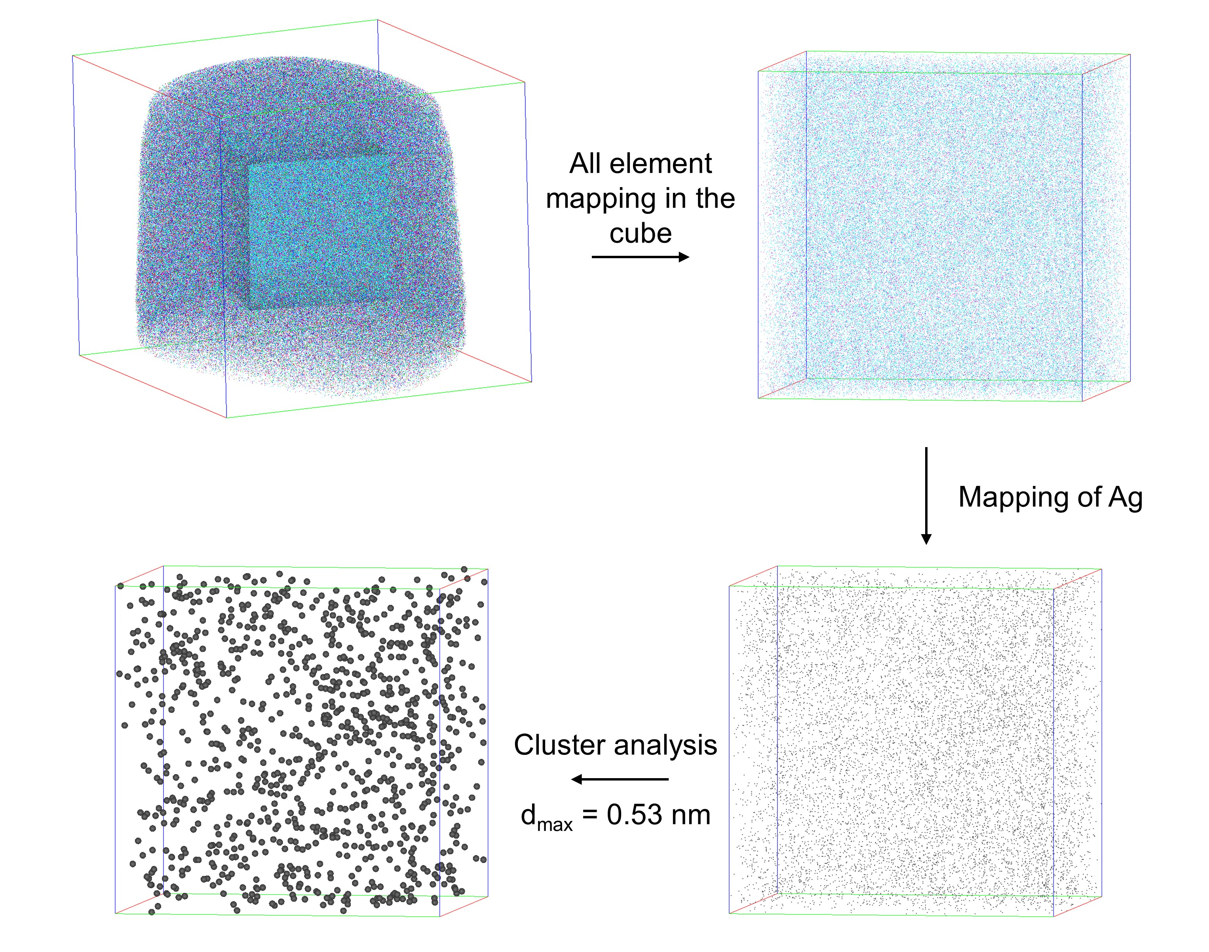

Fig S23 Schematic diagram of Ag QCs analysis based on the maximum separation method.

References
1. Ainsworth RI, Christie JK, de Leeuw NH. On the structure of biomedical silver-doped phosphate-based glasses from molecular dynamics simulations. Phys Chem Chem Phys 16, 21135-21143 (2014).
2. Zheng Q, et al. Understanding Glass through Differential Scanning Calorimetry. Chem Rev 119, 7848-7939 (2019).
3. Shaharyar Y, et al. Structure-solubility relationships in fluoride-containing phosphate based bioactive glasses. J Mater Chem B 3, 9360-9373 (2015).
4. Tauc J. Optical properties and electronic structure of amorphous Ge and Si. Mater Res Bull 3, 37-46 (1968).
5. Tauc J, Menth A. States in the gap. J Non-Cryst Solids 8, 569-585 (1972).
6. Hoffmann R. How Chemistry and Physics Meet in the Solid State. Angew Chem Int Ed 26, 846-878 (1987).
7. de Ligny D, Möncke D. Colors in Glasses. In: Springer Handbook of Glass (eds Musgraves JD, Hu J, Calvez L). Springer International Publishing (2019).
8. Kranjčec M, Studenyak IP, Kurik MV. On the Urbach rule in non-crystalline solids. J Non-Cryst Solids 355, 54-57 (2009).
9. Danto S, et al. Photowritable Silver‐Containing Phosphate Glass Ribbon Fibers. Adv Opt Mater 4, 162-168 (2015).
10. Fletcher LB, et al. Femtosecond laser writing of waveguides in zinc phosphate glasses [Invited]. Opt Mater Express 1, 845-855 (2011).
11. Hernandez-Rueda J, Troy NW, Freudenberger P, Brow RK, Krol DM. Femtosecond laser-matter interactions in ternary zinc phosphate glasses. Opt Mater Express 8, 3622-3634 (2018).
12. Das CR. A Review of the Chemical Resistance of Glass. T Indian Ceram Soc 24, 12-23 (2014).
13. Strachan DM. Glass dissolution: testing and modeling for long-term behavior. J Nucl Mater 298, 69-77 (2001).
14. Yue Y, Tuheen MI, Du J. Borosilicate Glasses. In: Encyclopedia of Materials: Technical Ceramics and Glasses (ed Pomeroy M). Elsevier (2021).
15. Brow RK. Review: the structure of simple phosphate glasses. J Non-Cryst Solids 263, 1-28 (2000).
16. Fares H, et al. Highly luminescent silver nanocluster-doped fluorophosphate glasses for microfabrication of 3D waveguides. RSC Adv 7, 55935-55944 (2017).
17. Liu XY, Guo H, Ye S, Peng MY, Zhang QY. Enhanced tunable color emission in transparent Ag/Mn2+codoped zinc borate glasses for broad band light source. J Mater Chem C 3, 5183-5191 (2015).
18. Skuja L, Hirano M, Hosono H, Kajihara K. Defects in oxide glasses. Phys Stat Sol 2, 15-24 (2005).
19. Espiau de Lamaestre R, Béa H, Bernas H, Belloni J, Marignier JL. Irradiation-induced Ag nanocluster nucleation in silicate glasses: Analogy with photography. Phys Rev B 76, 205431 (2007).
20. Möncke D, et al. Comparative spectroscopic investigation of different types of fluoride phosphate glasses. Phys Chem Glasses: Eur J Glass Sci Technol B 48, 399-402 (2007).
21. Laguta V, Buryi M, Nikl M, Zeler J, Zych E, Bettinelli M. Electron and hole trapping in Eu- or Eu,Hf-doped LuPO4 and YPO4 tracked by EPR and TSL spectroscopy. J Mater Chem C 7, 11473-11482 (2019).
22. Devaraj A, et al. Three-dimensional nanoscale characterisation of materials by atom probe tomography. Int Mater Rev 63, 68-101 (2017).
23. Gault B, et al. Atom probe tomography. Nat Rev Methods Primers 1, (2021).
24. Zheng W, et al. Fluorescence–Phosphorescence Manipulation and Atom Probe Observation of Fully Inorganic Silver Quantum Clusters: Imitating from and Behaving beyond Organic Hosts. Adv Opt Mater 10, 2101632 (2021).

