Gankyrin inhibits ferroptosis through the P53/SLC7A11/GPX4 axis in Triple-negative breast cancer cells
Ming Lei^{1,2,*}，Yun-long Zhang^{2,*}, Feng-Ying Huang^{2,*}, Heng-Yu Chen¹, Ming-Hui Chen², Ri-Hong Wu², Shu-Zhen Dai², Gui-Sheng He^{1,#}, Guang-Hong Tan^{2,#}, Wu-Ping Zheng^{1,#}
¹Department of Breast and Thyroid Surgery, The Second Affiliated Hospital, Hainan Medical University, Haikou 570311, China.
²Key Laboratory of Tropical Translational Medicine of Ministry of Education & School of Tropical Medicine, Hainan Medical University, Haikou 571199, China.
* These authors contributed equally to the work
#Corresponding Authors:
Wu-Ping Zheng: hnzwp2000@163.com
Gui-Sheng He: 512688772@qq.com
Guang-Hong Tan: tanhoho@163.com

Supplementary Figures and legends
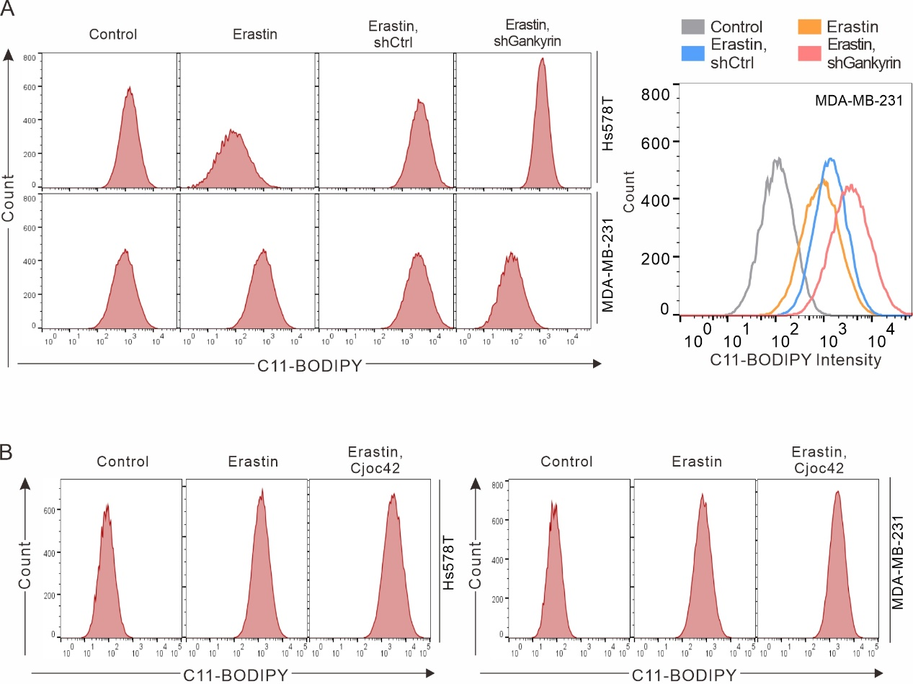
Figure S1. (A) Representative images of the flow cytometry results from three repeated experiments, related to Figure 2D. (B) Representative images of the flow cytometry results from three repeated experiments, related to Figure 2G.

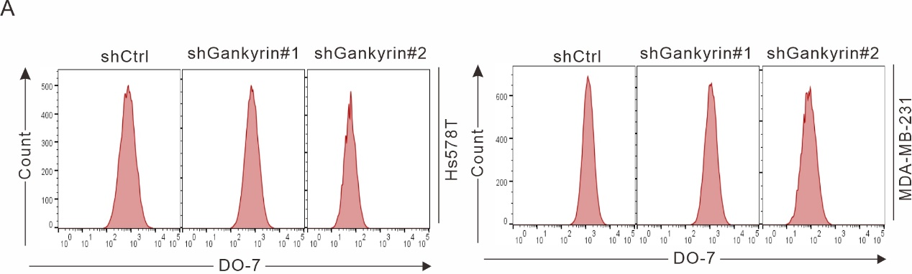
Figure S2. (A) Representative images of the flow cytometry results from three repeated experiments, related to Figure 3B.
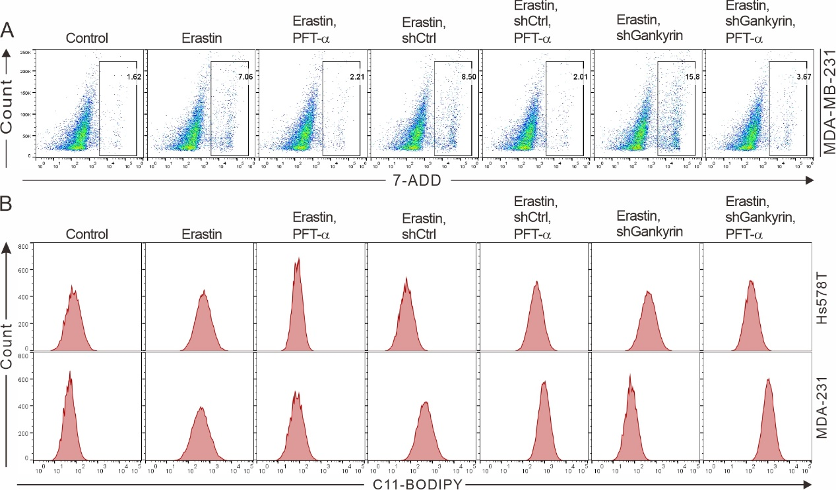
Figure S3. (A) Representative images of the flow cytometry results from three repeated experiments, related to Figure 4B. (B) Representative images of the flow cytometry results from three repeated experiments, related to Figure 4C.

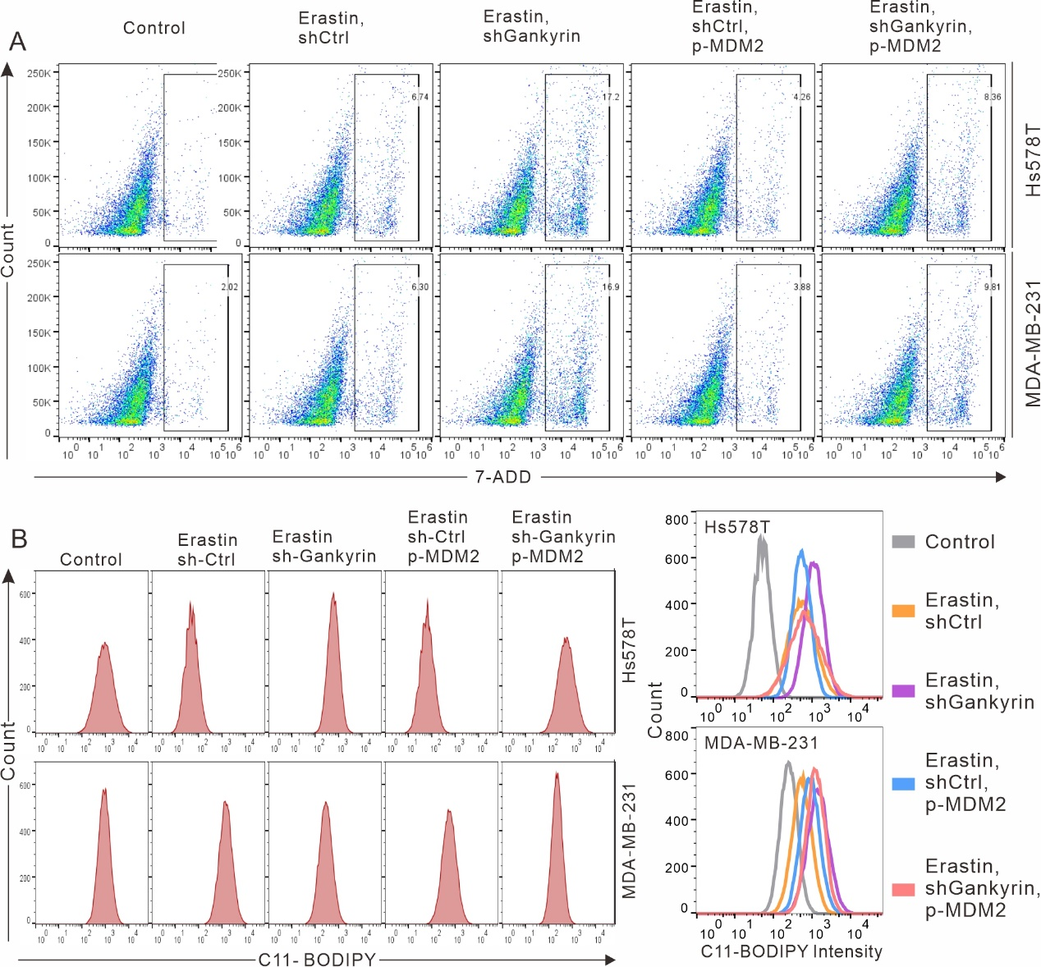
Figure S4. (A) Representative images of the flow cytometry results from three repeated experiments, related to Figure 6G. (B) Representative images of the flow cytometry results from three repeated experiments, related to Figure 6H.

Table S1: Primers Used for RT-qPCR Reaction
Gene | Forward (5’-3’) | Reverse (5’-3’)
Gankyrin | CTGGCCGGGATGAGATTGTAAAAG | CGGTGCATTGCTGTAGCCTCATAA
P53 | CACGAGCTGCCCCCAGG | TCAGTCGACGTCTGAGT
SLC7A11 | GCTGTGATATCCCTGGCATT | GGCGTCTTTAAAGTTCTGCG
GPX4 | AGAGATCAAAGAGTTCGCCGC | TCTTCATCCACTTCCACAGCG
β-actin | CCCAAGGCCAACCGCGAGAAGATG | GTCCCGGCCAGCCAGGTCCAGA

Table S2：Sequences of 3 designed shRNA-Gankyrin
Gene | Sequences
shRNA1-f | 5’-GATCCGCCGATAAATCCCTGGCTACTTCCTGTCAGATAGCCAGGGATTTATCGGCTTTTTG-3’
shRNA1-r | 5’-AATTCAAAAAGCCGATAAATCCCTGGCTATCTGACAGGAAGTAGCCAGGGATTTATCGGCC-3’
shRNA2-f | 5’-GATCCGGCTGTACTCCCTTACATTCTTCCTGTCAGAAATGTAAGGGAGTACAGCCTTTTTG-3’
shRNA2-r | 5’-AATTCAAAAAGGCTGTACTCCCTTACATTTCTGACAGGAAGAATGTAAGGGAGTACAGCCC-3’
NC-f | 5’-GATCCGAAGCCAGATCCAGCTTCCCTTCCTGTCAGAGGAAGCTGGATCTGGCTTCTTTTTG-3’
NC-r | 5-AATTCAAAAAGAAGCCAGATCCAGCTTCCTCTGACAGGAAGGGAAGCTGGATCTGGCTTCC-3’
Abbreviations: f, forward; r, reverse; shRNA, short hairpin RNA.

