Table 1. Demographic data from patients with distal radius fracture and traumatic TFCC injury
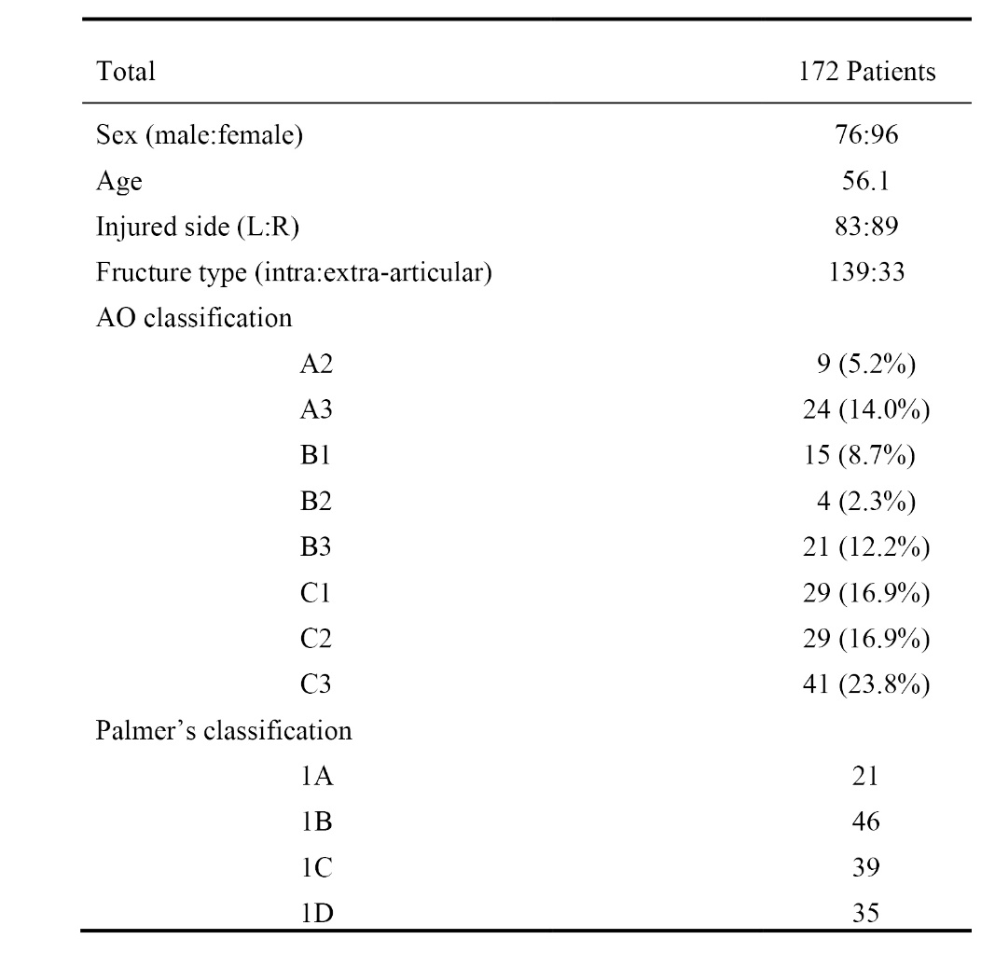
L, left; R, right; AO, arbeitsgemeinschaft fur osteosynthesfragen.

Table 2. Incidence and classification of TFCC injury in uninured and injured group.
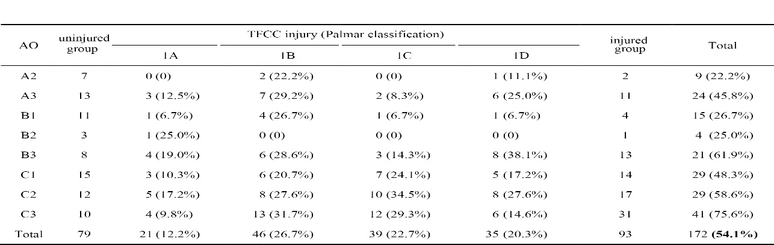
AO, arbeitsgemeinschaft fur osteosynthesfragen; TFCC, triangular fibrocartilage complex.

Table 3. Comparing of the demographic data and radiologic parameter of the two groups
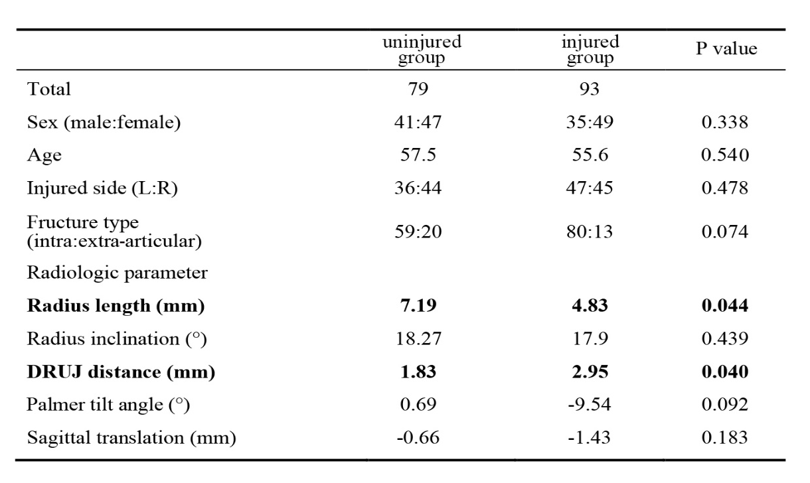
Radius length and DRUJ distance had significant relevance with TFCC injury in distal radius fracture (Student’s t-test, p < 0.05). L, left; R, right; DRUJ, distal radioulnar joint.

Table 4. Comparing radius length and DRUJ distance of different type of TFCC injury
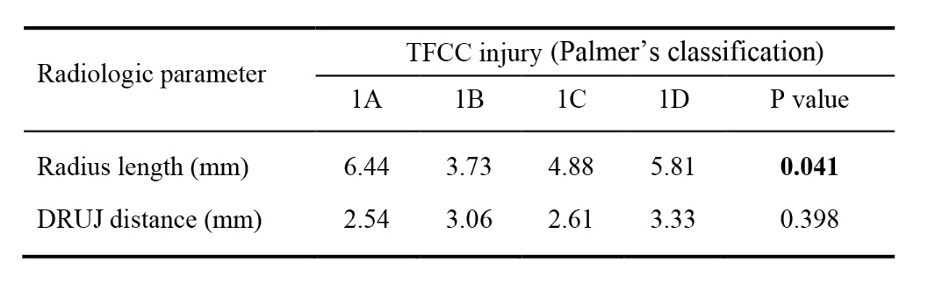
Radius length differed in different types of TFCC injury which showed shorter in type 1B (ANOVA, p < 0.05). TFCC, triangular fibrocartilage complex; DRUJ, distal radioulnar joint.

