Supplementary Materials
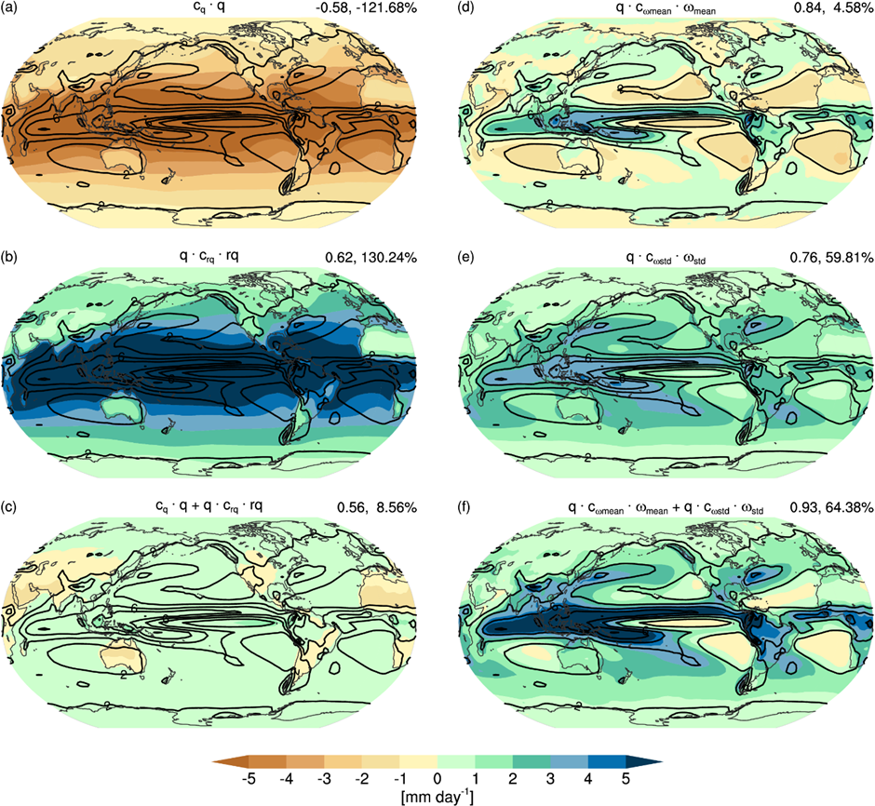
Figure S1: Same as in Fig. 3, but for CMIP5 multimodel mean.

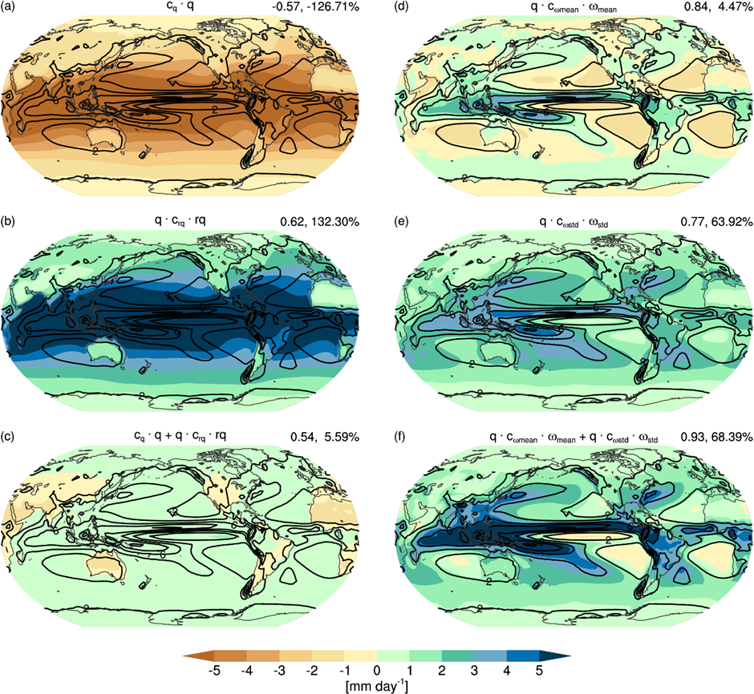
Figure S2: Same as in Fig. 3, but for CMIP6 multimodel mean.

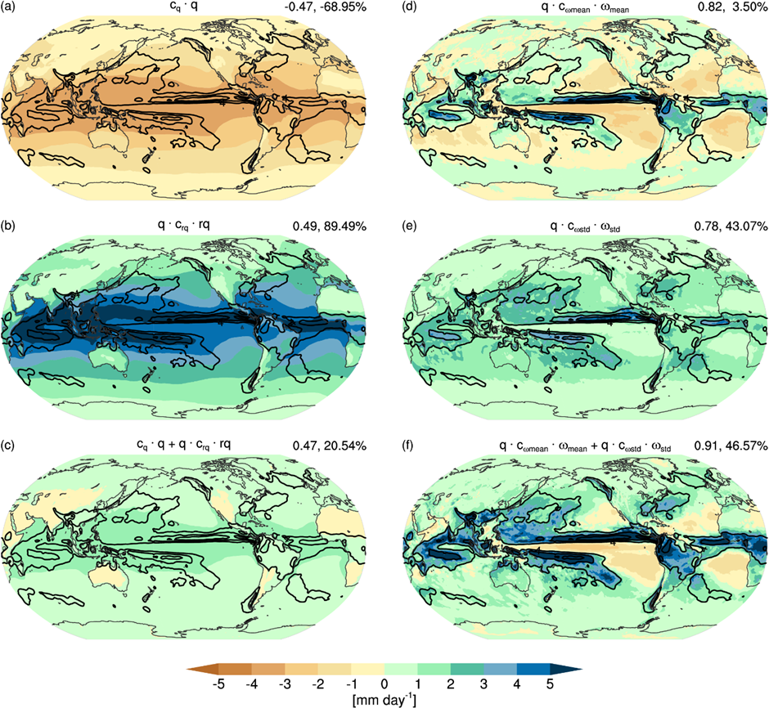
Figure S3: Same as in Fig. 3, but for ICON-Sapphire.

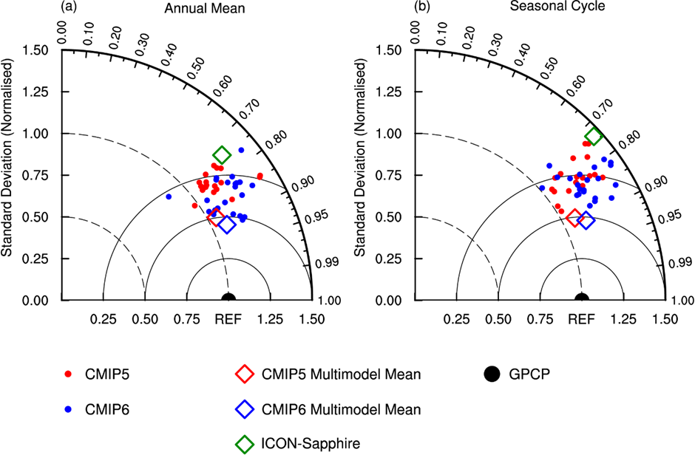
Figure S4: Taylor diagrams of (a) annual mean and (b) seasonal cycle of tropical precipitation in the individual CMIP5 (red dots) and CMIP6 (blue dots) models, the CMIP5 (red diamond) and CMIP6 (blue diamond) multimodel means, and ICON-Sapphire (green diamond) against the observed precipitation from GPCP (black dot).

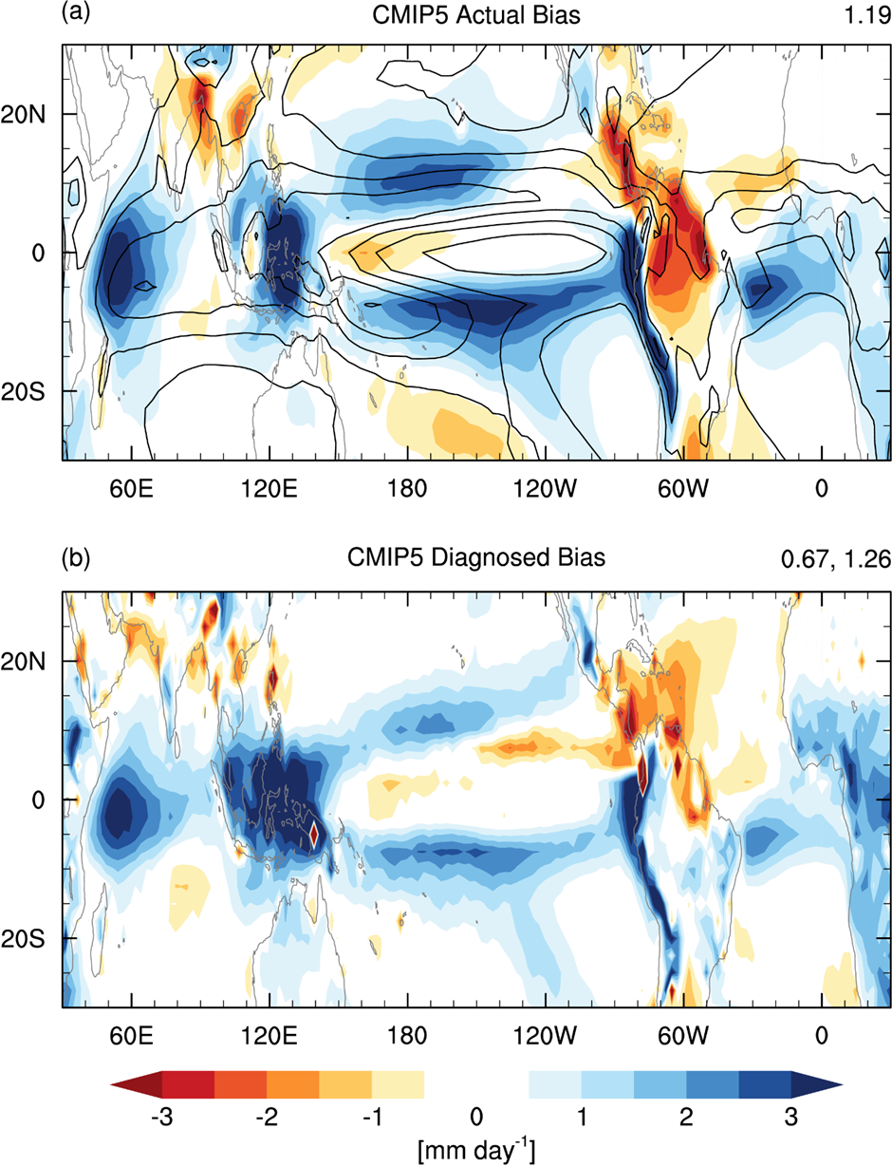
Figure S5: Same as in Figs. 4a,c, but for CMIP5 multimodel mean.

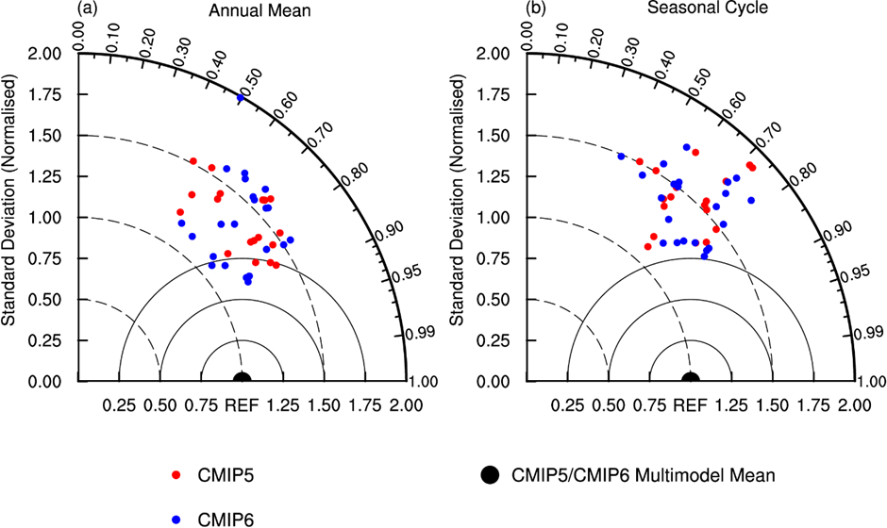
Figure S6: Taylor diagrams of tropical precipitation bias in (a) annual mean and (b) seasonal cycle in the individual CMIP5 (red dots) and CMIP6 (blue dots) models, with the bias in CMIP5/CMIP6 multimodel mean precipitation as reference (black dot).

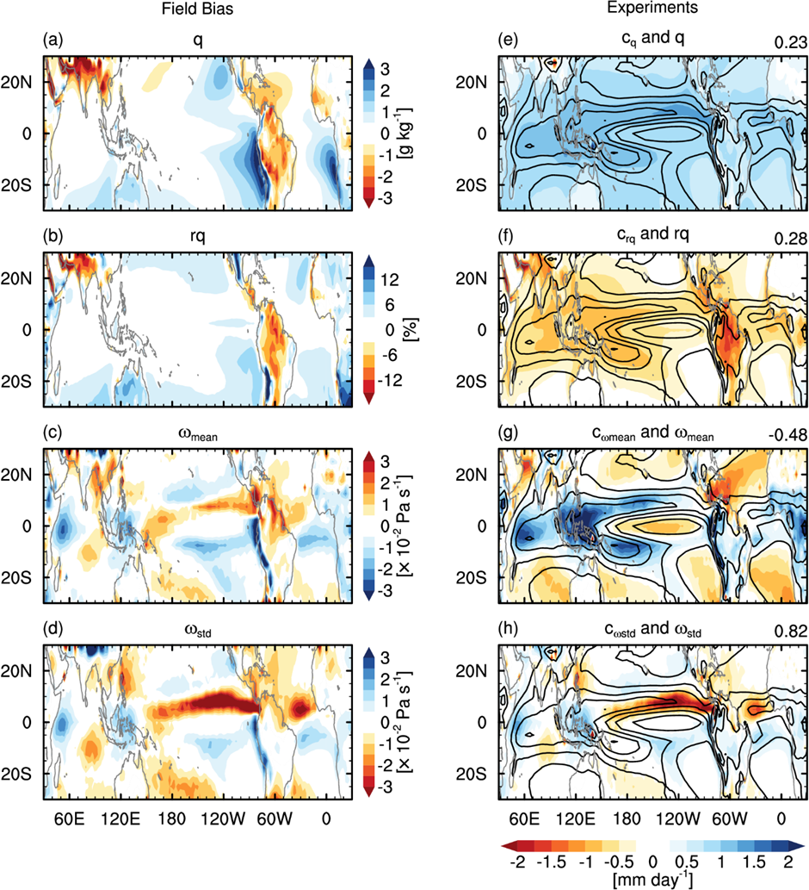
Figure S7: Same as in Fig. 7, but for CMIP5 multimodel mean.

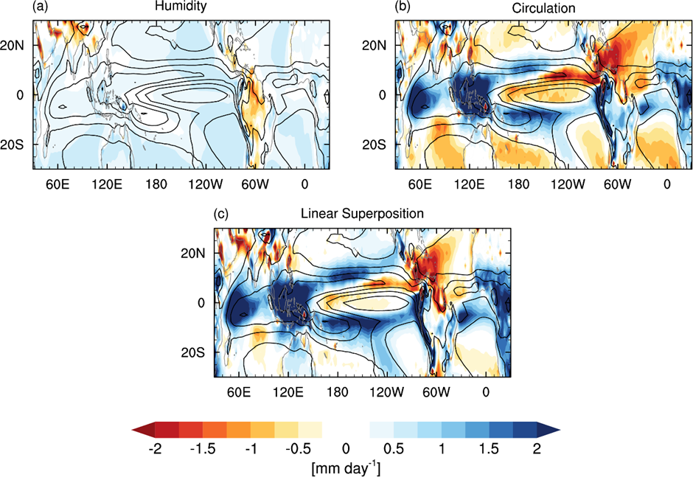
Figure S8: Same as in Fig. 8, but for CMIP5 multimodel mean.

