Supplementary Information

Time-domain-filtered terahertz nanoscopy of intrinsic light-matter interactions
Xiaoqiuyan Zhang^{1,2}, Xin Zhang³, Zhuocheng Zhang^{1,2},Tianyu Zhang^{1,2}, Xingxing Xu^{1,2}, Fu Tang^{1,2}, Jing Yang^{4,5}, Jiakun Wang^{4,5}, Hui Jiang⁶, Zhaoyun Duan^{1,2}, Yanyu Wei^{1,2}, Yubin Gong^{1,2}, Hui Zhang^{4,5,*}, Peining Li,^{3,*} and Min Hu^{1,2,*}

¹ Terahertz Research Center, School of Electronic Science and Engineering, University of Electronic Science and Technology of China, Chengdu, 610054, China
² Key Laboratory of Terahertz Technology, Ministry of Education, Chengdu, 610054, China
³ Wuhan National Laboratory for Optoelectronics, School of Optical and Electronic Information, Huazhong University of Science and Technology, Wuhan, 430074, China.
⁴ Dept. of Archaeology, Cultural Heritage and Museology, School of Art and Archaeology, Zhejiang University, Hangzhou, 310028, China
⁵ Laboratory of Art and Archaeology Image, Zhejiang University, Hangzhou, Zhejiang, 310028, China
⁶ School of Materials and Energy, University of Electronic Science and Technology of China, Chengdu, 610054, China

*Corresponding author
(M. H.); E-mail address: hu_m@uestc.edu.cn
(P.-N. L.); E-mail address: lipn@hust.edu.cn
(H. Z.); E-mail address: huizhang@zju.edu.cn

Table of contents
Supplementary Note 1: Optical images of the cantilevered probes.
Supplementary Note 2: Propagation characteristics of surface waves on probes.
Supplementary Note 3: Calculate THz dielectric function of vermilion and red lead from far-field measurements.
Supplementary Note 4: THz near field spectroscopy of vermilion and red lead.
Supplementary Note 5: Hyperspectral nanoimaging of 50-μm ribbon antenna.
This PDF file includes:
Supplementary Note 1 to Note 5
References

Supplementary Note 1: Optical images of the cantilevered probes
The metal probe used in THz s-SNOM is produced by the U.S. commercial company Rocky Mountain Nanotechnology (RMN). Supplementary Fig. 1 shows the optical images of the probes RMN 25PtIr200B-H (L = 285 μm) and probes RMN 25PtIr500B-H (L = 620 μm) used in the experiment.
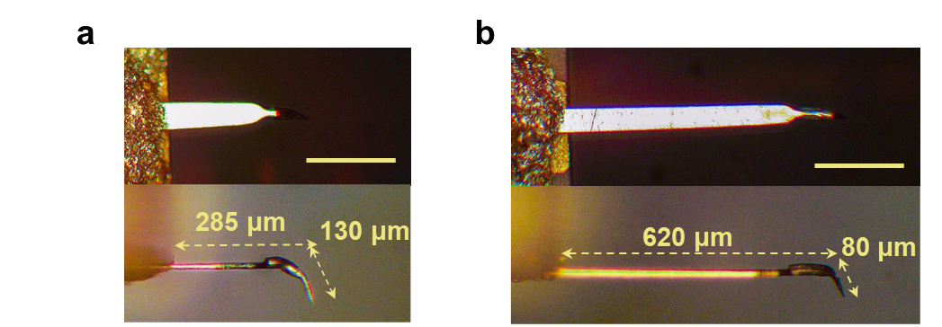
Supplementary Figure 1. The optical images of the front and side of probes RMN 25PtIr200B-H (L = 285 μm, panel a) and probes RMN 25PtIr500B-H (L = 620 μm, panel b).

Supplementary Note 2: Propagation characteristics of surface waves on probes
Supplementary Fig. 2 illustrates the normalized time-domain signals and spectra of 0_{th}-2_{nd} order pulses, along with the computed refraction index n_{tip} and extinction coefficient κ_{tip}. As the number of reflections increases, the time-domain pulse broadens and the frequency appears to be redshift. n_{tip} and κ_{tip} are calculated from the 0_{th} and 1_{st} pulse spectra^{1,2}.
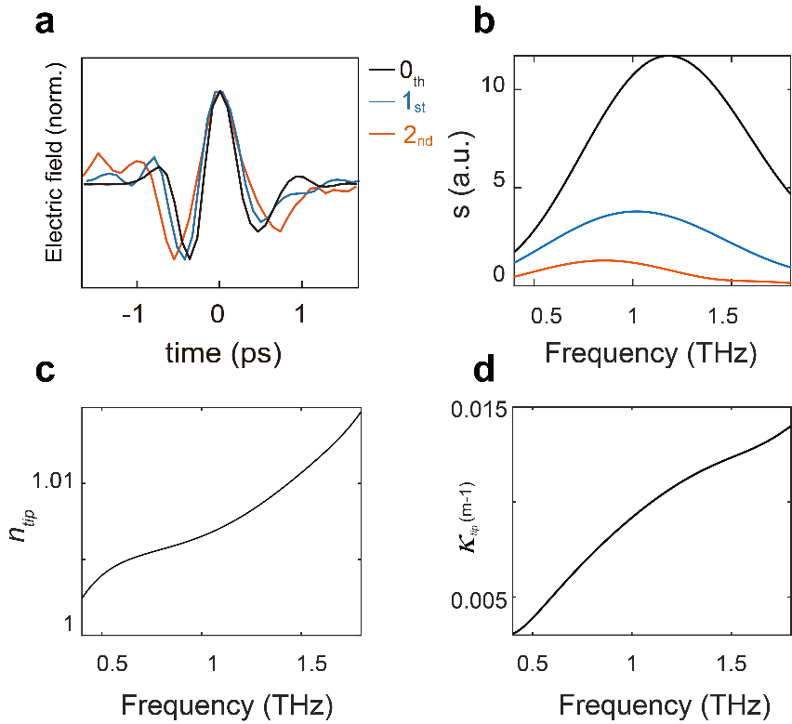
Supplementary Figure 2. a, Normalized near-field time-domain signals of 0_{th} -2_{nd} order pulses. b, Near-field spectra of 0_{th}-2_{nd} order pulses. c, d, n_{tip} and κ_{tip} computed by the 0_{th} and 1_{st} order pulses.

Supplementary Note 3: Calculate THz dielectric function of vermilion and rea lead from far-field measurements
Supplementary Fig. 3 shows the transmission time-domain signals and spectra of the vermilion and red lead pressed samples measured in the far field using dry air as the reference signal. The time-domain signals indicate that the resonances of both vermilion and red lead are behind the main pulse, so the probe filtering with a longer cantilever in the near-field measurements was able to extract more resonance signals. The transmission spectrum was used to calculate the dielectric permittivity. According to the basic methods used in transmission terahertz time-domain spectroscopy, we can calculate the complex dielectric permittivity by following formulas^{1,2}:
$$\frac{E_{sam}\left(ω\right)}{E_{ref}\left(ω\right)}=T\left(ω\right)exp\left[iφ\left(ω\right)\right]$$
$$n\left(ω\right)=1+\frac{c∙φ\left(ω\right)}{ωd}, α\left(ω\right)=\frac{2ω}{c}κ\left(ω\right)=-\frac{2}{d}ln\left[\frac{{\left[n\left(ω\right)+1\right]}^{2}}{4n\left(ω\right)}T\left(ω\right)\right]$$
$$ε(ω)=ε_{1}(ω)+iε_{2}(ω)={\left[n(ω)+iκ(ω)\right]}^{2}$$
where $E_{sam}\left(ω\right)$ and $E_{ref}\left(ω\right)$ are the TDS spectra of the sample and reference, and d is the thickness of the pressed sample.

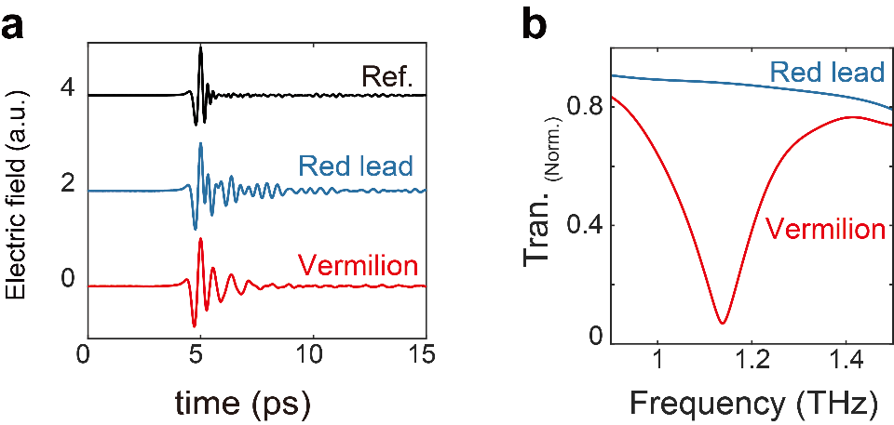
Supplementary Figure 3. Far-field time-domain signals (a) and spectra (b) of vermilion and red lead press samples measured by THz-TDS transmission.

Supplementary Note 4: THz near field spectroscopy of vermilion and red lead
Supplementary Fig. 4a and b show the near-field time-domain signals of red lead, vermilion and reference Si measured by L = 285 μm probe and L = 620 μm probe, respectively. The surface wave propagates over a longer distance on the longer cantilevered probe, with greater loss, making it easier to measure the intrinsic resonance of the sample compared to the shorter cantilevered probe. However, the near-field spectra still have interference from the probe resonance (see Supplementary Fig. 4e and f). Therefore, 0_{th} order time-domain filtering (intercepted before the 1st order time-domain signal) is required to remove the interference from the reflected signal. Note that the 0_{th} order signal ranges are defined by time-domain signals of Si.
We note that the results of far-field time-domain signal in Supplementary Fig. 3a reveal that the molecular resonance of the material is mainly manifested in the signal vibration after the main time-domain peak. However, for the L = 285 μm probe, we found the time interval too short between the 1_{st} reflection pulse and the 0_{th} order pulse (Supplementary Fig. 4a). It is difficult to extract the resonance information of the sample by the filtering method (see Supplementary Fig. 4g and h). Surprisingly, the near-field 0_{th} order signals measured by the L = 620 μm probe contains exactly the resonance signals of vermilion and red lead (Supplementary Fig. 4b). The resonance spectrum of the vermilion can be obtained by doing FFT for the 0_{th} order time-domain signals (Supplementary Fig. 4i and j). The longer the cantilever of the probe, the longer the duration of 0_{th} order time pulse is. This can effectively retain more of the sample resonance signal. Simultaneously, a longer cantilever on the probe results in increased near-field signal amplitude, facilitating improved near-field nanoimaging. Supplementary Fig. 4c and i depict the original spectra shown in Fig. 2c and d before normalization.
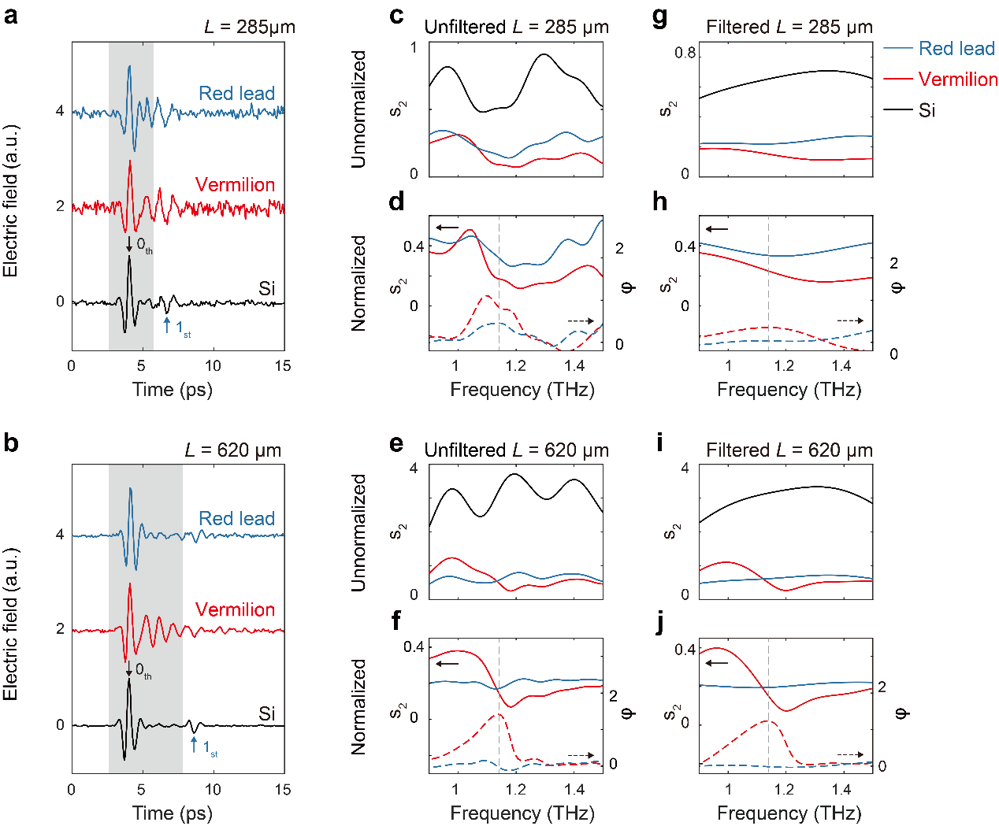
Supplementary Figure 4. a, b, Near-field time-domain signals of red lead, vermilion and Si are measured by L = 285 μm probe (a) and L = 620 μm probe (b), respectively. Note that the 0_{th} order pulse ranges (marked by gray squares) are determined by time-domain signals of Si. c, d, Unfiltered unnormalized (c) and normalized (d) spectra of red lead and vermilion, measured by L = 285 μm probe. Note that the spectra of both pigments are normalized to Si. e, f, Same as panels c and d, but measured by L = 620 μm probe. g, h, Filtered unnormalized (g) and normalized (h) spectra of red lead and vermilion, measured by L = 285 μm probe. i, j, Same as panels g and h, but measured by L = 620 μm probe.

Supplementary Note 5: Hyperspectral nanoimaging of 50-μm ribbon antenna
Supplementary Fig. 5a illustrates the near-field amplitude and phase measured directly at one end of the antenna, converted to real and imaginary parts for comparison with the simulation. Supplementary Fig. 5b and c present the near-field real and imaginary parts of the metal-ribbon antenna at different positions. The near-field distributions shown in Fig. 4d were obtained by extracting the amplitudes at 0.86 THz and 0.6 THz.
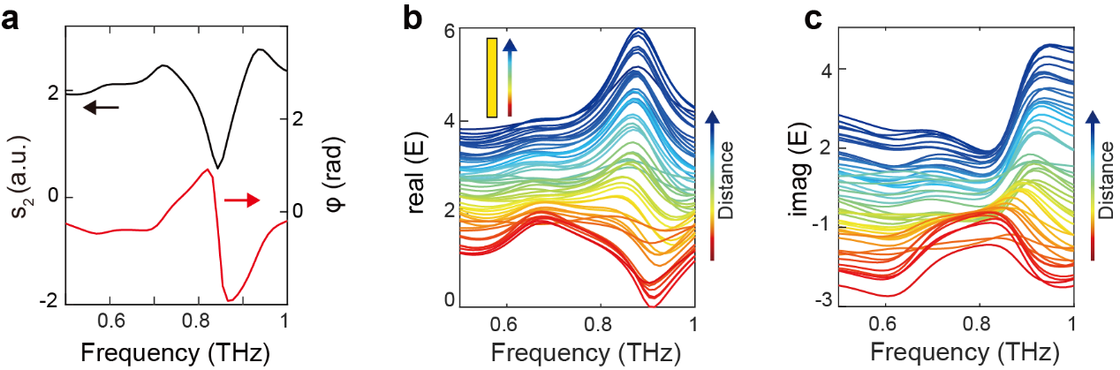
Supplementary Figure 5. a, Amplitude and phase of the near-field spectrum of the 50 μm metallic ribbon end, normalized to substrate. b, c, Real and imaginary parts of the spectra for different positions of the metal-ribbon antenna.

Reference
1. Jepsen, P. U., Cooke, D. G. & Koch, M. Terahertz spectroscopy and imaging - Modern techniques and applications. Laser Photon Rev 5, 124–166 (2011).
2. Neu, J. & Schmuttenmaer, C. A. Tutorial: An introduction to terahertz time domain spectroscopy (THz-TDS). J Appl Phys 124, (2018).

