Supplementary materials

Nitrogen addition reduces soil carbon stability by largely increasing particulate organic carbon
Yulin Xu^{1,2#}, Yuqing Zhao^{1,2#}, Xinyu Cha^{1,2}, Wanlin Yang^{1,2}, Mengtao Zheng^{1,2}, Shuang Liu^{1,2}, Yuxiao Wang^{1,2}, Andong Cai³, Xinhui Han^{1,2}, Gaihe Yang^{1,2}, Chengjie Ren^{1, 2*}
¹College of Agronomy, Northwest A&F University, Yangling, 712100 Shaanxi, China; ²The Research Center of Recycle Agricultural Engineering and Technology of Shaanxi Province, Yangling 712100 Shaanxi, China, ³Key Laboratory of Agricultural Environment, Ministry of Agriculture and Rural Affairs, Institute of Environment and Sustainable Development in Agriculture, Chinese Academy of Agricultural Sciences, Beijing 100081, China
*Corresponding author; Email: rencj1991@nwafu.edu.cn
#Yulin Xu and Yuqing Zhao should be considered joint first author

Fig S1 PRISMA flow diagram for publication inclusion.

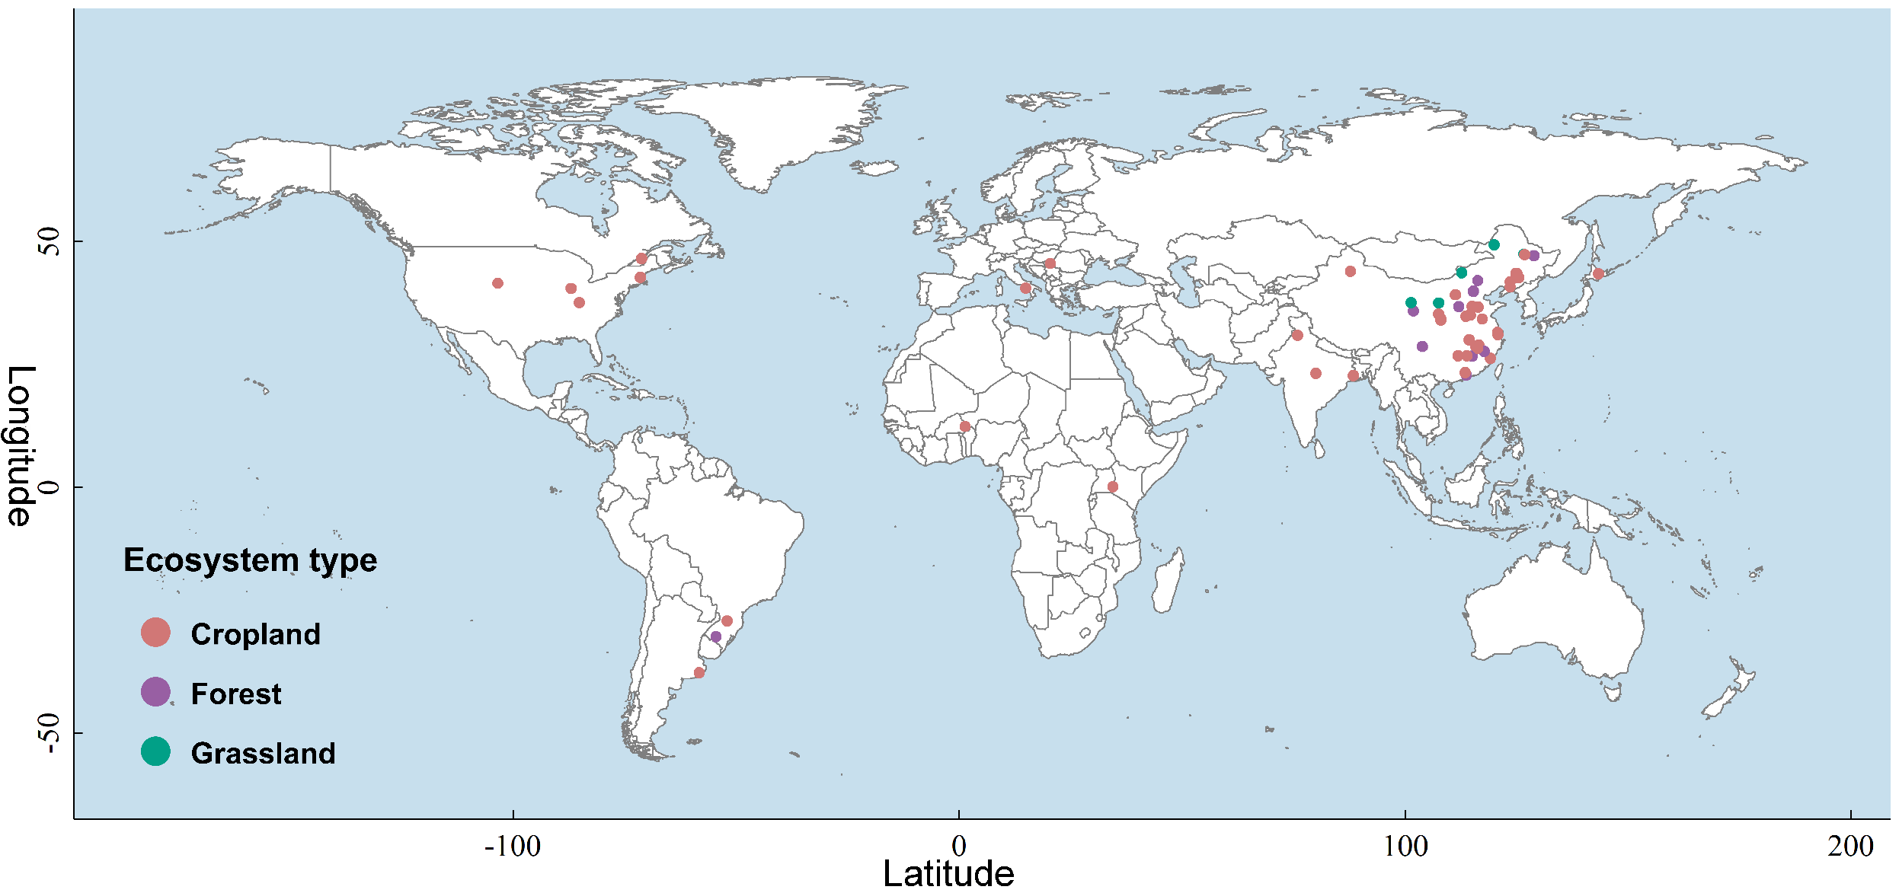
Fig S2 Global distribution of 69 N addition study sites used in this meta-analysis.
Fig S3 The natural log response ratio distribution for SOC, POC, MOC, fPOC, and fMOC across the dataset. The RR of POC, MOC, fPOC and fMOC refers to the natural log response ratio of POC, MOC, fPOC, and fMOC, respectively.

Fig S4 Relationship between the response ratios of soil carbon fraction to N addition and the soil ammonium nitrogen. The gray field next to the regression line represents the confidence interval.

Fig S5 Effect of N addition on the soil MBC and pH as related to N loading methods, biomes, N loading frequency, and experimental durations. Solid dots (●) represent changes in soil carbon fraction under N addition significantly influenced by the controlling factors (p < 0.05); hollow circles (○) indicate p > 0.05. The error bars represent 95% CI. The gray numbers on the left represent the sample size, and the vertical dashed lines represent the effect size of 0.

Fig S6 Relationship between the response ratios of soil carbon fraction to N addition and the experimental durations. The gray field next to the regression line represents the confidence interval.

Fig S7 Relationship between the response ratios of soil carbon fraction to N addition and the soil microbial biomass carbon. The gray field next to the regression line represents the confidence interval.

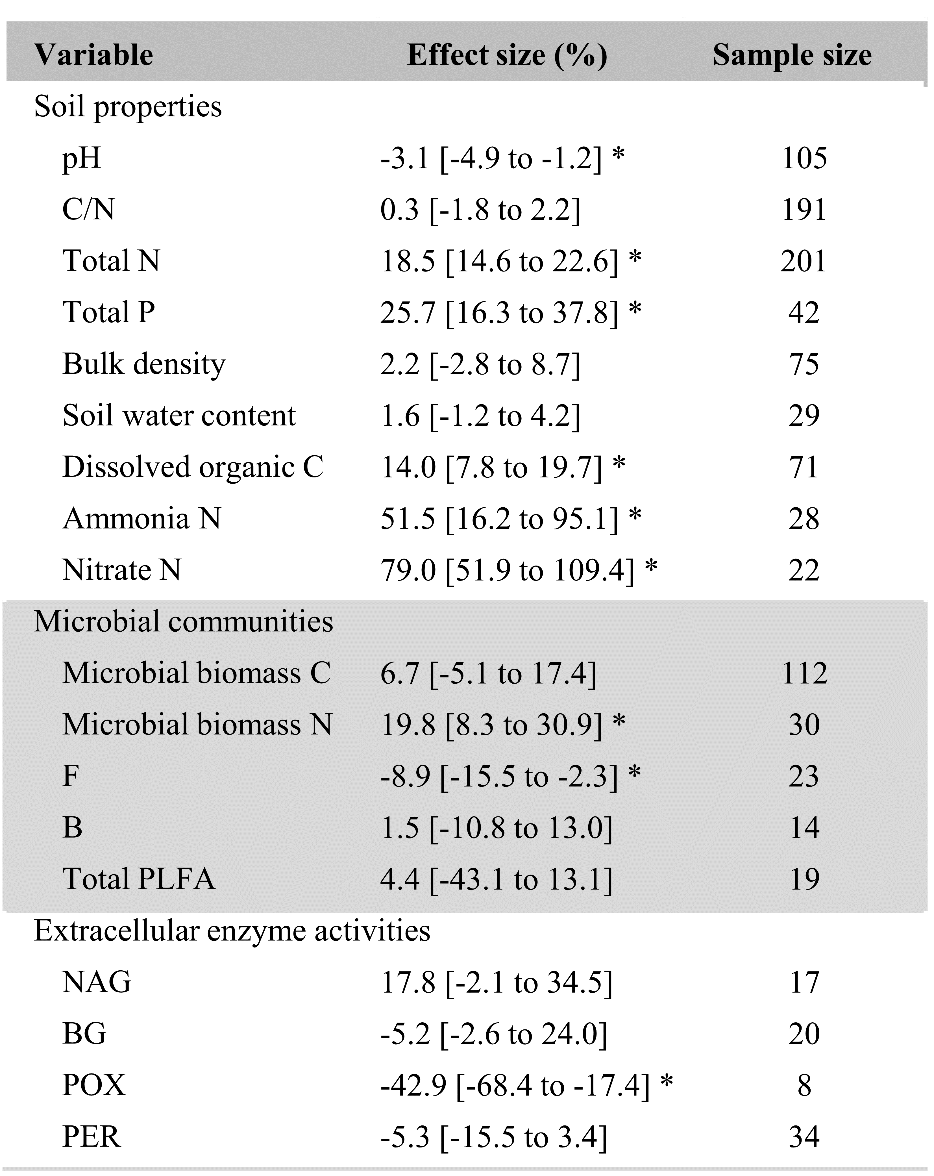
Table S1 The overall effects of N addition on soil properties, microbial communities, and extracellular enzyme activities. Numbers in the brackets are 95% confidence intervals (CI); “ * ” represents the significant effect of nitrogen addition on variables.

Table S2 Results of publication bias tests using Egger’s regression. If p ＞ 0.05 then bias is considered to exist in the publication.
Variable | Sample size | p value
SOC | 232 | 0.06
POC | 150 | 0.66
MOC | 182 | 0.89
fPOC | 427 | 0.63
fMOC | 427 | 0.26

References used in this meta-analysis
Aoyama, M., Angers, D.A., N'Dayegamiye, A., 1999. Particulate and mineral-associated organic matter in water-stable aggregates as affected by mineral fertilizer and manure applications. Canadian Journal of Soil Science 79, 295-302.
Aoyama, M., Chang, S., 2016. DRIFT spectroscopy combined with sodium hypochlorite oxidation reveals different organic matter characteristics in density-size fractions of organically managed soils. Canadian Journal of Soil Science 96, 317-327.
Baiano, Morra, 2017. Particulate and Mineral-Associated Organic Carbon in Aggregates as Affected by Biowaste Compost Applications in a Mediterranean Vegetables Cropping System. Communications in Soil Science and Plant Analysis 48, 383-394.
Benbi, D.K., Toor, A.S., Kumar, S., 2012. Management of organic amendments in rice-wheat cropping system determines the pool where carbon is sequestered. Plant and Soil 360, 145-162.
Cao, H., Wang, J., 2012. Effect of longBterm fertilization on different fractions of organic carbon on Black soil. Territory & Natural Resources Study.
Chen, J., Ji, C., Fang, J., He, H., Zhu, B., 2020a. Dynamics of microbial residues control the responses of mineral-associated soil organic carbon to N addition in two temperate forests. Science of the Total Environment 748, 141318.
Chen, J., Xiao, W., Zheng, C., Zhu, B., 2020b. Nitrogen addition has contrasting effects on particulate and mineral-associated soil organic carbon in a subtropical forest. Soil Biology and Biochemistry 142.
Chen, X., Liu, J., Deng, Q., Yan, J., Zhang, D., 2012. Effects of elevated CO2 and nitrogen addition on soil organic carbon fractions in a subtropical forest. Plant and Soil 357, 25-34.
Chen, Y., Liu, X., Hou, Y., Zhou, S., Zhu, B., 2019. Particulate organic carbon is more vulnerable to nitrogen addition than mineral-associated organic carbon in soil of an alpine meadow. Plant and Soil 458, 93-103.
Corrêa, J.C., Ródio, L.C., Rigo, A.Z., Grohskopf, M.A., Rebellatto, A., Mafra, Á.L., 2019. Carbon fractions and stock in response to solid and fluid organomineral fertilizers in highly fertile soils. Pesquisa Agropecuária Brasileira 54.
Divito, G.A., Rozas, H.R.S., Echeverría, H.E., Studdert, G.A., Wyngaard, N., 2011. Long term nitrogen fertilization: Soil property changes in an Argentinean Pampas soil under no tillage. Soil and Tillage Research 114, 117-126.
Elliott, E.T., Burke, I.C., Monz, C.A., Frey, S.D., Paustian, K.H., Collins, H.P., Paul, E.A., Cole, C.V., Blevins, R.L., Frye, W.W., Lyon, D.J., Halvorson, A.D., Huggins, D.R., Turco, R.F., Hickman, M.V., 1994. Terrestrial Carbon Pools: Preliminary Data from the Corn Belt and Great Plains Regions, Defining Soil Quality for a Sustainable Environment, pp. 179-191.
Fang, H.J., Cheng, S.L., Yu, G.R., Yang, X.M., Xu, M.J., Wang, Y.S., Li, L.S., Dang, X.S., Wang, L., Li, Y.N., 2014. Nitrogen deposition impacts on the amount and stability of soil organic matter in an alpine meadow ecosystem depend on the form and rate of applied nitrogen. European Journal of Soil Science 65, 510-519.
Fang, X.-M., Zhang, X.-L., Chen, F.-S., Zong, Y.-Y., Bu, W.-S., Wan, S.-Z., Luo, Y., Wang, H., 2019. Phosphorus addition alters the response of soil organic carbon decomposition to nitrogen deposition in a subtropical forest. Soil Biology and Biochemistry 133, 119-128.
Ferreira, G.W.D., Oliveira, F.C.C., Soares, E.M.B., Schnecker, J., Silva, I.R., Grandy, A.S., 2021. Retaining eucalyptus harvest residues promotes different pathways for particulate and mineral-associated organic matter. Ecosphere 12, 18.
Gao, M., Jiang, T., Han, X., Yang, J., 2018. Effects of applying biochar-based fertilizer and biochar on organic carbon fractions and contents of Brown soil. Scientia Agricultura Sinica 51, 2126-2135.
Gong, W., Yan, X., Cai, Z., Ran, H., 2008. Long-term fertilization on soil particles in wheat-maize crop systems Effects of organic carbon and nitrogen. Chinese Journal of Applied Ecology 19, 2375-2381. .
Guo, Z., Zhang, L., Yang, W., Hua, L., Cai, C., 2019. Aggregate Stability under Long-Term Fertilization Practices: The Case of Eroded Ultisols of South-Central China. Sustainability 11.
HE, W., WANG, H., HAN, F., 2020. Effect of long-term application of organic manure expanding organic carbon fractions in fluvo-aquic soil. Acta Pedologica Sinica 57, 425-434.
He, Y.T., Zhang, W.J., Xu, M.G., Tong, X.G., Sun, F.X., Wang, J.Z., Huang, S.M., Zhu, P., He, X.H., 2015. Long-term combined chemical and manure fertilizations increase soil organic carbon and total nitrogen in aggregate fractions at three typical cropland soils in China. Science of the Total Environment 532, 635-644.
Hernandez-Ramirez, G., Brouder, S.M., Smith, D.R., Van Scoyoc, G.E., 2009. Carbon and Nitrogen Dynamics in an Eastern Corn Belt Soil: Nitrogen Source and Rotation. Soil Science Society of America Journal 73, 128-137.
Hongjie, C., 2011. Effect of long-term fertilization on different fractions of organic carbon of Brown soil. Territory & Natural Resources Study 135, 85-88.
Hua, L., Xiao-gang, T., Xing-wang, M., Xi-he, W., Wen-ju, Z., Yong-mei, X., Ming-gang, X., 2010. Content and evolution characteristics of organic carbon associated with particle-size fractions of grey desert soil under long-term fertilization. Chinese Journal of Applied Ecology 21.
Huang, Q., 2008. Characteristics of Soil Fertility of Nitrogen under Long-term Fertilization in Paddy Soil Derived From Red Earth. 1-95. (in Chinese).
Huang, Q.R., Hu, F., Huang, S., Li, H.X., Yuan, Y.H., Pan, G.X., Zhang, W.J., 2009. Effect of Long-Term Fertilization on Organic Carbon and Nitrogen in a Subtropical Paddy Soil. Pedosphere 19, 727-734.
Huang, S., 2011. Advantages of Carbon Sequestration and Their Maintenance Practices in Paddy Soils: Based on Analyses of Carbon Fractions. 1-113. (in Chinese)
Lan, J., Lv, Z., Liu, M., Hou, H., Ji, J., 2021. Effects of Long-term Fertilization on Contents and Chemical Compositions of Particle and Mineral-combined Organic Matter in Red Paddy Soils. Soils 53, 140-147.
Li, C., 2020. Effects of wet deposition of nitrogen and phosphorus and litter addition on soil active organic carbon pool and nitrogen and phosphorus in broad-leaved Pinus koraiensis forest. 1-45. (in Chinese).
Li, H., Han, X., You, M., 2012. Particulate organic carbon distribution in aggregates differing in land use and long-term fertilization in Black soil. Journal of Soil and Water Conservation 26, 184-189.
Li, X., 2016. Effects of Nitrogen Deposition on Soil Aggregate and Organic Carbon stability in Subtropical Forest. 1-103. (in Chinese).
Li, Y., Xie, Z., Yu, Z., Wang, Y., Liu, C., Wang, G., Wu, J., Jin, J., Liu, X., 2021. Impact of surface soil manuring on particulate carbon fractions in relevant to nutrient stoichiometry in a Mollisol profile. Soil and Tillage Research 207.
Liang, Q., Chen, H., Gong, Y., Fan, M., Yang, H., Lal, R., Kuzyakov, Y., 2011. Effects of 15 years of manure and inorganic fertilizers on soil organic carbon fractions in a wheat-maize system in the North China Plain. Nutrient Cycling in Agroecosystems 92, 21-33.
Ling-li, W., Xiao-ri, H., Jin-feng, Y., Ye-qing, W., Ling-ling, M., Yi-lai, L., 2008. Effect of long-term fertilization on organic carbon fractions in a brown soil. Plant Nutrition and Fertilizer Science 14 (1), 79-83.
Lou, Y., Wang, J., Liang, W., 2011. Impacts of 22-year organic and inorganic N managements on soil organic C fractions in a maize field, northeast China. Catena 87, 386-390.
Manna, M.C., Bhattacharyya, P., Adhya, T.K., Singh, M., Wanjari, R.H., Ramana, S., Tripathi, A.K., Singh, K.N., Reddy, K.S., Subba Rao, A., Sisodia, R.S., Dongre, M., Jha, P., Neogi, S., Roy, K.S., Rao, K.S., Sawarkar, S.D., Rao, V.R., 2013. Carbon fractions and productivity under changed climate scenario in soybean–wheat system. Field Crops Research 145, 10-20.
Manna, M.C., Swarup, A., Wanjari, R.H., Singh, Y.V., Ghosh, P.K., Singh, K.N., Tripathi, A.K., Saha, M.N., 2006. Soil Organic Matter in a West Bengal Inceptisol after 30 Years of Multiple Cropping and Fertilization. Soil Science Society of America Journal 70, 121-129.
Mikha, M.M., Hergert, G.W., Benjamin, J.G., Jabro, J.D., Nielsen, R.A., 2017. Soil Organic Carbon and Nitrogen in Long-Term Manure Management System. Soil Science Society of America Journal 81, 153-165.
Oliveira, F.C.C., Ferreira, G.W.D., Dungait, J.A.J., Araújo, E.F., Soares, E.M.B., Silva, I.R., 2021. Eucalypt harvest residue management influences microbial community structure and soil organic matter fractions in an afforested grassland. Soil and Tillage Research 205.
Ouédraogo, E., Mando, A., Stroosnijder, L., 2006. Effects of tillage, organic resources and nitrogen fertiliser on soil carbon dynamics and crop nitrogen uptake in semi-arid West Africa. Soil and Tillage Research 91, 57-67.
Peng, B., 2017. Effect of Long-Term Fertilization on Aggregate Distribution and its Physical Protect Organic Carbon in a Losses Soil. 1-40. (in Chinese).
Russell, A.E., Laird, D.A., Parkin, T.B., Mallarino, A.P., 2005. Impact of nitrogen fertilization and cropping system on carbon sequestration in Midwestern Mollisols. Soil Science Society of America Journal 69, 413-422.
Seremesic, S., Nesic, L., Ciric, V., Vasin, J., Djalovic, I., Marinkovic, J., Vojnov, B., 2020. Soil organic carbon fractions in different land use systems of Chernozem soil. Zbornik Matice srpske za prirodne nauke, 31-39.
Shen, D., Ye, C., Hu, Z., Chen, X., Guo, H., Li, J., Du, G., Adl, S., Liu, M., 2018. Increased chemical stability but decreased physical protection of soil organic carbon in response to nutrient amendment in a Tibetan alpine meadow. Soil Biology and Biochemistry 126, 11-21.
Tong, X., Xu, M., Zhang, W., Lu, C., 2008. Influence of long-term fertilization on content and distribution of organic carbon in particle-size fractions of red soil and fluvo-aquic soil in China. Scientia Agricultura Sinica 41, 3664-3671.
Wang, L., 2017. Effects of simulating N-S deposition on soil organic carbon fractions in Larix principis rupprechtii plantation. 1-62. (in Chinese).
Wang, R., Dijkstra, F.A., Liu, H., Yin, J., Wang, X., Feng, X., Xu, Z., Jiang, Y., 2019. Response of soil carbon to nitrogen and water addition differs between labile and recalcitrant fractions: Evidence from multi–year data and different soil depths in a semi-arid steppe. Catena 172, 857-865.
Wang, S., 2015. Effect of long-term fertilization on organic carbon fractions and turnovers of cinnamon soil. 1-44.(in Chinese).
Wang, X., Hu, F., Peng, X., Zhou, H., Yu, X., 2012. Effects of long-term fertilization on soil organic carbon pools and their turnovers in a red soil. Acta Pedologica Sinica 49, 954-961.
Wang, Y., 2011. Characteristics of Organic Carbon Stock and Carbon Fixation Capacity in Orchard Soils by Different Managing Measures. 1-152. (in Chinese).
Wei, Z., Wu, J., Yan, X., Ni, G., 2016. Phosphorus and carbon status of a paddy soil under different fertilization regimes. Journal of Soils and Sediments 16, 1727-1734.
Wood, S.A., Sokol, N., Bell, C.W., Bradford, M.A., Naeem, S., Wallenstein, M.D., Palm, C.A., 2016. Opposing effects of different soil organic matter fractions on crop yields. Ecological Applications 26, 2072-2085.
Xiao-ri, H., Ling-li, W., Jin-feng, Y., 2008. Effect of longterm fertilizations on particulate organic carbon and enzyme activities in a brown earth. Chinese Journal of Soil Science 39, 266-269.
Xie, J., Peng, B., Wang, R., Batbayar, J., Hoogmoed, M., Yang, Y., Zhang, S., Yang, X., Sun, B., 2018. Responses of crop productivity and physical protection of organic carbon by macroaggregates to long-term fertilization of an Anthrosol. European Journal of Soil Science 69, 555-567.
Xiong, Y., 2013. Effects of Long-term Fertilization on Soil Fertility, Organic Carbon Pools and Aggregation in Paddy soil and Upland red soil. 1-118. (in Chinese).
Xu, M., Xu, L., Fang, H., Cheng, S., Yu, G., Yang, Y., Lu, M., 2020. Alteration in enzymatic stoichiometry controls the response of soil organic carbon dynamic to nitrogen and water addition in temperate cultivated grassland. European Journal of Soil Biology 101.
Yan, D., Wang, D., Yang, L., 2007. Long-term effect of chemical fertilizer, straw, and manure on labile organic matter fractions in a paddy soil. Biology and Fertility of Soils 44, 93-101.
YANG, C., OUYANG, Z., DONG, Y., 2005a. Organic carbon fractions and aggregate stability in aquatic soil under different fertilization. Chinese Journal of Ecology, 887.
Yang, C., Yang, L., Ouyang, Z., 2005b. Organic carbon and its fractions in paddy soil as affected by different nutrient and water regimes. Geoderma 124, 133-142.
Yang, X., Ren, W., Sun, B., Zhang, S., 2012. Effects of contrasting soil management regimes on total and labile soil organic carbon fractions in a loess soil in China. Geoderma 177-178, 49-56.
Yao, L., Han, X., Wang, F., Wang, F., 2011. Characteristics of Soil Labile Organic Carbon Fractions in Black Soil under Grassland and Farmland Ecosystem. Chinese Journal of Soil Science 42, 864-871.
Ye, C., Chen, D., Hall, S.J., Pan, S., Yan, X., Bai, T., Guo, H., Zhang, Y., Bai, Y., Hu, S., 2018. Reconciling multiple impacts of nitrogen enrichment on soil carbon: plant, microbial and geochemical controls. Ecol Lett 21, 1162-1173.
Yu, H., Ding, W., Luo, J., Geng, R., Cai, Z., 2012. Long-term application of organic manure and mineral fertilizers on aggregation and aggregate-associated carbon in a sandy loam soil. Soil and Tillage Research 124, 170-177.
Yuan, X., Qin, W., Xu, H., Zhang, Z., Zhou, H., Zhu, B., 2020. Sensitivity of soil carbon dynamics to nitrogen and phosphorus enrichment in an alpine meadow. Soil Biology and Biochemistry 150.
Zang, C., 2016. Effect of nitrogen deposition on soil carbon fractions of several forest stands in Muchuan County. 1-57. (in Chinese).
ZHANG, Y.-r., An, H., LIU, B.-r., WEN, Z.-l., WU, X.-z., LI, Q.-l., DU, Z.-y., 2019. Effects of short-term nitrogen and phosphorus addition on soil labile organic carbon in desert grassland. Acta Prataculturae Sinica 28, 12.

