Idiosyncratic Fermentation Behaviour of Rhodosporidium toruloides NCIM 3547 in Hemicellulose Hydrolysates derived from Neem Oilseed Cake for Lipid and β-carotene Synthesis
Sundaram Deepika Bharathi¹, Samuel Jacob¹*
¹ Department of Biotechnology, School of Bioengineering, College of Engineering and Technology, Faculty of Engineering and Technology, SRM Institute of Science and Technology, SRM Nagar, Chengalpattu Dist., Kattankulathur, 603203, Tamil Nadu, India.
*Corresponding author: samueljb@srmist.edu.in
Supplementary information

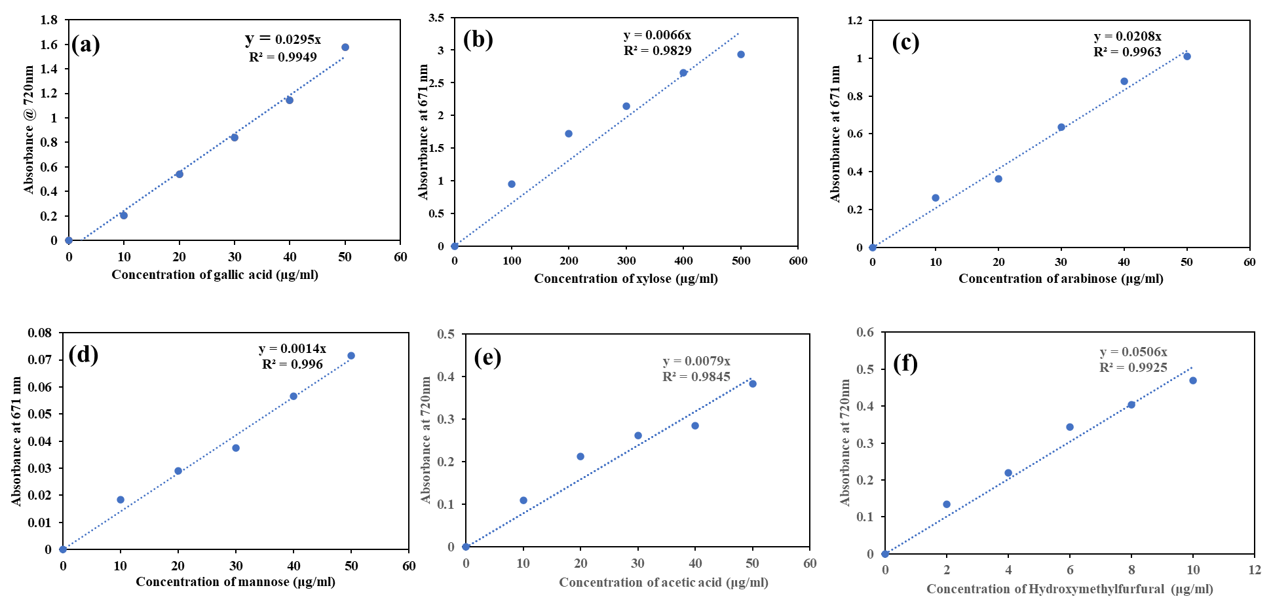
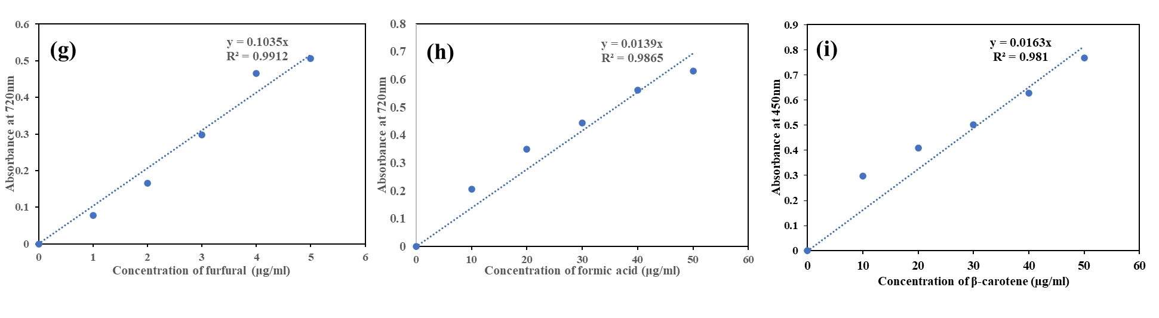

Fig. S1 Standard plots for sugars, sugar-derived inhibitors, lignin-derived inhibitors and carotenoids (a) Gallic acid; (b) Xylose; (c) Arabinose; (d) Mannose; (e) Acetic acid; (f) Hydroxymethylfurfural (HMF); (g) Furfural; (h) Formic acid; (i) β-carotene

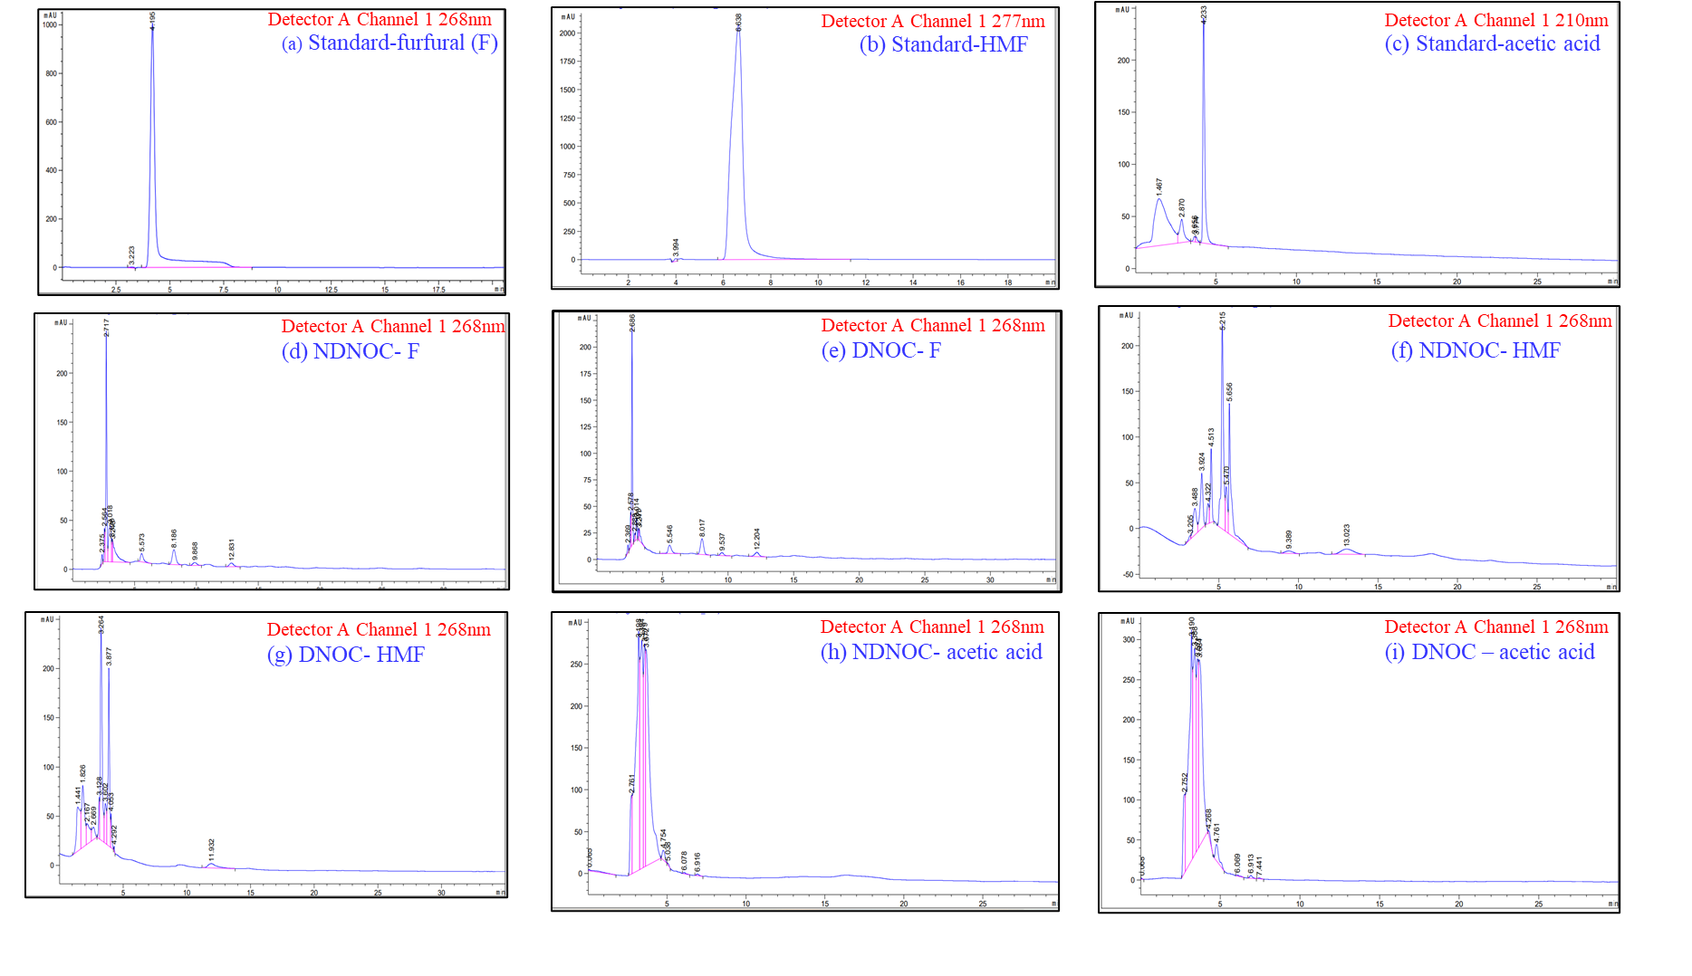

Fig. S2 HPLC chromatogram of inhibitors in non-detoxified and detoxified NOC hemicellulosic hydrolysate (a) Standard-furfural; (b) Standard-HMF; (c) Standard-acetic acid; (d) NDNH-furfural; (e) DNH-furfural; (f) NDNH-HMF; (g) DNH-HMF; (h) NDNH-acetic acid; (i) DNH-acetic acid

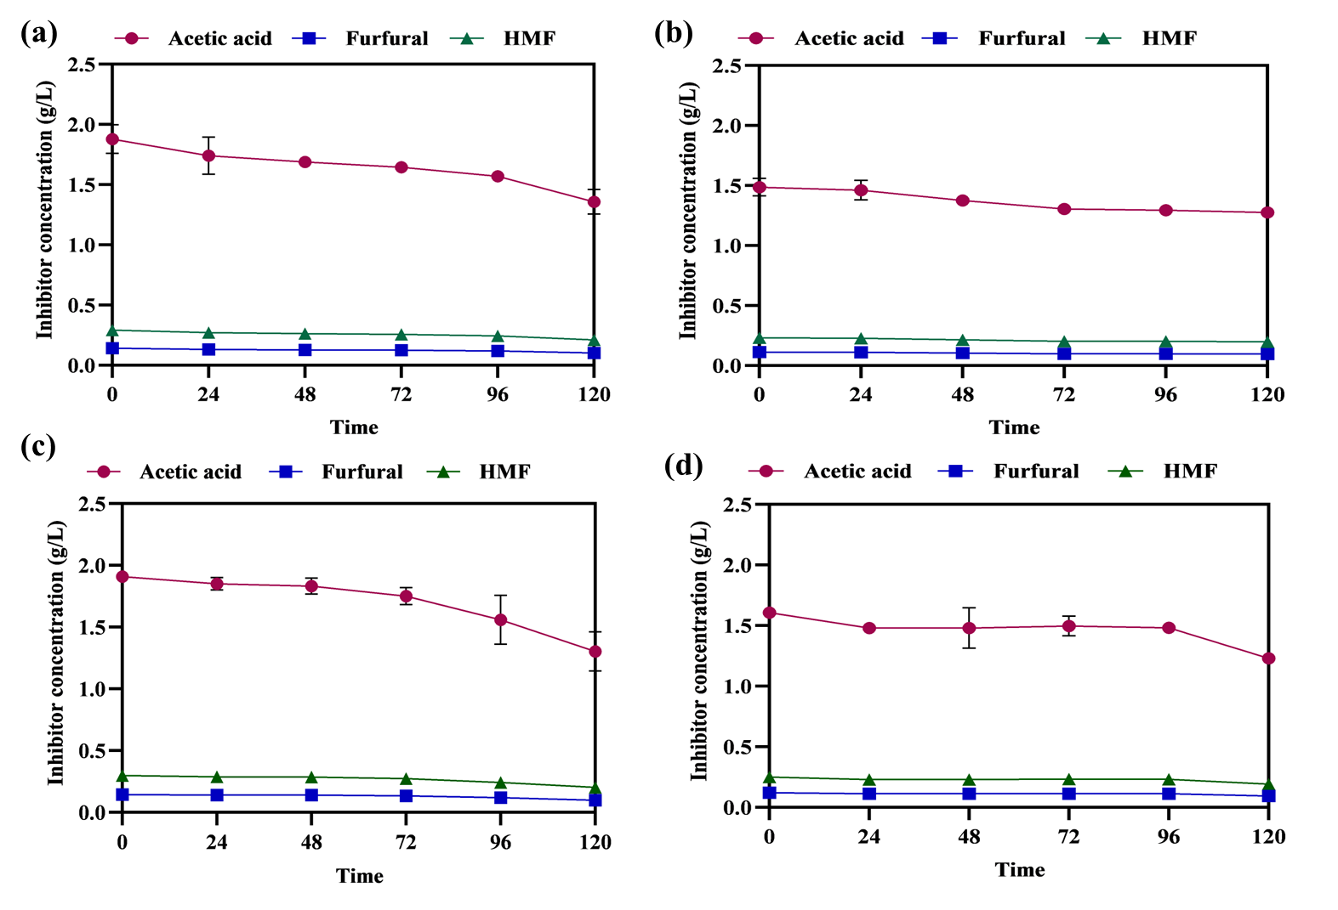

Fig. S3 Concentration of inhibitors (furfural, HMF and acetic acid) of various fermentative sets (a) NDNH (w/o) YE; (b) DNH (w/o) YE; (c) NDNH (w) YE; (d) DNH (w) YE; (w) - with; (w/o) – without.

(b)
(a)
(d)
(c)
Glucose = 42.598e^{-0.012x}
R² = 0.9421
Arabinose = 17.921e^{-0.022x}
R² = 0.9278
Xylose = 12.339e^{-0.022x}
R² = 0.9278

Glucose = 45.146e^{-0.015x}
R² = 0.8508
Arabinose= 17.907e^{-0.018x}
R² = 0.859
Xylose= 12.33e^{-0.018x}
R² = 0.859

(e)
Glucose= 51.739e^{-0.017x}
R² = 0.9082
Arabinose= 19.653e^{-0.018x}
R² = 0.9203
Xylose = 13.532e^{-0.018x}
R² = 0.9203

Fig. S4 Substrate (glucose, xylose, arabinose) uptake profile of R.toruloides in different fermentative sets (based on first-order kinetic rate)
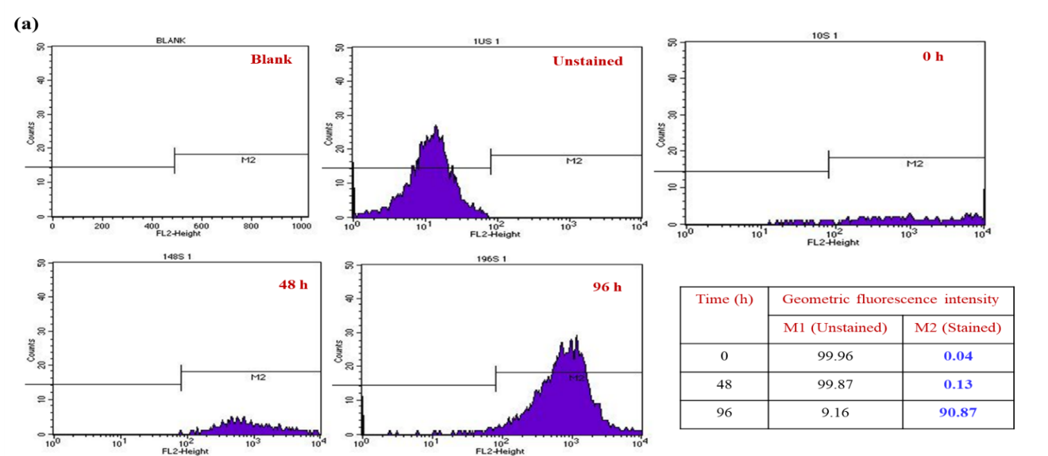
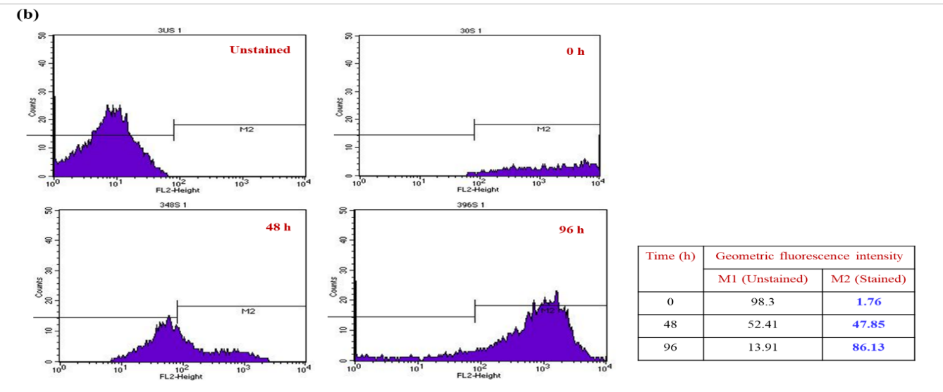
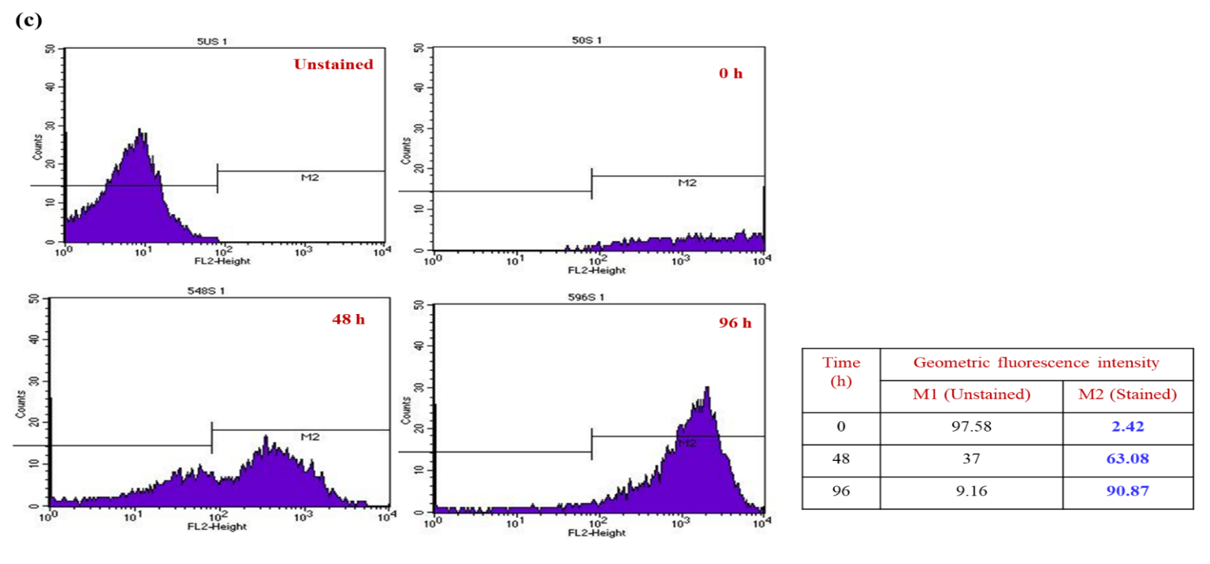
Fig. S5 Flow cytometry analysis of Nile red stained biomass of R. toruloides during various time intervals (a) YBM; (b) DNH (w/o) YE; (c) DNH (w) YE; (w) - with; (w/o) – without.

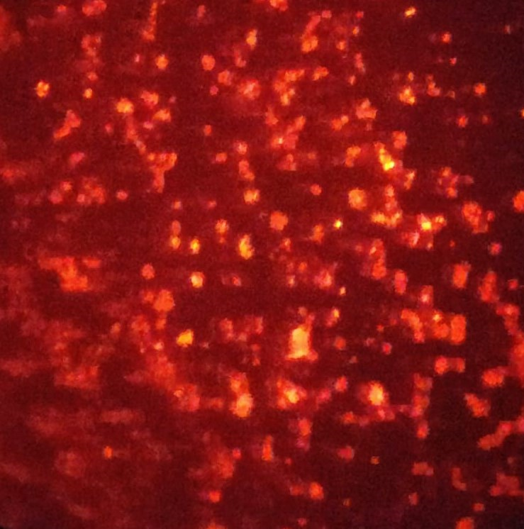
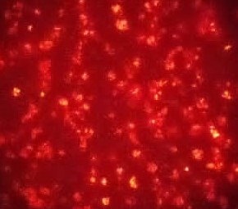
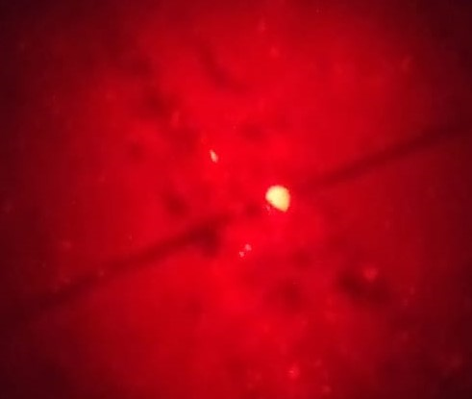
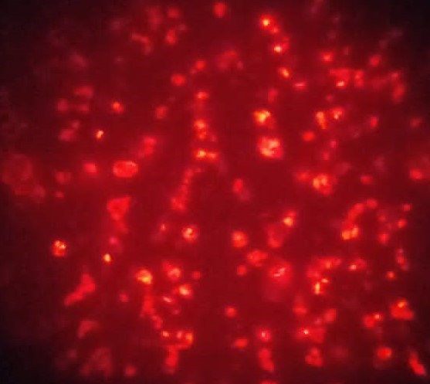
0 h
24 h
48 h
72 h
96 h

Fig. S6 Fluorescence microscopy analysis of Nile red-stained biomass [(NDNH (w) YE)] for regular intervals of fermentation.

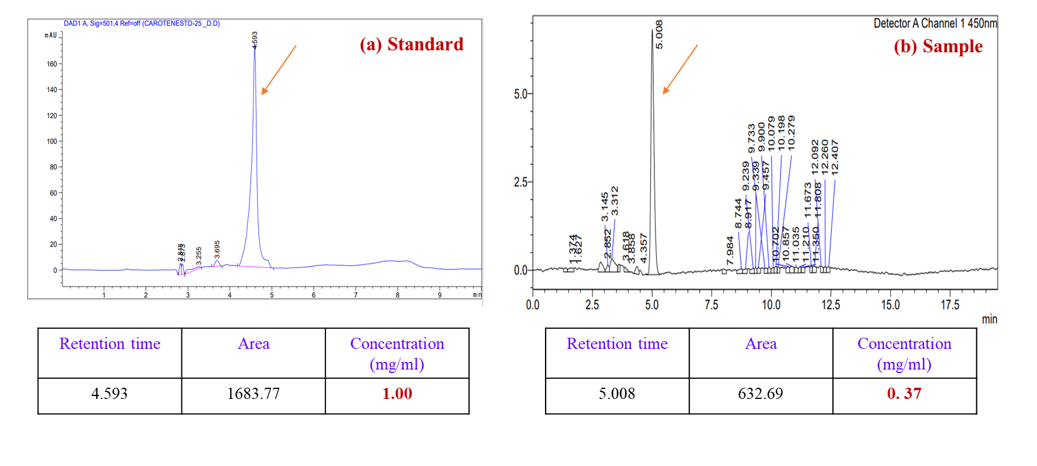

Fig. S7 HPLC chromatogram (a) Standard peak of β-carotene; (b) Sample peak of β-carotene produced by R. toruloides NCIM 3547

Table S1. Elemental composition analysis of NOC by SEM-EDX on a dry weight basis

Elements | Composition (%)
C | 33.32
N | 10.94
O | 40.27
Mg | 0.45
Al | 0.42
Si | 0.80
S | 1.23
Cl | 2.62
K | 8.57
Ca | 1.39

Compound name | Concentration (g/L)
Compound name | NDNH | DNH | Percentage reduction after detoxification
Monosaccharides
Glucose | 26.94 ± 0.61 | 24.52 ± 0.42 | 8.98
Xylose | 10.62 ± 0.06 | 9.34 ± 0.09 | 12.05
Arabinose | 15.42 ± 0.09 | 13.57 ± 0.14 | 11.99
Lignin derived inhibitors
Gallic acid | 0.47 ± 0.01 | 0.34 ± 0.03 | 27.65
Sugar derived inhibitors
Furfural | 0.13 ± N.D. | 0.09 ± 0.01 | 30.76
HMF | 0.27 ± N.D. | 0.19 ± 0.02 | 29.62
Acetic acid | 1.78 ± 0.05 | 1.27 ± 0.14 | 28.65
Formic acid | 1.01 ± 0.03 | 0.72 ± 0.08 | 28.71
Table S2. Concentration of Monosaccharides, Lignin and Sugar-derived inhibitors in NDNH and DNH after microwave mild acid hydrolysis (MMAH)

The values are average of triplicate experiments and the standard deviation is represented as (±) calculated from mean and three independent trials. (N.D. negligible deviation)

Table S3. Concentration of inhibitors (Furfural, HMF and acetic acid) through HPLC before and after detoxification of NOC hemicellulosic hydrolysate

Compound name | Inhibitor concentration before detoxification (µg/mL) | Inhibitors concentration after detoxification (µg/mL) | Fold decrease
Compound name | NDNH | DNH | Fold decrease
Furfural | 1.99 | 1.17 | 1.70
5-HMF | 20.20 | - | -
Acetic acid | 40.84 | 7.33 | 5.50

Table S4. Compositional analysis of fatty acid from the GC-MS profile of microbial lipids obtained from different fermentative sets
 | Fatty acid | Type of fatty acid | Relative composition by area %
 |  |  | NDNH (w/o) YE | DNH (w/o) YE | NDNH (w) YE | DNH (w) YE
(C4:0) | Butyric acid | Saturated fatty acid | - | - | - | 2.03
(C6:0) | Caproic acid | Saturated fatty acid | - | - | 1.01 | -
(C7:0) | Butanoic acid | Saturated fatty acid | - | 20.84 | - | -
(C8:0) | Caprylic acid | Saturated fatty acid | - | - | 25.25 | -
(C15:0) | Pentadecanoic acid | Saturated fatty acid | - | 79.16 | - | 7.12
 | Pentacosylic acid | Saturated fatty acid | 37.93 | - | - | -
(C16:0) | Palmitic acid | Saturated fatty acid | - | - | 72.73 | 2.48
(C17:0) | Margaric acid | Saturated fatty acid | - | - | - | 2.63
(C18:0) | Stearic acid | Saturated fatty acid | 37.94 | - | 1.01 | -
(C18:2) | Linolenic acid | Polyunsaturated fatty acid | 24.13 | - | - | -
(C22:0) | Behenic acid | Saturated fatty acid | - | - | - | 85.74

Table S5. One-way ANOVA of lipids produced from different fermentation sets represents statistically significant difference (p < 0.05); ****- Significant; ns- non-significant.

Table Analyzed | Lipid- ANOVA
Data sets analyzed | A-E
ANOVA summary
F | 54.31
P value | <0.0001
P value summary | ****
Significant diff. among means  (P < 0.05)? | Yes
R squared | 0.9560
Brown-Forsythe test
F (DFn, DFd) | 0.2049 (4, 10)
P value | 0.9299
P value summary | ns
Are SDs significantly different  (P < 0.05)? | No
Bartlett's test
Bartlett's statistic (corrected)
P value
P value summary
Are SDs significantly different
(P < 0.05)?
ANOVA table | SS | DF | MS | F (DFn, DFd) | P value
Treatment (between columns) | 422.3 | 4 | 105.6 | F (4, 10) = 54.31 | P<0.0001
Residual (within columns) | 19.44 | 10 | 1.944
Total | 441.8 | 14
Data summary
Number of treatments (columns) | 5
Number of values (total) | 15

Table S6. Tukey’s HSD test analysis of lipids produced from different fermentation sets represents statistically significant difference (p < 0.05); ****- Significant, ns- non-significant.

Tukey's multiple comparisons test | Mean Diff. | 95.00% CI of diff. | Significant? | Summary | Adjusted P Value
YBM vs. NDNH (w/o) YE | -15.55 | -19.29 to -11.80 | Yes | **** | <0.0001 | A-B
YBM vs. DNH (w/o) YE | -12.04 | -15.79 to -8.295 | Yes | **** | <0.0001 | A-C
YBM vs. NDNH (w) YE | -12.12 | -15.86 to -8.370 | Yes | **** | <0.0001 | A-D
YBM vs. DNH (w) YE | -11.25 | -14.99 to -7.499 | Yes | **** | <0.0001 | A-E
NDNH (w/o) YE vs. DNH (w/o) YE | 3.504 | -0.2425 to 7.251 | No | ns | 0.0695 | B-C
NDNH (w/o) YE vs. NDNH (w) YE | 3.430 | -0.3171 to 7.176 | No | ns | 0.0769 | B-D
NDNH (w/o) YE vs. DNH (w) YE | 4.301 | 0.5538 to 8.047 | Yes | * | 0.0235 | B-E
DNH (w/o) YE vs. NDNH (w) YE | -0.07459 | -3.821 to 3.672 | No | ns | >0.9999 | C-D
DNH (w/o) YE vs. DNH (w) YE | 0.7963 | -2.950 to 4.543 | No | ns | 0.9520 | C-E
NDNH (w) YE vs. DNH (w) YE | 0.8709 | -2.876 to 4.618 | No | ns | 0.9351 | D-E
Test details | Mean 1 | Mean 2 | Mean Diff. | SE of diff. | n1 | n2 | q | DF
YBM vs. NDNH (w/o) YE | 28.22 | 43.76 | -15.55 | 1.138 | 3 | 3 | 19.31 | 10
YBM vs. DNH (w/o) YE | 28.22 | 40.26 | -12.04 | 1.138 | 3 | 3 | 14.96 | 10
YBM vs. NDNH (w) YE | 28.22 | 40.33 | -12.12 | 1.138 | 3 | 3 | 15.05 | 10
YBM vs. DNH (w) YE | 28.22 | 39.46 | -11.25 | 1.138 | 3 | 3 | 13.97 | 10
NDNH (w/o) YE vs. DNH (w/o) YE | 43.76 | 40.26 | 3.504 | 1.138 | 3 | 3 | 4.353 | 10
NDNH (w/o) YE vs. NDNH (w) YE | 43.76 | 40.33 | 3.430 | 1.138 | 3 | 3 | 4.260 | 10
NDNH (w/o) YE vs. DNH (w) YE | 43.76 | 39.46 | 4.301 | 1.138 | 3 | 3 | 5.342 | 10
DNH (w/o) YE vs. NDNH (w) YE | 40.26 | 40.33 | -0.07459 | 1.138 | 3 | 3 | 0.09266 | 10
DNH (w/o) YE vs. DNH (w) YE | 40.26 | 39.46 | 0.7963 | 1.138 | 3 | 3 | 0.9893 | 10
NDNH (w) YE vs. DNH (w) YE | 40.33 | 39.46 | 0.8709 | 1.138 | 3 | 3 | 1.082 | 10

Table S7. One-way ANOVA of carotenoids produced from different fermentation sets represents statistically significant difference (p < 0.05); ****- Significant; ns- non-significant.

Table Analyzed | Carotenoid-ANOVA
Data sets analyzed | A-E
ANOVA summary
F | 236.5
P value | <0.0001
P value summary | ****
Significant diff. among means  (P < 0.05)? | Yes
R squared | 0.9947
Brown-Forsythe test
F (DFn, DFd) | 3.765e+027 (4, 5)
P value | <0.0001
P value summary | ****
Are SDs significantly different  (P < 0.05)? | Yes
Bartlett's test
Bartlett's statistic (corrected)
P value
P value summary
Are SDs significantly different
(P < 0.05)?
ANOVA table | SS | DF | MS | F (DFn, DFd) | P value
Treatment (between columns) | 476.4 | 4 | 119.1 | F (4, 5) = 236.5 | P<0.0001
Residual (within columns) | 2.518 | 5 | 0.5036
Total | 478.9 | 9
Data summary
Number of treatments (columns) | 5
Number of values (total) | 10

Table S8. Tukey’s HSD analysis of carotenoids produced from different fermentation sets represents statistically significant difference (p < 0.05); ****- Significant; ns- non-significant.
Tukey's multiple comparisons test | Mean Diff. | 95.00% CI of diff. | Significant? | Summary | Adjusted P Value
YBM vs. NDNH (w/o) YE | -10.67 | -13.52 to -7.828 | Yes | *** | 0.0001 | A-B
YBM vs. DNH (w/o) YE | -9.785 | -12.63 to -6.939 | Yes | *** | 0.0002 | A-C
YBM vs. NDNH (w) YE | -20.46 | -23.31 to -17.61 | Yes | **** | <0.0001 | A-D
YBM vs. DNH (w) YE | -16.20 | -19.04 to -13.35 | Yes | **** | <0.0001 | A-E
NDNH (w/o) YE vs. DNH (w/o) YE | 0.8896 | -1.957 to 3.736 | No | ns | 0.7269 | B-C
NDNH (w/o) YE vs. NDNH (w) YE | -9.785 | -12.63 to -6.939 | Yes | *** | 0.0002 | B-D
NDNH (w/o) YE vs. DNH (w) YE | -5.521 | -8.368 to -2.675 | Yes | ** | 0.0030 | B-E
DNH (w/o) YE vs. NDNH (w) YE | -10.67 | -13.52 to -7.828 | Yes | *** | 0.0001 | C-D
DNH (w/o) YE vs. DNH (w) YE | -6.411 | -9.258 to -3.564 | Yes | ** | 0.0015 | C-E
NDNH (w) YE vs. DNH (w) YE | 4.264 | 1.417 to 7.111 | Yes | ** | 0.0096 | D-E
Test details | Mean 1 | Mean 2 | Mean Diff. | SE of diff. | n1 | n2 | q | DF
YBM vs. NDNH (w/o) YE | 40.43 | 51.10 | -10.67 | 0.7096 | 2 | 2 | 21.27 | 5
YBM vs. DNH (w/o) YE | 40.43 | 50.21 | -9.785 | 0.7096 | 2 | 2 | 19.50 | 5
YBM vs. NDNH (w) YE | 40.43 | 60.89 | -20.46 | 0.7096 | 2 | 2 | 40.77 | 5
YBM vs. DNH (w) YE | 40.43 | 56.63 | -16.20 | 0.7096 | 2 | 2 | 32.28 | 5
NDNH (w/o) YE vs. DNH (w/o) YE | 51.10 | 50.21 | 0.8896 | 0.7096 | 2 | 2 | 1.773 | 5
NDNH (w/o) YE vs. NDNH (w) YE | 51.10 | 60.89 | -9.785 | 0.7096 | 2 | 2 | 19.50 | 5
NDNH (w/o) YE vs. DNH (w) YE | 51.10 | 56.63 | -5.521 | 0.7096 | 2 | 2 | 11.00 | 5
DNH (w/o) YE vs. NDNH (w) YE | 50.21 | 60.89 | -10.67 | 0.7096 | 2 | 2 | 21.27 | 5
DNH (w/o) YE vs. DNH (w) YE | 50.21 | 56.63 | -6.411 | 0.7096 | 2 | 2 | 12.78 | 5
NDNH (w) YE vs. DNH (w) YE | 60.89 | 56.63 | 4.264 | 0.7096 | 2 | 2 | 8.497 | 5

