Gut microbiota in subjects with prediabetes has a low mediating effect on the hypoglycemic outcome of linagliptin/metformin and metformin.

Martínez-López Yoscelina Estrella^{1,2,3}, Neri-Rosario Daniel⁴, Esquivel-Hernández Diego Armando¹, Padron-Manrique Cristian^{1,5}, Vázquez-Jiménez Aarón¹, Sánchez-Castañeda Jean Paul⁴, Girón-Villalobos David⁴, Mendoza-Ortíz Cristian⁴, Reyes-Escogido María de Lourdes³, Resendis-Antonio Osbaldo^{1,6*}, Guardado-Mendoza Rodolfo^{3*}
¹Human Systems Biology Laboratory. Instituto Nacional de Medicina Genómica (INMEGEN). México City, México.
²Programa de Doctorado en Ciencias Médicas, Odontológicas y de la Salud, Universidad Nacional Autónoma de México (UNAM). Ciudad de México, México.
³Metabolic Research Laboratory, Department of Medicine and Nutrition. University of Guanajuato. León, Guanajuato, México.
⁴Programa de Maestría en Ciencias Bioquímicas, Universidad Nacional Autónoma de México (UNAM). Ciudad de México, México.
⁵Programa de Doctorado en Ciencias Biomédicas, Universidad Nacional Autónoma de México (UNAM). Ciudad de México, México.
⁶Coordinación de la Investigación Científica – Red de Apoyo a la Investigación - Centro de Ciencias de la Complejidad, Universidad Nacional Autónoma de México (UNAM). Ciudad de México, México.

* Corresponding author

Variables | N | Basal | N | Treatment  (6 month) | Size effect (Cohen’s D) | p-value
Age (years) | 65 | 44.08±11.37 | 77 | 48.21±9.85 | 0.356 | 0.0364*
SBP (mmHg) | 65 | 123.90±17.93 | 76 | 116.45±15.37 | 0.472 | 0.0060*
DBP (mmHg) | 65 | 80.90±11.50 | 76 | 77.02±10.10 | 0.369 | 0.0306*
Anthropometric characteristics
Weight (kg) | 65 | 82.55±18.57 | 78 | 73.49±14.40 | 0.592 | 0.0006*
BMI (kg/m²) | 65 | 32.02±6.79 | 78 | 27.90±4.55 | 0.776 | 0.0001*
Waist circumference (cm) | 61 | 97.64±13.58 | 78 | 89.45±12.80 | 0.547 | 0.0017*
Hip circumference (cm) | 61 | 110.57±14.78 | 78 | 102.70±10.33 | 0.669 | 0.0001*
Waist/hip ratio | 61 | 0.88±0.08 | 78 | 0.87±0.01 | 0.119 | 0.4859
Body fat (%) | 64 | 38.30±8.81 | 77 | 33.77±8.39 | 0.473 | 0.0195*
Visceral fat (AU) | 54 | 9.97±3.99 | 62 | 8.76±3.69 | 0.318 | 0.0900
Biochemical characteristics
Fasting glucose (mg/dl) | 65 | 108.47±20.72 | 78 | 96.05±9.62 | 1.013 | 0.0001*
Glucose 120 min (mg/dl) | 65 | 163.58±46.83 | 77 | 128.60±36.63 | 0.912 | 0.0001*
HbA1c (%) | 56 | 5.72±0.79 | 72 | 5.49±0.39 | 0.435 | 0.0160*
AUC glucose (OGTT) | 65 | 20569.75±4299.47 | 75 | 16872.64±3710.32 | 1.005 | 0.0145*
Matsuda Index | 51 | 2.45±2.03 | 64 | 3.95±3.25 | 0.766 | 0.0001*
HOMA-IR | 52 | 4.35±3.94 | 64 | 2.01±2.93 | 1.022 | 0.0001*
QUICKI | 51 | 0.32±0.04 | 64 | 0.35±0.04 | 0.738 | 0.0001*
HOMA-B | 51 | 106.25±98.13 | 64 | 93.63±136.27 | 0.182 | 0.3348
AUC insulin (OGTT) | 51 | 9216.52±5431.34 | 64 | 7546.25±4982.75 | 0.356 | 0.0605
AIR (DI0_30/DG0_30) | 51 | 0.72±0.70 | 64 | 0.95±2.81 | 0.358 | 0.0607
Oral_DI (AIR*1/insulin) | 51 | 0.06±0.09 | 64 | 0.11±0.26 | 0.772 | 0.0001*
Insulin secretion (AUCins0-120/AUCgluc0-120) | 51 | 0.445±0.28 | 64 | 0.448±0.28 | 0.014 | 0.9391
β-Cell function₁ (Matsuda*(AUCins₀₋₁₂₀/AUCgluc₀₋₁₂₀)) | 51 | 2.63±1.20 | 64 | 5.18±5.08 | 0.956 | 0.0063*
β-Cell function₂ (Matsuda*(IncAUCins₀₋₁₂₀/IncAUCgluc₀₋₁₂₀)) | 51 | 1.09±0.43 | 64 | 1.77±0.71 | 1.113 | 0.0001*
Total Cholesterol (mg/dl) | 62 | 182.17±35.08 | 78 | 182.13±35.93 | 0.001 | 0.9941
HDL-c (mg/dl) | 61 | 38.11±11.58 | 76 | 43.97±21.87 | 0.454 | 0.0092*
LDL-c (mg/dl) | 48 | 108.09±29.61 | 38 | 103.58±42.39 | 0.112 | 0.6089
VLDL-c (mg/dl) | 47 | 32.52±13.88 | 32 | 33.39±23.09 | 0.059 | 0.7968
Triglycerides (mg/dl) | 62 | 163.32±69.82 | 78 | 147.20±91.85 | 0.224 | 0.1897
Independent samples t-test. SBP= systolic blood pressure, DBP= diastolic blood pressure, BMI= body mass index, WC= waist circumference, AC= hip circumference, AUC= area under the curve, IncAUC= increase in area under the curve, OGTT= curve of oral glucose tolerance, AIR= acute insulin response, HOMA-IR= homeostasis model assessment for insulin resistance, HOMA-B= homeostasis model assessment beta-cell, Oral_DI= insulin disposition index, HDL-c= cholesterol high-density lipoprotein cholesterol, LDL-c= low-density lipoprotein cholesterol, VLDL-c= very low-density lipoprotein colesterol, Size effect= Cohen’s D. *p<0.05.

Table S1. Contrasts between groups basal vs six months antidiabetic drugs. The independent contrast between groups; Basal vs with pharmacological treatment for 6 months establishes statistically significant differences in age, clinical, anthropometric, and biochemical parameters. In terms of age, subjects treated with pharmacological therapy for 6 months are older compared to untreated subjects [C-d 0.356 (0.022-0.687), p=0.0364]. Even though the treated subjects are older, blood pressures were lower for them; TAS [C-d 0.472 (0.135-0.806), p=0.0060] and TAD [C-d 0.369 (0.034-0.702), p=0.0300]. Regarding the anthropometric parameters, the body mass index [Cd 0.776 (0.433-1.116), p=0.0000], waist circumference [Cd 0.547 (0.205-0.888), p=0.0017] and body fat percentage [Cd 0.473 (0.136- 0.809), p=0.0195] were lower in the group treated for 6 months. The biochemical parameters; basal glucose [Cd 1.013 (0.663-1.362), p=0.0000], glucose at 120 min of the OGTT [Cd 0.912 (0.564-1.258), p=0.0000], HbA1c [Cd 0.435 (0.081-0.788), p= 0.0160], glucose AUC during OGTT [Cd 1.005 (0.651-1.356), p=0.0000], and HOMA-IR are lower parameters [Cd 1.022 (0.631-1.409), p=0.0000]. In contrast, the Matsuda index increases with pharmacological treatment [C-d 0.766 (0.383-1.145), p=0.0004] and in the evaluation of pancreatic β-cell function; Oral_DI (AIR*1/insulin) [C-d 0.772 (0.387-1.154), p= 0.0001], Disp_Indexb_Function [C-d 0.956 (0.269-1.637), p=0.0063] increase. However, Disp_Index2 (Matsuda*(IncAUCins0-120/IncAUCgluc0-120)) [C-d 1.113 (0.716-1.507), p=0.0000] decreased. On the other hand, HDL increased in the group of subjects treated pharmacologically [C-d 0.454 (0.112-0.795), p= 0.0092]. These results show the effect of antidiabetic drugs on the parameters of RI and pancreatic beta cell function.

Variables | N | Basal | N | Treatment  (12 months) | Size effect (Cohen’s D) | p-value
Age (years) | 65 | 44.08±11.37 | 63 | 47.60±12.11 | 0.265 | 0.1357
SBP (mmHg) | 65 | 123.90±17.93 | 61 | 115.80±15.10 | 0.522 | 0.0040*
DBP (mmHg) | 65 | 80.90±11.50 | 61 | 73.64±10.58 | 0.692 | 0.0002*
Anthropometric characteristics
Weight (kg) | 65 | 82.55±18.57 | 63 | 73.95±15.02 | 0.543 | 0.0026*
BMI (kg/m²) | 65 | 32.02±6.79 | 63 | 28.32±4.35 | 0.702 | 0.0001*
Waist circumference (cm) | 61 | 97.64±13.58 | 59 | 90.63±10.49 | 0.582 | 0.0018*
Hip circumference (cm) | 61 | 110.57±14.78 | 59 | 103.27±10.64 | 0.599 | 0.0013*
Waist/hip ratio | 61 | 0.88±0.08 | 59 | 0.87±0.08 | 0.119 | 0.4859
Body fat (%) | 64 | 38.30±8.81 | 62 | 34.69±7.49 | 0.408 | 0.0241*
Visceral fat (AU) | 54 | 9.97±3.99 | 58 | 9.93±3.70 | 0.183 | 0.3346
Biochemical characteristics
Fasting glucose (mg/dl) | 65 | 108.47±20.72 | 63 | 93.91±9.50 | 1.158 | 0.0001*
Glucose 120 min (mg/dl) | 65 | 163.58±46.83 | 63 | 132.18±33.86 | 0.838 | 0.0001*
HbA1c (%) | 56 | 5.72±0.79 | 60 | 5.48±0.33 | 0.455 | 0.0158*
AUC glucose (OGTT) | 65 | 20569.75±4299.47 | 61 | 17410.17±3023.66 | 0.919 | 0.0001*
Matsuda Index | 51 | 2.45±2.03 | 57 | 3.89±3.02 | 0.790 | 0.0001*
HOMA-IR | 52 | 4.35±3.94 | 57 | 1.90±1.43 | 1.181 | 0.0001*
QUICKI | 51 | 0.32±0.04 | 57 | 0.35±0.04 | 0.854 | 0.0001*
HOMA-B | 51 | 106.25±98.13 | 57 | 103.96±135.36 | 0.032 | 0.8665
AUC insulin (OGTT) | 51 | 9216.52±5431.34 | 57 | 7738.98±4775.64 | 0.310 | 0.1111
AIR (DI0_30/DG0_30) | 51 | 0.72±0.70 | 57 | 0.84±0.74 | 0.216 | 0.2687
Oral_DI (AIR*1/insulin) | 51 | 0.06±0.09 | 57 | 0.10±0.12 | 0.829 | 0.0001*
Insulin secretion (AUCins0-120/AUCgluc0-120) | 51 | 0.445±0.28 | 57 | 0.444±0.26 | 0.005 | 0.9775
β-Cell function₁ (Matsuda*(AUCins₀₋₁₂₀/AUCgluc₀₋₁₂₀)) | 51 | 2.63±1.20 | 56 | 4.49±5.51 | 0.779 | 0.0267*
β-Cell function₂ (Matsuda*(IncAUCins₀₋₁₂₀/IncAUCgluc₀₋₁₂₀)) | 51 | 1.09±0.43 | 57 | 1.73±0.66 | 1.056 | 0.0001*
Total Cholesterol (mg/dl) | 62 | 182.17±35.08 | 63 | 178.71±36.92 | 0.097 | 0.5897
HDL-c (mg/dl) | 61 | 38.11±11.58 | 63 | 43.13±11.82 | 0.433 | 0.0175*
Triglycerides (mg/dl) | 62 | 163.32±69.82 | 63 | 153.09±120.71 | 0.138 | 0.4422
Independent samples t-test. SBP= systolic blood pressure, DBP= diastolic blood pressure, BMI= body mass index, WC= waist circumference, AC= hip circumference, AUC= area under the curve, IncAUC= increase in area under the curve, OGTT= curve of oral glucose tolerance, AIR= acute insulin response, HOMA-IR= homeostasis model assessment for insulin resistance, HOMA-B= homeostasis model assessment beta-cell, Oral_DI= insulin disposition index, HDL-c= cholesterol high-density lipoprotein cholesterol, LDL-c= low-density lipoprotein cholesterol, VLDL-c= very low-density lipoprotein colesterol, Size effect= Cohen’s D. *p<0.05.

Table S2. Contrasts between groups basal vs 12 months antidiabetic drugs. The independent contrast between groups; Basal vs with pharmacological treatment for 12 months, statistically significant differences were found in the clinical parameters; in systolic and diastolic blood pressure, mmHg decreased compared to the no-treatment group [C-d 0.522 (0.166-0.877), p=0.0040] and [C-d 0.692 (0.331-1.050), p=0.0002], respectively. The anthropometric characteristics of: BMI [Cd 0.702 (0.343-1.058), p= 0.0001], waist circumference [Cd 0.582 (0.215-0.946), p=0.0018], and hip [Cd 0.599 (0.233-0.965), p= 0.0013] and body fat percentage [Cd 0.408 (0.053-0.759), p=0.0241]. In the biochemical parameters, lower values ​​were identified: basal glucose [Cd 1.158 (0.781-1.531), p=0.0000], glucose at 120 min of the OGTT [Cd 0.838 (0.475-1.198), p=0.0000], HbA1c [Cd 0.455 (0.085-0.823) p=0.0158], glucose AUC during OGTT [Cd 0.919 (0.549-1.285), p=0.0000], HOMA-IR [Cd 1.181 (0.771-1.586), p=0.0000] and increase in insulin sensitivity by Matsuda index [Cd 0.790 (0.396-1.181), p=0.0001], and pancreatic β-cell function; Oral_DI (AIR*1/insulin) [Cd 0.829 (0.428-1.227), p= 0.0000], Disp_Indexb_Function [Cd 0.779 (0.090-1.462), p=0.0063] and Disp_Index2 (Matsuda*(IncAUCins0-120/IncAUCgluc0-120) ) [Cd 1.056 (0.650-1.457), p=0.0000] increase, and were statistically significant. On the other hand, HDL increased in the group of subjects treated pharmacologically at 12 months [C-d 0.433 (0.076-0.788), p= 0.0175].

Variables | N | Treatment  (6 months) | N | Treatment  (12 months) | Size effect  (Δ de Glass) | p-value
SBP (mmHg) | 24 | 118.96±15.54 | 24 | 114.86±14.67 | 0.273 | 0.1664
DBP (mmHg) | 24 | 78.06±10.53 | 24 | 73.83±8.84 | 0.420 | 0.0223*
Anthropometric characteristics
Weight (kg) | 24 | 72.27±14.85 | 24 | 72.18±18.86 | 0.253 | 0.8763
BMI (kg/m²) | 24 | 27.66±3.04 | 24 | 27.69±2.95 | 0.010 | 0.9032
Waist circumference (cm) | 23 | 89.72±9.80 | 23 | 89.45±9.32 | 0.034 | 0.7829
Hip circumference (cm) | 23 | 100.71±6.93 | 23 | 101.43±6.73 | 0.102 | 0.5330
Waist/hip ratio | 23 | 0.889±0.11 | 23 | 0.881±0.09 | 0.082 | 0.5318
Body fat (%) | 22 | 35.56±6.57 | 22 | 35.29±5.74 | 0.062 | 0.6934
Visceral fat (AU) | 14 | 7.87±2.36 | 14 | 8.70±2.77 | 0.394 | 0.0654
Biochemical characteristics
Fasting glucose (mg/dl) | 24 | 92.5±6.05 | 24 | 93.13±6.44 | 0.104 | 0.5825
Glucose 120 min (mg/dl) | 24 | 122.80±30.58 | 24 | 122.73±32.78 | 0.020 | 0.9926
HbA1c (%) | 22 | 5.43±0.21 | 22 | 5.49±0.21 | 0.286 | 0.3113
AUC glucose (OGTT) | 22 | 16006.71±2872.06 | 22 | 16988.69±2413.02 | 0.320 | 0.0507
Matsuda Index | 21 | 3.88±3.66 | 21 | 3.73±2.37 | 0.194 | 0.7427
HOMA-IR | 21 | 2.08±4.40 | 21 | 1.99±1.16 | 0.227 | 0.8113
QUICKI | 21 | 0.344±0.04 | 21 | 0.345±0.03 | 0.025 | 0.9493
HOMA-B | 21 | 113.37±208.46 | 21 | 110.02±66.78 | 0.165 | 0.8660
AUC insulin (OGTT) | 21 | 8160.34±4878.59 | 21 | 8688.30±4309.54 | 0.023 | 0.4757
AIR (DI0_30/DG0_30) | 21 | 1.07±0.85 | 21 | 0.85±0.52 | 0.459 | 0.2091
Oral_DI (AIR*1/insulin) | 21 | 0.12±0.14 | 21 | 0.10±0.05 | 0.429 | 0.5128
Insulin secretion (AUCins0-120/AUCgluc0-120) | 21 | 0.52±0.28 | 21 | 0.51±0.24 | 0.107 | 0.8595
β-Cell function₁ (Matsuda*(AUCins₀₋₁₂₀/AUCgluc₀₋₁₂₀)) | 21 | 6.33±7.20 | 21 | 5.23±3.82 | 0.153 | 0.2626
β-Cell function₂ (Matsuda*(IncAUCins₀₋₁₂₀/IncAUCgluc₀₋₁₂₀)) | 21 | 2.03±0.81 | 21 | 1.92±0.45 | 0.247 | 0.5084
Total Cholesterol (mg/dl) | 24 | 184.93±40.81 | 24 | 176.25±33.66 | 0.233 | 0.2448
HDL-c (mg/dl) | 22 | 49.45±21.87 | 22 | 46.72±12.01 | 0.058 | 0.6573
Triglycerides (mg/dl) | 24 | 144.45±123.59 | 24 | 160.58±165.25 | 0.144 | 0.2661

Dependent samples t-test. SBP= systolic blood pressure, DBP= diastolic blood pressure, BMI= body mass index, WC= waist circumference, AC= hip circumference, AUC= area under the curve, IncAUC= increase in area under the curve, OGTT= curve of oral glucose tolerance, AIR= acute insulin response, HOMA-IR= homeostasis model assessment for insulin resistance, HOMA-B= homeostasis model assessment beta-cell, Oral_DI= insulin disposition index, HDL-c= cholesterol high-density lipoprotein cholesterol, LDL-c= low-density lipoprotein cholesterol, VLDL-c= very low-density lipoprotein colesterol, Size effect= Δ de Glass. *p<0.05.
Table S3. Contrasts between groups with pharmacological treatment (6 vs 12 months follow-up). The dependent contrast between the groups of 6 vs. 12 months of follow-up shows a statistically significant reduction in diastolic blood pressure (78.06±10.53 vs. 73.33±8.84, p=0.0223). The effect size was determined by Glass's Δ, for the visceral fat variable an increase of 1 arbitrary unit was observed with respect to the 6 months of intervention (7.87±2.36 vs 8.70±2.77, Glass's Δ= 0.394), and a reduction of AIR (DI0_30/DG0_30) (1.07±0.85 vs 0.85±0.52, Δ Glass= 0.459), Oral_DI (AIR*1/insulin) (0.12±0.14 vs 0.10±0.05, Δ Glass= 0.429). Therefore, the differences in follow-up show that most of the anthropometric and biochemical parameters remain unchanged at 6 months of follow-up, without presenting statistically significant differences.

Variables | N | Basal | N | Metformin  (6 months) | N | Metformin  (12 months) | N | Linagliptin/Metformin  (6 months) | N | Linagliptin/metformin  (12 months) | p-value
Age (years) | 65 | 44.08±11.37^{c} | 44 | 47.05±10.89^{b,c} | 28 | 44.47±12.82^{c} | 33 | 49.79±8.33ª | 35 | 50.26±11.26ª | 0.089
SBP (mmHg) | 65 | 123.90±17.93ª | 44 | 114.00±14.20^{b} | 28 | 116.93±14.59^{b} | 32 | 119.91±16.41ª | 33 | 114.85±15.69^{b} | 0.008
DBP (mmHg) | 65 | 80.90±11.50ª | 44 | 75.09±9.03^{b,c} | 28 | 75.44±8.48^{b,c} | 32 | 79.76±10.94ª | 33 | 71.65±12.06^{c} | 0.0001
Anthropometric characteristics
Weight (kg) | 65 | 82.55±18.57ª | 44 | 71.49±13.22^{b,c} | 28 | 76.91±17.78ª | 33 | 76.15±15.56^{b,c} | 35 | 71.67±11.98^{c} | 0.001
BMI (kg/m²) | 65 | 32.02±6.79ª | 44 | 27.11±4.28^{c} | 28 | 29.56±4.98^{b} | 33 | 29.01±4.71^{b} | 35 | 27.36±3.51^{b,c} | 0.0001
WC (cm) | 61 | 97.64±13.58ª | 44 | 86.84±13.69^{b} | 28 | 92.99±11.52ª | 33 | 92.95±11.05ª | 31 | 88.55±9.08^{b} | 0.001
Body fat (%) | 64 | 38.30±8.81ª | 44 | 31.81±8.20c | 27 | 36.37±6.89ª^{,b} | 33 | 36.57±8.08^{a,b} | 35 | 33.44±7.83^{b,c} | 0.003
Visceral fat (AU) | 54 | 9.97±3.99 | 42 | 8.39±3.73 | 25 | 9.68±4.47 | 20 | 9.62±3.60 | 33 | 8.96±2.98 | 0.275
Biochemical characteristics
Matsuda Index | 51 | 2.45±2.03^{c} | 30 | 4.96±2.57^{b} | 24 | 5.22±3.57ª^{,b} | 33 | 4.74±0.378^{b} | 33 | 4.17±2.51^{b} | 0.0001
HOMA-IR | 52 | 4.35±3.94ª | 30 | 2.45±3.54^{b} | 24 | 2.28±1.53^{b} | 33 | 3.03±2.29^{b} | 33 | 2.33±1.37^{b} | 0.0001
AIR (DI0_30/DG0_30) | 51 | 0.72±0.70^{b} | 30 | 0.88±0.53^{b} | 24 | 0.95±0.72^{b} | 33 | 1.95±3.79ª | 33 | 1.05±0.76^{b} | 0.023
Oral_DI (AIR*1/insulin) | 51 | 0.06±0.09^{c} | 30 | 0.13±0.08^{b} | 24 | 0.08±0.17^{b} | 33 | 0.21±0.35ª^{,b} | 33 | 0.11±0.06^{b} | 0.0001
Insulin secretion (AUCins0-120/AUCgluc0-120) | 51 | 0.445±0.28^{b} | 30 | 0.41±0.17^{b} | 24 | 0.42±0.21^{b} | 33 | 0.61±0.33ª | 33 | 0.57±0.28ª | 0.029
β-Cell function₁ (Matsuda*(AUCins₀₋₁₂₀/AUCgluc₀₋₁₂₀)) | 51 | 2.63±1.20^{c} | 30 | 5.45±3.67^{b} | 24 | 6.20±8.01^{b} | 33 | 7.64±5.93ª | 33 | 5.27±2.56^{b} | 0.018
β-Cell function₂ (Matsuda*(IncAUCins₀₋₁₂₀/IncAUCgluc₀₋₁₂₀)) | 51 | 1.09±0.43^{c} | 30 | 1.78±0.60^{b} | 24 | 1.75±0.85^{b} | 33 | 2.03±0.79ª | 33 | 1.92±0.49^{b} | 0.0001
SBP= systolic blood pressure, DBP= diastolic blood pressure, BMI= body mass index, WC= waist circumference, AC= hip circumference, AUC= area under the curve, IncAUC= increase in area under the curve, OGTT= curve of oral glucose tolerance, AIR= acute insulin response, HOMA-IR= homeostasis model assessment for insulin resistance, Oral_DI= insulin disposition index.
Table S4. The contrast between groups. We subsequently contrasted the groups by pharmacological treatment and month of follow-up. For this purpose, a one-way ANOVA was used to show significant differences between the groups. Sensitivity and IR indices were better for the group of subjects treated with M for 12 months. In contrast, pancreatic β-cell function indices were higher in subjects treated with LM at six-month follow-up. Furthermore, the anthropometric characteristics evaluated showed changes in the different months of intervention. The decrease in BMI in both treatments was lower in the M groups at six months and LM at 12 months of follow-up. The same behavior occurred with the fat percentage; both compared to the baseline group.

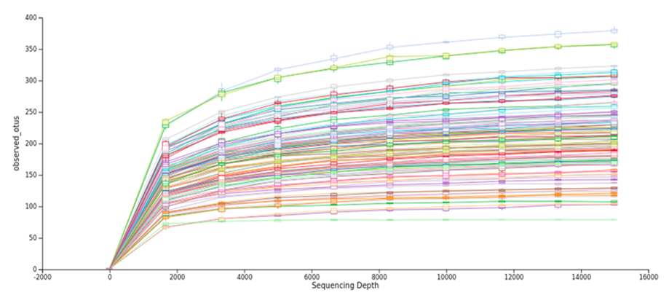
Figure S1. Rarefaction curve. Indicates the number of species found (OTUs) with respect to the sampling unit (sequences). At 1981 sequencing depth, representative samples of all the sequences are obtained.

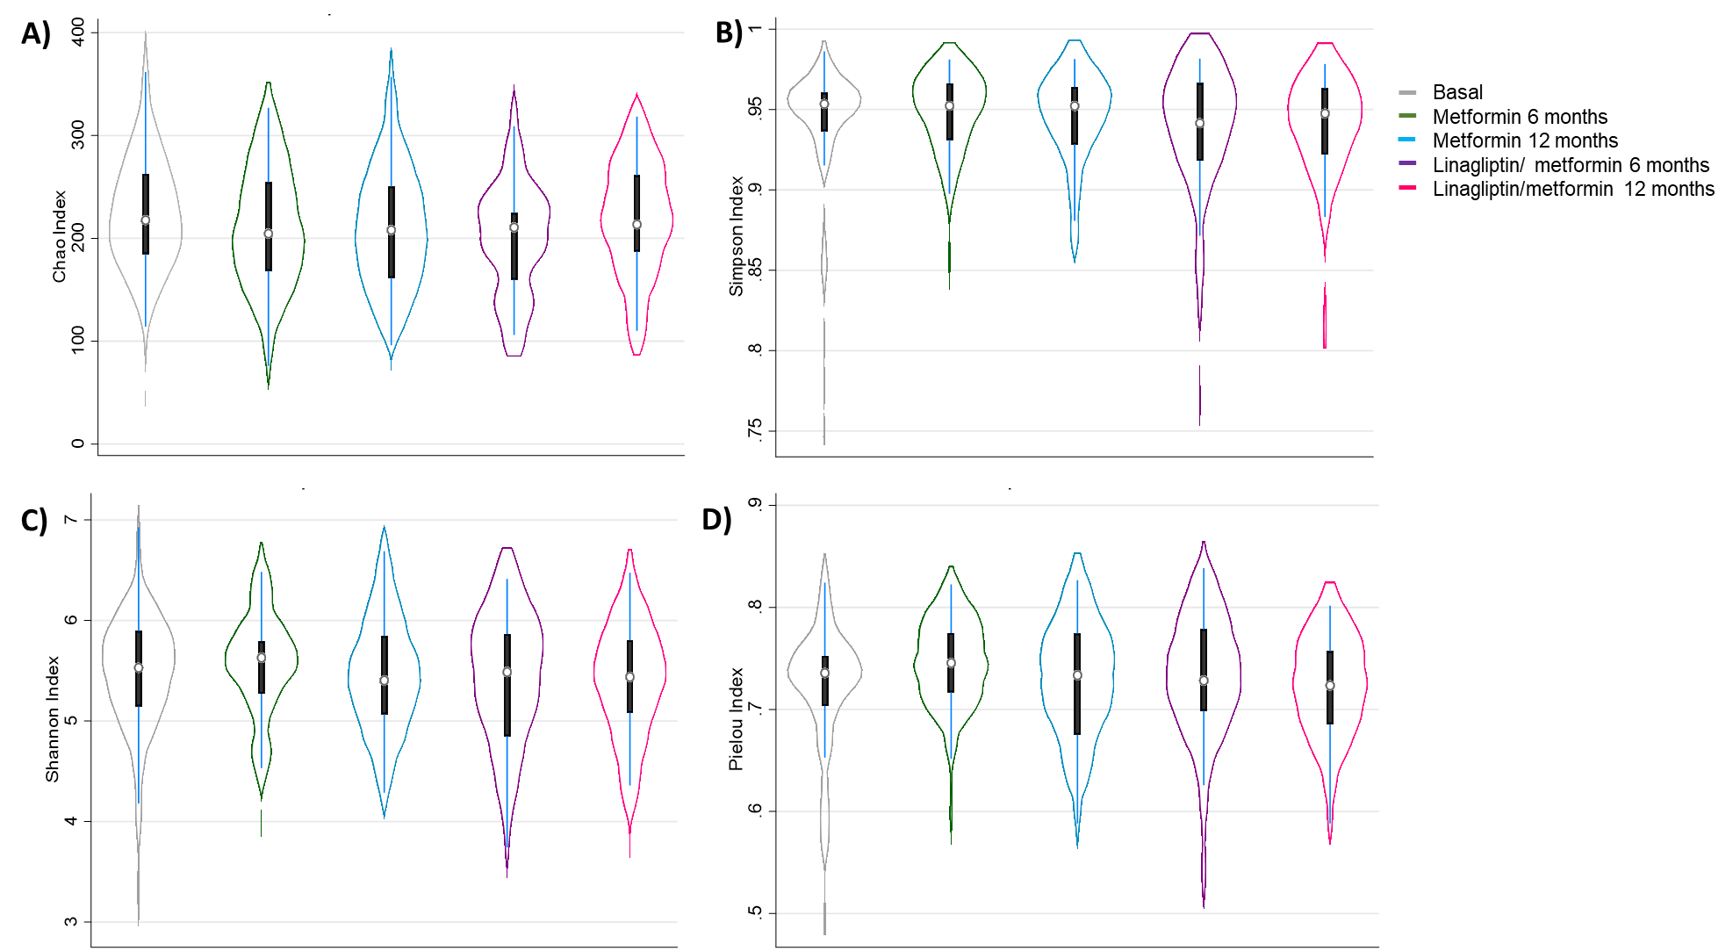
Figure S2. Richness and diversity indices by group. The microbial community richness (Chao 1 index; A, p = 0.550 and Simpson index; B, p = 0.817) and diversity (Shannon index; C, p = 0.796 and Pielou index; D, p = 0.469). Violin plots show the median, quartiles, and min/max values. Kruskal-Wallis test *p < 0.05.

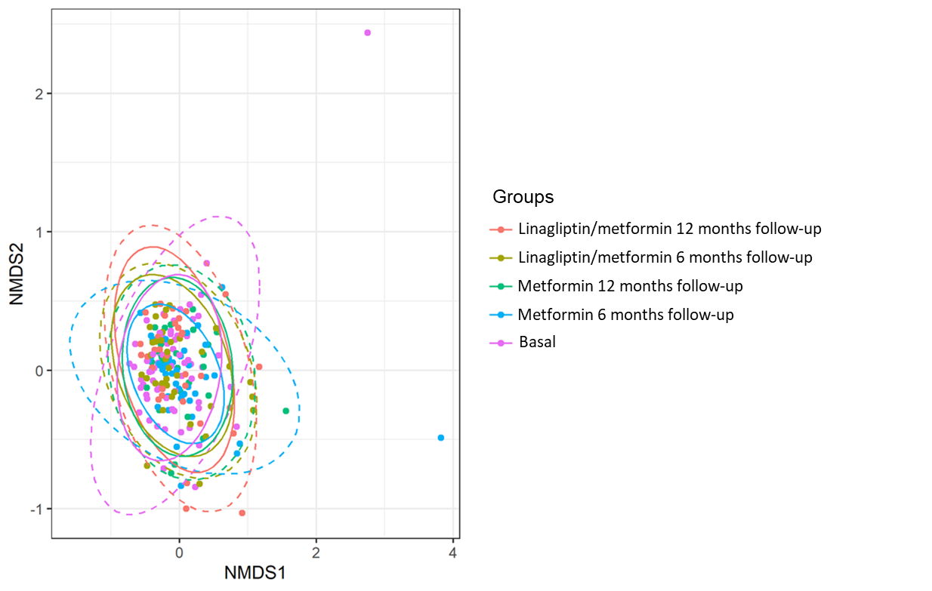

Figure S3. Beta diversity analysis. The beta diversity analysis with Jaccard distances shows that we cannot define any grouping pattern from the microbial diversity between the analysis groups. These results show that from the microbial diversity between the analysis groups we cannot define any grouping pattern.
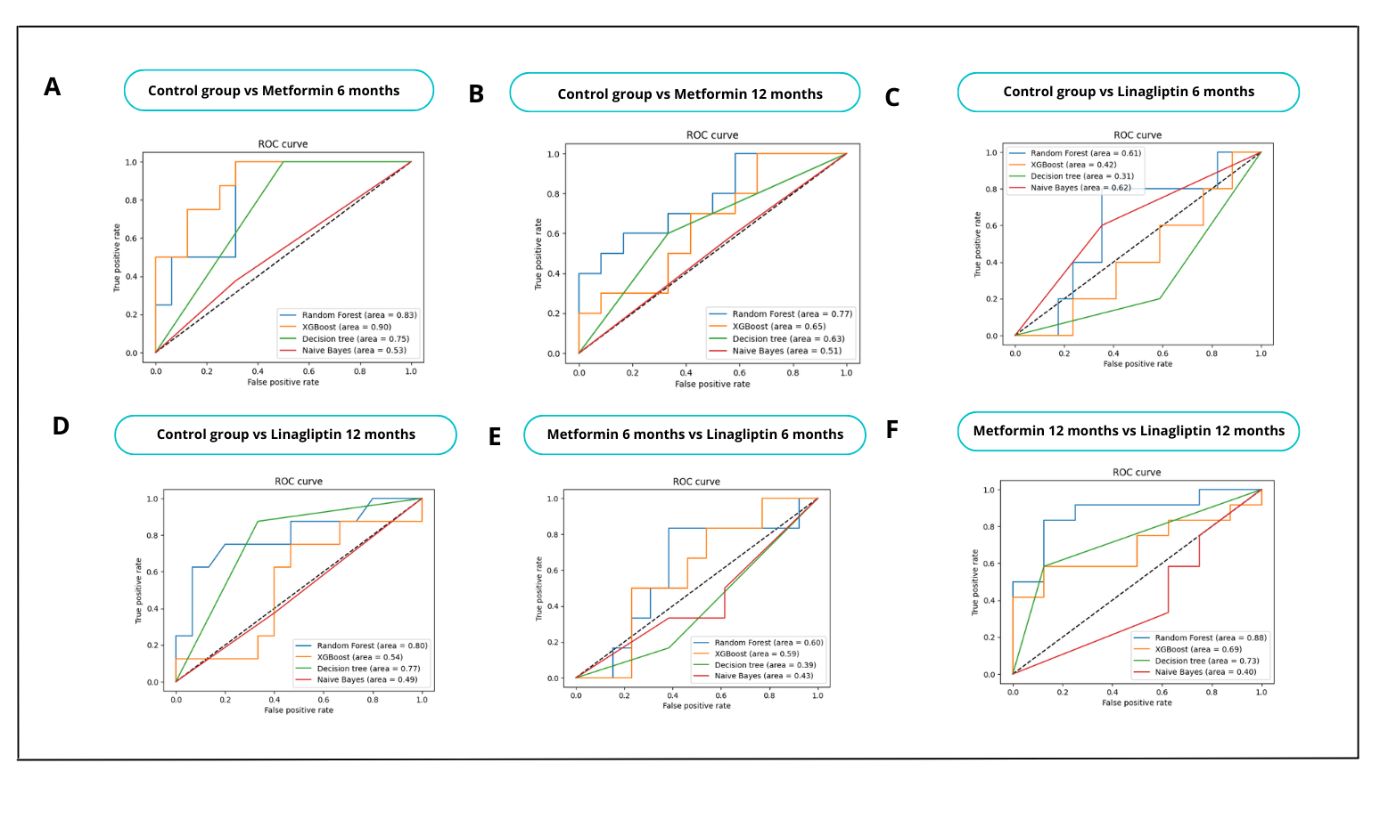
Figure S4. Comparison analysis between models. We compared the predictive performance using area under the curve (AUC) of the ROC curves of different algorithms to select the method to use, including the decision tree, naive Bayes, and XGBoost.

Group | Accuracy | AUC | Mean Accuracy | SD (CV=5) | Mean  AUC | DE (CV=5)
Basal vs Metformin 6 months | 0.66 | 0.75 | 0.69 | 0.02 | 0.79 | 0.04
Basal vs Linagliptin/Metformin 6 months | 0.59 | 0.66 | 0.65 | 0.13 | 0.60 | 0.12
Basal vs Metformin 12 months | 0.59 | 0.60 | 0.68 | 0.07 | 0.74 | 0.07
Basal vs Linagliptin/Metformin 12 months | 0.73 | 0.74 | 0.65 | 0.4 | 0.66 | 0.13
Metformin 6 months vs Linagliptin/Metformin 6 months | 0.73 | 0.76 | 0.63 | 0.15 | 0.66 | 0.18
Metformin 12 months vs Linagliptin/Metformin 12 months | 0.75 | 0.75 | 0.65 | 0.1 | 0.74 | 0.11
Table S5. Machine Learning algorithms performance. We compare the performance of comparisons by pharmacological treatment and monitoring month using precision and AUC values. We use the stratified cross-validation technique to obtain the standard deviation in our results (K fold = 10).

Fixed effects | β | SE | p-value | 95% CI |  | Eta-Squared | 95%CI
Butyrycicoccus
Matsuda Index | 0.666 | 0.337 | 0.048 | 0.006 | 1.326 | 0.027 | 0.0001 | 0.099
AUCinsgluc_OGTT | -0.717 | 0.359 | 0.046 | -1.421 | -0.012 | 0.027 | 0.0001 | 0.101
Erysipelotrichaceae UCG-003
AUCinsgluc_OGTT | -0.824 | 0.338 | 0.015 | -1.487 | -0.162 | 0.039 | 0.0006 | 0.121
[Eubacterium] xylanophilum group
Matsuda Index | -0.630 | 0.304 | 0.038 | -1.227 | -0.033 | 0.029 | 0.0001 | 0.104
AUCinsgluc_OGTT | 0.647 | 0.325 | 0.047 | 0.009 | 1.285 | 0.027 | 0.0001 | 0.100
Granulicatella
Matsuda Index | 0.544 | 0.241 | 0.024 | 0.072 | 1.017 | 0.034 | 0.0001 | 0.113
Ruminococcaceae UCG-008
Matsuda Index | -0.366 | 0.185 | 0.042 | -0.729 | -0.004 | 0.027 | 0.0001 | 0.099
Prevotella 6
Matsuda Index | -0.480 | 0.223 | 0.031 | -0.916 | -0.044 | 0.031 | 0.0001 | 0.108
HOMA-IR | 0.385 | 0.188 | 0.041 | 0.017 | 0.754 | 0.028 | 0.0001 | 0.103
Catabacter
Matsuda Index | -0.508 | 0.232 | 0.029 | -0.964 | -0.053 | 0.032 | 0.0001 | 0.110
HOMA-IR | 0.390 | 0.196 | 0.047 | 0.005 | 0.776 | 0.027 | 0.0001 | 0.100
Actinomyces
HOMA-IR | -0.752 | 0.270 | 0.005 | -1.279 | -0.223 | 0.052 | 0.0036 | 0.139
ORAL-DI | 0.551 | 0.249 | 0.027 | 0.063 | 1.038 | 0.034 | 0.0001 | 0.113
Negativibacillus
HOMA-IR | -0.450 | 0.227 | 0.048 | -0.895 | -0.005 | 0.027 | 0.0001 | 0.100
ORAL-DI | 0.537 | 0.204 | 0.008 | 0.138 | 0.936 | 0.047 | 0.0022 | 0.134
DIsp_Index2 | 0.972 | 0.349 | 0.005 | 0.289 | 1.655 | 0.052 | 0.0036 | 0.139
Bilophila
AIR | -0.566 | 0.240 | 0.018 | -1.036 | -0.096 | 0.038 | 0.0001 | 0.119
Mogibacterium
AIR | 0.652 | 0.222 | 0.003 | 0.216 | 1.088 | 0.057 | 0.0052 | 0.148
ORAL-DI | 0.630 | 0.205 | 0.002 | 0.227 | 1.031 | 0.063 | 0.0069 | 0.156
Lachnospiraceae UCG-004
AIR | -0.423 | 0.199 | 0.034 | -0.814 | -0.033 | 0.031 | 0.0001 | 0.108
ORAL-DI | -0.497 | 0.182 | 0.006 | -0.854 | -0.139 | 0.050 | 0.0030 | 0.138
Disp_Index2 | -1.069 | 0.311 | 0.001 | -1.679 | -0.461 | 0.077 | 0.0127 | 0.173
AUCinsgluc_OGTT | -0.531 | 0.259 | 0.040 | -1.039 | -0.023 | 0.029 | 0.0001 | 0.103
Fournierella
AIR | 0.448 | 0.214 | 0.036 | 0.029 | 0.867 | 0.030 | 0.0001 | 0.107
Atopobium
ORAL-DI | 0.508 | 0.209 | 0.015 | 0.098 | 0.918 | 0.404 | 0.0006 | 0.123
Disp_Index2 | 0.787 | 0.358 | 0.028 | 0.086 | 1.489 | 0.033 | 0.0001 | 0.110
Catenibacterium
Disp_Index2 | 0.785 | 0.301 | 0.009 | 0.194 | 1.375 | 0.045 | 0.0019 | 0.130
Eggerthellaceae uncultured
AUCinsgluc_OGTT | 0.571 | 0.262 | 0.030 | 0.056 | 1.085 | 0.032 | 0.0001 | 0.109
Peptococcaceae unclutured
AUCinsgluc_OGTT | 0.618 | 0.302 | 0.041 | 0.027 | 1.208 | 0.028 | 0.0001 | 0.103
N | 142

Table S6. MLGM for bacterial genera and effect size and confidence interval for each bacterium. In the generalized linear mixed models, the abundances of bacteria were considered with statistical significance with the objective of knowing the existence of bidirectional relationships between the outcome variables and the abundance of bacteria. Models were adjusted for months of follow-up, drug treatment, sex, age, BMI, insulin resistance indices, and pancreatic β-cell function. 17 bacterial genes with bidirectional relationships were found and with these the analysis continued.

Fixed effects | β | SE | p-value | 95% CI |  | Eta-Squared | 95%CI
Catabacter
V6 Tmet | -0.327 | 0.194 | 0.093 | -0.708 | 0.054 | 0.043 | 0.0001 | 0.101
V12 Tmet | -0.278 | 0.177 | 0.117 | -0.625 | 0.069
V6 Tlina+met | -0.166 | 0.187 | 0.372 | -0.532 | 0.199
V12 Tlina+met | 0.049 | 0.169 | 0.770 | -0.282 | 0.380
Sexo | 0.133 | 0.121 | 0.269 | -0.103 | 0.369 | 0.008 | 0.0001 | 0.063
Edad | 0.038 | 0.485 | 0.937 | -0.912 | 0.988 | 0.00004 | 0.0001 | 0.013
IMC | -0.423 | 0.797 | 0.596 | -1.984 | 1.139 | 0.0019 | 0.0001 | 0.042
Matsuda Index | -0.503 | 0.233 | 0.031 | -0.959 | -0.047 | 0.031 | 0.0001 | 0.108
N | 143

Table S7. Mixed generalized linear models for the genus Catabacter and each bacterium's effect size and confidence interval. To elucidate the effect of antidiabetic drugs and the new metabolic condition on bacterial genera, we performed generalized linear mixed models (for a Tweedie distribution) where bacterial genera were considered as the dependent variable and antidiabetic drugs as an independent variable. Additionally, we adjusted the model for gender, age, BMI, and the Matsuda index or Disp_Index2. Interestingly, we observed that antidiabetic drugs and increased insulin sensitivity explain the change in the abundance of the Catabacter genus. These results guide us to consider that the metabolic condition is the main reason for the change in the bacterial structure.

Fixed effects | β | SE | p-value | 95% CI |  | Eta-Squared | 95%CI
Lachnospiraceae UCG-004
V6 Tmet | 0.467 | 0.205 | 0.023 | 0.065 | 0.870 | 0.059 | 0.0001 | 0.126
V12 Tmet | 0.175 | 0.183 | 0.339 | -0.184 | 0.533
V6 Tlina+met | 0.519 | 0.202 | 0.010 | 0.123 | 0.914
V12 Tlina+met | 0.206 | 0.187 | 0.268 | -0.160 | 0.573
Sexo | 0.193 | 0.125 | 0.125 | -0.053 | 0.438 | 0.016 | 0.0007 | 0.081
Edad | -0.695 | 0.503 | 0.167 | -1.679 | 0.290 | 0.013 | 0.0001 | 0.074
IMC | 0.222 | 0.794 | 0.780 | -1.335 | 1.779 | 0.0005 | 0.0001 | 0.031
Disp_Index2 | -0.990 | 0.317 | 0.002 | -1.612 | -0.368 | 0.064 | 0.0076 | 0.156
N | 166

Table S8. Mixed generalized linear models for the genus Lachnospiraceae UCG-004 and effect size and confidence interval for each bacterium. Pharmacological treatments and increasing the function of pancreatic β cells explain the change in abundance of the Lachnospiraceae genus UCG-004.

Protocol S1. Fecal sample processing protocol.

DNA Extraction
DNA extraction used MoBio PowerSoil DNA Isolation kit (Mo Bio Laboratories, Inc. Carlsbad, USA) following the manufacturer’s instructions with modifications. After adding C1 solution and mixing, 25 µl proteinase K solution was added, vortexed, and incubated at 65°C for 10 min, with inversion mixing every three min. Tubes were secured horizontally and vortexed at 3,000 rpm for 15 min. Incubated at 95°C for 10 min with mixing as mentioned. Total DNA eluted in 100 µl sterile water. DNA concentration quantified with Qubit (Thermo Scientific, USA) and validated by Nanodrop (ND 2000, Thermo Scientific, USA).

16S rRNA Gene Amplification and Sequencing
DNA templates used in a two-step PCR to sequence the V4 hypervariable region of bacterial 16S rRNA gene. Fusion primers contained v4 region and Nextera Illumina adapter sequences for multiplexing pooled libraries. Initial PCR used primers with partial Nextera adapter and V4 targeting forward or reverse primer sequence in agreement with.
NEXT_16S_V4_U515_F
5’-TCGTCGGCAGCGTCAGATGTGTATAAGAGACAGGTGCCAGCMGCCGCGGTAA-3′
NEXT_16S_V4_E786_R
5’-GTCTCGTGGGCTCGGAGATGTGTATAAGAGACAGGGACTACHVGGGTWTCTAAT-3′
For each sample, an equal DNA template (up to 12.5 ng per reaction) is used. Reactions had 3 min denature step at 94°C, followed by 25 cycles of denaturation at 94°C for 45 s, annealing at 50°C for 60 s, and extension at 72°C for 90 s, with final extension at 72°C for 10 min. All reactions used 2x KAPA HiFi HotStart ReadyMix to generate amplicons⁵².
Amplicons purified using Agencourt Ampure XP beads (Beckman Coulter) at 1.25x (v/v) proportion. PCR products checked via electrophoresis in 2% (w/v) agarose gels in TAE buffer stained with SYBR Gold and visualized under UV light.
For each amplicon, a second PCR performed at 95°C for 3 min, followed by 8 cycles of denaturation at 95°C for 30 s, annealing at 55°C for 30 s, and extension at 72°C for 30 s, with final extension at 72°C for 5 min. 5 µl of previous purified DNA template and primers attaching dual indices and Illumina sequencing adapters from Nextera XT kit used. PCR products purified as before, DNA concentration determined using Qubit® 2.0 Broad Range Assay (Life Technologies™). Agilent TapeStation (Agilent, Santa Clara, CA) with DNA High Sensitivity kit used for PCR product size verification, only for 23 amplicons. Samples randomly distributed into five pools in similar proportions, then mixed equally (to 10 nM). Final concentration of each pool determined using Qubit® 2.0.

Pools diluted to 9 pM for sequencing using 2x250 bp paired-end chemistry v2 on Illumina MiSeq. All samples distributed in five pools equally (to 10 nM) as per consecutive numbers assigned by the experimental lab. Final concentration of each pool determined using Qubit® 2.0. Amplicons denatured with 0.2 N NaOH, further diluted according to MiSeq user guide, combined with denatured PhiX control library. PhiX spiked into the amplicon pool at 10% relative concentration. Image processing and base calling done on BaseSpace cloud from Illumina (http://basespace.illumina.com).

