Bisbenzimidazole salts and their in silico-in vitro inhibitory abilities on hCAI, hCAII, and AChE enzymes
Ülkü Yılmaz¹* ● Yeliz Demir² ● Tuğba Taşkın Tok^{3,4} ● Yetkin Gök⁵ ● Aydın Aktaş⁶ ● İlhami Gülçin⁷

¹ Departmen of Engineering Basic Sciences, Faculty of Engineering and Natural Sciences, Malatya Turgut Özal University, Malatya, Türkiye
² Departmen of Pharmacy Services, Nihat Delibalta Göle Vocational High School, Ardahan University, 75000-Ardahan, Türkiye
³ Departmen of Chemistry, Faculty of Arts and Sciences, Gaziantep University, 27310-Gaziantep, Türkiye
⁴ Departmen of Bioinformatics and Computational Biology, Institute of Health Sciences, Gaziantep University, 27310-Gaziantep, Türkiye
⁵ Departmen of Chemistry, Faculty of Science and Arts, İnönü University, 44280 Malatya, Türkiye
⁶ Health Services Vocational School, İnönü University, 44280 Malatya, Türkiye
⁷ Atatürk University, Faculty of Science, Department of Chemistry, 25240 Erzurum, Türkiye

Ülkü Yılmaz
E-mail: ulku.yilmaz@ozal.edu.tr

¹H, ¹³C-NMR and IR Spectra

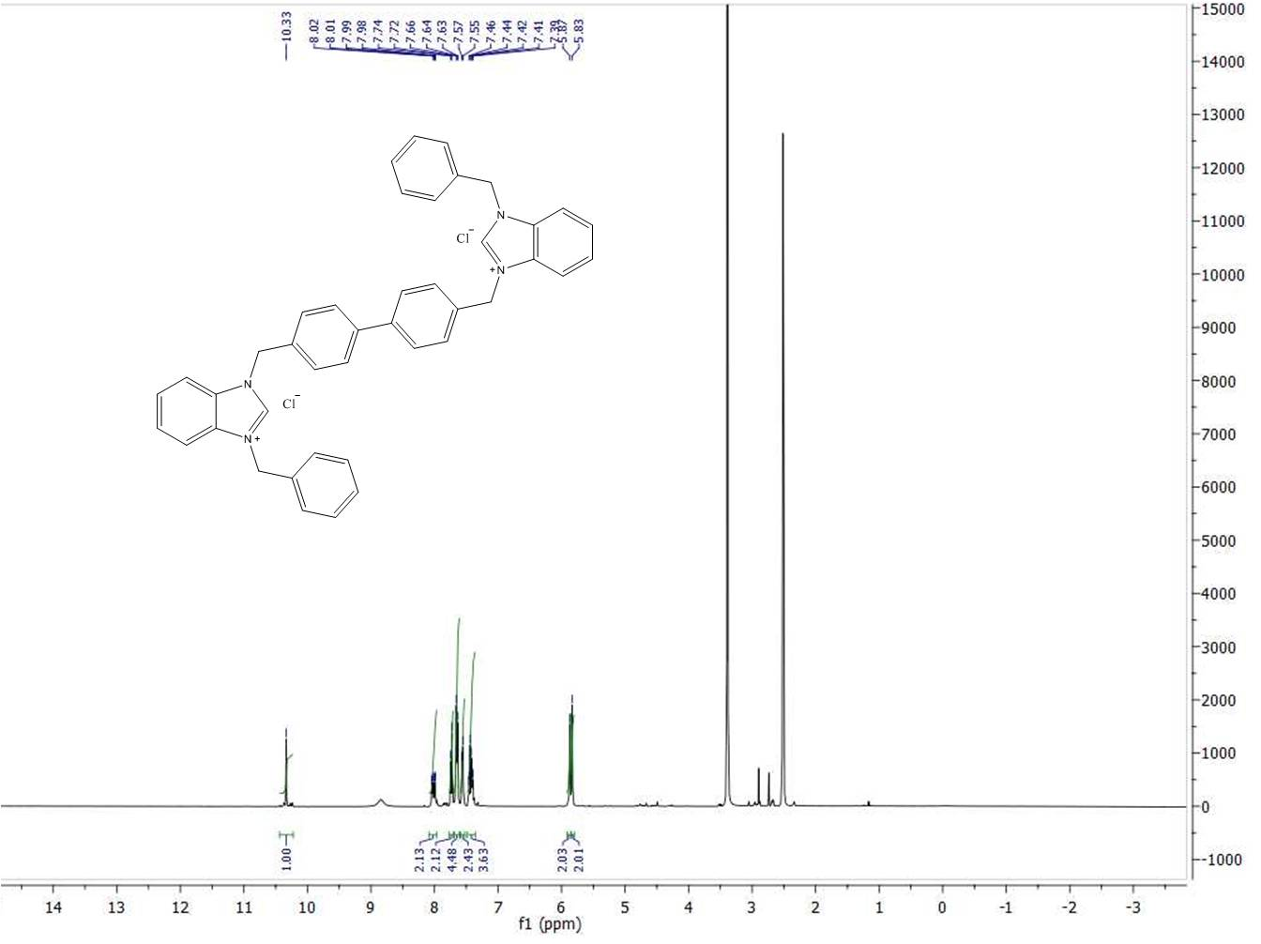
S1. ¹H-NMR spectrum of compound 1a

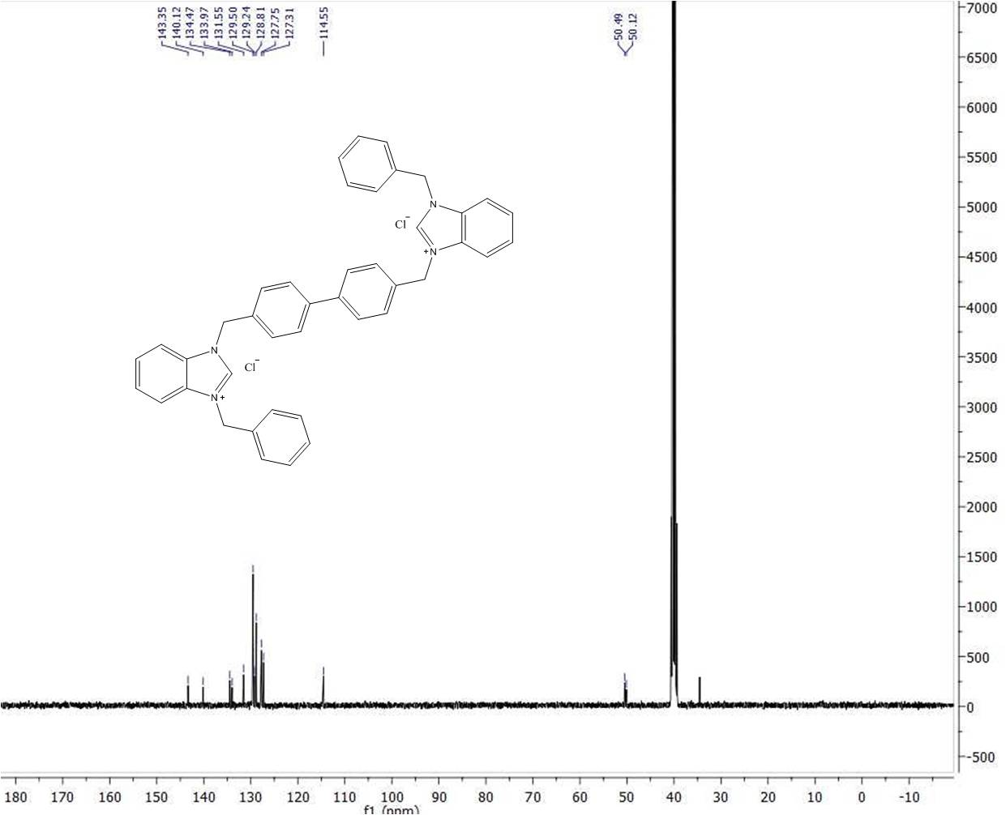
S2. ¹³C-NMR spectrum of compound 1a

S3. IR spectrum of compound 1a

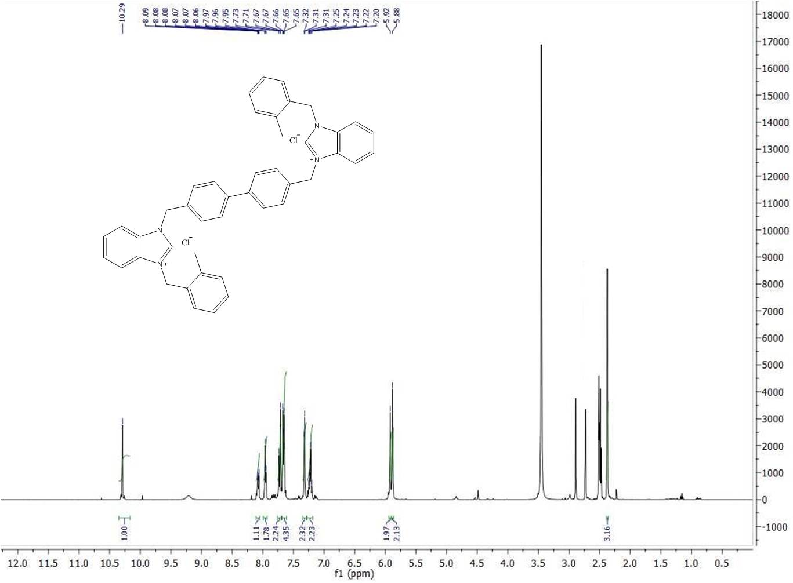
S4. ¹H-NMR spectrum of compound 1b

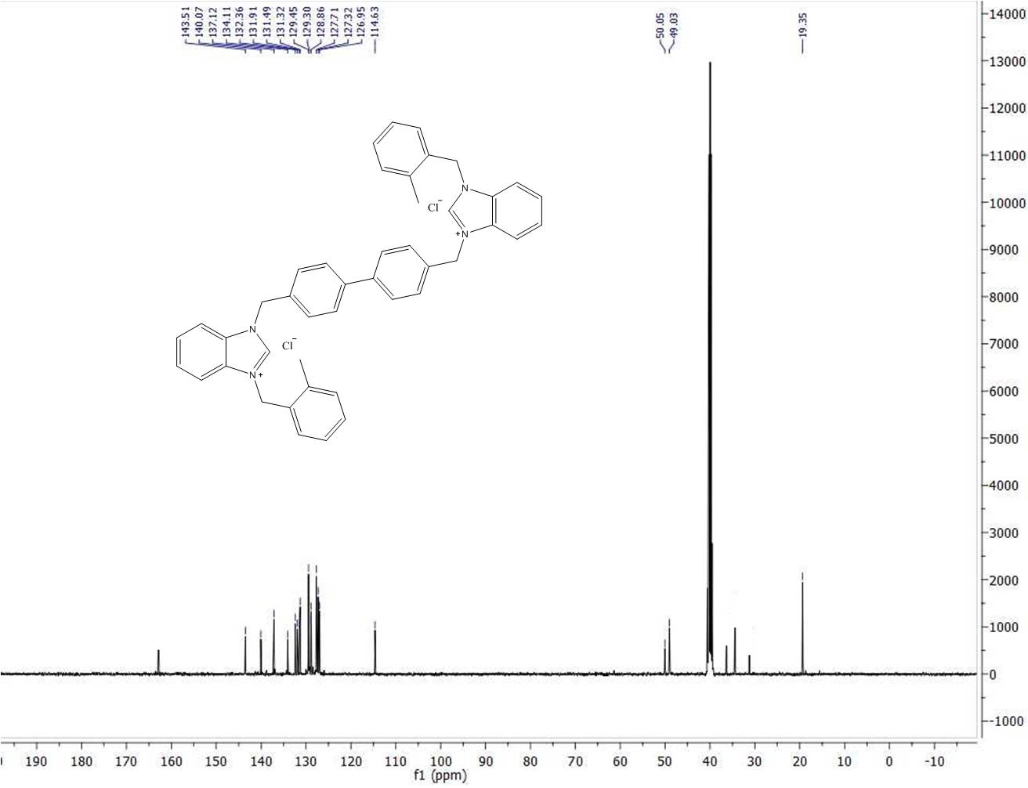
S5. ¹³C-NMR spectrum of compound 1b

S6. IR spectrum of compound 1b

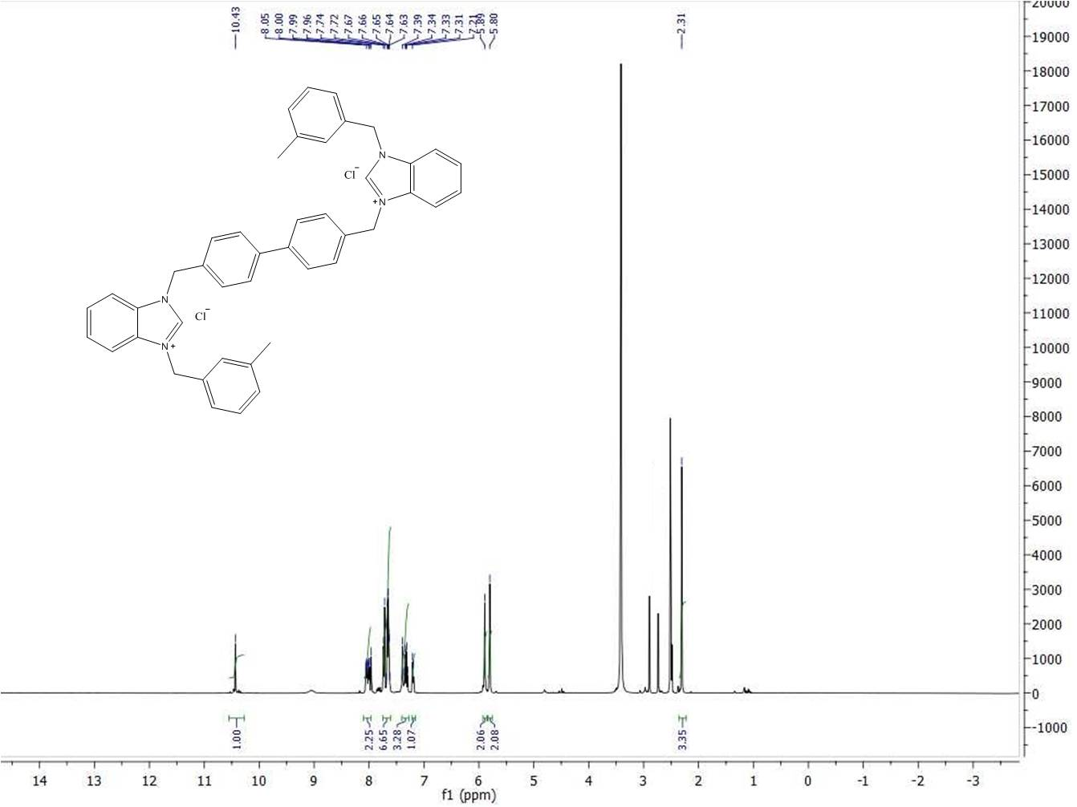
S7. ¹H-NMR spectrum of compound 1c

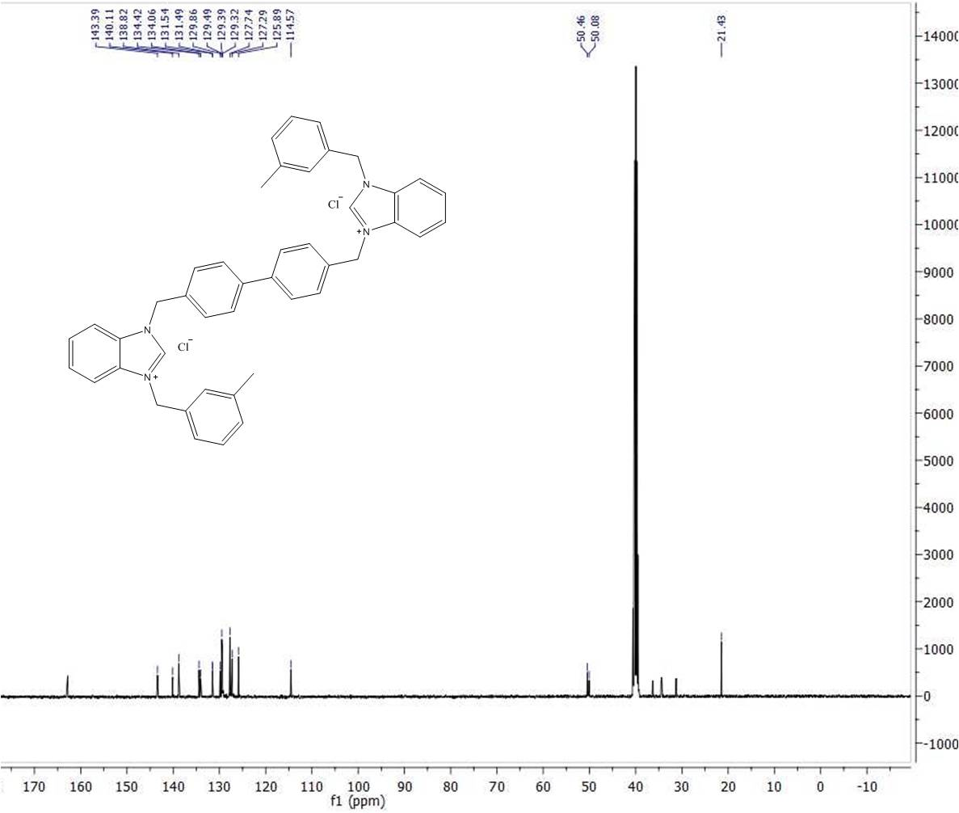
S8. ¹³C-NMR spectrum of compound 1c

S9. IR spectrum of compound 1c

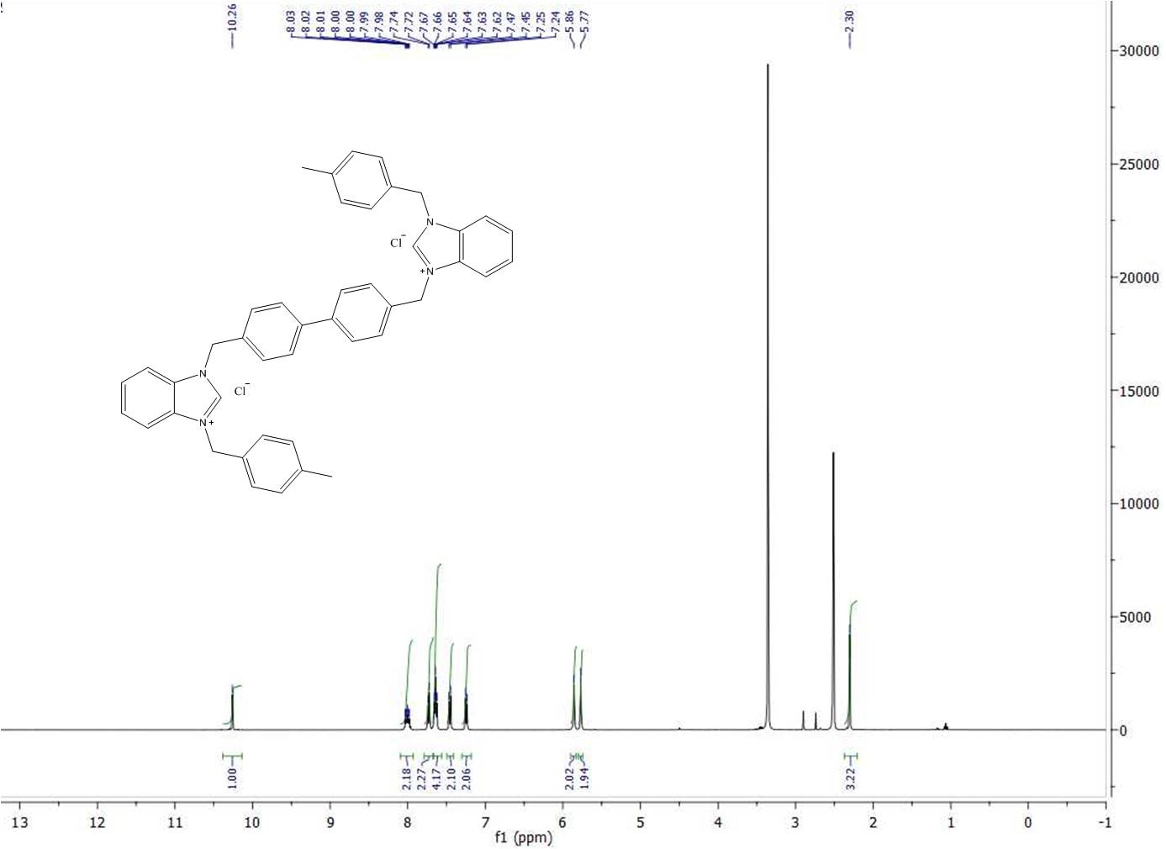
S10. ¹H-NMR spectrum of compound 1d

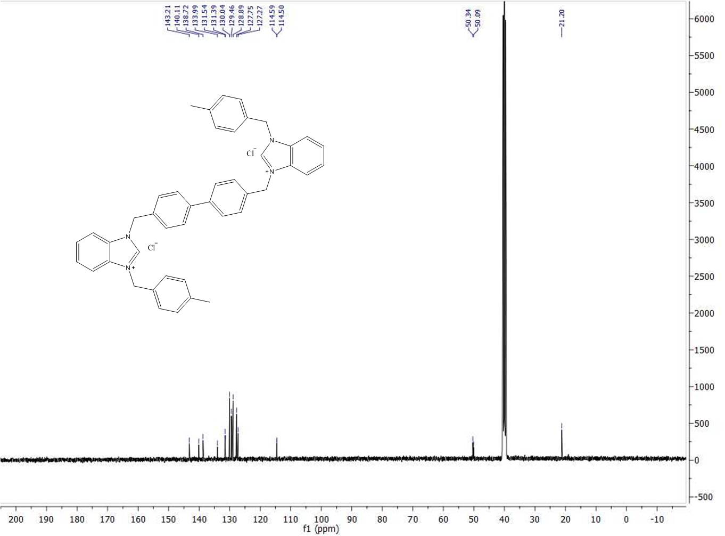
S11. ¹³C-NMR spectrum of compound 1d

S12. IR spectrum of compound 1d

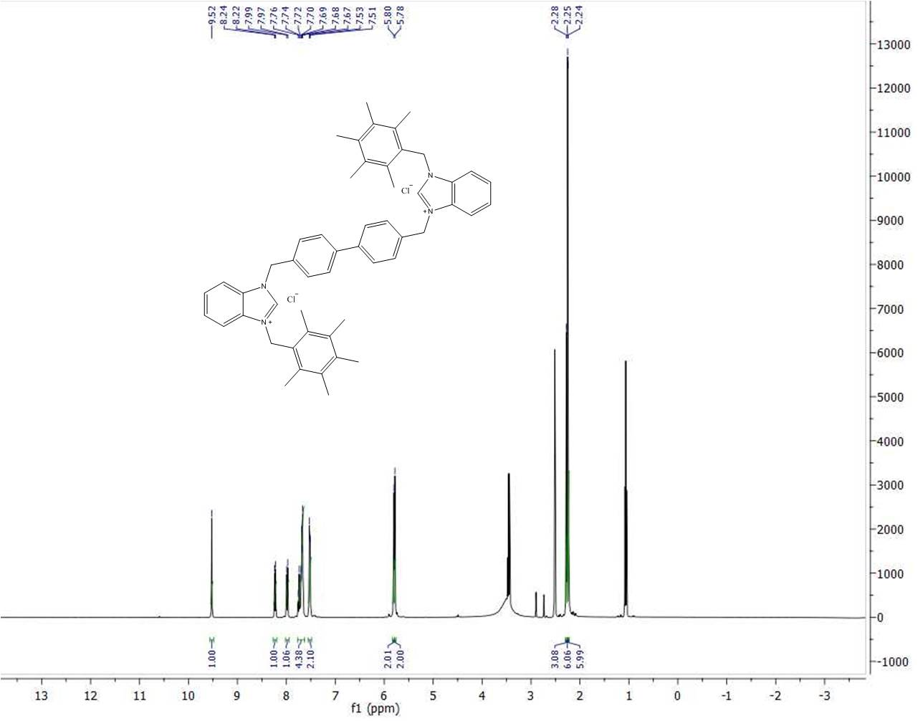
S13. ¹H-NMR spectrum of compound 1e

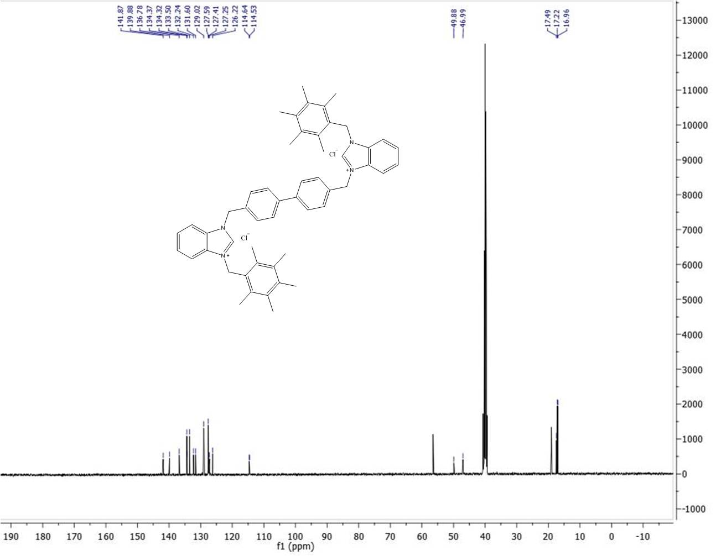
S14. ¹³C-NMR spectrum of compound 1e

S15. IR spectrum of compound 1e

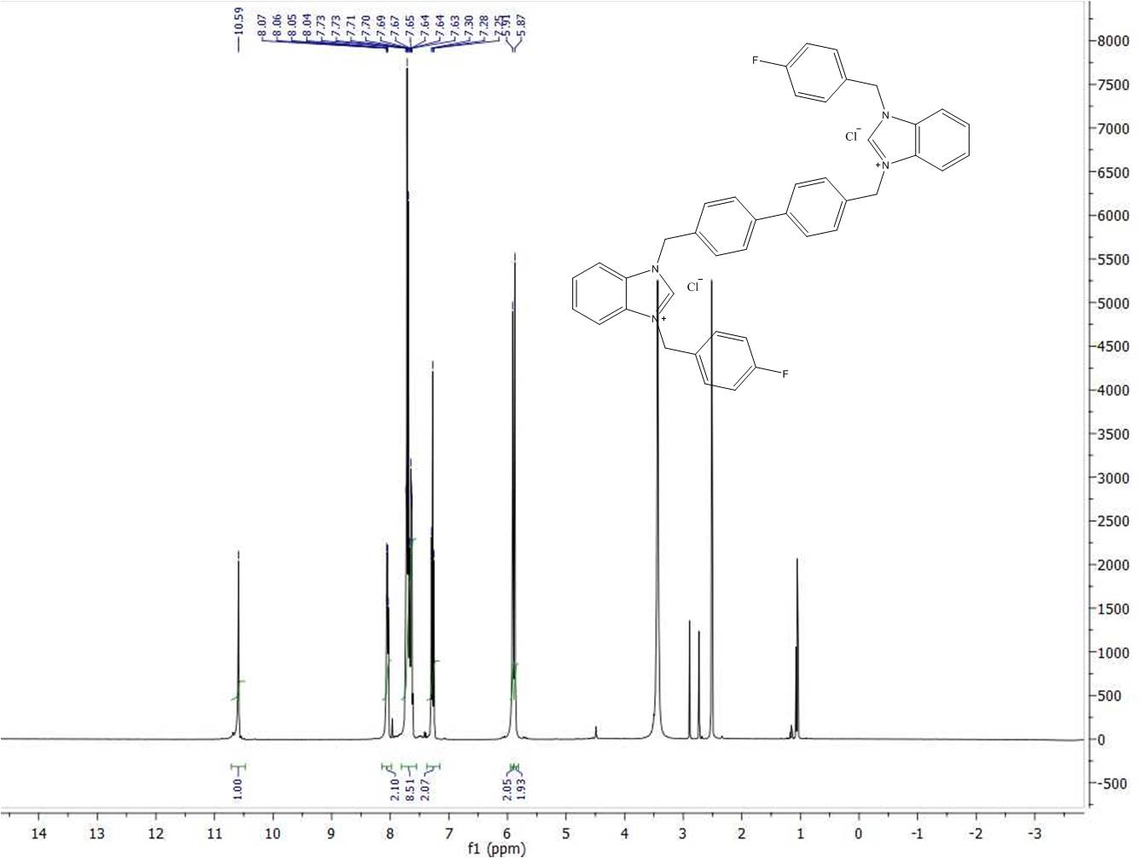
S16. ¹H-NMR spectrum of compound 1f

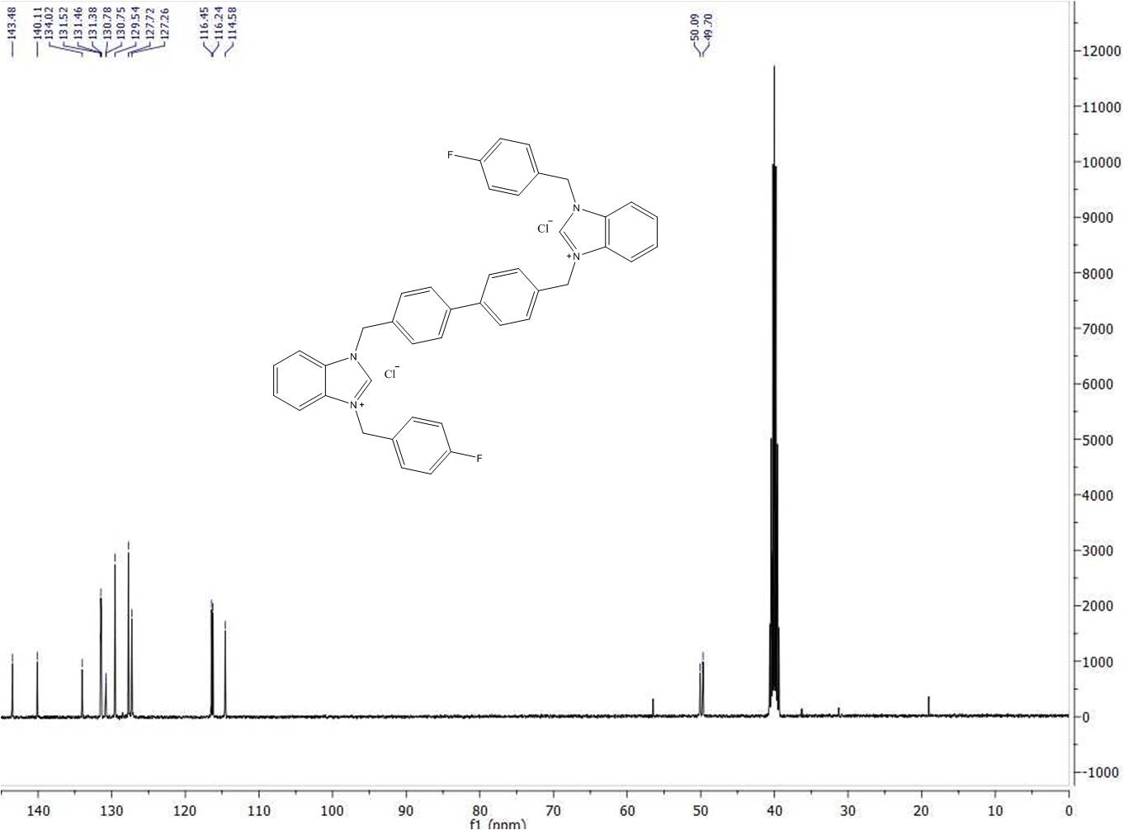
S17. ¹³C-NMR spectrum of compound 1f

S18. IR spectrum of compound 1f

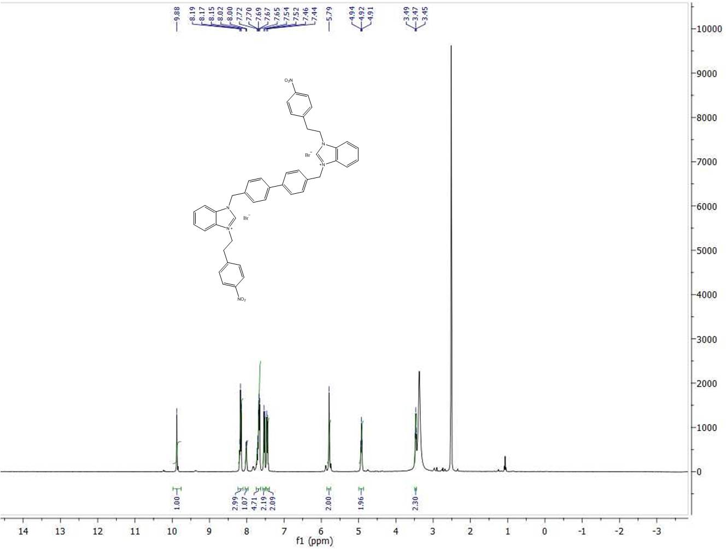
S19. ¹H-NMR spectrum of compound 1g

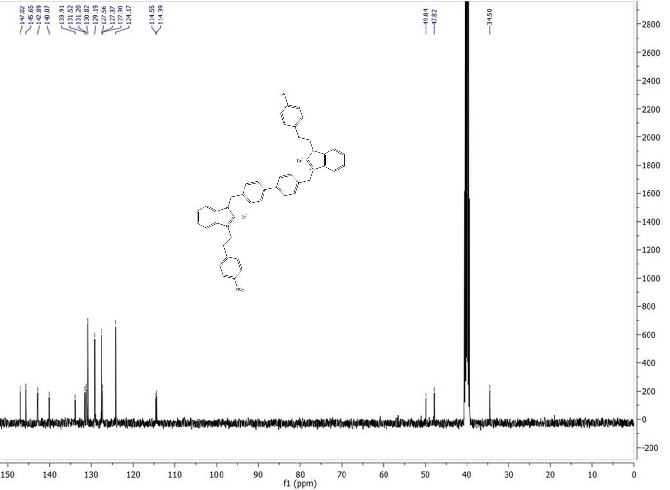
S20. ¹³C-NMR spectrum of compound 1g

S21. IR spectrum of compound 1g

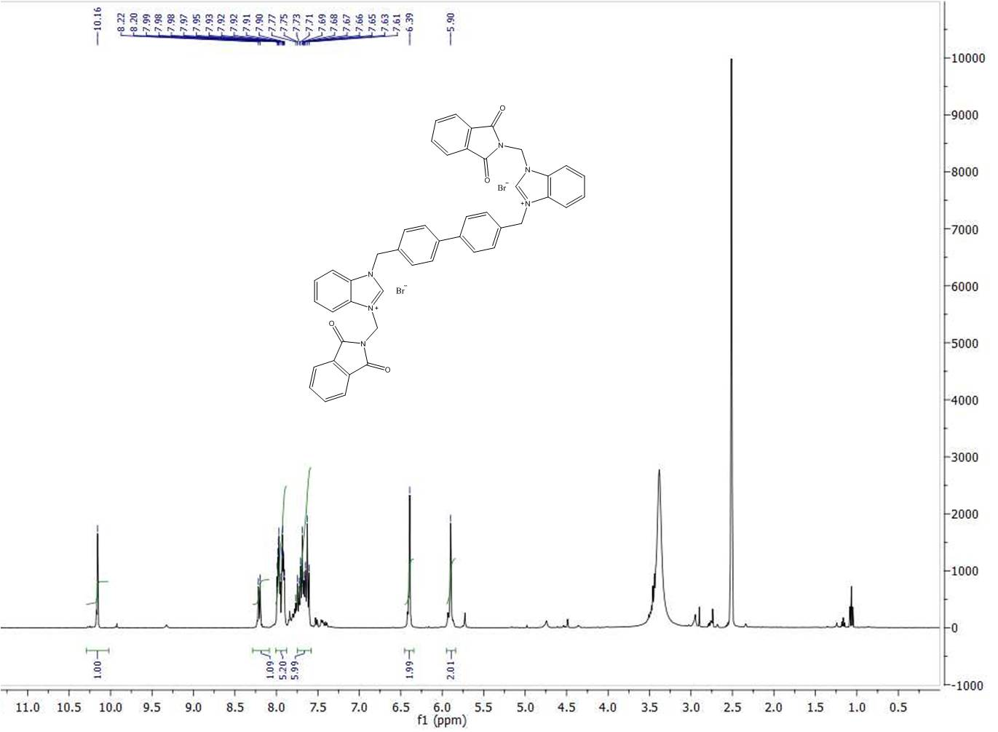
S22. ¹H-NMR spectrum of compound 1h

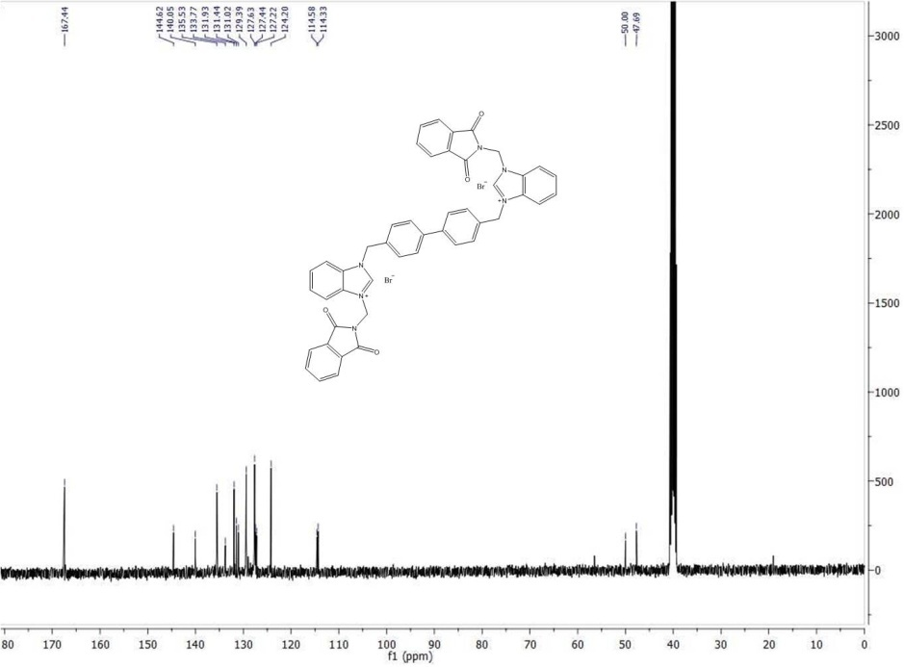
S23. ¹³C-NMR spectrum of compound 1h

S24. IR spectrum of compound 1h

